**Supplementary Material**

**of**

**Measurement and modeling of metoclopramide hydrochloride (anti-emetic drug) solubility in supercritical carbon dioxide**

**Gholamhossein Sodeifian a,b,c,* , Chieh-Ming Hsieh**d**, Reza Derakhsheshpoura,b,c Yu-Ming Chen**d**, Fariba Razmimanesha,b,c**

aDepartment of Chemical Engineering, Faculty of Engineering, University of Kashan, Postal Code: 87317-53153, Kashan, Iran.

bLaboratory of Supercritical Fluids and Nanotechnology, University of Kashan, Postal Code: 87317-53153, Kashan, Iran.

cModeling and Simulation Centre, Faculty of Engineering, University of Kashan, Postal Code: 87317-53153, Kashan, Iran

dDepartment of Chemical and Materials Engineering, National Central University, Taoyuan 320317, Taiwan

*Corresponding author. Tel.: +983155912406; fax: +98315591*2*424.

E-mail address: **sodeifian@kashanu.ac.ir (**G. Sodeifian**)**

Three figures are provided in the supplementary material:

* Figure S1 compares MCP Solubility in SC-CO2 versus pressure from experiment and semi-empirical models: (a) Chrastil, (b) MST, (c) Kumar-Johnston, (d) Bartle, (e) Sofeidian and (f) Gordillo.
* Figure S2 compares MCP Solubility in SC-CO2 versus density from experiment and semi-empirical models: (a) Chrastil, (b) MST, (c) Kumar-Johnston, (d) Bartle, (e) Sofeidian and (f) Gordillo.
* Figure S3 compares the solubility of metoclopramide hydrochloride in SC-CO2 from experimental measurement and three thermodynamic models based on PR EoS: (a) PR+vdW-kij, (b) PR-WS-Wilson and (c) PR-MHV1-COSMOSAC.

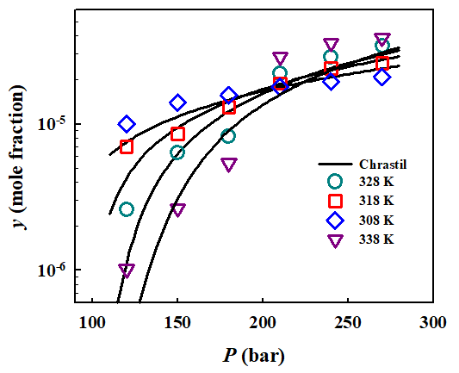 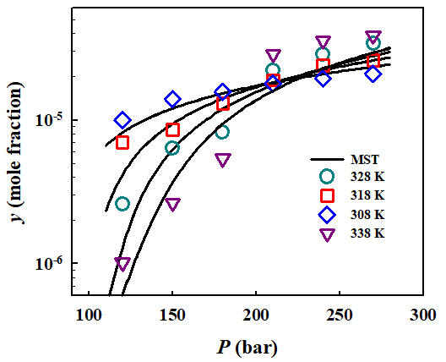

(b)

(d)

(c)

(a)

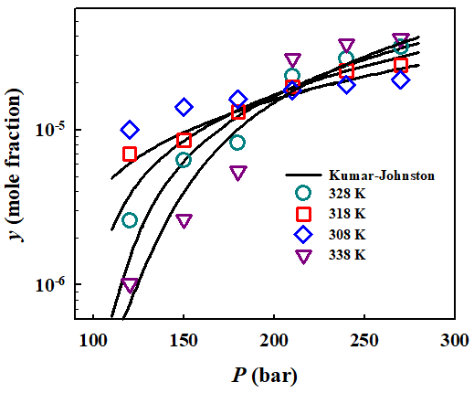 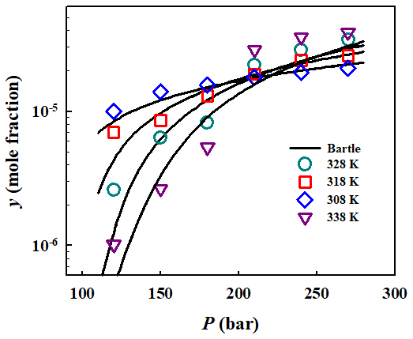

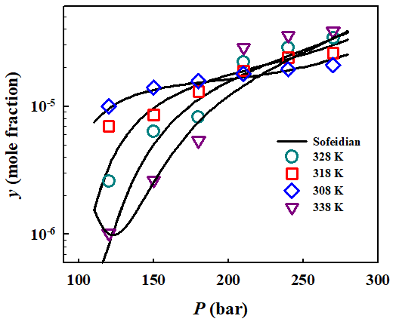 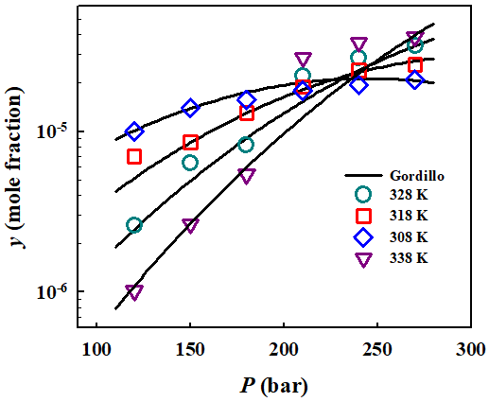

(f)

(e)

**Figure S1.** Comparison of MCP Solubility in SC-CO2 versus pressure from experiment and semi-empirical models: (a) Chrastil, (b) MST, (c) Kumar-Johnston, (d) Bartle, (e) Sofeidian and (f) Gordillo.

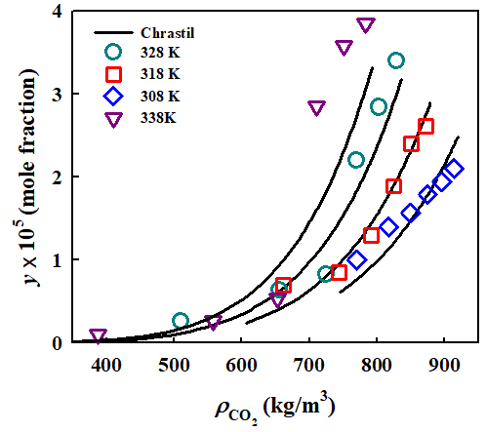 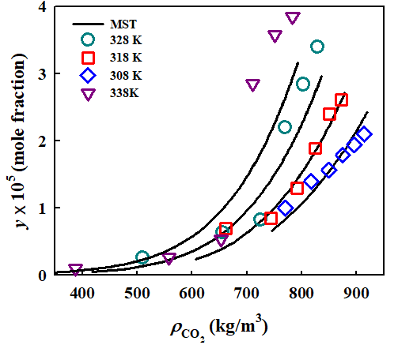

(b)

(a)

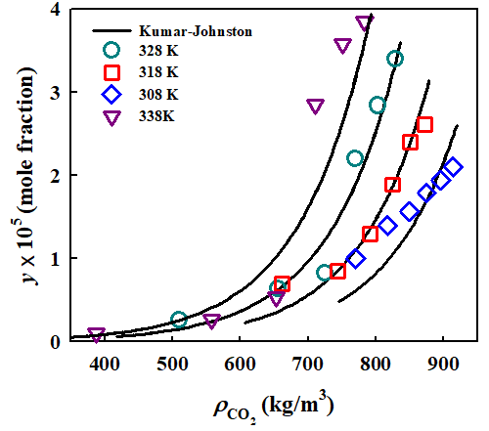 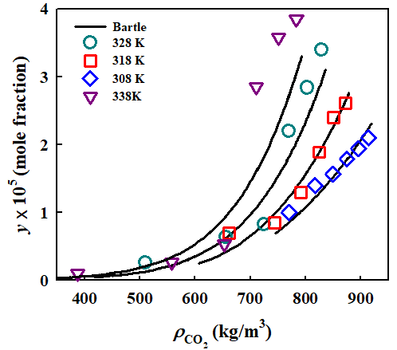

(d)

(c)

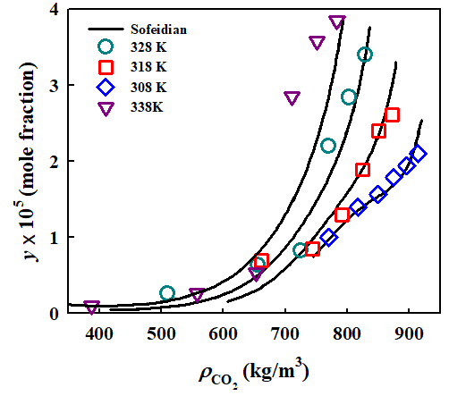 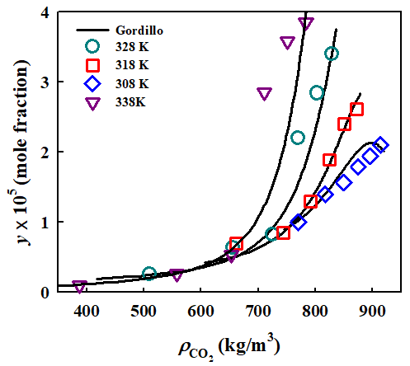

(f)

(e)

**Figure S2.** Comparison of MCP Solubility in SC-CO2 versus density from experiment and semi-empirical models: (a) Chrastil, (b) MST, (c) Kumar-Johnston, (d) Bartle, (e) Sofeidian and (f) Gordillo.

(b)

(a)



(c)



**Figure S3.** MCP Solubility in SC-CO2 from experimental measurement and three thermodynamic models based on PR EoS: (a) PR+vdW-kij, (b) PR-WS-Wilson and (c) PR-MHV1-COSMOSAC.