***Supporting Information***

**Removal of multiple pollutants from water using a noble metal/magnetite/graphene/H2O2 system under light and ultrasound irradiation**

Rosari Saleh*, Saskia Andiane Hidayat, and Ardiansyah Taufik+

1Departemen Fisika, Fakultas MIPA-Universitas Indonesia, 16424 Depok, Indonesia

2Integrated Laboratory of Energy and Environment, Fakultas MIPA-Universitas Indonesia, 16424 Depok, Indonesia

3Institute of Multidisciplinary Research for Advanced Materials, Tohoku University, 2-1-1 Katahira, Aoba-ku, Sendai 980-8577, Japan

**Supplementary Files**

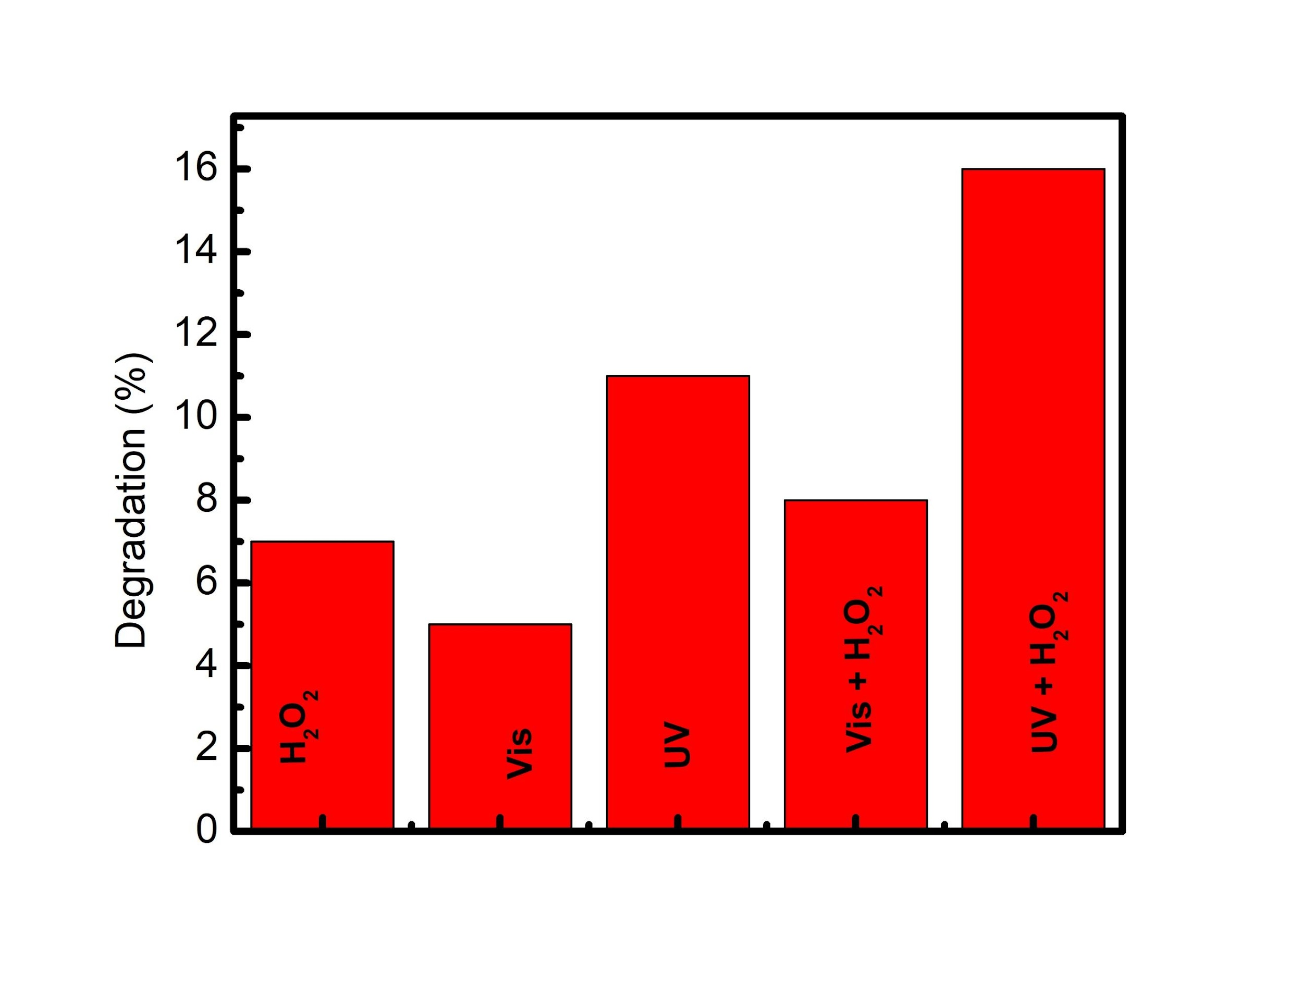**Fig. S1**. Blank test experiment, without samples

|  |
| --- |
|  |
| **Fig. S2.** Leaching of Fe2+ ion of Ag/Au/F-10G at different acid. |

|  |
| --- |
|  |
| **Fig. S3.** Leaching of Total Fe ion of Ag/Au/F-10G at different acid. |

|  |
| --- |
|  |
| **Fig. S4.** Leaching of Ag ion of Ag/Au/F-10G at different acid. |

|  |
| --- |
|  |
| **Fig. S5.** Change of the pH value during MB degradation in the presence of acids solution. |

|  |
| --- |
|  |
| **Fig. S6.** Leaching of Ag in the Ag/Au/F-10G at anion. |

|  |
| --- |
|  |
| **Fig. S7.** Influence of anion concentration on the removal ability of MB.  **Table S1.** Au, Ag, and Fe concentration taken by XPS analysis.   |  |  |  |  |  | | --- | --- | --- | --- | --- | | **Sample** | **Atomic %** | | | **Fe:Ag:Au** | | **Ag** | **Au** | **Fe** | | Ag/F-10G | 2.13 | - | 12.38 | 1:0.17:0 | | Au/F-10G | - | 1.62 | 7.09 | 1:0:0.22 | | Ag/Au/F-10G | 0.62 | 0.83 | 9.85 | 1:0.08:0.06 | |