Supplementary Table 1: Potential inhibitors of FGFR4 identified from virtual screening.
Ligand Name | Structure | Score | Minimized RMSD
PubChem-137300327 | 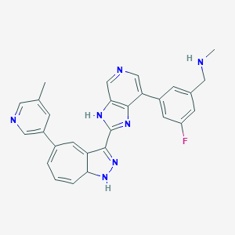 | -10.05 | 1.422
PubChem-20868770 | 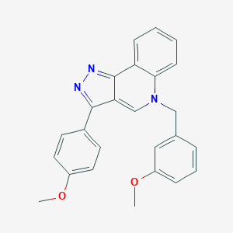 | -9.03 | 1.514
PubChem-42852342 | 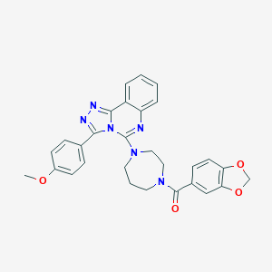 | -8.86 | 1.491
PubChem-46045273 | 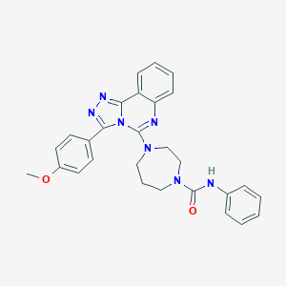 | -8.65 | 1.517
PubChem-46045028 | 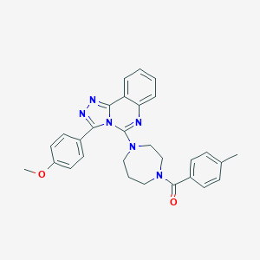 | -8.62 | 1.422
PubChem-136498886 | 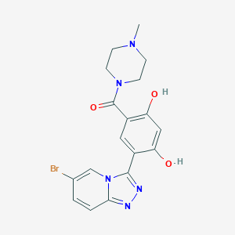 | -8.62 | 1.422
PubChem-42852344 | 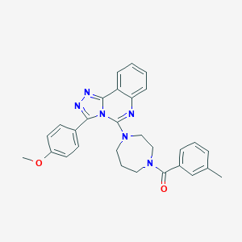 | -8.57 | 1.564
PubChem-46064646 | 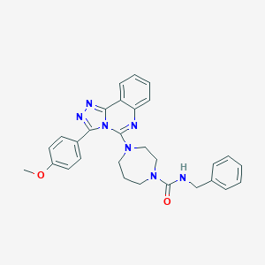 | -8.51 | 1.653
PubChem-46064449 | 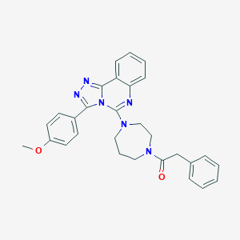 | -8.42 | 1.395
PubChem-135566848 | 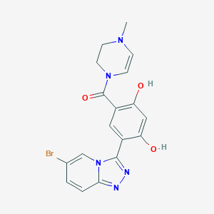 | -8.4 | 1.496
PubChem-46045027 | 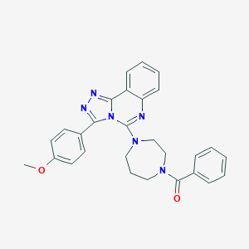 | -8.39 | 1.463
PubChem-121057779 | 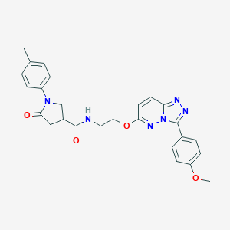 | -8.39 | 1.201
PubChem-46045032 | 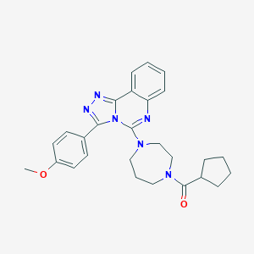 | -8.35 | 1.368
PubChem-121057779 |  | -8,39 | 1.201
PubChem-46045032 |  | -8,35 | 1.368
PubChem-74763324 | 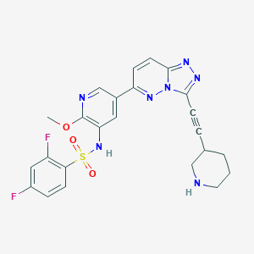 | -8.31 | 1.763
PubChem-121057804 | 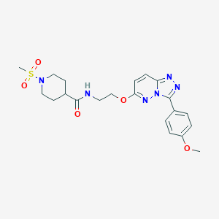 | -8,27 | 1.795
PubChem-74763182 | 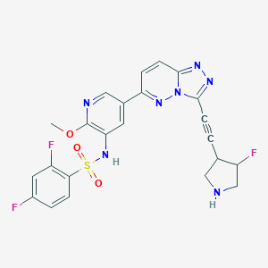 | -8,26 | 1.087
PubChem-118659256 | 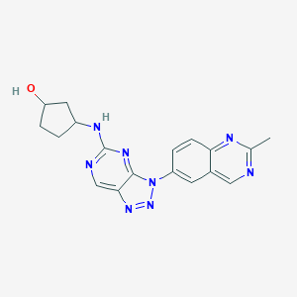 | -8,24 | 1.975
PubChem-21283339 | 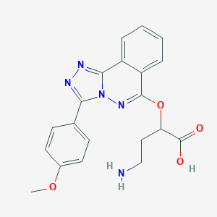 | -8,15 | 1.512
PubChem-46045036 | 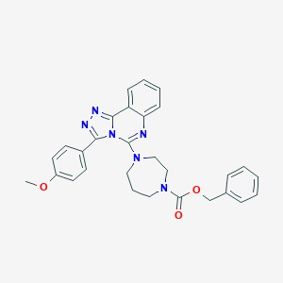 | -8,13 | 1.698
PubChem-42852340 | 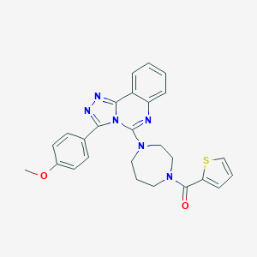 | -8,12 | 1.46
PubChem-86279119 | 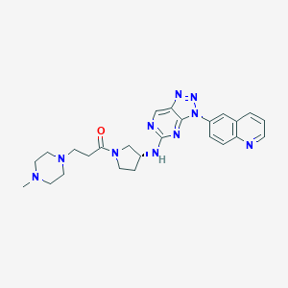 | -8,05 | 1.074
PubChem-45529170 | 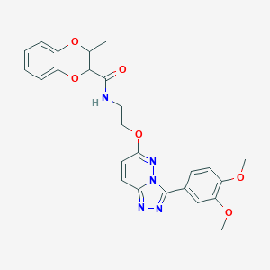 | -8.04 | 1.525

Supplementary Table 2: Grid box parameters used for docking with gatekeeper mutant FGFR1-4.
Receptor Protein | Grid Box Center |  |  | Number of Points |  |  | Spacing (Å)
 | X | Y | Z | X dimension | Y dimension | Z dimension
^{V561M}FGFR1 (PDB ID: 4RWI) | -8.83 | -5.22 | 12.35 | 28 | 28 | 28 | 0.375
^{V564F}FGFR2 (PDB ID: 7KIE) | 23.55 | 18.55 | 26.75 | 28 | 28 | 28 | 0.375
^{V564I}FGFR2 | 23.55 | 18.55 | 26.75 | 28 | 28 | 28 | 0.375
^{V564M}FGFR2 | 23.55 | 18.55 | 26.75 | 28 | 28 | 28 | 0.375
^{V555L}FGFR3 | 2.10 | -5.91 | -23.63 | 28 | 28 | 28 | 0.375
^{V555M}FGFR3 | 2.10 | -5.91 | -23.63 | 28 | 28 | 28 | 0.375
^{V550M}FGFR4 (PDB ID: 5XFJ) | -39.911 | -15.664 | 378.265 | 32 | 38 | 36 | 0.375

