L-cysteine as sustainable and effective sulfur source in the synthesis of diaryl sulfides and heteroarenethiols

Yan Xiao, [a],# Xiangling Pu,[a],# Fuqing Lu, [a] Yanmin Wang, [a] Yongnan Xu, [a] Hui Zhang, [a],* and Yajun Liu[b],*

#These authors contribute equally to this work.

[a] School of Pharmaceutical Engineering, Shenyang Pharmaceutical University, Wenhua Road 103, Shenyang 110016, China, E-mail: zh19683@163.com

[b] School of Life and Pharmaceutical Sciences, Dalian University of Technology, Dagong Road 2, Panjin 124221, China, E-mail: yjliu85@dlut.edu.cn

1. **Spectra data**

**di-*p*-tolylsulfane** (**3a**) [1] [CAS No.: 620-94-0]: White solid, 53.2 mg, yield 99%. 1H NMR (600 MHz, CDCl3) δ 7.22 (d, *J* = 8.1 Hz, 4H), 7.09 (d, *J* = 7.8 Hz, 4H), 2.31 (s, 6H); 13C NMR (151 MHz, CDCl3) δ 136.8, 132.6, 131.0, 130.0, 21.2. GC-MS (*m/z*): 214. Melting point: 55 - 57 oC.

**di-*m*-tolylsulfane** (**3b**) [1] [CAS No.: 3111-77-1]: Yellow solid, 41.4 mg, yield 77%. 1H NMR (600 MHz, DMSO-d6) δ 7.26 (t, *J* = 7.7 Hz, 2H), 7.17 (d, *J* = 1.9 Hz, 2H), 7.14 - 7.07 (m, 4H), 2.28 (s, 6H)；13C NMR (151 MHz, DMSO-d6) δ 138.9, 134.6, 131.1, 129.3, 128.1, 127.8, 20.8. GC-MS (*m/z*): 214. Melting point: 80 - 81 oC.

**di-*o*-tolylsulfane** (**3c**)[1] [CAS No.: 4537-05-7]: White powder, 48.3 mg, yield 90%. 1H NMR (600 MHz, DMSO-d6) δ 7.33 (d, *J* = 7.5 Hz, 2H), 7.24 (t, *J* = 7.4 Hz, 2H), 7.17 (t, *J* = 7.6 Hz, 2H), 7.01 (d, *J* = 7.7 Hz, 2H), 2.32 (s, 6H); 13C NMR (151 MHz, DMSO-d6) δ 138.2, 133.3, 130.7, 130.6, 127.5, 127.0, 19.9. GC-MS (*m/z*): 214. Melting point: 64 - 65 oC.

**bis(3,5-dimethylphenyl)sulfane** (**3d**) [2] [CAS No.: 148278-62-0]: White solid, 46.2 mg, yield 76% . 1H NMR (600 MHz, DMSO-d6) δ 6.93 (s, 4H), 6.86 (s, 2H), 2.18 (s, 12H); 13C NMR (151 MHz, DMSO-d6) δ 138.5, 134.6, 128.8, 128.3, 20.6. GC-MS (*m/z*): 242. Melting point: 145 - 147 oC.

**bis(4-(tert-butyl)phenyl)sulfane** (**3e**) [1] [CAS No.: 52908-55-1]: White solid, 55.0 mg, yield 74%. 1H NMR (600 MHz, DMSO-d6) δ 7.37 (d, *J* = 8.0 Hz, 4H), 7.23 (d, *J* = 7.9 Hz, 4H), 1.25 (s, 18H); 13C NMR (151 MHz, DMSO-d6) δ 149.7, 131.4, 130.2, 126.0, 33.9, 30.7. GC-MS (*m/z*): 298. Melting point: 81 - 83 °C.

**diphenylsulfane** (**3f**) [1] [CAS No.: 139-66-2]: Light yellow liquid, 32.9 mg, yield 71%. 1H NMR (600 MHz, DMSO-d6) δ 7.36 – 7.33 (m, 8H), 7.30 – 7.27 (m, 2H); 13C NMR (151 MHz, DMSO-d6) δ 134.9, 130.6, 129.4, 127.2. GC-MS (*m/z*): 186.

**di(naphthalen-1-yl)sulfane** (**3g**) [1] [CAS No.: 607-53-4]: Brown crystals, 65.6 mg, yield 92%.1H NMR (600 MHz, DMSO-d6) δ 8.32 – 8.30 (m, 2H), 8.02 – 8.00 (m, 2H), 7.92 (d, *J* = 8.2 Hz, 2H), 7.61 – 7.59 (m, 4H), 7.41 (td, *J* = 7.7, 2.0 Hz, 2H), 7.32 (d, *J* = 7.2 Hz, 2H); 13C NMR (151 MHz, DMSO-d6) δ 133.8, 131.8, 131.2, 129.8, 128.8, 128.3, 127.1, 126.7, 126.1, 124.2. GC-MS (*m/z*): 286. Melting point: 176 - 178 °C.

**bis(4-methoxyphenyl)sulfane** (**3h**) [1] [CAS No.: 3393-77-9]: Yellow solid, 53.1 mg, yield 86%. 1H NMR (600 MHz, DMSO-d6) δ 7.27 (dd, *J* = 8.5, 1.4 Hz, 4H), 6.94 (dd, *J* = 8.5, 1.4 Hz, 4H), 3.75 (s, 6H); 13C NMR (151 MHz, DMSO-d6) δ 158.8, 132.6, 126.4, 115.1, 55.2. GC-MS (*m/z*): 246. Melting point: 43 - 44 °C.

**bis(3-methoxyphenyl)sulfane** (**3i**) [3] [CAS No.: 134953-13-2]: Yellow powder, 39.9 mg, yield 65%. 1H NMR (600 MHz, DMSO-d6) δ 7.27 (t, *J* = 8.2 Hz, 2H), 6.89 – 6.85 (m, 6H), 3.70 (s, 6H); 13C NMR (151 MHz, DMSO-d6) δ 159.4, 135.4, 129.9, 122.4, 115.6, 112.6, 54.7. GC-MS (*m/z*): 246. Melting point: 130 - 132 °C.

**bis(2-methoxyphenyl)sulfane** (**3j**) [3] [CAS No.: 126770-56-7]: White solid, 32.6 mg, yield 53%. 1H NMR (600 MHz, DMSO-d6) δ 7.31 - 7.25 (m, 2H), 7.09 - 7.04 (m, 2H), 6.93 - 6.87 (m, 4H), 3.80 (s, 6H); 13C NMR (151 MHz, DMSO-d6) δ 156.9, 130.7, 128.3, 121.2, 120.8, 111.1, 55.4. GC-MS ( *m/z*): 246. Melting point: 70 - 73 °C.

**4,4'-thiodianiline** (**3k**) [2] [CAS No.: 139-65-1]: Yellow powder, 30.9 mg, yield 57%. 1H NMR (600 MHz, DMSO-d6) δ 7.08 – 6.98 (m, 4H), 6.52–6.48 (m, 4H), 5.20 (s, 4H); 13C NMR (151 MHz, DMSO-d6) δ 148.2, 132.6, 121.2, 114.5. GC-MS (*m/z*): 216. Melting point: 103 - 105 °C

**2,2'-thiodianiline** (**3l**) [5] [CAS No.: 5873-51-8]: Yellow solid, 27.5 mg, yield 51% . 1H NMR (600 MHz, DMSO-d6) δ 7.11 (dd, *J* = 7.7, 1.6 Hz, 2H), 7.03 (ddd, *J* = 8.6, 7.3, 1.6 Hz, 2H), 6.74 (dd, *J* = 8.1, 1.4 Hz, 2H), 6.52 (td, *J* = 7.5, 1.4 Hz, 2H), 5.30 (s, 4H); 13C NMR (151 MHz, DMSO-d6) δ 148.4, 133.3, 128.9, 116.8, 115.9, 114.8. GC-MS (*m/z*):216. Melting point: 45 - 47 °C.

**bis(4-chlorophenyl)sulfane** (**3m**) [1] [CAS No.: 5181-10-2]: White solid, 55.4 mg, yield 87%. 1H NMR (600 MHz, DMSO-d6) δ 7.46 (d, *J* = 8.5 Hz, 4H), 7.35 (d, *J* = 8.5 Hz, 4H); 13C NMR (151 MHz, DMSO-d6) δ 133.4, 132.5, 129.6. (Note: Peak overlap was observed at 132.5 ppm.) GC-MS(*m/z*): 254. Melting point: 88-89 °C.

**bis(4-(trifluoromethyl)phenyl)sulfane** (**3n**) [1] [CAS No.: 90141-51-8]: Yellow liquid, 52.3 mg, yield 65%. 1H NMR (600 MHz, DMSO-d6) δ 7.74 (d, *J* = 8.1 Hz, 4H), 7.56 (d, *J* = 8.1 Hz, 4H); 13C NMR (151 MHz, DMSO-d6) δ 138.8, 130.8, 127.7 (q, *J* = 31.5 Hz), 125.7 (q, *J* = 3 Hz), 123.6 (q, *J* = 270 Hz). GC-MS (*m/z*): 322.

**bis(4-nitrophenyl)sulfane** (**3o**) [1] [CAS No.: 1223-31-0]: Orange powder, 53.8 mg, yield 78%. 1H NMR (600 MHz, DMSO-d6) δ 8.25 (d, *J* = 8.9 Hz, 4H), 7.65 (d, *J* = 8.9 Hz, 4H); 13C NMR (151 MHz, DMSO-d6) δ 146.7, 142.1, 131.3, 124.7. GC-MS (*m/z*): 276. Melting point: 148-151 °C.

**bis(3-nitrophenyl)sulfane** (**3p**) [4] [CAS No.: 37755-03-6]: Yellow powder, 42.4 mg, yield 61%. 1H NMR (600 MHz, DMSO-d6) δ 8.20 - 8.18 (m, 2H), 8.15 - 8.13 (m, 2H), 7.84 - 7.81 (m, 2H), 7.69 (t, *J* = 8.0 Hz, 2H); 13C NMR (151 MHz, DMSO-d6) δ 148.1, 136.9, 135.5, 130.8, 124.8, 122.6. GC-MS (*m/z*): 276. Melting point: 40 - 42 °C.

**di(pyridin-4-yl)sulfane** (**3q**)[6] [CAS No.: 37968-97-1]: Yellow solid, 46.7 mg, yield 99%. 1H NMR (600 MHz, DMSO-d6) δ 8.56 (s, 4H), 7.37 (d, *J* = 4.0 Hz, 4H); 13C NMR (151 MHz, DMSO-d6) δ 150.1, 142.7, 124.4. GC-MS (*m/z*):188. Melting point: 69 - 71 °C.

**di(pyridin-2-yl)sulfane** (**3r**) [1] [CAS No.: 4262-06-0]: Yellow solid, 23.1 mg, yield 49%. 1H NMR (600 MHz, DMSO-d6) δ 8.52 – 8.51 (m, 2H), 7.78 (td, *J* = 7.7, 1.9 Hz, 2H), 7.46 (d, *J* = 8.0 Hz, 2H), 7.31 (ddd, *J* = 7.6, 4.8, 1.1 Hz, 2H); 13C NMR (151 MHz, DMSO-d6) δ 155.5, 149.7, 137.3, 125.3, 121.8. GC-MS (*m/z*): 188. Melting point: 56 - 57 °C.

**di(pyridin-3-yl)sulfane** (**3s**) [3] [CAS No.: 57331-00-7]: Light yellow liquid, 26.2 mg, yield 56%. 1H NMR (600 MHz, DMSO-d6) δ 8.58 (d, *J* = 2.5 Hz, 2H), 8.53 (dd, *J* = 4.8, 1.6 Hz, 2H), 7.79 (dt, *J* = 8.1, 2.0 Hz, 2H), 7.41 (dd, *J* = 8.0, 4.7 Hz, 2H); 13C NMR (151 MHz, DMSO-d6) δ 150.7, 148.4, 138.4, 130.8, 124.3. GC-MS (*m/z*): 188.

**di(thiophen-3-yl)sulfane** (**3t**) [4] [CAS No.: 3807-38-3]: Light yellow oil, 32.5 mg, yield 66%. 1H NMR (600 MHz, DMSO-d6) δ 7.63 (dd, *J* = 5.0, 3.0 Hz, 2H), 7.50 - 7.49 (m, 2H), 7.04 - 7.02 (m, 2H); 13C NMR (151 MHz, DMSO-d6) δ 129.8, 129.2, 127.4, 125.3. GC-MS (*m/z*): 198.

**benzo[d]thiazole-2-thiol** (**12a**) [7] [CAS No.: 149-30-4]: Light yellow powder, 70.4 mg, yield 84%. 1H NMR (600 MHz, DMSO-d6) δ 13.75 (brs, 1H), 7.69 – 7.67 (m, 1H), 7.40 – 7.38 (m, 1H), 7.31 – 7.26 (m, 2H); 13C NMR (151 MHz, DMSO-d6) δ 189.8, 141.2, 129.3, 127.1, 124.8, 121.7, 112.4. LC-MS (*m/z*): 165.9 [M-H]-. Melting point: 175 - 177 °C.

**6-bromobenzo[d]thiazole-2-thiol** (**12b**) [7] CAS No.: 51618-30-5]: White powder, 93.8 mg, 77%. 1H NMR (600 MHz, DMSO-d6) δ 13.89 (brs, 1H), 7.96 (d, *J* = 2.0 Hz, 1H), 7.54 (dd, *J* = 8.6, 2.0 Hz, 1H), 7.23 (d, *J* = 8.5 Hz, 1H); 13C NMR (151 MHz, DMSO-d6) δ 190.1, 140.6, 131.4, 130.0, 124.2, 116.4, 113.9. LC-MS (*m/z*): 243.8 [M-H]-. Melting point: 260 - 263 °C.

**6-aminobenzo[d]thiazole-2-thiol** (**12c**) [8] [CAS No.: 7442-07-1]: Yellow solid, 55.6 mg, yield 61%. 1H NMR (600 MHz, DMSO-d6) δ 13.32 (brs, 1H), 7.00 (dd, *J* = 8.6, 1.7 Hz, 1H), 6.75 (d, *J* = 2.1 Hz, 1H), 6.62 (dt, *J* = 8.6, 2.0 Hz, 1H), 5.28 (s, 2H); 13C NMR (151 MHz, DMSO-d6) δ 185.8, 146.4, 131.9, 130.8, 114.0, 113.0, 104.8. LC-MS (*m/z*): 180.9 [M-H]-. Melting point: 258 - 261 °C.

**6-nitrobenzo[d]thiazole-2-thiol** (**12d**) [9] [CAS No.: 4845-58-3]: Yellow powder, 72.4 mg, yield 68%. 1H NMR (600 MHz, DMSO-d6) δ 14.20 (brs, 1H), 8.69 (q, *J* = 2.4 Hz, 1H), 8.27 - 8.20 (m, 1H), 7.42 - 7.39 (m, 1H); 13C NMR (151 MHz, DMSO-d6) δ 192.9, 146.1, 143.7, 130.3, 123.3, 118.2, 112.3. LC-MS (*m/z*): 210.9 [M-H]-. Melting point: 223 - 224 °C.

**benzo[d]oxazole-2-thiol** (**12e**) [10] [CAS No.: 2382-96-9]: White solid, 54.5 mg, yield 72%. 1H NMR (600 MHz, DMSO-d6) δ 13.85 (brs, 1H), 7.50 – 7.49 (m, 1H), 7.30 – 7.23 (m, 3H); 13C NMR (151 MHz, DMSO-d6) δ 180.1, 148.1, 131.2, 125.1, 123.8, 110.5, 110.0. LC-MS (*m/z*): 149.9 [M-H]-. Melting point：192 - 195 °C.

**5-methylbenzo[d]oxazole-2-thiol** (**12f**) [10] [CAS No.: 22876-22-8]: White solid, 62.0 mg, yield 75%. 1H NMR (600 MHz, DMSO-d6) δ 13.76 (brs, 1H), 7.35 (d, *J* = 8.2 Hz, 1H), 7.04 (d, *J* = 8.5 Hz, 2H), 2.35 (s, 3H); 13C NMR (151 MHz, DMSO-d6) δ 180.2, 146.3, 134.8, 131.2, 124.3, 110.5, 109.5, 20.8. LC-MS (*m/z*): 163.9 [M-H]-. Melting point: 215 - 218 °C.

**5-bromobenzo[d]oxazole-2-thiol** (**12g**) [11] [CAS No.: 439607-87-1]: Pink powder, 91.6 mg, yield 80%. 1H NMR (600 MHz, DMSO-d6) δ13.98 (brs, 1H), 7.48 - 7.40 (m, 3H); 13C NMR (151 MHz, DMSO-d6) δ 180.6, 147.4, 133.2, 126.2, 116.9, 113.1, 111.6. LC-MS (*m/z*): 227.8. [M-H]-. Melting point: 279 - 281 °C.

**5-chlorobenzo[d]oxazole-2-thiol** (**12h**) [10] [CAS No.: 22876-19-3]: White powder, 59.8 mg, yield 65%. 1H NMR (600 MHz, DMSO-d6) δ 14.02 (brs, 1H), 7.52 (d, *J* = 8.4 Hz, 1H), 7.30 - 7.28(m, 2H); 13C NMR (151 MHz, DMSO-d6) δ 180.7, 146.9, 132.5, 129.3, 123.5, 111.2, 110.3. LC-MS (*m/z*): 183.9 [M-H]-. Melting point: 269 - 272 °C.

**Spectra data for other compounds mentioned in the maintext:**

**4-methylbenzenethiol** [CAS: 106-45-6]:white crystal,1H NMR (600 MHz, DMSO-d6) δ 7.38 (d, J = 7.8 Hz, 2H), 7.16 (d, J = 8.0 Hz, 3H), 7.05 (s, 1H), 2.26 (s, 3H). LC-MS (*m/z*): 122.9 [M-H]-. Melting point: 65 - 66 °C.

**3-(*p*-tolylthio)propanoic acid (5)** [CAS: 13739-35-0]: white solid, 1H NMR (600 MHz, DMSO-*d*6) δ 12.33 (s, 1H), 7.26 (d, *J* = 8.1 Hz, 2H), 7.15 (d, *J* = 7.9 Hz, 2H), 3.08 (t, *J* = 7.1 Hz, 2H), 2.50 (t, *J* = 7.0 Hz, 2H), 2.28 (s, 3H). LC-MS (*m/z*): 194.6 [M-H]-. Melting point：68 - 70 °C.

**2-(*p*-tolylthio)ethan-1-amine** (**7**) [CAS: 42404-23-9]: Light yellow liquid, 1H NMR (600 MHz, DMSO-*d*6) δ 7.26 (d, *J* = 7.8 Hz, 2H), 7.12 (d, *J* = 7.8 Hz, 2H), 2.93 (t, *J* = 6.9 Hz, 2H), 2.71 (t, *J* = 6.9 Hz, 2H), 2.27 (s, 3H), 1.84 (s, 2H). LC-MS (*m/z*): 168 [M+H]+.

**References:**

[1] Ogiwara, Y., Maeda, H., Sakai, N., 2018. Copper-catalyzed Production of Diaryl Sulfides Using Aryl Iodides and a Disilathiane. *Synlett*, 29(05), 655-657. <https://doi.org/10.1055/s-0036-1591723>.

[2] Chen, J., Zhang, Y., Liu, L., Yuan, T., Yi, F., 2012. Efficient Copper-Catalyzed Double S-Arylation of Aryl Halides with Sodium Sulfide in Peg-400. *Phosphorus Sulfur Silicon Relat Elem*, 187, 1284-1290. <https://doi.org/10.1080/10426507.2012.694003>.

[3] Ke, F., Qu, Y., Jiang, Z., Li, Z., Wu, D., Zhou, X., 2011. An Efficient Copper-Catalyzed Carbon-Sulfur Bond Formation Protocol in Water. *Org. Lett.*, 13, 454-457. <https://doi.org/10.1002/chin.201119078>.

[4] Reddy, K.H.V., Reddy, V.P., Shankar, J., Madhav, B., Kumar, B.S.P.A., Nageswar, Y.V.D., 2011. Copper oxide nanoparticles catalyzed synthesis of aryl sulfides via cascade reaction of aryl halides with thiourea. *Tetrahedron Lett.*, 52, 2679-2682. <https://doi.org/10.1016/j.tetlet.2011.03.070>.

[5] Kuhn, M., Falk, F.C., Paradies, J., 2011. Palladium-Catalyzed C-S Coupling: Access to Thioethers, Benzo[b]thiophenes, and Thieno[3,2-*b*]thiophenes. *Org. Lett.*, 13(15), 4100-4103. <https://doi.org/10.1002/chin.201149040>.

[6] Ongoma, P.O., Jaganyi, D., 2013. Bridge-Splitting Reactions of Platinum(II) Complexes with Parametalated Pyridine Spacer Groups: A Kinetic and Mechanistic Study. *Int J Chem Kinet*, 45(10), 676-691. <https://doi.org/10.1002/kin.20806>.

[7] Wang, F., Cai, S., Wang, Z., Xi, C., 2011. Synthesis of 2-Mercaptobenzothiazoles via DBU-Promoted Tandem Reaction of o-Haloanilines and Carbon Disulfide. *Org. Lett.*, 13(12), 3202-3205. <https://doi.org/10.1021/ol2011105>.

[8] The 1H NMR spectrum is identical with the spectra provided in Scifinder. Spectral data were obtained from John Wiley & Sons, Inc.

[9] Huang, W., Tan, Y., Ding, M., Yang, G., 2007. Improved Synthesis of 2-(3H)Benzothiazolethiones under Microwave Irradiation. *Synth Commun*, 37(3), 369-376, <https://doi.org/10.1080/00397910601038665>.

[10] Chen, W., Huang, Y., Gundala, S.R., Yang, H., Li, M., Tai, P.C., Wang, B., 2010. The first low μM SecA inhibitors. *Synth Commun*, 18(4), 1617-1625. <https://doi.org/10.1016/j.bmc.2009.12.074>.

[11] O'Donnell, C.J., Rogers, B.N., Bronk, B.S., Bryce, D.K., Coe, J.W., Cook, K.K., Duplantier, A.J., Evrard, E., Hajos, M., Hoffmann, W.E., Hurst, R.S., Maklad, N., Mather, R.J., McLean, S., Nedza, F.M., O'Neill, B.T., Peng, L., Qian, W., Rottas, M.M., Sands, S.B., Schmidt, A.W., Shrikhande, A.V., Spracklin, D.K., Wong, D.F., Zhang, A., Zhang, L., 2010. Discovery of 4-(5-Methyloxazolo[4,5-b]pyridin-2-yl)-1,4-diazabicyclo[3.2.2]nonane (CP-810,123), a Novel α7 Nicotinic Acetylcholine Receptor Agonist for the Treatment of Cognitive Disorders in Schizophrenia: Synthesis, SAR Development, and in vivo Efficacy in Cognition Models. *J. Med. Chem.*, 53(3), 1222-1237. <https://doi.org/10.1021/jm9015075>.

1. 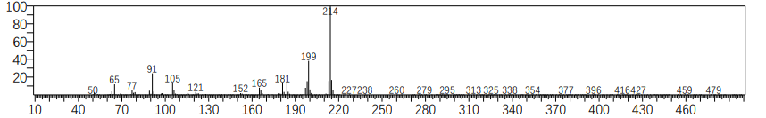**Spectra**

Figure S1. MS spectrum of Compound **3a**

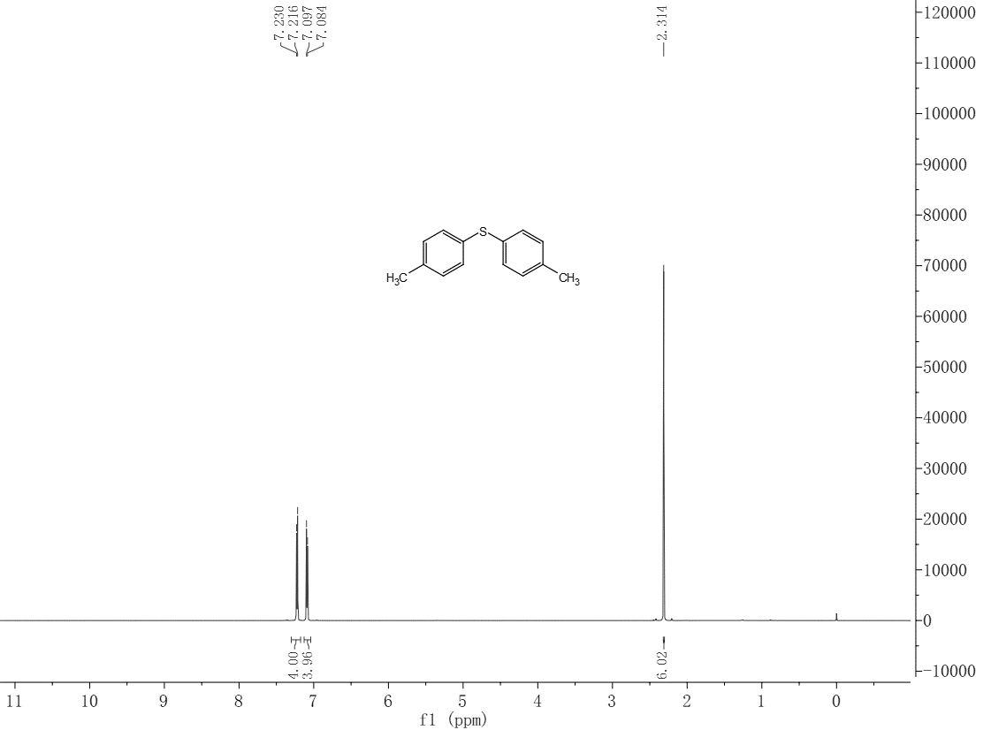

Figure S2. 1H NMR spectrum of compound **3a**

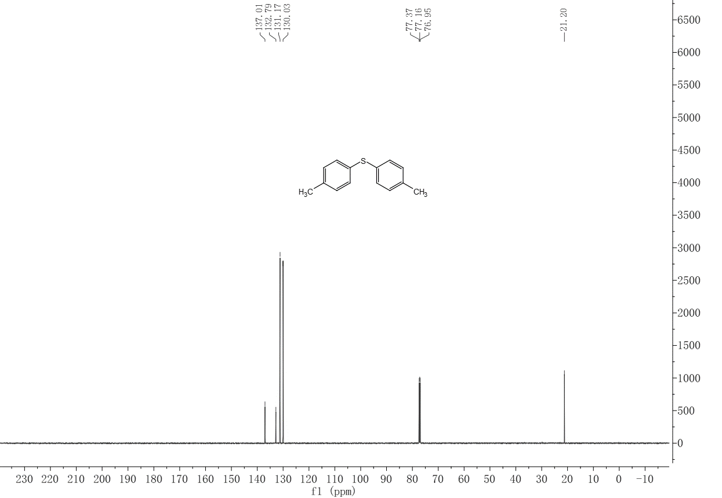

Figure S3. 13C NMR spectrum of compound **3a**

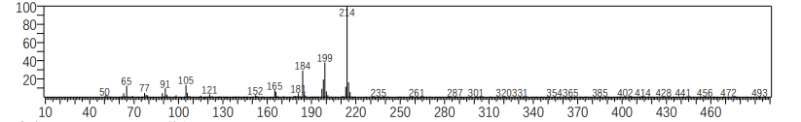

Figure S4. MS spectrum of Compound **3b**

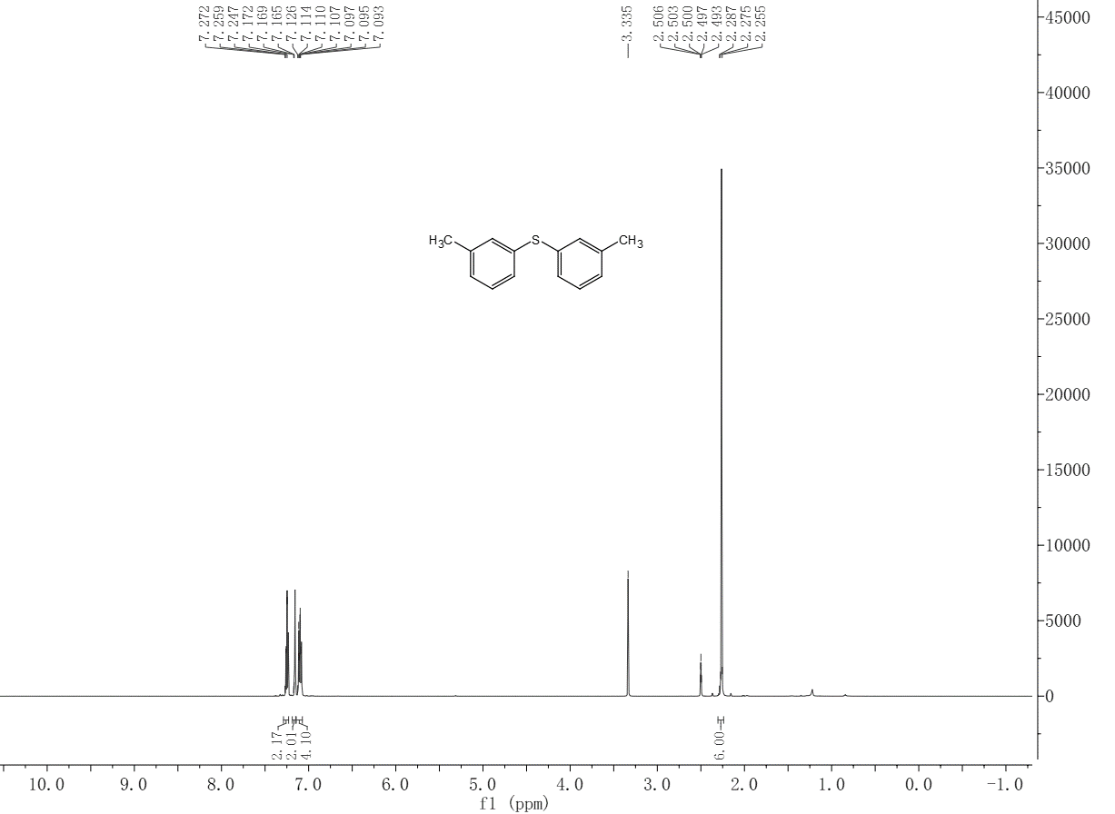

Figure S5. 1H NMR spectrum of compound **3b**

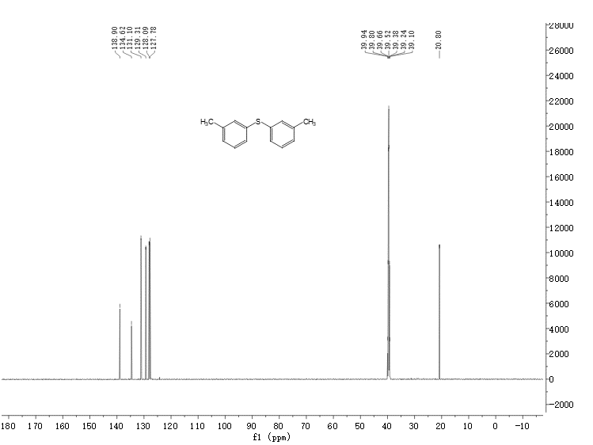

Figure S6. 13C NMR spectrum of compound **3b**

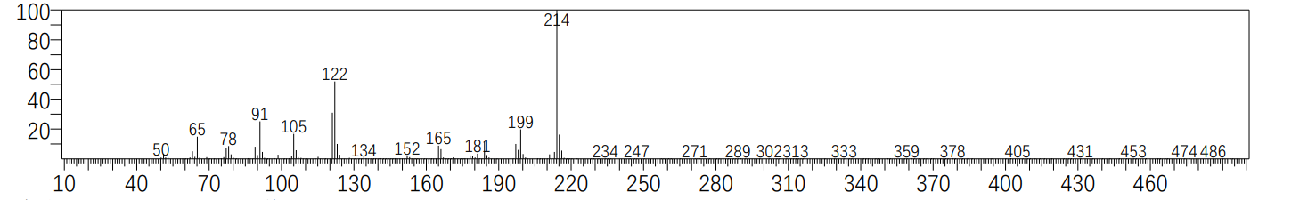

Figure S7. MS spectrum of Compound **3c**

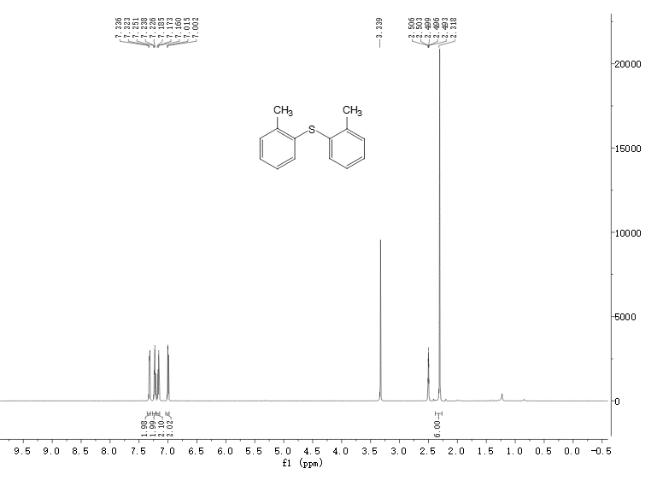

Figure S8. 1H NMR spectrum of compound **3c**

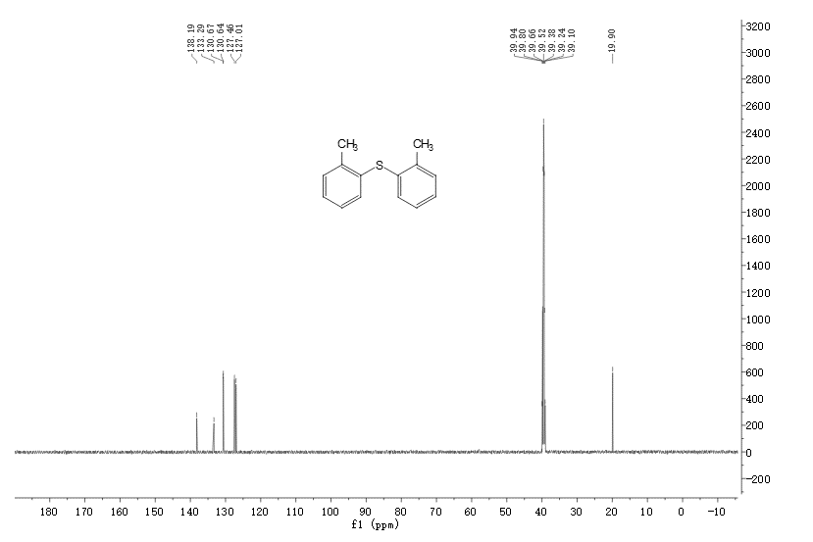

Figure S9. 13C NMR spectrum of compound **3c**

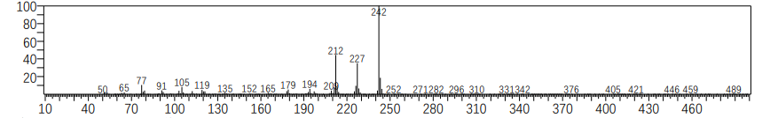

Figure S10. **MS spectrum of Compound 3d**

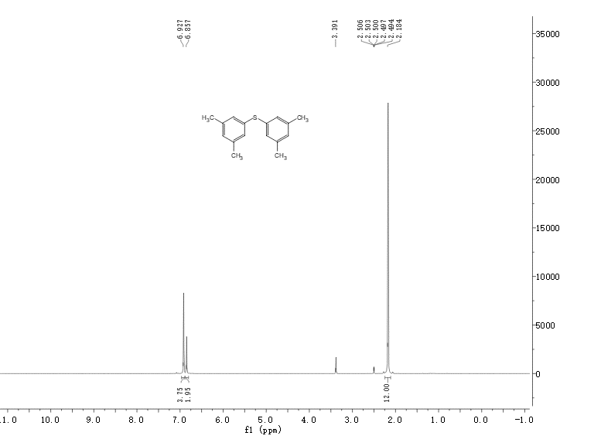Figure S11. 1H NMR spectrum of compound **3d**

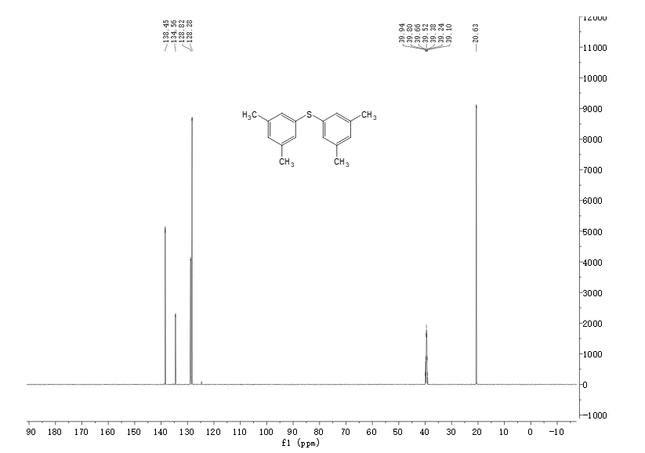

Figure S12. 13C NMR spectrum of compound **3d**

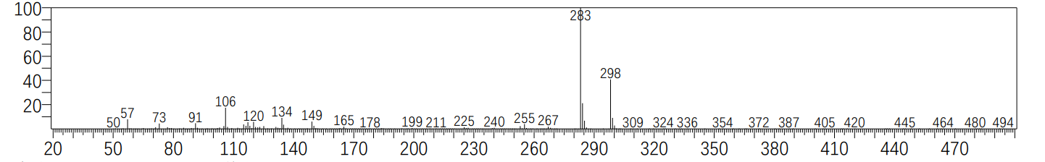

Figure S13. MS spectrum of Compound **3e**

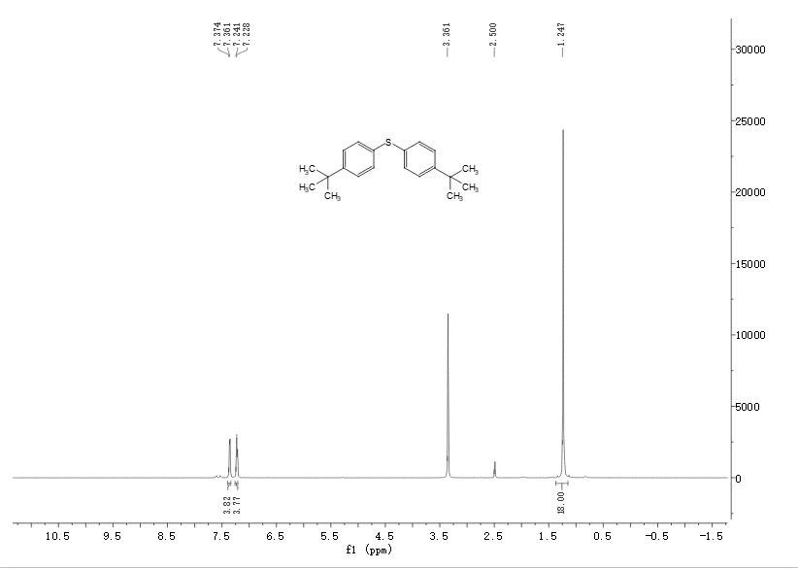

Figure S14. 1H NMR spectrum of compound **3e**

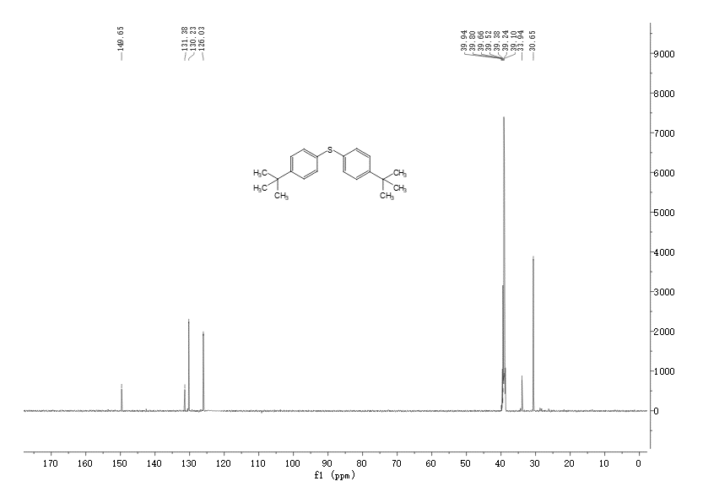

Figure S15. 13C NMR spectrum of compound **3e**

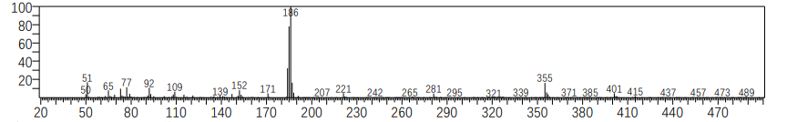

Figure S16. MS spectrum of Compound **3f**

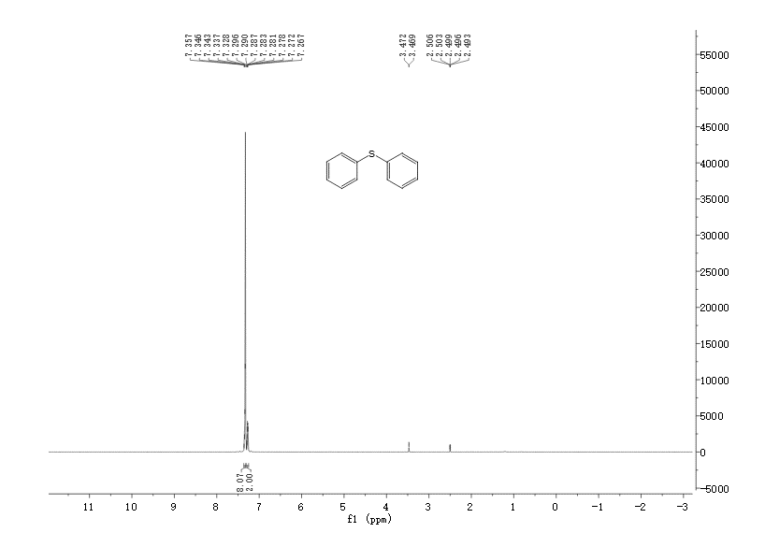

Figure S17. 1H NMR spectrum of compound **3f**

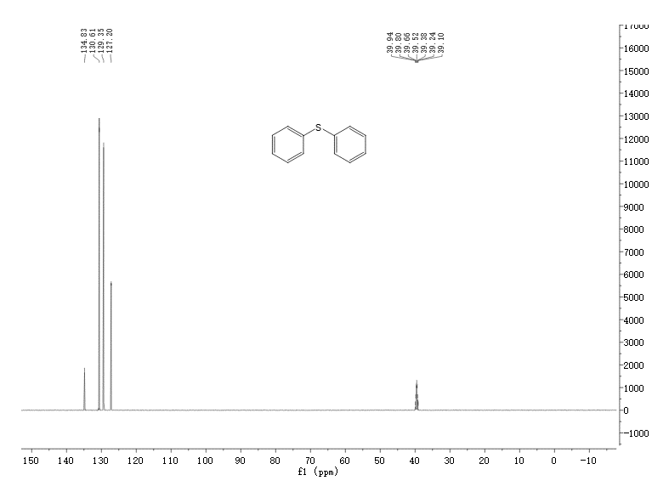

Figure S18. 13C NMR spectrum of compound **3f**

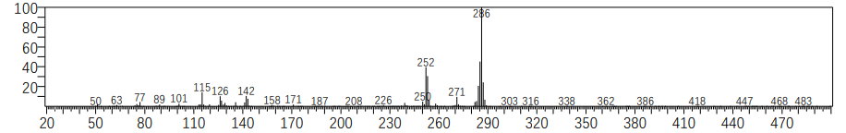

Figure S19. MS spectrum of Compound **3g**

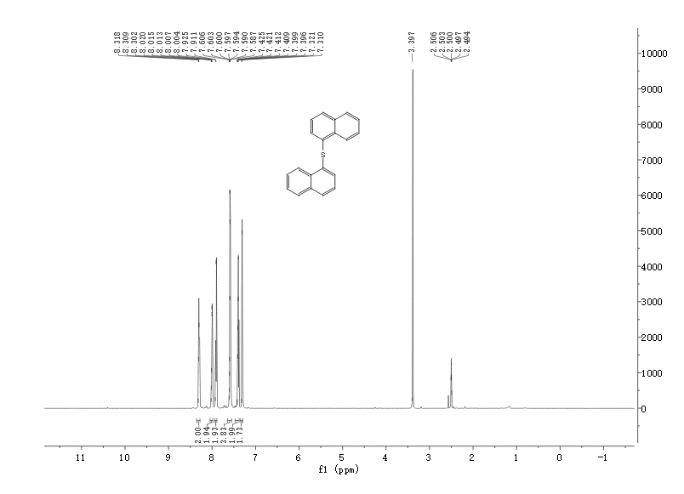

Figure S20. 1H NMR spectrum of compound **3g**

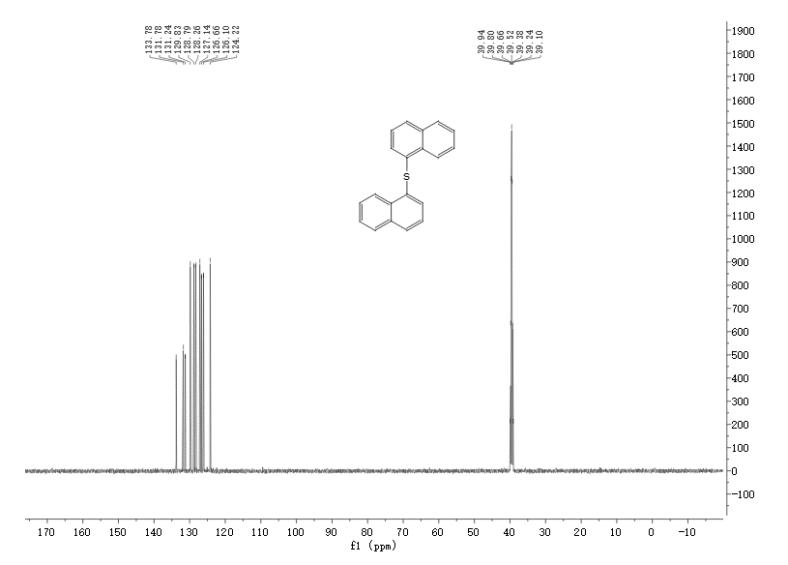

Figure S21. 13C NMR spectrum of compound **3g**

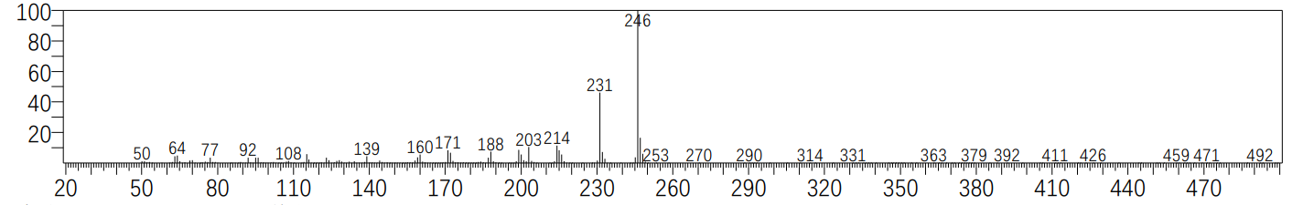

Figure S22. MS spectrum of Compound **3h**

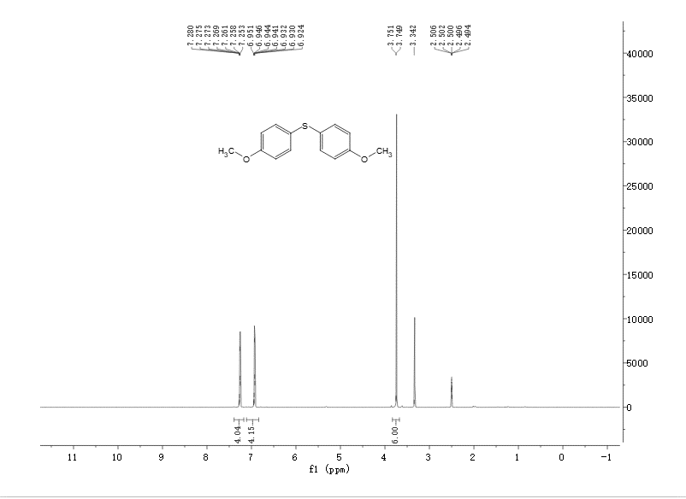

Figure S23. 1H NMR spectrum of compound **3h**

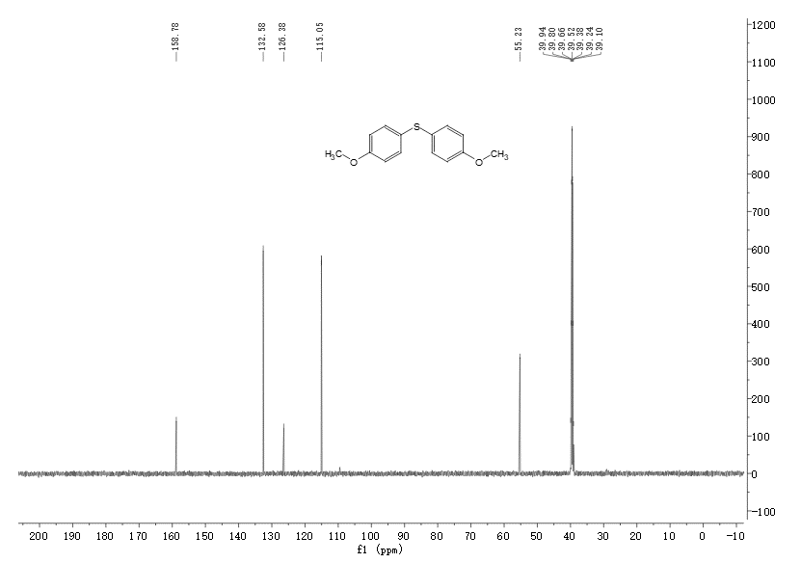

Figure S24. 13C NMR spectrum of compound **3h**

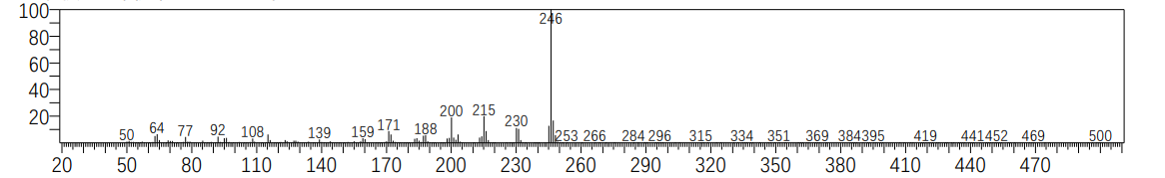

Figure S25. MS spectrum of Compound **3i**

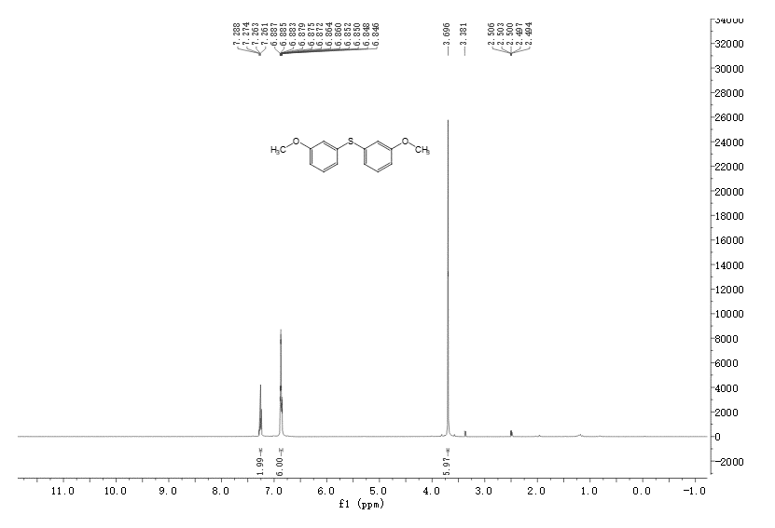

Figure S26. 1H NMR spectrum of compound **3i**

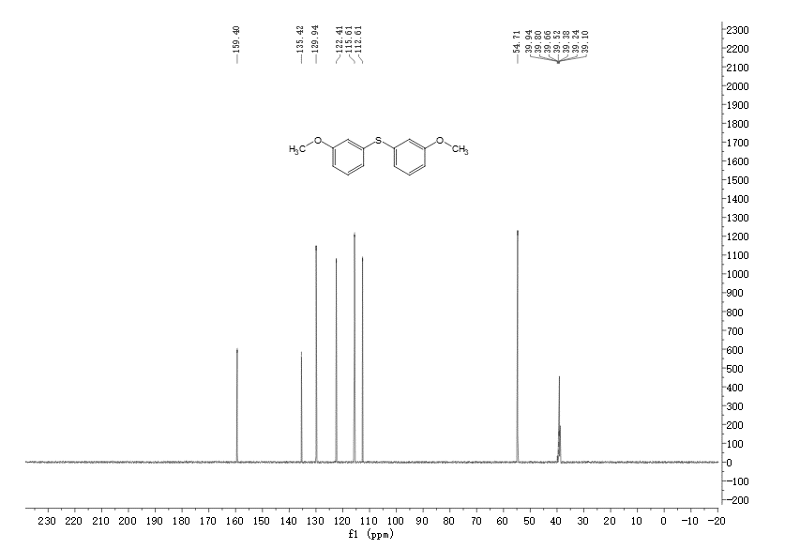

Figure S27. 13C NMR spectrum of compound **3i**

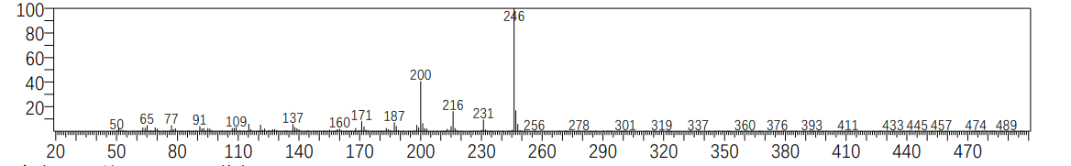

Figure S28. MS spectrum of Compound **3j**

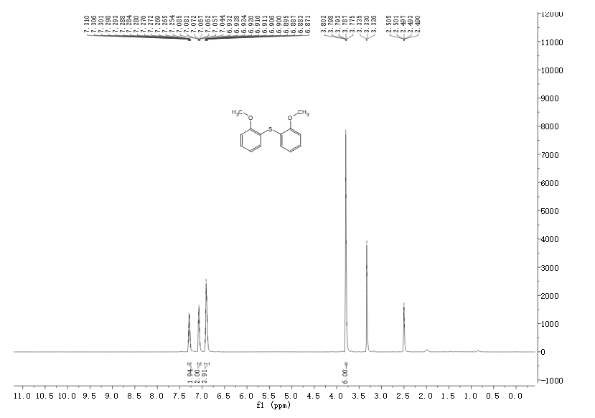

Figure S29. 1H NMR spectrum of compound **3j**

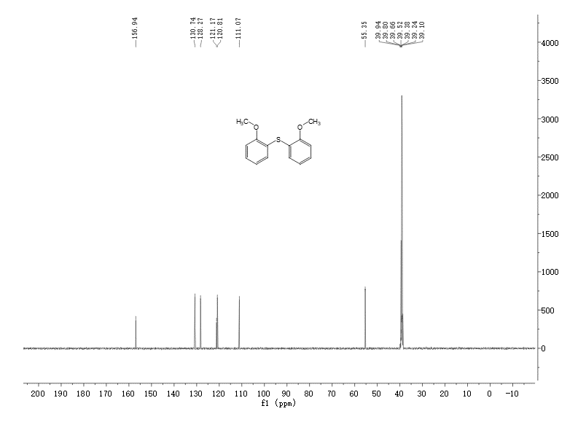

Figure S30. 13C NMR spectrum of compound **3j**

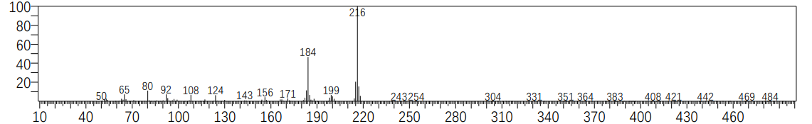

Figure S31. MS spectrum of Compound **3k**

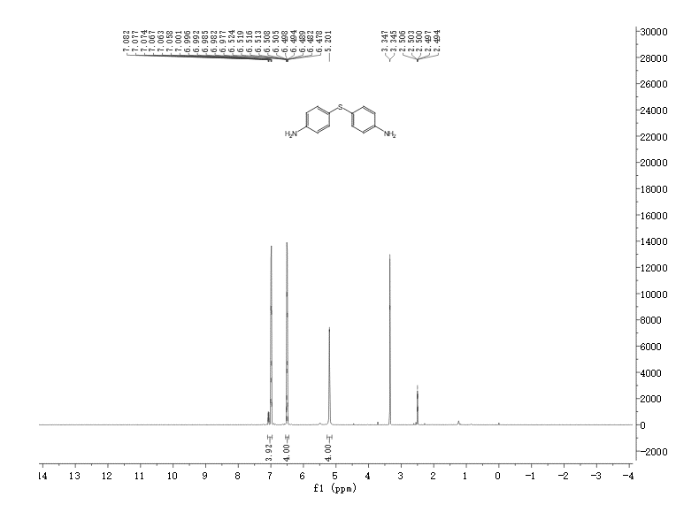

Figure S32. 1H NMR spectrum of compound **3k**

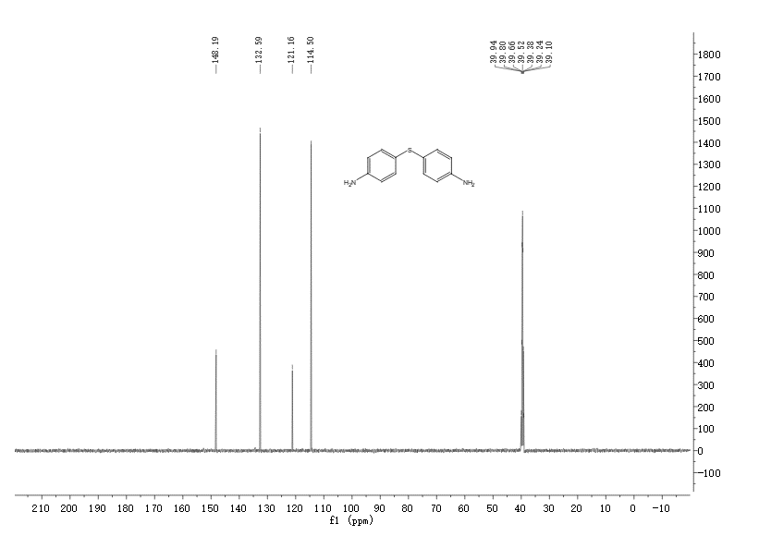

Figure S33. 13C NMR spectrum of compound **3k**

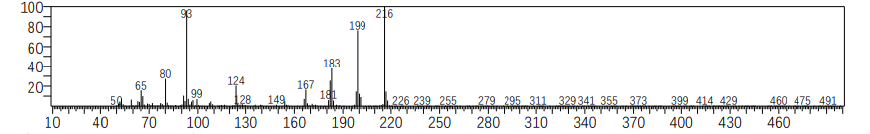

Figure S34. MS spectrum of Compound **3l**

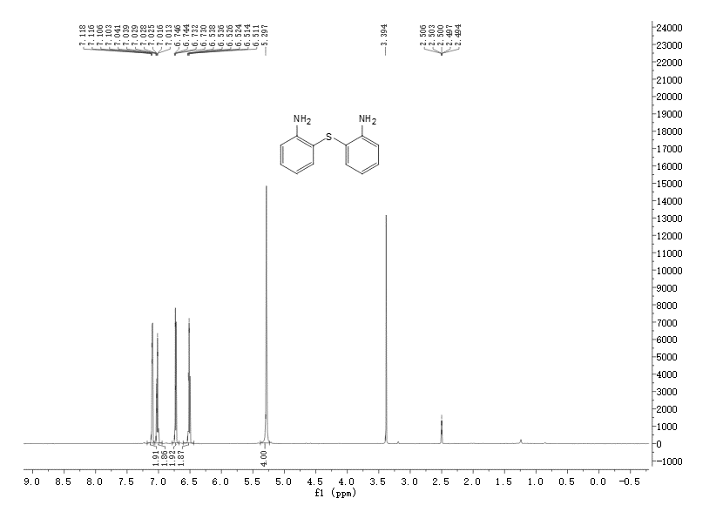

Figure S35. 1H NMR spectrum of compound **3l**

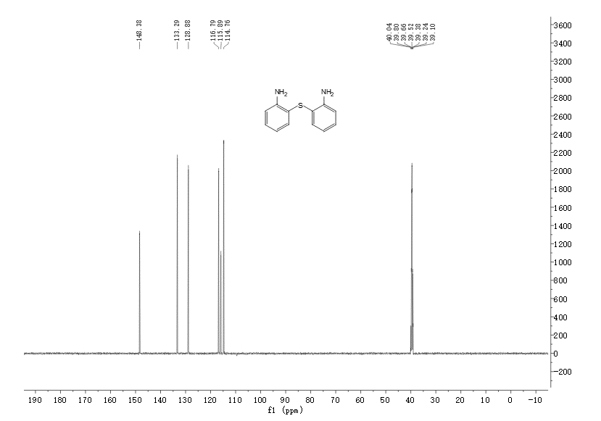

Figure S36. 13C NMR spectrum of compound **3l**

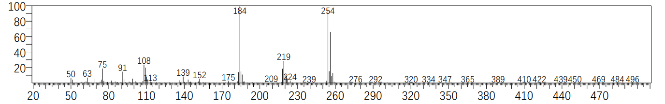

Figure S37. MS spectrum of Compound **3m**

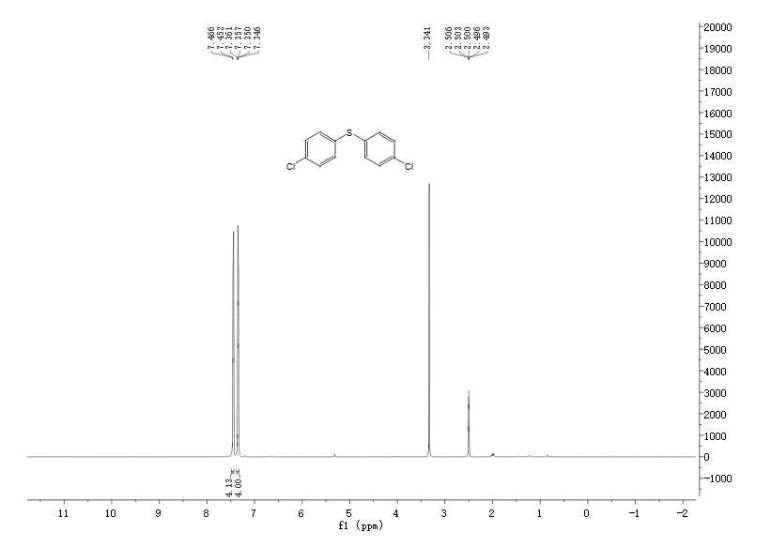

Figure S38. 1H NMR spectrum of compound **3m**

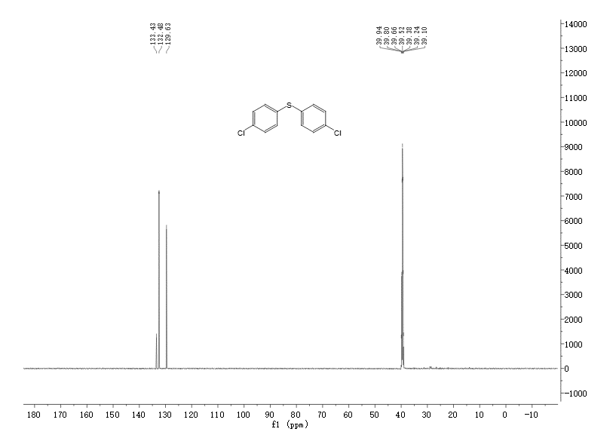

Figure S39. 13C NMR spectrum of compound **3m**

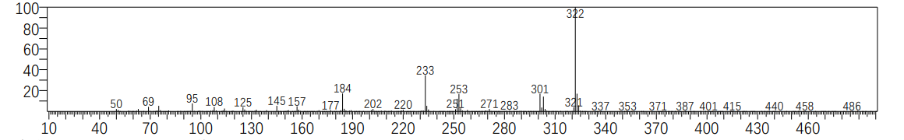

Figure S40. MS spectrum of Compound **3n**

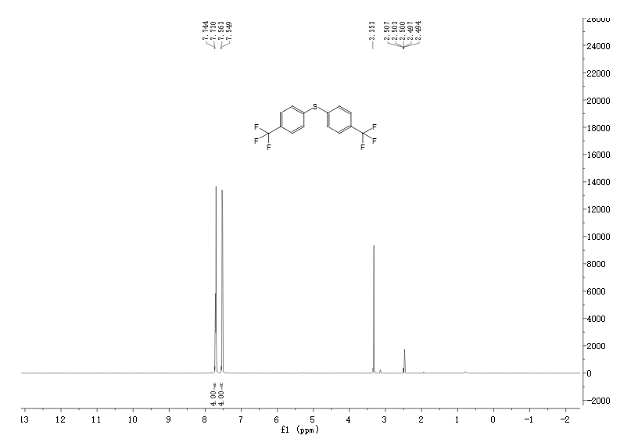

Figure S41. 1H NMR spectrum of compound **3n**

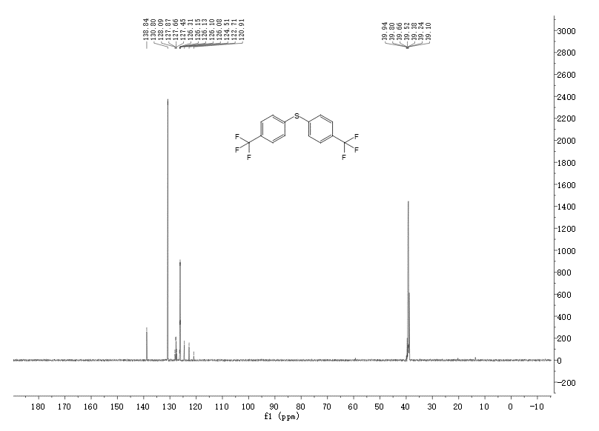

Figure S42. 13C NMR spectrum of compound **3n**

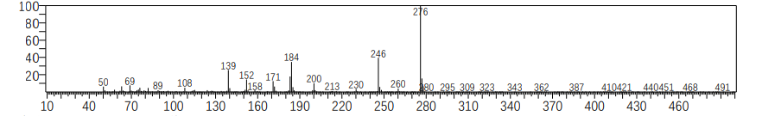

Figure S43. MS spectrum of Compound **3o**

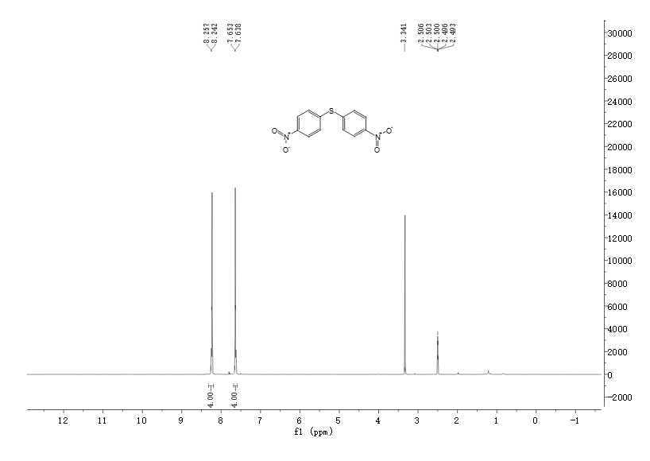

Figure S44. 1H NMR spectrum of compound **3o**

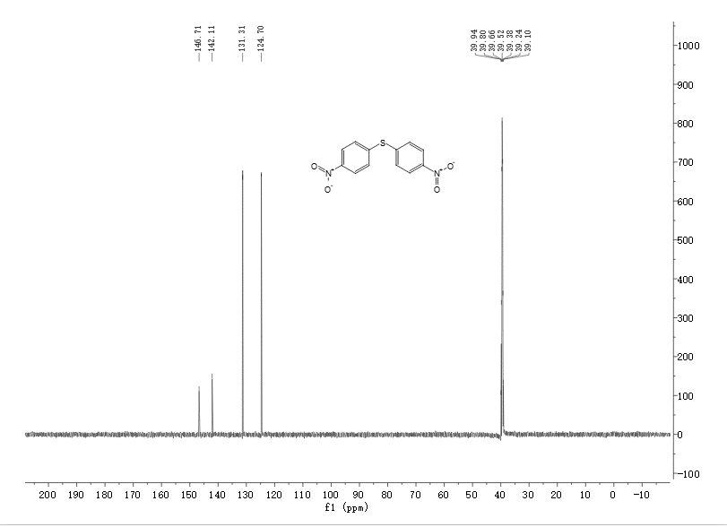

Figure S45. 13C NMR spectrum of compound **3o**

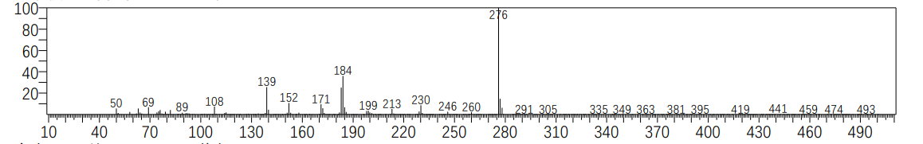

Figure S46. MS spectrum of Compound **3p**

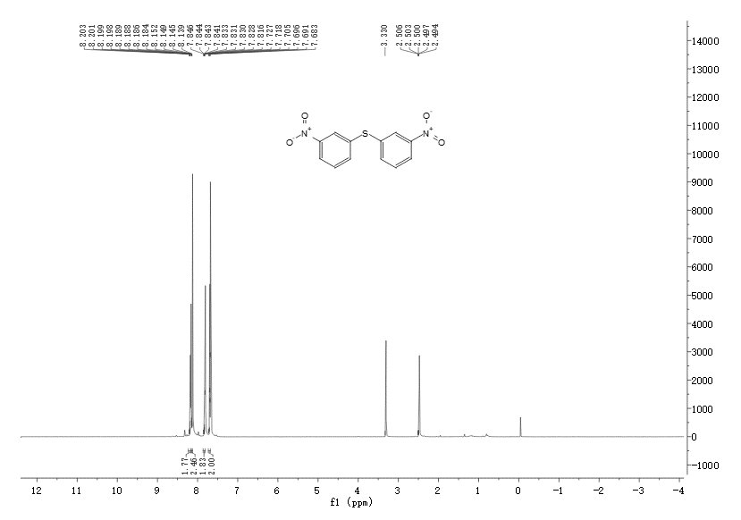

Figure S47. 1H NMR spectrum of compound **3p**

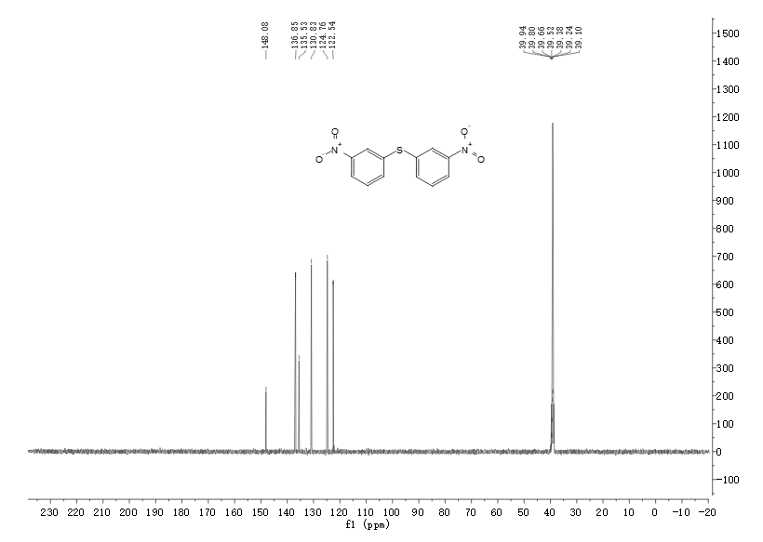

Figure S48. 13C NMR spectrum of compound **3p**

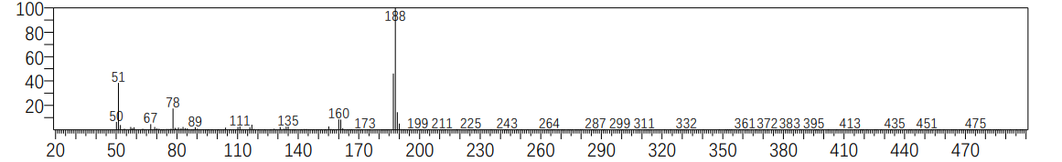

Figure S49. MS spectrum of Compound **3q**

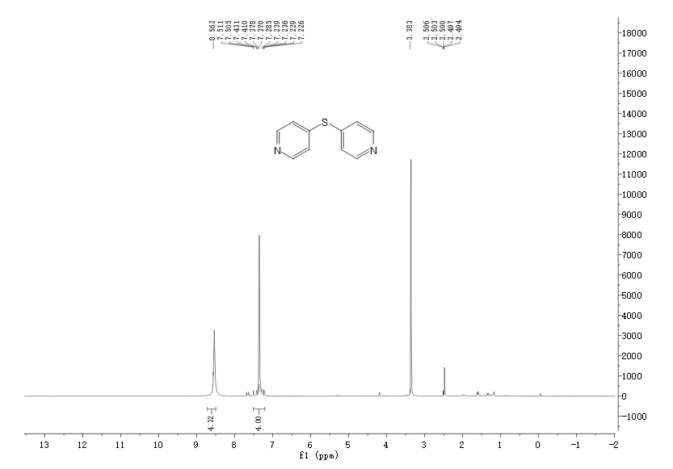

Figure S50. 1H NMR spectrum of compound **3q**

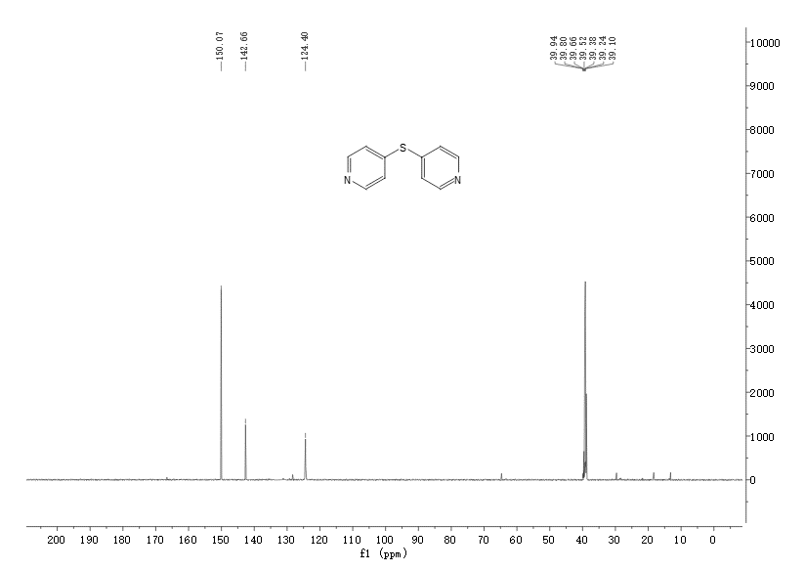

Figure S51. 13C NMR spectrum of compound **3q**

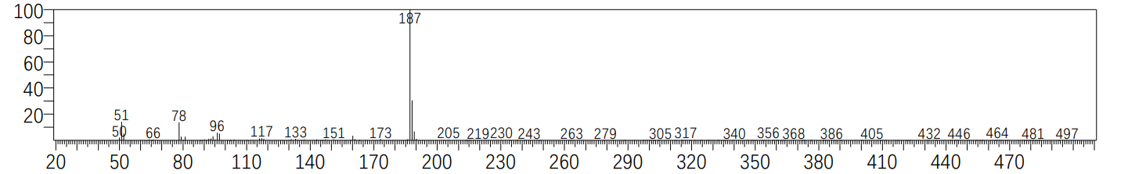

Figure S52. MS spectrum of Compound **3r**

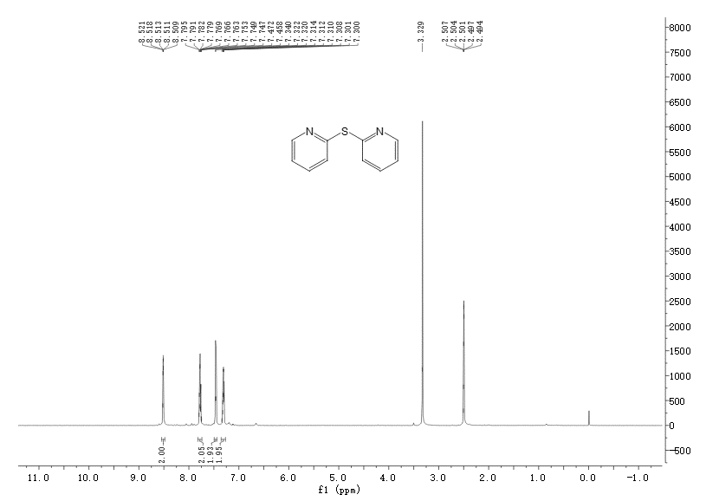

Figure S53. 1H NMR spectrum of compound **3r**

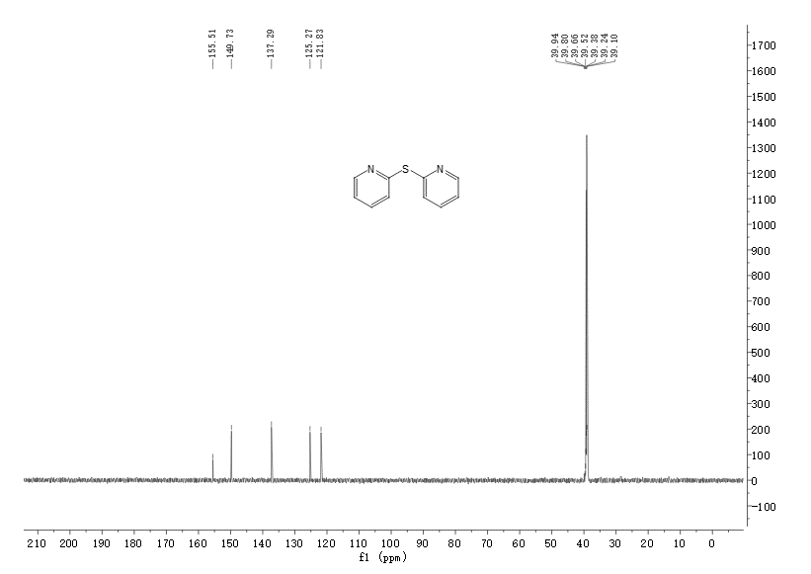

Figure S54. 13C NMR spectrum of compound **3r**

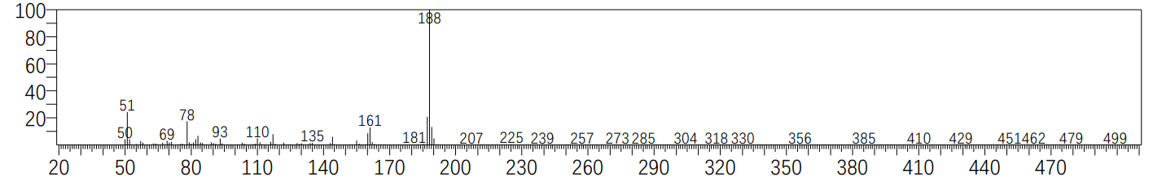

Figure 55. MS spectrum of Compound **3s**

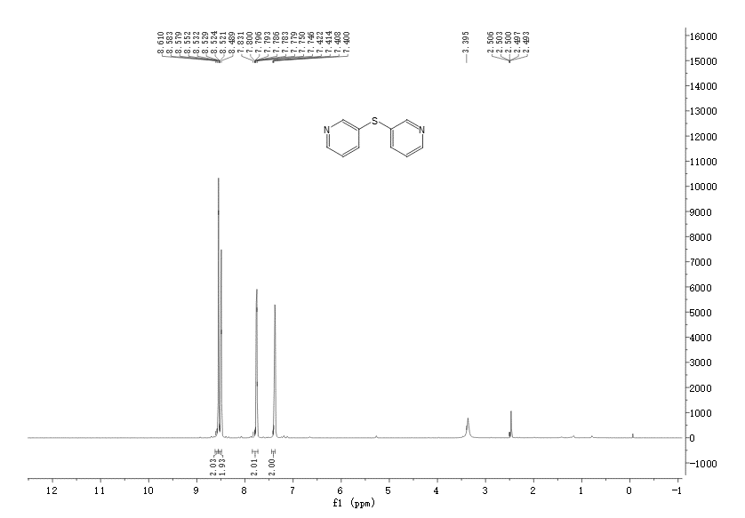

Figure S56. 1H NMR spectrum of compound **3s**

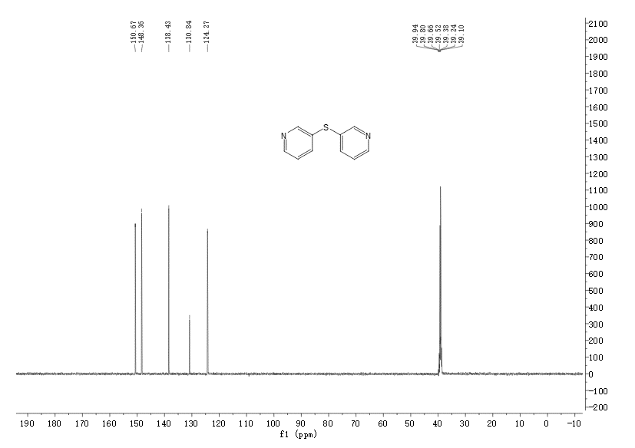

Figure S57. 13C NMR spectrum of compound **3s**

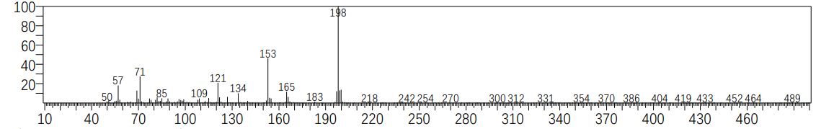

Figure S58. MS spectrum of Compound **3t**

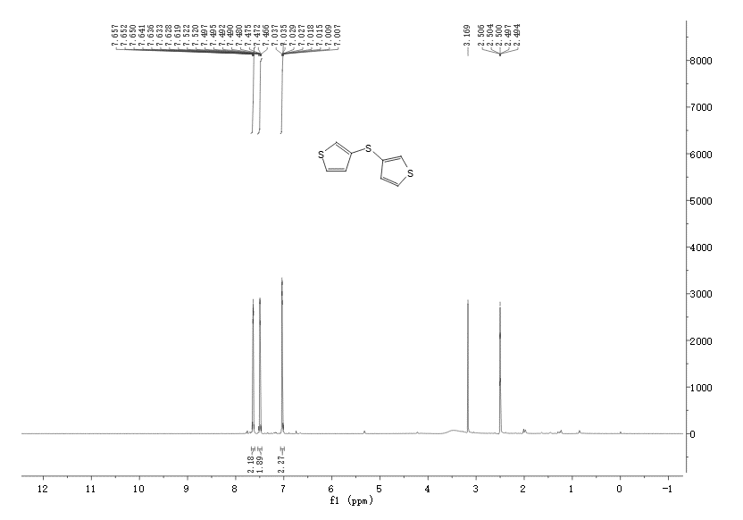

Figure S59. 1H NMR spectrum of compound **3t**

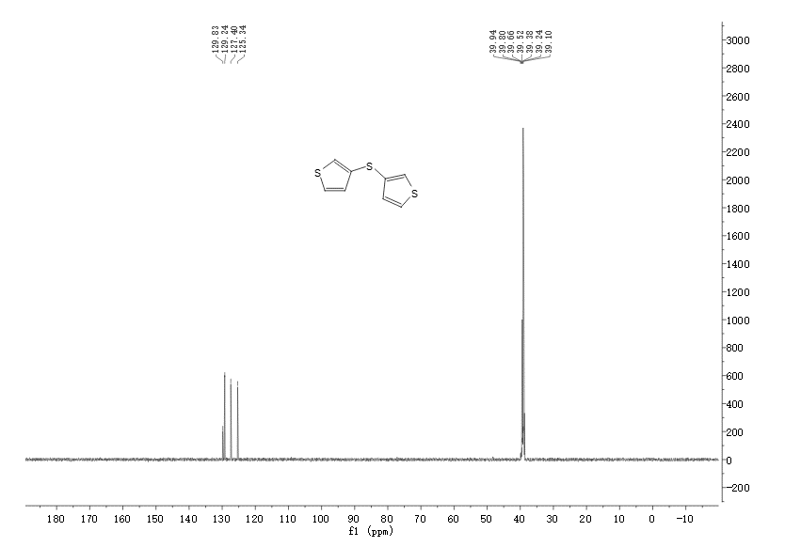

Figure S60. 13C NMR spectrum of compound **3t**

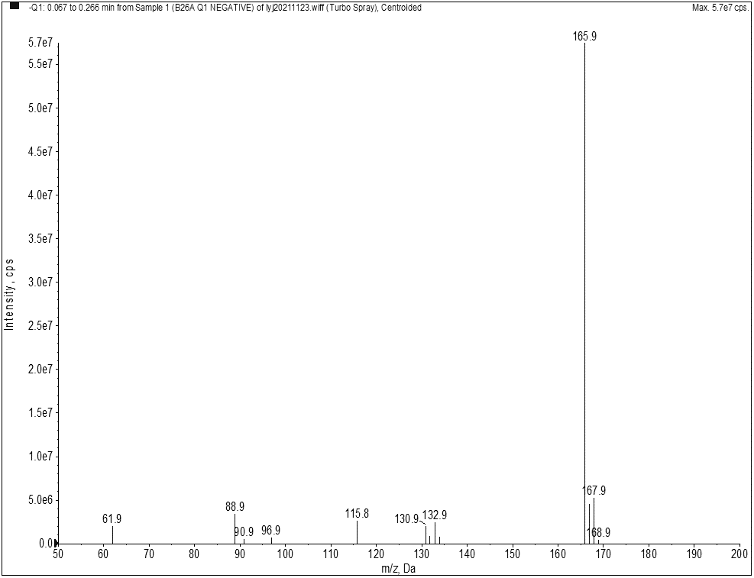

Figure. S61 MS spectrum of Compound **12a**

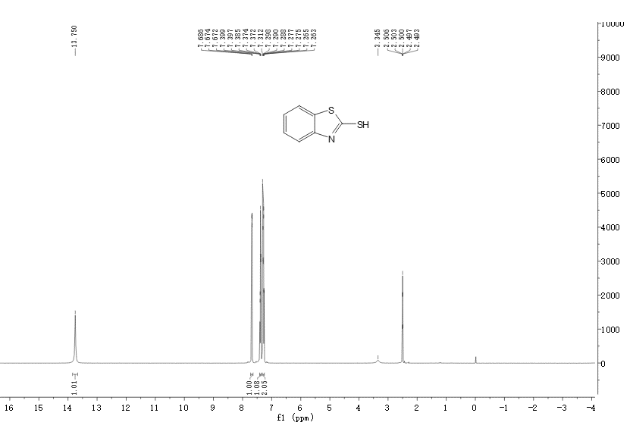

Figure S62. 1H NMR spectrum of compound **12a**

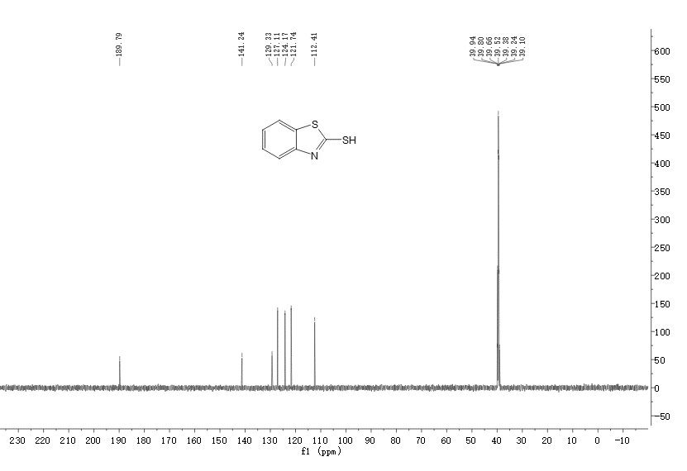

Figure S63. 13C NMR spectrum of compound **12a**

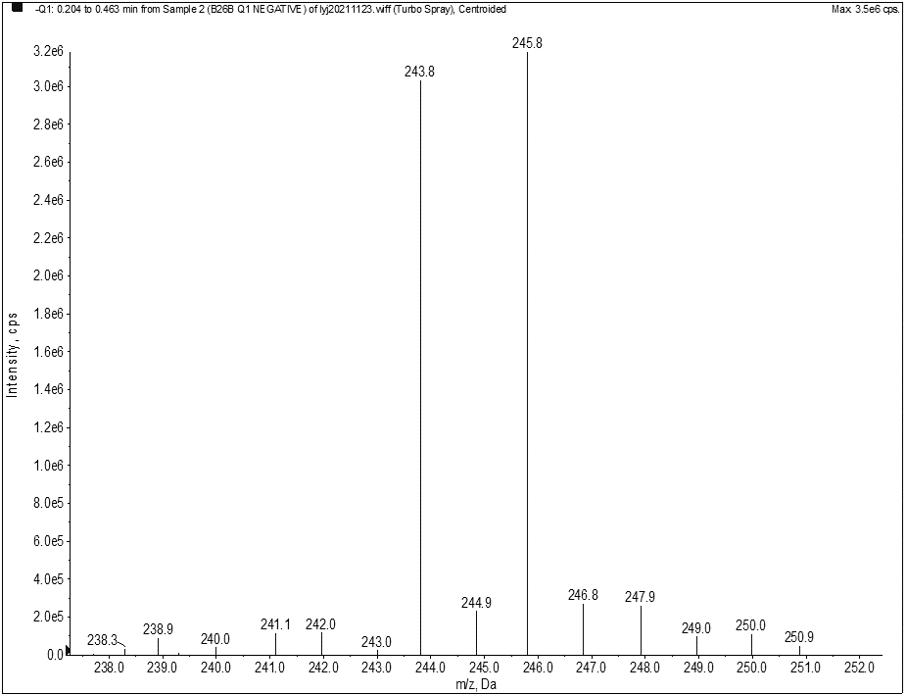

Figure S64. MS spectrum of Compound **12b**

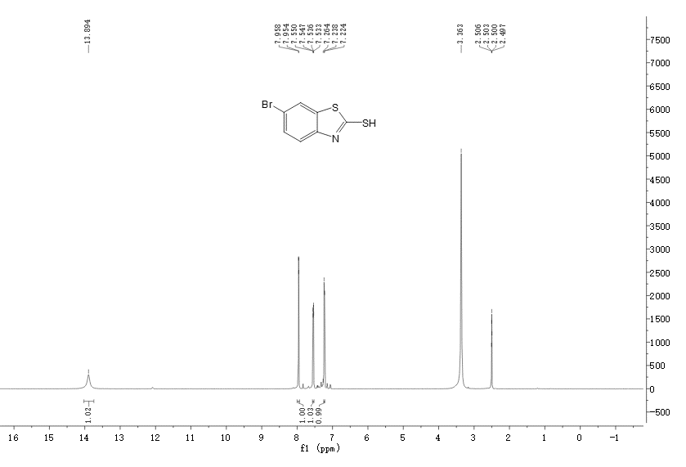

Figure S65. 1H NMR spectrum of compound **12b**

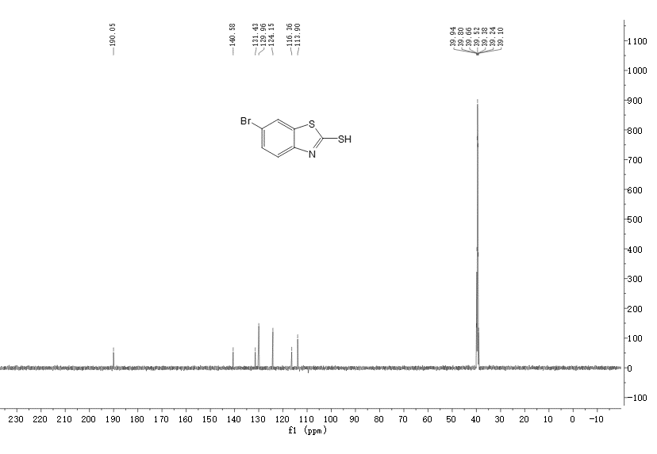

Figure S66. 13C NMR spectrum of compound **12b**

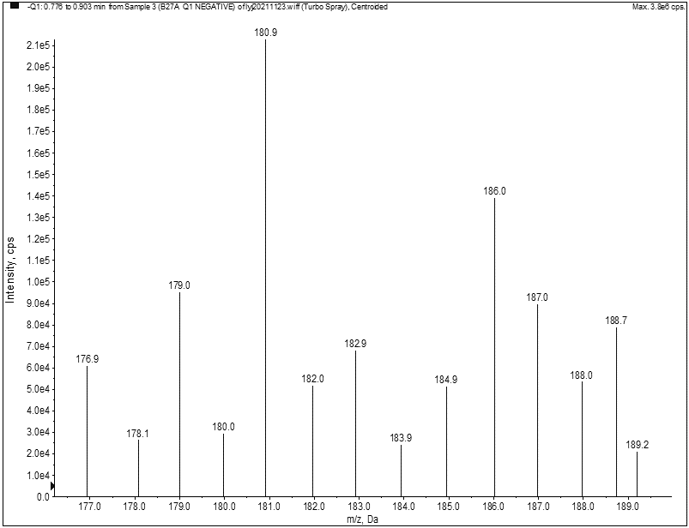

Figure S67. MS spectrum of Compound **12c**

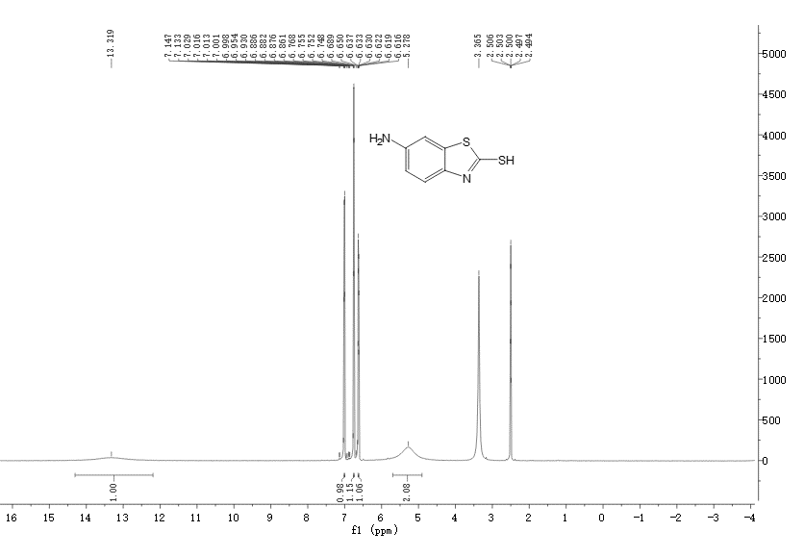

Figure S68. 1H NMR spectrum of compound **12c**

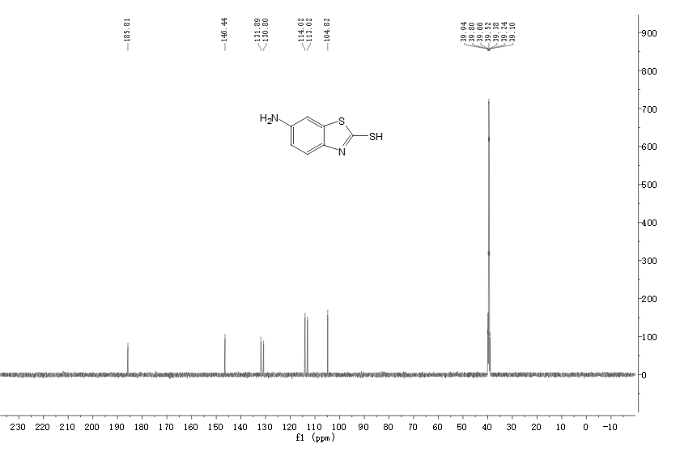

Figure S69. 13C NMR spectrum of compound **12c**

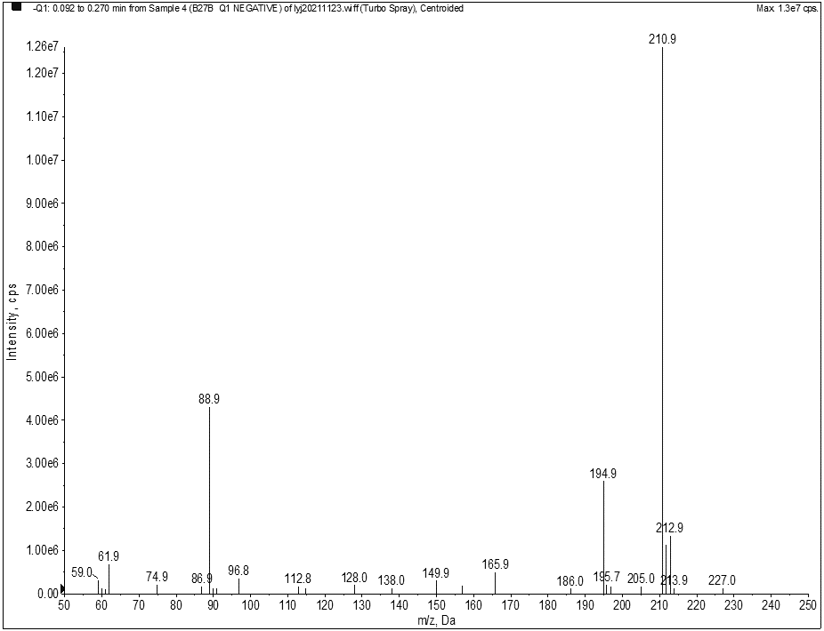

Figure S70. MS spectrum of Compound **12d**

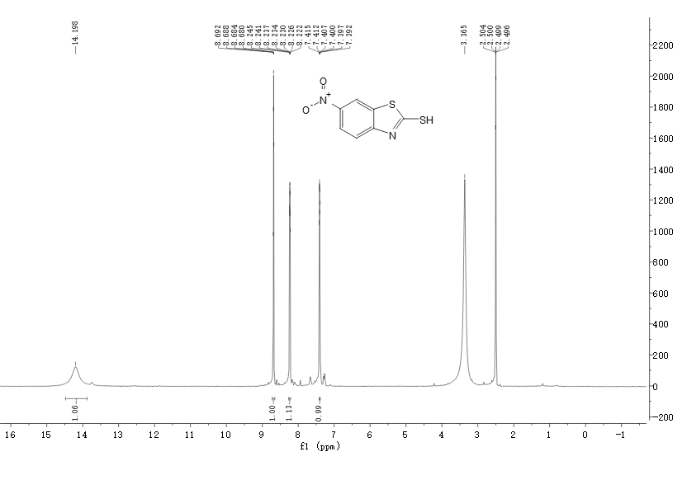

Figure S71. 1H NMR spectrum of compound **12d**

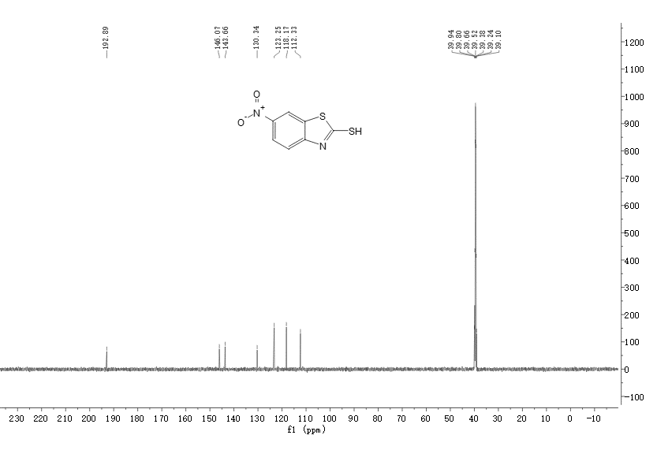

Figure S72. 13C NMR spectrum of compound **12d**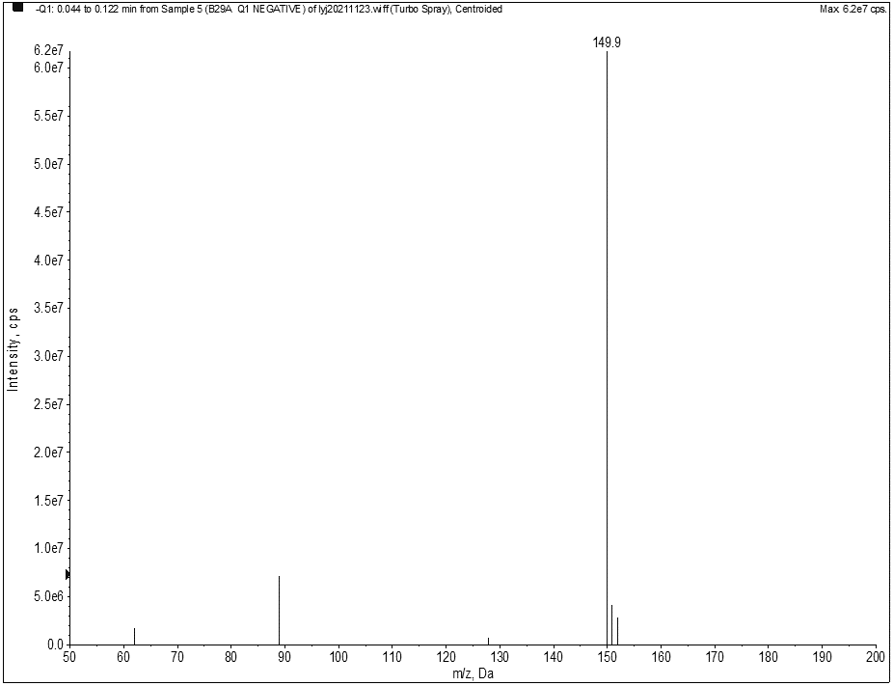

Figure S73. MS spectrum of Compound **12e**

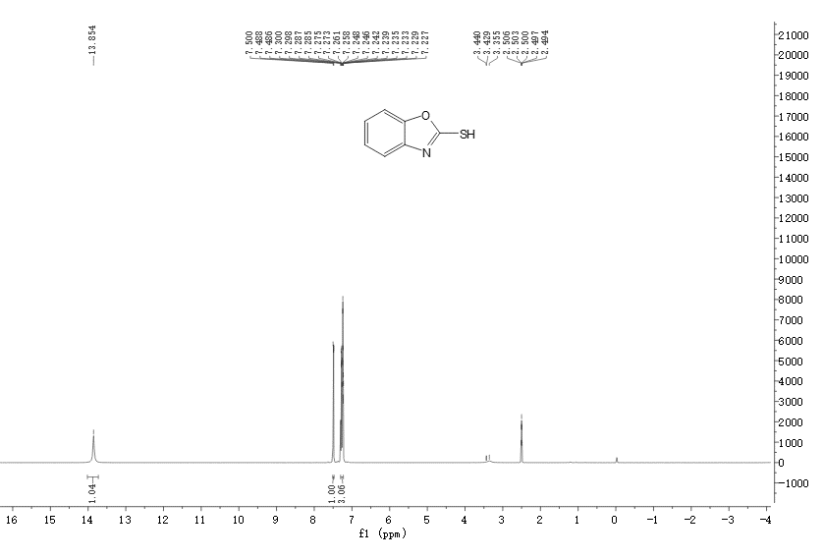

Figure S74. 1H NMR spectrum of compound **12e**

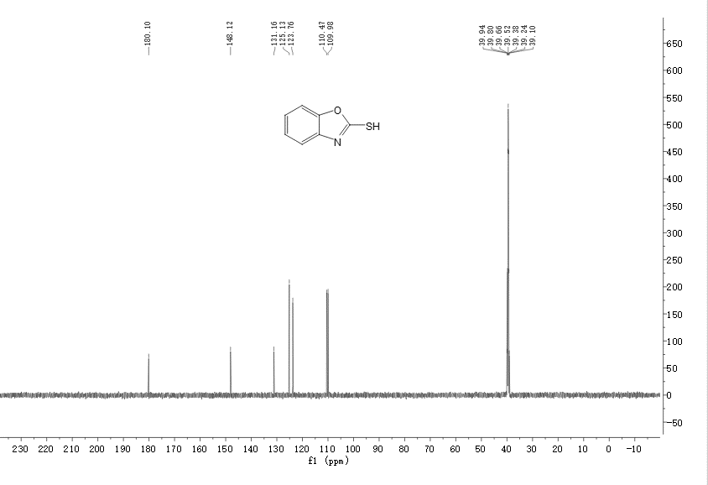

Figure S75. 13C NMR spectrum of compound **12e**

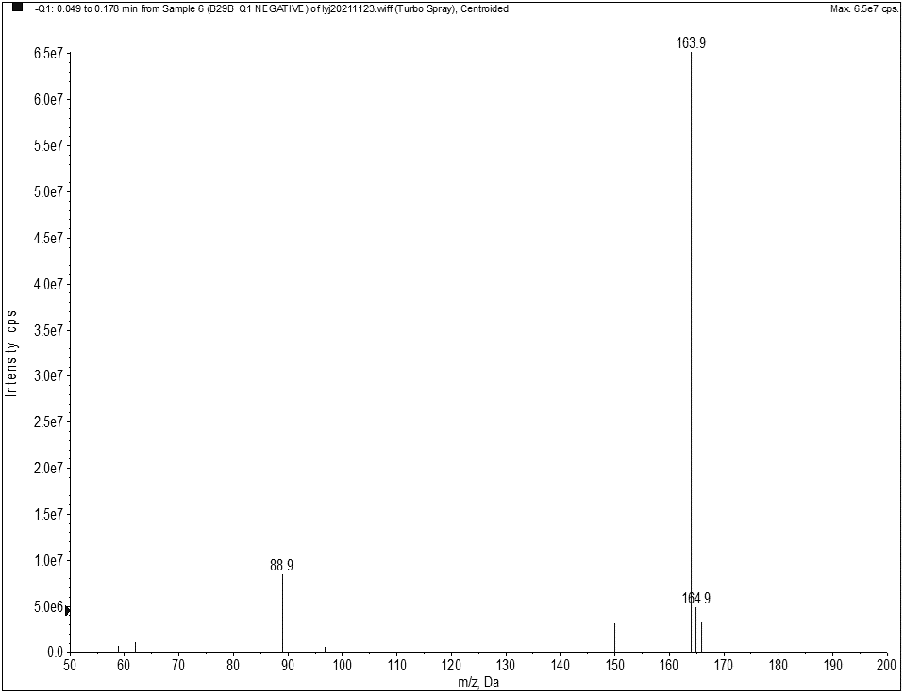

Figure S76. MS spectrum of Compound **12f**

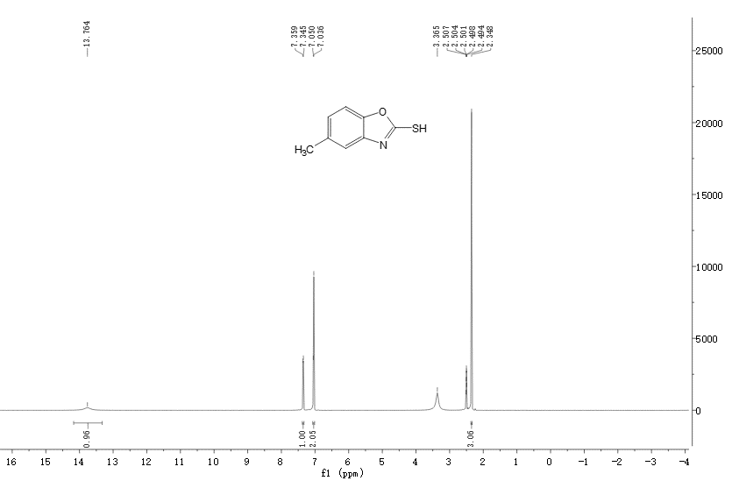

Figure S77. 1H NMR spectrum of compound **12f**

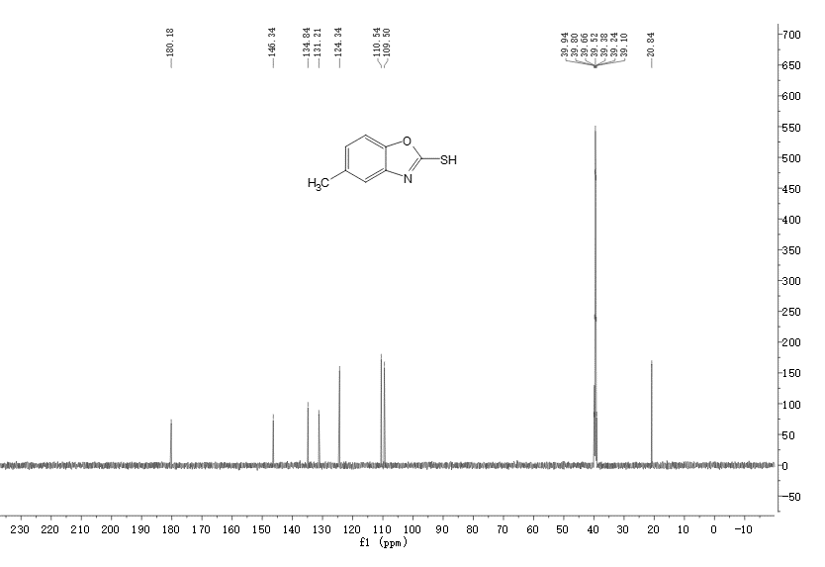

Figure S78. 13C NMR spectrum of compound **12f**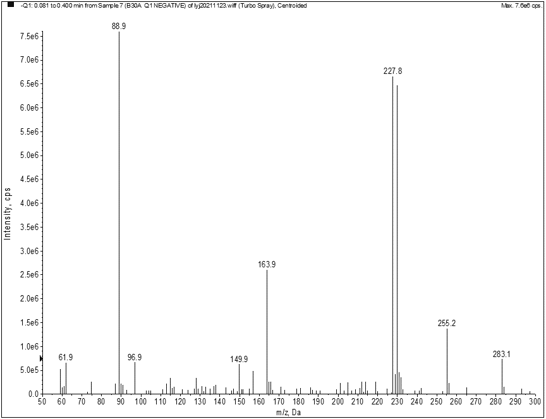

Figure S79. MS spectrum of Compound **12g**

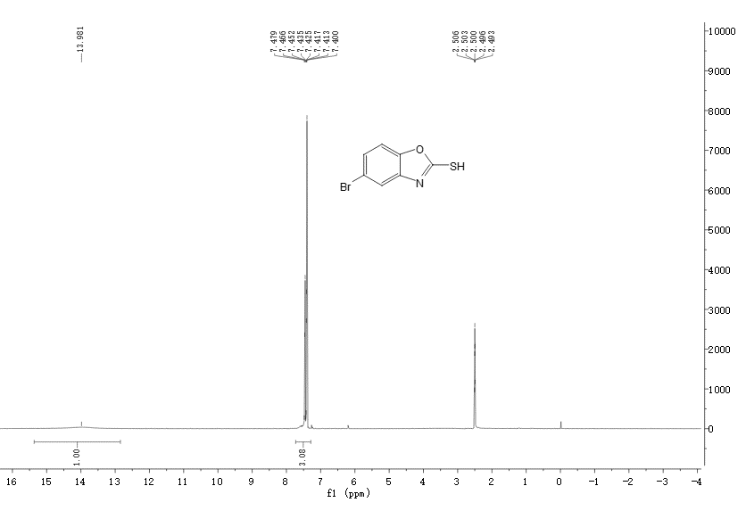

Figure S80. 1H NMR spectrum of compound **12g**

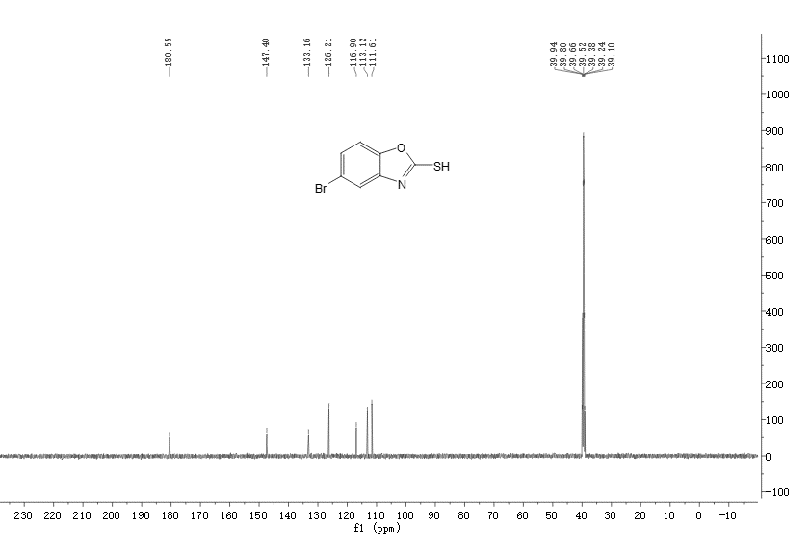

Figure S81. 13C NMR spectrum of compound **12g**

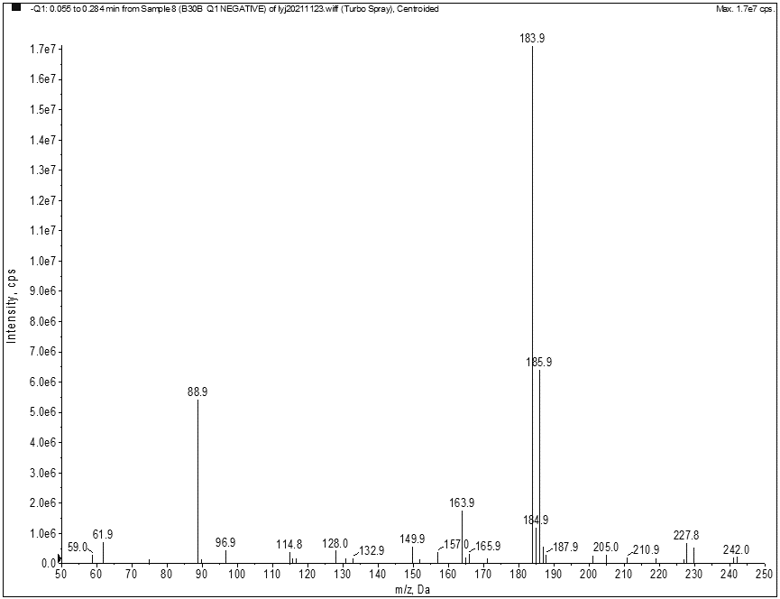

Figure S82. MS spectrum of Compound **12h**

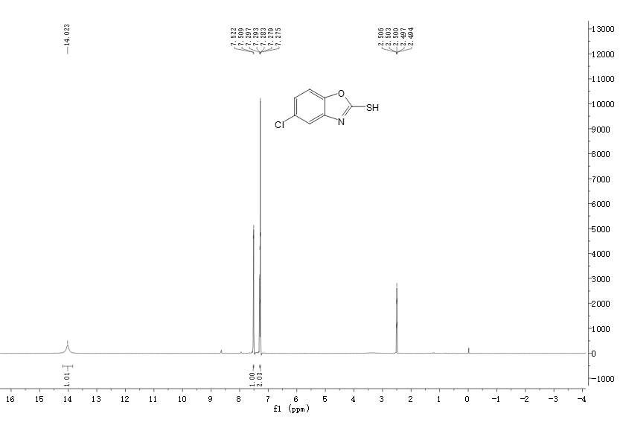

Figure S83. 1H NMR spectrum of compound **12h**

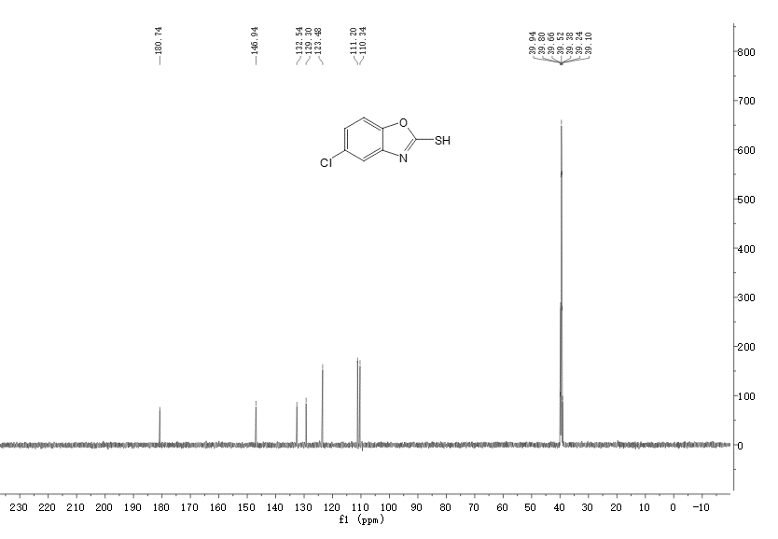

Figure S84. 13C NMR spectrum of compound **12h**

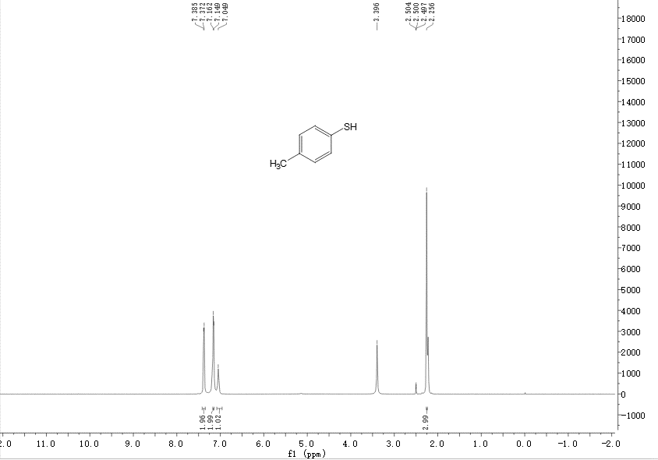

Figure S85. 1H NMR spectrum of compound **4-methylbenzenethiol**

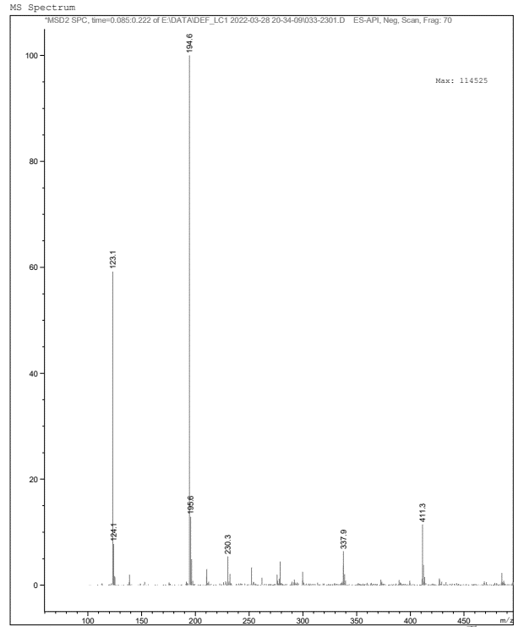

Figure S86. MS spectrum of Compound **5**

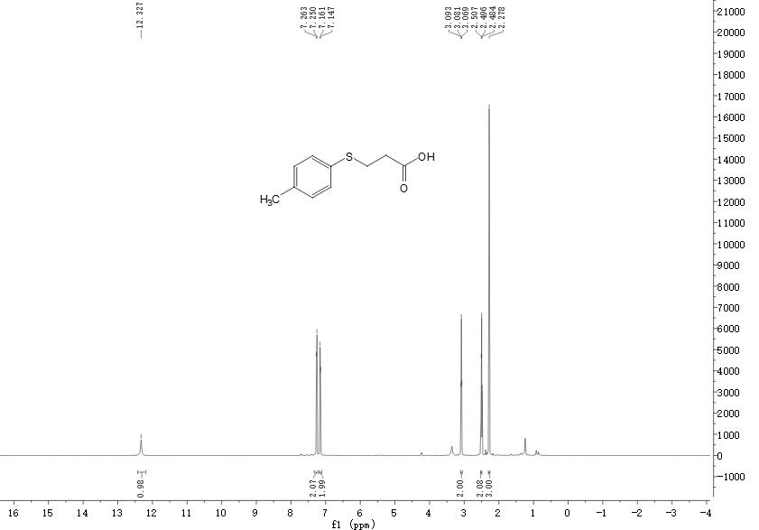

Figure S87. 1H NMR spectrum of compound **5**

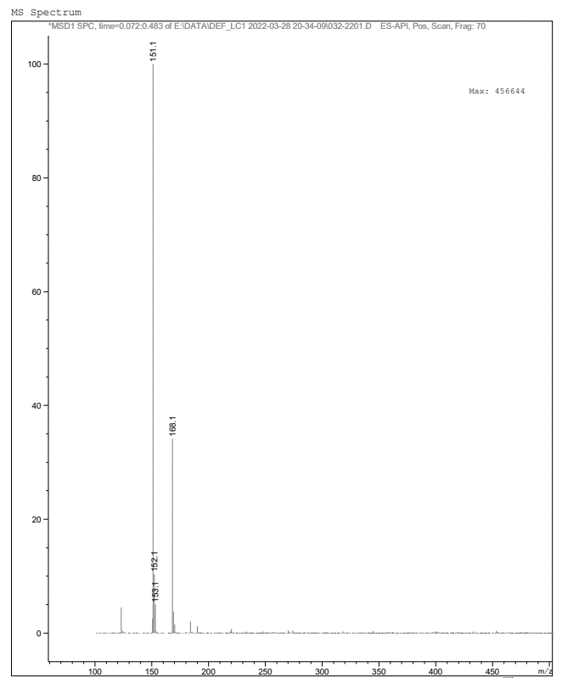

Figure S88. MS spectrum of Compound **7**

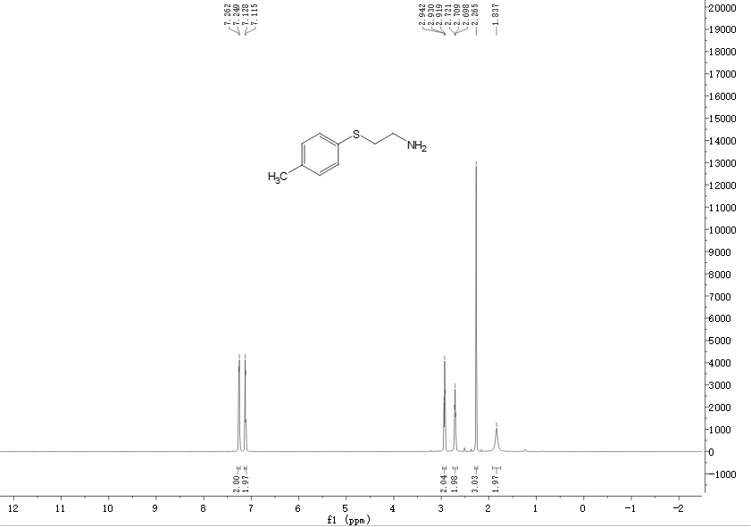

Figure S89. 1H NMR spectrum of compound **7**