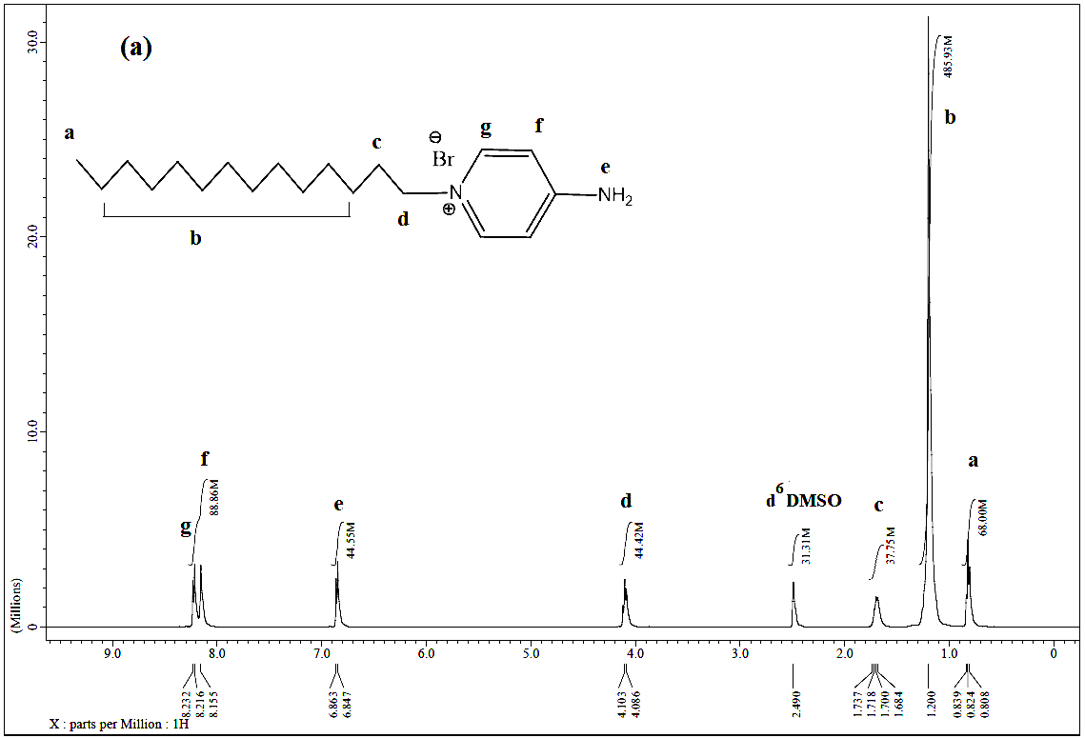

**1HNMR spectrum of the synthesized 4-amino-N-tetradecyl pyridinium bromide (C14)**

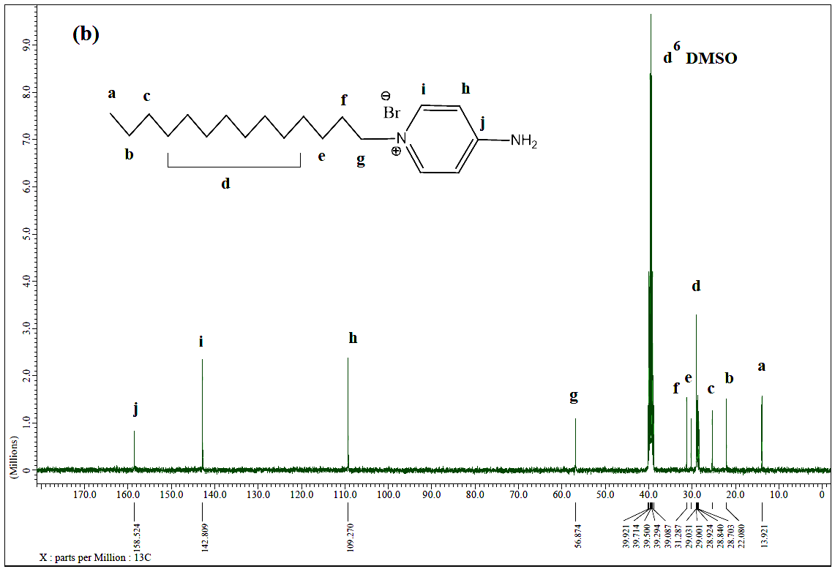

**13CNMR spectrum of the synthesized 4-amino-N-tetradecyl pyridinium bromide (C14)**