**Design, Synthesis and Biological evaluation of novel Quinazoline Derivatives as potential NF-κb inhibitors**

Jing Pana, Long Maa, Yu-Xia Tanga, Ying Tiana, Yi-Hang Lina, Long-Jiang Zhanga,*, Feng Gaob,* and Guang-Ming Lua,*

a Department of Medical Imaging, Jinling Hospital, School of Medicine, Nanjing University, Nanjing, China

b Haina Precision Machining Research Center, Yangtze Delta Region Research Institute of Tsinghua University, Zhejiang，China

*Corresponding authors: rggaofeng@hotmail.com (F. Gao);

kevinzhlj@163.com (L. Zhang);

cjr.luguangming@vip.163.com (G. Lu)

**1. General**

All reactions were carried out in dried glassware. All NMR spectra were performed in CDCl3 and DMSO using Bruker 300MHz spectrometers. Mass spectra were taken in ESI mode on Shimadzu LC-MS-2020. All solvents, reagents and raw materials are commercially available and were used without further purification. All the chemicals such as sodium salt MTT, DMSO were purchased from Sigma-Aldrich. Positive control drugs such as Afatinib and Erlotinib were purchased from MedChemExpress Inc (MCE, USA).

**2. Synthesis Procedures**

Into an inert atmosphere of nitrogen, was added 7-methoxy-4-oxo-3,4-dihydroquinazolin-6-yl acetate (426.97 mmol) and sulfurooyl dichloride (1000 mL). This was followed by the addition of N, N-dimethylformamide (10 mL) dropwise with stirring, while reflux for 3 hrs. Then the reaction mixture was cooled to room temperature. The resulting mixture was concentrated under vacuum. The residue was dissolved in DCM. The mixture was poured into water/ice. The resulting solution was extracted with dichloromethane and the organic layers combined. The resulting mixture was washed with brine, dried over anhydrous sodium sulfate and concentrated under vacuum. The residue was washed with ether. The solids were collected by filtration to afford (65 g, 60%) compound **1** as a light-yellow solid.

To a solution of 4-chloro-7-methoxyquinazolin-6-yl acetate (**1**)(39.58 mmol) was followed by the addition of NH3 (7M in methanol) (100 mL) dropwise with stirring and for 30 min below10℃. The solids were collected by filtration and washed with Et2O to afford (6.5 g, 78%) of compound **2** as a light-yellow solid.

Into an inert atmosphere of nitrogen, was placed 4-chloro-7-methoxyquinazolin-6-ol (**2**) (30.86 mmol), tetrahydrofuran (120 mL), 2-(pyrrolidin-1-yl) ethan-1-ol (39.94 mmol), and PPh3 (40.18 mmol). This was followed by the addition of (E)-di-tert-butyl diazene-1,2-dicarboxylate (40.22 mmol) in several batches at 0℃. The resulting solution was stirred overnight at room temperature. The reaction was then quenched by water. The resulting solution was extracted with dichloromethane and the organic layers combined. The resulting mixture was washed with brine. The mixture was dried over anhydrous sodium sulfate and concentrated under vacuum. The residue was applied onto a silica gel column to obtain compound **3** (4 g, 42%) as a white solid.

Into an inert atmosphere of nitrogen, was placed 4-chloro-7-methoxy-6-[2-(pyrrolidin-1-yl) ethoxy] quinazoline (3) (4.74 mmol), compounds **4a-e** (4.74 mmol), 4-methylbenzene-1-sulfonic acid (6.16 mmol), propan-2-ol (50 mL). The resulting solution was stirred for 3 hrs at 90℃. The reaction mixture was cooled to room temperature with a water/ice bath. The resulting mixture was concentrated under vacuum. Dissolve the residue in DCM/CF3COOH (40/20 mL). The resulting solution was heated to reflux for 2 hrs. The reaction mixture was cooled to room temperature and concentrated under vacuum. The residue was dissolved in 100 mL of DCM. The pH value of the solution was adjusted to 9 with sodium carbonate (aq). The resulting solution was extracted with dichloromethane and the organic layers combined. The resulting mixture was washed with brine. The mixture was dried over anhydrous sodium sulfate and concentrated under vacuum. The crude product was purified by Flash-Prep-HPLC to afford target compounds **5a-e**.

Into an inert atmosphere of nitrogen, was placed a solution of 1H-pyrrole (745.28 mmol) in tetrahydrofuran (500 mL). This was followed by the addition of EtMgBr (3 M in ether) (266.8 mL) dropwise with stirring at 0℃ in 30 min. The resulting solution was stirred for 1 h at room temperature. To this was added methyl 2-bromoacetate (298.74 mmol) dropwise with stirring at 0℃. The resulting solution was stirring for an additional 1 h at room temperature. Then the reaction was quenched by 1N hydrogen chloride. The resulting solution was extracted with ethyl acetate and the organic layers combined. The resulting mixture was washed with brine, dried over anhydrous sodium sulfate and concentrated under vacuum. The residue was applied onto a silica gel column to obtain compound **6** (19 g, 46%) as brown oil.

Into an inert atmosphere of nitrogen, a solution of methyl 2-(1H-pyrrol-2-yl)acetate (**6**)(136.54 mmol) in tetrahydrofuran (200 mL), was added LiAlH4 (165.08 mmol) in several batches at 0℃. The resulting solution was stirred for 30 min at 0℃, then quenched by water and 15% NaOH (aq.) with stirring for an additional 10 min at room temperature. The mixture was dried over anhydrous sodium sulfate and concentrated under vacuum. The residue was applied onto a silica gel column to afford compound **7** (10 g, 66%) as brown oil.

Into an inert atmosphere of nitrogen, a solution of 4-chloro-7-methoxyquinazolin-6-ol (**2**)(64.09 mmol) in tetrahydrofuran (150 mL), 2-(1H-pyrrol-2-yl)ethan-1-ol (**7**)(53.99 mmol) and PPh3 (65.20 mmol) was added DTAD (65.22 mmol) in several batches at 0-5℃,and then was stirred overnight at room temperature. The solids were filtered out. The filtrate was concentrated under vacuum. The residue was applied onto a silica gel column to obtain compound **8** (8.8 g, 54%) as an off-white solid.

To a solution of 4-chloro-7-methoxy-6-[2-(1H-pyrrol-2-yl) ethoxy] quinazoline (**8**)(9.22 mmol) in n-BuOH (40 mL), was added compounds **4a-e** (9.48 mmol) and trifluoroacetic acid (0.01 mL). The resulting solution was stirred for 1.5 hrs at 75℃ in an oil bath, and then was cooled to 25℃. The pH value of the solution was adjusted to 9 with aqueous sodium carbonate. The resulting solution was extracted with ethyl acetate and the organic layers combined. The resulting mixture was washed with brine. The organic phase was dried over anhydrous sodium sulfate and concentrated under vacuum. Dissolve the residue in dichloromethane (30 mL) and trifluoroacetic acid (15 mL). The resulting solution was stirred for 1.5 hrs at 25℃. The pH value of the solution was adjusted to 9 with aqueous sodium carbonate. The resulting solution was extracted with dichloromethane and the organic layers combined. The resulting mixture was washed with brine. The mixture was dried over anhydrous sodium sulfate and concentrated under vacuum. The residue was applied onto a silica gel column to afford target compounds **9f-j**.

(1) Synthesis of 1-N-[(4-fluorophenyl)methyl]-4-N-[7-methoxy-6-[2-(pyrrolidin-1-yl) ethoxy]quinazolin-4-yl]benzene-1,4-diamine (**LU1501**)

1.35 g, 41%; Yellow solid; C28H30FN5O2; Molecular Weight: 487.57; ESI-MS, *m/z*: [M+H]+:488; 1H-NMR(300 MHz, CD3Cl): δ 8.60 (s, 1H), 7.69-7.63 (m, 1H), 7.53-7.51 (m, 3H), 7.43-7.35 (m, 2H), 7.21 (s, 1H), 7.08-7.03 (t, *J* = 8.4 Hz, 2H), 6.70-6.68 (d, *J* = 8.7 Hz, 2H), 4.50-4.46 (t, *J* = 6.0 Hz, 2H), 4.35-4.33 (m, 2H), 4.08-4.06 (m, 1H), 4.00 (s, 3H), 3.18-3.11 (t, *J* = 5.7 Hz, 4H), 2.92-2.78 (m, 1H), 1.93-1.84 (m, 4H).

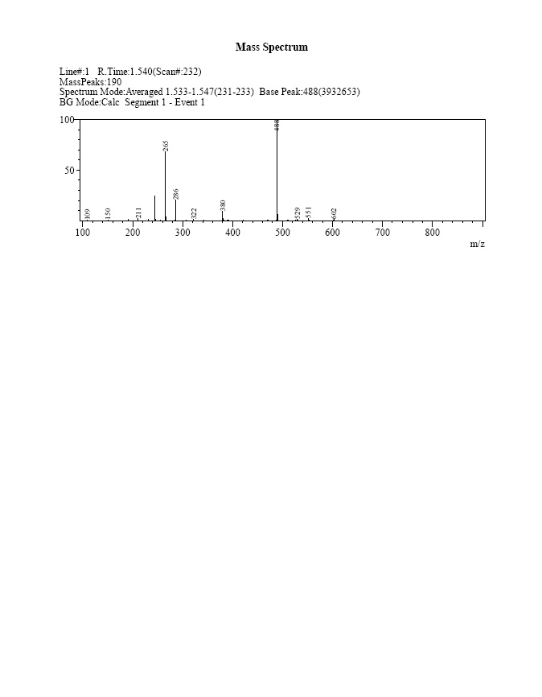

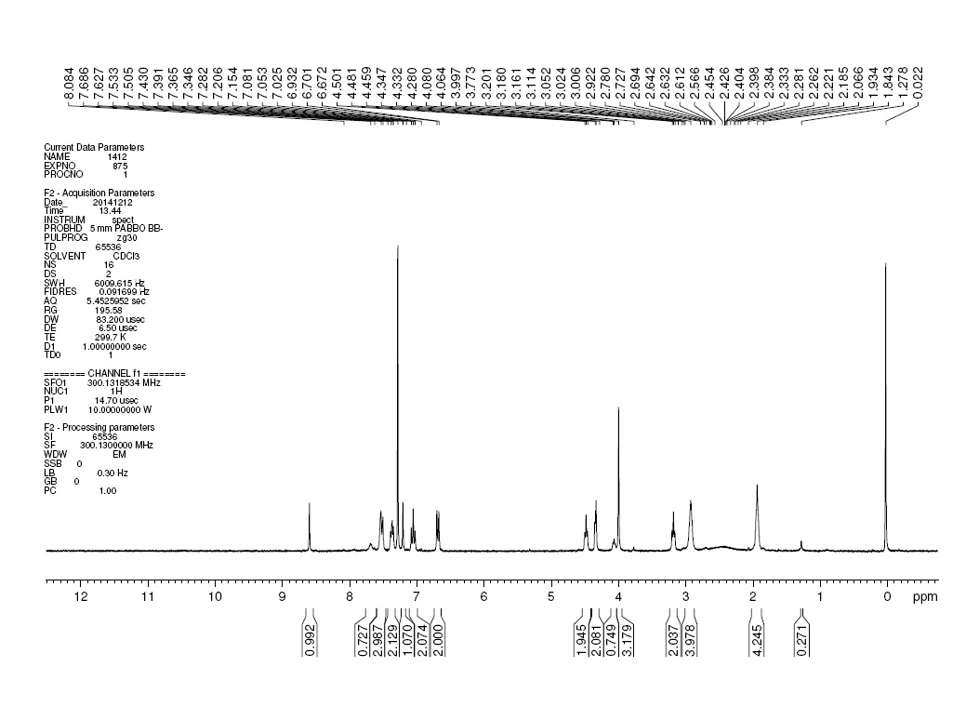

(2) Synthesis of 1-N-[7-methoxy-6-[2-(pyrrolidin-1-yl) ethoxy] quinazolin-4-yl]-4-N-[(4-nitrophenyl) methyl]benzene-1,4-diamine (**5b**)

1.3 g, 26%;Yellow solid; C28H30N6O4; Molecular Weight: 514.58; ESI-LC, m/z: [M+H]+:515; 1H-NMR(300 MHz, DMSO-d6): δ 9.20 (s, 1H), 8.29 (s, 1H), 8.23-8.20 (d, *J* = 8.7 Hz, 2H), 7.78 (s, 1H), 7.67-7.64 (d, *J* = 8.4 Hz, 2H), 7.33-7.30 (d, *J* = 8.4 Hz, 2H),7.12 (s, 1H), 6.60-6.58 (d, *J* = 8.7 Hz, 2H), 6.45-6.41 (t, *J* = 6.0 Hz, 1H), 4.46-4.44 (d, *J* = 6.0 Hz, 2H), 4.21-4.18 (t, *J* = 6.0 Hz, 2H), 3.91 (s, 3H), 2.91-2.86 (t, *J* = 6.0 Hz, 2H), 2.56 (m, 4H), 1.70 (m, 1H).

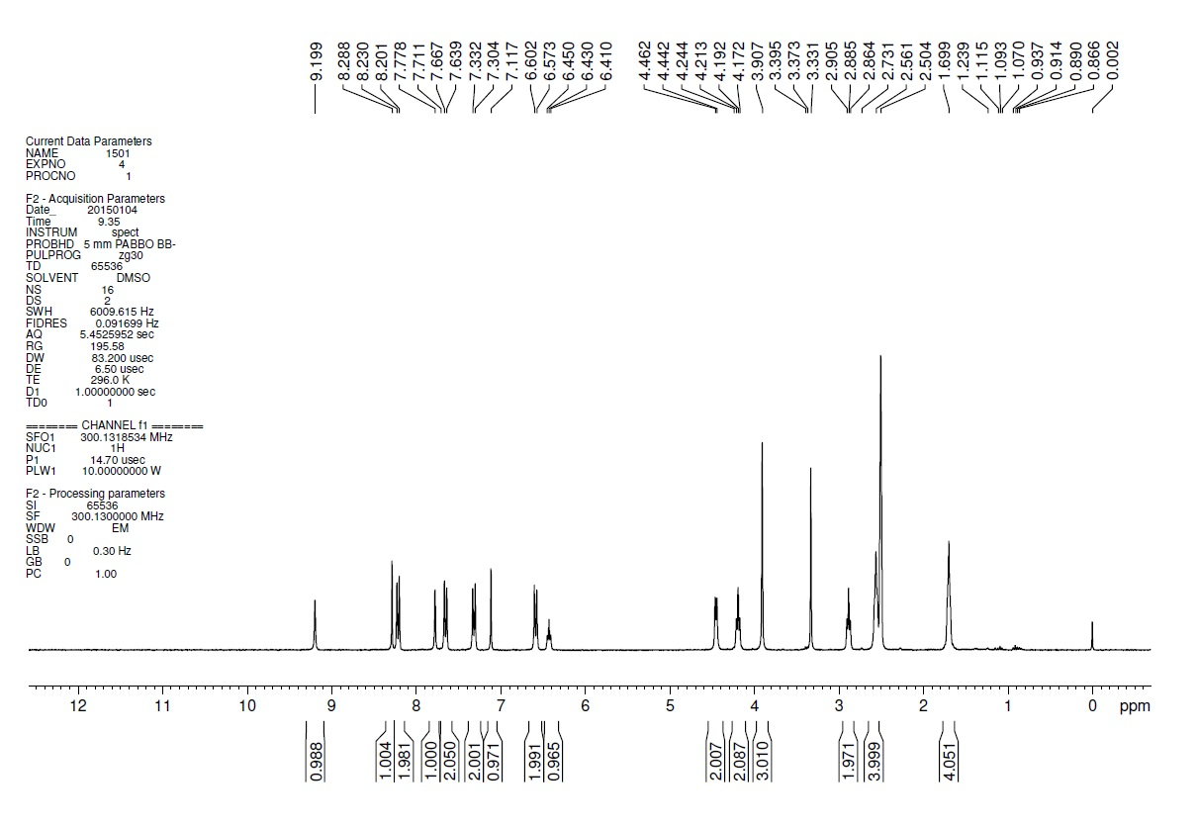

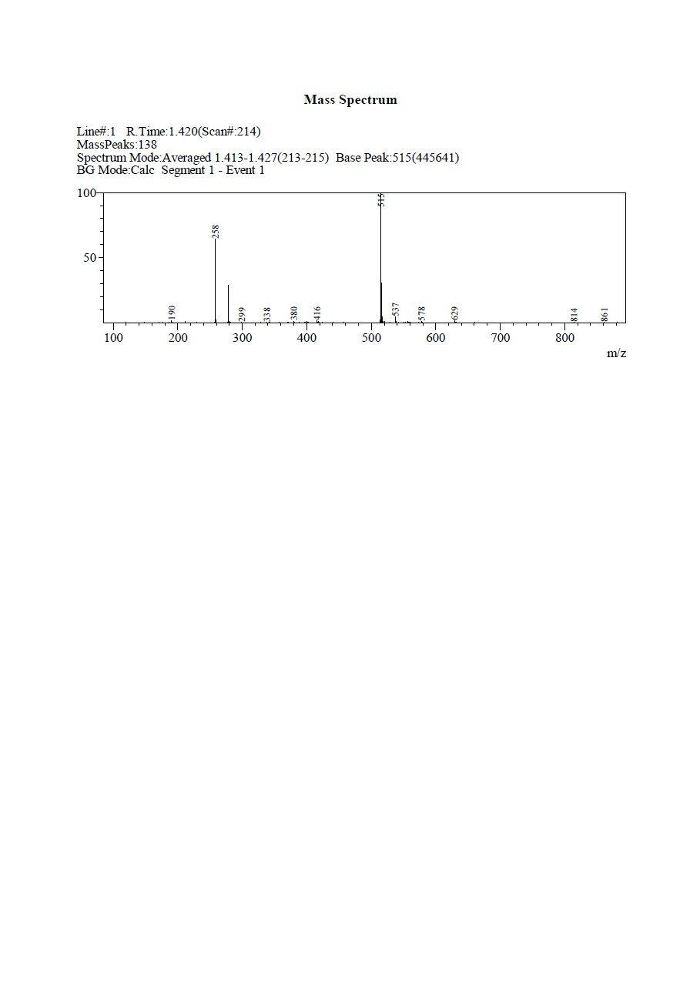

(3) Synthesis of 1-N-[[4-(dimethylamino) phenyl] methyl]-4-N-[7-methoxy-6-[2-(pyrrolidin-1-yl) ethoxy] quinazolin-4-yl] benzene-1,4-diamine (**5c**)

1.347 g, 54%; Orange solid; C30H36N6O2; Molecular Weight: 512.65; ESI-LC, m/z: [M+H]+:513; 1H-NMR: (300 MHz, DMSO-d6):δ 9.18 (s, 1H), 8.29 (s, 1H), 7.79 (s, 1H), 7.30-7.27 (d, *J* = 8.7 Hz, 2H), 7.21-7.18 (d, *J* = 8.7 Hz, 2H), 7.11 (s, 1H), 6.71-6.68 (d, *J* = 8.7 Hz, 2H), 6.62-6.59 (d, *J* = 8.7 Hz, 2H), 6.01-5.97 (t, *J* = 5.4 Hz, 1H), 4.22-4.18 (t, *J* = 6.0 Hz, 2H), 4.15-4.13 (d, *J* = 5.7Hz, 2H), 3.91 (s, 3H), 2.91 (m, 2H), 2.85 (s, 6H), 2.60 (m, 4H), 1.71 (m, 4H).

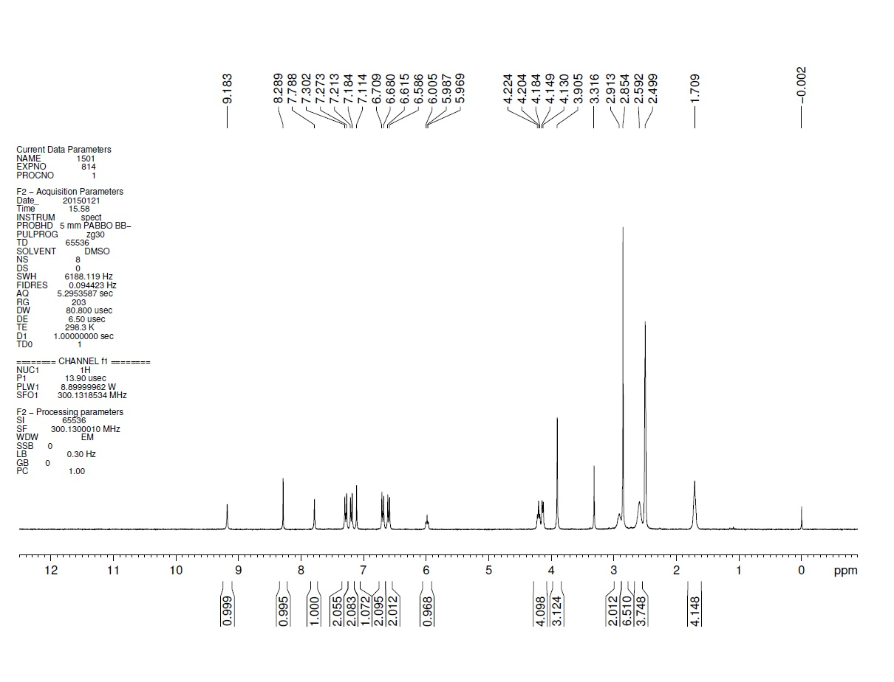

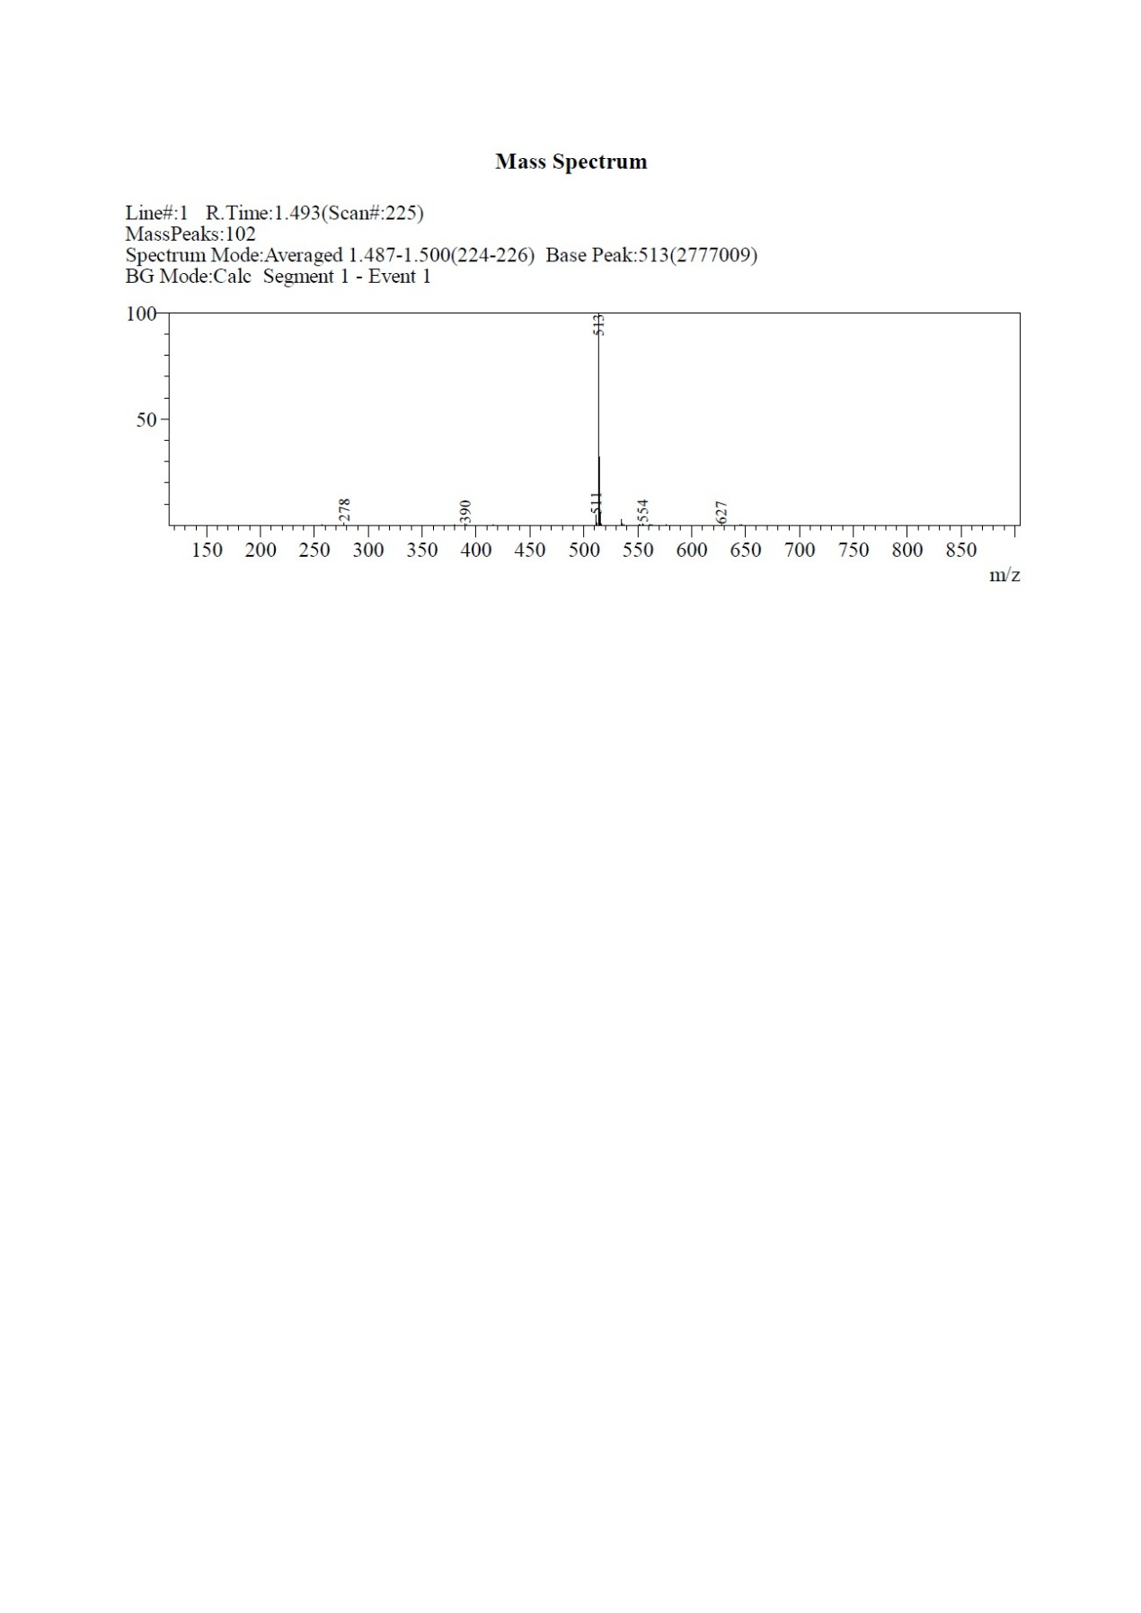

(4) Synthesis of 4-([[4-([7-methoxy-6-[2-(pyrrolidin-1-yl) ethoxy] quinazolin-4-yl] amino) phenyl] amino] methyl) phenol (**5d**)

805.1 mg , 80%; Light green solid; C28H31N5O3;Molecular Weight: 485.58; ESI-LC: m/z: [M+H]+: 486; 1H-NMR:(300 MHz, DMSO-d6): δ 9.25 (s, 1H), 9.20 (s, 1H), 8.30 (s, 1H), 7.79 (s, 1H), 7.31-7.28 (d, *J* = 8.7 Hz, 2H), 7.19-7.16 (d, *J* = 8.7 Hz, 2H), 7.12 (s, 1H), 6.72-6.70 (d, *J* = 8.4 Hz, 2H), 6.61-6.58 (d, *J* = 8.7 Hz, 2H), 6.04-6.01 (t, *J* = 5.4 Hz, 1H), 4.22-4.18 (t, *J* = 5.7 Hz, 2H), 4.15-4.13 (d, *J* = 5.7 Hz, 2H), 3.90 (s, 3H), 2.91-2.88 (t, *J* = 5.7 Hz, 2H), 2.57 (m, 4H), 1.70 (m, 4H).

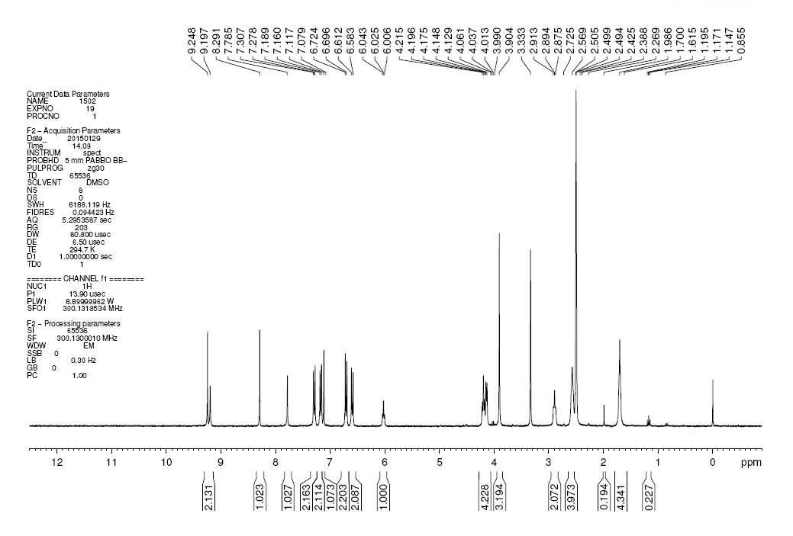

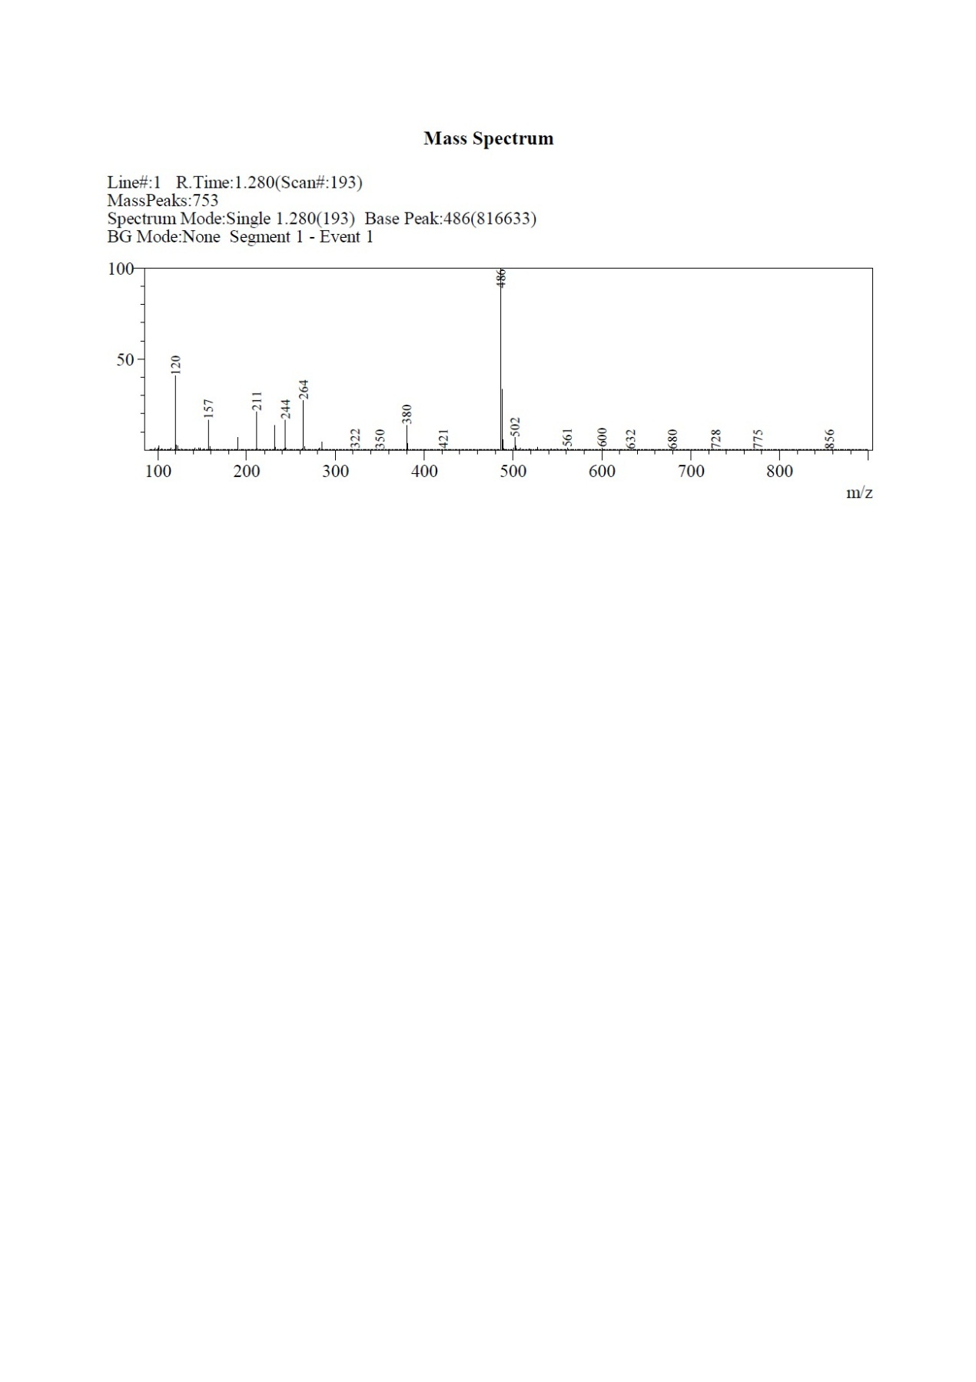

(5) Synthesis of N-(4-[[4-(dimethylamino) phenyl] methoxy] phenyl)-7-methoxy-6-[2-(pyrrolidin-1-yl) ethoxy] quinazolin-4-amine (**5e**)

900 mg, 22%; Off-white solid; C30H35N5O3; Molecular Weight: 513.63; ESI-LC, m/z: [M+H]+:514; 1H-NMR:(300 MHz, DMSO-d6): δ 9.35 (s, 1H), 8.37 (s, 1H), 7.83 (s, 1H), 7.61-7.58 (d, *J* = 8.7 Hz, 2H), 7.29-7.26 (d, *J* = 8.4 Hz, 2H), 7.15 (s, 1H), 7.02-6.99 (d, *J* = 9 Hz, 2H), 6.74-6.71 (d, *J* = 9 Hz, 2H), 4.96 (s, 2H), 4.24-4.20 (t, J = 6.3 Hz, 2H), 3.92 (s, 3H), 2.90 (m, 8H), 2.58 (m, 4H), 1.71 (m, 4H).

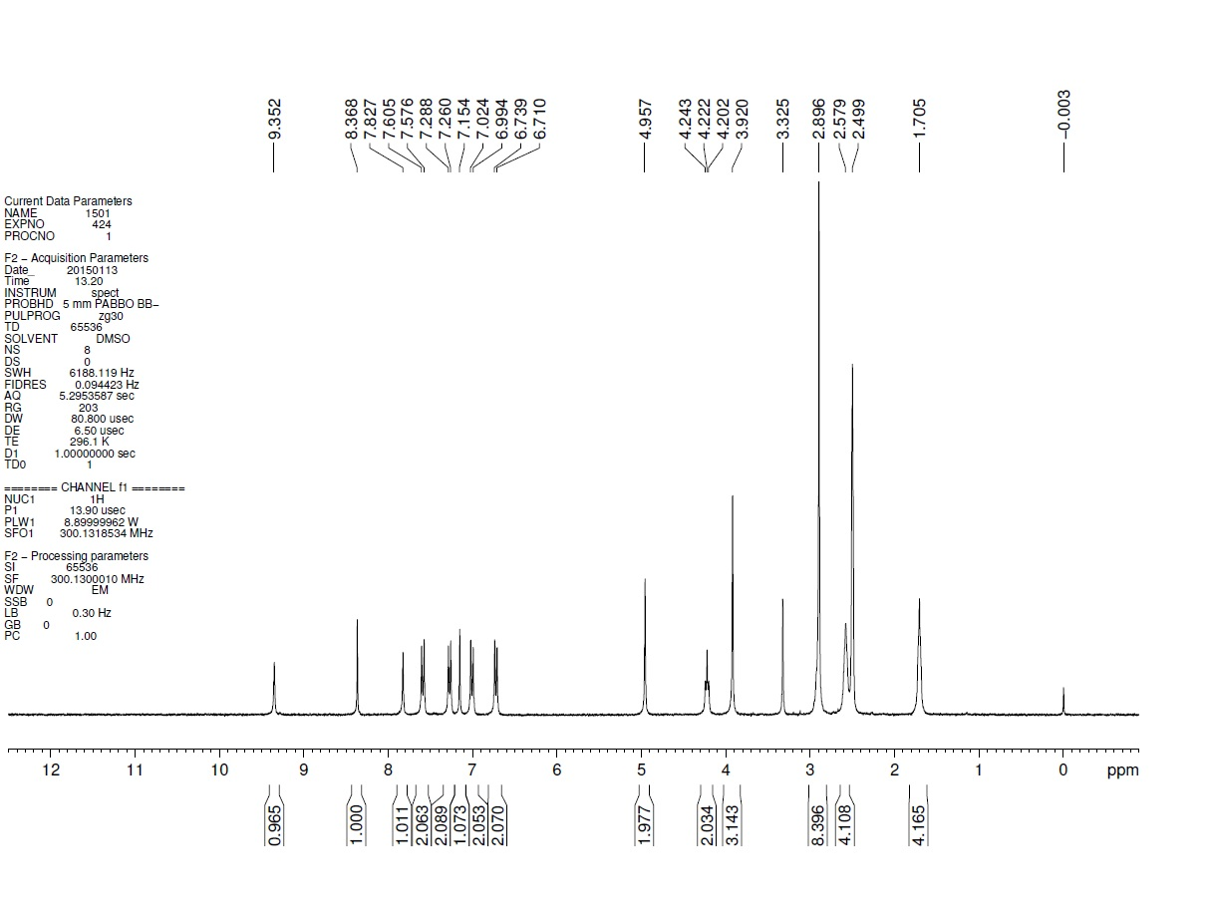

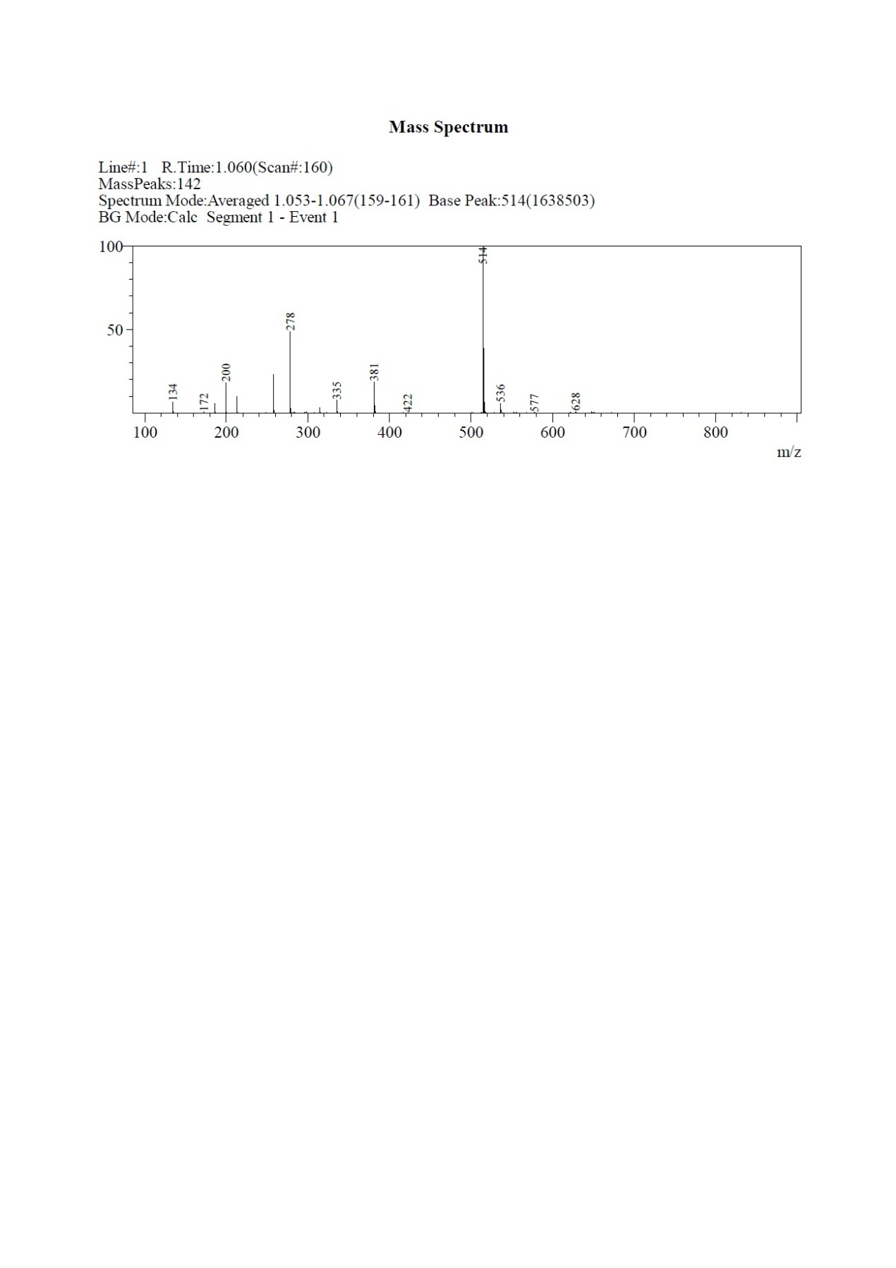

(6) Synthesis of 1-N-[(4-fluorophenyl) methyl]-4-N-[7-methoxy-6-[2-(1H-pyrrol-2-yl) ethoxy] quinazolin-4-yl] benzene-1,4-diamine (**9f**)

827.8 mg, 33%; Yellow solid. C28H26FN5O2; Molecular Weight: 483.54; ESI-LC, m/z: [M+H]+:484; 1H-NMR: (300 MHz, DMSO-d6): δ 10.77 (s, 1H), 9.25 (s, 1H), 8.29 (s, 1H), 7.78 (s, 1H), 7.50-7.38 (m, 2H), 7.29-7.26 (d, *J* = 8.4 Hz, 2H), 7.17-7.12 (m, 3H), 6.65 (s, 1H), 6.60-6.56 (d, *J* = 8.4 Hz, 2H), 6.26-6.15 (m, 1H), 5.93 (s, 2H), 4.26-4.21 (m, 4H), 3.92 (s, 3H), 3.11-3.01 (t, *J* =6.9Hz, 2H).

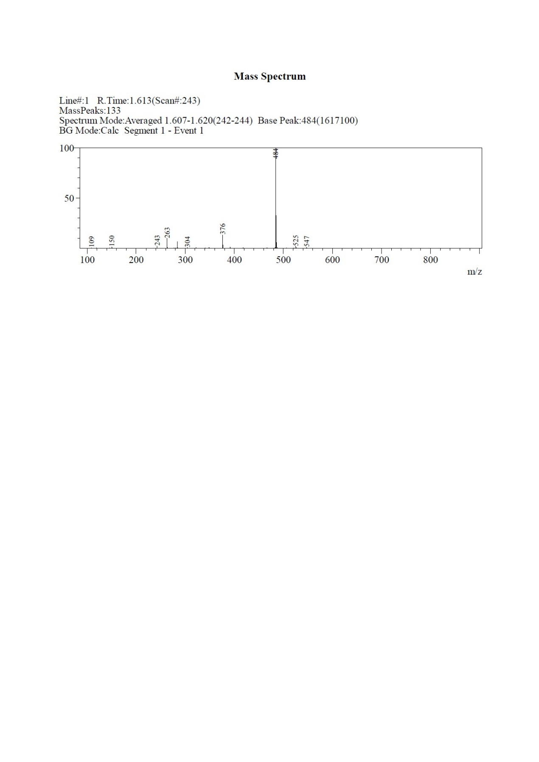

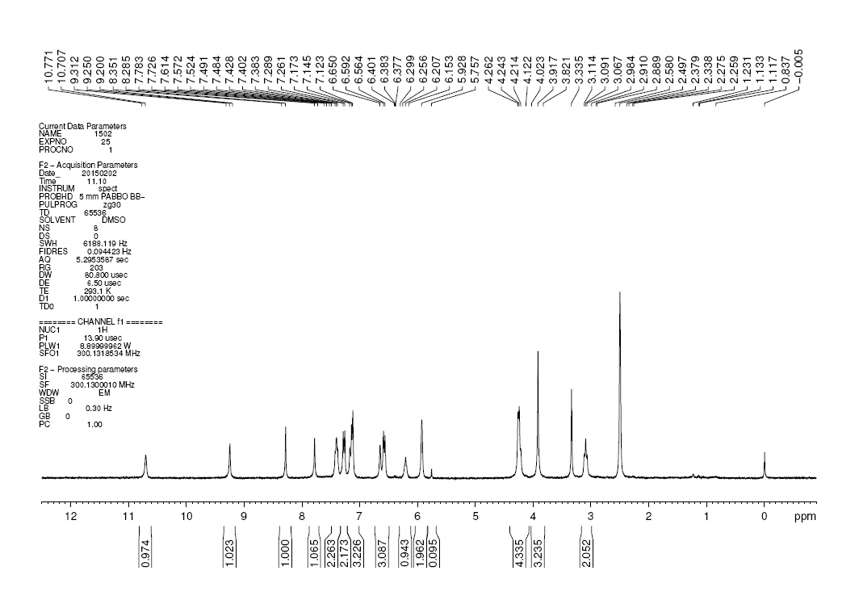

(7) Synthesis of 1-N-[7-methoxy-6-[2-(1H-pyrrol-2-yl) ethoxy] quinazolin-4-yl]-4-N-[(4-nitrophenyl) methyl] benzene-1,4-diamine (**9g**)

970 mg, 26%; Yellow solid; C28H26N6O4; Molecular Weight: 510.54; ESI-LC, m/z: [M+H]+:511; 1H-NMR: (300 MHz, DMSO-d6):δ 10.70 (s, 1H), 9.24 (s, 1H), 8.28 (s, 1H), 8.22-8.19 (d, *J* = 8.7 Hz, 2H), 7.77 (s, 1H), 7.66-7.63 (d, *J* = 8.7 Hz, 2H), 7.31-7.28 (d, *J* = 8.7 Hz, 2H), 7.12 (s, 1H), 6.65 (s, 1H), 6.58-6.55 (d, *J* = 9.0 Hz, 2H), 6.43-6.39 (t, *J* = 6.0Hz, 1H), 5.94-5.92 (t, *J* = 2.4Hz, 2H), 4.45-4.43 (d, *J* = 6.0Hz, 1H), 4.26-4.21 (t, *J* =7.8 Hz, 3H), 3.92 (s, 3H), 3.12-3.09 (t, *J* =7.8Hz, 2H).

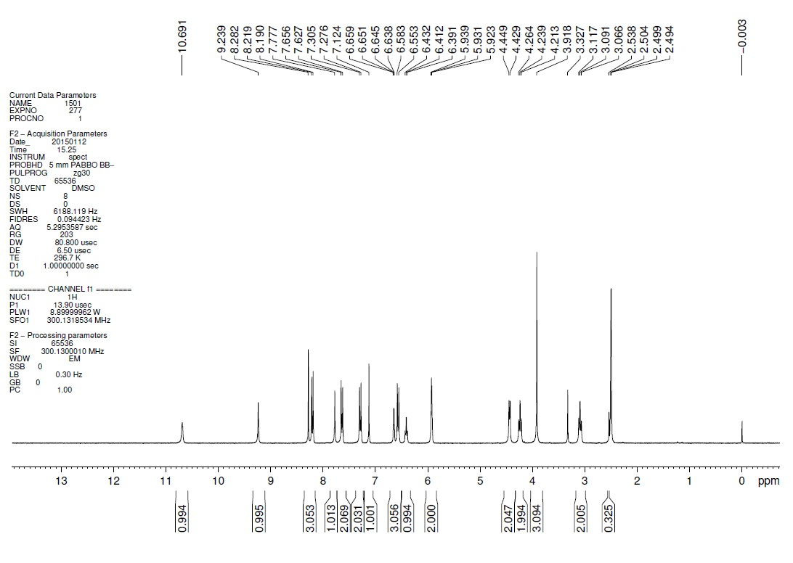

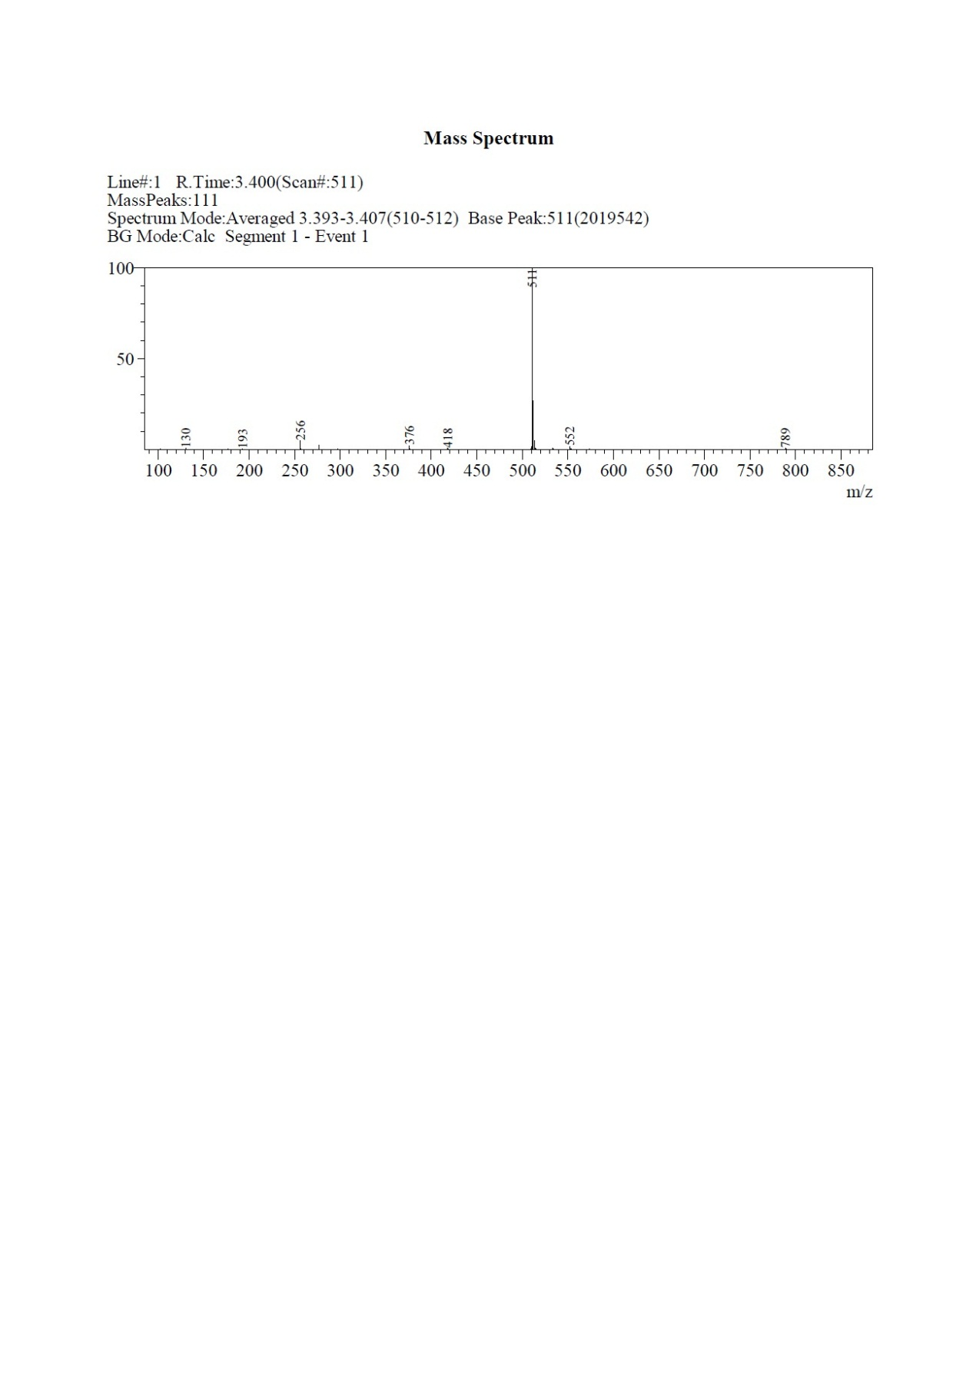

(8) Synthesis of 1-N-[[4-(dimethylamino) phenyl] methyl]-4-N-[7-methoxy-6-[2-(1H-pyrrol-2-yl) ethoxy] quinazolin-4-yl] benzene-1,4-diamine (**9h**)

1.2 g, 36%; Light yellow solid; C30H32N6O2; Molecular Weight: 508.61; ESI-LC, m/z: [M+H]+: 509; 1H-NMR: (300 MHz, DMSO-d6): δ 10.70 (s, 1H), 9.23 (s, 1H), 8.29 (s, 1H), 7.79 (s, 1H), 7.28-7.25 (d, *J* = 6.9 Hz, 2H), 7.21-7.18 (d, *J* = 8.7 Hz, 2H), 7.12 (s, 1H), 6.70-6.64 (m, 3H), 6.60-6.57 (d, *J* = 8.7 Hz, 2H), 6.01-6.5.97 (t, *J* = 5.7 Hz, 1H), 4.27-4.22 (t, *J* = 7.5 Hz, 2H), 4.14-4.12 (d, *J* = 5.7 Hz, 2H), 3.92 (s, 3H), 3.20-3.17 (t, *J* =7.5Hz, 2H), 2.85 (s, 6H).

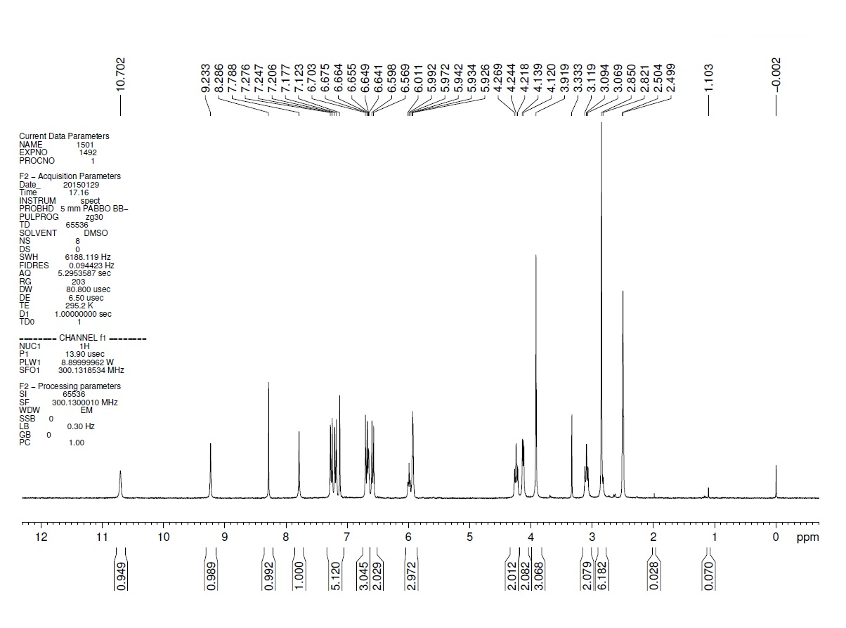

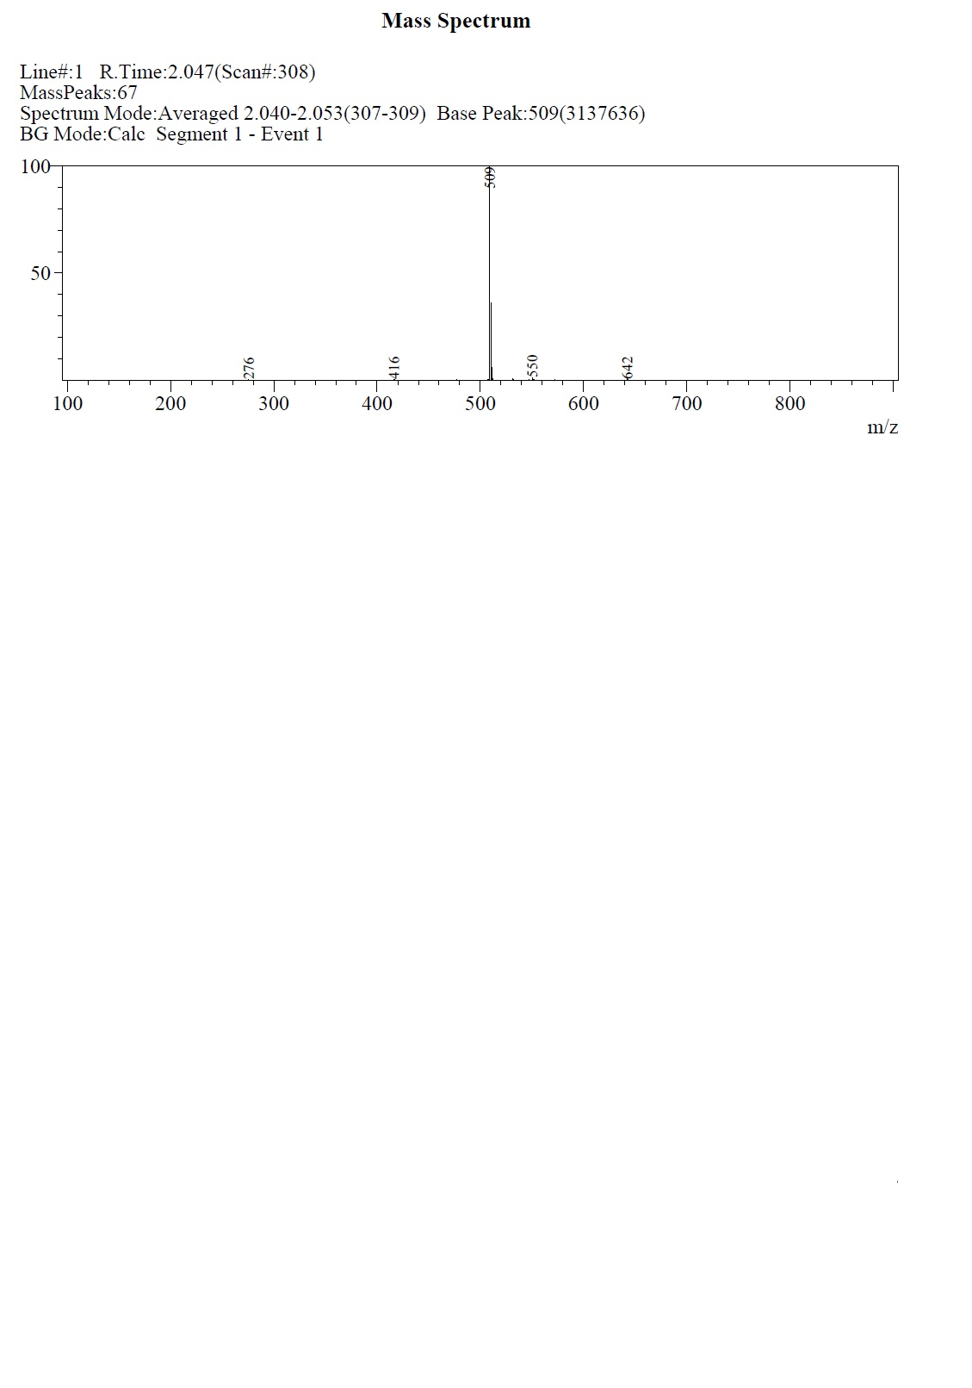

(9) Synthesis of 4-([[4-([7-methoxy-6-[2-(1H-pyrrol-2-yl)ethoxy] quinazolin-4-yl]amino)phenyl]amino]methyl)phenol (**9i**)

1.147 g, 57%; Brown solid; C28H27N5O3; Molecular Weight: 481.55; ESI-LC, m/z: [M+H]+: 482; 1H-NMR: (300 MHz, DMSO-d6):δ 10.70 (s, 1H), 9.25 (s, 1H), 8.29 (s, 1H), 7.79 (s, 1H), 7.28-7.26 (d, *J* = 8.4 Hz,2H), 7.18-7.15 (d, *J* = 8.4 Hz, 2H), 7.13 (s, 1H), 6.72-6.69 (d, *J* = 8.4 Hz, 2H), 6.49 (s, 1H), 6.60-6.57 (d, *J* = 8.7 Hz, 2H), 6.03-5.93 (t, *J* = 5.4 Hz, 1H), 5.93 (s, 2H), 4.27-4.22 (t, *J* = 5.1 Hz, 1H), 4.14-4.12 (d, *J* = 5.4 Hz, 1H), 3.92 (s, 3H), 3.12-3.07 (t, *J* =7.5Hz, 2H).

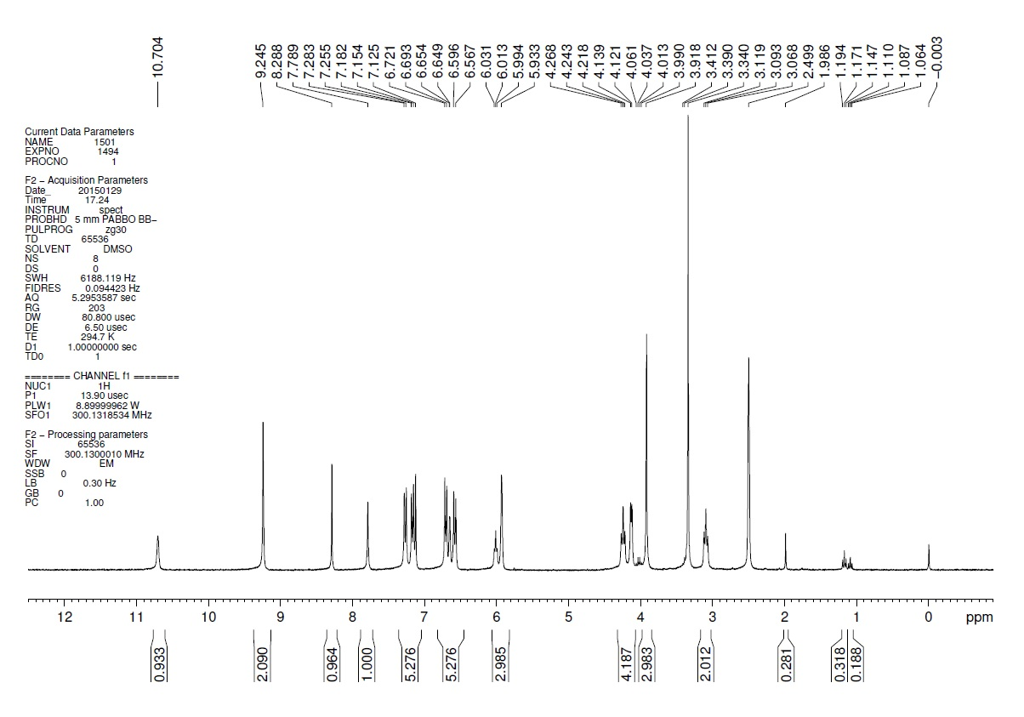

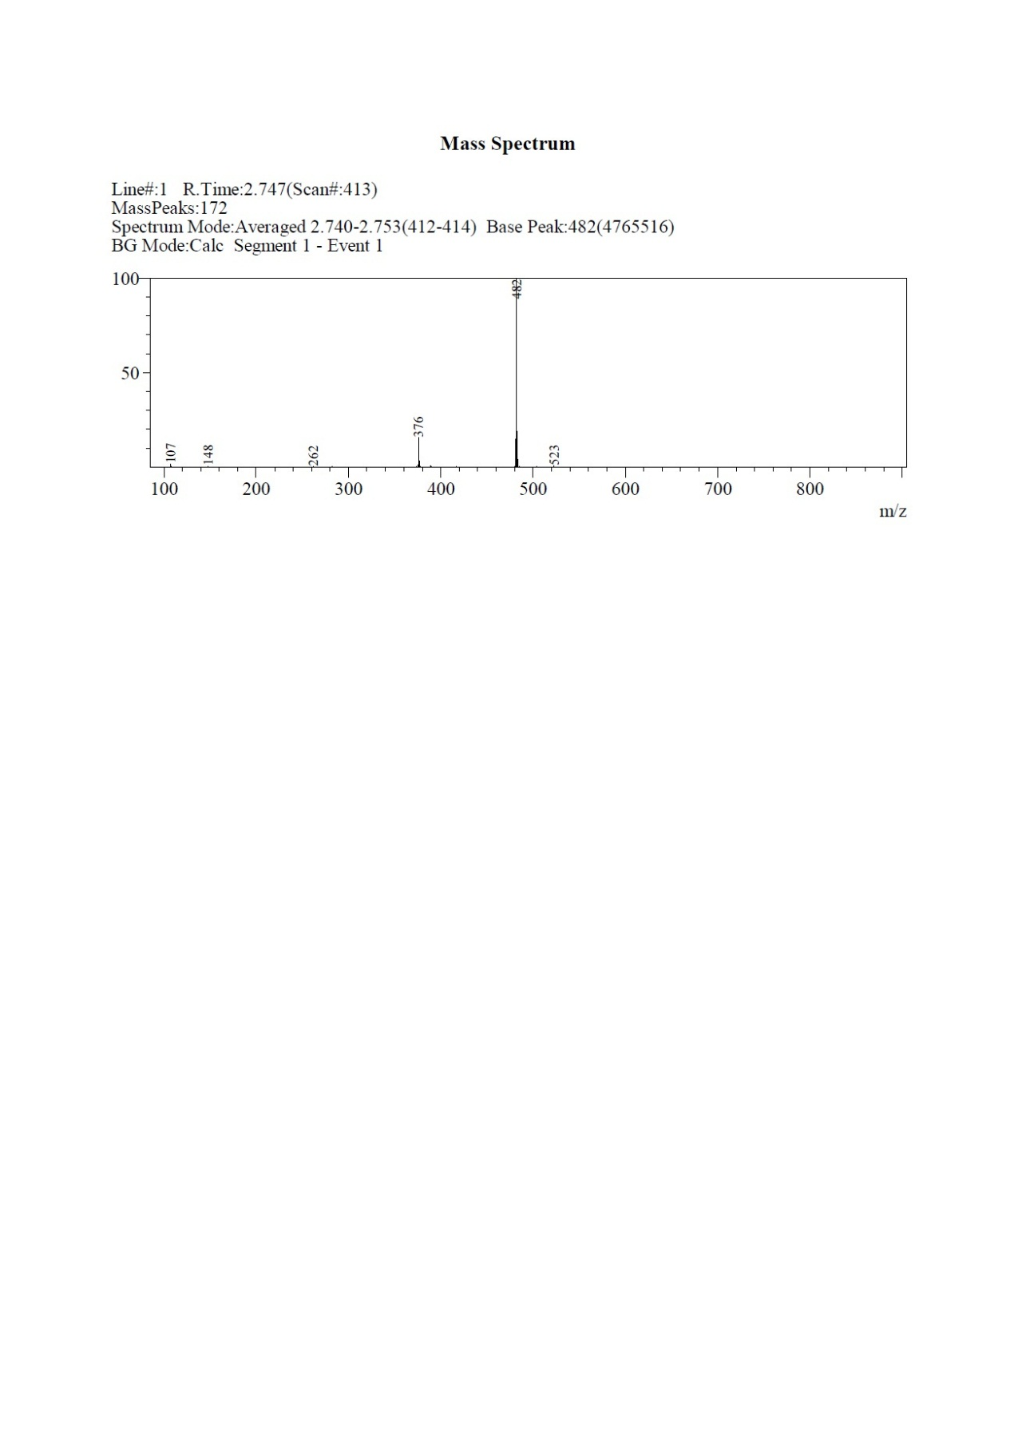

(10) Synthesis of N-(4-[[4-(dimethylamino) phenyl] methoxy] phenyl)-7-methoxy-6-[2-(1H-pyrrol-2-yl) ethoxy] quinazolin-4-amine (**9j**)

359 mg, 7%; Light yellow solid; ESI-LC, m/z: [M+H]+: 510 ; 1H-NMR: (300 MHz, DMSO-d6): δ 10.71 (s, 1H), 9.46 (s, 1H), 8.38 (s, 1H), 7.84 (s, 1H), 7.58-7.55 (d, *J* = 8.7 Hz, 2H), 7.29-7.26 (d, *J* = 8.4 Hz, 2H), 7.17 (s, 1H), 7.02-6.99 (d, *J* = 8.7 Hz, 2H), 674-6.71 (d, *J* = 8.4 Hz, 2H), 6.66 (s, 1H), 5.94 (s, 2H), 4.96 (s, 2H), 4.30-4.25 (t, *J* =7.4Hz, 2H), 3.94 (s, 3H), 3.14-3.09 (t, *J* =7.2Hz, 2H), 2.90 (s, 6H).

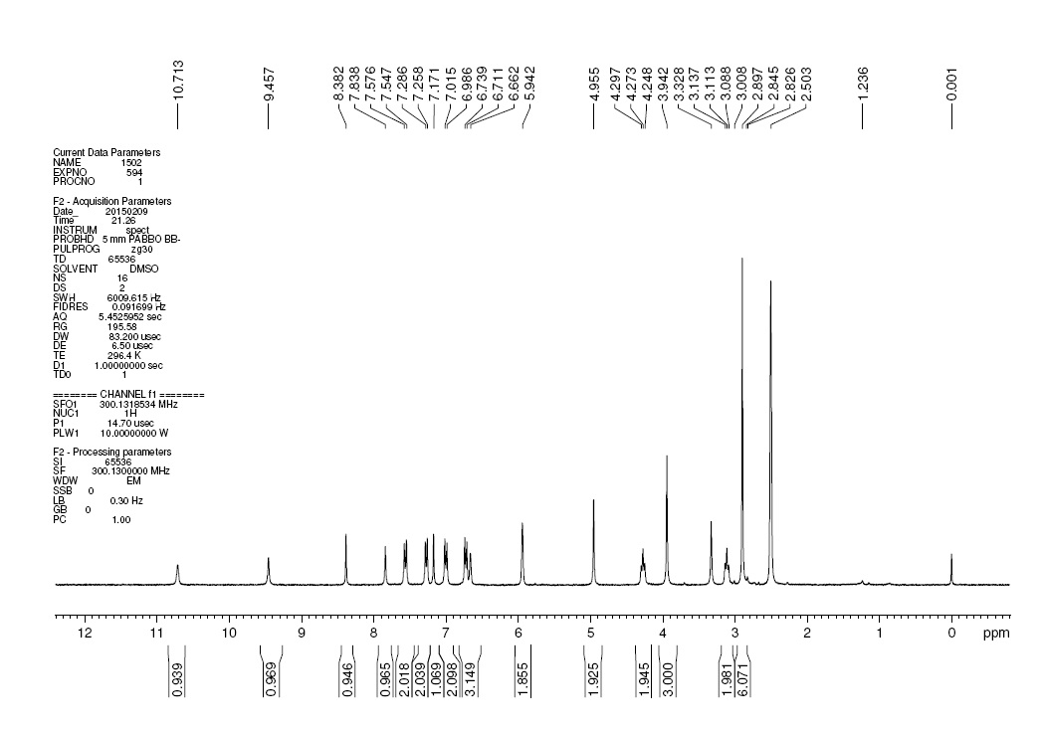

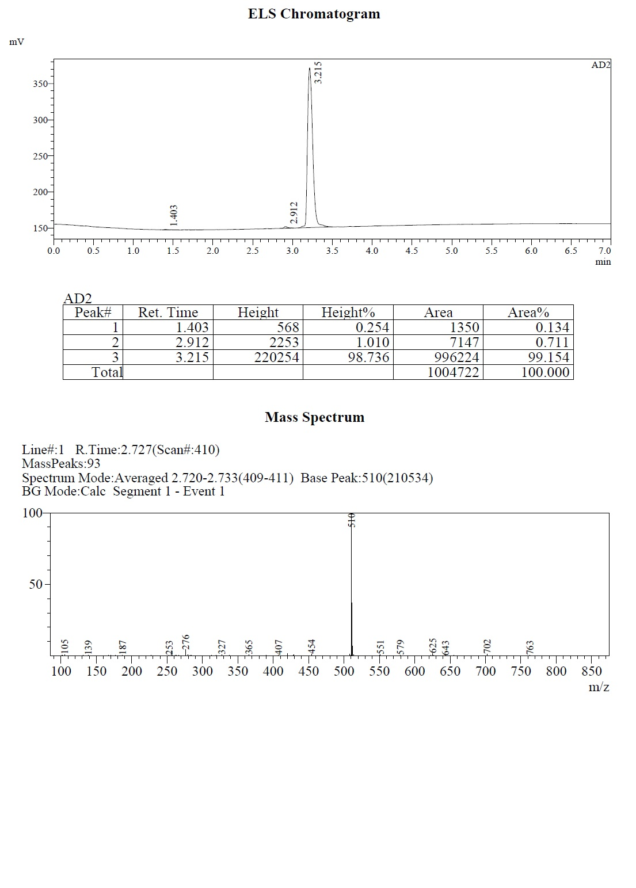

**3 Cell culture**

Human breast cancer cell lines, SK-BR-3, MCF-7, MDA-MB-468 and HCC1806, were purchased from Cobioer company (Nanjing, China). HCC1806 and SK-BR-3 was cultured in RPMI-1640 Medium (Invitrogen, USA) with 10% fetal bovine serum (FBS). MCF-7 and MDA-MB-468 was cultured in Leibovitz’s L-15 medium supplemented with 2mM glutamine and 15% FBS. All the culture medium was mixed with 1% penicillin/streptomycin (KeyGEN, China).

**4 Cell viability assay**

Breast cancer cells were seeded in 96-well culture plates (1.0 × 104cells/well) and grown overnight. Twenty-four hours later, the medium was removed and replaced with fresh medium with or without **LU1501** or the positive control, wherein 6 wells were parallel. After 48 hours treatment, the cells were incubated with MTT (methylthiazo-letrazolium) (Sigma Corporation, dissolved in PBS and prepared to 5mg/mL solution, used after being filtered and sterilized, 10 μl/well) and cultured at 37 °C for another 4 hours. A supernatant was absorbed out carefully, and 150μl DMSO was added into each well to dissolve purple residue (formazan). After flatly oscillating for 10 min to completely dissolve deposits, absorbance of the dissolved solutions was detected at 570 nm wavelength on a Thermo Scientific Varioskan Flash microplate reader (USA). The cell viability rate was calculated as follows: (absorbance of drug treated sample/absorbance of control sample) × 100%.

**5 Gene Expression Detection**

The gene expression profile of SK-BR-3 with or without **LU1501** treatment, was detected by Agilent SurePrint G3 Human Gene Expression 8x60K V3 Microarray (Agilent, Cat. No: G4851C, Design ID: 072363, USA). It is summarized as follows: total RNA is reverse-transcribed into double-stranded cDNA, and cRNA labeled with Cyanine-3-CTP (Cy3) is synthesized. The labeled cRNA is hybridized with the chip, and the original image is obtained by scanning with Agilent Scanner G2505C (Agilent Technologies) after elution. Finally, the data are read. (The above chip detection and data reading are completed by Beijing CapitalBio Technology Co., Ltd.).

**6 Animal models**

The SK-BR-3 cells (1 × 107cells in 0.1 ml of PBS) were injected subcutaneously into the right flank of male nude mice, aged 6-8 weeks (weight≥15g). When tumors grew to 100 mm3, saline, Erlotinib, Afatinib or LU1501 solution were then continuous intraperitoneal injected every day. Tumor growth was examined every two days. The mice were sacrificed after two weeks, and tumor size and weight were measured. The experimental protocols of the present study, including all surgical procedures and animal usages, were approved by the Experimental Animal Ethics Committee of Jinling Hospital of Nanjing University and conducted in accordance with the Guide for the Care.

**7 Western blotting assays**

Breast cancer cells and mice tumor homogenates were lysed in CelLytic™ MT Cell Lysis Reagent (Sigma, Cat. No.C3228) containing protease and phosphatase inhibitors (Roche, Cat. No.04693116001, 04906837001) on ice for 30 min. After centrifugation at 12000 rpm for 15 min at 4 °C, the supernatant was collected and subjected to BCA assay to determine the protein concentration. Totally 25 μg proteins from each sample were separated by SDS-PAGE (10%) and transferred onto PVDF membrane. Afterwards, the membranes were blocked with 0.5% BSA for 1 h and incubated with primary antibodies against GAPDH (CST, Cat. No.5174S, 1:3000), NF-κB/p65(abcam, Cat. No.ab230449,1:1000), and IκB (G-bioscience, Cat. No.ITA9678, 1:500) overnight at 4 °C. After being washed with 1 × TBST, the membranes were incubated with respective secondary antibodies conjugated with horseradish peroxidase for 1 h at room temperature. The protein bands were visualized with Immobilon™ Western Chemiluminescent HRP Substrate (Millipore Corporation, Cat.No.WBKLS0500), and the images were captured on the visualization instrument Tanon-5200 (Tanon, China).

**8 H&E staining and Immunohistochemical analysis**

Formaldehyde-fixed specimens were embedded in paraffin and cut into 4-μm-thick sections that were deparaffinized with xylene and rehydrated in a graded series of alcohol. Hematoxylin and Eosin (H&E) staining was conducted, while antigen retrieval was carried out by microwaving in citric acid buffer. Sections were incubated with an antibody against Ki67 and Caspase-3 at a dilution rate of 1:1000 (abcam, Cat. No. ab15580, USA), washed, and then incubated with secondary antibody for 60min at room temperature. The negative control was prepared without adding the primary antibody. Three randomly selected visual fields were analyzed. The intensity of the signal was evaluated as follows: 0, no positive cells; 1, very few positive cells; 2, moderate number of positive cells; 3, many positive cells; and 4, the highest number of positive cells.

**9 TUNEL Detection**

Tumor tissue sections were prepared as described in H&E staining and TUNEL detection for apoptosis was performed according to the protocol of TUNEL apoptosis detection kit (KeyGEN, China). TdT-mediated biotin-dUTP nick-end labelling (TUNEL)-positive cells were counterstained with hematoxylin, and observed by inverted microscope (Olympus, Japan). Three independent assays were requested. The total number of TUNEL+ and all hematoxylin-stained cells were quantified separately to calculate the apoptosis rate (%).

**10 Statistical analysis**

All experimental data were shown as means ± standard deviation (SD) of three independent experiments and analyzed by GraphPad Prism 5.0. Student’s t test and one-way analysis of variance (ANOVA) were used to assess the significant difference of groups. P<0.05 was considered as statistical significance.