**Chemical synthesis methods and spectral data of compounds W1 and W2.**

**Chemical synthesis**

**Instruments and Materials.** All chemical reagents were commercially available without any further purification. The melting points (mp) were recorded on a Shanghai INESA melting point instrument (WRS-3, INESA Company, China), and the thermometer was uncorrected. Infrared (IR) spectra were measured as KBr pellets on ALPHA-T (Bruker Company, DEU). 1H and 13C nuclear magnetic resonance (NMR) spectra were measured on a Bruker AV400 spectrometer (Bruker, Inc., Billerica, MA, U.S.A.) with CDCl3 as the solvent.

**Synthesis of Compound W1 (*(E)-5-(3-(4-bromophenyl)acryloyl)-6-hydroxy-2,3-dihydropyridin-4(1H)-one* )[28].** 4-Bromocinnamic acid (12 mmol), SOCl2 (30 mmol) and CH2Cl2 (40 mL) were added in three-necked flask, the mixture was reﬂuxed at 40 ℃ for 2.5 h. The solution was added dropwise to a 150 mL three-necked flask with *N*-Boc-2,4-piperidinedione (10 mmol) and Et3N (2.75 mL) at 0 ℃. The resulting mixture was then reacted at room temperature for 1 h until the reaction completion (TLC monitored). The organic phase was neutralized with HCl aq. (30 mL × 2, 1M) and washed with saturated saline water. Then it was concentrated and puriﬁed by silica gel column chromatography to afford the intermediate **1**.

Intermediate **1** was dissolved in 35 mL CHCl3, Et3N (2.75 mmol), CH3CN (17 mmol) and acetone cyanohydrin (0.48 mmol) were added successively in the solution and stirred at room temperature (TLC monitored). After 12 h the organic phase was treated as above-mentioned procedure. The intermediate **2** was puriﬁed by silica gel column chromatography.

Trifluoroacetic acid (TFA) (0.5 mL) was added dropwise to the solution of intermediate **2** at 0 ℃ and stirred at room temperature for 1 h (TLC monitored). The final product (**W1**) was concentrated and puriﬁed by silica gel column chromatography with *n*-hexane: EtOAc (3:1, *V:V*) as eluant.



**Scheme 1. Route for the synthesis of compound W1.**

**Synthesis of Compound W2 (*****2-(1H-indole-2-carbonyl) cyclohexane-1,3-dione*).** Indole-2-carboxylic acid (10 mmol) was dissolved in CH2Cl2 (20 mL), and the oxalyl chloride (11.4 mmol) was added dropwise in the solution and stirred at room temperature for 1 h (TLC monitored). The solution was added dropwise to a 150 mL three-necked flask with 1,3-cyclohexanedione (10 mmol) and pyridine (15 mmol) at 0℃. After the reaction was finished, the mixture was washed successively with dilute HCl aq. (30 mL × 2, 1M) and saturated saline water. Intermediate (**3**) was obtained after dry, filtered and concentrated.

The mixture of intermediate 3, Et3N (2.8 mL) and acetone cyanohydrin (0.5 mmol), acetonitrile (17 mL) was stirred at room temperature for 5 h, and then the organic phase was extracted with NaHCO3 aq. After drying and concentrating, it was neutralized with HCl aq. and extracted with EtOAc. Crude product was separated by silica gel column chromatograph with *n*-hexane: EtOAc (3:2, *V:V*) as eluant.



**Scheme 2. Route for the synthesis of compound W2.**

**The spectral data and spectrogram**

***(E)-5-(3-(4-bromophenyl)acryloyl)-6-hydroxy-2,3-dihydropyridin-4(1H)-one (W1).*** Yield: 30%, Yellow solid, m.p. 161.3-162.3 ℃; IR (KBr, cm-1) ν 3208 (-NH), 3093-2870 (C-H), 1653 (C=O), 1581-1450 (C=C). 1H NMR (400 MHz, CDCl3) δ 17.33 (s, 1H, OH), 8.35 (s, 1H, NH), 7.81 (d, *J*=15.8 Hz, 1H, =CH-), 7.72 (d, *J*=15.8 Hz, 1H, =CH-), 7.54 (d, *J*=15.8 Hz, 4H, Ph-H), 3.56-3.48 (t, *J* = 6.4 Hz, 2H, -CH2-), 2.78 (m, 2H, -CH2-). 13C NMR (100 MHz, CDCl3) δ 192.49, 184.11, 180.73, 142.92, 131.58, 131.25, 130.94, 130.62, 130.46, 129.97, 121.72, 101.51, 38.71, 37.14. HRMS (322.0085).

***2-(1H-indole-2-carbonyl)cyclohexane-1,3-dione* (W2).** Yield: 45%, White solid, m.p. 96-97 ℃; IR (KBr, cm-1) ν 3055 (-NH), 2954-2895 (-CH2-, =CH), 1649 (C=O), 1526-1400 (C=C). 1H NMR (400 MHz, CDCl3) δ 19.31 (s, 1H, OH), 12.54 (s, 1H, NH), 7.75-7.12 (m, 5H, Ar-H) 2.75 (t, *J* = 6.5 Hz, 2H), 2.68 (t, *J* = 6.5 Hz, 2H), 2.03 (p, *J* = 6.6 Hz, 2H). 13C NMR (100 MHz, CDCl3) δ 203.25, 197.05, 182.88, 138.15, 132.61, 127.19, 126.86, 122.87, 121.10, 114.57, 113.06, 112.35, 39.64, 35.58, 18.84. HRMS (255.0932).

**Spectra of compounds W1 and W2**

Compound **W1**



**(*E*)-5-(3-(4-bromophenyl)acryloyl)-6-hydroxy-2,3-dihydropyridin-4(1H)-one**

C14H12BrNO3

IR

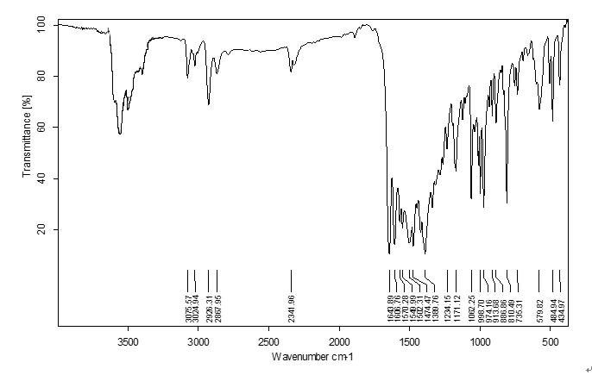

1H NMR



13C NMR



HRMS

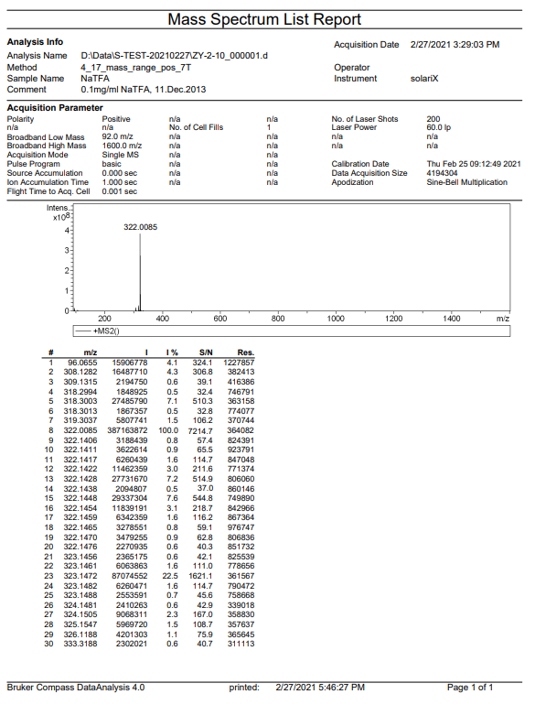Compound **W2**



***2-(1H-indole-2-carbonyl)cyclohexane-1,3-dione***

C15H13NO3

IR

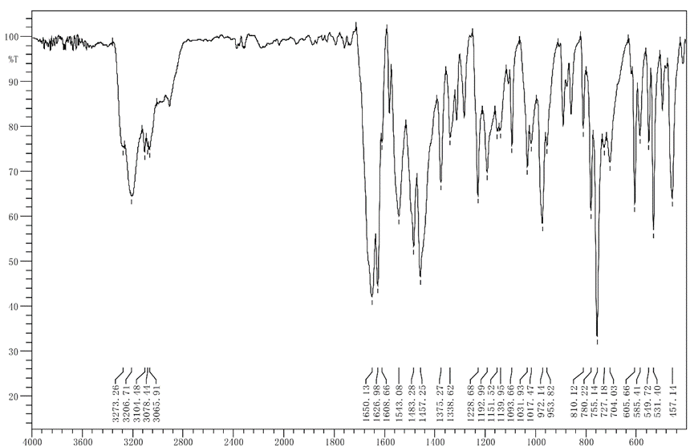

1H NMR



13C NMR



HRMS

