Supporting Information

Insight into the performance of novel kaolinite-cellulose/cobalt oxide nanocomposite as green adsorbent for liquid phase abatement of heavy metal ions: Modelling and mechanism
Daud Hussainª, Suhail Ayoub Khanª, Salman S. Alharthi^{b}, Tabrez Alam Khanª*

ª Department of Chemistry, Jamia Millia Islamia, Jamia Nagar, New Delhi 110 025, India
^{b} Department of Chemistry, College of Science, Taif University, P.O. Box 110999, Taif 21944,
Saudi Arabia

Calibration plot of Pb²⁺

Figure S1a
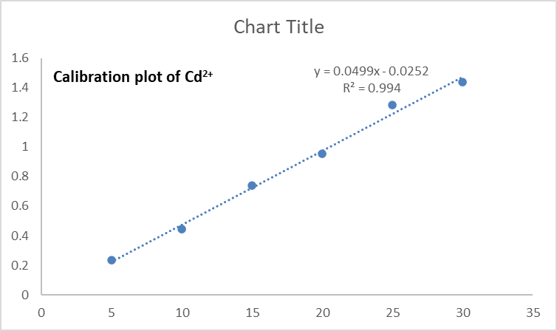
Figure S1b

Figure S2. Freundlich isotherm plot for Pb²⁺ (a), Cd²⁺ (b), removal

Figure S3. Temkin isotherm plot for Pb²⁺ (a), Cd²⁺ (b), removal

Figure S4. D-R isotherm plot for Pb²⁺ (a), Cd²⁺ (b), removal

Figure S5. Pseudo-first order kinetics plot for Pb²⁺ (a), Cd²⁺ (b), removal

Figure S6. Intraparticle diffusion plot for Pb²⁺ (a), Cd²⁺ (b), removal

Figure S7. Liquid film diffusion plot for Pb²⁺ (a), Cd²⁺ (b), removal

Figure S8. van’t Hoff plots

