**Supplementary Material**

**Evaluation of the chronic intoxication of fluoride on human serum metabolome using untargeted metabolomics**

Muhammad Usmana, Arslan Alib, Amna Jabbar Siddiquib, Fizza Iftikharb, Sindhia Kumaria, Syed Sibt-e-Hassana, Raja Shadc, Tahir Rafiqued, Syed Kashif Razae, Hesham R. El-Seedi f,g,h,Syed Ghulam Musharrafa,b,*

*aH.E.J. Research Institute of Chemistry, International Center for Chemical and Biological Sciences, University of Karachi, Karachi-75270, Pakistan*

*bDr. Panjwani Center for Molecular Medicine and Drug Research, International Center for Chemical and Biological Sciences, University of Karachi, Karachi-75270, Pakistan*

*cBasic Health Unit Bughar, Mithryo Bhatti,Sindh Health Department, Tharparker, Pakistan*

*dApplied Chemistry Research Centre, PCSIR Laboratories Complex, Karachi-75280, Pakistan.*

*eFaculty of Rehabilitation and Allied Health Sciences (FRAHS), Riphah International University, Faisalabad, Pakistan*

*fDepartment of Molecular Biosciences, The Wenner-Gren Institute, Stockholm University,*

*SE-106 91 Stockholm, Sweden*

*gDepartment of Chemistry, Faculty of Science, Menoufia University, Shebin El-Kom 32512,*

*Egypt*

*hInternational Research Center for Food Nutrition and Safety, Jiangsu University, Zhenjiang*

*212013, China*

*Corresponding author. Tel.: +92 21 34824924-5; 34819010; Fax: + 92 21 34819018-9.

*E-mail address:* [musharraf1977@yahoo.com](mailto:musharraf1977@yahoo.com)

**Table 1:** Concentration of fluoride ion (ppm) in serum samples from patient and healthy individuals.

|  |  |  |  |  |  |
| --- | --- | --- | --- | --- | --- |
| **Sr. No** | **Sample Code** | **F- ion (mg/L)** | **Sr. No** | **Sample Code** | **F- ion (mg/L)** |
| 1 | FU1a | 0.76 | 31 | FU31 a | 0.26 |
| 2 | FU2 a | 0.61 | 32 | FU32 a | 0.88 |
| 3 | FU3 a | 0.73 | 33 | FU33 a | 0.97 |
| 4 | FU4 a | 0.16 | 34 | FU34 a | 0.72 |
| 5 | FU5 a | 0.7 | 35 | FU35 a | 0.75 |
| 6 | FU6 a | 0.29 | 36 | FU36 a | 0.99 |
| 7 | FU7 a | 1.18 | 37 | FU37 a | 0.82 |
| 8 | FU8 a | 1.25 | 38 | FU38 a | 0.94 |
| 9 | FU9 a | 0.18 | 39 | FU39 a | 0.89 |
| 10 | FU10 a | 0.73 | 40 | HS1b | 0.007 |
| 11 | FU11a | 0.83 | 41 | HS2 b | 0.034 |
| 12 | FU12a | 0.72 | 42 | HS3 b | 0.013 |
| 13 | FU13a | 0.82 | 43 | HS4 b | 0.009 |
| 14 | FU14a | 1.01 | 44 | HS5 b | 0.031 |
| 15 | FU15a | 1.21 | 45 | HS6 b | 0.023 |
| 16 | FU16 a | 0.18 | 46 | HS7 b | 0.033 |
| 17 | FU17 a | 0.93 | 47 | HS8 b | 0.033 |
| 18 | FU18 a | 0.83 | 48 | HS9 b | 0.012 |
| 19 | FU19 a | 0.37 | 49 | HS10 b | 0.035 |
| 20 | FU20 a | 0.31 | 50 | HS11 b | 0.023 |
| 21 | FU21 a | 1 | 51 | HS12 b | 0.012 |
| 22 | FU22 a | 0.3 | 52 | HS13 b | 0.035 |
| 23 | FU23 a | 1.11 | 53 | HS14 b | 0.028 |
| 24 | FU24 a | 0.93 | 54 | HS15 b | 0.009 |
| 25 | FU25 a | 0.81 | 55 | HS16 b | 0.019 |
| 26 | FU26 a | 0.92 | 56 | HS17 b | 0.038 |
| 27 | FU27 a | 0.63 | 57 | HS18 b | 0.007 |
| 28 | FU28 a | 0.83 | 58 | HS19 b | 0.022 |
| 29 | FU29 a | 0.92 | 59 | HS20 b | 0.035 |
| 30 | FU30 a | 0.93 |  |  |  |

FUa = Disease Untreated HSb =Healthy Sample

**Table 2:** MS/MS fragments of identified metabolites.

__________= Experimental Values, _________= Reported Values

|  |  |  |
| --- | --- | --- |
| **Sr.No** | **Name** | **Spectra of Identified Metabolites** |
| 1 | Inosine |  |
| 2 | α-linolenic acid |  |
| 3 | Guanosine |  |
| 4 | Octanoyl-L-Carnitine |  |
| 5 | Phytosphingosine |  |
| 6 | His-Trp |  |
| 7 | Lauroyl L-carnitine |  |
| 8 | Hydrocortisone |  |

**Table 3:** List ofidentified metabolites through exact mass measurement represents the level 3-Tentative structure identification. All Identified metabolites have ppm error <10.

|  |  |  |  |  |  |  |  |
| --- | --- | --- | --- | --- | --- | --- | --- |
| **Sr.No** | **Name** | **RT** | **Formula** | **Ion type** | **Observed mass** | **Exact mass** | **Error (ppm)** |
| 1 | 1,3,7-Trimethyluric acid | 6.80 | C8H10N4O3 | [M+H] + | 211.0844 | 210.0771 | -8.539 |
| 2 | 16-Dehydroprogesterone | 9.71 | C21H28O2 | [M+Na] + | 335.2006 | 312.2108 | 3.423 |
| 3 | 2-Methylglutaric acid | 0.47 | C6H10O4 | [M+Na] + | 169.0486 | 146.06 | 1.602 |
| 4 | 4-Aminohippuric acid | 4.4 | C9H10N2O3 | [M+H] + | 195.0765 | 194.0686 | -1.572 |
| 5 | 5-Dodecenoic acid | 7.38 | C12H22O2 | [M+H] + | 199.1691 | 198.1612 | -8.186 |
| 6 | Acetaminophen glucuronide | 9.24 | C14H17NO8 | [M+H] + | 328.0997 | 327.0925 | -9.078 |
| 7 | Acetylphosphate | 12 | C2H5O5P | [M+H] + | 140.9942 | 139.9869 | 9.303 |
| 8 | Anserine | 7.56 | C10H16N4O3 | [M+H] + | 241.1275 | 240.1203 | 0.518 |
| 9 | Azelaic acid | 0.96 | C9H16O4 | [M+H] + | 189.1124 | 188.1052 | -4.052 |
| 10 | Carnosine/isomer | 10 | C9H14N4O3 | [M+H] + | 227.114 | 226.1066 | 0.44 |
| 11 | Carnosine/isomer | 6.45 | C9H14N4O3 | [M+H] + | 227.1126 | 226.1066 | -5.72 |
| 12 | Chitin | 5.10 | C28H49N3O16 | [M+H] + | 684.3209 | 683.3136 | -7.711 |
| 13 | Cinnamic acid/isomer | 9.65 | C9H8O2 | [M+H] + | 149.0598 | 148.0526 | 0.67 |
| 14 | Cinnamic acid/isomer | 11.07 | C9H8O2 | [M+H] + | 149.0598 | 148.0526 | 0.67 |
| 15 | cis-Aconitic acid | 5.21 | C6H6O6 | [M+H] + | 175.024 | 174.0167 | 1.677 |
| 16 | Deoxyinosine | 7.15 | C10H12N4O4 | [M+H] + | 253.0928 | 252.0855 | -8.303 |
| 17 | Diethyl-phthalate | 1.07 | C12H14O4 | [M+H] + | 223.095 | 222.0877 | 4.329 |
| 18 | Dodecanedioic acid/isomer | 1.90 | C12H22O4 | [M+H] + | 231.1571 | 230.1518 | 3.965 |
| 19 | D-Phenyllactic acid/isomer | 8.03 | C9H10O3 | [M+H] + | 167.0699 | 166.0629 | -2.39 |
| 20 | D-Phenyllactic acid/isomer | 8.07 | C9H10O3 | [M+H] + | 167.0694 | 166.0629 | -5.38 |
| 21 | D-Phenyllactic acid/isomer | 9.65 | C9H10O3 | [M+H] + | 167.0694 | 166.0629 | -5.38 |
| 22 | D-Phenyllactic acid/isomer | 10.17 | C9H10O3 | [M+H] + | 167.0694 | 166.0629 | -5.38 |
| 23 | D-Phenyllactic acid/isomer | 10.28 | C9H10O3 | [M+H] + | 167.0694 | 166.0629 | -5.38 |
| 24 | D-Phenyllactic acid/isomer | 10.37 | C9H10O3 | [M+H] + | 167.0694 | 166.0629 | -5.38 |
| 25 | D-Phenyllactic acid/isomer | 10.88 | C9H10O3 | [M+H] + | 167.0694 | 166.0629 | -5.38 |
| 26 | D-Phenyllactic acid/isomer | 11.20 | C9H10O3 | [M+H] + | 167.0693 | 166.0629 | -5.98 |
| 27 | D-Phenyllactic acid/isomer | 11.59 | C9H10O3 | [M+H] + | 167.0694 | 166.0629 | -5.38 |
| 28 | Hexadecanedioic acid | 11.27 | C16H30O4 | [M+H] + | 287.2205 | 286.2133 | -5.124 |
| 29 | kaempferol | 0.41 | C15H10O6 | [M+H] + | 287.0542 | 286.0469 | 0.281 |
| 30 | L(-)-Nicotine pestanal | 6.05 | C10H14N2 | [M+Na] + | 185.1042 | 162.1156 | 7.175 |
| 31 | N-Acetylaspartic acid | 0.88 | C6H9NO5 | [M+H] + | 176.0555 | 175.0482 | -5.189 |
| 32 | Naproxen | 8.09 | C14H14O3 | [M+H] + | 231.0997 | 230.0924 | -5.537 |
| 33 | Nicotinuric acid/isomer | 3.10 | C8H8N2O3 | [M+H] + | 181.0616 | 180.0535 | 4.41 |
| 34 | Nicotinuric acid/isomer | 3.64 | C8H8N2O3 | [M+H] + | 181.0616 | 180.0535 | 4.41 |
| 35 | Nicotinuric acid/isomer | 3.77 | C8H8N2O3 | [M+H] + | 181.0616 | 180.0535 | 4.41 |
| 36 | Pregnenolone | 9.04 | C21H32O2 | [M+H] + | 339.2317 | 316.2436 | -5.434 |
| 37 | Sebacic acid | 0.86 | C10H18O4 | [M+H] + | 203.1273 | 202.1245 | -3.991 |
| 38 | Traumatic acid/isomer | 0.52 | C12H20O4 | [M+H] + | 229.1417 | 228.1362 | -7.41 |
| 39 | Traumatic acid/isomer | 0.97 | C12H20O4 | [M+H] + | 229.1415 | 228.1362 | -8.29 |

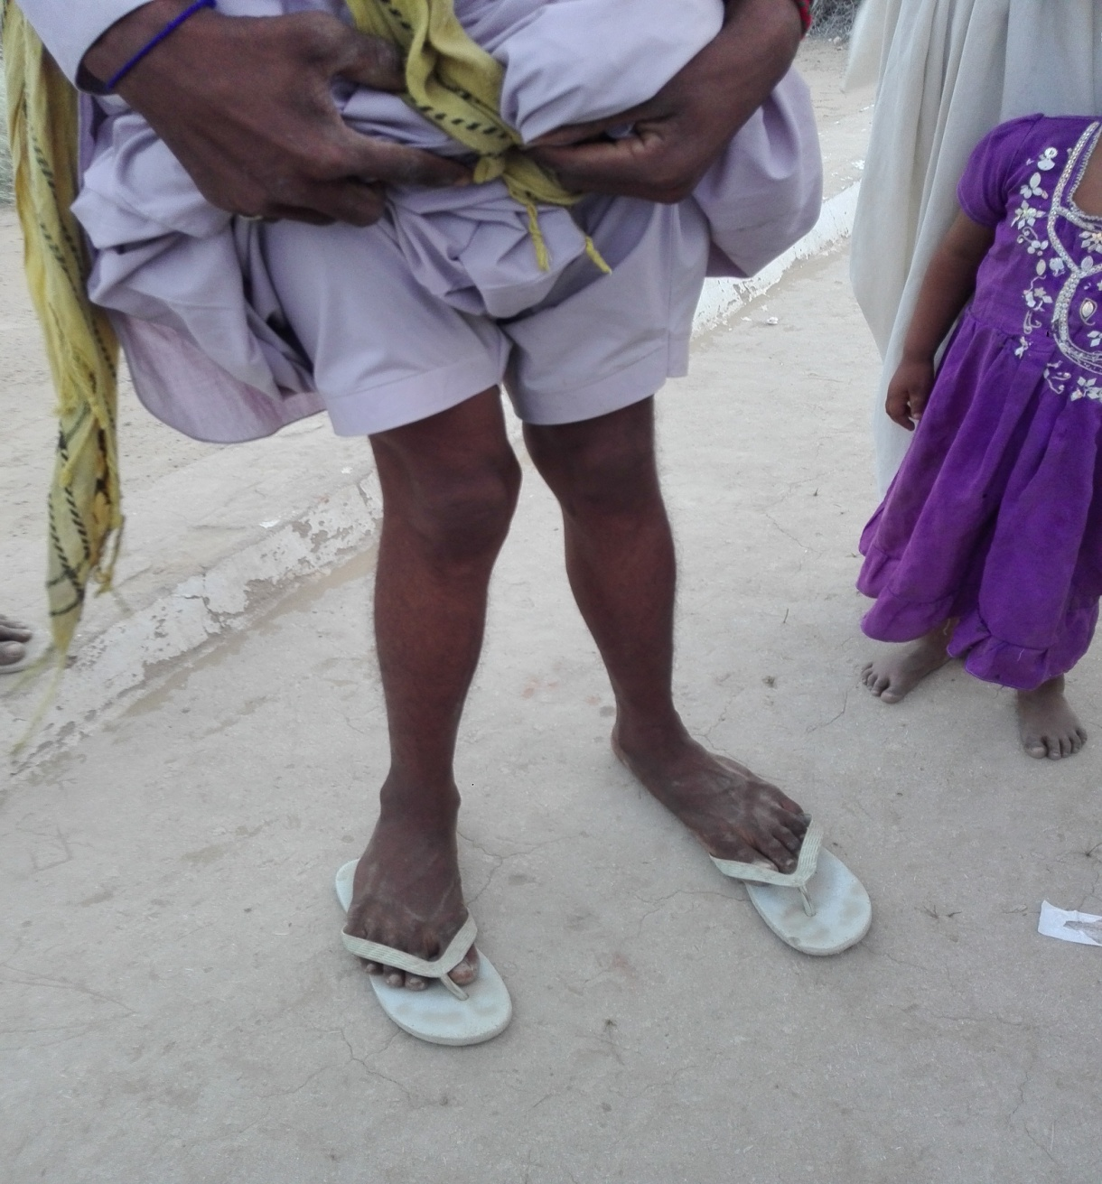

**Figure 1:** Photograph of skeletal fluorosis affected people in study area.