A sensitive and selective fluorescent probe for acetylcholinesterase: synthesis, performance, application and mechanism
Meng Yaoª, Hailiang Nie*ª, Wenxue Yaoª, Guowei Zhang*^{b}
ª Key Laboratory of Public Health Safety of Hebei Province, College of Public Health, Hebei University Baoding 071002, Hebei (China)
^{b} Hebei Collaborative Innovation Center of Tumor Microecological Metabolism Regulation, College of Traditional Chinese Medicine, Hebei University Baoding 071002, Hebei (China)
- Email: niehailiangts@163.com (H. Nie); Fax: +86–312–5079010; Tel: +86–312–5079010.
xxzgw@126.com (G. Zhang); Fax: +86–312–5079526; Tel: +86–312–5079526.

- Fluorescence spectra of BDFA in PBS with different pH
Fig. S1 Fluorescence spectra of BDFA (2 μM) in the absence and presence of AChE (2 U/mL) in PBS solutions of pH 5-9. λex= 470 nm
- Time-dependent fluorescence spectra of BDFA and BDFA-AChE reaction product
Fig. S2 Changes in the fluorescence spectra of BDFA and BDFA-AChE reaction product with storage time. λex= 470 nm

- Study on the BDFA-AChE reaction mechanism by the HPLC method
Fig. S3 Comparison of HPLC spectra of BDFA, BDFAP and BDFA-AChE reaction solution. The compounds were separated by reverse-phase HPLC with equivalent elution [Column: C18, 150×4.6 mm, 3.5 μm; eluent: 20% H₂O / 80% CH₃OH; flow rate: 0.7 mL/min; column temperature: 35 ℃；detection wavelength: 460 nm).

- Comparison of the analytical performance of BDFA and reported AChE fluorescent probes
Table S1 Analytical parameters of BDFA and reported AChE fluorescent probes
Probe  structure | Linear range | Detection limit | Response time | Ref.
 | 1-20  U/mL | 0.36  U/mL | 30 min | J. Am. Chem. Soc., 2019, 141, 2061-2068.
 | 0-8  U/mL | 0.1173 U/mL | 3 h | ACS Sens., 2020, 5, 83−92.
 | 0-20 U/mL | 0.017 U/mL | 6 h | Chem. Sci., 2020, 11, 11285-11292.
 | 0-80 U/mL | 0.127 U/mL | 3 s | Anal. Chem., 2020, 92, 13405-13410.
 | 0-20 U/mL | 0.21 U/mL | 15 min | J. Mater. Chem. B, 2021, 9, 2623–2630
 | 0.0045-1 U/mL | 0.0045 U/mL | 20 min | This work

- Determination of AChE activity in the blood samples
Table S2. Determination of AChE activity in the blood samples by BDFA-based fluorometry and Ellman assayª
Measured AChE activity | Sample | BDFA (u/L) | RSD  (n=3) | Ellman method  (u/L) | RSD  (n=3)
Blood AChE | 1 | 4603.4±171.2 | 3.7% | 4752.5±  206.0 | 4.3%
Blood AChE | 2 | 4683.6±125.5 | 2.7% | 4876.0±  103.4 | 2.1%
Blood AChE | 3 | 4456.8±127.3 | 2.9% | 4647.8±  202.7 | 4.4%
ª The blood samples collected from three healthy volunteers in our laboratory were diluted 20 times with PBS solution (pH 7.0, 10 mM) to prevent blood clotting. Subsequently, ethopropazine hydrochloride (200 μM) was added to the blood samples to inhibit BChE activity. Then, AChE activity in blood samples was determined by BDFA-based fluorometry and Ellman assay, respectively.

- Structural characterization of BDFA and BDFA-AChE reaction product (BDFAP)
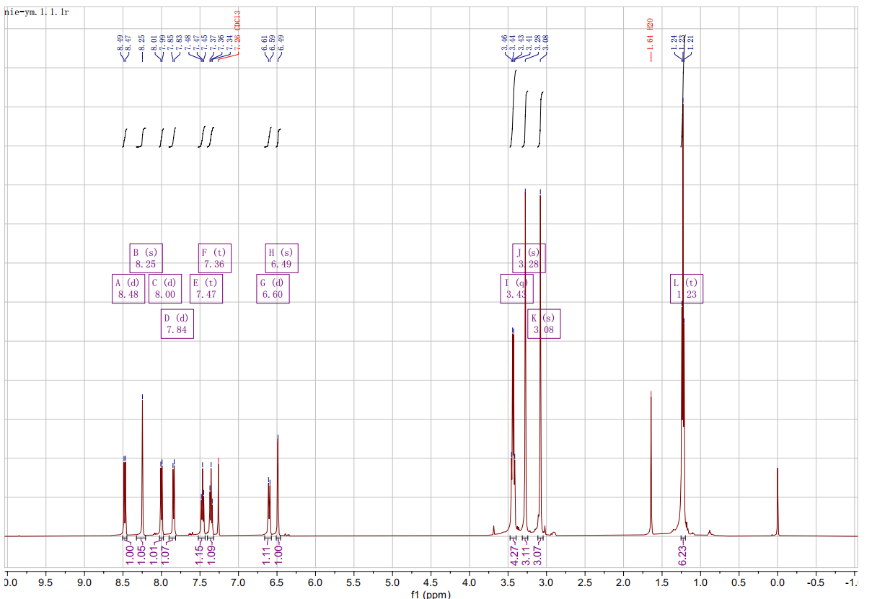
Fig. S4 ¹H-NMR spectra of BDFA

Fig. S5 ¹³C-NMR spectra of BDFA
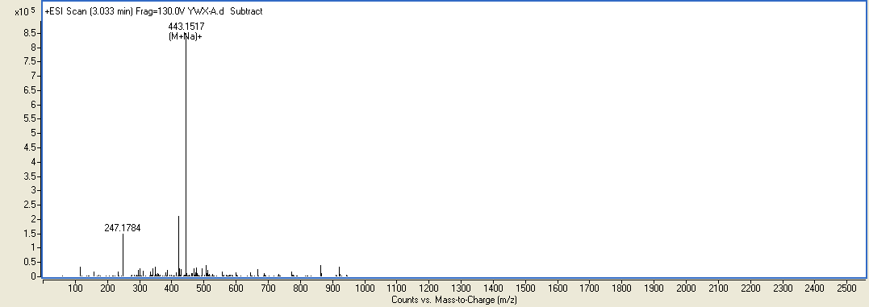
Sample No. | Formula (M) | Ion Formula | Measured m/z | Calc m/z | Diff (ppm)
BDFA | C₂₃ H₂₄ N₄ O₂ S | C₂₃ H₂₄ N₄ Na O₂ S | 443.1517 | 443.1512 | 1.13
Fig.S6 ESI-MS spectra of BDFA

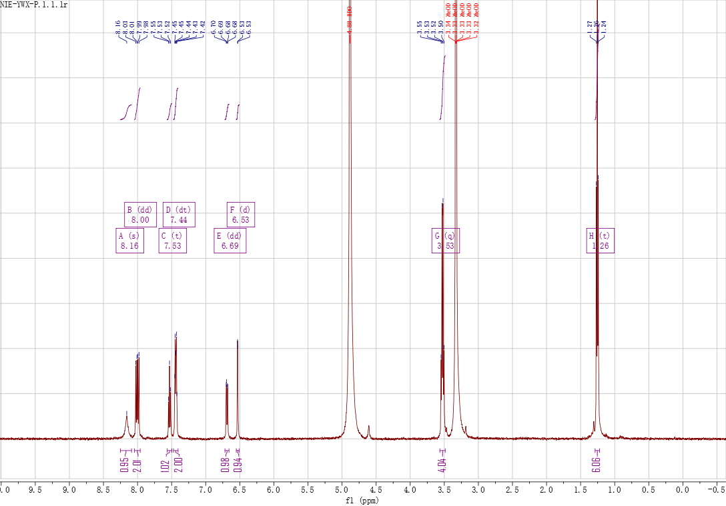
Fig. S7 ¹H-NMR spectra of BDFAP

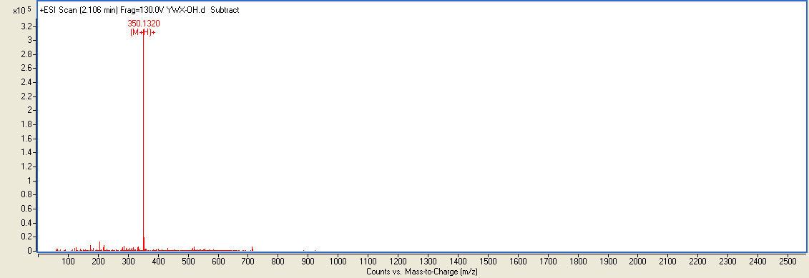
Sample No. | Formula (M) | Ion Formula | Measured m/z | Calc m/z | Diff (ppm)
BDFAP | C₂₀ H₁₉ N₃ O S | C₂₀ H₂₀ N₃ O S | 350.1320 | 350.1322 | 0.57
Fig. S8 ESI-MS spectra of BDFAP

