## Supplementary data

1. **Specific calculation steps of grey correlation analysis (GCA) is as follows:**
2. The measured pharmacodynamics indicators were used as reference sequence; the peak areas of 13 common peaks were used as comparison sequence.
3. The mean value method is used to non-dimensionally process the original data.
4. The correlation coefficient is defined according to the following formula:

 (1)

1. The formula for the grey correlation degree is as follows:

 (2)

1. The order of association is obtained by sorting the grey correlation degree.

Abbreviations: min, minimum; max, maximum; *Ym*(*k*) is the pharmacodynamics indicators; *Yz*(*k*) is the the normalized value of the common peak area; z is the order of common peak; k is the numbers of batches of Taxilli Herba; *ρ* is the resolution coefficient lying from 0 to 1, and it is generally set as 0.5.

1. **Specific calculation steps of Technique for order preference by similarity to ideal solution (TOPSIS) is as follows:**

(1) Normalization of raw data  
 The matrix V consists of assay data normalized according to formula (1) because of the different content (m=1, 2, 3 ... i, n=1, 2, 3... j; in this experiment, m=20, n=5), where m is the evaluation object and n is the evaluation index.

$a_{ij}={x_{ij}}/{\sqrt{\sum_{j=1}^{m}{{(a_{ij}^{+}−a_{ij})}^{2}}}}$ (1)

(2) Selection of optimal and worst schemes

The optimal scheme and the worst scheme are selected based on the normalized matrix results. The optimal solution A+ is the maximum value of 5 evaluation indicators for the samples; the worst solution A– is the minimum value of 5 evaluation indicators for the samples.

1. Calculation of Euclidean distance between each evaluation object and ideal value

The distance between each evaluation object and the optimal and inferior solutions is calculated according to formulas (2) and (3).

$D_{i}^{+}=\sqrt{\sum_{j=1}^{m}{{{(a}_{ij}^{+}−a_{ij})}^{2}}}$ (2)

$D_{i}^{−}=\sqrt{\sum_{j=1}^{m}{{{(a}_{ij}^{−}−a_{ij})}^{2}}}$ (3)

(4) Calculation of the proximity between each evaluation object and the optimal scheme

The relative proximity (*Ci*) of each evaluation object to the optimal solution is calculated according to formula (4), where *Ci* ranges from 0 to 1.

(5) Ranking

The evaluation objects are ranked according to the *Ci* value.

**Table S1.** Establishment and administration of adjuvant-induced arthritis (AIA) model in mice.

|  |  |  |  |  |
| --- | --- | --- | --- | --- |
| Groups | | | Molding ( 8 d ) | Administration  (10 g/d, 21d ) |
| Control | | | 0.1mL of 0.9% NaCl | 0.3 mL of 0.5% CMC-Na |
| Model | | | 0.1mL FCA | 0.3 mL of 0.5% CMC-Na |
| TGT | | | 10 mg/kg |
| Taxilli Herba from two hosts | *Morus alba* L. | High dose | 0.3 g |
| Middle dose | 0.15 g |
| Low dose | 0.075g |
| *Liquidambar formosana* Hance | High dose | 0.3 g |
| Middle dose | 0.15 g |
| Low dose | 0.075 g |

**Table S2.** Results of precision, stability and repeatability.

|  |  |  |  |  |  |  |
| --- | --- | --- | --- | --- | --- | --- |
| Order | the relative peak area, (RSD, %) (n = 6) | | | the relative tR, (RSD, %) (n = 6) | | |
| precision | stability | repeatability | precision | stability | repeatability |
| 1 | 2.145 | 2.716 | 1.853 | 0.247 | 0.191 | 0.072 |
| 2 | 2.096 | 2.621 | 1.625 | 0.254 | 0.086 | 0.116 |
| 3 | 1.117 | 2.704 | 1.251 | 0.120 | 0.066 | 0.085 |
| 4 | 2.797 | 2.685 | 1.910 | 0.074 | 0.041 | 0.084 |
| 5 | 2.866 | 2.253 | 1.504 | 0.092 | 0.060 | 0.056 |
| 6 | 1.283 | 2.684 | 0.382 | 0.086 | 0.041 | 0.062 |
| 7 | 1.945 | 2.836 | 1.633 | 0.110 | 0.067 | 0.060 |
| 8 | 2.325 | 2.278 | 1.450 | 0.082 | 0.028 | 0.066 |
| 9 | 2.936 | 2.338 | 1.243 | 0.083 | 0.044 | 0.063 |
| 10 | 2.155 | 2.081 | 1.565 | 0.079 | 0.097 | 0.051 |
| 11 | 2.619 | 2.339 | 1.582 | 0.094 | 0.036 | 0.071 |
| 12 | 1.443 | 2.319 | 1.959 | 0.250 | 0.044 | 0.084 |
| 13(R) | 0.000 | 0.000 | 0.000 | 0.000 | 0.000 | 0.000 |

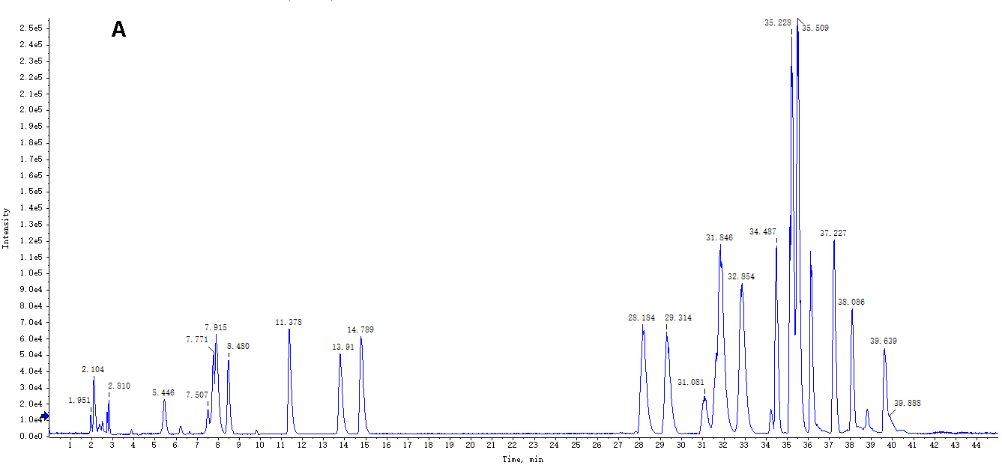

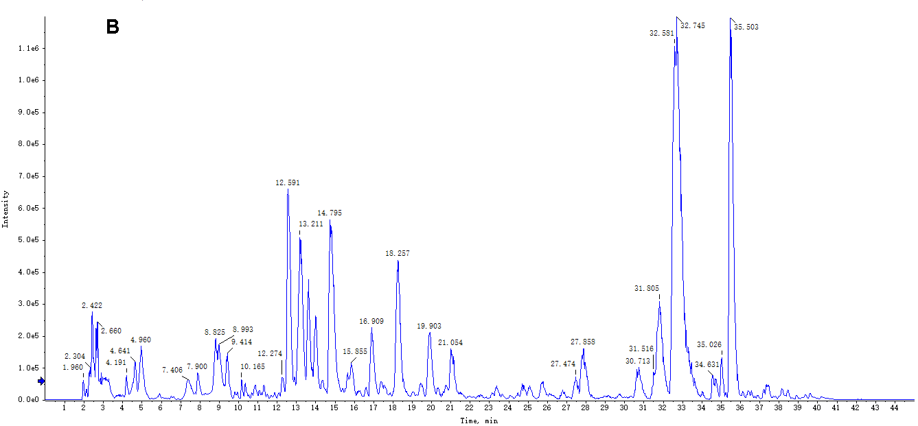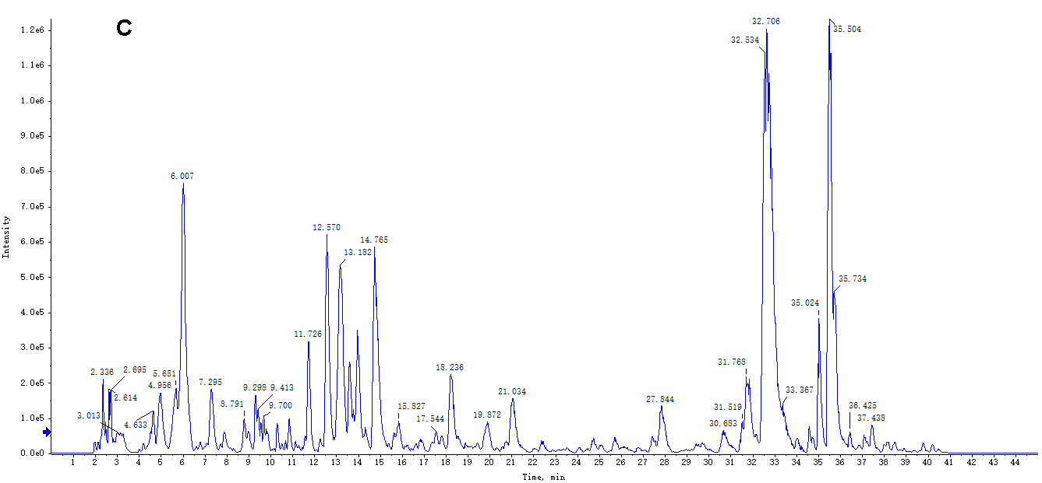

**Fig. S1** HPLC-Triple TOF-MS/MS base peak chromatograms of the reference mixtures (A) and TH samples from *Morus alba* L. (B) and *Liquidambar formosana* Hance (C) under negative ion mode.

**Table S3.** Relative peak area of each common peak from TH samples based on HPLC-Triple TOF-MS/MS under negative ion mode.

|  |  |  |  |  |  |  |  |  |  |  |  |  |  |
| --- | --- | --- | --- | --- | --- | --- | --- | --- | --- | --- | --- | --- | --- |
| Peak No. | **1** | **2** | **3** | **4** | **5** | **6** | **7** | **8** | **9** | **10** | **11** | **12** | **13** |
| S1 | 2094518 | 720627.8 | 663555.9 | 4255384 | 971600.4 | 6633560 | 2867836 | 818768.1 | 847237.1 | 2159350 | 17200370 | 681474.9 | 12243870 |
| S2 | 1899378 | 2429822 | 2132114 | 10117350 | 2599877 | 10308620 | 8876419 | 2712458 | 3032546 | 6106422 | 31779860 | 907244.6 | 17040780 |
| S3 | 1959573 | 2681799 | 1774940 | 10044840 | 5045195 | 12090960 | 6364482 | 3591641 | 3194177 | 7079829 | 23887280 | 912248.1 | 22919620 |
| S4 | 2133376 | 6537389 | 1752405 | 9196537 | 3387122 | 11247180 | 6160052 | 2745947 | 2261768 | 6354659 | 36829900 | 643297.6 | 20673770 |
| S5 | 2299886 | 1941083 | 1155550 | 7017253 | 1876086 | 8632031 | 5717375 | 1713077 | 2511697 | 2758804 | 30436320 | 1366208 | 14940530 |
| S6 | 2259192 | 2522125 | 1469268 | 7673209 | 2402120 | 9581961 | 6735268 | 2347151 | 2920572 | 5820566 | 11889980 | 1173450 | 17426510 |
| S7 | 3379928 | 1463656 | 1248601 | 7233255 | 2280227 | 9016212 | 6485242 | 1798484 | 2503680 | 4017264 | 15470050 | 932672.8 | 16009130 |
| S8 | 1812544 | 2453266 | 1951577 | 10344310 | 2527250 | 10981250 | 8535644 | 2522228 | 3070893 | 6281289 | 32582900 | 932783.1 | 16721570 |
| S9 | 1999259 | 2643620 | 1774409 | 9804626 | 4314996 | 12745380 | 6790351 | 3519209 | 3073304 | 8203136 | 36162780 | 665486 | 22053420 |
| S10 | 2084472 | 3457233 | 1813219 | 8969660 | 4376681 | 10868110 | 6260313 | 2782031 | 2463641 | 5531816 | 34547330 | 862120.5 | 20389800 |
| S11 | 2346019 | 730430.8 | 644222.1 | 6705304 | 3453864 | 8705739 | 3039331 | 2695672 | 2186922 | 3786884 | 17062650 | 3380994 | 15041630 |
| S12 | 2345611 | 765989.6 | 730279.6 | 6669780 | 3872848 | 8270305 | 2969375 | 2587151 | 2087832 | 4128708 | 31341090 | 3260505 | 18537570 |
| S13 | 2284198 | 768310.1 | 656571.1 | 7353701 | 3735457 | 8892831 | 3512623 | 2916197 | 2378888 | 4191983 | 20485020 | 3703785 | 14402210 |
| S14 | 2395051 | 816272.9 | 922740.1 | 6892480 | 3804786 | 8828300 | 3607406 | 2799883 | 2503188 | 4282389 | 9554538 | 3485653 | 14620410 |
| S15 | 2551873 | 844617.9 | 861852.8 | 6645699 | 4043451 | 9014006 | 3267618 | 2844410 | 1630585 | 4598153 | 29593780 | 3353095 | 19755230 |
| S16 | 1659161 | 577035.4 | 662719.1 | 5530046 | 3195811 | 6721299 | 2218227 | 1855399 | 1023911 | 1963859 | 17163830 | 2217819 | 9600822 |
| S17 | 2223383 | 747776.4 | 682501.9 | 6563175 | 3230887 | 8511918 | 3271741 | 2528613 | 2171015 | 3593230 | 31468430 | 2997567 | 13613670 |
| S18 | 1431134 | 330984.3 | 423804.2 | 1363947 | 3900986 | 1873901 | 5639956 | 1170529 | 1204987 | 2052448 | 19725430 | 2119537 | 10638490 |
| S19 | 1574509 | 414384 | 934797.3 | 3755493 | 1672181 | 6083582 | 1694028 | 1306093 | 928737 | 2393985 | 21485340 | 2242214 | 14778730 |
| S20 | 1887396 | 698993.5 | 701452.7 | 6644685 | 3923022 | 7400926 | 2476482 | 2386326 | 1408282 | 2113440 | 21585880 | 2813377 | 10338780 |

* No. S1–S10: TH samples from *Morus alba* L., No. S11–S20: TH samples from *Liquidambar formosana* Hance.

**Table S4.** Similarity evaluation results of 20 batches of Taxilli Herba.

|  |  |  |  |  |  |  |  |  |  |  |  |  |  |  |  |  |  |  |  |  |  |
| --- | --- | --- | --- | --- | --- | --- | --- | --- | --- | --- | --- | --- | --- | --- | --- | --- | --- | --- | --- | --- | --- |
| Samples | S1 | S2 | S3 | S4 | S5 | S6 | S7 | S8 | S9 | S10 | S11 | S12 | S13 | S14 | S15 | S16 | S17 | S18 | S19 | S20 | SR |
| S1 | 1.000 | 0.968 | 0.903 | 0.974 | 0.980 | 0.922 | 0.858 | 0.971 | 0.978 | 0.977 | 0.756 | 0.940 | 0.779 | 0.820 | 0.932 | 0.867 | 0.885 | 0.901 | 0.916 | 0.861 | 0.972 |
| S2 | 0.968 | 1.000 | 0.898 | 0.977 | 0.980 | 0.918 | 0.843 | 0.992 | 0.984 | 0.980 | 0.745 | 0.921 | 0.797 | 0.814 | 0.909 | 0.882 | 0.905 | 0.884 | 0.888 | 0.884 | 0.973 |
| S3 | 0.903 | 0.898 | 1.000 | 0.899 | 0.882 | 0.875 | 0.974 | 0.900 | 0.917 | 0.908 | 0.854 | 0.851 | 0.728 | 0.744 | 0.853 | 0.786 | 0.784 | 0.793 | 0.814 | 0.775 | 0.917 |
| S4 | 0.974 | 0.977 | 0.899 | 1.000 | 0.981 | 0.913 | 0.839 | 0.980 | 0.985 | 0.991 | 0.739 | 0.933 | 0.771 | 0.811 | 0.920 | 0.858 | 0.889 | 0.889 | 0.897 | 0.859 | 0.970 |
| S5 | 0.980 | 0.980 | 0.882 | 0.981 | 1.000 | 0.913 | 0.831 | 0.986 | 0.979 | 0.982 | 0.732 | 0.942 | 0.767 | 0.818 | 0.927 | 0.861 | 0.897 | 0.898 | 0.900 | 0.868 | 0.970 |
| S6 | 0.922 | 0.918 | 0.875 | 0.913 | 0.913 | 1.000 | 0.828 | 0.921 | 0.925 | 0.917 | 0.710 | 0.869 | 0.860 | 0.752 | 0.867 | 0.795 | 0.804 | 0.810 | 0.826 | 0.792 | 0.922 |
| S7 | 0.858 | 0.843 | 0.974 | 0.839 | 0.831 | 0.828 | 1.000 | 0.849 | 0.854 | 0.848 | 0.846 | 0.794 | 0.674 | 0.689 | 0.799 | 0.729 | 0.721 | 0.730 | 0.752 | 0.716 | 0.865 |
| S8 | 0.971 | 0.992 | 0.900 | 0.980 | 0.986 | 0.921 | 0.849 | 1.000 | 0.989 | 0.983 | 0.737 | 0.928 | 0.771 | 0.808 | 0.916 | 0.856 | 0.884 | 0.879 | 0.882 | 0.859 | 0.970 |
| S9 | 0.978 | 0.984 | 0.917 | 0.985 | 0.979 | 0.925 | 0.854 | 0.989 | 1.000 | 0.988 | 0.755 | 0.938 | 0.783 | 0.816 | 0.928 | 0.865 | 0.889 | 0.892 | 0.900 | 0.863 | 0.976 |
| S10 | 0.977 | 0.980 | 0.908 | 0.991 | 0.982 | 0.917 | 0.848 | 0.983 | 0.988 | 1.000 | 0.744 | 0.933 | 0.772 | 0.812 | 0.922 | 0.859 | 0.886 | 0.889 | 0.896 | 0.861 | 0.972 |
| S11 | 0.756 | 0.745 | 0.854 | 0.739 | 0.732 | 0.710 | 0.846 | 0.737 | 0.755 | 0.744 | 1.000 | 0.808 | 0.760 | 0.848 | 0.813 | 0.817 | 0.802 | 0.859 | 0.807 | 0.806 | 0.843 |
| S12 | 0.940 | 0.921 | 0.851 | 0.933 | 0.942 | 0.869 | 0.794 | 0.928 | 0.938 | 0.933 | 0.808 | 1.000 | 0.834 | 0.882 | 0.994 | 0.923 | 0.941 | 0.949 | 0.956 | 0.918 | 0.972 |
| S13 | 0.779 | 0.797 | 0.728 | 0.771 | 0.767 | 0.860 | 0.674 | 0.771 | 0.783 | 0.772 | 0.760 | 0.834 | 1.000 | 0.811 | 0.836 | 0.905 | 0.889 | 0.838 | 0.829 | 0.898 | 0.863 |
| S14 | 0.820 | 0.814 | 0.744 | 0.811 | 0.818 | 0.752 | 0.689 | 0.808 | 0.816 | 0.812 | 0.848 | 0.882 | 0.811 | 1.000 | 0.880 | 0.889 | 0.892 | 0.935 | 0.879 | 0.884 | 0.889 |
| S15 | 0.932 | 0.909 | 0.853 | 0.920 | 0.927 | 0.867 | 0.799 | 0.916 | 0.928 | 0.922 | 0.813 | 0.994 | 0.836 | 0.880 | 1.000 | 0.919 | 0.929 | 0.939 | 0.949 | 0.911 | 0.966 |
| S16 | 0.867 | 0.882 | 0.786 | 0.858 | 0.861 | 0.795 | 0.729 | 0.856 | 0.865 | 0.859 | 0.817 | 0.923 | 0.905 | 0.889 | 0.919 | 1.000 | 0.985 | 0.935 | 0.919 | 0.993 | 0.935 |
| S17 | 0.885 | 0.905 | 0.784 | 0.889 | 0.897 | 0.804 | 0.721 | 0.884 | 0.889 | 0.886 | 0.802 | 0.941 | 0.889 | 0.892 | 0.929 | 0.985 | 1.000 | 0.953 | 0.935 | 0.987 | 0.948 |
| S18 | 0.901 | 0.884 | 0.793 | 0.889 | 0.898 | 0.810 | 0.730 | 0.879 | 0.892 | 0.889 | 0.859 | 0.949 | 0.838 | 0.935 | 0.939 | 0.935 | 0.953 | 1.000 | 0.953 | 0.931 | 0.947 |
| S19 | 0.916 | 0.888 | 0.814 | 0.897 | 0.900 | 0.826 | 0.752 | 0.882 | 0.900 | 0.896 | 0.807 | 0.956 | 0.829 | 0.879 | 0.949 | 0.919 | 0.935 | 0.953 | 1.000 | 0.909 | 0.946 |
| S20 | 0.861 | 0.884 | 0.775 | 0.859 | 0.868 | 0.792 | 0.716 | 0.859 | 0.863 | 0.861 | 0.806 | 0.918 | 0.898 | 0.884 | 0.911 | 0.993 | 0.987 | 0.931 | 0.909 | 1.000 | 0.931 |
| SR | 0.972 | 0.973 | 0.917 | 0.970 | 0.970 | 0.922 | 0.865 | 0.970 | 0.976 | 0.972 | 0.843 | 0.972 | 0.863 | 0.889 | 0.966 | 0.935 | 0.948 | 0.947 | 0.946 | 0.931 | 1.000 |

**Table S5.** Effect of TH on body weight of AIA model mice (mean ± SD, n = 10).

|  |  |  |  |  |  |
| --- | --- | --- | --- | --- | --- |
| Groups | Body weight (g) | | | | |
| 0d | 8d | 15d | 22d | 29d |
| Control | 20.07±1.74 | 23.59±2.69 | 27.85±2.53 | 31.67±2.86 | 33.86±2.38 |
| Model | 20.81±1.23 | 22.69±1.69 | 25.69±1.42# | 27.63±1.59## | 29.41±1.71## |
| TGT | 20.87±1.48 | 22.35±1.92 | 25.40±1.63 | 30.32±1.77** | 35.19±2.16** |
| SHD | 20.05±1.92 | 22.41±1.24 | 25.17±1.90** | 30.42±1.92** | 34.40±2.16** |
| SMD | 20.19±0.72 | 22.89±1.30 | 25.12±2.14** | 31.58±3.02** | 33.87±2.44** |
| SLD | 20.81±2.09 | 22.12±2.65 | 25.72±2.66 | 29.39±3.15 | 31.15±4.21 |
| FHD | 20.65±1.72 | 22.19±3.15 | 25.40±2.95 | 30.26±2.11* | 34.25±2.71** |
| SMD | 20.24±2.80 | 22.05±3.38 | 25.74±4.12 | 30.04±4.88 | 33.86±3.17** |
| FLD | 20.99±1.55 | 22.56±1.75 | 25.41±1.78 | 29.79±1.78* | 31.49±1.53* |

#compared with model group (*p* < 0.05) ; ## compared with control group (*p* < 0.01) ; *compared with model group (*p* < 0.05) ; ** compared with model group (*p* < 0.01).

**Table S6.** Effect of TH on swelling degree of AIA model mice (mean ± SD, n = 10).

|  |  |  |  |  |  |
| --- | --- | --- | --- | --- | --- |
| Groups | Ankle diameter (mm) | | | | |
| 0d | 8d | 15d | 22d | 29d |
| Control | 3.39±0.17 | 3.14±0.08 | 3.03±0.07 | 2.77±0.13 | 2.76±0.14 |
| Model | 3.34±0.09 | 5.07±0.11# | 5.20±0.07# | 4.91±0.10# | 4.88±0.24# |
| TGT | 3.31±0.09 | 5.28±0.19* | 4.95±0.08** | 4.66±0.10** | 4.43±0.19** |
| SHD | 3.40±0.20 | 5.51±0.15** | 4.95±0.40** | 4.58±0.28** | 4.39±0.32** |
| SMD | 3.46±0.14 | 5.54±0.16** | 4.99±0.28* | 4.71±0.26** | 4.55±0.22** |
| SLD | 3.39±0.08 | 5.60±0.26** | 5.25±0.35 | 4.92±0.26 | 4.85±0.20 |
| FHD | 3.41±0.20 | 5.80±0.17** | 4.93±0.37* | 4.57±0.44** | 4.48±0.50** |
| FMD | 3.39±0.19 | 5.45±0.20** | 5.12±0.21 | 4.72±0.35* | 4.62±0.23** |
| FLD | 3.42±0.17 | 5.52±0.41** | 5.24±0.35 | 5.13±0.31 | 4.94±0.30 |

#compared with model group (*p* < 0.05) ; ## compared with control group (*p* < 0.01) ; *compared with model group (*p* < 0.05) ; ** compared with model group (*p* < 0.01).

**Table S7.** Effect of TH on level of serum IL-10, TNF-ɑ, IL-1β, and IL-6 and immune organ indexes of AIA model mice (mean ± SD, n = 10).

|  |  |  |  |  |  |  |
| --- | --- | --- | --- | --- | --- | --- |
| Groups | IL-10 (pg/mL) | TNF-ɑ  (pg/mL) | IL-1β  (pg/mL) | IL-6  (pg/mL) | Thymus index (mg/g) | Spleen index (mg/g) |
| Control | 106.76 ± 10.63 | 132.71 ±8.99 | 15.23 ± 2.80 | 7.45 ± 3.06 | 0.97 ± 0.01 | 3.10 ± 0.005 |
| Model | 42.28 ± 1.84# | 177.24 ±5.33# | 42.18 ± 4.87# | 29.15 ± 0.95# | 1.48 ± 0.02# | 4.27 ± 0.01# |
| TGT | 85.03 ± 3.64** | 131.76 ±9.21** | 28.13 ± 3.47** | 12.75 ± 1.24** | 1.07 ± 0.02** | 2.93 ± 0.01** |
| SHD | 92.45 ± 6.01** | 132.83 ±7.78** | 22.01 ± 1.03** | 10.31 ± 3.10** | 1.11 ± 0.01** | 3.27 ± 0.00** |
| SMD | 67.28 ± 5.86** | 151.05 ±0.98** | 31.55 ± 0.99* | 20.68 ± 1.75** | 1.34 ± 0.02* | 3.66 ± 0.01* |
| SLD | 57.88 ± 4.30 | 164.38 ±2.79 | 37.30 ± 0.77 | 28.34 ± 1.35 | 1.54 ± 0.01 | 4.22 ± 0.01 |
| FHD | 83.31 ± 4.80** | 138.07 ±6.18** | 25.29 ± 1.69** | 12.63 ± 0.36** | 1.13 ± 0.02** | 3.44 ± 0.00** |
| FMD | 64.52 ± 4.27 | 158.55 ±7.90* | 33.05 ± 3.92* | 27.02 ± 0.64* | 1.45 ± 0.01* | 4.23 ± 0.01* |
| FLD | 51.33 ± 3.49 | 166.76 ±6.26 | 36.44 ± 2.61 | 30.43 ± 0.66 | 1.48 ± 0.02 | 4.41 ± 0.00 |

#compared with model group (*p* < 0.05) ; ## compared with control group (*p* < 0.01) ; *compared with model group (*p* < 0.05) ; ** compared with model group (*p* < 0.01).

**Table S8.** Regression equations of IL-10, TNF-ɑ, IL-1β, and IL-6.

|  |  |  |  |
| --- | --- | --- | --- |
| Names | Regression Equation | r | Liner Range (pg/mL) |
| IL-10 | Y = 0.0029X + 0.1774 | 0.9989 | 12.5 – 400 |
| TNF-ɑ | Y = 0.0021X + 0.0683 | 0.9903 | 20 – 640 |
| IL-1β | Y = 0.0087X + 0.153 | 0.9916 | 3.75 – 120 |
| IL-6 | Y = 0.014X + 0.0437 | 0.9917 | 3.75 – 120 |

**Table S9.** Regression equations, LOD, and LOQ of 5 constituents.

|  |  |  |  |  |  |  |
| --- | --- | --- | --- | --- | --- | --- |
| No. | Analytes | Calibration curves | r | Linear range (ng/mL) | LOD  (ng/mL) | LOQ  (ng/mL) |
| 1 | Isosakuranetin | Y = 7540X – 11 800 | 0.999 4 | 3.08 – 789.1 | 0.48 | 1.60 |
| 2 | (+)-catechin | Y = 968X +12 800 | 0.999 3 | 189.45 – 24 250 | 40.60 | 135.32 |
| 3 | Hyperoside | Y = 2350X + 54 100 | 0.999 1 | 4.82 – 9 880 | 1.29 | 4.28 |
| 4 | Isoquercitrin | Y = 867X + 461 000 | 0.999 1 | 24.49 – 25 075 | 5.01 | 16.70 |
| 5 | Quercitrin | Y = 3980X + 608 000 | 0.999 7 | 17.76 – 36 375 | 2.26 | 7.55 |

**Table S10.** Precision, repeatability, stability, and recovery of 5 constituents.

|  |  |  |  |  |  |  |  |  |
| --- | --- | --- | --- | --- | --- | --- | --- | --- |
| No. | Analytes | Precision  (RSD, %, n = 6) | | Repeatability  (RSD, %) | Stability  (RSD, %) | Recovery  (%, n = 3) | | Matrix  Effect |
| Intra-Day  (n = 6) | Inter-Day  (n = 9) | (n = 6) | (n = 6) | Mean | RSD |  |
| 1 | Isosakuranetin | 1.12 | 3.52 | 3.65 | 4.58 | 98.03 | 2.78 | 1.03 |
| 2 | (+)-catechin | 1.63 | 2.93 | 3.29 | 3.25 | 100.54 | 1.63 | 0.98 |
| 3 | Hyperoside | 1.27 | 1.67 | 1.65 | 1.37 | 99.25 | 2.04 | 1.03 |
| 4 | Isoquercitrin | 1.39 | 1.33 | 2.41 | 1.75 | 100.86 | 1.42 | 0.97 |
| 5 | Quercitrin | 1.80 | 1.77 | 2.94 | 1.43 | 99.97 | 2.18 | 0.95 |

**Table S11.** Content of 5 constituents in samples. (μg/g, mean ± SD, n = 3)

|  |  |  |
| --- | --- | --- |
| Analytes | Content | |
| S1−10 | S11−20 |
| Isosakuranetin | 0.81 ± 0.16 | 0.56 ± 0.11 |
| (+)-Catechin | 7069.51 ± 25.30 | 4491.12 ± 16.72 |
| Isoquercitrin | 3492.41 ± 16.52 | 3227.27 ± 18.94 |
| Hyperoside | 1557.08 ± 10.11 | 1071.83 ± 26.60 |
| Quercitrin | 5670.83 ± 12.00 | 3360.38 ± 12.67 |