**Supplementary Material**

**Carbazole-based Schiff base: A sensitive fluorescent ‘turn-on’ chemosensor for recognition of Al(III) ions in aqueous-alcohol media**

A triphenylamine-functionalized ﬂuorescent organic

polymer as a turn-on ﬂuorescent sensor for Fe

3+

ion

with high sensitivity and selectivity

A triphenylamine-functionalized ﬂuorescent organic

polymer as a turn-on ﬂuorescent sensor for Fe

3+

ion

with high sensitivity and selectivity

A triphenylamine-functionalized ﬂuorescent organic

polymer as a turn-on ﬂuorescent sensor for Fe

3+

ion

with high sensitivity and selectivity

A triphenylamine-functionalized ﬂuorescent organic

polymer as a turn-on ﬂuorescent sensor for Fe

3+

ion

with high sensitivity and selectivity

A triphenylamine-functionalized ﬂuorescent organic

polymer as a turn-on ﬂuorescent sensor for Fe

3+

ion

with high sensitivity and selectivity

**Feyza Kolcu a,b and İsmet Kayaa\***

aÇanakkale Onsekiz Mart University, Faculty of Science and Arts, Department of Chemistry, Polymer Synthesis and Analysis Lab., Çanakkale, Turkey

bLapseki Vocational School, Department of Chemistry and Chemical Processing Technologies, Çanakkale Onsekiz Mart University, Çanakkale, Turkey

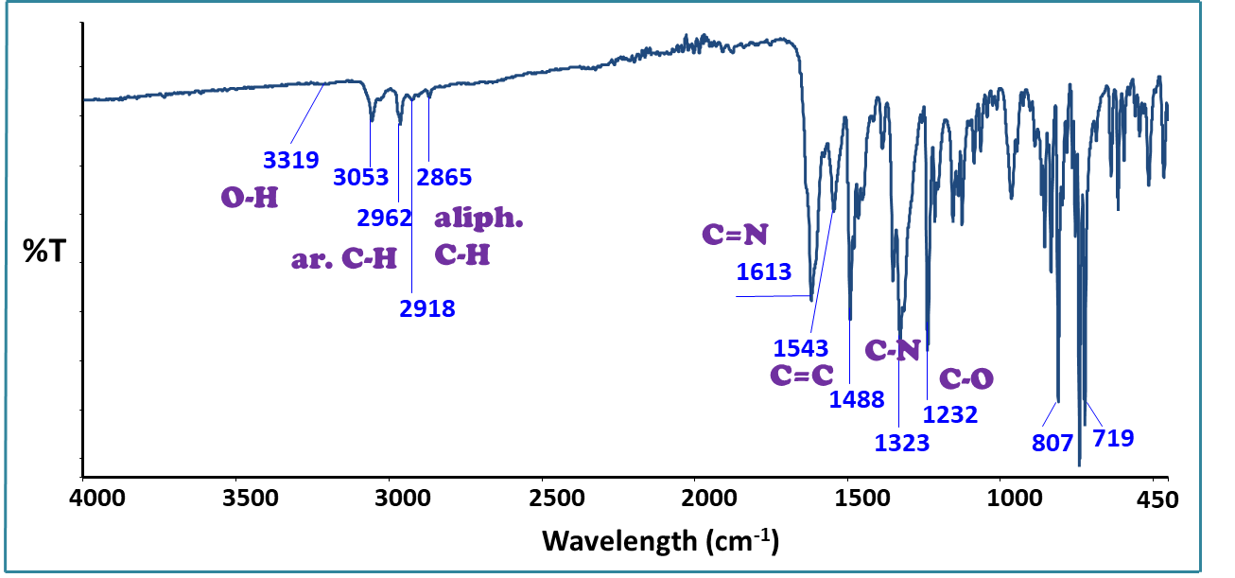

**Fig. S1.** FT-IR spectrum of the synthesized Schiff base (Ligand, L).



**Fig. S2.** 1H NMR spectra of (a) Schiff base (Ligand, L), and (b) L+Al3+ (1:1, v/v)



**Fig. S3.** 13C NMR spectrum of Schiff base (Ligand, L).



**Fig. S4.** Time-resolved photoluminescence spectrum for photostability of L-Al3+ system in EtOH/deionized H2O (1:1, v:v, ex=320 nm, em=533 nm, excitation and emission slit widths = 5 nm).

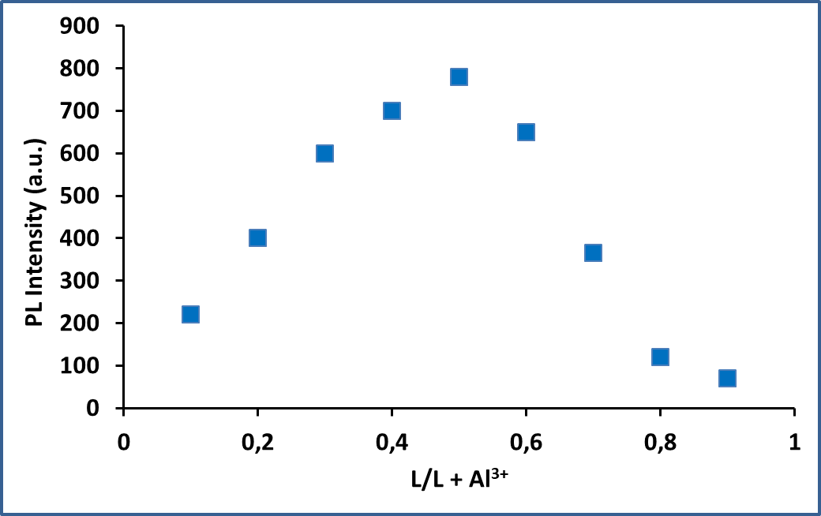

**Fig. S5.** Job’s plot of L-Al3+ complexin EtOH: H2O (1:1, v:v) at 533 nm of PL emission intensity.



**Fig. S6.** LC-MS/MS spectrum of the L.



**Fig. S7.** LC-MS/MS spectrum of Ligand+Al3+

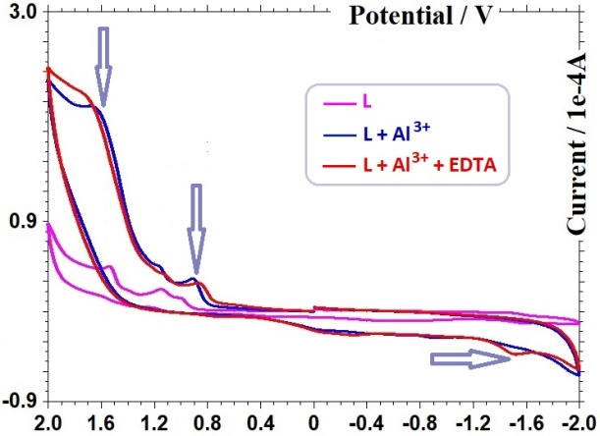

**Fig. S8.** CV profiles of L, L+Al3+ complex, and L+Al3+ with EDTA ( 1.0 eqv.).