**SUPPLEMENTARY MATERIAL**

**Prediction of COVID-19 manipulation by selective ACE inhibitory compounds of *Potentilla reptans* root: *In silico* study and ADMET profile**

**Running title:**

*Potentilla reptans* L. manipulate COVID-19.

**\* Corresponding authors**: Dr. Ayesheh Enayati, Hassan Mirzaeiand Aref Salehicontribute equally to this work.

Address: Ischemic Disorders Research Center, Golestan University of Medical Sciences, Gorgan, Iran. P.O.BOX. 4934174515.

Tel.: +98-17-32451434, FAX: +98-173-2451434.

Email: [enayati_phyto@yahoo.com](mailto:enayati_phyto@yahoo.com), [mirzaei22@yahoo.com](mailto:mirzaei22@yahoo.com), aref.salehi50@yahoo.com

**Abstract**

**Background and objectives:** In the novel SARS-CoV-2 (COVID-19) as a global emergency event, the main reason of the cardiac injury from COVID-19 is angiotensin-converting enzyme 2 (ACE2) targeting in SARS-CoV-2 infection. The inhibition of ACE2 induces an increase in the angiotensin II (Ang II) and the angiotensin II receptor type 1 (AT1R) leading to impaired cardiac function or cardiac inflammatory responses. The ethyl acetate fraction of *Potentilla reptans* L. root can rescue heart dysfunction, oxidative stress, cardiac arrhythmias and apoptosis. Therefore, isolated components of *P. reptans* evaluated to identify natural anti-SARS-CoV-2 agents via molecular docking.

**Methods:** *In silico* molecular docking study were carried out using the Auto Dock software on isolated compounds of *Potentilla reptans* root and captopril. The protein targets obtained from Protein Data Bank (PDB). The best binding pose between amino acid residues involved in active site of the targets and compounds was discovered via molecular docking. Furthermore, ADMET properties of the compounds were evaluated.

**Results:** The triterpenoids of *P. reptans* showedmore ACE inhibitory potential than catechin in both domains. They were selective on the nACE domain, especially compound **5.** Also, the compound **5** & **6** had the highest binding affinity toward active site of nACE, cACE, AT1R, ACE2, and TNF-α receptors. Meanwhile, compound **3** showed more activity to inhibit TXA2. Drug likeness and ADMET analysis showed that the compounds passed the criteria of drug likeness and Lipinski rules.

**Conclusion:**The current study depicted that *P. reptans* root showed cardioprotective effect in COVID-19 infection and manipulation of angiotensin II-induced side effects**.**

**Keyword:** COVID-19, *Potentilla reptans*, Angiotensin II, Molecular docking simulation, ADMET.

**Molecular docking of the compounds**

**S1.** Results

**Figure S1.** Pictorial presentation (3D) of compound **5** and 6EN5 (nACE).

**Figure S2.** Pictorial presentation (3D) of compound **6** and 6F9U (cACE).

**Figure S3.** Pictorial presentation (3D) of captopriland 6F9U (cACE).

**Figure S4.** Pictorial presentation (3D) of compound **6** and 6F9T (cACE).

**Figure S5.** Pictorial presentation (3D) of compound **6** and 2OC2 (cACE).

**Figure S6.** Pictorial presentation (3D) of compound **5** and 4ZUD (AT1R).

**Figure S7.** Pictorial presentation (3D) of compound **6** and 4YAY (AT1R).

**Figure S8.** Pictorial presentation (3D) of compound **5** and 1R4L (ACE2).

**Figure S9.** Pictorial presentation (3D) of compound **6** and 2AZ5 (TNF-α).

**Figure S10.** Pictorial presentation (3D) of compound **3** and 6IIU (TXA2).

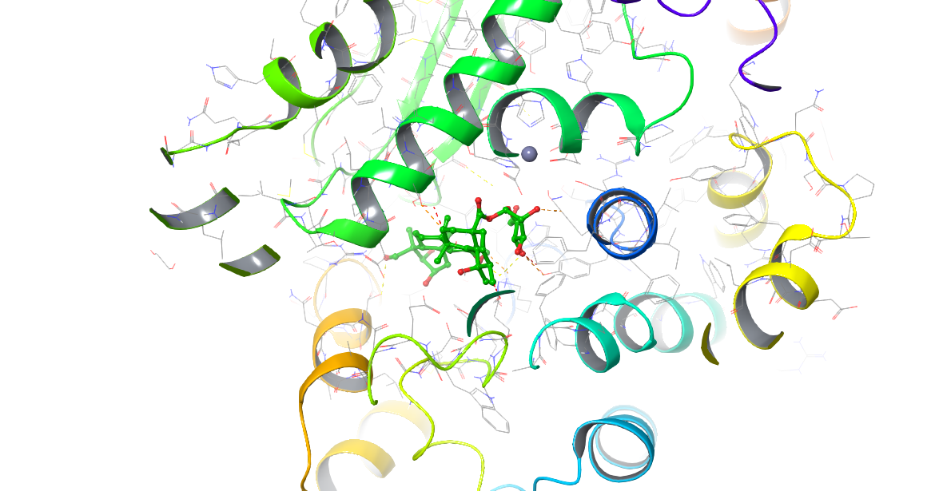

**Figure S1.** Pictorial presentation (3D) of compound **5** and 6EN5 (nACE).

The analysis of the interactions between compound **6** and target of 6F9U illustrated that amino acid residues such as Phe527, Phe457, Val518, Tyr520, Tyr523, Ala354, Cys352, Pro163, Leu161, Cys370, Val380, Val379 and Trp279 involved in the active site of the target through hydrophobic interaction, and also, the polar interactions with residues like His513, Ser355, His353, Thr166, Gln369, Lys511, Glu162, Ser526, THr371, Asn374, Glu376, Glu384, His387, Gln530 were showed. Furthermore, the hydroxyl groups of compound **6,** formed 11 hydrogen bond with residues Lys454, Asp415, Val370, Asp377, Thr372, Cys352, Ala354, Thr372, Cys370, Met278 and Asn277 at a distances of 2.52, 2.65, 2.34, 2.99, 3.31, 2.58, 2.87, 1.75, 2.82, 2.72, and 3.04 Å, respectively. While captopril as standard drug revealed a binding energy of -7.4 kcal/mol and interacted with acid residues such as Cys370, Ala354, Cys352, Val380, Pro163 through hydrophobic interaction, and also, the polar interactions with residues like Gln369, Thr372, Asn374, Thr166, His353, Asp377, Glu162 were illustrated. Moreover, captopril exhibited five hydrogen bond with residues Thr166, Glu162, Ala354, Cys370 at a distances of 2.93, 1.99, 2.38, 1.21 and 2.78 Å, respectively. obtained results demonstrated compound 6 with lower binding energy and strong non-covalent interactions with the receptor had the higher binding affinity toward active site of 6F9U compared to captopril.

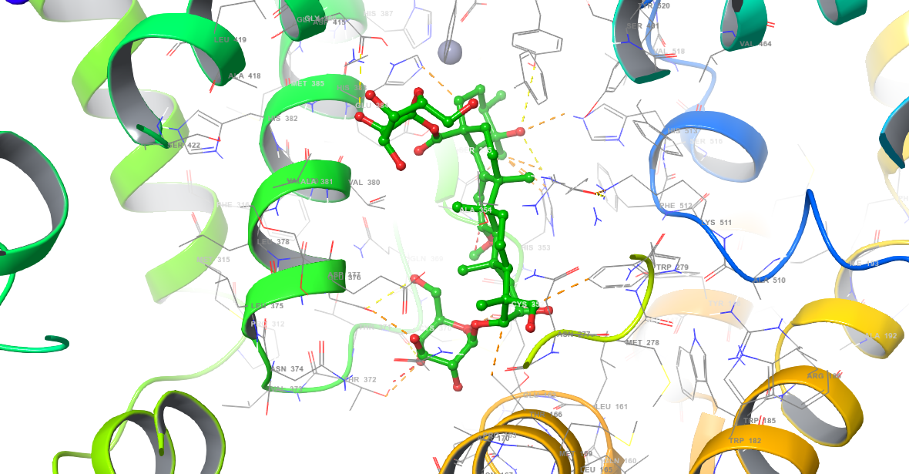

**Figure S2.** Pictorial presentation (3D) of compound **6** and 6F9U (cACE).

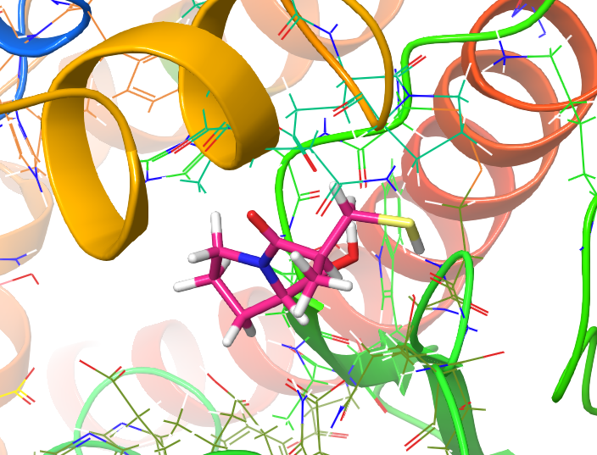

**Figure S3.** Pictorial presentation (3D) of captopril and 6F9U (cACE).

Compound **6** revealed the lowest dock score (binding energy) and best orientations toward 6F9T receptor. Amino acid residues such as Phe391, Tyr394, Trp357, Pro407, Tyr523, Pro407, Val351, Val518 and Phe512 involved in the active site of the target through hydrophobic interaction. Also, compound **6** formed polar interaction with residues like Glu403, His410, Ser355, Arg522, Lys368, Asn70, Ser516, His513, His 383, his387, Glu384. Moreover, hydroxyl and carbonyl groups of the compound **6** formed nine hydrogen bonds with residues His353, Ala354, Ala356, Asp358, Trp360 and Glu411 at the distances 3.05, 3.03, 2.67, 1.89, 2.51, 2.28, 2.29, and 3.16 Å, respectively.

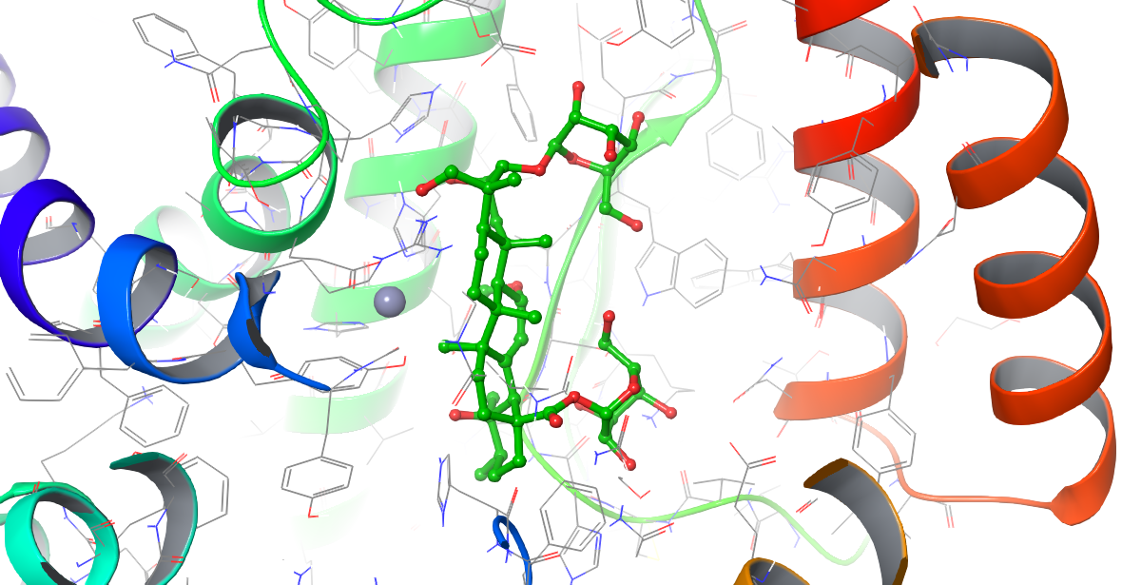

**Figure S4.** Pictorial presentation (3D) of compound **6** and 6F9T (cACE).

The interactions between compound **6** and 2OC2 showed the amino acid residues Phe512, Val518, Pro519, Tyr523, Met223, Phe391, Tyr394, Trp59, Trp357, Tyr360, Pro407, Ala354, Ala356 and Val351 formed the hydrophobic interaction with compound **6**. In addition, compound **6** revealed its polar interaction with target’s active site at residues Asn66, His513, ser516, Arg522, Lys118, Arg402, Glu403, Glu411, His410, Ser355, His353, His387, Glu384, Lys368, and Asn70. Likewise, hydroxyl groups of the compound **6** formed hydrogen bond with residues His513, Ala354, His353, His410, Arg402, Tyr360 and Asn70 at the distances 2.78, 2.55, 2.83, 2.79, 2.91, 2.56, 2.34, 3.09, 3.07, 3.22 and 2.88 Å, respectively.

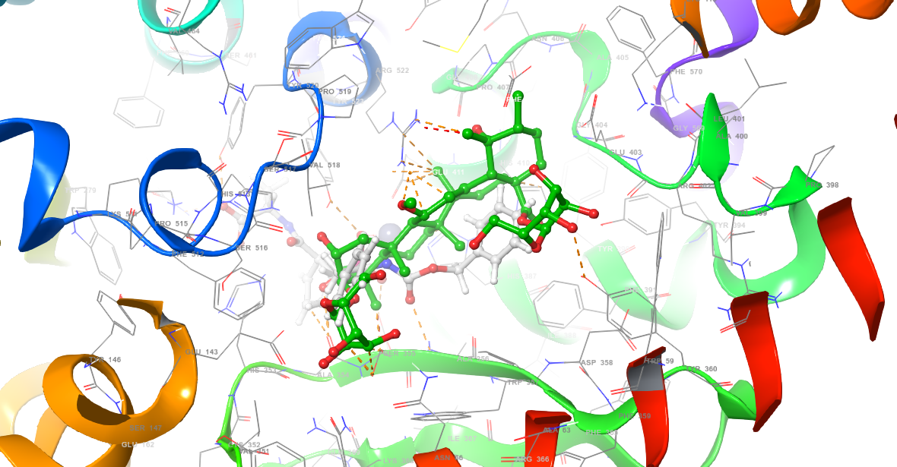

**Figure S5.** Pictorial presentation (3D) of compound **6** and 2OC2 (cACE).

The analysis of the interactions between compound **5** and target of 4ZUD (AT1R) illustrated that amino acid residues such as Ile288, Pro285, Met284, Trp84, Tyr92, Tyr87, Tyr35, Tyr292, Ile31, Pro162, Val163, Leu112, Phe182 and Trp253 involved in the active site of the target through hydrophobic interaction, and also, the compound **5** formed polar interaction with residues like Ser160, Ser105, Arg167, Ser109, Lys199, Thr260, His256. Furthermore, the hydroxyl groups of the compound **5** exhibited hydrogen bonds with residues Arg167, Tyr184, Ser109, Val108 and Thr88 at the distances of 2.80, 1.68, 3.01, 3.04, 3.08 and 2.31 Å, respectively. Notably, Zinc atom interacted with compound **5** at distance of 2.9 Å.

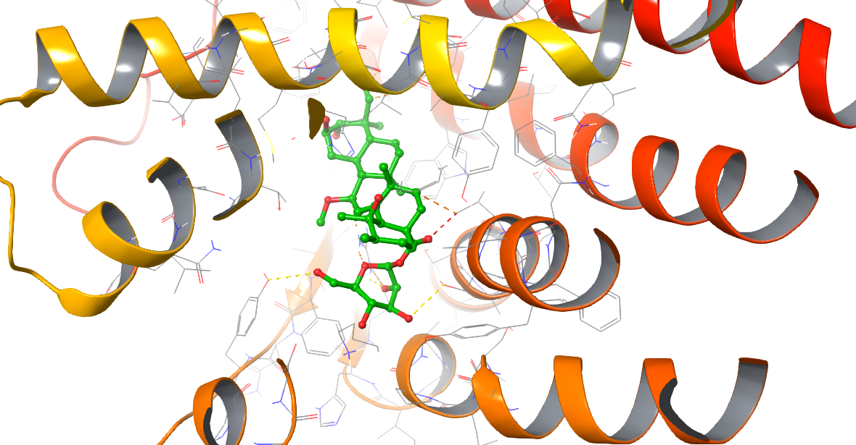

**Figure S6.** Pictorial presentation (3D) of compound **5** and 4ZUD (AT1R).

Compound **6** formed the hydrophobic interactions with the amino acid residues Tyr184, Cys180, Ala181, Val179, Tyr87, Val108, Phe77, Leu81, Tyr292, Lys298, Ile288, Tyr35, Met284, Ile31 and Tyr92 of 4YAY (AT1R) protein. Also, compound **6** represented polar interaction with residues Ser15, Gln267, Asp263, Asp281, Arg167. Furthermore, the hydroxyl groups of compound **6** interacted with the residues Phe182, Cys180, Tyr87, Trp84, Thr88, Pro285, Tyr184 and Gln267 through hydrogen bonding at the distances 2.58, 3.27, 2.62, 2.90, 2.0, 3.21, 2.19, 2.54 and 1.77 Å, respectively.

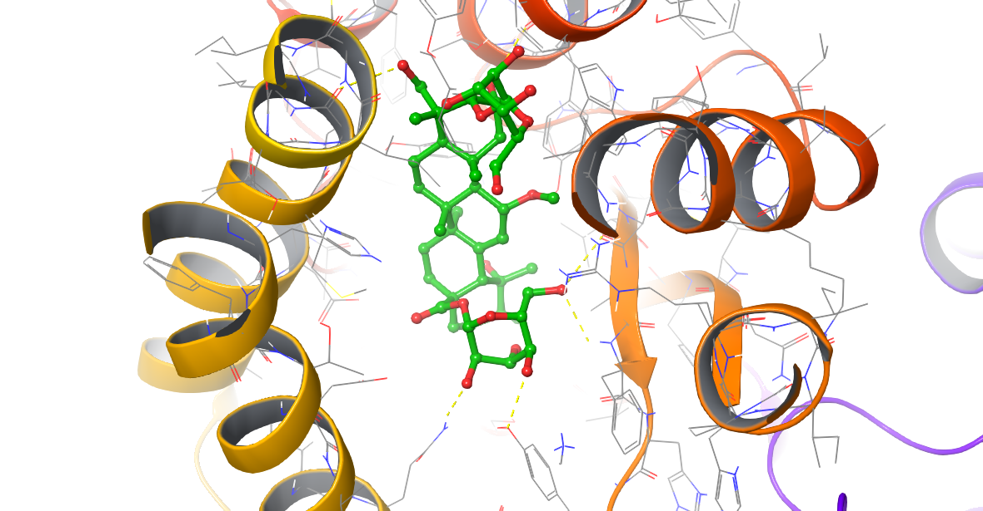

**Figure S7.** Pictorial presentation (3D) of compound **6** and 4YAY (AT1R).

The analysis of the interactions between compound **5** and target of 1R4L (ACE2) illustrated that amino acid residues Ala153, Cys361, Met360, Tyr127, Leu144, Met270, Trp271, Tyr515, Phe504 and Phe274 of the target interacted with compound **5** through hydrophobic interactions. While, the compound **5** formed polar interaction with residues Thr371, Thr365, Asp368, Lys363, Glu145, Asp269, Arg273, His505, His345, Arg518, Asn277. Furthermore, the hydroxyl groups of compound **6** formed seven hydrogen bond with residues Asp367, ASn149, Tyr127, His354, Cys344 and Glu375 at the distances of 2.98, 2.52, 2.23, 2.26, 2.64, 3.26 and 2.30 Å, respectively. Also, Zinc element interacted with compound **5** at the distance of 2.9 Å.

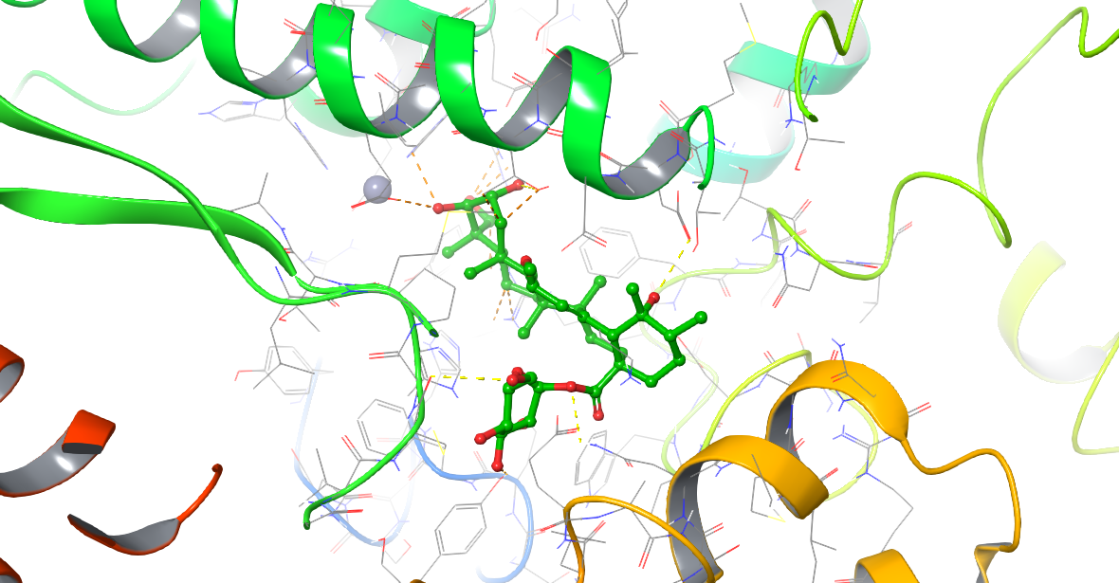

**Figure S8.** Pictorial presentation (3D) of compound **5** and 1R4L (ACE2).

The compound **6** interacted with 2AZ5 (TNF-α) protein in the active amino acid residues Ile155, Tyr151, Tyr59, Ile58, leu57, Tyr119, Gly121, Gly122 and the A ring and Tyr59, Tyr151, Leu57, Ile155, Tyr119, Leu120 and Ile58 through hydrophobic interaction. In addition, the compound **6** formed polar interaction with residues Gln61, Thr298, Ser60, Hid15. Furthermore, hydroxyl groups of the compound **6** represented hydrogen bonds between the A ring and residues Ile58, Tyr50 and Tyr151 and Tyr151, at the distances of 2.0, 2.39, 1.68, and 1.60 Å, respectively. Moreover, compound **6** formed hydrogen bonds between the hydroxyl groups of B ring with residues Ser60 and Leu120 at the distances of 2.04 and 2.30 Å, respectively.

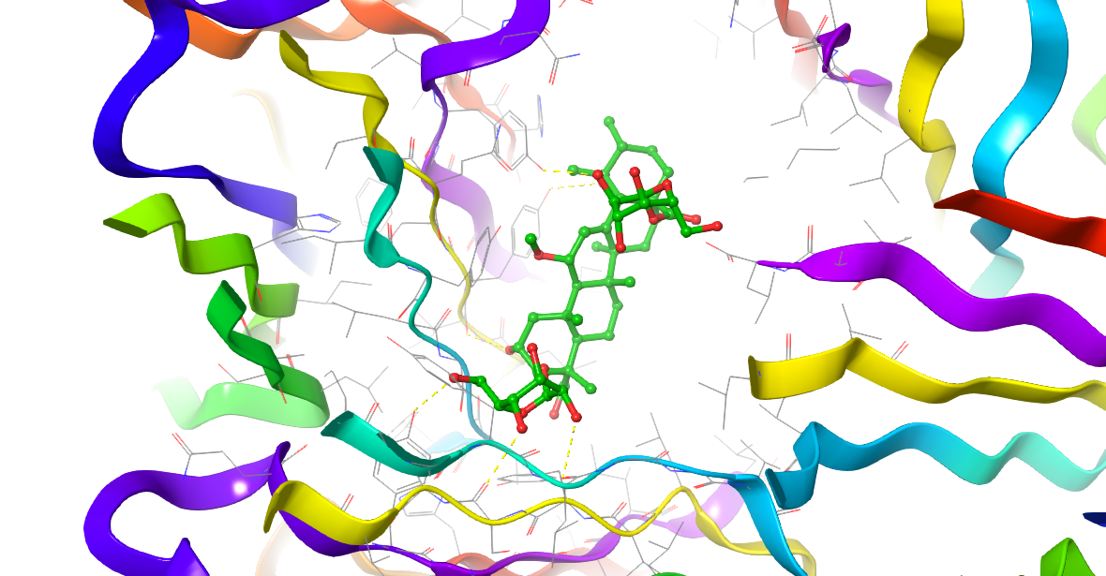

**Figure S9.** Pictorial presentation (3D) of compound **6** and 2AZ5 (TNF-α).

Compound **3** interacted with 6IIU amino acid residues Trp258, Phe115, Trp299, Trp182, Ala297, Pro179, Leu294, Cys35, Phe34, Leu291, Ala31, Phe30, Val85, Leu78, Met108, Val111 and Met112 in the active site of the target through hydrophobic interaction. The compound **3** formed polar interaction with residues Gln301, Thr298, Ser181, Hid89, Thr81. Furthermore, its hydroxyl groups showed two hydrogen bond with residues Trp209 and Arg295 at the distances of 2.72 and 2.06 Å, respectively.

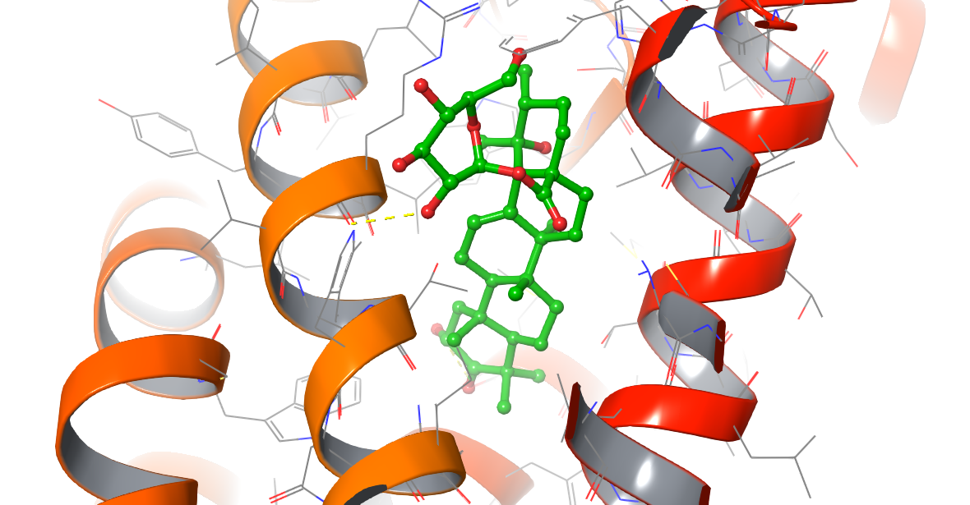

**Figure S10.** Pictorial presentation (3D) of compound **3** and 6IIU (TXA2).