**Supporting information**

Comparative Research on Promising Energetic 1,3-Diazinane and 1,3-Oxazinane Structures

Kaidi Yang, Fuqiang Bi, Junlin Zhang*, Qi Xue, Jiarong Zhang, Kunkai Wang, Bozhou Wang*

State Key Laboratory of Fluorine & Nitrogen Chemicals, Xi’an Modern Chemistry Research Institute, Xi’an 710065, China

Emails: junlin-111@163.com (Junlin Zhang); wbz600@163.com (Bozhou Wang)

**Computer Method**

The detonation performances of energetic compounds involved were carried out using Gaussian 09 and EXPLO5 v6.04 package. The geometry optimizations were characterized to be true local energy minima on the potential-energy surface and the frequency analysis were conducted by Gaussian at the B3LYP/6-31G(d,p) level without imagined frequency. Meanwhile, the heat of formation (ΔfH) and the calculated density were calculated at the same. Then, with ΔfH and calculated density the desired data were obtained using the EXPLO5 program.

The Chemical bond dissociation energy (BDE) was determined by Gaussian 09 program. The compound was optimized and the frequencies were calculated to obtain the bond orders. Two weaker bond orders were chosen to calculated the enthalpy of fragments. Then the enthalpy of fragments were added and the enthalpy of compounds were subtracted to obtain the value of BDE.

**Crystallographic data**

**The apparatus and conditions of crystal structure determination**

A single crystal of TNNP suitable for X-ray diffraction was prepared by slow evaporation of ethyl acetate at room temperature and normal pressure. A colorless crystal with dimension of 0.20 ×0.20 ×0.15 mm was selected for X-ray crystal analysis and mounted on a Bruker APEX-II CCD diffractometer with with a Cu Kα radiation (λ=1.54178 A) using an ω-θ scan mode at 150 K. A total 5582 reflections were obtained in the range of 6.154≤θ≤74.287, of which 2067 were independent (R int =0.0239) were considered to be observed and used for in all calculations. The structure was solved by direct methods and refined by full-matrix least-squares techniques on F2 using SHELES-97 and SHELXL-97 programs. A full-matrix least-squares refinement gave the final R1= 0.0531 and ωR2= 0.1329(ω=1/[σ2(F02) + (0.0270 P)2 + 0.0000 P], where P =(F02+2Fc2)/3). The goodness-of-fit on F2 is 1.172. The largest difference peak and the deepest hole were 0.503 and -0.342 e/Å3.

A single crystal of TNOP suitable for X-ray diffraction was prepared by slow evaporation of ethyl acetate-light petroleum at room temperature. A colorless crystal with dimension of 0.25 ×0.21 ×0.14 mm was selected for X-ray crystal analysis and mounted on a Bruker APEX-II CCD diffractometer with with a Mo Kα radiation (λ=0.71073 A) using an ω-θ scan mode at 293 K. A total 4641 reflections were obtained in the range of 3.107≤θ≤21.605, of which 2243 were independent were considered to be observed and used for in all calculations. The structure was solved by direct methods and refined by full-matrix least-squares techniques on F2 using SHELES-97 and SHELXL-97 programs. A full-matrix least-squares refinement gave the final R1= 0.0603and ωR2= 0.1109(ω=1/[σ2(F02) + (0.0357 P)2 + 0.9599 P], where P =(F02+2Fc2)/3). The goodness-of-fit on F2 is 1.043. The largest difference peak and the deepest hole were 0.206 and -0.193 e/Å3.

**Table S1.** Crystal data and structure refinement parameters for TNNP and TNOP

|  |  |  |
| --- | --- | --- |
| Compound | TNNP | TNOP |
| Empirical formula | C5H8N7O8 | C5H8N4O8 |
| Molar mass (g/mol) | 294.18 | 252.15 |
| Temperature (K) | 150(2) | 293(2) |
| Crystal system | Monoclinic | Orthorhombic |
| Space group | *P*21 | *Pbca* |
| Crystal size (mm) | 0.20 x 0.20 x 0.15 | 0.25 × 0.21 × 0.14 |
| *a* (Å) | 6.038(10) | 12.1305(17) |
| *b* (Å) | 14.382(3) | 10.2837(16) |
| *c* (Å) | 6.185(2) | 15.591(2) |
| *α* (◦) | 90 | 90(6) |
| *β* (◦) | 96.564(10) | 90(8) |
| *γ* (◦) | 90 | 90(6) |
| *V* (Å 3) | 999.6(4) | 1944.9(5) |
| *Z* | 2 | 8 |
| *h* | -7<= *h* <=7 | -15<= *h* <=15 |
| *k* | -17<= *k* <=17 | -13<= *k* <=13 |
| *l* | -6<= *l* <=7 | -20<= *l* <=20 |
| *D*c (g/cm3) | 1.831 | 1.722 |
| *λ* (Å) | 1.54178 | 0.71073 |
| *F*(0 0 0) | 302 | 1040 |
| *θ* range (◦) | 6.15-74.28 | 3.11-21.61 |
| Measured reflections | 5582 | 4641 |
| Unique data | 2067 | 2243 |
| *R*1, *wR*2 [*I* > *2σ*(*I*)] | 0.0531,0.1329 | 0.0603,0.0925 |
| *R*1, *wR*2 (all data) | 0.0538,0.1337 | 0.1400,0.1109 |
| Goodness-of-fit | 1.172 | 1.043 |
| *δp*max, *δp*min (e/ Å3) | 0.503, -0.342 | 0.206, -0.193 |
| CCDC number | 2065261 | 2065260 |

**X-ray crystal structure**

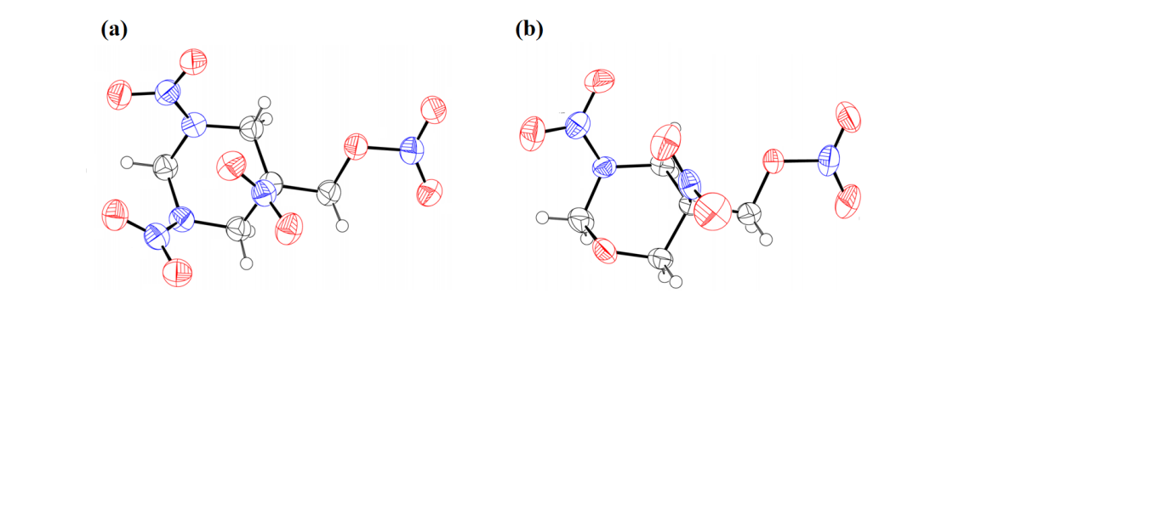

1. Molecule of TNNP (b) Molecule of TNOP

**Figure S1.** The molecular structure of TNNP and TNOP

**Bond length and angles of TNNP and TNOP**

**Table S2.** Bond length of TNNP/ Å

|  |  |
| --- | --- |
| Bond | length |
| N(7)－O(1) | 1.218(4) |
| N(4)－N(5) | 1.424(4) |
| N(4)－C(3) | 1.451(4) |
| N(5)－O(3) | 1.188(5) |
| N(5)－O(4) | 1.200(5) |
| N(1)－O(5) | 1.215(5) |
| C(2)－N(7) | 1.542(4) |
| N(6)－N(7) | 1.368(4) |
| N(1)－N(2) | 1.406(4) |
| N(6)－C(4) | 1.458(5) |
| N(6)－C(5) | 1.454(5) |
| C(2)－C(3) | 1.520(5) |

**Table S3.** Bond angle of TNNP

|  |  |
| --- | --- |
| Bond | angle |
| N(5)－N(2)－C(3) | 112.6(3) |
| O(6)－N(7)－C(2) | 117.4(3) |
| O(9)－N(7)－O(6) | 125.0 (3) |
| O(9)－N(7)－C(2) | 117.5(2) |
| O(1)－N(7)－O(2) | 124.5(3) |
| O(2)－N(7)－N(6) | 117.8(6) |
| C(1)－N(2)－C(4) | 114.1(3) |
| O(5)－N(1)－O(8) | 125.8(3) |
| O(5)－N(1)－N(2) | 117.0(3) |
| N(7)－C(2)－C(1) | 106.2(3) |
| C(5)－C(2)－N(7) | 109.9(3) |
| C(5)－C(2)－C(1) | 111.6(3) |

**Table S4.** Bond length of TNOP/ Å

|  |  |
| --- | --- |
| Bond | length |
| N(4)－O(6) | 1.414(3) |
| O(6)－C(5) | 1.440(3) |
| O(1)－C(1) | 1.422(3) |
| N(2)－O(2) | 1.223(3) |
| N(1)－N(2) | 1.367(3) |
| O(5)－N(3) | 1.218(3) |
| O(8)－N(4) | 1.195(3) |
| O(3)－N(2) | 1.224(3) |
| N(3)－C(3) | 1.529(3) |
| C(2)－C(3) | 1.525(3) |
| C(3)－C(4) | 1.526(3) |
| C(3)－C(5) | 1.521(3) |

**Table S5.** Bond angle of TNOP

|  |  |
| --- | --- |
| Bond | angle |
| N(2)－N(1)－C(4) | 119.2(19) |
| O(2)－N(2)－O(3) | 124.3(2) |
| O(5)－N(3)－C(3) | 118.5(2) |
| O(4)－N(3)－C(3) | 117.0(2) |
| O(7)－N(4)－O(6) | 117.1(2) |
| C(4)－C(3)－N(3) | 110.53(19) |
| C(5)－C(3)－C(4) | 111.67(19) |
| O(3)－N(2)－N(1) | 118.2(2) |
| O(4)－N(3)－O(5) | 124.5(2) |
| C(1)－N(1)－C(4) | 116.3(2) |
| O(2)－N(2)－N(1) | 117.5(2) |
| O(8)－N(4)－O(6) | 111.7(2) |

**NMR spectra**

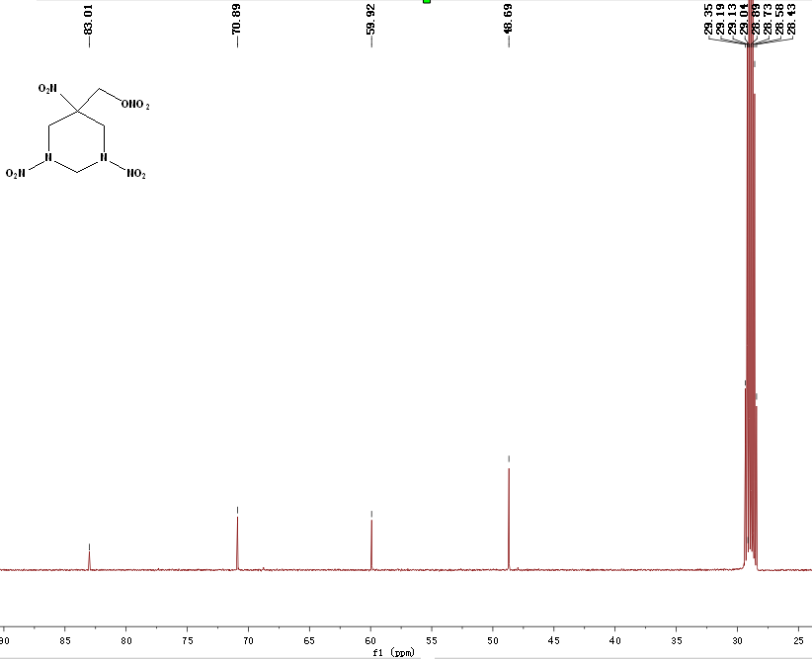

**Figure S2. 13C NMR of TNNP(*d*-acetone)**

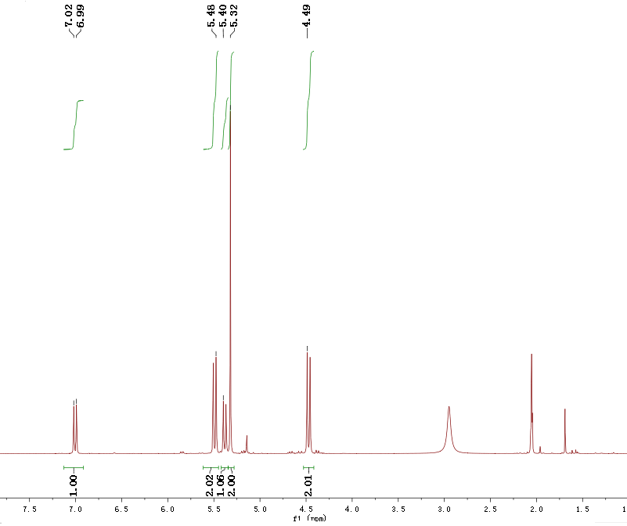

**Figure S3. 1H NMR of TNNP (*d*-acetone)**

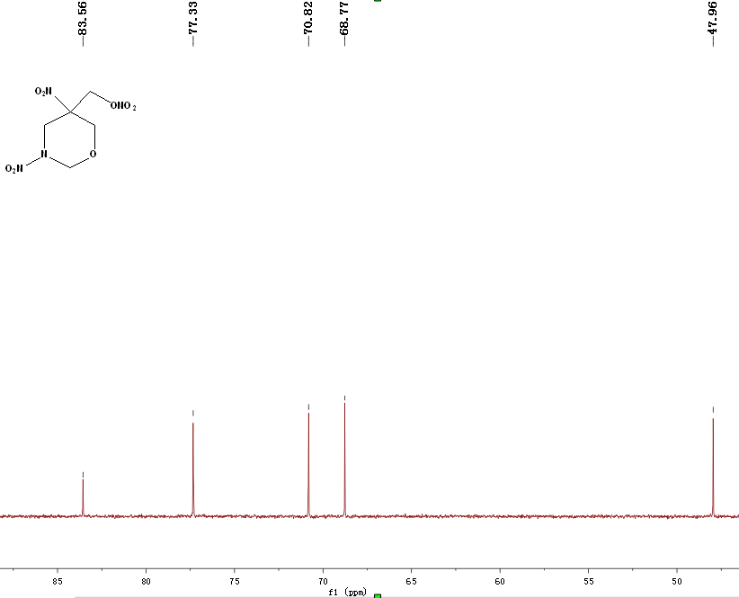

**Figure S4. 13C NMR of TNOP(*d*-acetone)**

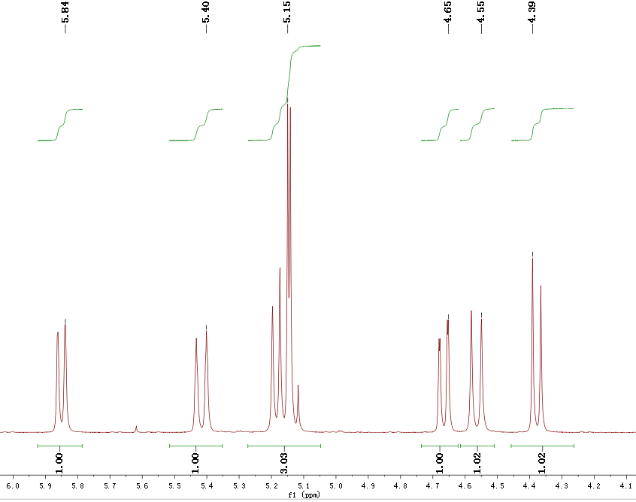

**Figure S5. 1H NMR of TNOP (*d*-acetone)**