Table S1. Docking score of all thirty-six compounds for three docked proteins (Substrate Binding Site)
Name of Ligand | 5UJA | 6FN1 | 6FFC
Co-crystalized Ligands | -8.1 | -9.5 | -9.3
DOXORUBICIN | -9 | -8.4 | -10
1 | -6.3 | -6 | -6.8
2 | -6.2 | -5.9 | -6.9
3 | -8.9 | -8.6 | -8.6
4 | -8.6 | -7.8 | -9.7
5 | -5.9 | -5.6 | -6
6 | -8.9 | -8.2 | -8.9
7 | -6.4 | -5.9 | -6.3
8 | -10.6 | -9.2 | -10.7
9 | -8.5 | -7.9 | -9.6
10 | -8.8 | -9.2 | -9
11 | -9.9 | -9.9 | -10.8
12 | -10.2 | -10 | -9.4
13 | -8.7 | -8 | -8
14 | -10.8 | -8.9 | -10.8
15 | -11 | -9.1 | -11.1
16 | -9.9 | -8.9 | -9.1
17 | -9.2 | -8.5 | -8.3
18 | -9.2 | -8.9 | -10
19 | -8.5 | -9.1 | -10.2
20 | -10 | -9 | -9.4
21 | -9 | -8.1 | -8.2
22 | -8 | -8.2 | -9.2
23 | -8.4 | -8 | -9.5
24 | -10.5 | -9.4 | -10.4
25 | -8.6 | -7.6 | -9.4
26 | -5.5 | -6.4 | -7.1
27 | -7.8 | -7.6 | -7.9
28 | -6.5 | -6.8 | -7.9
29 | -6.1 | -6.2 | -7.6
30 | -5.1 | -5.5 | -6.8
31 | -5.4 | -6.3 | -6.9
32 | -9.2 | -9.6 | -8.8
33 | -5.6 | -5.5 | -6.6
34 | -5.5 | -5.7 | -7
35 | -4.9 | -5.7 | -6.7
36 | -5.1 | -6.1 | -7.2

Docked Ligands in the Substrate Binding site of 5UJA
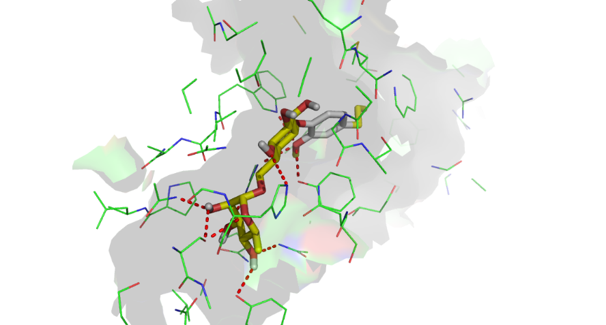
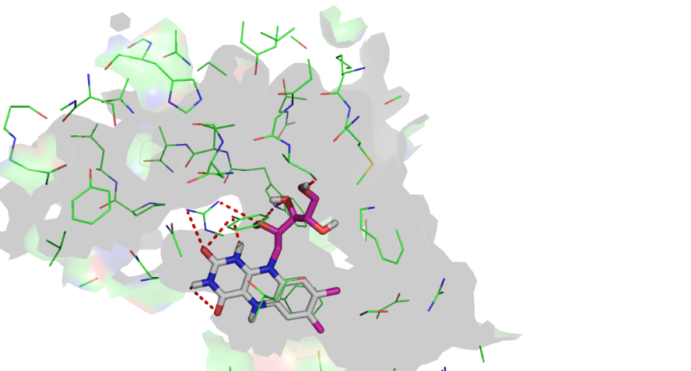
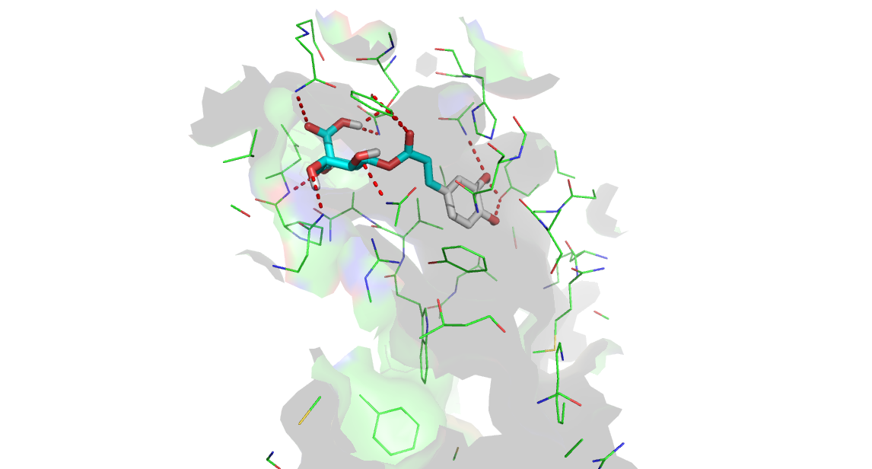

3
6
4
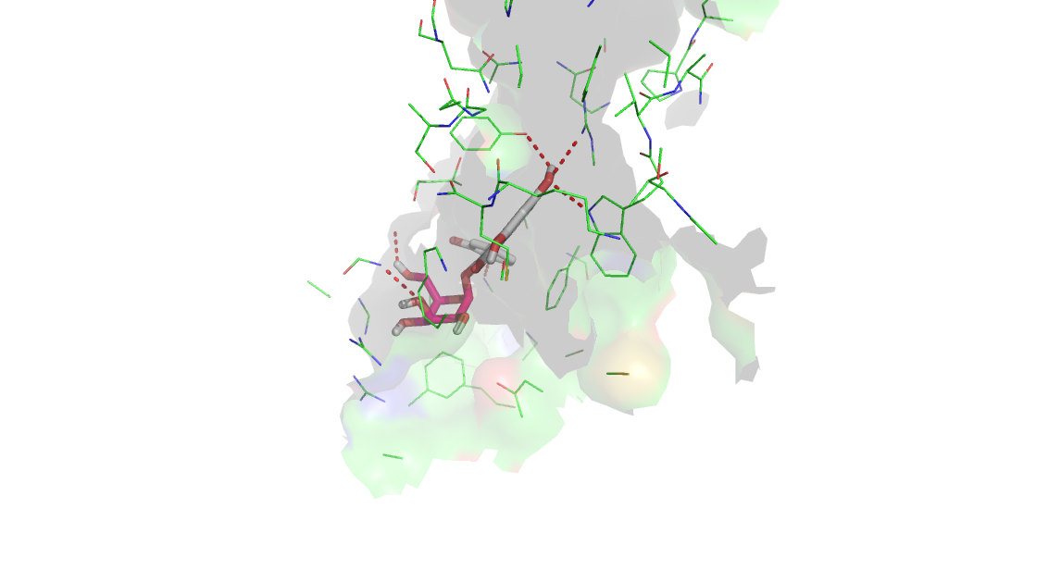
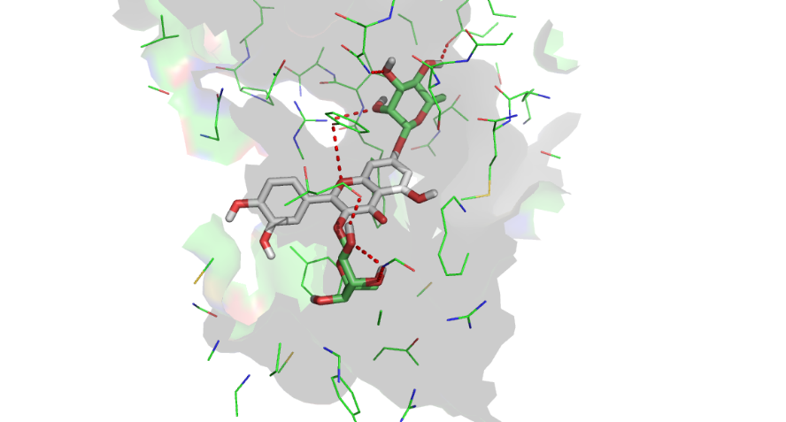
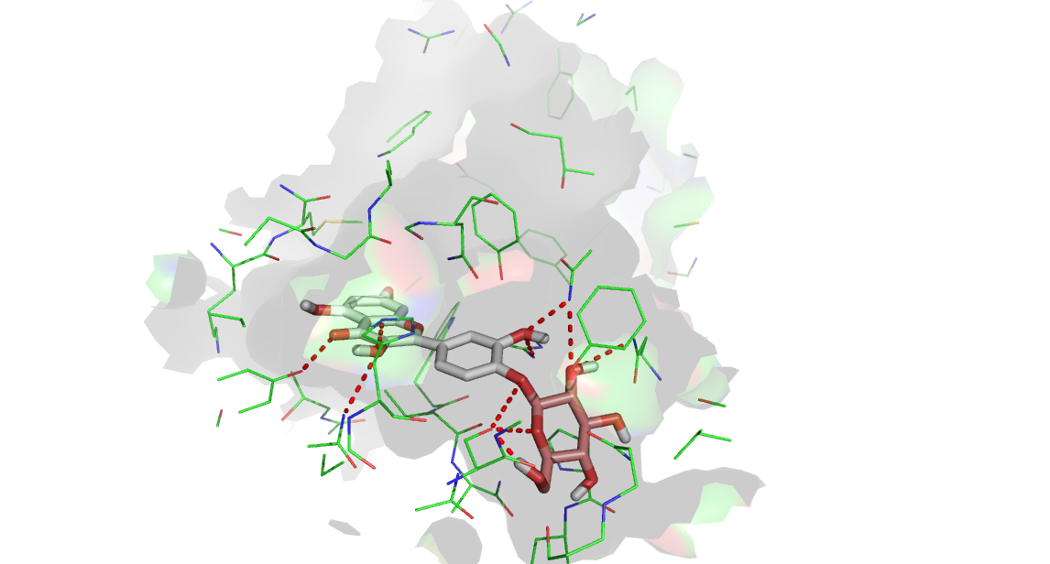
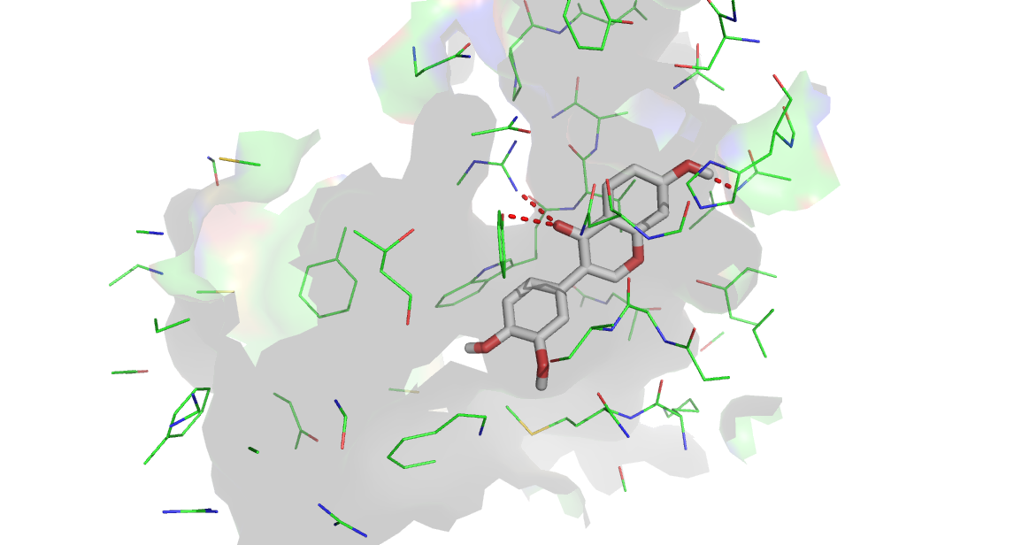
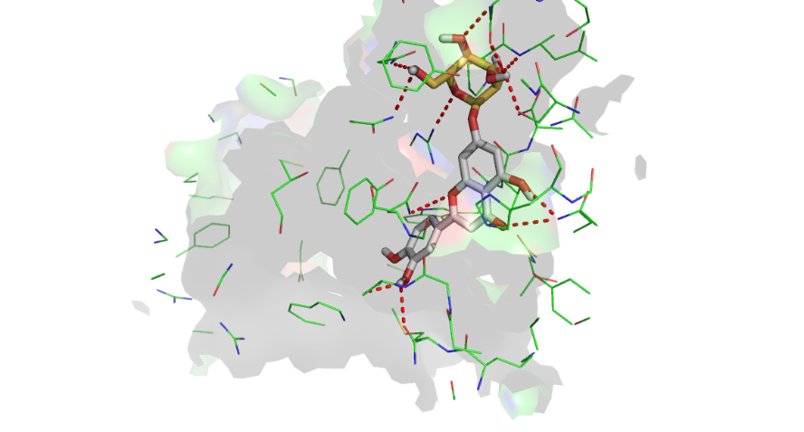
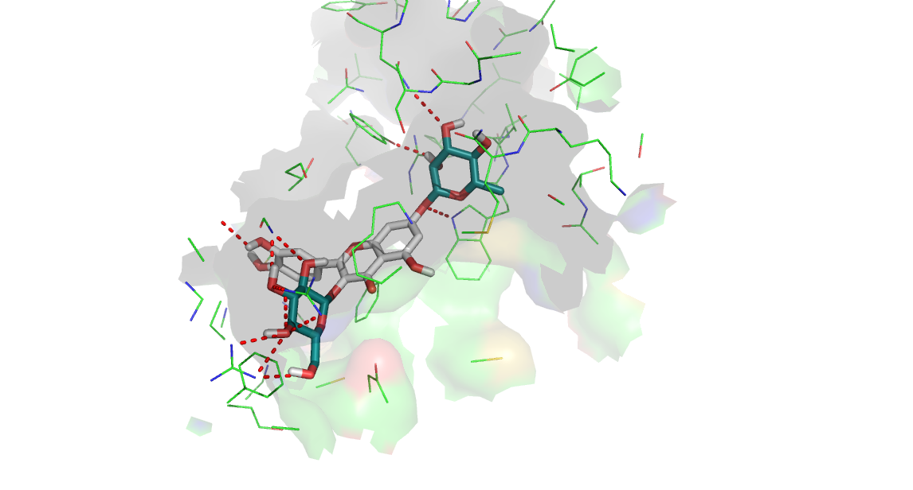

8
11
9

12
14
13
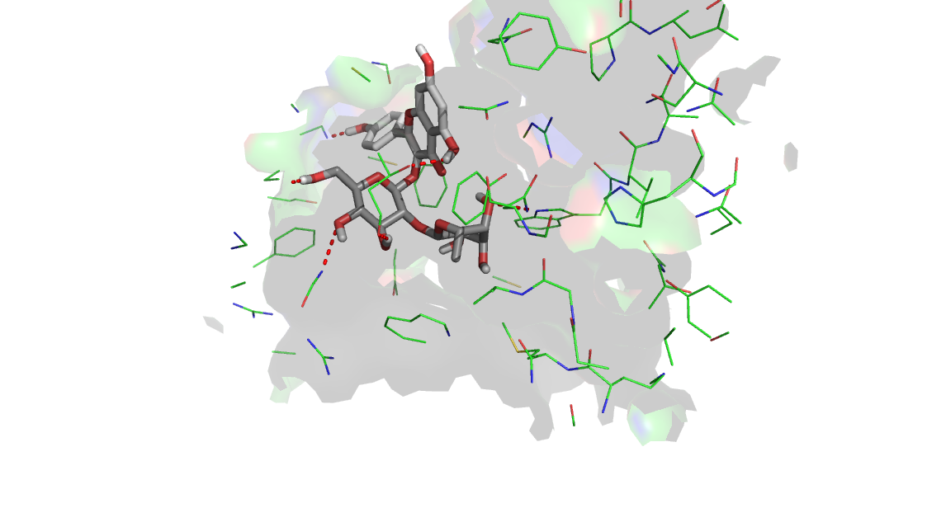
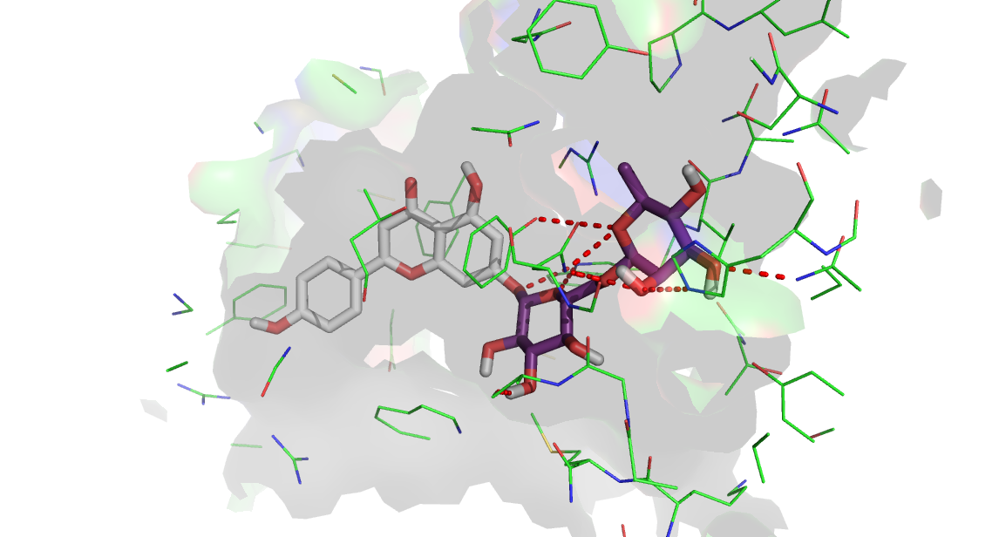

15
16

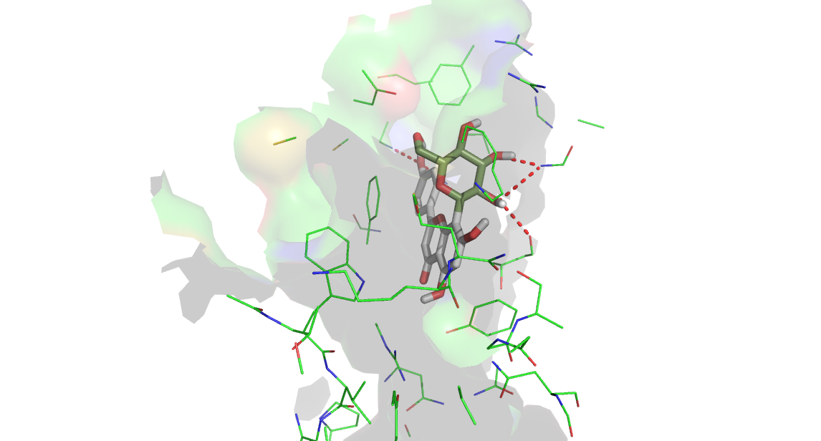
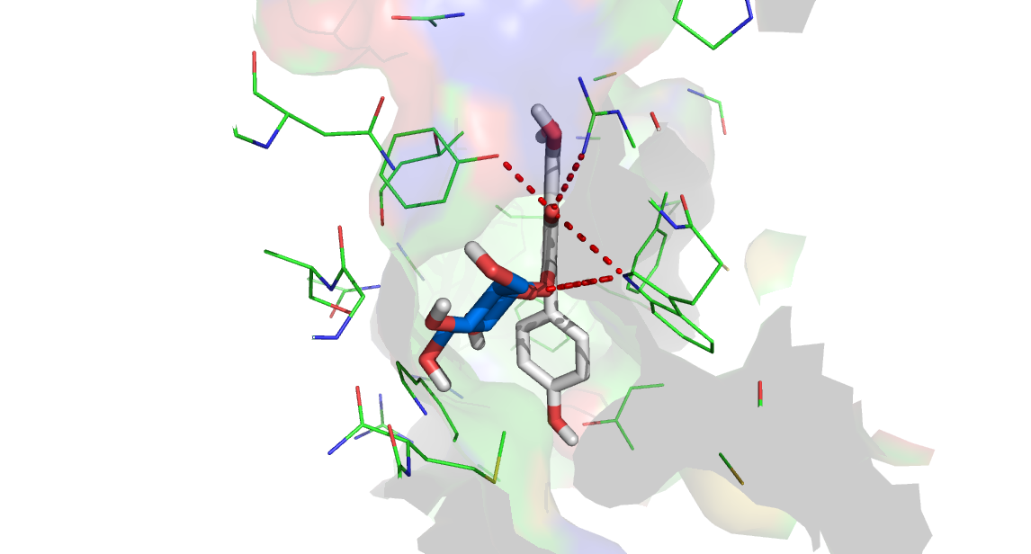
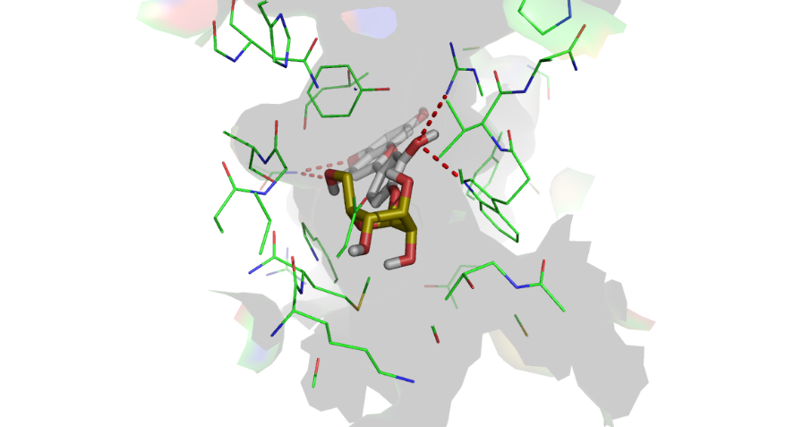

19
17
18
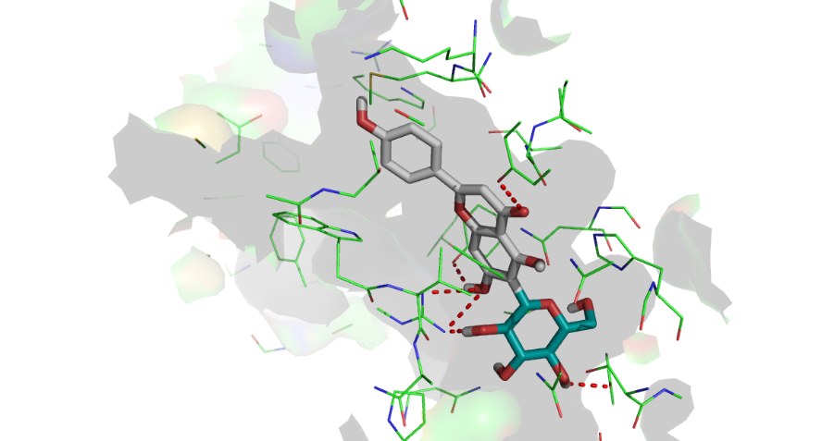
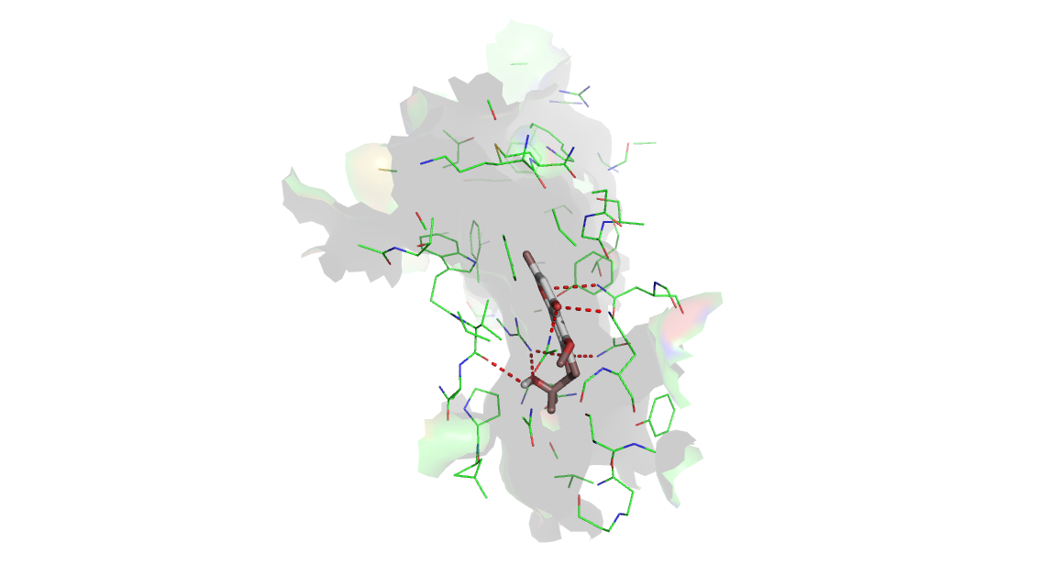
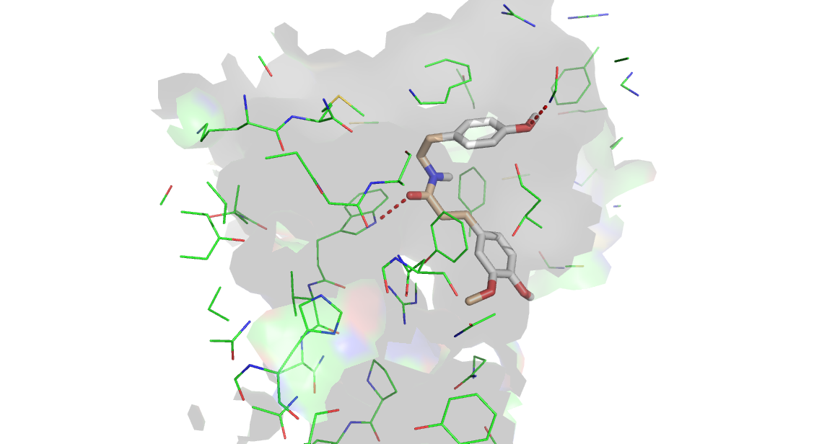

20
21
22
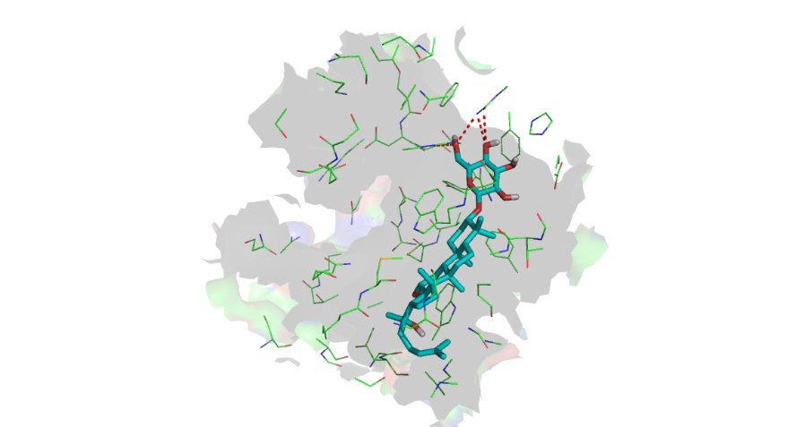
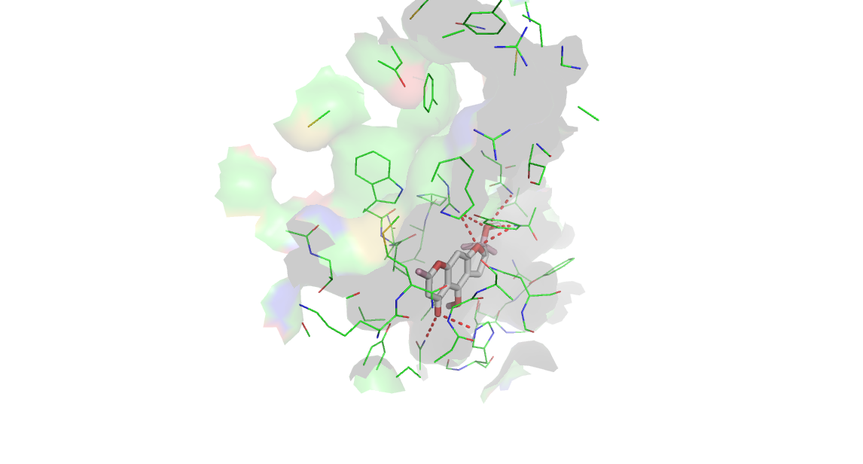
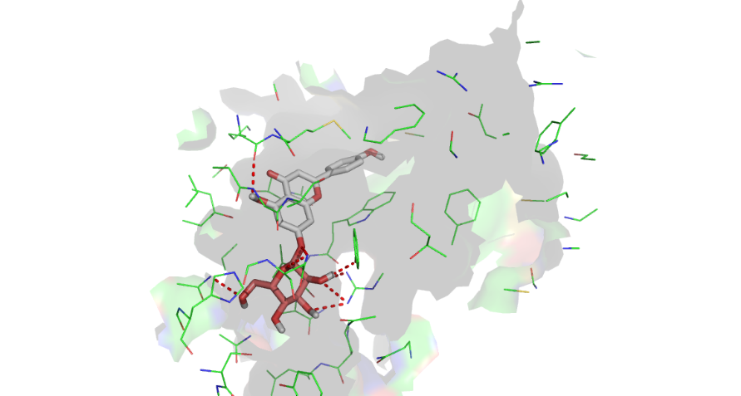

24
25
32

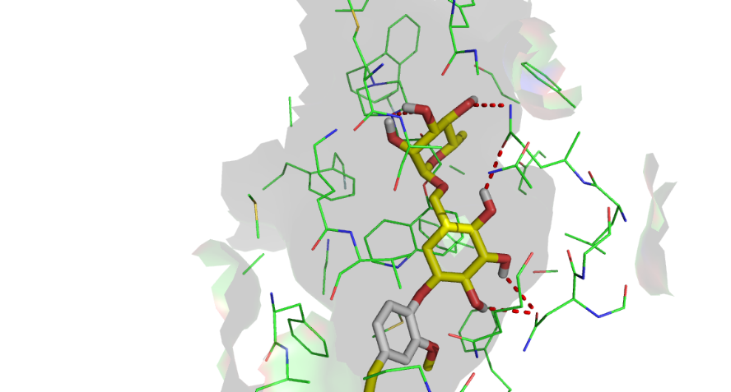
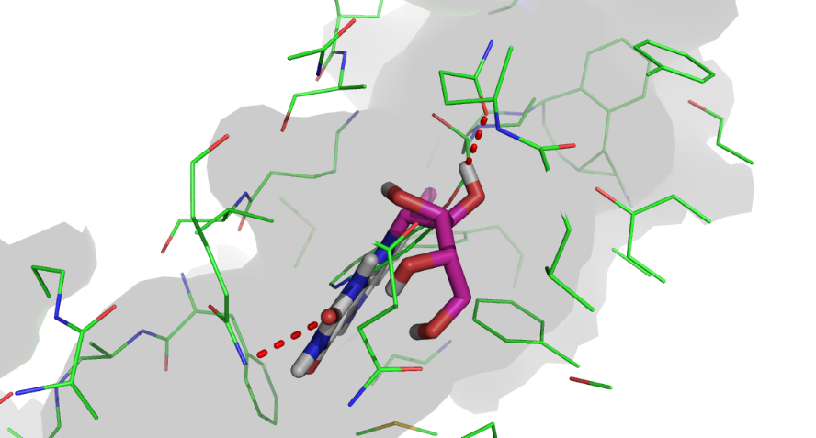
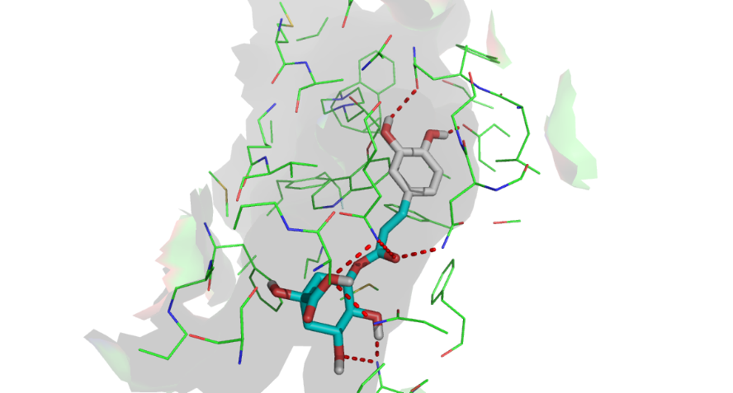
Docked Ligands in the Substrate Binding site of 6FN1
6
4
3
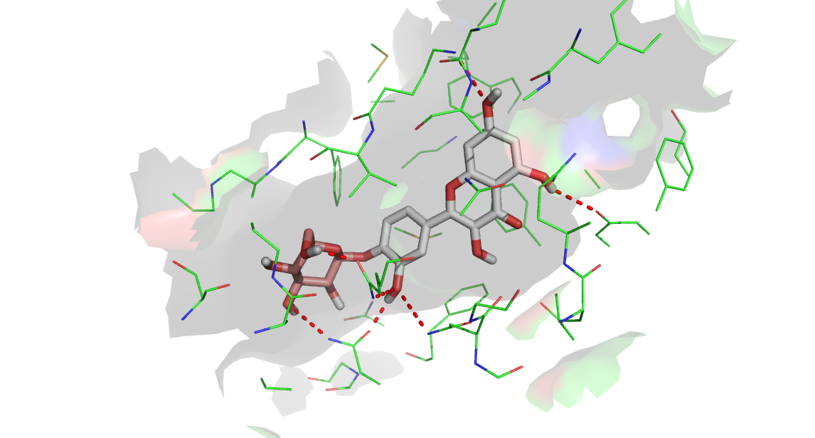
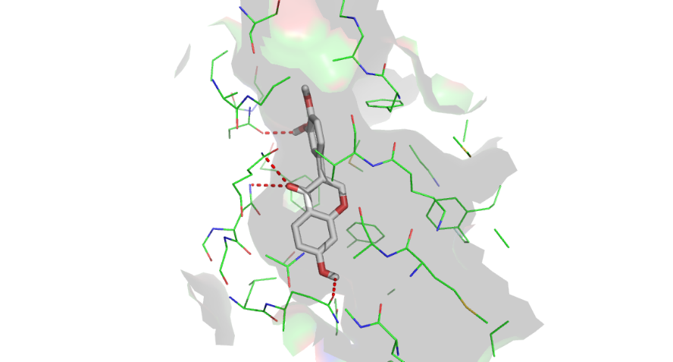
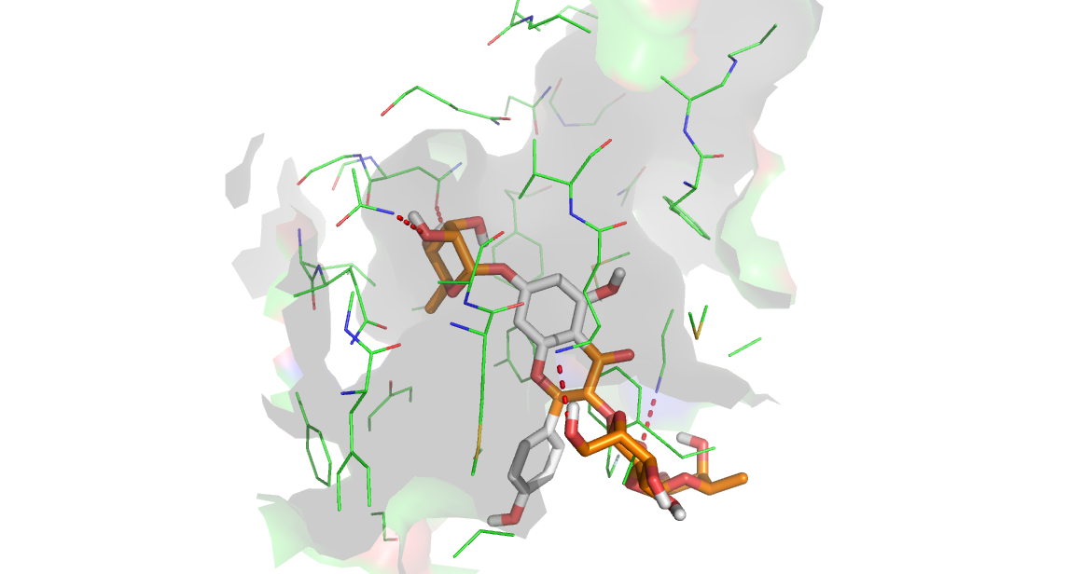

10
9
8
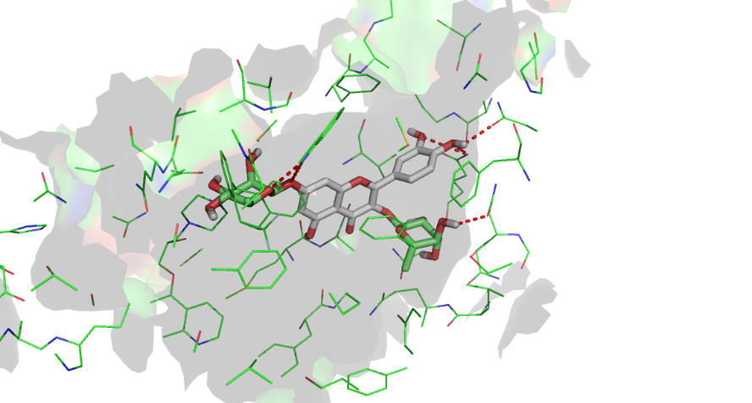
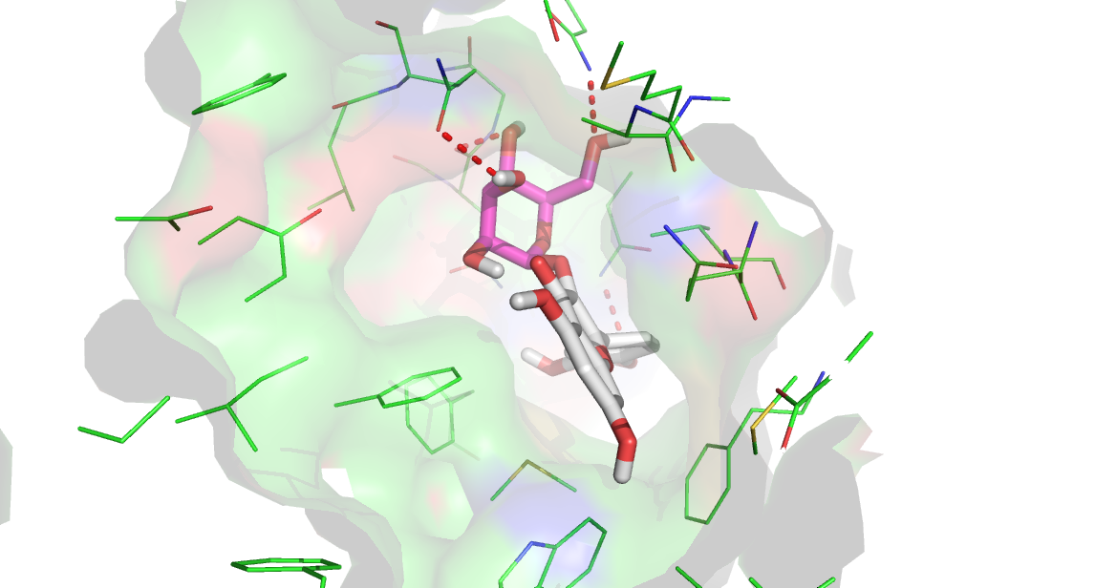
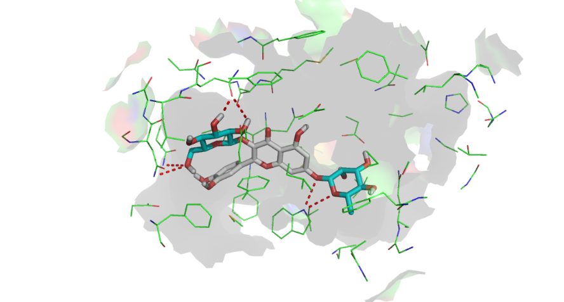

11
12
13
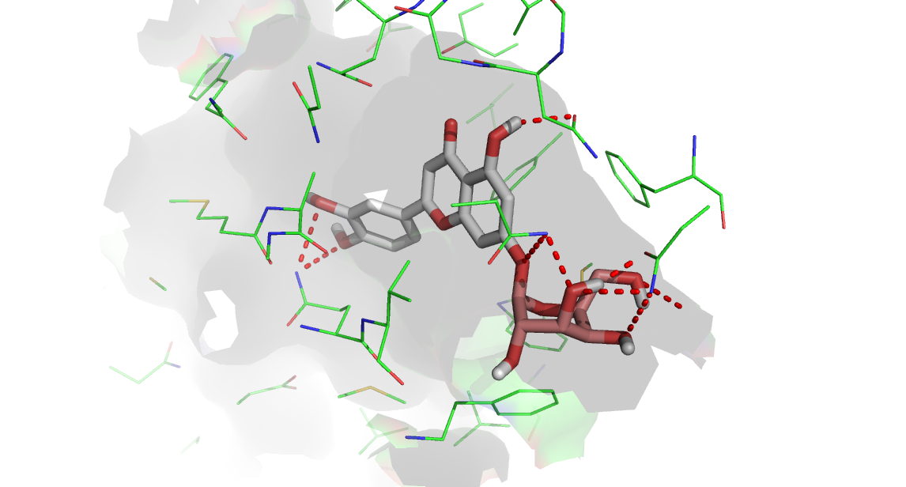
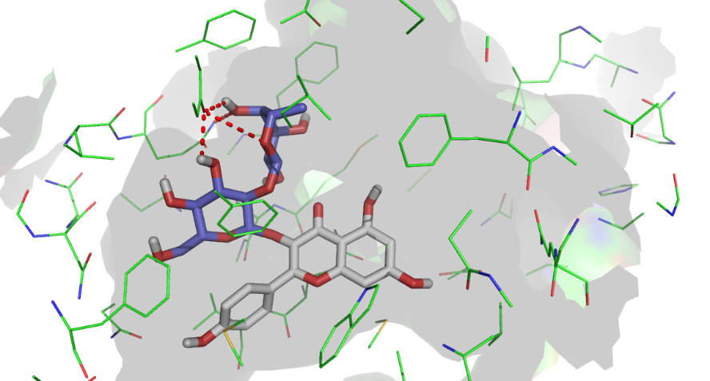
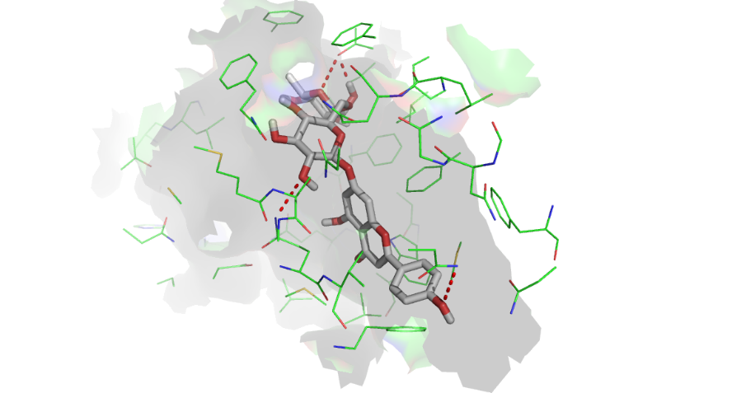
14
15
16
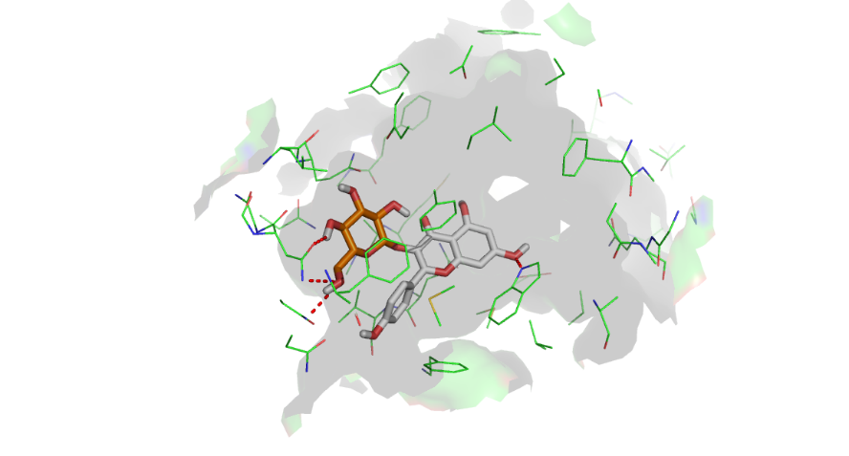
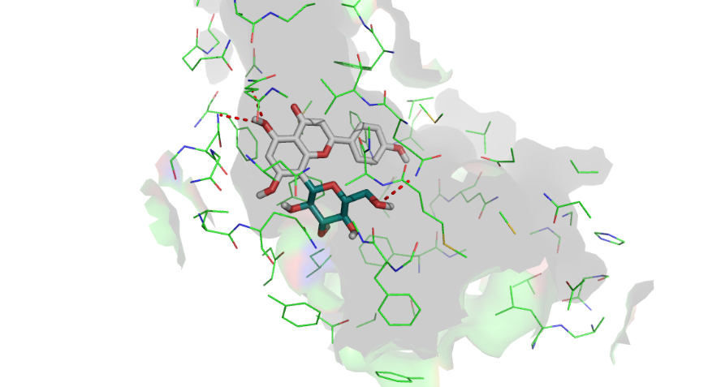
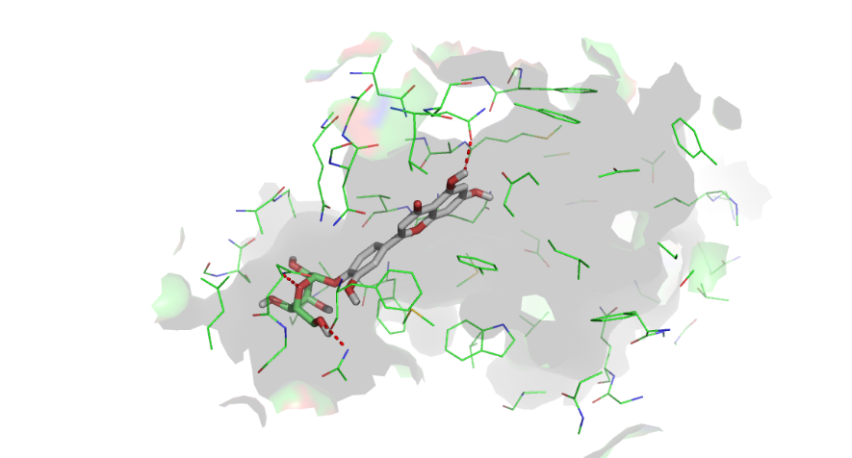

17
18
19
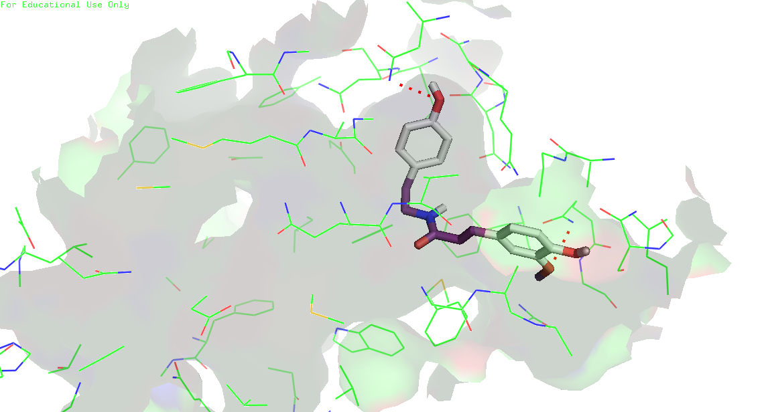
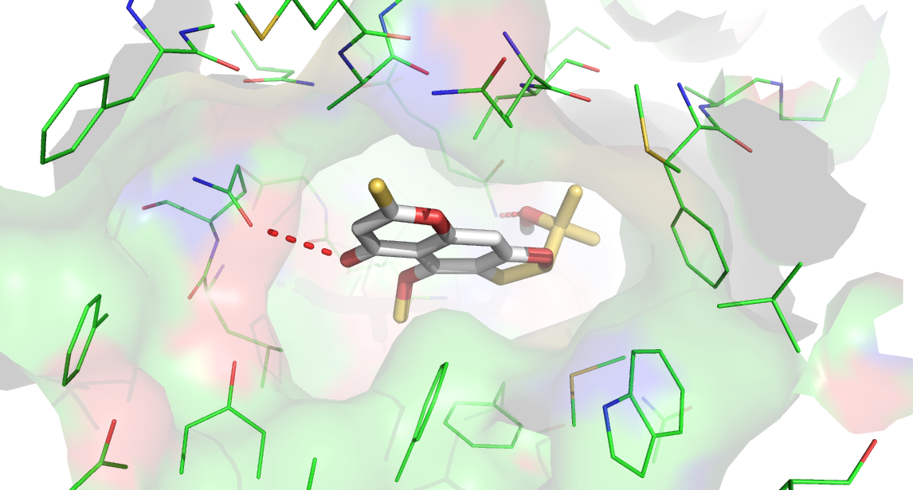
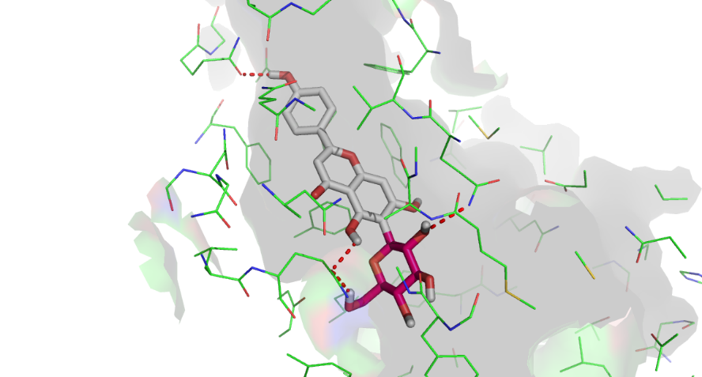

20
21
22

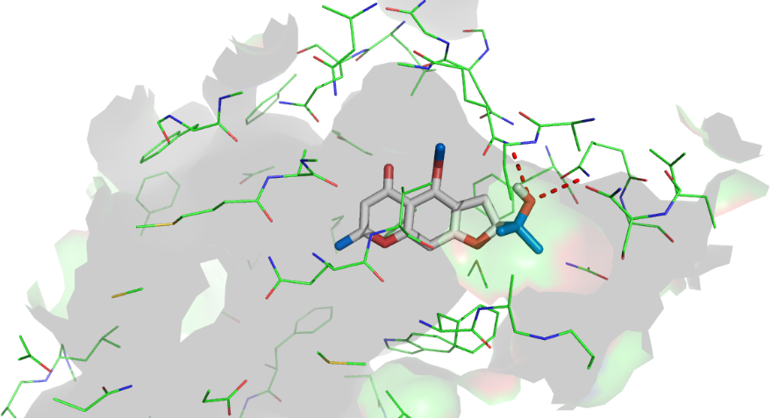
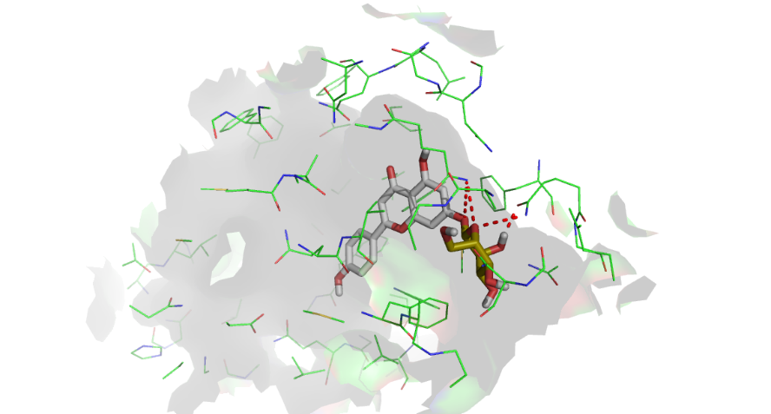
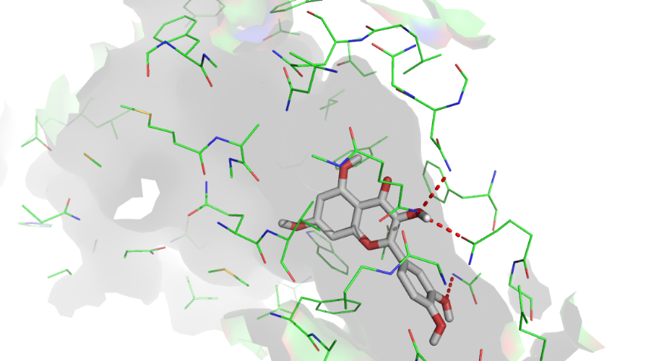

23
24
25

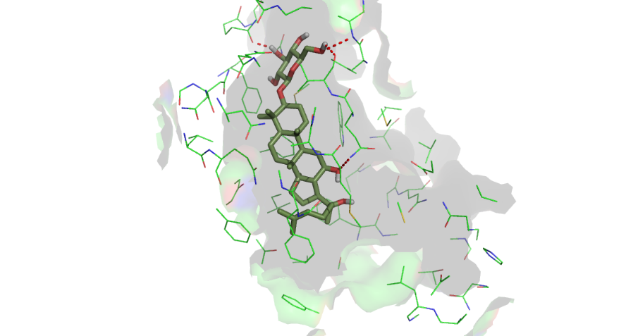

32

Binding Mode of Ligands in the Substrate binding site of 6FFC
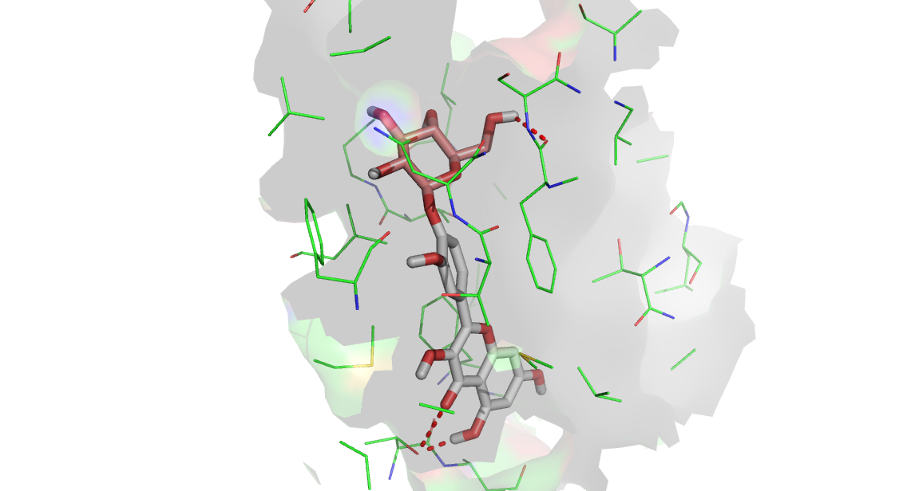
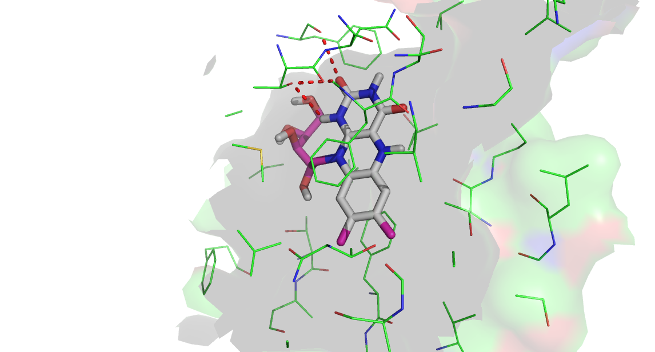
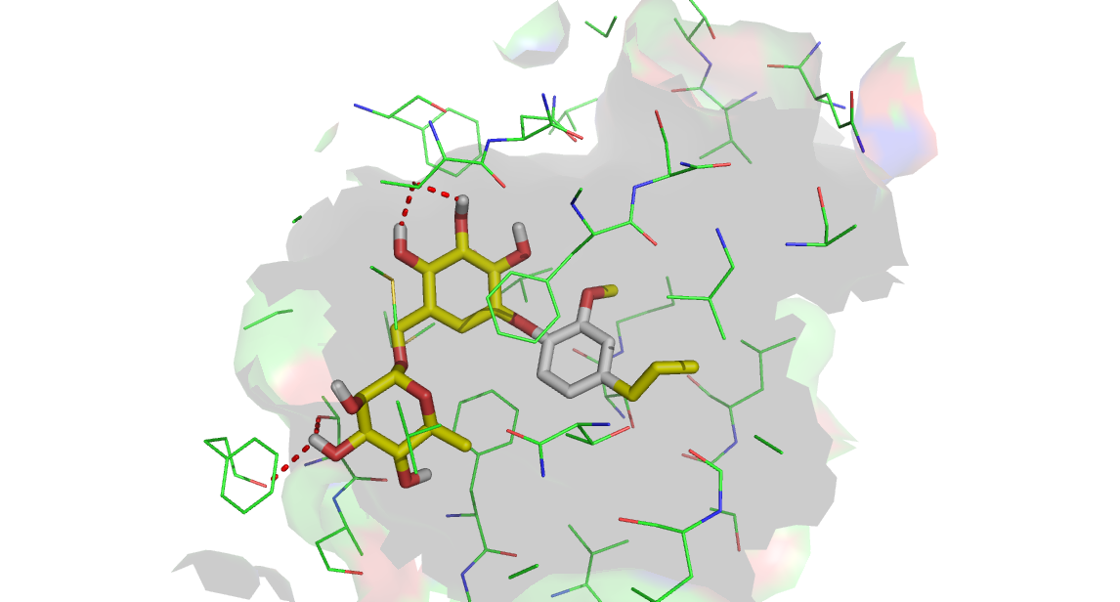
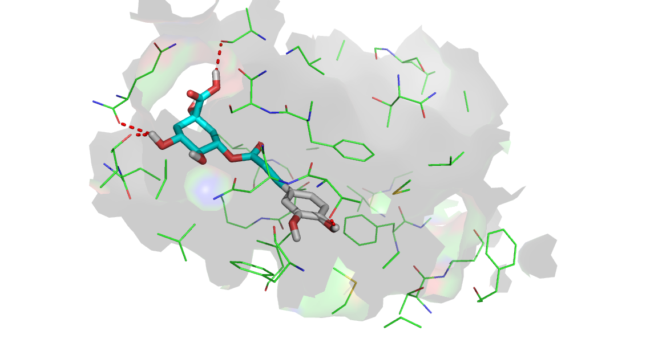

3
4
6
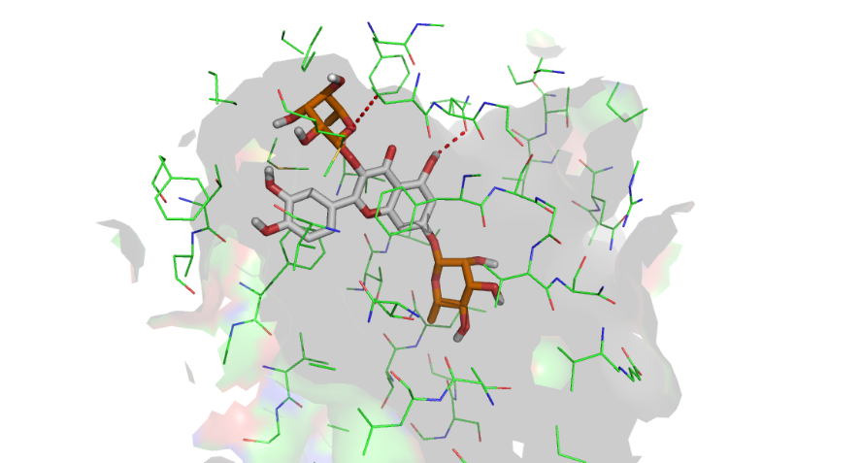
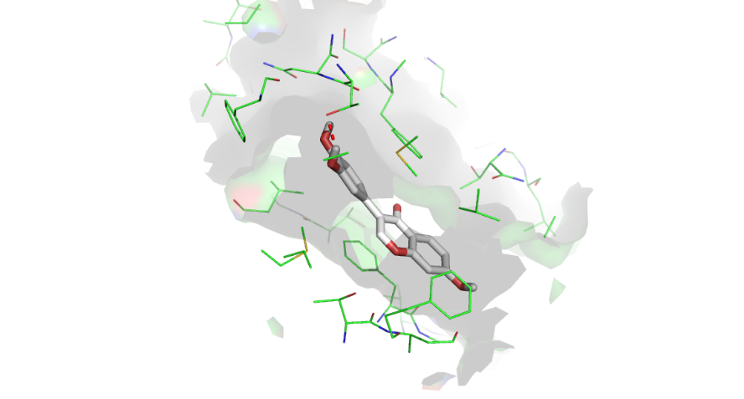

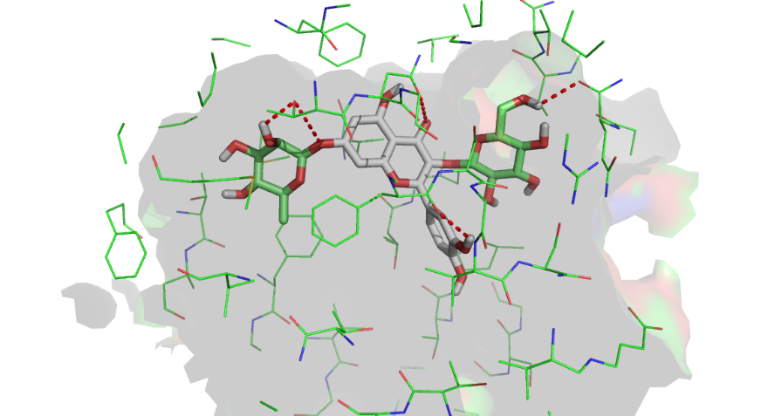
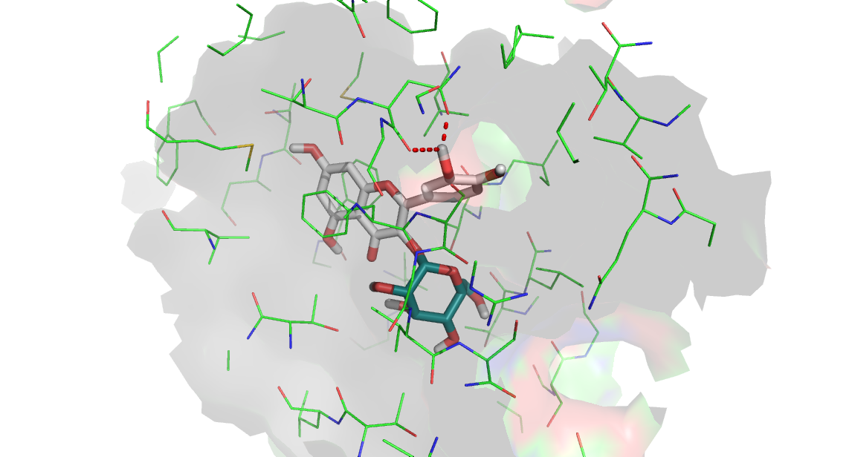
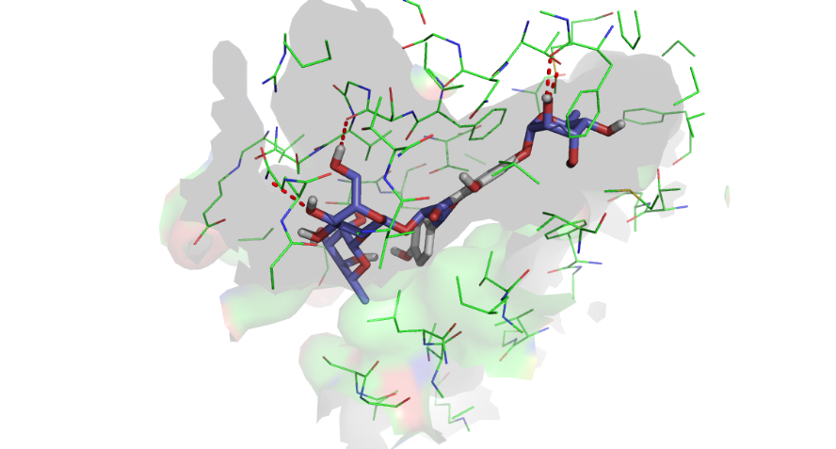
8
9
10

11
13
12
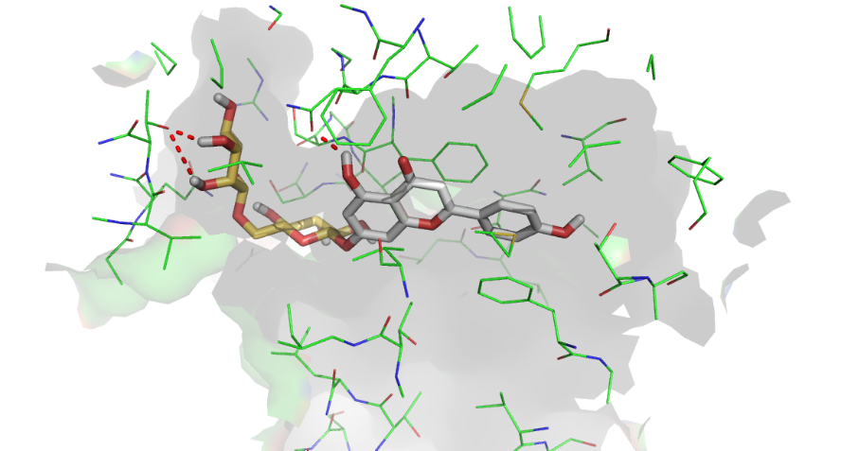
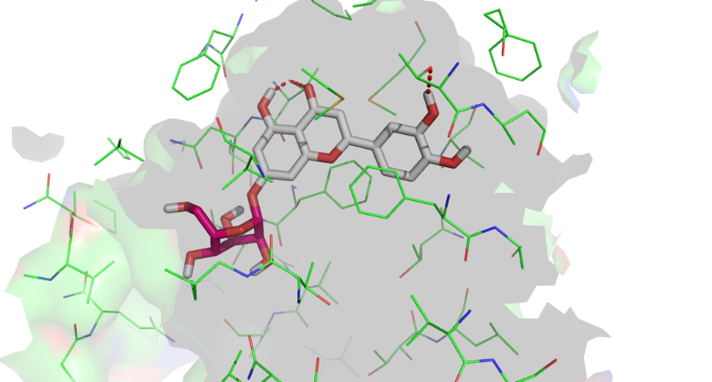
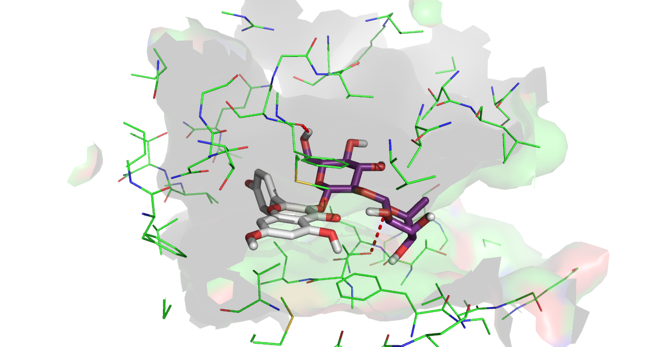
14
15
16
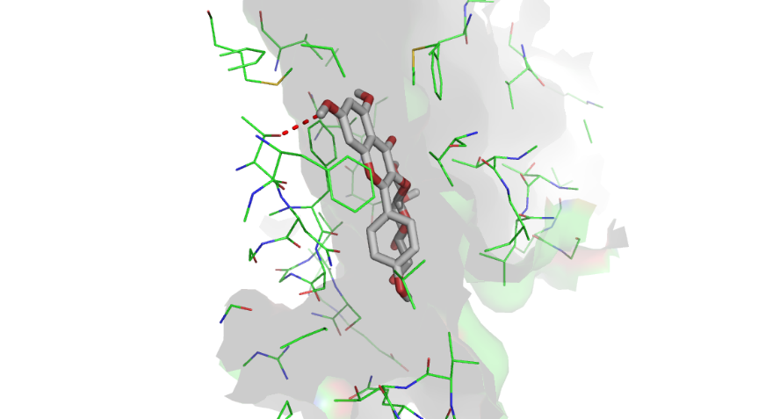
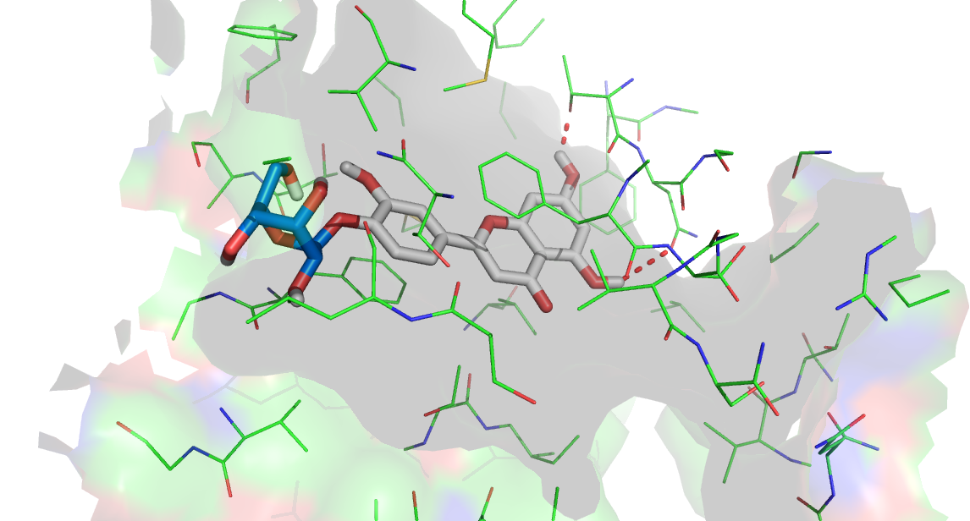
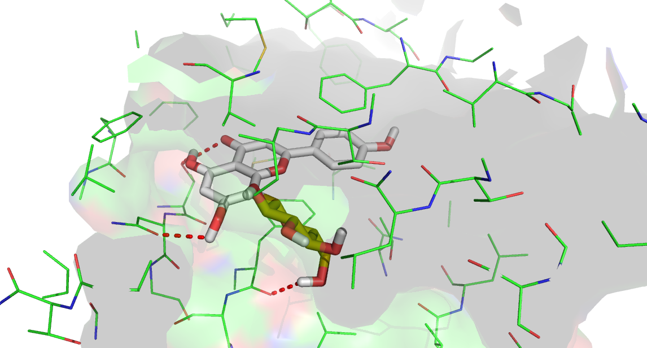
17
18
19
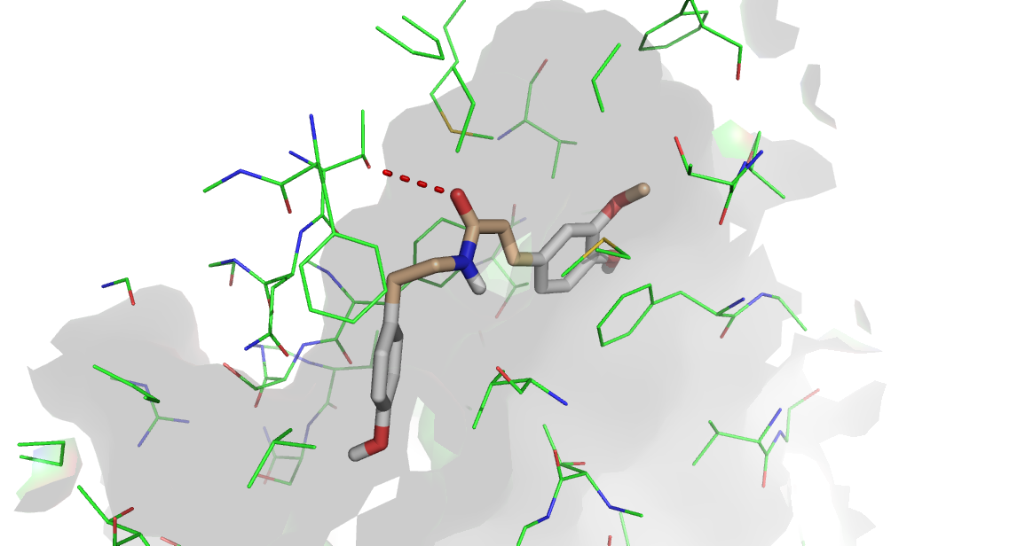
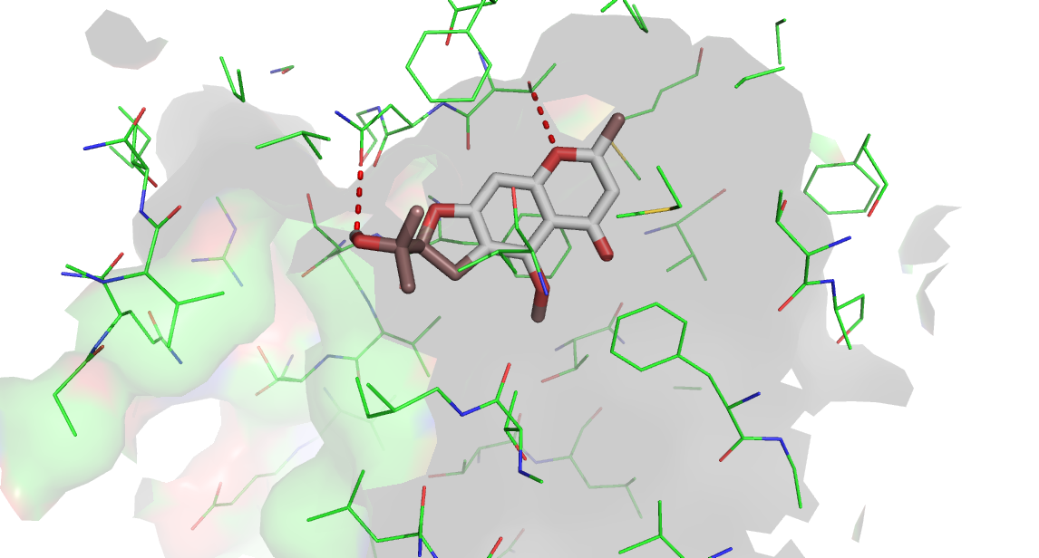
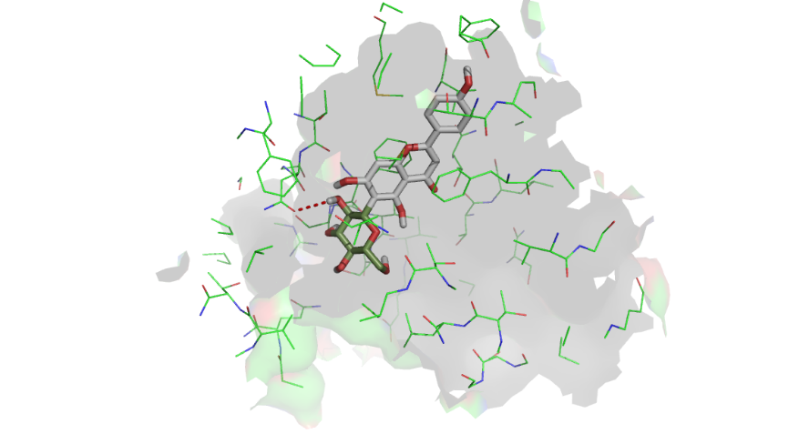

20
21
22
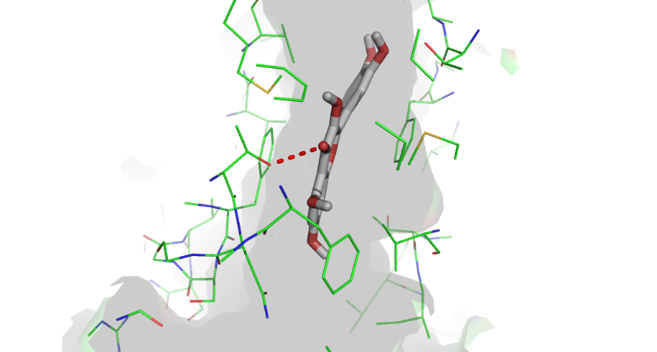
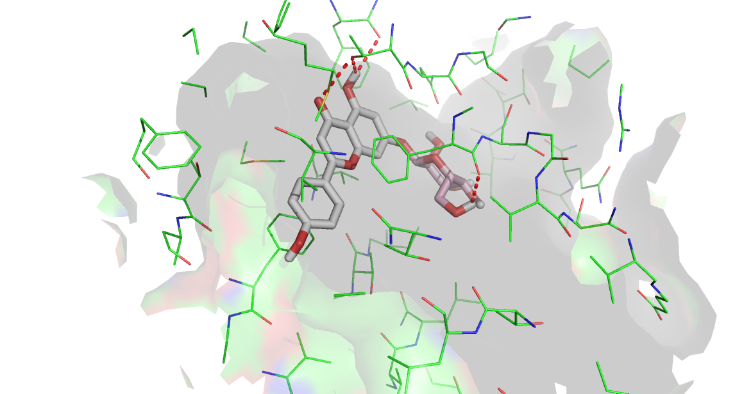

23
24
25
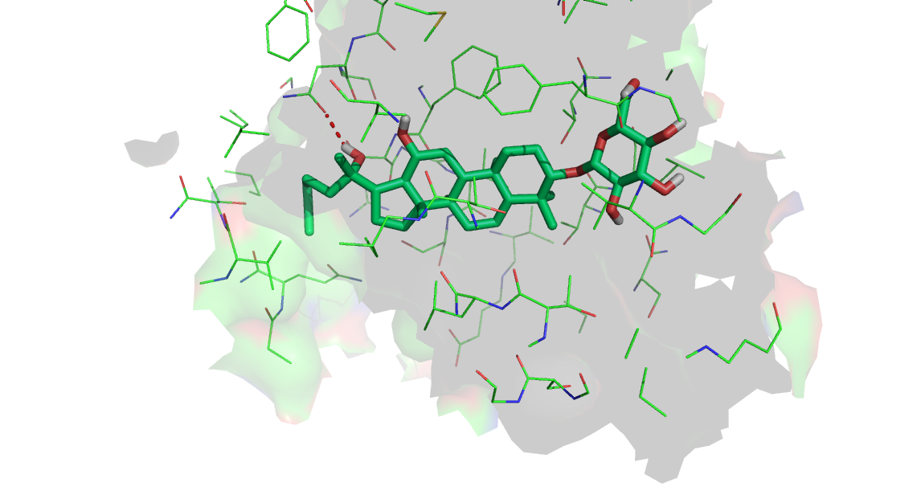

32

Table S2. Docking score of all thirty-six compounds for ATP binding Site
Symbol of Ligand | 2CBZ
ATP | -7.7
DOXORUBICIN | -7
1 | -5.1
2 | -5.4
3 | -6.3
4 | -7.1
5 | -5.2
6 | -6.5
7 | -5.4
8 | -7.3
9 | -6.6
10 | -6.8
11 | -8.2
12 | -7.5
13 | -6.7
14 | -7.2
15 | -8
16 | -7.1
17 | -6.6
18 | -7
19 | -7.2
20 | -7.2
21 | -6.4
22 | -6.3
23 | -6.2
24 | -7.1
25 | -6.7
26 | -4.4
27 | -6.7
28 | -4.7
29 | -4.4
30 | -4.3
31 | -4.8
32 | -7.2
33 | -4.6
34 | -4.5
35 | -4.2
36 | -4.1

Details of the Configuration file used for docking in four different proteins

- 5UJA

center_x = 95.127
center_y = 59.842
center_z = 57.434

size_x = 40
size_y = 40
size_z = 40

num_modes = 10
energy_range = 4
log = log.txt
out = out.pdbqt

- 6FN1

center_x = 153.149
center_y = 150.339
center_z = 149.82

size_x = 30
size_y = 30
size_z = 30

num_modes = 10
energy_range = 4
log = log.txt

- 6FFC

center_x = 130.451
center_y = 122.745
center_z = 143.598

size_x = 30
size_y = 30
size_z = 30

num_modes = 10
energy_range = 4
log = log.txt
out = out.pdbqt

- 2CBZ

center_x = -17.136
center_y = 47.546
center_z = 1.873

size_x = 40
size_y = 40
size_z = 40

num_modes = 10
energy_range = 4
log = log.txt
out = out.pdbqt

