Supporting Information for
Preparation, characterization, and antitumor activity of Chaenomeles speciosa polysaccharide-based selenium nanoparticles
Supplementary materials and methods
Materials and regents
The dried fruits of Chaenomeles speciosa were purchased from Sichuan province (Sichuan, China) and identified by professor Yuanqiang Guo, Nankai University (Tianjin, China). The monosaccharide standards were obtained from Chengdu Desite Biotechnology Co. Ltd. (Sichuan, Chian). Sodium selenite (Na₂SeO₃) was obtained from Sigma Chemical Co. (St. Louis, MO, USA). Ascorbic acid and Tween-80 were purchased from Aladdin Biochemical Technology Co. Ltd. (Shanghai, China). 3-(4,5-Dimethylthiazol-2-yl)-2,5-diphenyltetrazolium bromide (MTT) was acquired from Dingguo Changsheng Biotech Co. Ltd. (Beijing, China). An annexin V-FITC Apoptosis Detection Kit was acquired from Beyotime Co. Ltd. (Shanghai, China). All the other reagents were of analytical grade.

Extraction and preparation of CSP
Initially, the crushed C. speciosa fruits (500 g) were immersed in 5 L of distilled water and extracted twice at 80 ℃ (3 h for each time). After extraction, the filtrate of extract was further concentrated to one fifth of original volume. After that, absolute ethanol was added into the concentrate until the final concentration was 90% (v/v), and the mixed solution was incubated at 4 ℃ for 24 h to afford the crude polysaccharide precipitation. Subsequently, the crude polysaccharide was redissolved in distilled water and deproteinized by the Sevage reagents (chloroform: n-butanol = 1: 4) three times to remove proteins. The deproteinized solution was further concentrated, dialyzed (molecular weight cut off: 3500 Da), and lyophilized to obtain the CSP.

Monosaccharide composition analysis of CSP
Briefly, 4 mg of CSP was hydrolyzed with 2 mL of TFA (2 M) at 120 ℃ for 6 h. After that, the hydrolysate of CSP was co-concentrated with 5 mL of absolute methanol three times to remove the redundant TFA completely. The dried hydrolysate was redissolved in 1 mL of deionized water and 100 μL of hydrolysate was further reacted with 100 μL of sodium hydroxide (NaOH) solution (0.3 M) and 100 μL of PMP-methanol solution (0.5 M) at 70 ℃ for 30 min. After reaction, the reacted solution was neutralized with 100 μL of hydrochloric acid (HCl, 0.3 M) to afford the PMP-derivatives of CSP, which were used for monosaccharide analysis. An HPLC system coupled with a Kromasil 100-5 C18 column (5 μm, 4.6 × 250 mm) was used to analyze the monosaccharide composition of CSP with the chromatographic conditions were set as follows: ultraviolet detector at 250 nm for detection, acetonitrile and a phosphate buffer solution (17: 83, v/v, pH = 6.9) as the mobile phase at a flow rate of 0.8 mL/min. Standard monosaccharides including mannose, rhamnose, glucuronic acid, galacturonic acid, glucose, galactose, xylose, arabinose, and fucose were converted to their corresponding PMP-derivatives and analyzed according to the above-mentioned methods.

Cell culture and zebrafish breeding
Tumor cells were cultured in RPMI-1640 (A549 and HeLa cells) or DMEM (HepG2 cells) medium supplemented with 10 % (v/v) fetal bovine serum and 100 U/mL penicillin/streptomycin under a water-saturated atmosphere of 95 % air and 5 % CO₂.
Zebrafish were obtained from the Department of Immunology, School of Medicine, Nankai University (Tianjin, China) and bred according to the standard protocols (Nusslein-Volhard & Dahm, 2002). Zebrafish were fed with commercial flakes twice a day and reared on a 14 h light/10 h dark cycle at 28.5 °C. Suitable embryos were selected, rinsed, and then maintained in embryo culture medium (CaCl₂ 66.2 mM, MgSO₄∙7H₂O 13.4 mM, NaHCO₃ 21 mM, KCl 3.8 mM) for further experiments.
Supplementary figures
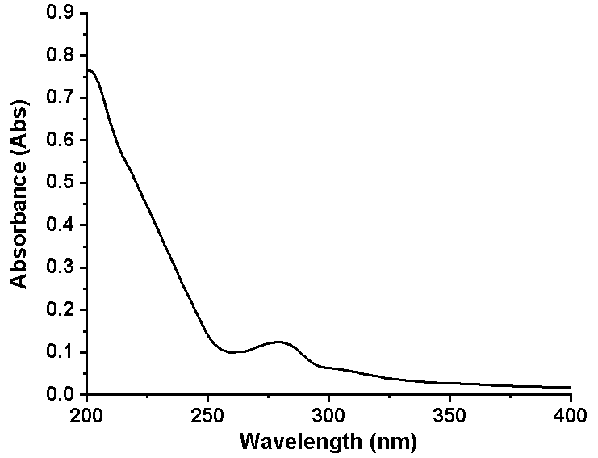
Fig. S1 UV spectrum of CSP in the range of 200−400 nm.

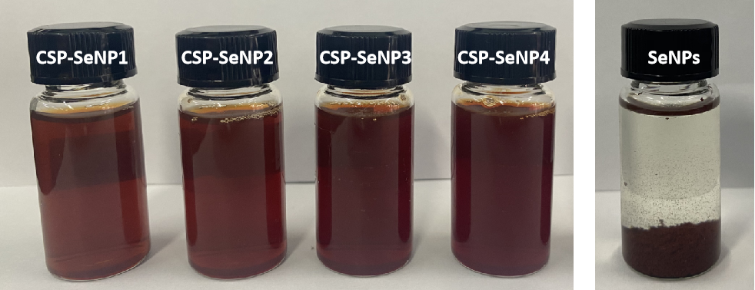
Fig. S2 Photographs of the aqueous solutions of SeNPs and CSP-SeNPs.

