Supplementary Material

Mechanistic Study on DNA Mutation of the Cytosine Methylation Reaction at C5 Position

Mansour H. Almatarneh ^{a,b*}, Ghada G. Kayed ª, Sanaa S. Al Abbad ^{c}, Zainab H. A. Alsunaidi ^{c}, Mohammed S. Al-Sheraideh ^{c}, Yuming Zhao ^{b*}

ª Department of Chemistry, University of Jordan, Amman 11942, Jordan.
^{b} Department of Chemistry, Memorial University, St. John’s, NL A1B 3X7, Canada.
^{c} Department of Chemistry, College of Science, Imam Abdulrahman Bin Faisal University, Dammam 31441, Saudi Arabia.

* Corresponding authors:
Mansour H. Almatarneh (E-mail: m.almatarneh@ju.edu.jo)
Yuming Zhao (E-mail: yuming@mun.ca)

Contents:
Scheme S1 Schematic representation of cytosine methylation reaction at position 5 considering the existence of Glu and Arg residues.

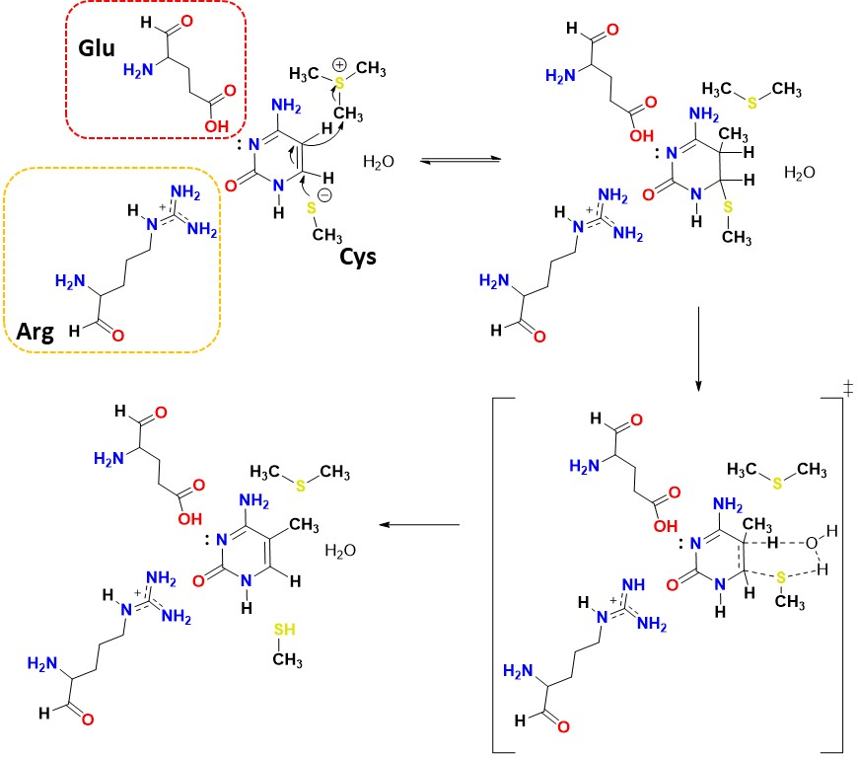
Scheme S1. Schematic representation of cytosine methylation reaction at position 5 considering the existence of Glu and Arg residues.

