**Liquid chromatographic determination of per- and polyfluoroalkyl substances in environmental river water samples**

**Shirley Kholofelo Selahle1,2, Anele Mpupa1,2, Philiswa Nosizo Nomngongo1,2,3\***

1 Department of Chemical Sciences, University of Johannesburg, Doornfontein Campus, P.O. Box 17011, Doornfontein, 2028, South Africa

2 Department of Science and Innovation-National Research Foundation South African Research Chair Initiative (DSI-NRF SARChI): Nanotechnology for Water, University of Johannesburg, Doornfontein, 2028, South Africa

3 Department of Science and Innovation (DSI)/Mintek Nanotechnology Innovation Centre, University of Johannesburg, Doornfontein 2028, South Africa

Supplementary data

Table S1:Parameter and levels used in screening (fractional factorial design).

|  |  |  |  |
| --- | --- | --- | --- |
| parameters | Minimum | Central | Maximum |
| pH | 4 | 6.5 | 9 |
| Mass of sorbent (mg) | 5 | 12.5 | 20 |
| Eluent volume(µL) | 500 | 750 | 1000 |
| Extraction time (min) | 10 | 20 | 30 |
| Elution time(min) | 10 | 20 | 30 |

Table S2: The design matrix and respective analytical response

|  |  |  |  |  |  |  |  |  |  |  |
| --- | --- | --- | --- | --- | --- | --- | --- | --- | --- | --- |
|  |  |  | Parameters | | | | %R | | |  |
| Runs | Pt | pH | MA (mg) | ET (min) | ELT (min) | EV (Ul) | PFOA | PFTeDA | PFDA | PFOS |
| 1 | 1 | 4 | 5 | 10 | 30 | 1000 | 78.4 | 77.5 | 79.3 | 81.4 |
| 2 | 1 | 9 | 5 | 10 | 10 | 500 | 34.5 | 43.5 | 28.4 | 43.7 |
| 3 | 1 | 4 | 20 | 10 | 10 | 1000 | 95.7 | 93.4 | 94.7 | 96.1 |
| 4 | 11 | 9 | 20 | 10 | 30 | 500 | 60.6 | 62.8 | 52.7 | 59.8 |
| 5 | 1 | 4 | 5 | 30 | 30 | 500 | 95.6 | 91.6 | 94.5 | 96.7 |
| 6 | 1 | 9 | 5 | 30 | 10 | 1000 | 24.3 | 39.3 | 23.7 | 23.4 |
| 7 | 1 | 4 | 20 | 30 | 10 | 500 | 97.9 | 96.3 | 95.7 | 98.1 |
| 8 | 1 | 9 | 20 | 30 | 30 | 1000 | 61.3 | 19.4 | 63.1 | 65.2 |
| 9 | 0 | 6.5 | 12.5 | 20 | 20 | 750 | 81.6 | 76.3 | 80.9 | 81.4 |
| 10 | 0 | 6.5 | 12.5 | 20 | 20 | 750 | 78.5 | 75.2 | 81.8 | 79.7 |
| 11 | 0 | 6.5 | 12.5 | 20 | 20 | 750 | 81.7 | 74.7 | 83.8 | 82.1 |
| 12 | 0 | 6.5 | 12.5 | 20 | 20 | 750 | 81.6 | 74.2 | 79.5 | 82.3 |

Table S3: CCD matrix and respective analytical response

|  |  |  |  |  |  |  |  |
| --- | --- | --- | --- | --- | --- | --- | --- |
| Runs | Parameters | | | %R | | | |
| Runs | pH | MA (mg) | ELT (min) | PFOA | PFTeDA | PFDA | PFOS |
| 1 | 4 | 5 | 10 | 79.1 | 99.6 | 92.3 | 78.3 |
| 2 | 4 | 5 | 30 | 94 | 102.4 | 99 | 93.5 |
| 3 | 4 | 20 | 10 | 4 | 100.6 | 95.5 | 104.8 |
| 4 | 4 | 20 | 30 | 105.9 | 101.3 | 97.2 | 118.9 |
| 5 | 9 | 5 | 10 | 120.1 | 55.7 | 72.9 | 57.7 |
| 6 | 9 | 5 | 30 | 58.3 | 32.3 | 53.2 | 70.3 |
| 7 | 9 | 20 | 10 | 71 | 45.7 | 56.5 | 60.2 |
| 8 | 9 | 20 | 30 | 60.8 | 70.1 | 71.6 | 53.5 |
| 9 | 3.1 | 12.5 | 20 | 54.1 | 96.8 | 88 | 103.2 |
| 10 | 9.9 | 12.5 | 20 | 104.2 | 60.3 | 45 | 42.5 |
| 11 | 6.5 | 2.4 | 20 | 42.9 | 69. | 52.2 | 59.8 |
| 12 | 6.5 | 22.6 | 20 | 60.4 | 95.7 | 99.5 | 110 |
| 13 | 6.5 | 12.5 | 6.5 | 111.1 | 41.1 | 28.1 | 28.1 |
| 14 | 6.5 | 12.5 | 33.5 | 28.3 | 108 | 101.2 | 72 |
| 15(C) | 6.5 | 12.5 | 20 | 73.2 | 73.2 | 96.9 | 77,1 |
| 16 (C) | 6.5 | 12.5 | 20 | 98.1 | 98.1 | 80.2 | 89,9 |
| 17(C) | 6.5 | 12.5 | 20 | 76.8 | 76.8 | 94.1 | 93.6 |

Table S4: Global concentrations of PFASs in comparison with the current study

|  |  |  |  |  |  |  |  |
| --- | --- | --- | --- | --- | --- | --- | --- |
| Country | | Concentrations (ng/L) | | | | |  |
|  | PFOA | | PFTeDA | PFDA | PFOS | Refs | |
| Australia | 39.9 | | 40 | 4.3 | 25.5 | [62] | |
| China | 12.0 | | < 18 | 10.9 | 14.4 | [60] | |
| Germany | 8.4 | | ND | 2.0 | 4.3 | [61] | |
| Netherlands | 1.78 | | 1.26 | 2.71 | ND | [63] | |
| China | 87.5 | | ND | 95.3 | 89.3 | [56] | |
| United States | 0.0070 | | ND | ND | 0.037 | [58] | |
| Australia | 71.1 | | ND | ND | 26.3 | [57] | |
| South Africa | 41.8 | | 10.4 | ND | 38.3 | [64] | |
| South Africa | 62.0 | | ND | 32.1 | 12.4 | [59] | |
| South Africa | 34.5 | | 4.2 | ND | ND | [65] | |
| South Africa | 314 | | 182 | ND | ND | [66] | |
| South Africa | 3.6-42.3 | | 0-9.28 | 0-11.2 | 0.51-38.2 | This study | |

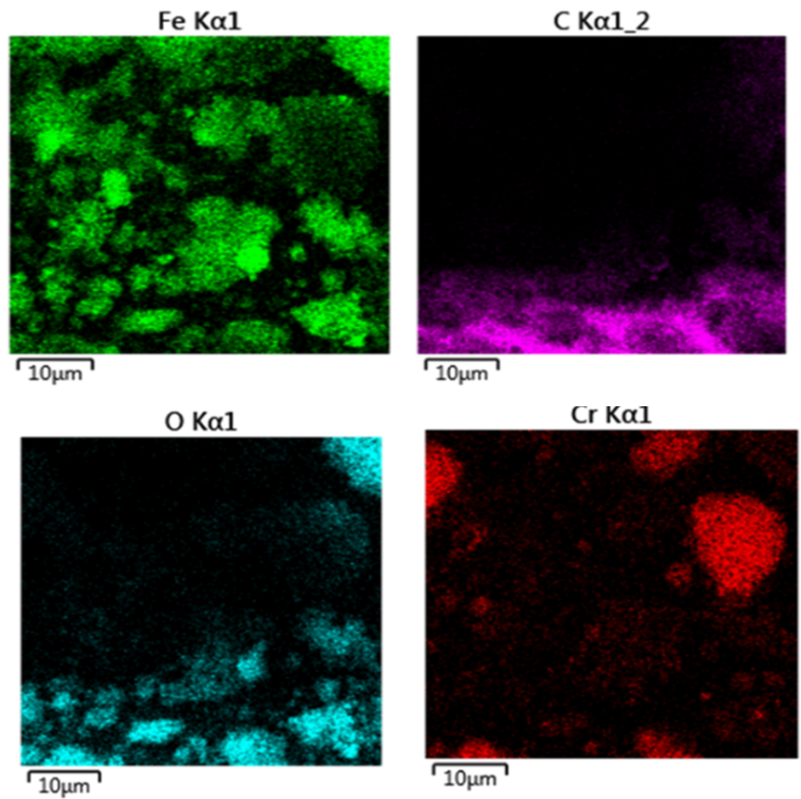

Figure S1: Element distribution from EDS mapping

Figure S2: XRD of (a) MIL-101 (Cr), (b) Fe3O4 and (c)Fe3O4@MIL-101(Cr).

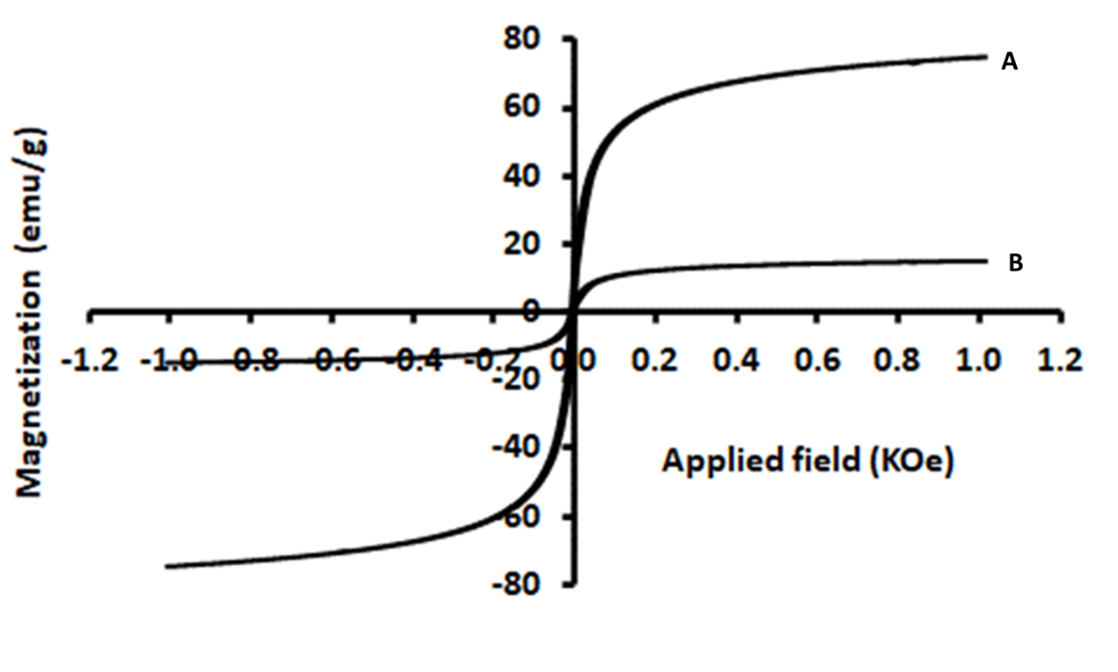

Figure S3: Vibrating sample magnetometry (VSM) of (A)Fe3O4 and (B) Fe3O4@MIL-101(Cr)

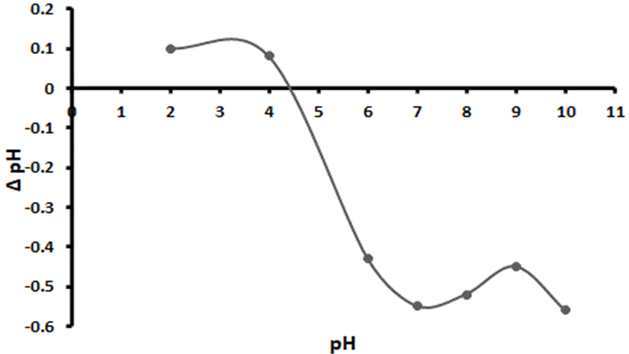

Figure S4: Point of zero charge

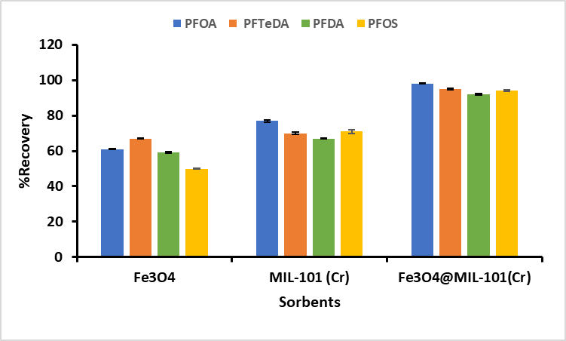

Figure S5: Selection of adsorbent material

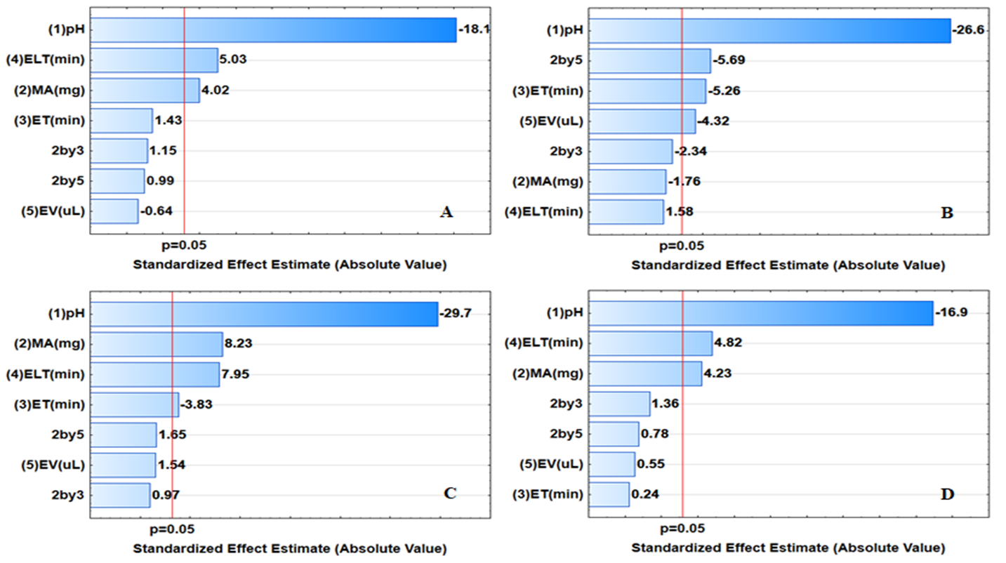

Figure S6: Pareto charts of standardised effects: (A) PFDA, (B) PFOA (C)) PFOS and (D) PFTeDA. ELT (min: Elution time, ET (min): Extraction time, MA (mg): Mass of adsorbent, EV (uL): Eluent volume. 2by3: Interaction between MA and ET, 2by5: interaction between MA and EV.

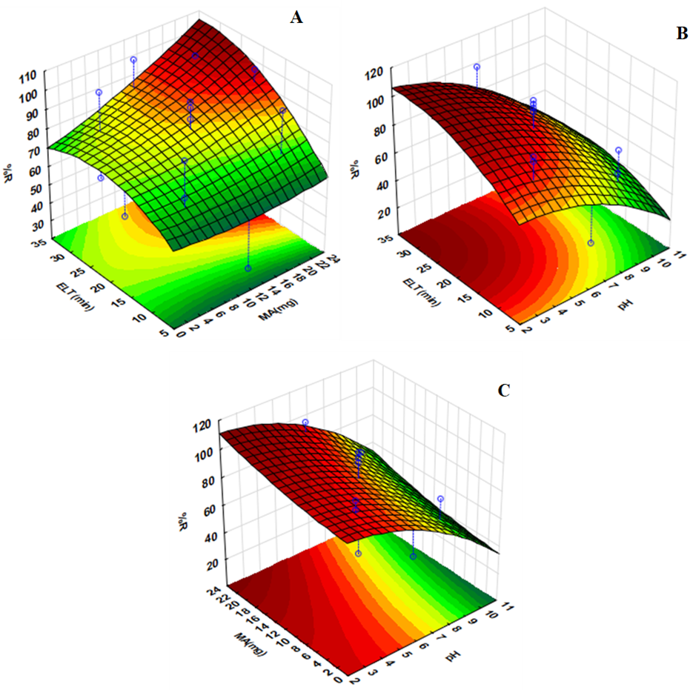

Figure S7: 3D response surface plots of (A) the interactive effect of elution time (ELT) and mass of adsorbent (MA) (B) the interactive effect of ELT and pH, and (C) the interactive effect of MA and pH.

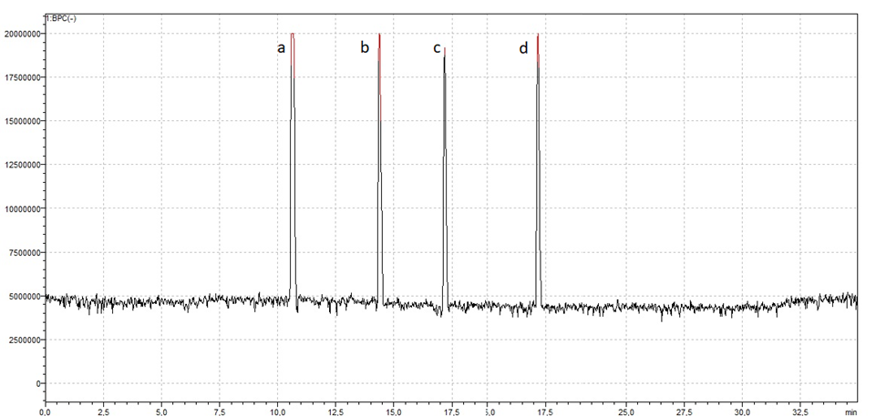

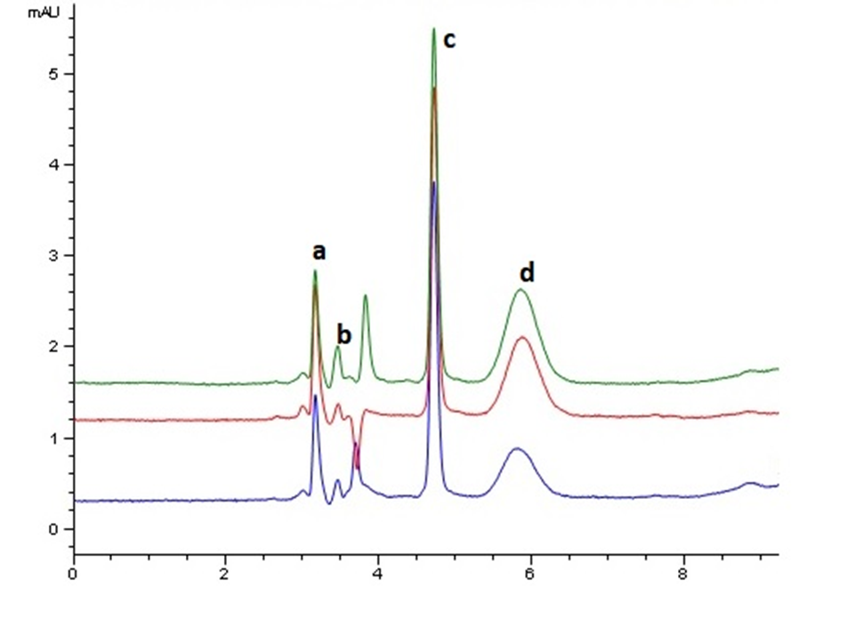Figure S8: Liquid chromatography peaks: (a) PFOS, (b) PFDA, (c) PFTeDA and (d) PFOS (Apies River water sample)



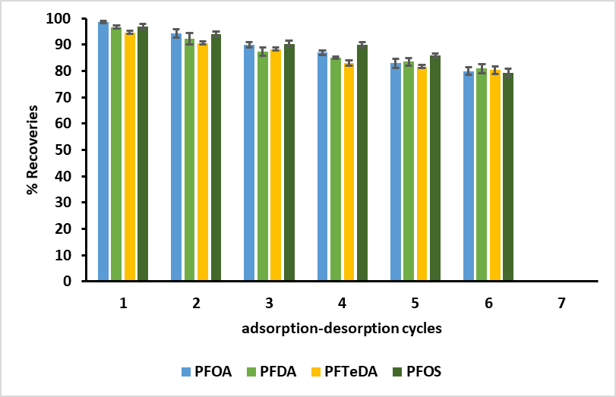

Figure S11: Reusability of Fe3O4@MIL-101(Cr) nanocomposite.