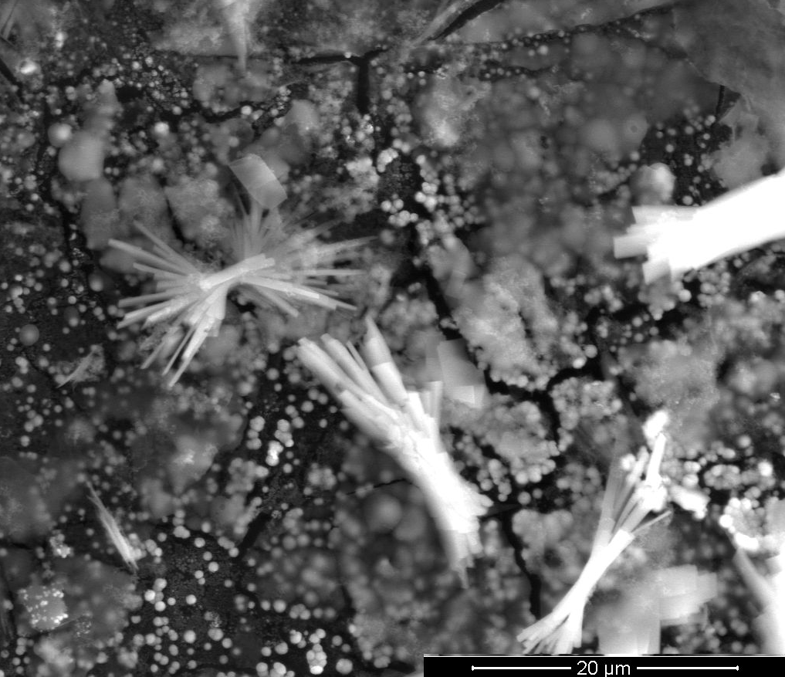

**Figure S1:** FE-SEM image of then-CoOx/n-Au/n-Pt/GC catalyst, magnification: 5,000x.



**Figure S2:** CVs obtained at the (a) n-Pt/GC, (b) n-Au/n-Pt/GC, and (c) n-CoOx/n-Au/n-Pt/GC catalysts in 0.3 M FA (pH = 3.5). Potential scan rate: 100 mVs̶ 1.



**Figure S3:** LSVs for oxidative CO stripping obtained at the (a,d) n-Pt/GC, (b,e) n-Au/n-Pt/GC, and (c,f) n-CoOx/n-Au/n-Pt/GC catalysts in 0.5 M Na2SO4 (pH = 3.5). Potential scan rate: 100 mVs−1. Before measurements, CO was adsorbed from 0.5 M FA at the open circuit potential for 10 min. The solid lines represent the first LSV and the dotted lines represent the second LSV.