**Supplementary information**

**Inhibitory effect of protonic bis(5-amino-1,10-phenanthroline) on proliferation of hepatocellular carcinoma and its molecular mechanism**

Zizhen Zhao, Chen Fu, Yuping Zhang, Yingying Zhang, Xiaoxi Yang, Ailing Fu *

College of Pharmaceutical Science, Southwest University; Chongqing, 400715

*Corresponding author.

E-mail: [fal@swu.edu.cn](mailto:fal@swu.edu.cn) (A.F.)

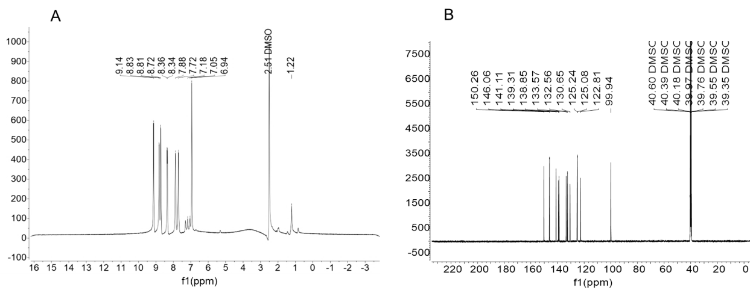

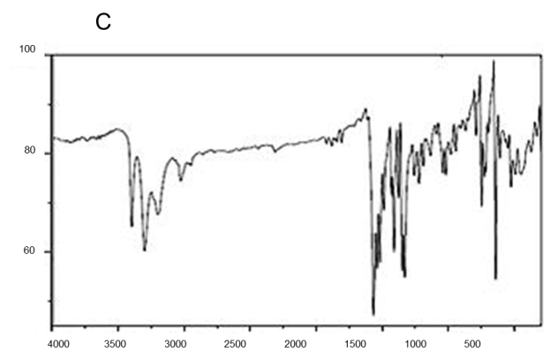

Fig. S1. Characteristics of P-BAP. The chemical was respectively identified by (A) 1H NMR, (B) 13C NMR, and (C) FTIR.

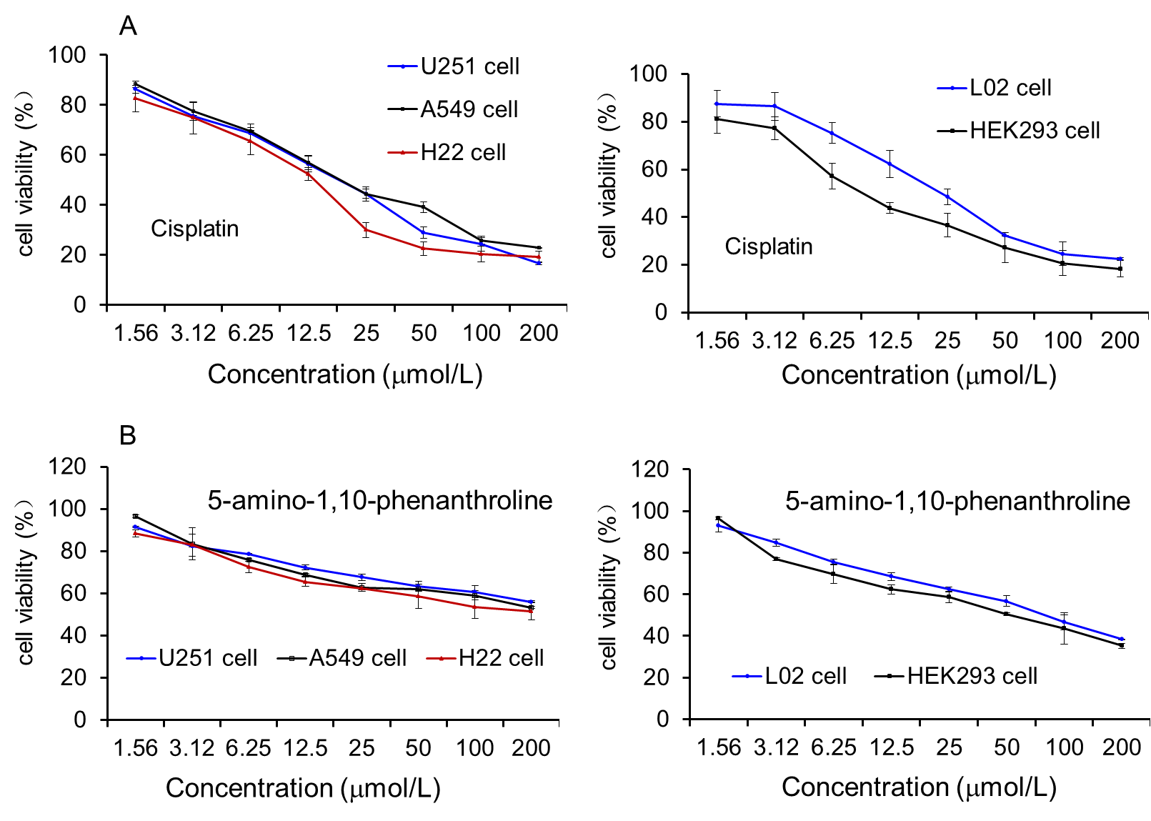

Fig S2. Cytotoxicity of cisplatin and 5-amino-1,10-phenanthroline. (A) Cytotoxicity of cisplatin. Difference concentrations of cisplatin were respectively added into the cell media, the viabilities were measured by CCK-8 method. (B) Cytotoxicity of 5-amino-1,10-phenanthroline.

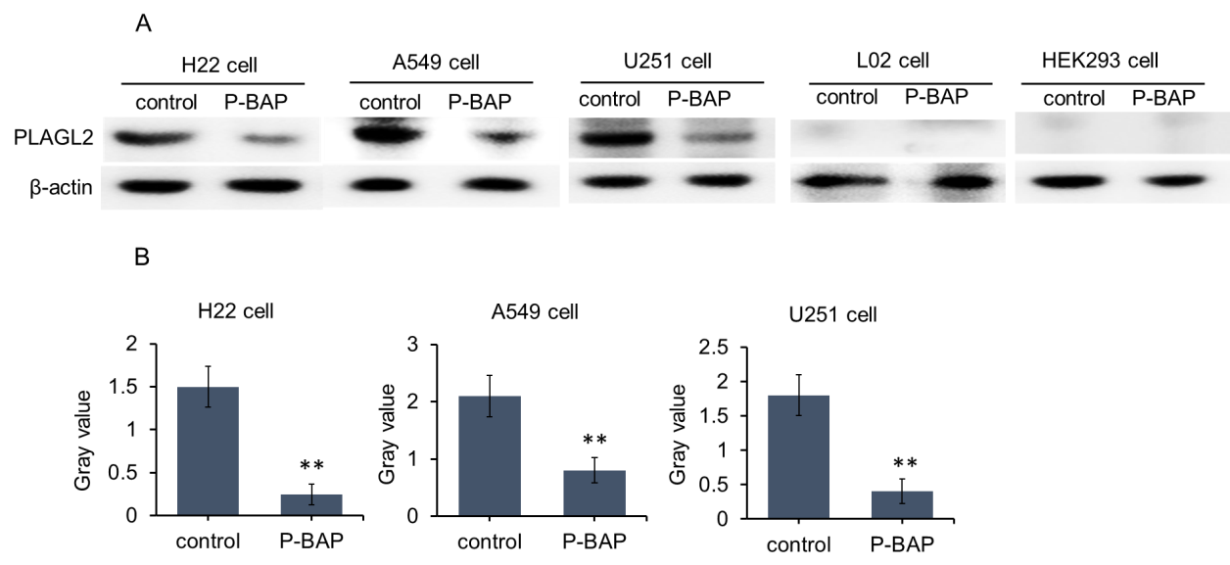

Fig S3. The expression levels of PLAGL2 in cells. There were high expression level of PLAGL2 in H22 cells, A549 cells and U251 cells, but few expressions in L02 cells and HEK 293 cells. After P-BAP treatment, the levels of PLAGL2 in the tumor cells were reduced. \*\**p* < 0.01 compared with the control.