**Supplementary Material**

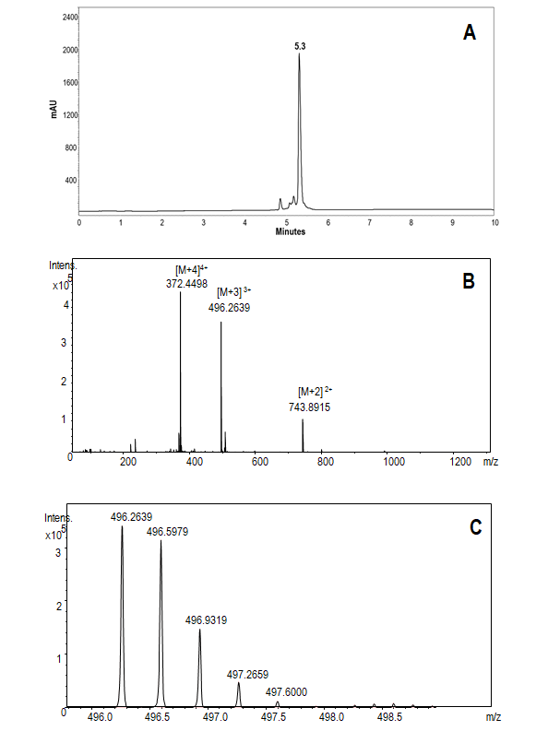

**S1.** LfcinB (21-25)pal characterization: (A) Chromatographic profile; (B) LC-MS spectrum: [M+2]2+;[M+3]3+ and [M+4]4+ species are observed; (C) LC-MS [M+3]3+ spectrum zoom: the isotopic pattern indicates a difference between signals of 0.33 (n = 3). Theoretical mass: 1485.7534, calculated mass: 1485.7920

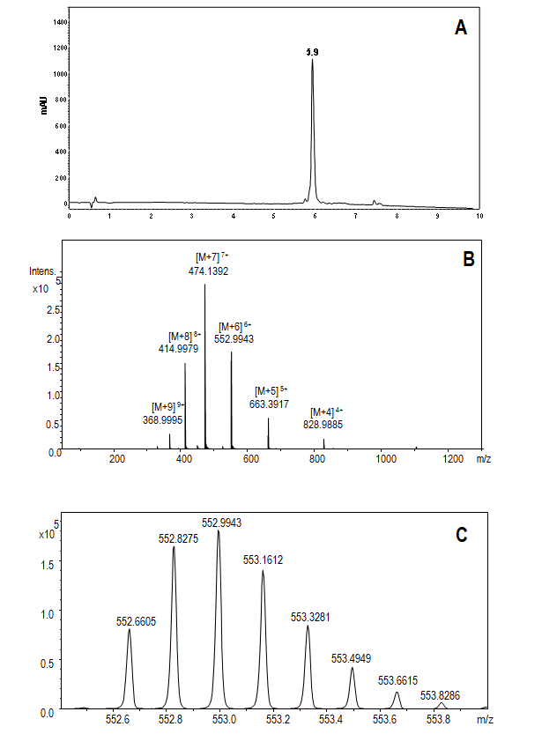

**S2.** LfcinB (20-30)2 characterization: (A) Chromatographic profile; (B) LC-MS spectrum: [M+4]4+, [M+5]5+, [M+6]6+, [M+7]7+, [M+8]8+ and [M+9]9+ species are observed; (C) [M+6]6 mass spectrum zoom: the isotopic pattern indicates a difference between signals of 0.17 (n = 6). Theoretical mass: 3312.0920, calculated mass: 3311.9540

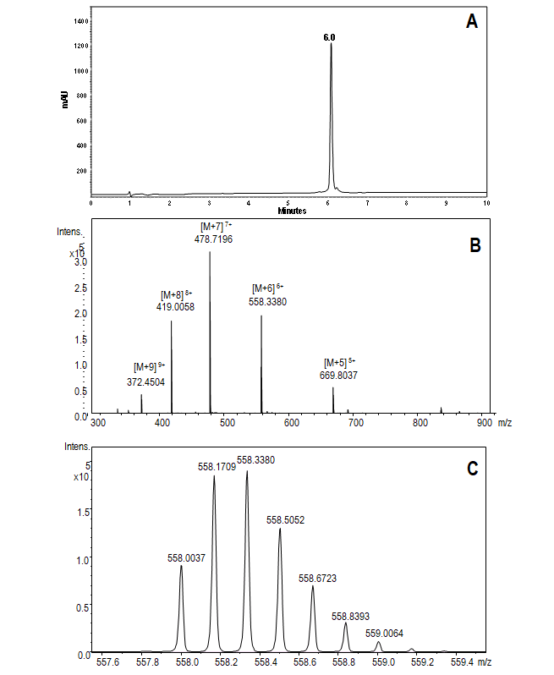

**S3.** 26[F] LfcinB (20-30)2 characterization: (A) Chromatographic profile; (B) LC-MS spectrum: [M+4]4+, [M+5]5+, [M+6]6+, [M+7]7+, [M+8]8+ and [M+9]9+ species are observed; (C) LC-MS [M+6]6+ spectrum zoom. The isotopic pattern indicates a difference between signals of 0.17 (n = 6). Theoretical mass: 3344.0510, calculated mass: 3344.0464

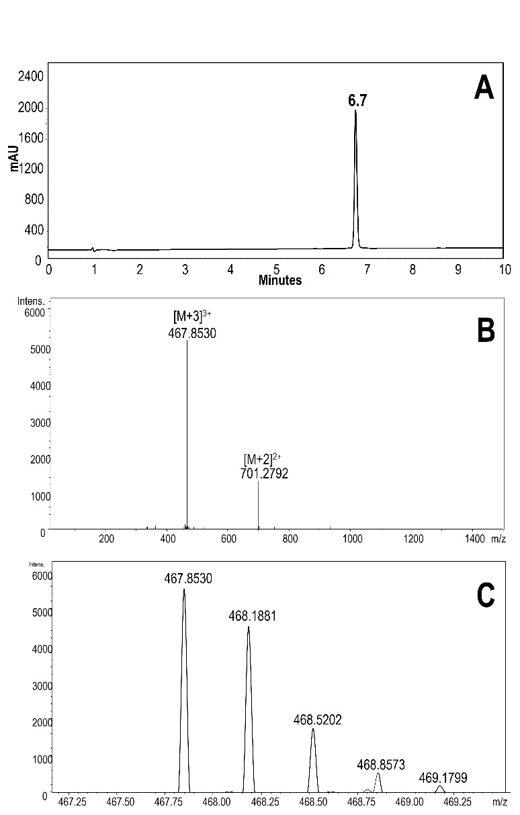

**S4.** 5[A] LfcinB (21-25)pal characterization: (A) Chromatographic profile; (B) LC-MS spectrum: [M+2]2+;[M+3]3+ and [M+4]4+ species are observed; (C) LC-MS [M+3]3+ spectrum zoom: the isotopic pattern indicates a difference between signals of 0.33 (n = 3). Theoretical mass: 1400.6890, calculated mass: 1400.6580.

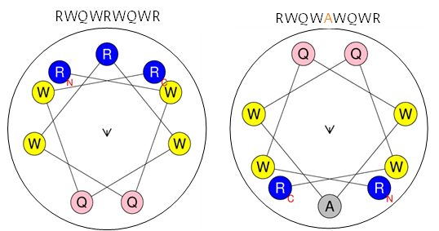

**S3**. Helical wheel projections as visual representation of LfcinB (21-25)Pal and 5[A] LfcinB (21-25)Pal.