Electronic Supplementary Material

L-cysteine-regulated in situ formation of Prussian blue /Turnbull’s blue nanoparticles as the colorimetric probe for the detection of copper ion

Hang-Yu Zhou ª, Hao Zhang ^{b*}, Li-Jing Peng ª, Wei-Yi Zhang ª, Tao Tian ª, Feng-Qing Yang ^{a*}

ª School of Chemistry and Chemical Engineering, Chongqing University, Chongqing 401331, China
^{b} Chongqing Key Laboratory of High Active Traditional Chinese Drug Delivery System, Chongqing Medical and Pharmaceutical College, Chongqing 401331, China

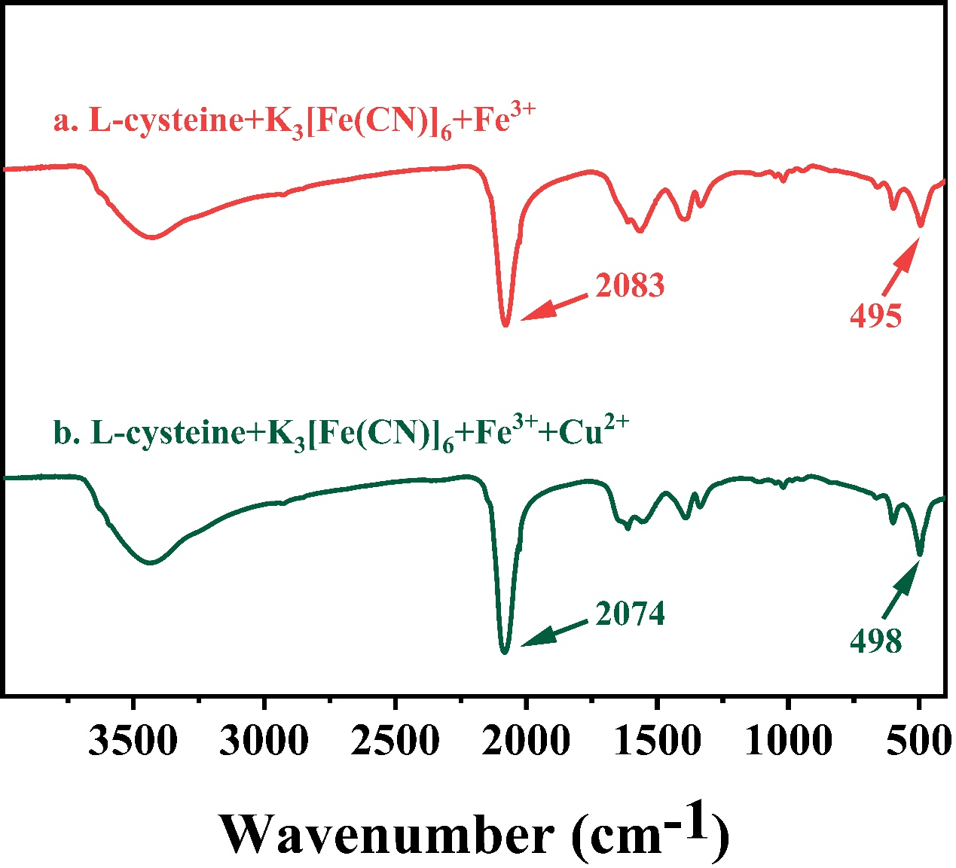
Figure S1. FT-IR spectra of L-cys-PBNPs/TBNPs (a) and L-cys-PBNPs/TBNPs after addition of Cu²⁺ (b).

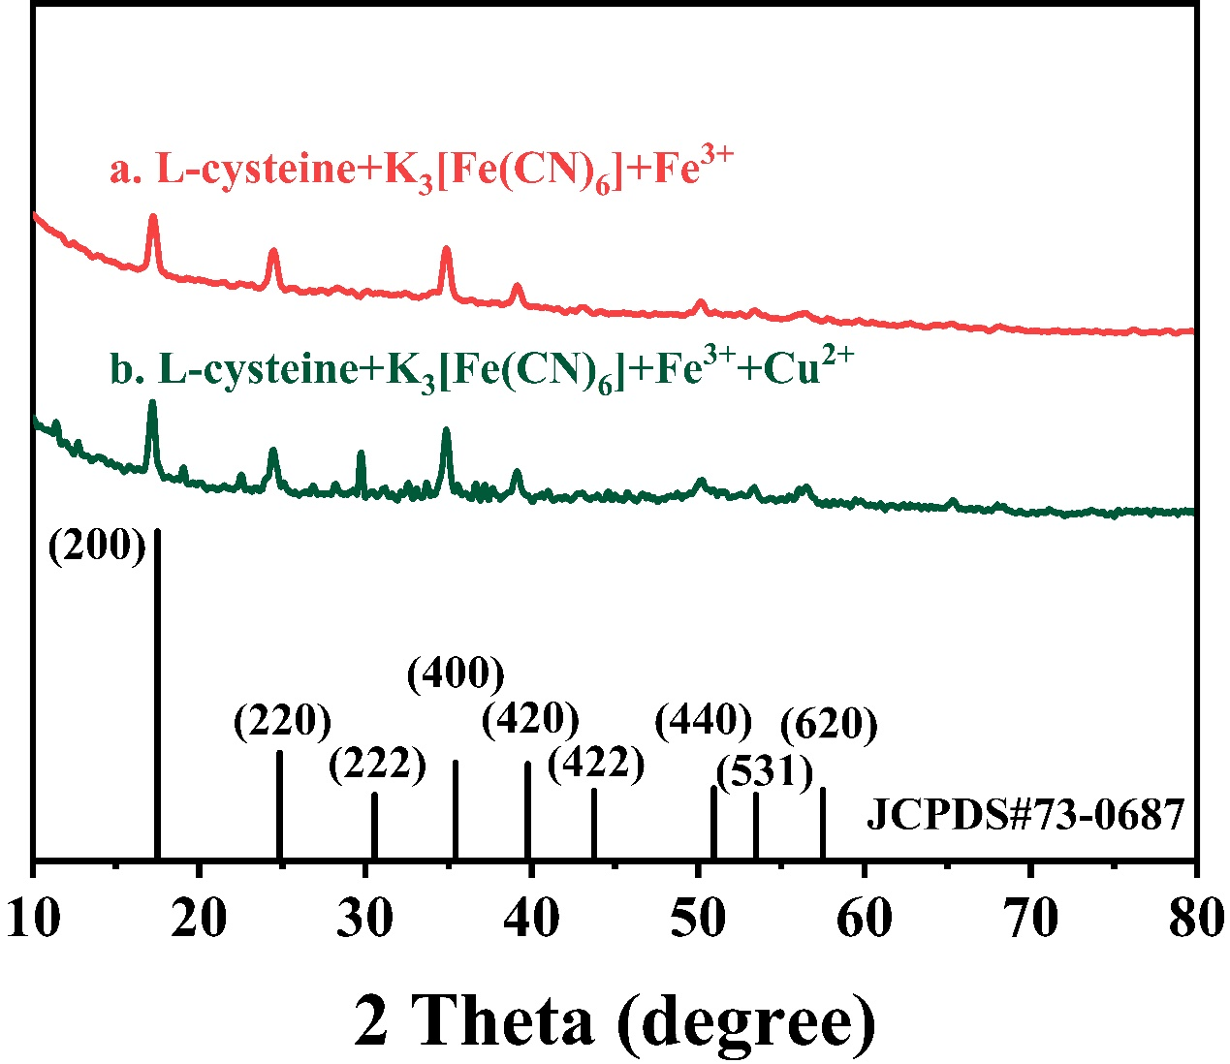
Figure S2. XRD images of L-cys-BNPs/TBNPs (a) and L-cys-PBNPs/TBNPs after addition of Cu²⁺ (b).
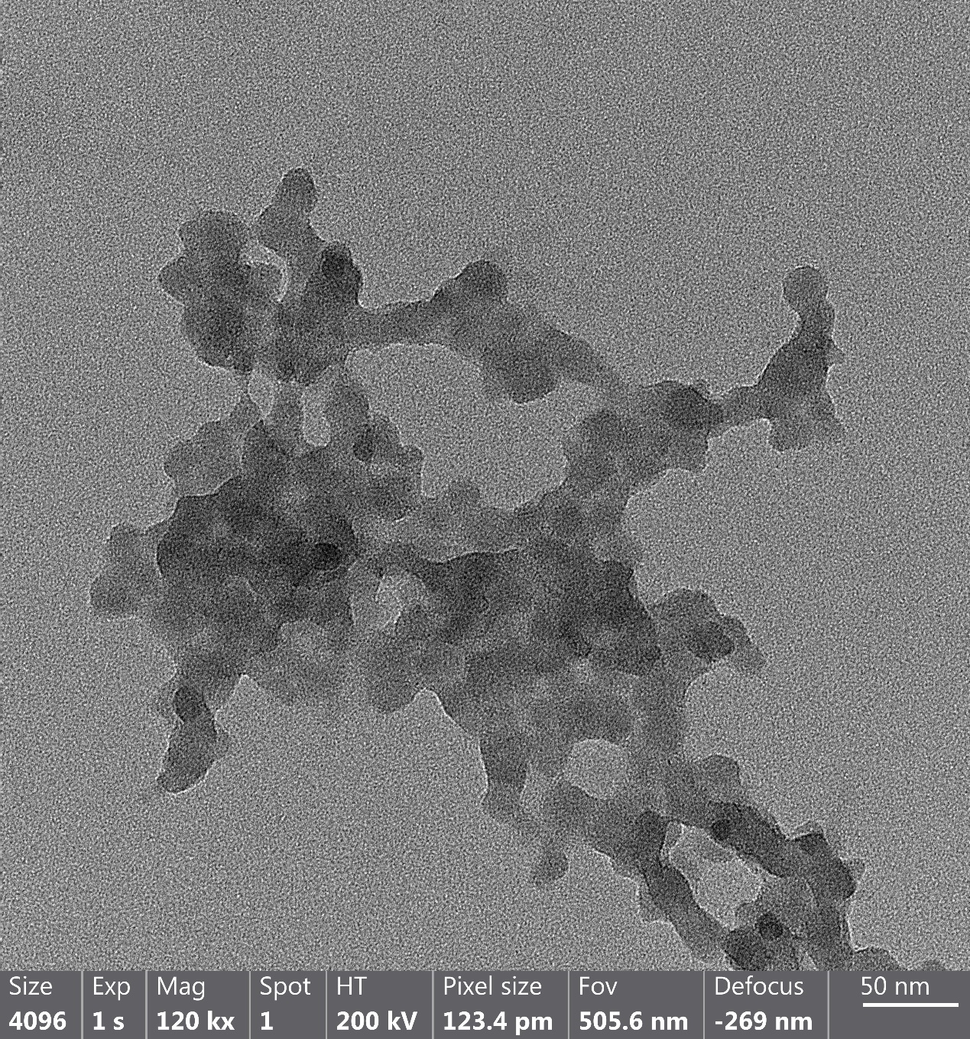
Figure S3. TEM images of L-cys-PBNPs/ TBNPs (magnification times: 120000).

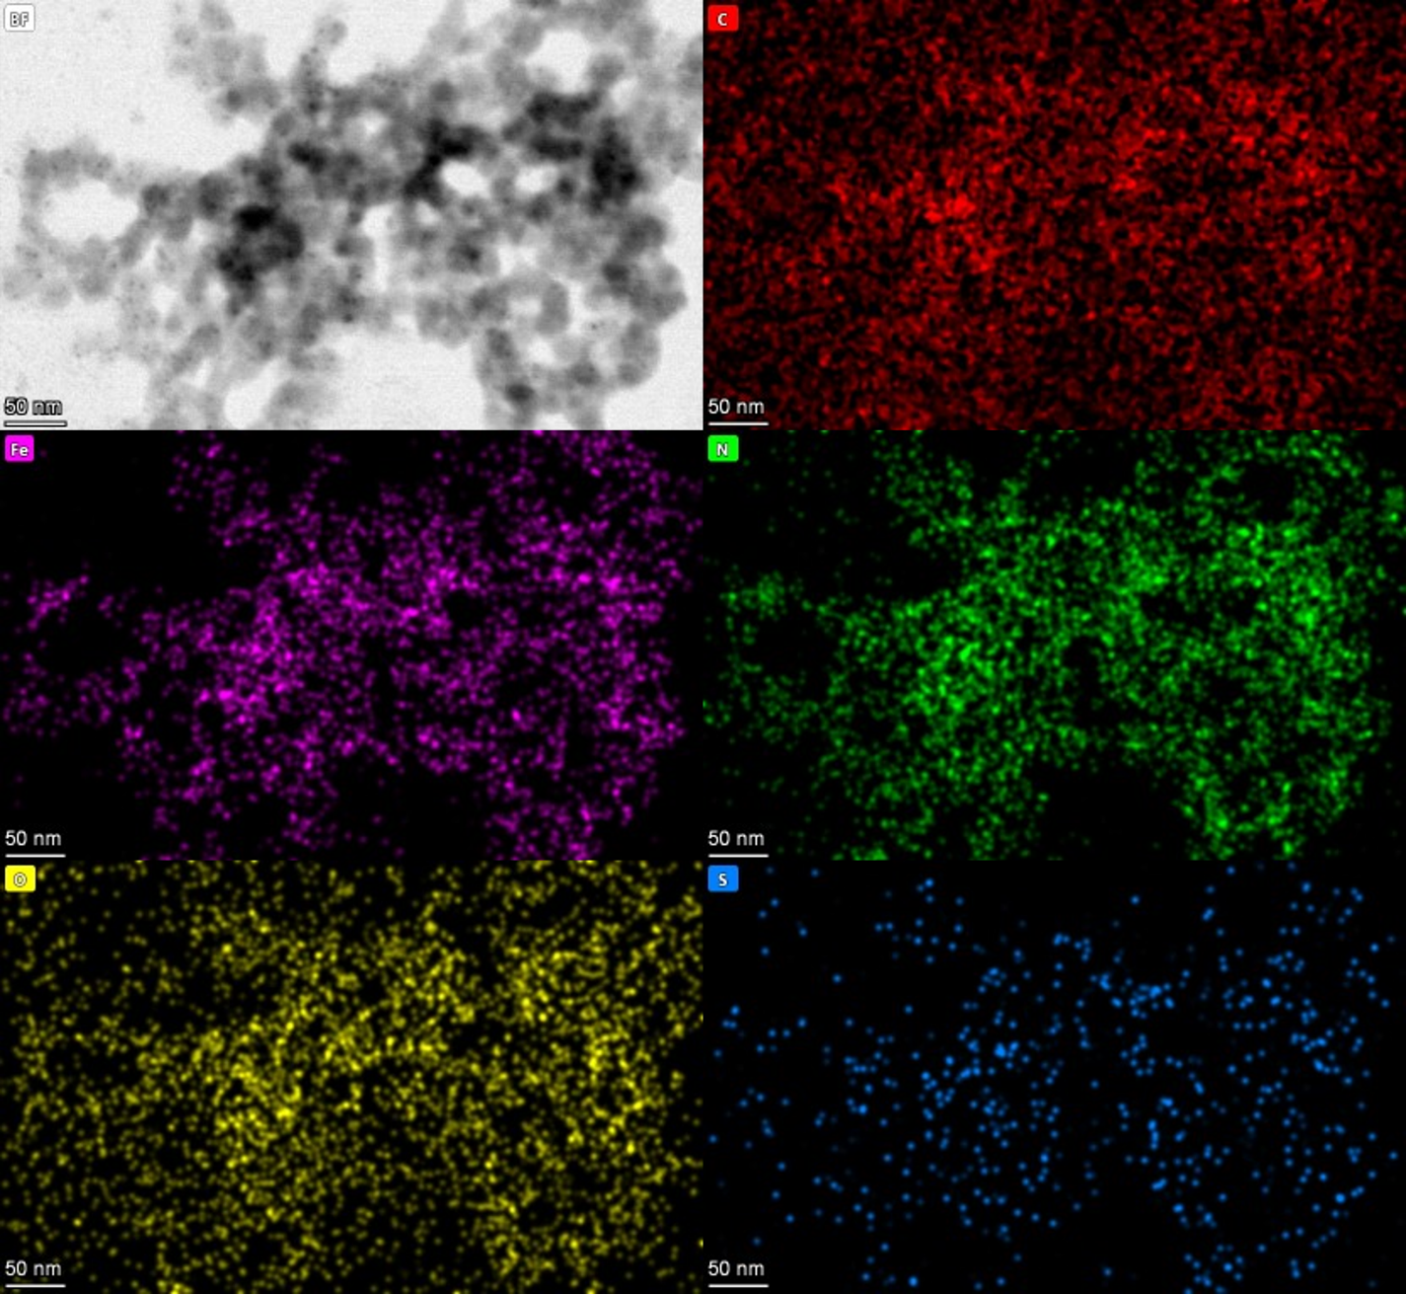Figure S4. EDS elemental mapping images of L-cys-PBNPs/ TBNPs. Elements: C, Fe, N, O, and S.

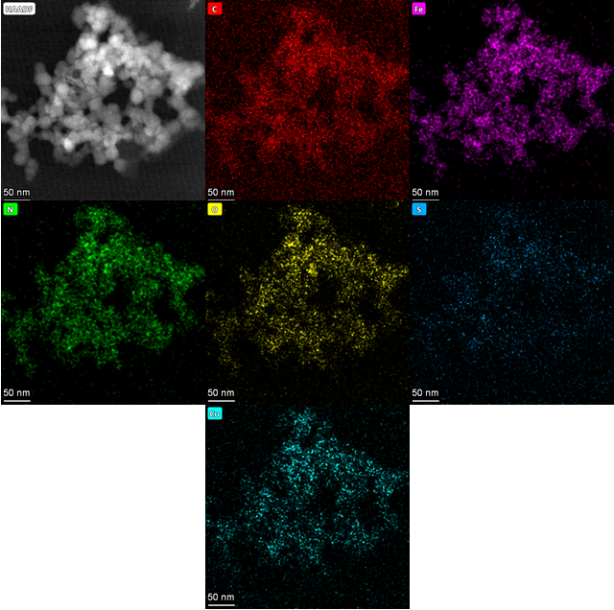
Figure S5. EDS elemental mapping images of L-cys-PBNPs/TBNPs after addition of Cu²⁺. Elements: C, Fe, N, O, S, and Cu.

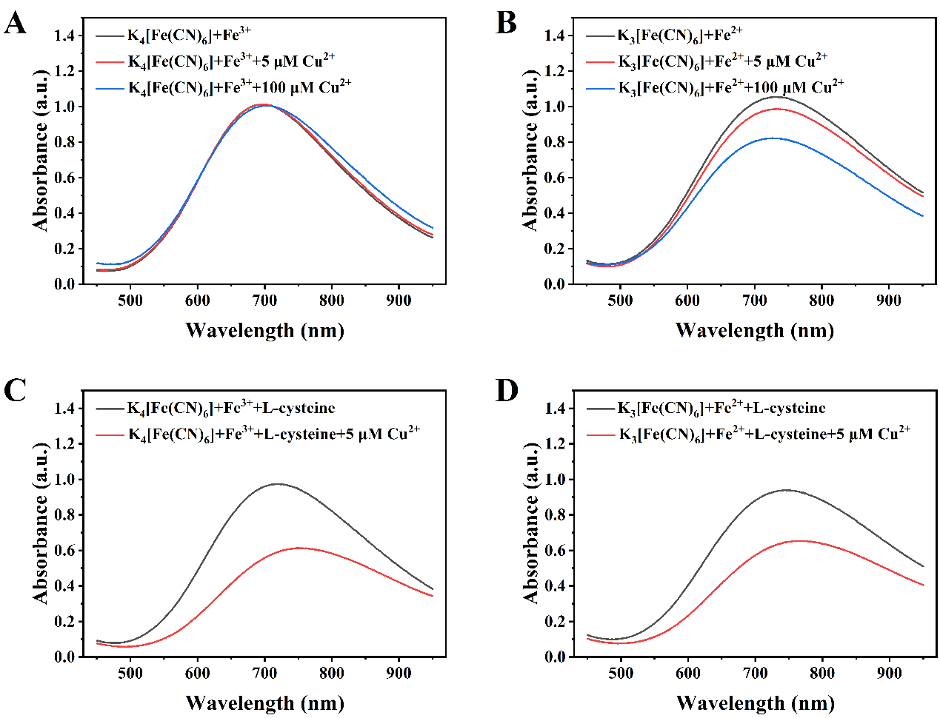
Figure S6. Different conditions for investigating the feasibility of the sensing system. The UV-Vis spectra of PBNPs synthesized using K₄[Fe(CN)₆] and Fe³⁺ and the influence of addition of Cu²⁺ (A), TBNPs synthesized using K₃[Fe(CN)₆] and Fe²⁺ and the influence of addition of Cu²⁺ (B), L-cys-PBNPs synthesized using K₄[Fe(CN)₆], Fe³⁺, and L-cysteine, and the influence of addition of Cu²⁺ (C), and L-cys-TBNPs synthesized using K₃[Fe(CN)₆], Fe²⁺, and L-cysteine and the influence of addition of Cu²⁺ (D). (The final concentrations of L-cysteine, FeCl₃, FeCl₂, K₃[Fe(CN)₆], and K₄[Fe(CN)₆] solutions are 2 mM, 1 mM, 1 mM, 0.25 mM, and 0.25 mM, respectively; the pH of NaAc-HAc buffer and reaction temperature between L-cysteine and Cu²⁺ are 4.5 and 30°C, respectively; the formation time of L-cysteine and reaction time between L-cysteine and Cu²⁺ are both 5 min).

Figure S7. Effects of formation time of L-cys-PBNPs/ TBNPs (A) and reaction time between Cu²⁺ and L-cys-PBNPs/ TBNPs (B) on the determination of Cu²⁺.

