**Appendix A. Supplementary data**

**Design, synthesis, biological activity evaluation and mechanism of action of myricetin derivatives containing thioether quinazolinone**

Tingting Liu,#,a Feng Peng,#,a Yunying Zhu,b Xiao Cao,a Qifan Wang,a Fang Liu,a Liwei Liu,a Wei Xue*,a

a State Key Laboratory Breeding Base of Green Pesticide and Agricultural Bioengineering; Key Laboratory of Green Pesticide and Agricultural Bioengineering, Ministry of Education; Research and Development Center for Fine Chemicals, Guizhou University, Guiyang 550025, P.R. China.

b School of Chemical Engineering, Guizhou Institute of Technology, Guiyang 550001, China

# Contributed equally to this work

*Corresponding author: Tel.: 0086-851-88292090, Fax: 0086-851-88292090, E-mail: [wxue@gzu.edu.cn](mailto:wxue@gzu.edu.cn) (Wei Xue)

1. **Spectra data of target compounds T1**−**T25**

**2-((3-((5,7-dimethoxy-4-oxo-2-(3,4,5-trimethoxyphenyl)-4*H*-chromen-3-yl)oxy)propyl)thio)-6-methyl-3-phenylquinazolin-4(3*H*)-one (T1)**.White solid, m.p. 175.8-177.6 °C, yield 59%; 1H NMR (500 MHz, Chloroform-*d*) *δ* 7.98 (s, 1H, Ph-H), 7.51 (dd, J = 6.9, 3.1 Hz, 4H, Ph-H), 7.43 (d, *J* = 8.1 Hz, 1H, Ph-H), 7.29 (s, 2H, Ph-H), 7.26 (d, J = 3.4 Hz, 1H, Ph-H), 7.25 (d, J = 2.3 Hz, 1H, Ph-H), 6.47 (d, *J* = 2.3 Hz, 1H, Ph-H), 6.34 (d, *J* = 2.1 Hz, 1H, Ph-H), 4.11 (t, *J* = 6.0 Hz, 2H, -O-CH2CH2CH2-S-), 3.95 (s, 3H, Ph-OCH3), 3.89 (s, 3H, Ph-OCH3), 3.88 (s, 3H, Ph-OCH3), 3.86 (s, 6H, Ph-OCH3), 3.25 – 3.21 (m, 2H, -O-CH2CH2CH2-S-), 2.44 (s, 3H, Ph-CH3), 2.12 (p, *J* = 6.4 Hz, 2H, -O-CH2CH2CH2-S-); 13C NMR (126 MHz, Chloroform-*d*) *δ* 174.03, 164.08, 162.03, 161.08, 158.85, 156.08, 153.03, 152.71, 145.97, 140.52, 139.90, 136.11 (d, J = 6.0 Hz), 135.88, 129.91, 129.71, 129.25, 126.63, 126.13 (d, J = 14.8 Hz), 119.58, 109.45, 105.83, 95.91, 92.47, 71.19, 61.11, 56.53, 56.39, 55.93, 29.80, 29.35, 21.35; HRMS (ESI) calcd for C38H37O9N2S [M+H]+: 697.22143, found 697.22076.

**7-chloro-2-((3-((5,7-dimethoxy-4-oxo-2-(3,4,5-trimethoxyphenyl)-4*H*-chromen-3-yl)oxy)propyl)thio)-3-phenylquinazolin-4(3*H*)-one (T2)**.White solid, m.p. 173.9-175.8 °C, yield 27%; 1H NMR (500 MHz, Chloroform-*d*) *δ* 8.11 (d, J = 8.5 Hz, 1H, Ph-H), 7.56 (d, J = 1.8 Hz, 1H, Ph-H), 7.54 – 7.51 (m, 3H, Ph-H), 7.31 (s, 2H, Ph-H), 7.30 – 7.25 (m, 3H, Ph-H), 6.47 (d, J = 2.0 Hz, 1H, Ph-H), 6.33 (d, J = 2.2 Hz, 1H, Ph-H), 4.01 (t, J = 5.7 Hz, 2H, -O-CH2CH2CH2-S-), 3.94 (s, 3H, Ph-OCH3), 3.90 – 3.88 (m, 12H, Ph-OCH3), 3.16 (t, J = 6.8 Hz, 2H, -O-CH2CH2CH2-S-), 1.84 – 1.82 (m, 2H, -O-CH2CH2CH2-S-); 13C NMR (126 MHz, Chloroform-*d*) *δ* 174.05, 164.05, 161.36, 161.08, 159.30, 158.84, 153.01, 152.66, 148.72, 140.69 (d, J = 13.4 Hz), 139.88, 135.80, 130.12, 129.81, 129.13, 128.74, 126.26, 126.13, 125.87, 118.34, 109.45, 105.82, 95.88, 92.46, 71.67, 61.11, 56.52, 56.37, 55.93, 32.38, 29.44, 25.35. HRMS (ESI) calcd for C37H34O9N2ClS [M+H]+: 717.16681, found 717.16650.

**2-((3-((5,7-dimethoxy-4-oxo-2-(3,4,5-trimethoxyphenyl)-4*H*-chromen-3-yl)oxy)propyl)thio)-7-nitro-3-phenylquinazolin-4(3*H*)-one (T3)**.Yellow solid, m.p. 224.0-225.6 °C, yield, 17%; 1H NMR (400 MHz, Chloroform-*d*) *δ* 8.39 – 8.35 (m, 2H, Ph-H), 8.12 (dd, J = 8.7, 2.2 Hz, 1H, Ph-H), 7.58 – 7.55 (m, 3H, Ph-H), 7.32 – 7.29 (m, 4H, Ph-H), 6.49 (d, J = 2.2 Hz, 1H, Ph-H), 6.36 (d, J = 2.3 Hz, 1H, Ph-H), 4.15 (t, J = 5.9 Hz, 2H, -O-CH2CH2CH2-S-), 3.96 (s, 3H, Ph-OCH3), 3.90 (t, J = 4.7 Hz, 12H, Ph-OCH3), 3.32 (t, J = 7.3 Hz, 2H, -O-CH2CH2CH2-S-), 2.13 (p, J = 6.3 Hz, 2H, -O-CH2CH2CH2-S-); 13C NMR (101 MHz, Chloroform-*d*) *δ* 173.91, 164.06, 161.01, 160.77, 160.58, 158.80, 152.99, 152.77, 151.77, 148.21, 140.31, 139.91, 135.28, 130.34, 129.93, 129.13, 128.85, 125.94, 123.98, 121.77, 119.20, 109.35, 105.83, 95.89, 92.41, 70.80, 61.01, 56.47, 56.32, 55.86, 29.69, 29.53; HRMS (ESI) calcd for C37H34O11N3S [M+H]+: 728.19086, found 728.19012.

**6,8-dichloro-2-((3-((5,7-dimethoxy-4-oxo-2-(3,4,5-trimethoxyphenyl)-4*H*-chromen-3-yl)oxy)propyl)thio)-3-phenylquinazolin-4(3*H*)-one (T4).** White solid, m.p. 220.6-222.0 °C, yield, 14%; 1H NMR (500 MHz, Chloroform-*d*) *δ* 8.06 (d, J = 2.3 Hz, 1H, Ph-H), 7.72 (d, J = 2.3 Hz, 1H, Ph-H), 7.53 (q, J = 2.6 Hz, 4H, Ph-H), 7.27 (s, 2H, Ph-H), 7.26 – 7.25 (m, 1H, Ph-H), 6.47 (d, J = 2.3 Hz, 1H, Ph-H), 6.33 (d, J = 2.2 Hz, 1H, Ph-H), 4.13 (t, J = 6.1 Hz, 2H, -O-CH2CH2CH2-S-), 3.94 (s, 3H, Ph-OCH3), 3.89 (s, 3H, Ph-OCH3), 3.87 (d, J = 5.2 Hz, 9H, Ph-OCH3), 3.28 (t, J = 7.1 Hz, 2H, -O-CH2CH2CH2-S-), 2.21 (p, J = 6.4 Hz, 2H, -O-CH2CH2CH2-S-); 13C NMR (126 MHz, Chloroform-*d*) *δ* 164.08, 161.06, 160.43, 158.86, 153.02, 134.73, 130.71, 130.33, 129.96, 128.90, 126.06, 125.44, 121.83, 105.86, 95.90, 92.46, 77.40, 77.14, 76.89, 71.18, 61.11, 56.46 (d, J = 17.1 Hz), 55.93, 30.26, 29.99, 29.57; HRMS (ESI) calcd for C37H33O9N2Cl2S [M+H]+: 751.12783, found 751.12750.

**2-((3-((5,7-dimethoxy-4-oxo-2-(3,4,5-trimethoxyphenyl)-4*H*-chromen-3-yl)oxy)propyl)thio)-6-fluoro-3-phenylquinazolin-4(3*H*)-one (T5)**. White solid, m.p. 185.6-187.3 °C, yield, 27%; 1H NMR (500 MHz, Chloroform-*d*) *δ* 7.83 (dd, J = 8.1, 2.9 Hz, 1H, Ph-H), 7.55 – 7.53 (m, 1H, Ph-H), 7.53 – 7.51 (m, 3H, Ph-H), 7.41 (td, J = 8.3, 2.9 Hz, 1H, Ph-H), 7.28 (s, 2H, Ph-H), 7.28 – 7.25 (m, 2H, Ph-H), 6.48 (d, J = 2.2 Hz, 1H, Ph-H), 6.34 (d, J = 2.3 Hz, 1H, Ph-H), 4.11 (t, J = 6.2 Hz, 2H, -O-CH2CH2CH2-S-), 3.95 (s, 3H, Ph-OCH3), 3.89 (s, 3H, Ph-OCH3), 3.88 (s, 3H, Ph-OCH3), 3.87 (s, 6H, Ph-OCH3), 3.26 – 3.22 (m, 2H, -O-CH2CH2CH2-S-), 2.11 (p, J = 6.3 Hz, 2H, -O-CH2CH2CH2-S-); 13C NMR (126 MHz, Chloroform-*d*) *δ* 174.02, 167.85, 164.11, 161.07, 158.87, 156.67, 153.04, 152.77, 144.65, 140.48, 139.92, 135.78, 126.05, 123.24, 123.05, 120.97 (d, J = 8.4 Hz), 112.17, 111.99, 109.44, 105.85, 95.94, 92.48, 71.09, 61.11, 56.54, 56.39, 55.94, 29.73, 29.43; 19F NMR (471 MHz, Chloroform-*d*) *δ* -114.11; HRMS (ESI) calcd for C37H34O9N2FS [M+H]+: 701.19636, found 701.19629.

**6-bromo-2-((3-((5,7-dimethoxy-4-oxo-2-(3,4,5-trimethoxyphenyl)-4*H*-chromen-3-yl)oxy)propyl)thio)-3-phenylquinazolin-4(3*H*)-one (T6).** White solid, m.p. 183.2-184.8 °C, yield, 48%; 1H NMR (500 MHzChloroform-*d*) *δ* 8.30 (d, J = 2.3 Hz, 1H, Ph-H), 7.75 (dd, J = 8.6, 2.3 Hz, 1H, Ph-H), 7.53 – 7.50 (m, 3H, Ph-H), 7.41 (d, J = 8.7 Hz, 1H, Ph-H), 7.27 (s, 2H, Ph-H), 7.25 (t, J = 3.1 Hz, 2H, Ph-H), 6.47 (d, J = 2.0 Hz, 1H, Ph-H), 6.34 (d, J = 2.3 Hz, 1H, Ph-H), 4.10 (t, J = 6.0 Hz, 2H, -O-CH2CH2CH2-S-), 3.95 (s, 3H, Ph-OCH3), 3.89 (s, 3H, Ph-OCH3), 3.88 (s, 3H, Ph-OCH3), 3.86 (s, 6H, Ph-OCH3), 3.24 (t, J = 7.2 Hz, 2H, -O-CH2CH2CH2-S-), 2.13 – 2.08 (m, 2H, -O-CH2CH2CH2-S-); 13C NMR (126 MHz, Chloroform-*d*) *δ* 174.01, 164.12, 161.07, 160.78, 158.86, 158.12, 153.04, 152.78, 146.72, 140.46, 139.97, 137.76, 135.71, 130.15, 129.84, 129.68, 129.09, 128.22, 126.03, 121.28, 118.94, 109.43, 105.88, 95.94, 92.49, 71.05, 61.10, 56.53, 56.39, 55.93, 29.70, 29.50; HRMS (ESI) calcd for C37H34O9N2BrS [M+H]+: 761.11629, found 761.11584.

**2-((3-((5,7-dimethoxy-4-oxo-2-(3,4,5-trimethoxyphenyl)-4*H*-chromen-3-yl)oxy)propyl)thio)-6-nitro-3-phenylquinazolin-4(3*H*)-one (T7).** Yellow solid, m.p. 166.1-168.0 °C, yield, 12%; 1H NMR (500 MHz, Chloroform-*d*) *δ* 9.05 (d, J = 2.5 Hz, 1H, Ph-H), 8.47 (dd, J = 9.0, 2.7 Hz, 1H, Ph-H), 7.63 (d, J = 9.0 Hz, 1H, Ph-H), 7.56 – 7.54 (m, 3H, Ph-H), 7.28 (dd, J = 4.1, 2.0 Hz, 2H, Ph-H), 7.27 (s, 2H, Ph-H), 6.47 (d, J = 2.2 Hz, 1H, Ph-H), 6.34 (d, J = 2.2 Hz, 1H, Ph-H), 4.10 (t, J = 6.0 Hz, 2H, -O-CH2CH2CH2-S-), 3.95 (s, 3H, Ph-OCH3), 3.89 (s, 3H, Ph-OCH3), 3.88 (s, 3H, Ph-OCH3), 3.87 (s, 6H, Ph-OCH3), 3.33 – 3.29 (m, 2H, -O-CH2CH2CH2-S-), 2.13 – 2.09 (m, 2H, -O-CH2CH2CH2-S-); 13C NMR (126 MHz, Chloroform-*d*) *δ* 173.99, 164.17, 162.60, 161.07, 160.62, 158.87, 153.06, 152.86, 151.63, 144.68, 140.37, 135.22, 130.47, 130.13, 130.03, 128.99 – 128.83 (m), 127.75, 125.99, 124.17, 119.84, 109.40, 105.90, 95.96, 92.52, 70.86, 61.10, 56.54, 56.40, 55.94, 29.83, 29.62; HRMS (ESI) calcd for C37H34O11N3S [M+H]+: 728.19086, found 728.19067.

**3-(4-chlorophenyl)-2-((3-((5,7-dimethoxy-4-oxo-2-(3,4,5-trimethoxyphenyl)-4*H*-chromen-3-yl)oxy)propyl)thio)-6-methylquinazolin-4(3*H*)-one (T8).** White solid, m.p. 129.3-130.9 °C, yield, 21%; 1H NMR (500 MHz, Chloroform-*d*) *δ* 7.97 (s, 1H, Ph-H), 7.52 – 7.50 (m, 1H, Ph-H), 7.49 – 7.46 (m, 2H, Ph-H), 7.43 (d, J = 8.2 Hz, 1H, Ph-H), 7.28 (s, 2H, Ph-H), 7.22 – 7.18 (m, 2H, Ph-H), 6.48 (d, J = 2.1 Hz, 1H, Ph-H), 6.34 (d, J = 2.2 Hz, 1H, Ph-H), 4.11 (t, J = 6.0 Hz, 2H, -O-CH2CH2CH2-S-), 3.95 (s, 3H, Ph-OCH3), 3.90 – 3.86 (m, 12H, Ph-OCH3), 3.25 (t, J = 7.3 Hz, 2H, -O-CH2CH2CH2-S-), 2.44 (s, 3H, Ph-CH3), 2.11 (p, J = 6.5 Hz, 2H, -O-CH2CH2CH2-S-); 13C NMR (126 MHz, Chloroform-*d*) *δ* 174.01, 164.10, 161.94, 161.08, 158.87, 155.66, 153.04, 152.79, 145.88, 140.48, 139.92, 136.24, 136.02 (d, J = 10.7 Hz), 134.55, 130.69, 130.03, 126.63, 126.24, 126.05, 119.41, 109.45, 105.87, 95.93, 92.49, 71.06, 61.10, 56.54, 56.38, 55.93, 29.73, 29.42, 21.35, 14.31; HRMS (ESI) calcd for C38H36O9N2ClS [M+H]+: 731.18246, found 731.18243.

**7-chloro-3-(4-chlorophenyl)-2-((3-((5,7-dimethoxy-4-oxo-2-(3,4,5-trimethoxyphenyl)-4*H*-chromen-3-yl)oxy)propyl)thio)quinazolin-4(3*H*)-one (T9)**. White solid, m.p. 160.5-162.1 °C, yield, 27%; 1H NMR (500 MHz, Chloroform-*d*) *δ* 8.10 (d, J = 8.3 Hz, 1H, Ph-H), 7.54 (d, J = 2.2 Hz, 1H, Ph-H), 7.48 (d, J = 8.6 Hz, 2H, Ph-H), 7.31 (dd, J = 8.6, 2.2 Hz, 1H, Ph-H), 7.28 (s, 2H, Ph-H), 7.21 (d, J = 8.6 Hz, 2H, Ph-H), 6.47 (d, J = 2.3 Hz, 1H, Ph-H), 6.34 (d, J = 2.3 Hz, 1H, Ph-H), 4.10 (t, J = 5.8 Hz, 2H, -O-CH2CH2CH2-S-), 3.95 (s, 3H, Ph-OCH3), 3.90 – 3.87 (m, 12H, Ph-OCH3), 3.26 (t, J = 7.2 Hz, 2H, -O-CH2CH2CH2-S-), 2.13 – 2.06 (m, 2H, -O-CH2CH2CH2-S-); 13C NMR (126 MHz, Chloroform-*d*) *δ* 173.98, 164.11, 161.21, 161.06, 158.86, 158.72, 153.05, 152.84, 148.61, 140.96, 140.39, 139.95, 136.23, 134.12, 131.04, 130.56, 130.15, 128.93, 128.75, 126.47, 125.98 (d, J = 8.8 Hz), 118.17, 109.42, 105.87, 95.95, 92.48, 70.87, 61.10, 56.54, 56.38, 55.93, 29.62 (d, J = 4.4 Hz); HRMS (ESI) calcd for C37H33O9N2Cl2S [M+H]+: 751.12783, found 751.12689.

**3-(4-chlorophenyl)-2-((3-((5,7-dimethoxy-4-oxo-2-(3,4,5-trimethoxyphenyl)-4*H*-chromen-3-yl)oxy)propyl)thio)-7-nitroquinazolin-4(3*H*)-one (T10)**.White solid, m.p. 210.8-211.5 °C, yield, 25%; 1H NMR (400 MHz, Chloroform-*d*) *δ* 8.37 (d, J = 2.2 Hz, 1H, Ph-H), 8.35 (d, J = 8.7 Hz, 1H, Ph-H), 8.13 (dd, J = 8.7, 2.2 Hz, 1H, Ph-H), 7.55 – 7.51 (m, 2H, Ph-H), 7.30 (s, 2H, Ph-H), 7.28 – 7.26 (m, 2H, Ph-H), 6.49 (d, J = 2.3 Hz, 1H, Ph-H), 6.36 (d, J = 2.2 Hz, 1H, Ph-H), 4.14 (t, J = 5.9 Hz, 2H, -O-CH2CH2CH2-S-), 3.96 (s, 3H, Ph-OCH3), 3.92 – 3.88 (m, 12H, Ph-OCH3), 3.33 (t, J = 7.1 Hz, 2H, -O-CH2CH2CH2-S-), 2.13 (p, J = 6.3 Hz, 2H, -O-CH2CH2CH2-S-); 13C NMR (101 MHz, Chloroform-*d*) *δ* 173.90, 164.07, 161.01, 160.48, 160.38, 158.81, 153.00, 152.84, 151.84, 148.15, 140.25, 139.92, 136.50, 133.67, 130.31, 130.26, 129.14, 125.93, 123.82, 121.81, 119.34, 109.34, 105.85, 95.91, 92.41, 70.63, 61.01, 56.47, 56.31, 55.86, 29.78, 29.42; HRMS (ESI) calcd for C37H33O11N3ClS [M+H]+: 762.15188, found 762.15143.

**6,8-dichloro-3-(4-chlorophenyl)-2-((3-((5,7-dimethoxy-4-oxo-2-(3,4,5-trimethoxyphenyl)-4*H*-chromen-3-yl)oxy)propyl)thio)quinazolin-4(3*H*)-one (T11)**. White solid, m.p. 235.1-235.7 °C, yield, 19%; 1H NMR (500 MHz, Chloroform-*d*) *δ* 8.04 (d, J = 2.7 Hz, 1H, Ph-H), 7.72 (d, J = 2.3 Hz, 1H, Ph-H), 7.51 – 7.48 (m, 2H, Ph-H), 7.26 (s, 2H, Ph-H), 7.22 – 7.20 (m, 2H, Ph-H), 6.47 (d, J = 2.2 Hz, 1H, Ph-H), 6.33 (d, J = 2.1 Hz, 1H, Ph-H), 4.12 (t, J = 6.0 Hz, 2H, -O-CH2CH2CH2-S-), 3.94 (s, 3H, Ph-OCH3), 3.89 – 3.87 (m, 12H, Ph-OCH3), 3.29 (t, J = 7.1 Hz, 2H, -O-CH2CH2CH2-S-), 2.22 – 2.17 (m, 2H, -O-CH2CH2CH2-S-); 13C NMR (126 MHz, Chloroform-*d*) *δ* 173.99, 164.09, 161.05, 160.33, 159.01, 158.86, 153.03, 152.87, 142.99, 140.40, 139.89, 136.47, 134.87, 133.82, 131.96, 130.88, 130.32 (d, J = 9.5 Hz), 126.04, 125.42, 121.66, 109.41, 105.88, 95.91, 92.47, 71.00, 61.10, 56.53, 56.38, 55.93, 30.08, 29.43; HRMS (ESI) calcd for C37H32O9N2Cl3S [M+H]+: 785.08886, found 785.08844.

**3-(4-chlorophenyl)-2-((3-((5,7-dimethoxy-4-oxo-2-(3,4,5-trimethoxyphenyl)-4*H*-chromen-3-yl)oxy)propyl)thio)-6-fluoroquinazolin-4(3*H*)-one (T12)**.White solid, m.p. 136.5-137.7 °C, yield, 14%; 1H NMR (500 MHz, Chloroform-*d*) *δ* 7.81 (dd, J = 8.4, 3.0 Hz, 1H, Ph-H), 7.54 (dd, J = 8.9, 4.8 Hz, 1H, Ph-H), 7.50 – 7.47 (m, 2H, Ph-H), 7.41 (td, J = 8.5, 3.0 Hz, 1H, Ph-H), 7.27 (s, 2H, Ph-H), 7.23 – 7.19 (m, 2H, Ph-H), 6.48 (d, J = 2.1 Hz, 1H, Ph-H), 6.35 (d, J = 2.2 Hz, 1H, Ph-H), 4.10 (t, J = 6.0 Hz, 2H, -O-CH2CH2CH2-S-), 3.95 (s, 3H, Ph-OCH3), 3.90 – 3.87 (m, 12H, Ph-OCH3), 3.26 (t, J = 7.2 Hz, 2H, -O-CH2CH2CH2-S-), 2.10 (p, J = 6.5 Hz, 2H, -O-CH2CH2CH2-S-); 13C NMR (126 MHz, Chloroform-*d*) *δ* 174.00, 164.13, 161.13 (d, J = 14.6 Hz), 159.22, 158.87, 156.26, 153.05, 152.83, 144.56, 140.43, 139.94, 136.21, 134.18, 130.56, 130.14, 128.73 (d, J = 8.2 Hz), 126.03, 123.39, 123.20, 120.81 (d, J = 8.5 Hz), 112.19, 112.01, 109.43, 105.87, 95.95, 92.49, 70.96, 61.10, 56.55, 56.38, 55.94, 29.65, 29.51; 19F NMR NMR (471 MHz, Chloroform-*d*) *δ* -113.82; HRMS (ESI) calcd for C37H33O9N2ClFS [M+H]+: 735.15738, found 735.15692.

**6-bromo-3-(4-chlorophenyl)-2-((3-((5,7-dimethoxy-4-oxo-2-(3,4,5-trimethoxyphenyl)-4*H*-chromen-3-yl)oxy)propyl)thio)quinazolin-4(3*H*)-one (T13)**.White solid, m.p. 137.6-139.4 °C, yield 32%; 1H NMR (500 MHz, Chloroform-*d*) *δ* 8.28 (d, J = 2.3 Hz, 1H, Ph-H), 7.75 (dd, J = 8.6, 2.4 Hz, 1H, Ph-H), 7.49 – 7.46 (m, 2H, Ph-H), 7.40 (d, J = 8.8 Hz, 1H, Ph-H), 7.27 (s, 2H, Ph-H), 7.21 – 7.18 (m, 2H, Ph-H), 6.47 (d, J = 2.3 Hz, 1H, Ph-H), 6.34 (d, J = 2.3 Hz, 1H, Ph-H), 4.10 (d, J = 6.4 Hz, 2H, -O-CH2CH2CH2-S-), 3.94 (s, 3H, Ph-OCH3), 3.88 (d, J = 4.3 Hz, 6H, Ph-OCH3), 3.87 (s, 6H, Ph-OCH3), 3.26 (t, J = 7.2 Hz, 2H, -O-CH2CH2CH2-S-), 2.09 (p, J = 6.4 Hz, 2H, -O-CH2CH2CH2-S-); 13C NMR (126 MHz, Chloroform-*d*) *δ* 173.98, 164.14, 161.07, 160.67, 158.87, 157.71, 153.05, 152.84, 146.63, 140.41, 140.00, 137.91, 136.26, 134.12, 130.54, 130.16, 129.67, 128.26, 126.01, 121.11, 119.09, 109.42, 105.93, 95.95, 92.52, 70.91, 61.09, 56.53, 56.39, 55.93, 29.60 (d, J = 4.8 Hz); HRMS (ESI) calcd for C37H33O9N2BrClS [M+H]+: 795.07732, found 795.07727.

**3-(4-chlorophenyl)-2-((3-((5,7-dimethoxy-4-oxo-2-(3,4,5-trimethoxyphenyl)-4*H*-chromen-3-yl)oxy)propyl)thio)-6-nitroquinazolin-4(3*H*)-one (T14)**.Yellow solid, m.p. 162.1-164.0 °C, yield 14%; 1H NMR (500 MHz, Chloroform-*d*) *δ* 9.04 (d, J = 2.6 Hz, 1H, Ph-H), 8.47 (dd, J = 8.9, 2.6 Hz, 1H, Ph-H), 7.63 (d, J = 9.1 Hz, 1H, Ph-H), 7.52 – 7.50 (m, 2H, Ph-H), 7.26 (s, 2H, Ph-H), 7.24 – 7.22 (m, 2H, Ph-H), 6.47 (d, J = 2.2 Hz, 1H, Ph-H), 6.35 (d, J = 2.1 Hz, 1H, Ph-H), 4.10 (t, J = 5.9 Hz, 2H, -O-CH2CH2CH2-S-), 3.95 (s, 3H, Ph-OCH3), 3.89 (s, 3H, Ph-OCH3), 3.89 (s, 3H, Ph-OCH3), 3.88 (s, 6H, Ph-OCH3), 3.33 (t, J = 7.2 Hz, 2H, -O-CH2CH2CH2-S-), 2.13 – 2.08 (m, 2H, -O-CH2CH2CH2-S-); 13C NMR (126 MHz, Chloroform-*d*) *δ* 173.97, 164.18, 162.19, 161.06, 160.51, 158.88, 153.07, 152.94, 151.52, 144.76, 140.31, 140.01, 136.64, 133.60, 130.37, 129.00, 127.81, 125.97, 124.13, 119.70, 109.39, 105.92, 95.98, 92.53, 70.71, 61.10, 56.55, 56.39, 55.94, 29.91, 29.53; HRMS (ESI) calcd for C37H33O11N3ClS [M+H]+: 762.15188, found 762.15192.



**2-((4-((5,7-dimethoxy-4-oxo-2-(3,4,5-trimethoxyphenyl)-4*H*-chromen-3-yl)oxy)butyl)thio)-6-methyl-3-phenylquinazolin-4(3*H*)-one (T15)**.White solid, m.p. 196.9-198.2 °C, yield, 56%; 1H NMR (500 MHz, Chloroform-*d*) *δ* 7.98 (s, 1H, Ph-H), 7.53 – 7.48 (m, 4H, Ph-H), 7.45 (d, J = 8.3 Hz, 1H, Ph-H), 7.31 (s, 2H, Ph-H), 7.29 – 7.26 (m, 2H, Ph-H), 6.47 (d, J = 2.3 Hz, 1H, Ph-H), 6.33 (d, J = 2.3 Hz, 1H, Ph-H), 4.04 – 4.00 (m, 2H, -O-CH2CH2CH2CH2-S-), 3.94 (s, 3H, Ph-OCH3), 3.90 – 3.87 (m, 12H, Ph-OCH3), 3.19 – 3.14 (m, 2H, -O-CH2CH2CH2CH2-S-), 2.44 (s, 3H, Ph-CH3), 1.83 (p, J = 3.0, 2.6 Hz, 4H, -O-CH2CH2CH2CH2-S-); 13C NMR (126 MHz, Chloroform-*d*) *δ* 174.07, 164.04, 162.06, 161.09, 158.85, 156.30, 153.00, 152.60, 145.98, 140.68, 139.88, 136.21, 136.07, 135.80, 129.90, 129.71, 129.27, 126.63, 126.15, 119.58, 109.47, 105.84, 95.87, 92.46, 71.82, 61.12, 56.52, 56.38, 55.92, 32.26, 29.54, 25.43, 21.35; HRMS (ESI) calcd for C39H39O9N2S [M+H]+: 711.23708, found 711.23706.

**2-((4-((5,7-dimethoxy-4-oxo-2-(3,4,5-trimethoxyphenyl)-4*H*-chromen-3-yl)oxy)butyl)thio)-7-nitro-3-phenylquinazolin-4(3*H*)-one (T16)**.Yellow solid, m.p. 239.9-240.7 °C, yield, 30%; 1H NMR (500 MHz, Chloroform-*d*) *δ* 8.35 (d, J = 2.3 Hz, 1H, Ph-H), 8.33 (d, J = 8.7 Hz, 1H, Ph-H), 8.08 (dd, J = 8.6, 2.1 Hz, 1H, Ph-H), 7.56 – 7.54 (m, 3H, Ph-H), 7.31 – 7.29 (m, 4H, Ph-H), 6.45 (d, J = 2.2 Hz, 1H, Ph-H), 6.32 (d, J = 2.3 Hz, 1H, Ph-H), 4.03 (t, J = 5.9 Hz, 2H, -O-CH2CH2CH2CH2-S-), 3.92 (s, 3H, Ph-OCH3), 3.88 (d, J = 2.8 Hz, 12H, Ph-OCH3), 3.21 (t, J = 6.9 Hz, 2H, -O-CH2CH2CH2CH2-S-), 1.88 – 1.82 (m, 4H, -O-CH2CH2CH2CH2-S-); 13C NMR (126 MHz, Chloroform-*d*) *δ* 174.02, 164.08, 161.03 (d, J = 12.3 Hz), 160.68, 158.83, 153.02, 152.71, 151.79, 148.28, 140.63, 139.94, 135.43, 130.39, 129.97, 129.15, 128.95, 126.08, 124.04, 121.79, 119.17, 109.41, 105.87, 95.91, 92.46, 71.61, 61.06, 56.50, 56.37, 55.92, 32.50, 29.33, 25.30; HRMS (ESI) calcd for C38H36O11N3S [M+H]+: 742.20651, found 742.20648.

**6,8-dichloro-2-((4-((5,7-dimethoxy-4-oxo-2-(3,4,5-trimethoxyphenyl)-4*H*-chromen-3-yl)oxy)butyl)thio)-3-phenylquinazolin-4(3*H*)-one (T17)**. White solid, m.p. 201.7-202.4 °C, yield, 19%; 1H NMR (500 MHz, Chloroform-*d*) *δ* 8.05 (d, J = 2.4 Hz, 1H, Ph-H), 7.70 (d, J = 2.4 Hz, 1H, Ph-H), 7.54 (dd, J = 7.0, 3.4 Hz, 3H, Ph-H), 7.30 (s, 2H, Ph-H), 7.27 (dd, J = 6.8, 2.7 Hz, 2H, Ph-H), 6.46 (d, J = 2.3 Hz, 1H, Ph-H), 6.32 (d, J = 2.4 Hz, 1H, Ph-H), 4.02 (t, J = 6.0 Hz, 2H, -O-CH2CH2CH2CH2-S-), 3.93 (s, 3H, Ph-OCH3), 3.88 (d, J = 5.1 Hz, 12H, Ph-OCH3), 3.22 (t, J = 7.0 Hz, 2H, -O-CH2CH2CH2CH2-S-), 1.91 – 1.83 (m, 4H, -O-CH2CH2CH2CH2-S-); 13C NMR (126 MHz, Chloroform-*d*) *δ* 174.04, 164.05, 161.08, 160.45, 159.56, 158.83, 153.00, 152.62, 143.07, 140.67, 139.92, 135.53, 134.67, 131.82, 130.60, 130.30, 129.92, 128.95, 126.11, 125.44, 121.83, 109.44, 105.87, 95.87, 92.45, 71.82, 61.08, 56.44 (d, J = 16.0 Hz), 55.91, 32.66, 29.51, 25.46; HRMS (ESI) calcd for C38H35O9N2Cl2S [M+H]+: 765.14348, found 765.14337.

**2-((4-((5,7-dimethoxy-4-oxo-2-(3,4,5-trimethoxyphenyl)-4*H*-chromen-3-yl)oxy)butyl)thio)-6-fluoro-3-phenylquinazolin-4(3*H*)-one (T18)**.White solid, m.p. 168.8-169.4 °C, yield, 21%; 1H Unknown NMR (500 MHz, Chloroform-*d*) *δ* 7.82 (dd, J = 8.4, 3.0 Hz, 1H, Ph-H), 7.55 (dd, J = 9.0, 4.8 Hz, 1H, Ph-H), 7.53 – 7.51 (m, 3H, Ph-H), 7.38 (td, J = 8.5, 3.0 Hz, 1H, Ph-H), 7.30 (s, 2H, Ph-H), 7.26 (dd, J = 6.7, 2.9 Hz, 2H, Ph-H), 6.46 (d, J = 2.2 Hz, 1H, Ph-H), 6.33 (d, J = 2.3 Hz, 1H, Ph-H), 4.03 – 4.00 (m, 2H, -O-CH2CH2CH2CH2-S-), 3.94 (s, 3H, Ph-OCH3), 3.89 (d, J = 2.9 Hz, 6H, Ph-OCH3), 3.87 (s, 6H, Ph-OCH3), 3.18 – 3.14 (m, 2H, -O-CH2CH2CH2CH2-S-), 1.82 (p, J = 3.1 Hz, 4H, -O-CH2CH2CH2CH2-S-); 13CNMR (126 MHz, Chloroform-*d*) *δ* 174.10, 164.11, 161.34 (d, J = 3.4 Hz), 161.08, 159.15, 158.85, 156.86, 153.01, 152.67, 144.66, 140.66, 139.96, 135.85, 130.09, 129.79, 129.14, 128.64 (d, J = 7.9 Hz), 126.10, 123.19, 123.00, 120.94 (d, J = 8.7 Hz), 112.14, 111.95, 109.43, 105.90, 95.91, 92.48, 71.80, 61.10, 56.44 (d, J = 14.2 Hz), 55.92, 32.28, 29.46, 25.38; 19F NMR (471 MHz, Chloroform-*d*) *δ* -114.20; HRMS (ESI) calcd for C38H36O9N2FS [M+H]+: 715.21201, found 715.21167.

**6-bromo-2-((4-((5,7-dimethoxy-4-oxo-2-(3,4,5-trimethoxyphenyl)-4*H*-chromen-3-yl)oxy)butyl)thio)-3-phenylquinazolin-4(3*H*)-one (T19)**. White solid, m.p. 162.1-163.9 °C, yield, 38%; 1H NMR (500 MHz, Chloroform-*d*) *δ* 8.30 (d, J = 2.3 Hz, 1H, Ph-H), 7.72 (dd, J = 8.6, 2.3 Hz, 1H, Ph-H), 7.54 – 7.52 (m, 3H, Ph-H), 7.42 (d, J = 8.6 Hz, 1H, Ph-H), 7.29 (s, 2H, Ph-H), 7.27 – 7.25 (m, 2H, Ph-H), 6.47 (d, J = 2.2 Hz, 1H, Ph-H), 6.34 (d, J = 2.1 Hz, 1H, Ph-H), 4.05 – 4.02 (m, 2H, -O-CH2CH2CH2CH2-S-), 3.94 (s, 3H, Ph-OCH3), 3.90 (s, 6H, Ph-OCH3), 3.88 (s, 6H, Ph-OCH3), 3.18 – 3.15 (m, 2H, -O-CH2CH2CH2CH2-S-), 1.82 (p, J = 3.4 Hz, 4H, -O-CH2CH2CH2CH2-S-); 13C NMR (126 MHz, Chloroform-*d*) *δ* 174.06, 164.08, 161.08, 160.79, 158.84, 158.30, 153.00, 152.58, 146.72, 140.68, 139.92, 137.70, 135.78, 130.14, 129.83, 129.67, 129.10, 128.19, 126.10, 121.27, 118.84, 109.44, 105.86, 95.90, 92.47, 71.76, 61.11, 56.53, 56.38, 55.93, 32.32, 29.44, 25.39; HRMS (ESI) calcd for C38H36O9N2BrS [M+H]+: 775.13194, found 775.13147.

**2-((4-((5,7-dimethoxy-4-oxo-2-(3,4,5-trimethoxyphenyl)-4*H*-chromen-3-yl)oxy)butyl)thio)-6-nitro-3-phenylquinazolin-4(3*H*)-one (T20)**.Yellow solid, m.p. 154.4-156.1 °C, yield, 15%; 1H NMR (500 MHz, Chloroform-*d*) *δ* 9.03 (d, J = 2.7 Hz, 1H, Ph-H), 8.43 (dd, J = 9.0, 2.7 Hz, 1H, Ph-H), 7.63 (d, J = 9.0 Hz, 1H, Ph-H), 7.56 – 7.54 (m, 3H, Ph-H), 7.30 – 7.28 (m, 4H, Ph-H), 6.45 (d, J = 2.3 Hz, 1H, Ph-H), 6.34 (d, J = 2.3 Hz, 1H, Ph-H), 4.04 (t, J = 5.9 Hz, 2H, -O-CH2CH2CH2CH2-S-), 3.94 (s, 3H, Ph-OCH3), 3.89 (d, J = 2.3 Hz, 6H, Ph-OCH3), 3.88 (s, 6H, Ph-OCH3), 3.23 (t, J = 6.8 Hz, 2H, -O-CH2CH2CH2CH2-S-), 1.84 (dt, J = 10.1, 5.7 Hz, 4H, -O-CH2CH2CH2CH2-S-); 13C NMR (126 MHz, Chloroform-*d*) *δ* 174.04, 164.13, 162.76, 161.06, 160.63, 158.81, 153.02, 152.60, 151.63, 144.59, 140.65, 139.95, 135.30, 130.46, 130.02, 128.93, 128.78, 127.69, 124.14, 119.80, 109.38, 105.85, 95.93, 92.44, 71.67, 61.09, 56.53, 56.38, 55.93, 32.56, 29.32, 25.34; HRMS (ESI) calcd for C38H36O11N3 [M+H]+: 742.20651, found 742.20605.

**3-(4-chlorophenyl)-2-((4-((5,7-dimethoxy-4-oxo-2-(3,4,5-trimethoxyphenyl)-4*H*-chromen-3-yl)oxy)butyl)thio)-7-nitroquinazolin-4(3*H*)-one (T21)**.Yellow solid, m.p. 223.4-224.6 °C, yield, 17%; 1H NMR (400 MHz, Chloroform-*d*) *δ* 8.37 (d, J = 2.2 Hz, 1H, Ph-H), 8.34 (d, J = 8.7 Hz, 1H, Ph-H), 8.11 (dd, J = 8.7, 2.2 Hz, 1H, Ph-H), 7.55 (d, J = 8.7 Hz, 2H, Ph-H), 7.31 (s, 2H, Ph-H), 7.29 (s, 2H, Ph-H), 6.47 (d, J = 2.3 Hz, 1H, Ph-H), 6.34 (d, J = 2.3 Hz, 1H, Ph-H), 4.05 (t, J = 5.8 Hz, 2H, -O-CH2CH2CH2CH2-S-), 3.95 (s, 3H, Ph-OCH3), 3.91 (t, J = 1.3 Hz, 12H, Ph-OCH3), 3.24 (t, J = 6.8 Hz, 2H, -O-CH2CH2CH2CH2-S-), 1.88 (p, J = 7.9, 6.4 Hz, 4H, -O-CH2CH2CH2CH2-S-); 13C NMR13C NMR (101 MHz, Chloroform-*d*) *δ* 173.94, 164.02, 161.01, 160.52, 160.50, 158.76, 152.96, 152.70, 151.78, 148.15, 140.56, 139.86, 136.49, 133.76, 130.34, 130.24, 129.09, 126.01, 123.82, 121.75, 119.24, 109.34, 105.80, 95.85, 92.38, 71.52, 60.99, 56.45, 56.29, 55.86, 32.45, 29.22, 25.21; HRMS (ESI) calcd for C38H35O11N3ClS [M+H]+: 776.16753, found 776.16718.

**6,8-dichloro-3-(4-chlorophenyl)-2-((4-((5,7-dimethoxy-4-oxo-2-(3,4,5-trimethoxyphenyl)-4*H*-chromen-3-yl)oxy)butyl)thio)quinazolin-4(3*H*)-one (T22)**.White solid, m.p. 203.3-204.4 °C, yield, 20%; 1H NMR(400 MHz, Chloroform-*d*) *δ* 8.06 (d, J = 2.4 Hz, 1H, Ph-H), 7.73 (d, J = 2.4 Hz, 1H, Ph-H), 7.53 (d, J = 8.6 Hz, 2H, Ph-H), 7.31 (s, 2H, Ph-H), 7.28 – 7.25 (m, 2H, Ph-H), 6.48 (d, J = 2.3 Hz, 1H, Ph-H), 6.35 (d, J = 2.3 Hz, 1H, Ph-H), 4.05 (t, J = 5.9 Hz, 2H, -O-CH2CH2CH2CH2-S-), 3.95 (s, 3H, Ph-OCH3), 3.91 (d, J = 3.5 Hz, 12H, Ph-OCH3), 3.25 (t, J = 6.8 Hz, 2H, -O-CH2CH2CH2CH2-S-), 1.93 – 1.84 (m, 4H, -O-CH2CH2CH2CH2-S-); 13C NMR (101 MHz, Chloroform-*d*) *δ* 173.96, 163.99, 161.01, 160.30, 159.06, 158.77, 152.93, 152.62, 142.91, 140.60, 139.83, 136.40, 134.73, 133.86, 131.81, 130.69, 130.34, 130.19, 126.04, 125.36, 121.61, 109.36, 105.80, 95.80, 92.38, 71.73, 61.00, 56.45, 56.29, 55.84, 32.61, 29.38, 25.37; HRMS (ESI) calcd for C38H34O9N2Cl3S [M+H]+: 799.10451, found 799.10443.



**3-(4-chlorophenyl)-2-((4-((5,7-dimethoxy-4-oxo-2-(3,4,5-trimethoxyphenyl)-4*H*-chromen-3-yl)oxy)butyl)thio)-6-fluoroquinazolin-4(3*H*)-one (T23)**.White solid, m.p. 160.6-162.4 °C, yield, 48%; 1H NMR (500 MHz, Chloroform-*d*) *δ* 7.81 (dd, J = 8.4, 3.0 Hz, 1H, Ph-H), 7.54 (dd, J = 9.0, 4.8 Hz, 1H, Ph-H), 7.50 – 7.48 (m, 2H, Ph-H), 7.39 (td, J = 8.5, 3.0 Hz, 1H, Ph-H), 7.29 (s, 2H, Ph-H), 7.23 – 7.20 (m, 2H, Ph-H), 6.46 (d, J = 2.3 Hz, 1H, Ph-H), 6.34 (d, J = 2.1 Hz, 1H, Ph-H), 4.04 – 4.01 (m, 2H, -O-CH2CH2CH2CH2-S-), 3.94 (s, 3H, Ph-OCH3), 3.90 – 3.88 (m, 12H, Ph-OCH3), 3.19 – 3.15 (m, 2H, -O-CH2CH2CH2CH2-S-), 1.82 (p, J = 3.9, 3.3 Hz, 4H, -O-CH2CH2CH2CH2-S-); 13C NMR (126 MHz, Chloroform-*d*) *δ* 174.06, 164.10, 161.09, 159.19, 158.85, 156.43, 153.02, 152.66, 144.57, 140.65, 139.97, 136.20, 134.27, 130.58, 130.11, 128.70 (d, J = 8.1 Hz), 126.10, 123.32, 123.13, 120.80 (d, J = 8.9 Hz), 112.15, 111.97, 109.44, 105.92, 95.92, 92.48, 71.74, 61.09, 56.51, 56.37, 55.92, 32.32, 29.44, 25.37; 19F NMR (471 MHz, Chloroform-*d*) *δ* -113.92; HRMS (ESI) calcd for C38H35O9N2ClFS [M+H]+: 749.17303, found 749.17236.

**6-bromo-3-(4-chlorophenyl)-2-((4-((5,7-dimethoxy-4-oxo-2-(3,4,5-trimethoxyphenyl)-4*H*-chromen-3-yl)oxy)butyl)thio)quinazolin-4(3*H*)-one (T24)**.White solid, m.p. 162.1-163.2 °C, yield, 36%; 1H NMR (500 MHz, Chloroform-*d*) δ 8.29 (d, J = 2.5 Hz, 1H, Ph-H), 7.72 (dd, J = 8.8, 2.5 Hz, 1H, Ph-H), 7.50 (d, J = 8.5 Hz, 2H, Ph-H), 7.41 (d, J = 8.6 Hz, 1H, Ph-H), 7.28 (s, 2H, Ph-H), 7.21 (d, J = 8.6 Hz, 2H, Ph-H), 6.46 (d, J = 2.2 Hz, 1H, Ph-H), 6.34 (d, J = 2.3 Hz, 1H, Ph-H), 4.05 – 4.02 (m, 2H, -O-CH2CH2CH2CH2-S-), 3.94 (s, 3H, Ph-OCH3), 3.90 (d, J = 1.4 Hz, 6H, Ph-OCH3), 3.88 (s, 6H, Ph-OCH3), 3.19 – 3.15 (m, 2H, -O-CH2CH2CH2CH2-S-), 1.82 (p, J = 3.2 Hz, 4H, -O-CH2CH2CH2CH2-S-).; 13C NMR (126 MHz, Chloroform-*d*) δ 174.07, 164.09, 161.07, 160.69, 158.84, 157.86, 153.00, 152.64, 146.63, 140.66, 137.85, 136.26, 134.18, 130.55, 130.16, 129.65, 128.22, 126.08, 121.10, 119.00, 109.42, 105.88, 95.92, 92.47, 71.73, 61.10, 56.53, 56.37, 55.93, 32.34, 29.39, 25.37; HRMS (ESI) calcd for C38H35O9N2BrClS [M+H]+: 809.09279, found 809.09265.

**3-(4-chlorophenyl)-2-((4-((5,7-dimethoxy-4-oxo-2-(3,4,5-trimethoxyphenyl)-4*H*-chromen-3-yl)oxy)butyl)thio)-6-nitroquinazolin-4(3*H*)-one (T25)**.Yellow solid, m.p. 193.3-194.8 °C, yield, 14%; 1H NMR (500 MHz, Chloroform-*d*) δ 9.01 (d, J = 2.8 Hz, 1H, Ph-H), 8.43 (dd, J = 8.9, 2.7 Hz, 1H, Ph-H), 7.62 (d, J = 9.1 Hz, 1H, Ph-H), 7.52 (d, J = 8.6 Hz, 2H, Ph-H), 7.28 (s, 2H, Ph-H), 7.25 (d, J = 1.8 Hz, 1H, Ph-H), 7.24 (d, J = 2.1 Hz, 1H, Ph-H), 6.44 (d, J = 2.2 Hz, 1H, Ph-H), 6.34 (d, J = 2.3 Hz, 1H, Ph-H), 4.04 (t, J = 5.9 Hz, 2H, -O-CH2CH2CH2CH2-S-), 3.93(s, 3H, Ph-OCH3), 3.89 (d, J = 2.9 Hz, 6H, Ph-OCH3), 3.88(s, 6H, Ph-OCH3), 3.23 (t, J = 6.9 Hz, 2H, -O-CH2CH2CH2CH2-S-), 1.84 (dt, J = 11.1, 6.4 Hz, 4H, -O-CH2CH2CH2CH2-S-); 13C NMR (126 MHz, Chloroform-*d*) δ 174.04, 164.15, 162.32, 161.05, 160.53, 158.82, 153.02, 152.67, 151.51, 144.66, 140.64, 139.96, 136.63, 133.69, 130.37 (d, J = 5.9 Hz), 128.89, 127.73, 126.03, 124.09, 119.66, 109.35, 105.87, 95.94, 92.45, 71.66, 61.09, 56.53, 56.37, 55.94, 32.58, 29.26, 25.32; HRMS (ESI) calcd for C38H35O11N3ClS [M+H]+: 776.16753, found 776.16718.

1. **Spectra of target compounds T1-T25**

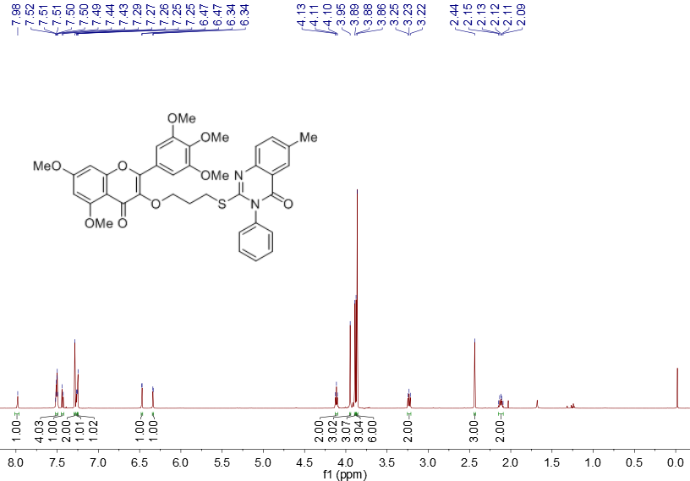

**Fig. S1 1H NMR spectra of compound T1**

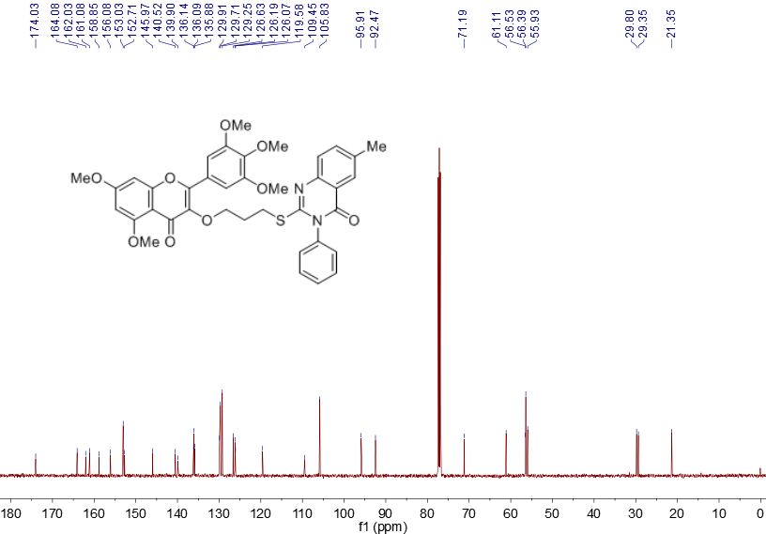

**Fig. S2 13C NMR spectra of compound T1**



**Fig. S3 HRMS spectra of compound T1**

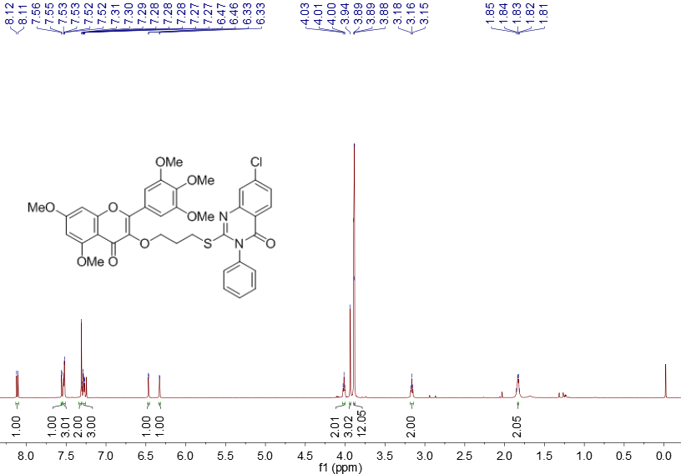

**Fig. S4 1H NMR spectra of compound T2**

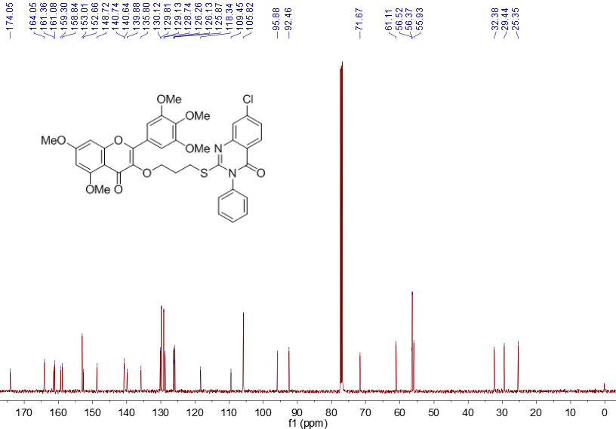

**Fig. S5 13C NMR spectra of compound T2**



**Fig. S6 HRMS spectra of compound T2**

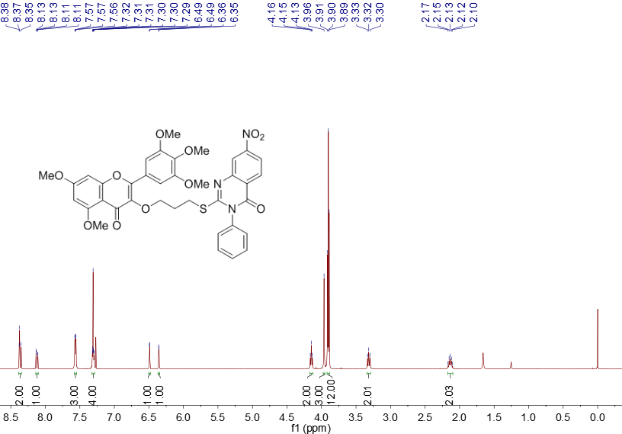

**Fig. S7 1H NMR spectra of compound T3**

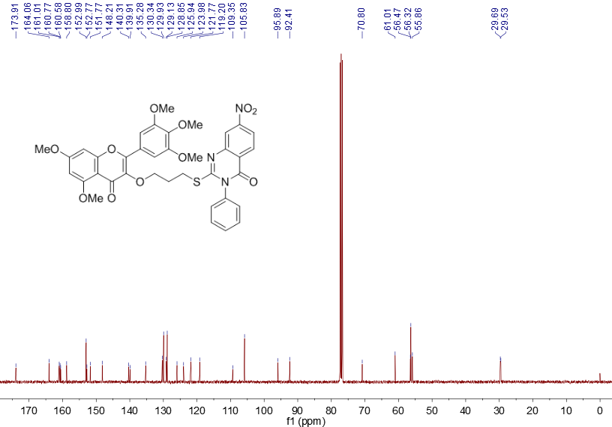

**Fig. S8 13C NMR spectra of compound T3**



**Fig. S9 HRMS spectra of compound T3**

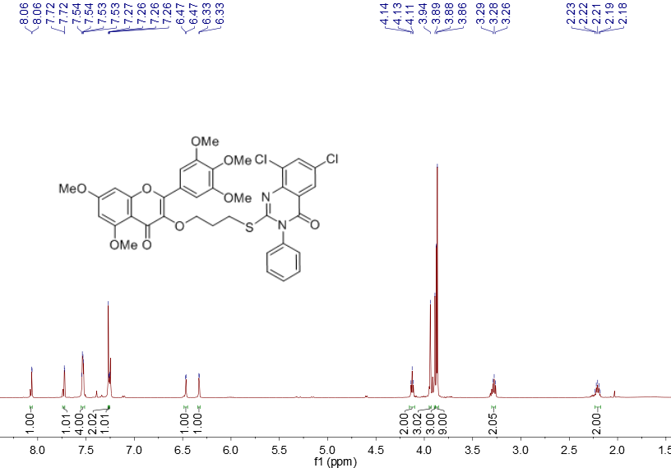

**Fig. S10 1H NMR spectra of compound T4**

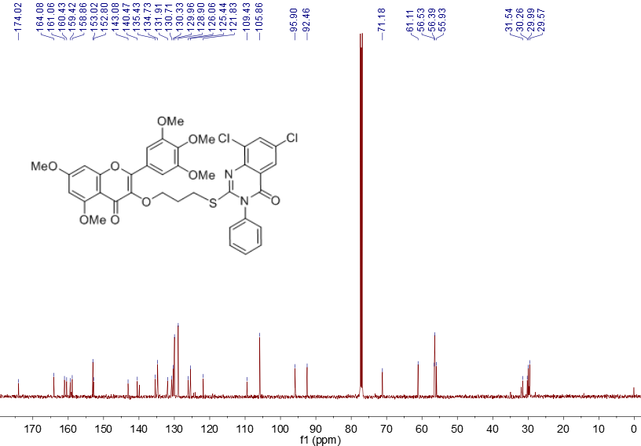

**Fig. S11 13C NMR spectra of compound T4**



**Fig. S12 HRMS spectra of compound T4**

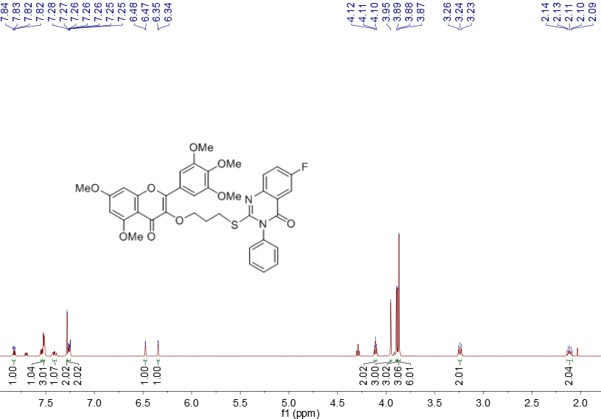

**Fig. S13 1H NMR spectra of compound T5**

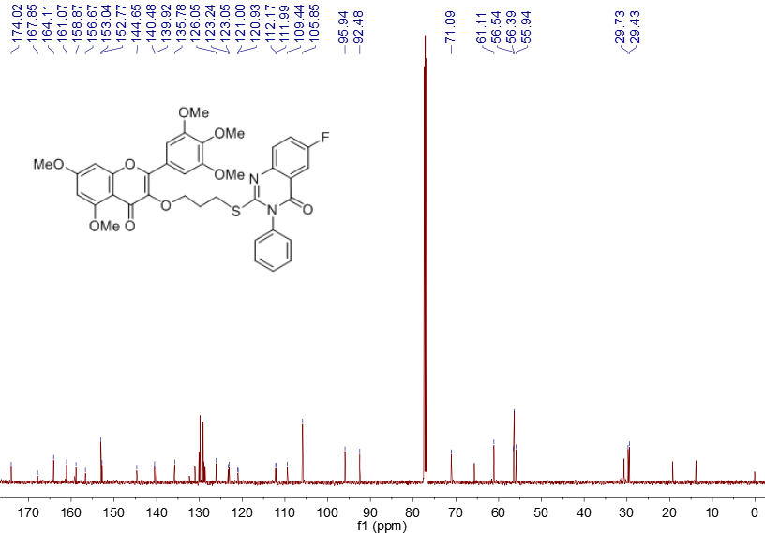

**Fig. S14 13C NMR spectra of compound T5**

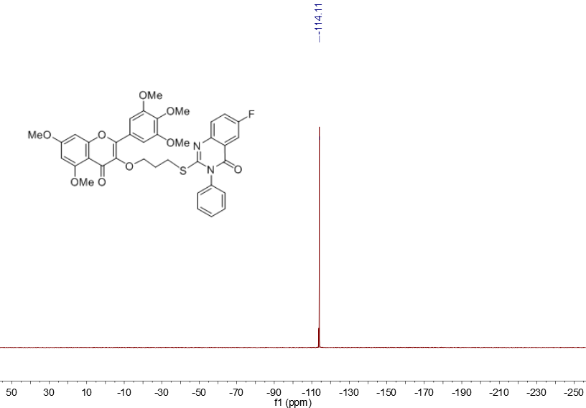

**Fig. S15 19F NMR spectra of compound T5**



**Fig. S16 HRMS spectra of compound T5**

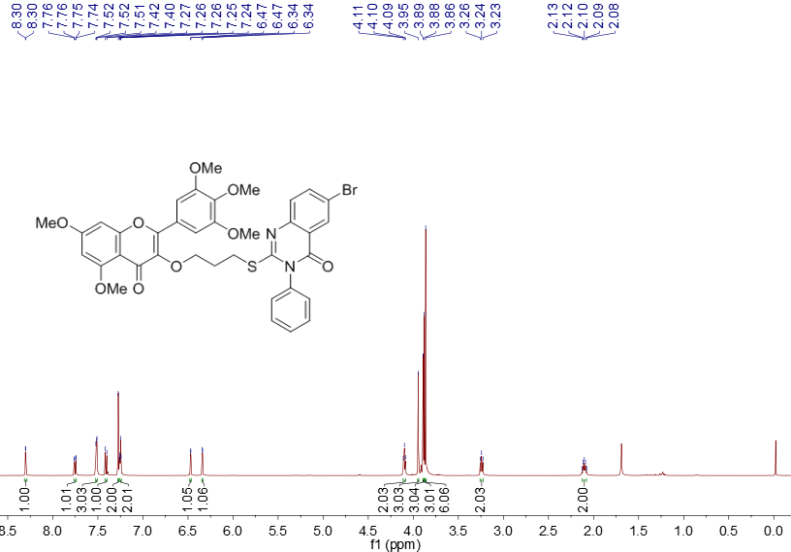

**Fig. S17 1H NMR spectra of compound T6**

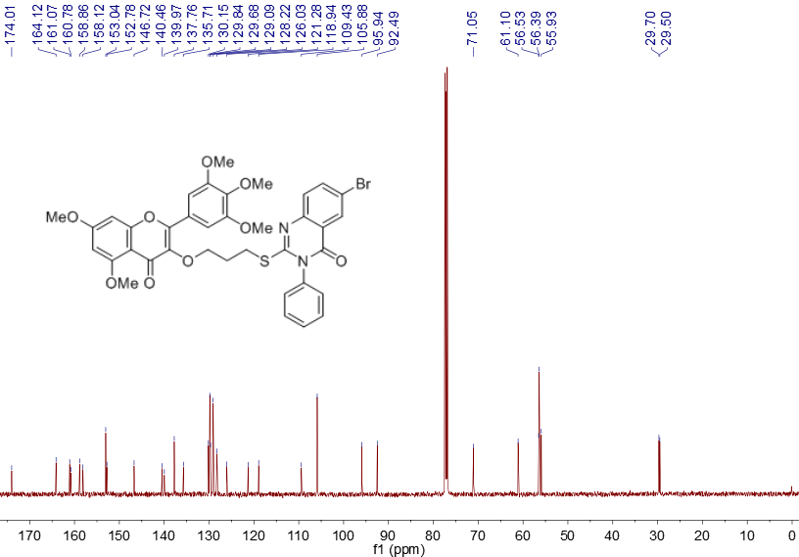

**Fig. S18 13C NMR spectra of compound T6**



**Fig. S19 HRMS spectra of compound T6**

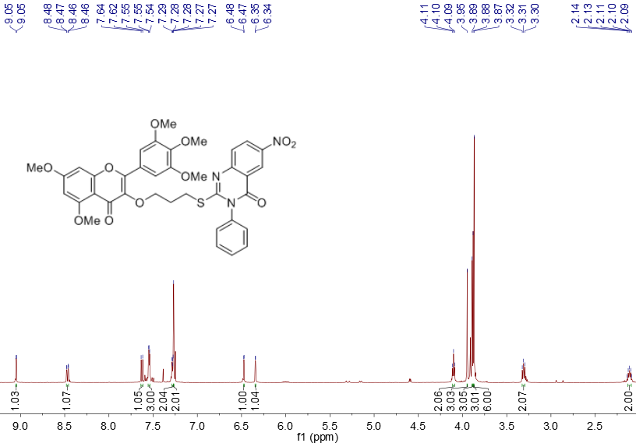

**Fig. S20 1H NMR spectra of compound T7**

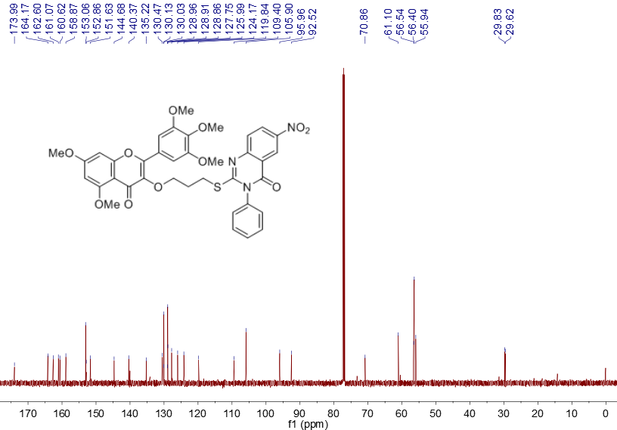

**Fig. S21 13C NMR spectra of compound T7**



**Fig. S22 HRMS spectra of compound T7**

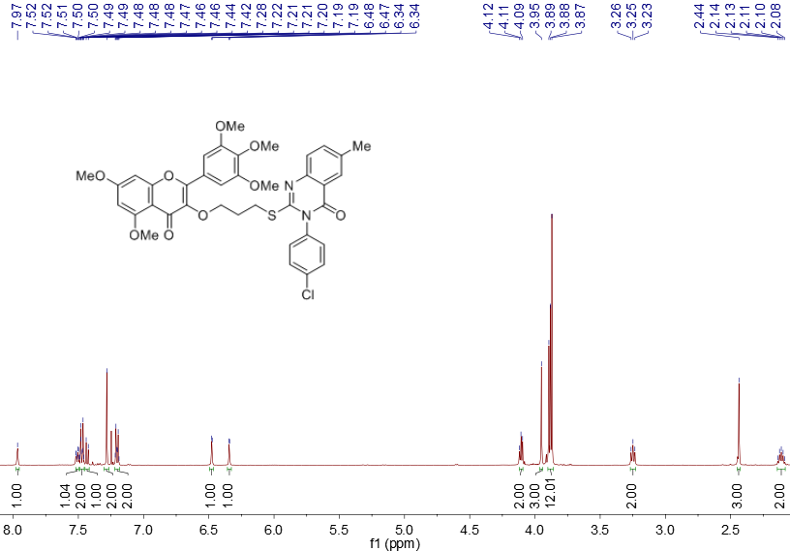

**Fig. S23 1H NMR spectra of compound T8**

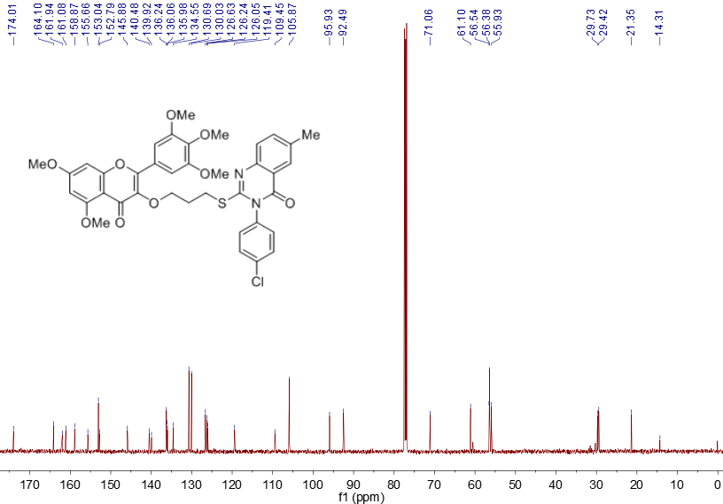

**Fig. S24 13C NMR spectra of compound T8**



**Fig. S25 HRMS spectra of compound T8**

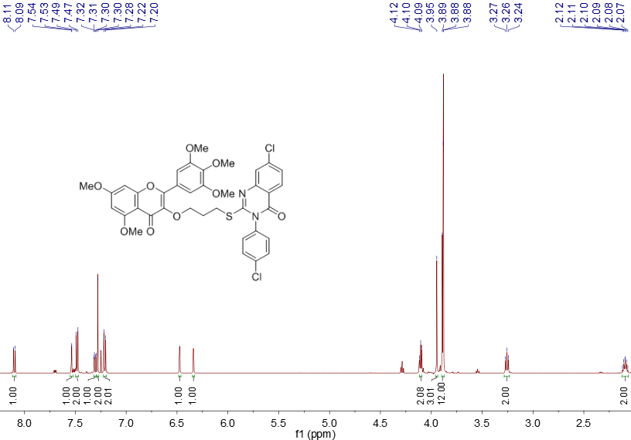

**Fig. S26 1H NMR spectra of compound T9**

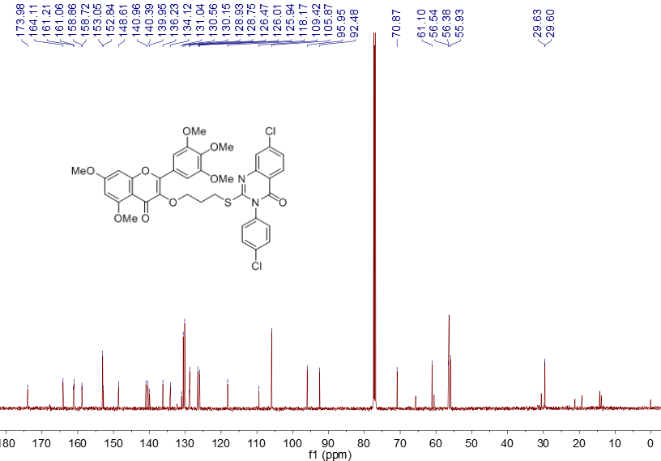

**Fig. S27 13C NMR spectra of compound T9**



**Fig. S28 HRMS spectra of compound T9**

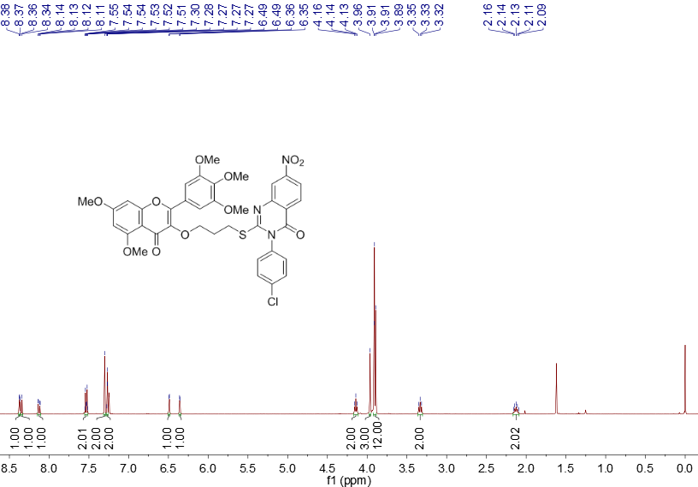

**Fig. S29 1H NMR spectra of compound T10**

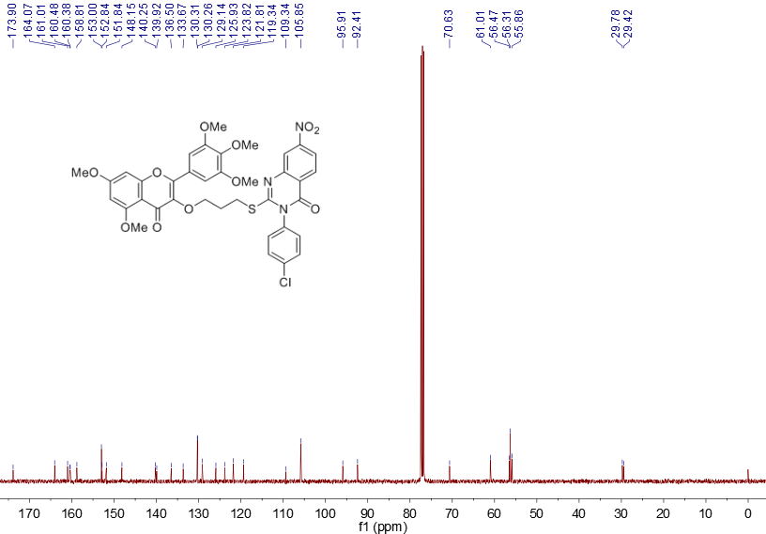

**Fig. S30 13C NMR spectra of compound T10**



**Fig. S31 HRMS spectra of compound T10**

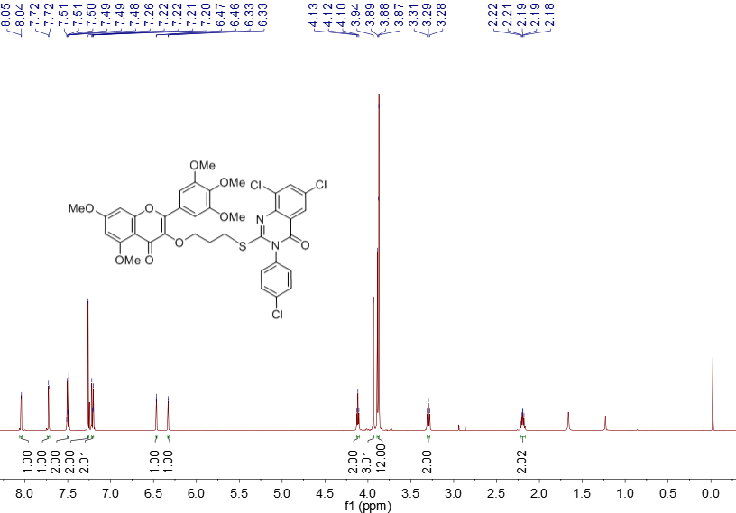

**Fig. S32 1H NMR spectra of compound T11**

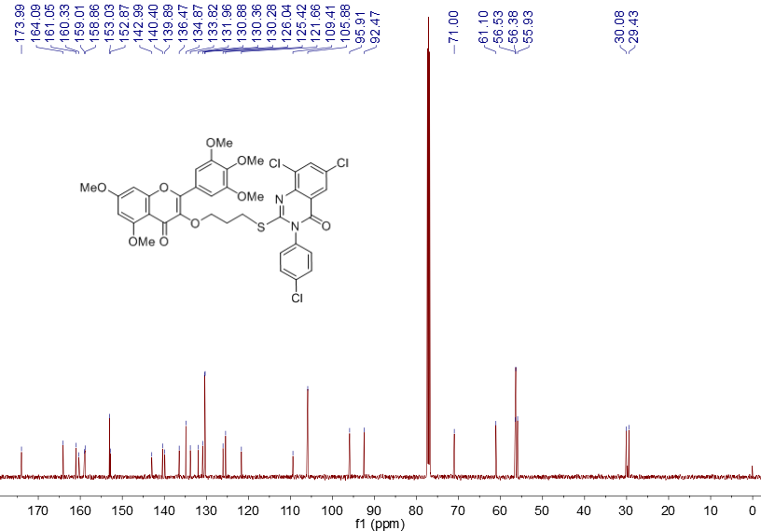

**Fig. S33 13C NMR spectra of compound T11**



**Fig. S34 HRMS spectra of compound T11**

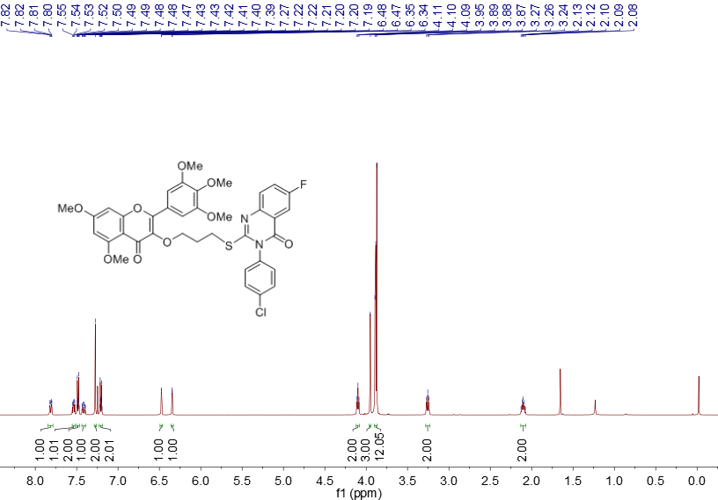

**Fig. S35 1H NMR spectra of compound T12**

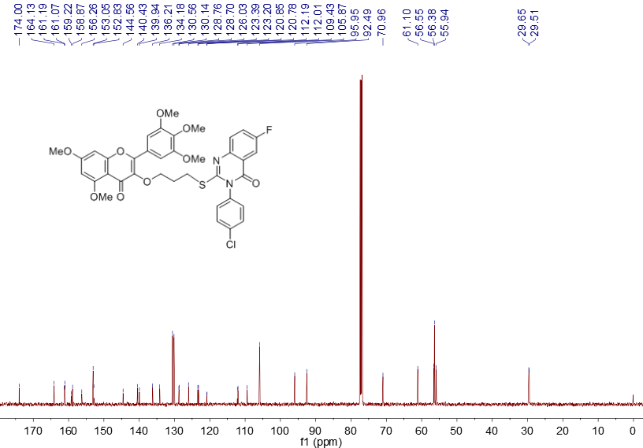

**Fig. S36 13C NMR spectra of compound T12**

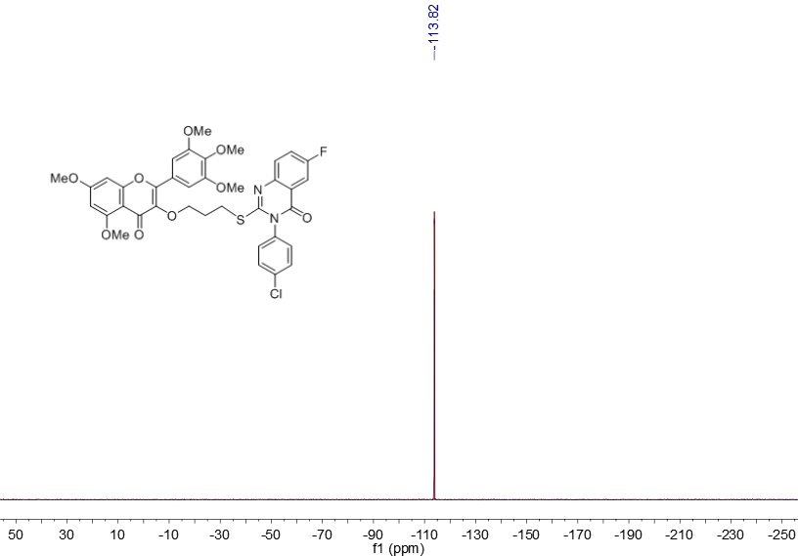

**Fig. S37 19F NMR spectra of compound T12**



**Fig. S38** **HRMS spectra of compound T12**

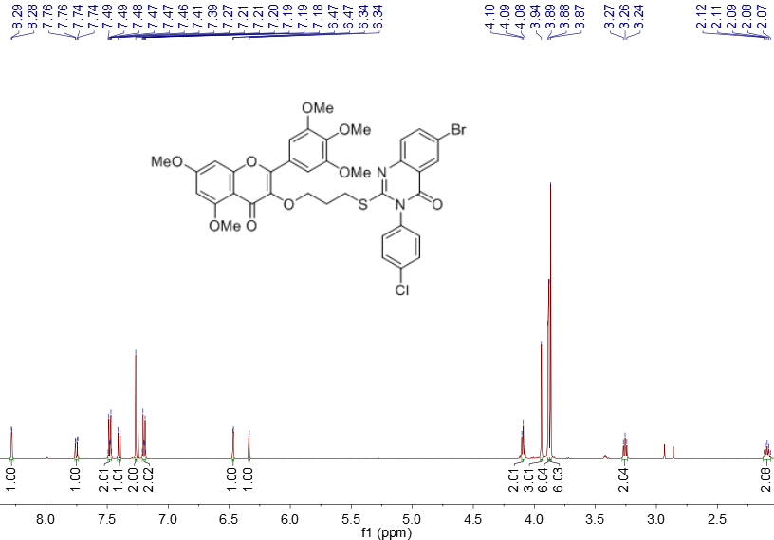

**Fig. S39 1H NMR spectra of compound T13**

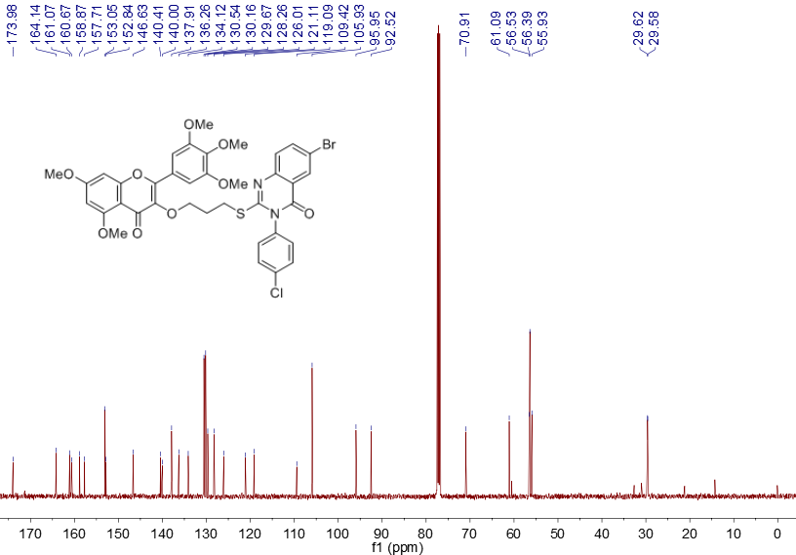

**Fig. S40 13C NMR spectra of compound T13**



**Fig. S41 HRMS spectra of compound T13**

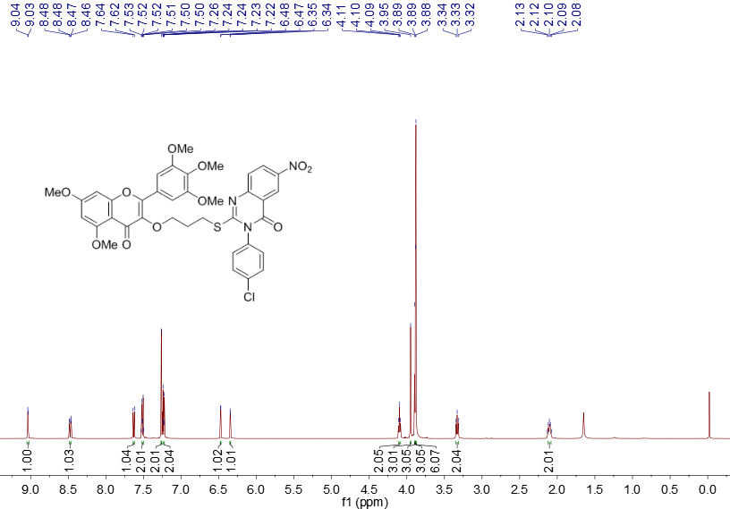

**Fig. S42 1H NMR spectra of compound T14**

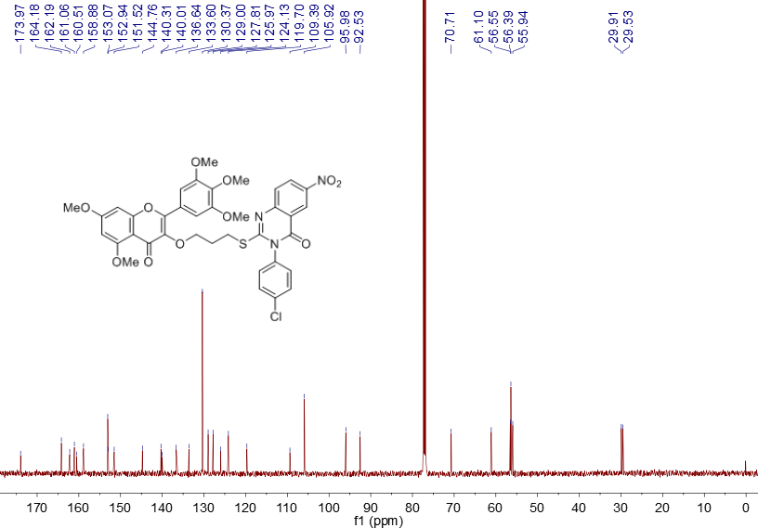

**Fig. S43 13C NMR spectra of compound T14**



**Fig. S44 HRMS spectra of compound T14**

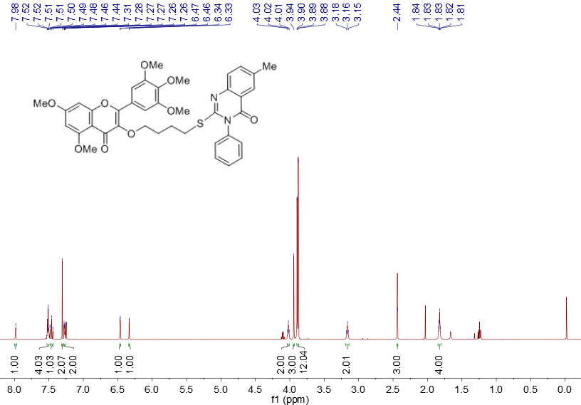

**Fig. S45 1H NMR spectra of compound T15**

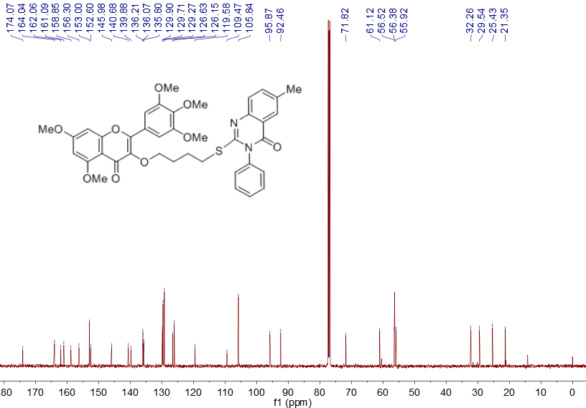

**Fig. S46 13C NMR spectra of compound T15**



**Fig. S47 HRMS spectra of compound T15**

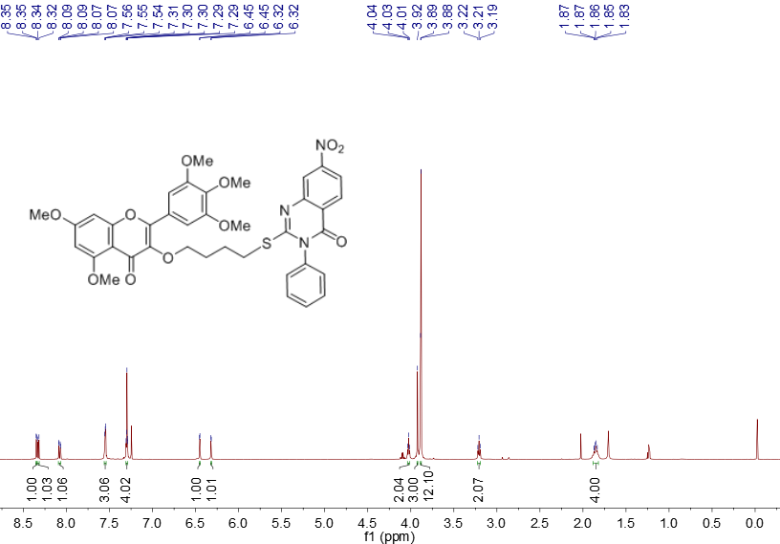

**Fig. S48 1H NMR spectra of compound T16**

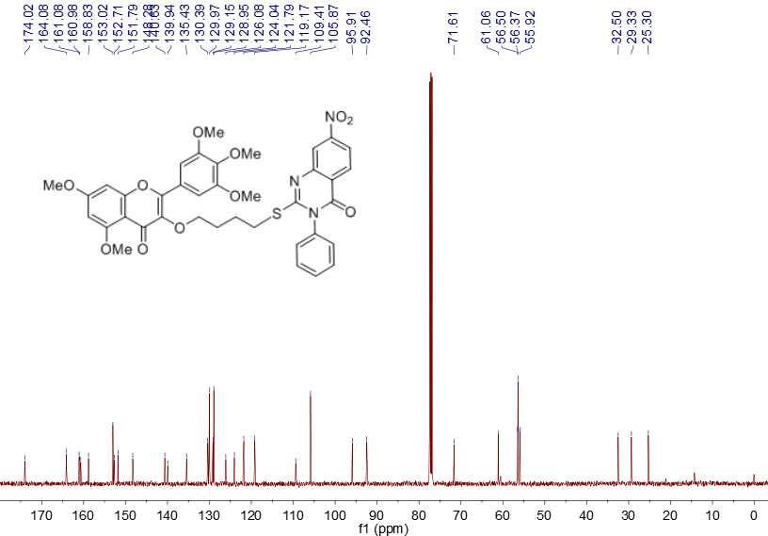

**Fig. S49 13C NMR spectra of compound T16**



**Fig. S50 HRMS spectra of compound T16**

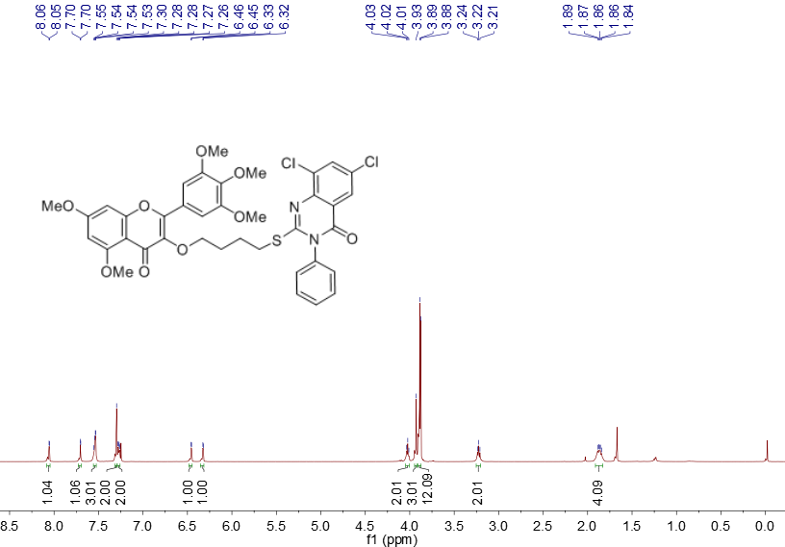

**Fig. S51 1H NMR spectra of compound T17**

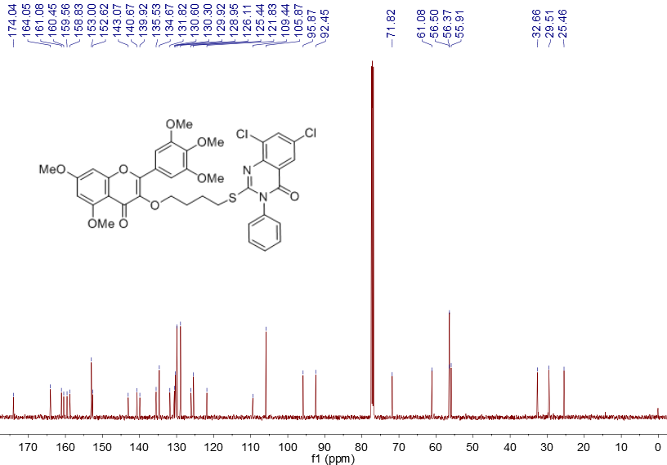

**Fig. S52 13C NMR spectra of compound T17**



**Fig. S53 HRMS spectra of compound T17**

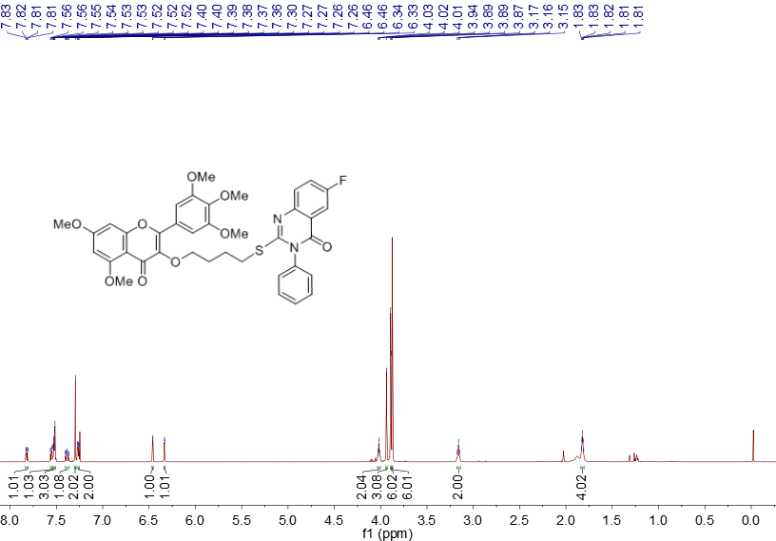

**Fig. S54 1H NMR spectra of compound T18**

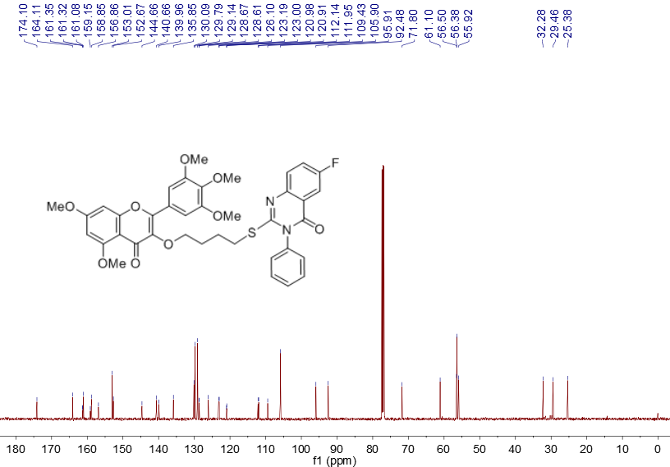

**Fig. S55 13C NMR spectra of compound T18**

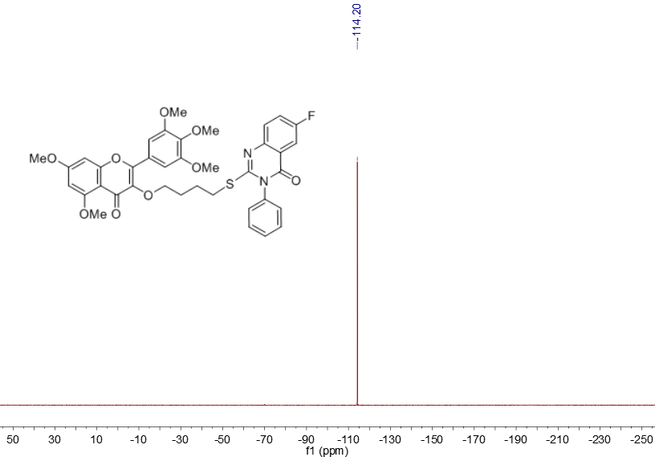

**Fig. S56 19F NMR spectra of compound T18**



**Fig. S57 HRMS spectra of compound T18**

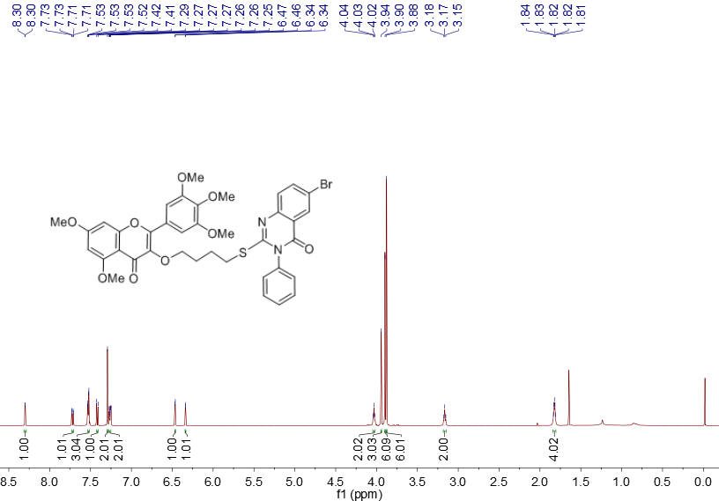

**Fig. S58 1H NMR spectra of compound T19**

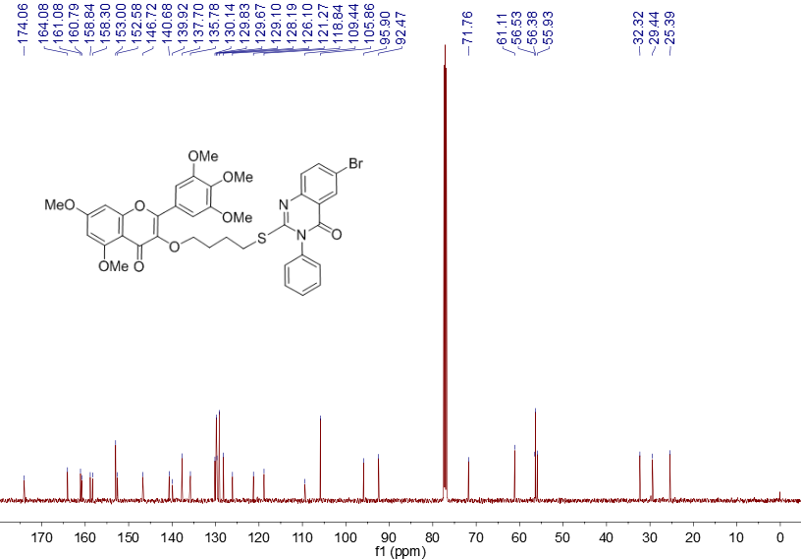

**Fig. S59 13C NMR spectra of compound T19**



**Fig. S60 HRMS spectra of compound T19**

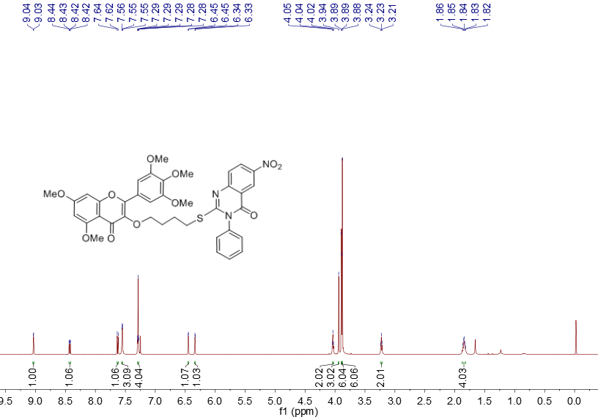

**Fig. S61 1H NMR spectra of compound T20**

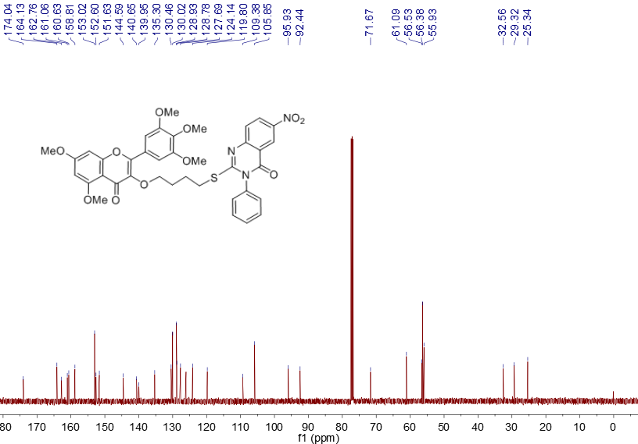

**Fig. S62 13C NMR spectra of compound T20**



**Fig. S63 HRMS spectra of compound T20**

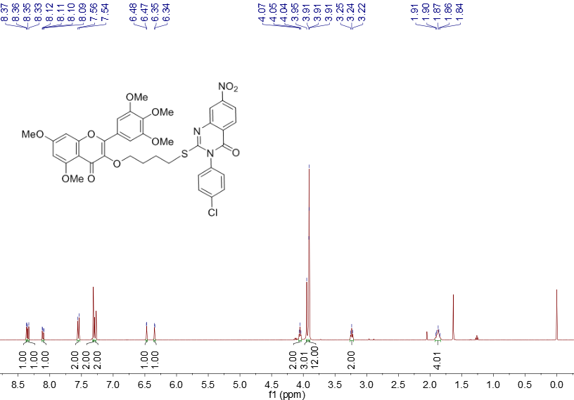

**Fig. S64 1H NMR spectra of compound T21**

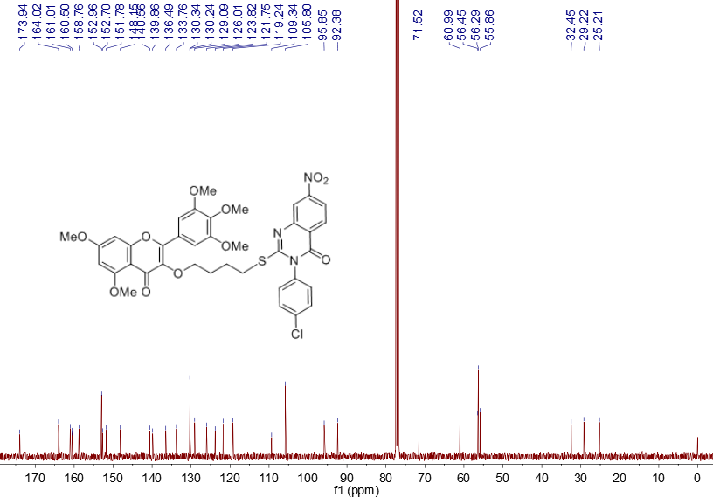

**Fig. S65 13C NMR spectra of compound T21**



**Fig. S66 HRMS spectra of compound T21**

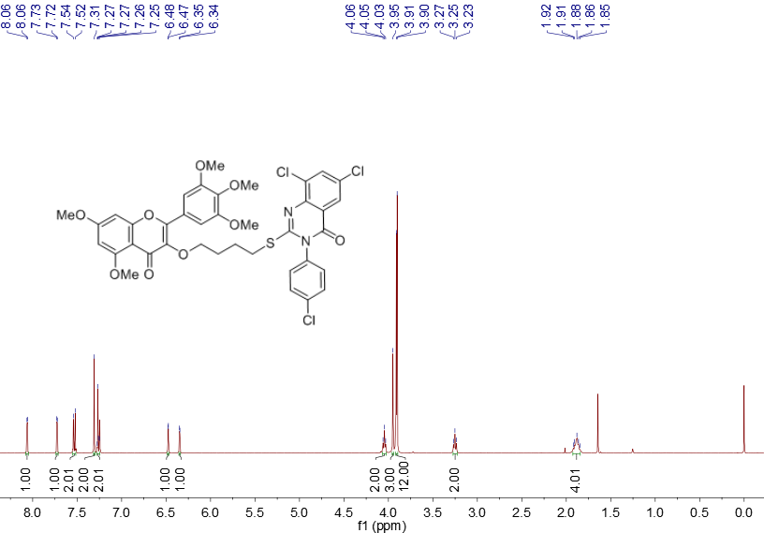

**Fig. S67 1H NMR spectra of compound T22**

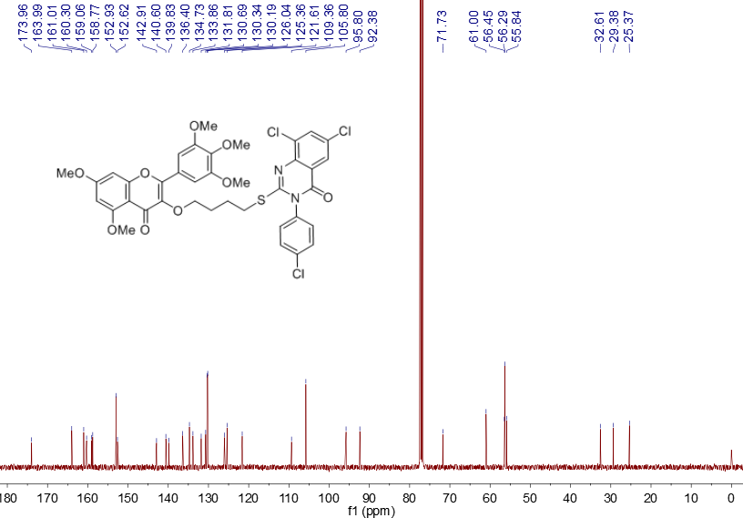

**Fig. S68 13C NMR spectra of compound T22**



**Fig. S69 HRMS spectra of compound T22**

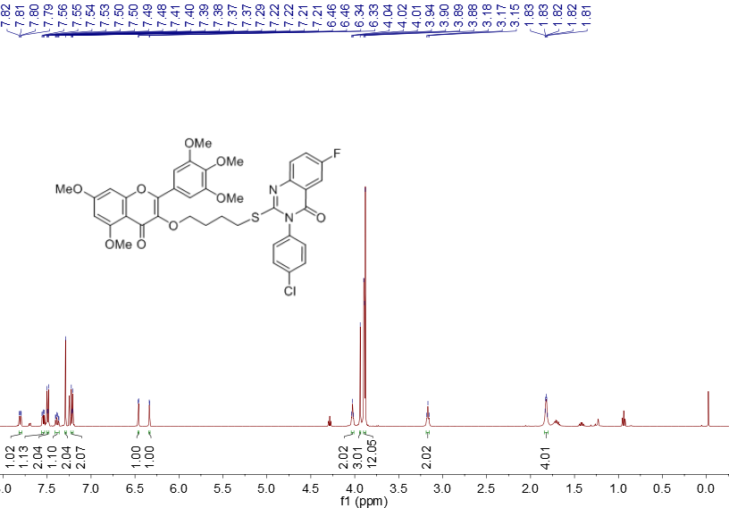

**Fig. S701H NMR spectra of compound T23**

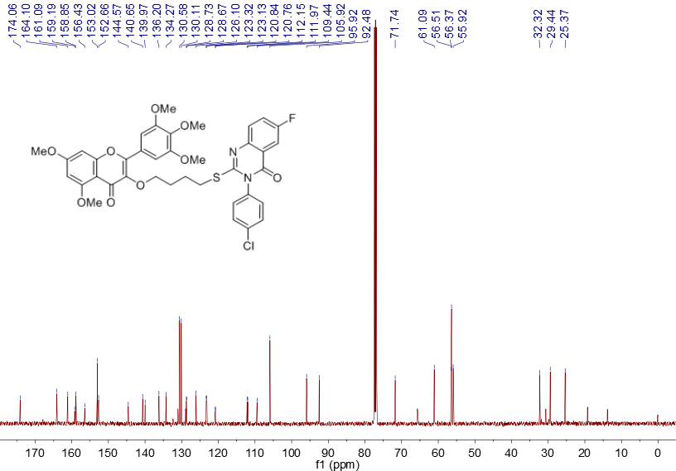

**Fig. S71 13C NMR spectra of compound T23**

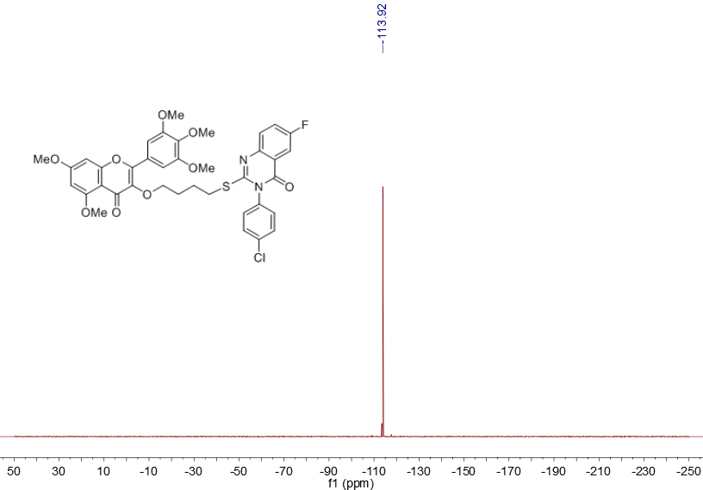

**Fig. S72 19F NMR spectra of compound T23**



**Fig. S73 HRMS spectra of compound T23**

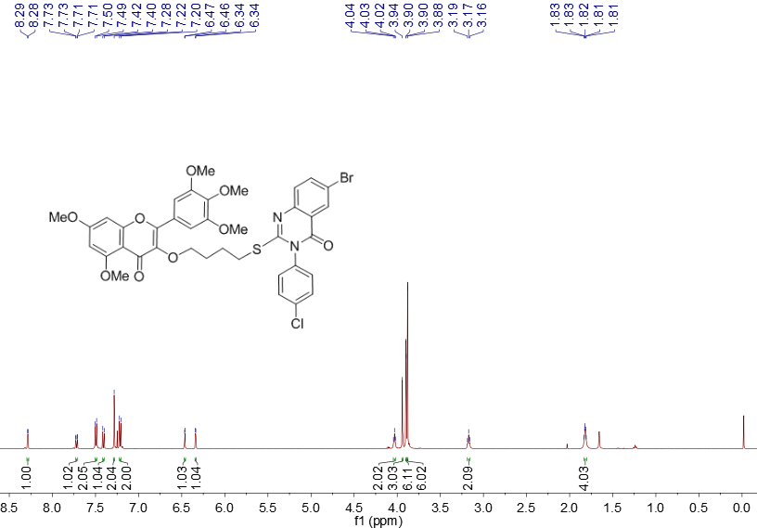

**Fig. S74 1H NMR spectra of compound T24**

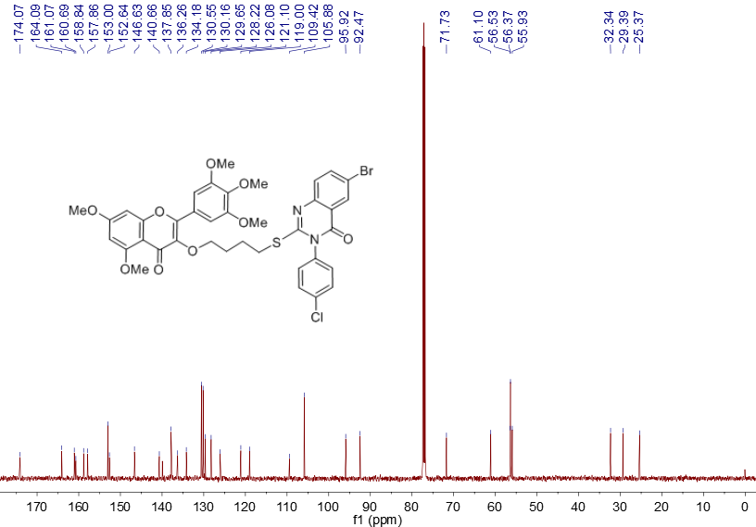

**Fig. S75 13C NMR spectra of compound T24**



**Fig. S76 HRMS spectra of compound T24**

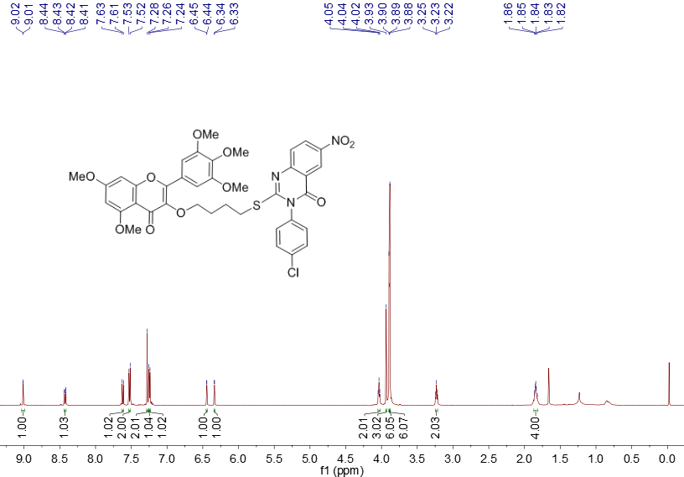

**Fig. S77 1H NMR spectra of compound T25**

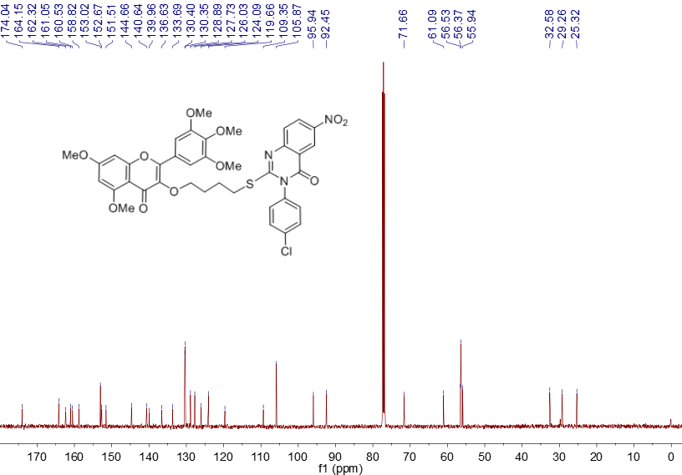

**Fig. S78 13C NMR spectra of compound T25**



**Fig. S79 HRMS spectra of compound T25**