Arabian Journal of Chemistry

**Bacterial synthesis of magnetic Fe3O4 nanoparticles: decolorization Acid Red 88 using FeNPs /Ca-Alg beads**

Samira Eshghi1, Fereshteh Jookar Kashi2*

1, 2 Department of Cell and Molecular Biology, Faculty of Chemistry, University of Kashan, Kashan, Iran

* Corresponding author: Fereshteh Jookar Kashi

Postal address: University of Kashan, Ootb-e Ravandi Blvd, Kashan, Isfahan, Iran

Tel: +989130928875;

Fax: +983155911121,

Postal code: 8731753153

E-mail: [jookar@kashanu.ac.ir](mailto:jookar@kashanu.ac.ir)

Email address: [samira.eshghi@grad.kashanu.ac.ir](mailto:samira.eshghi@grad.kashanu.ac.ir)

ORCID ID: 0000-0002-6202-5663

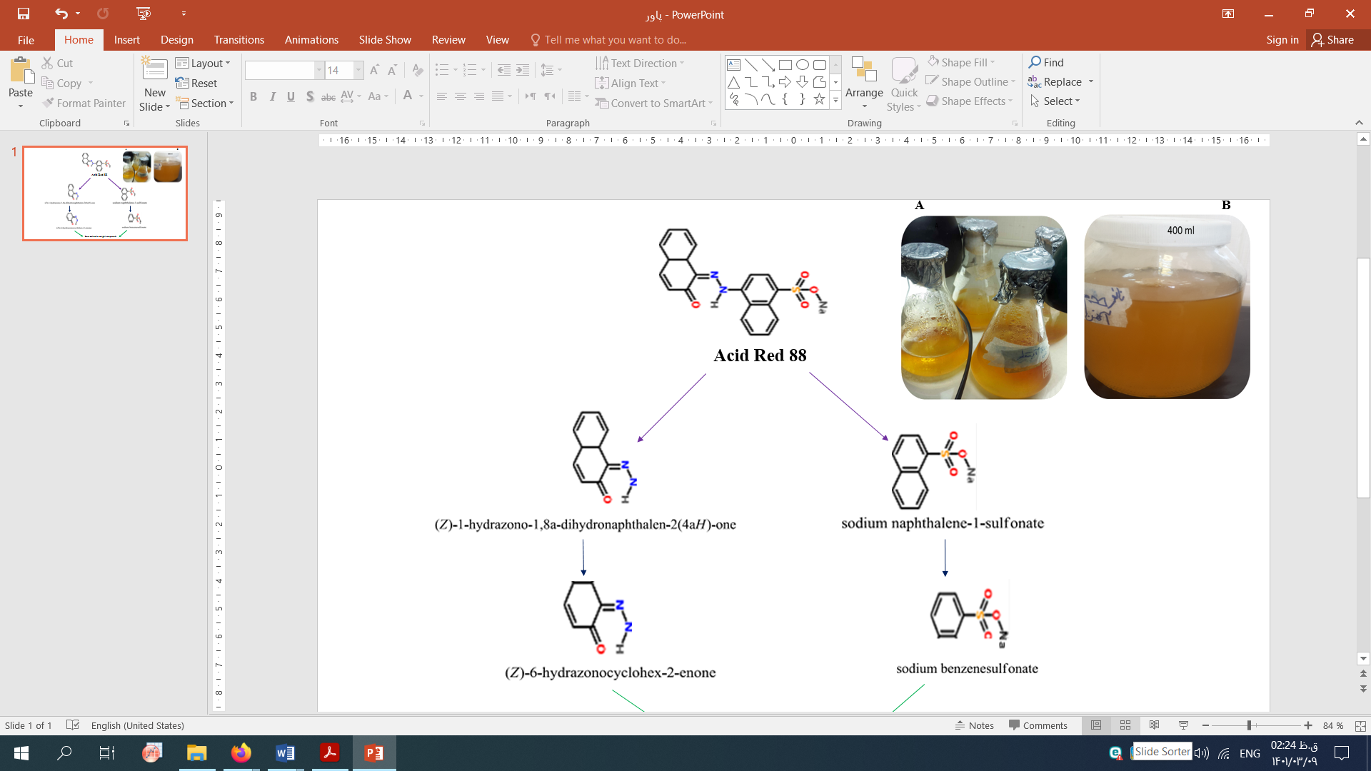

Figure S1. Biosynthesis of FeNPs

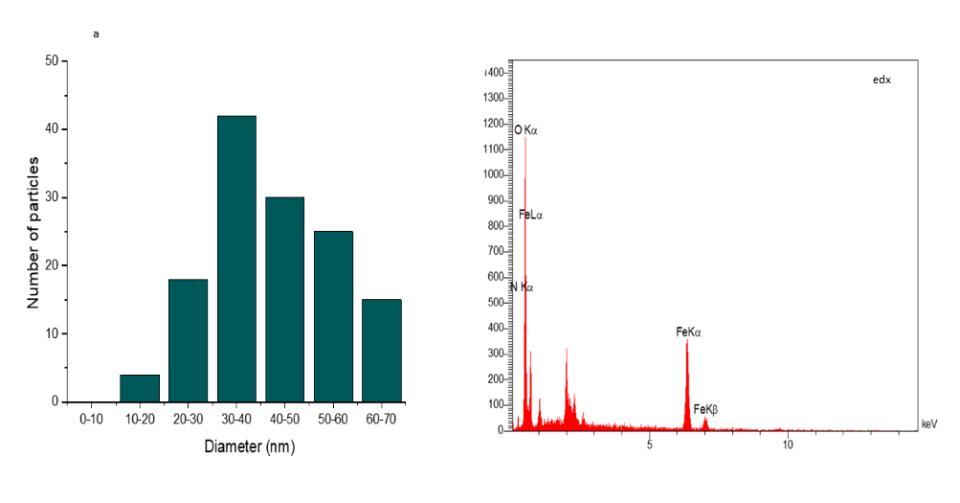

Figure S2. Biosynthesized FeNPs size distribution

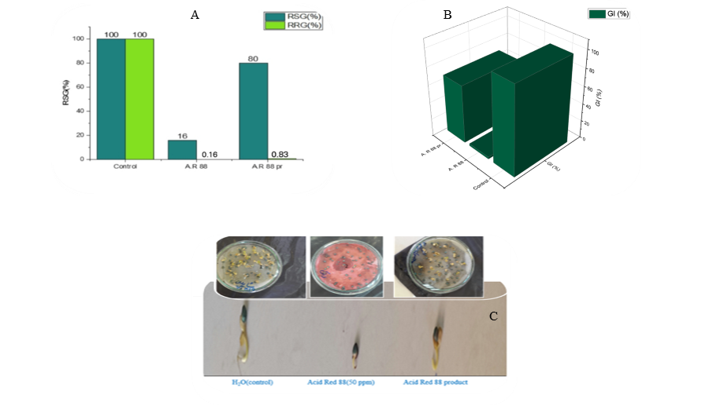

Figure S3. Evaluation of biotoxicity using radish seeds after 7 days of sun exposure (comparison of RSG, RRG) [A] and (comparison of GI) [ B], The sizes of radish seeds are in order from the left (control H2O [3 cm], Acid Red 88 dye [0.5 cm], Acid Red 88 product [2.5 cm], respectively (C)

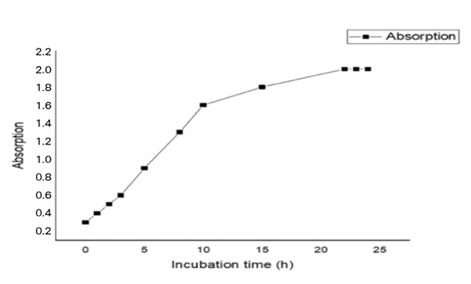

Figure S4. Growth curve strain S2