# Supplementary material

**for**

**Prediction of breakthrough curves for multicomponent adsorption in a fixed-bed column using logistic and Gompertz functions**

Qili Hua,b,*, Dan Wangb, Shuyue Pangb, Li Xuc,[1]*

a State Environmental Protection Key Laboratory of Synergetic Control and Joint Remediation for Soil & Water Pollution, Chengdu University of Technology, Chengdu 610059, China

b College of Ecology and Environment, Chengdu University of Technology, Chengdu 610059, China

c The United Front Work Department, Chengdu University of Technology, Chengdu 610059, China

Prior to establishment of the empirical multicomponent breakthrough models, it is necessary to introduce the basic information of the logistic and Gompertz functions. The logistic function is given as:

|  |  |
| --- | --- |
| $$\text{y}=\frac{\text{1}}{\text{1}+\text{exp(}-\text{x}\text{)}}$$ | (1) |

The first and second derivatives of Eq. (1) with respect to *x* are given as:

|  |  |
| --- | --- |
| $$\frac{\text{d}\text{y}}{\text{d}\text{x}}=\frac{\text{exp(}-\text{x}\text{)}}{{\text{[1}+\text{exp(}-\text{x}\text{)]}}^{\text{2}}}$$ | (2) |
| $$\frac{{\text{d}}^{\text{2}}\text{y}}{\text{d}{\text{x}}^{\text{2}}}=\frac{\text{exp(}-\text{x}\text{)}⋅\text{[1}+\text{exp(}-\text{x}\text{)]}⋅\text{[exp(}-\text{x}\text{)}-\text{1]}}{{\text{[1}+\text{exp(}-\text{x}\text{)]}}^{\text{4}}}$$ | (3) |

The second derivative is equal to zero at the inflection point *x* = *xi*.

|  |  |
| --- | --- |
|  | (4) |

The slope of the curve can be obtained by calculating the first derivative at *x* = *xi*.

|  |  |
| --- | --- |
|  | (5) |

The description of the tangent line through the inflection point is:

|  |  |
| --- | --- |
| $$\text{y}=\frac{\text{1}}{\text{4}}\text{x}+\frac{\text{1}}{\text{2}}$$ | (6) |

The Gompertz function is given as:

|  |  |
| --- | --- |
| $$\text{y}=\text{exp[}-\text{exp(}-\text{x}\text{)]}$$ | (7) |

The first and second derivatives of Eq. (7) with respect to *x* are given as:

|  |  |
| --- | --- |
| $$\frac{\text{d}\text{y}}{\text{d}\text{x}}=\text{exp[}-\text{exp(}-\text{x}\text{)]}⋅\text{exp(}-\text{x}\text{)}$$ | (8) |
| $$\frac{{\text{d}}^{\text{2}}\text{y}}{\text{d}{\text{x}}^{\text{2}}}=\text{exp[}-\text{exp(}-\text{x}\text{)]}⋅\text{exp(}-\text{x}\text{)}⋅\left[\text{exp(}-\text{x}\text{)}-\text{1}\right]$$ | (9) |

The second derivative is equal to zero at the inflection point *x* = *xi*.

|  |  |
| --- | --- |
|  | (10) |

The slope of the curve can be obtained by calculating the first derivative at *x* = *xi*.

|  |  |
| --- | --- |
|  | (11) |

The description of the tangent line through the inflection point is:

|  |  |
| --- | --- |
| $$\text{y}={\text{e}}^{-\text{1}}\text{(}\text{x}+\text{1)}$$ | (12) |

The mathematical characteristics of the logistic and Gompertz functions are depicted in Fig. S1. One can readily see that the logistic and Gompertz functions represent asymptotic and asymptotic S-shaped curves, respectively. The two function curves are well consistent with the breakthrough curve. Thus, the logistic and Gompertz functions can be appropriately transformed to describe the breakthrough curves.

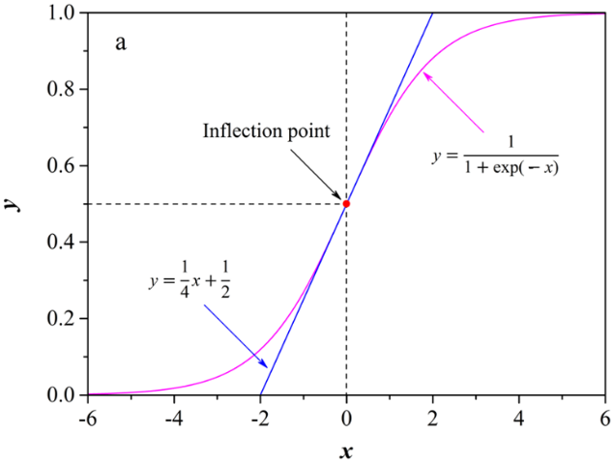 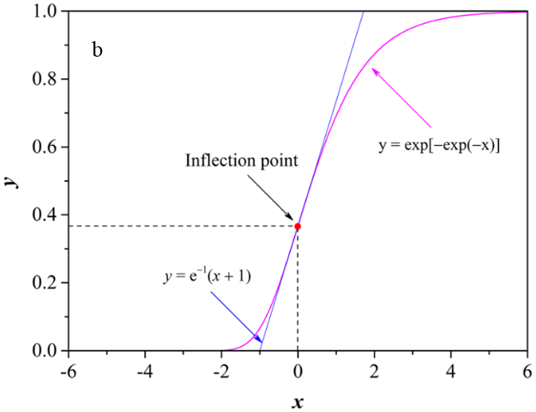

**Fig. S1.** Mathematical characteristics of (a) logistic and (b) Gompertz functions.

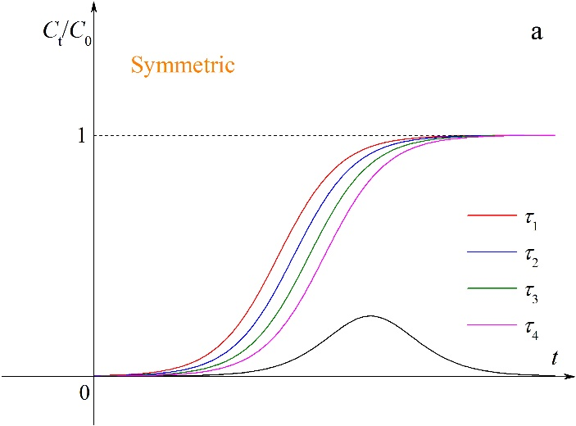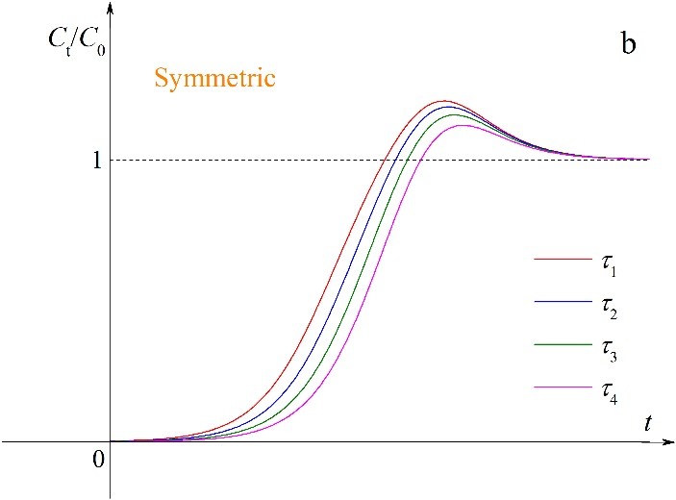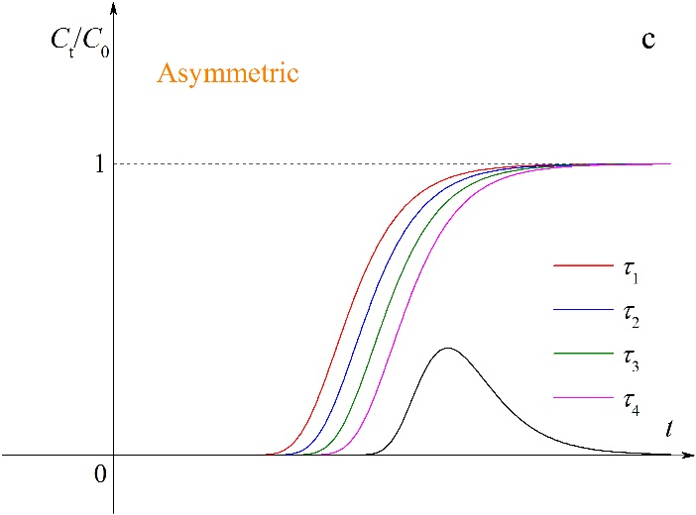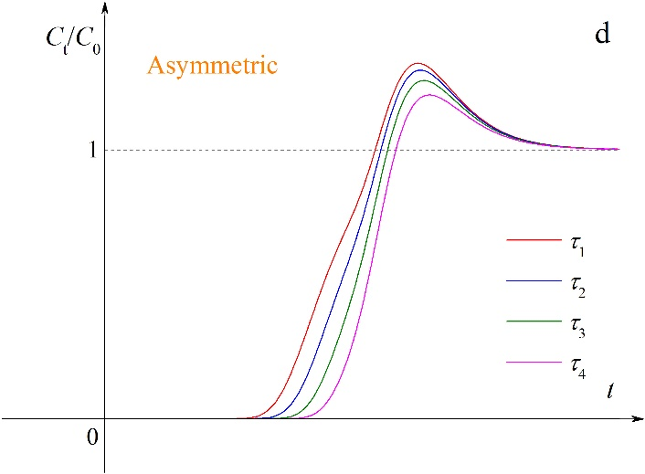

**Fig. S2.** Effects of the parameter *τ* on breakthrough curves before and after superposition (*τ*1 < *τ*2 < *τ*3 < *τ*4).

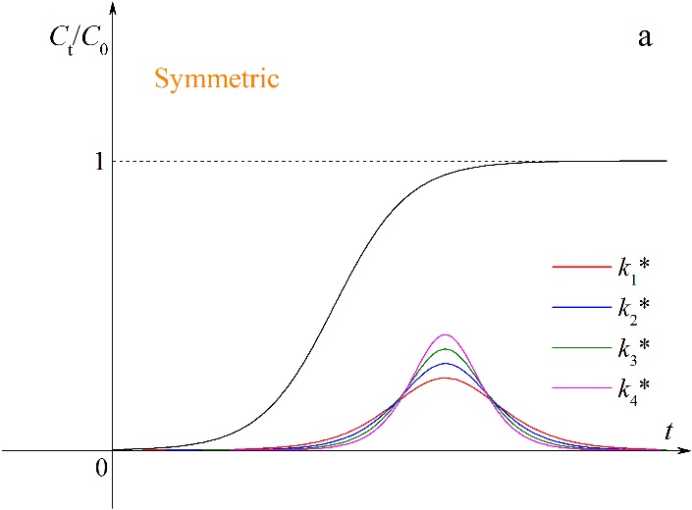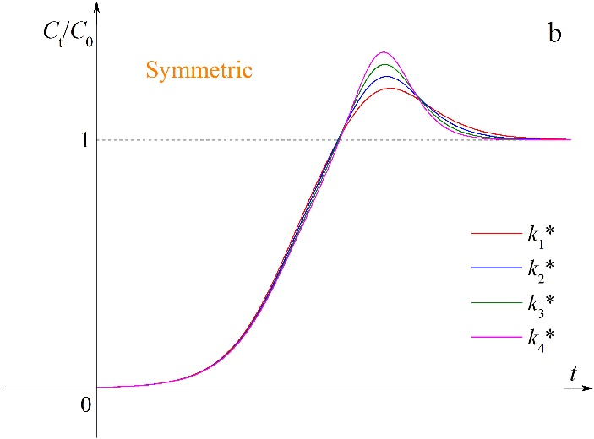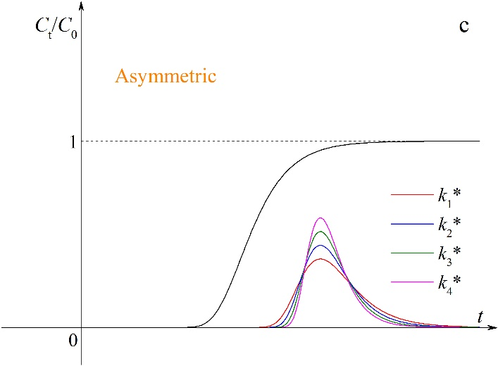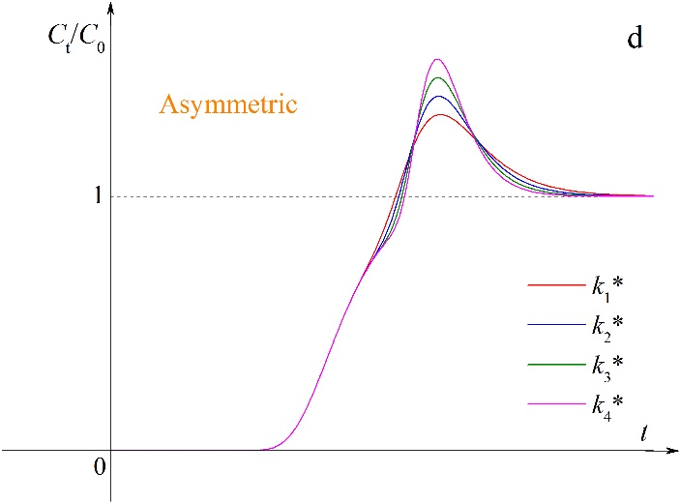

**Fig. S3.** Effects of the parameter *k*\* on breakthrough curves before and after superposition (*k*1* < *k*2* < *k*3* < *k*4*).

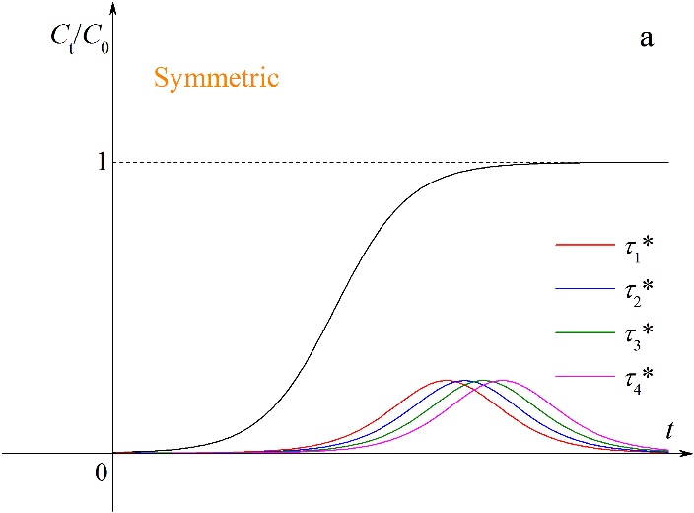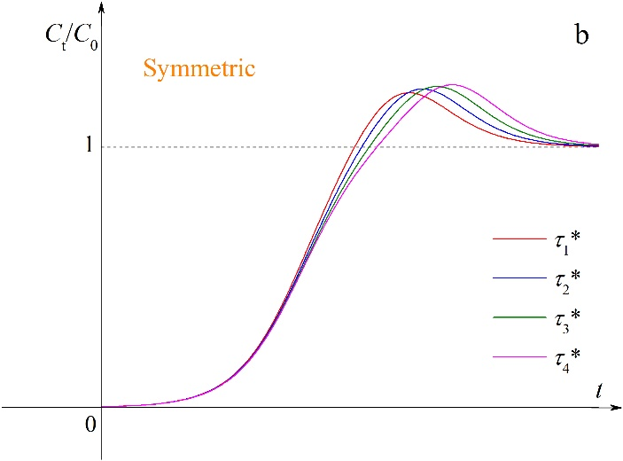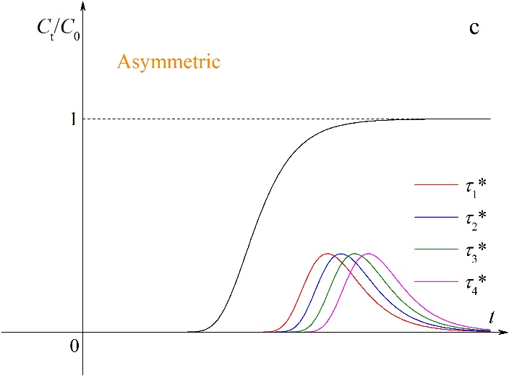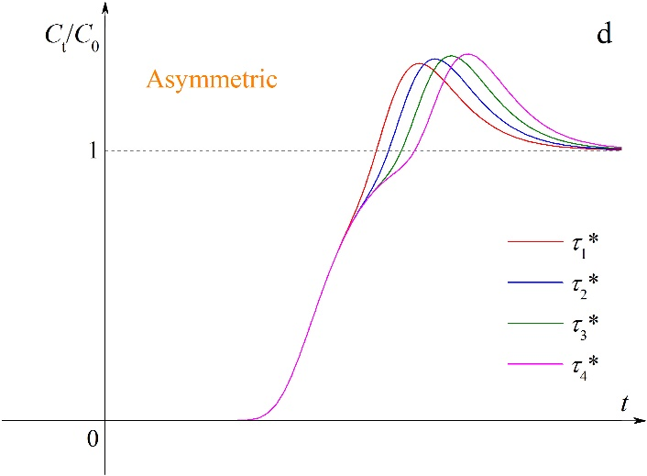

**Fig. S4.** Effects of the parameter *τ*\* on breakthrough curves before and after superposition (*τ*1* < *τ*2* < *τ*3* < *τ*4*).

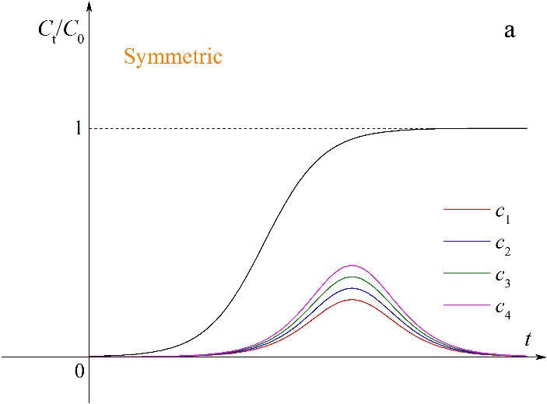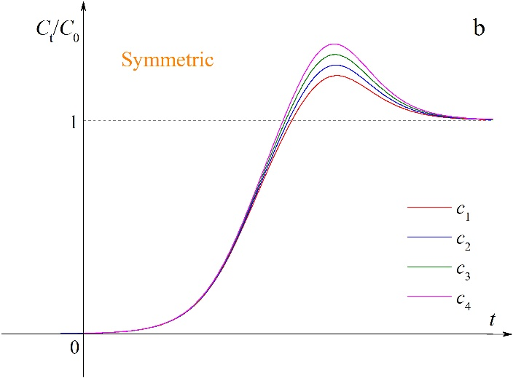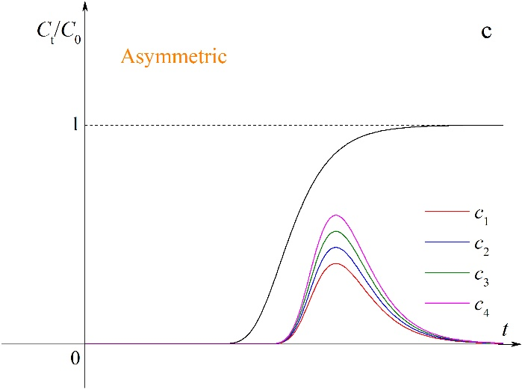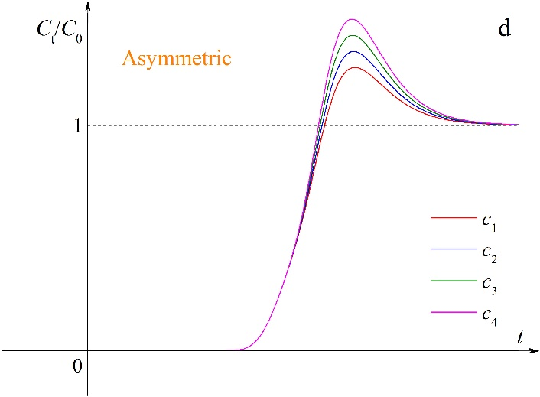

**Fig. S5.** Effects of the parameter *c* on breakthrough curves before and after superposition (*c*1 < *c*2 < *c*3 < *c*4).

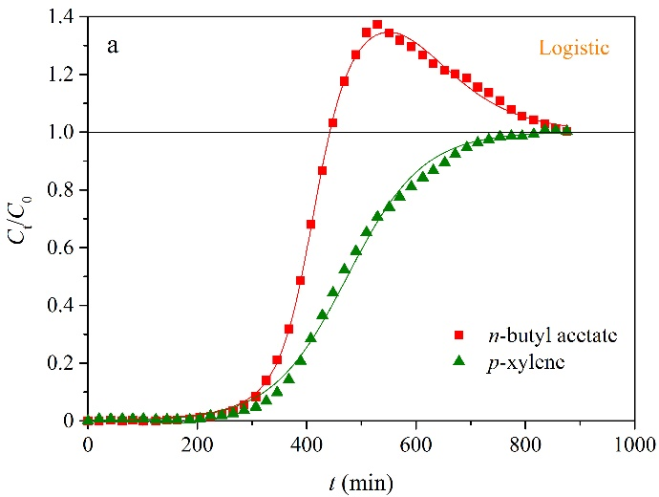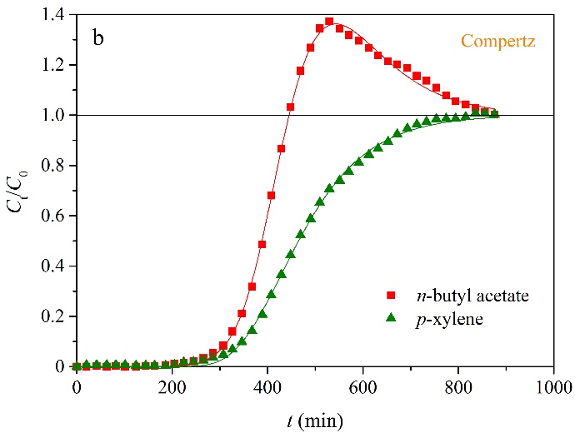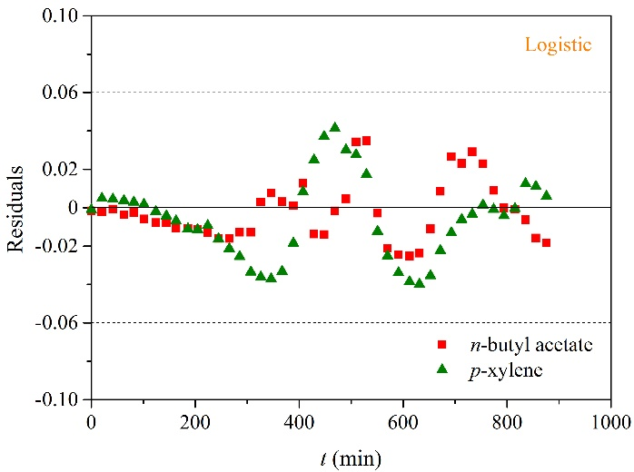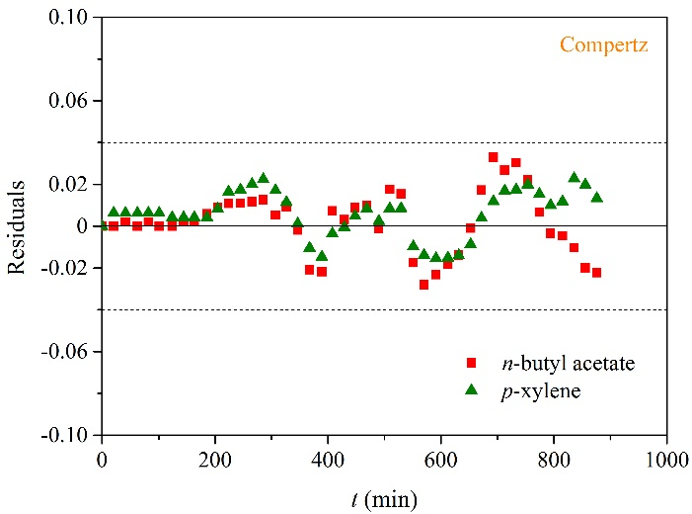

**Fig. S6.** Breakthrough curves and residual plots of *n*-butyl acetate and *p*-xylene binary system (0.45 Ndm3 min−1): (a) Eq. (7) and (b) Eq. (8).

**Table S1** Fitting results of *n*-butyl acetate and *p*-xylene binary system (0.45 Ndm3 min−1).

|  |  |  |  |  |  |  |  |
| --- | --- | --- | --- | --- | --- | --- | --- |
| Models | Adsorbate | *k* (min−1) | *τ* (min) | *k*\* (min−1) | *τ*\* (min−1) | *c* | *R*2 |
| Logistic | *n*-butyl acetate | 3.47 × 10−2 | 410 | 1.25 × 10−2 | 540 | 114 | 0.9992 |
|  | *p*-xylene | 1.45 × 10−2 | 474 | 0 | 0 | 0 | 0.9973 |
| Gompertz | *n*-butyl acetate | 9.02 × 10−3 | 414 | 1.03 × 10−2 | 505 | 179 | 0.9993 |
|  | *p*-xylene | 1.02 × 10−2 | 429 | 0 | 0 | 0 | 0.9991 |

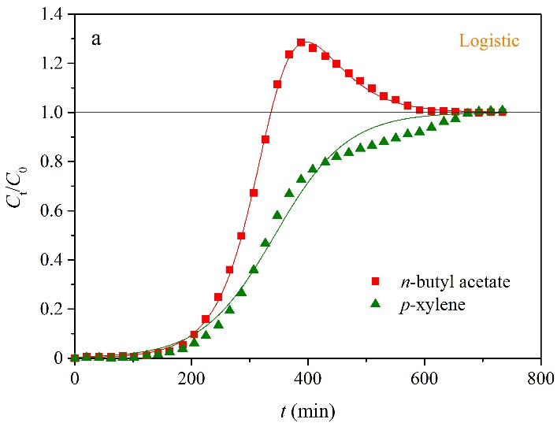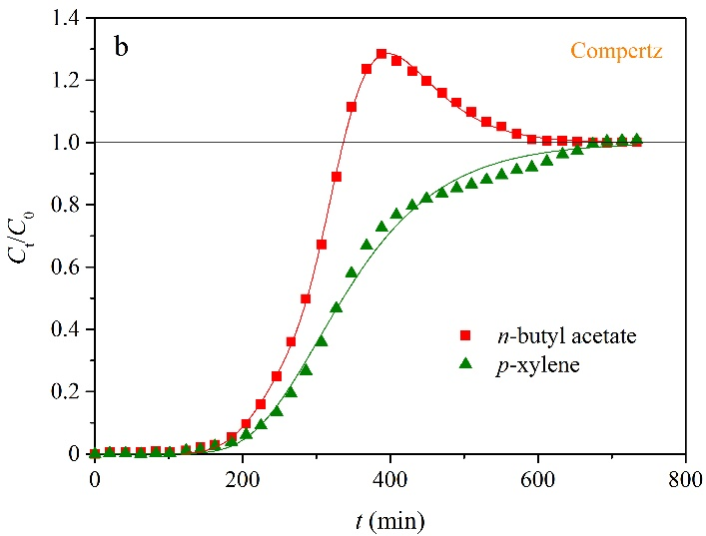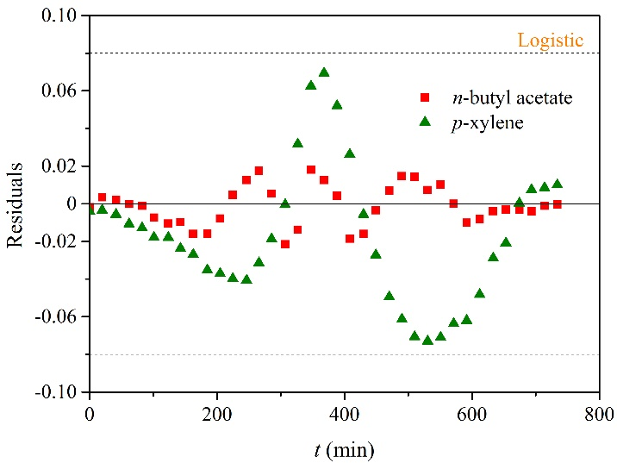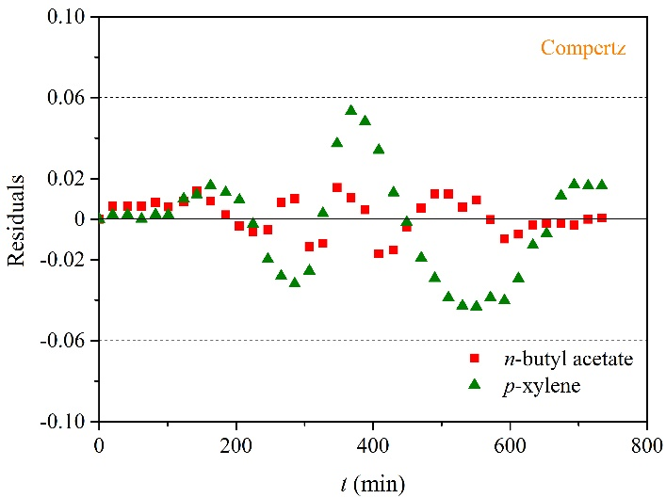

**Fig. S7.** Breakthrough curves and residual plots of *n*-butyl acetate and *p*-xylene binary system (0.75 Ndm3 min−1): (a) Eq. (7) and (b) Eq. (8).

**Table S2** Fitting results of *n*-butyl acetate and *p*-xylene binary system (0.75 Ndm3 min−1).

|  |  |  |  |  |  |  |  |
| --- | --- | --- | --- | --- | --- | --- | --- |
| Models | Adsorbate | *k* (min−1) | *τ* (min) | *k*\* (min−1) | *τ*\* (min−1) | *c* | *R*2 |
| Logistic | *n*-butyl acetate | 3.26 × 10−2 | 326 | 1.90 × 10−2 | 357 | 90.8 | 1.000 |
|  | *p*-xylene | 1.61 × 10−2 | 343 | 0 | 0 | 0 | 0.991 |
| Gompertz | *n*-butyl acetate | 1.24 × 10−2 | 272 | 1.66 × 10−2 | 378 | 81.3 | 1.000 |
|  | *p*-xylene | 1.11 × 10−2 | 303 | 0 | 0 | 0 | 0.996 |

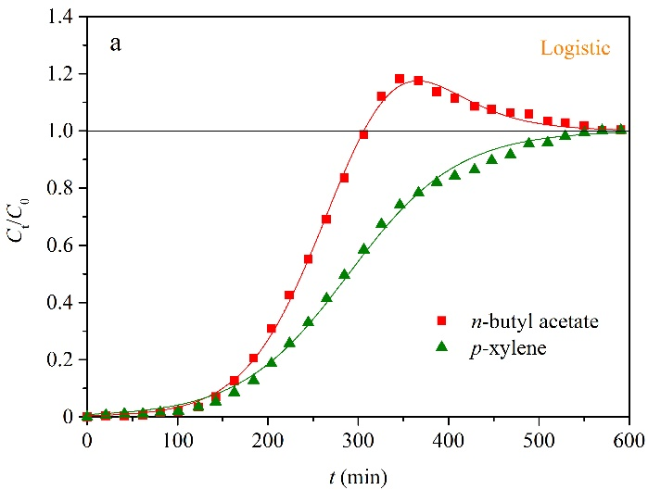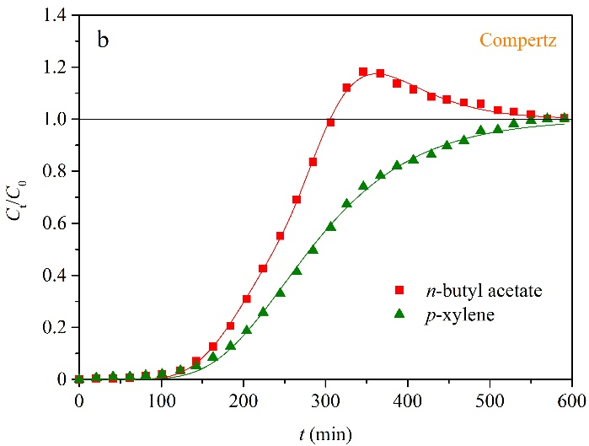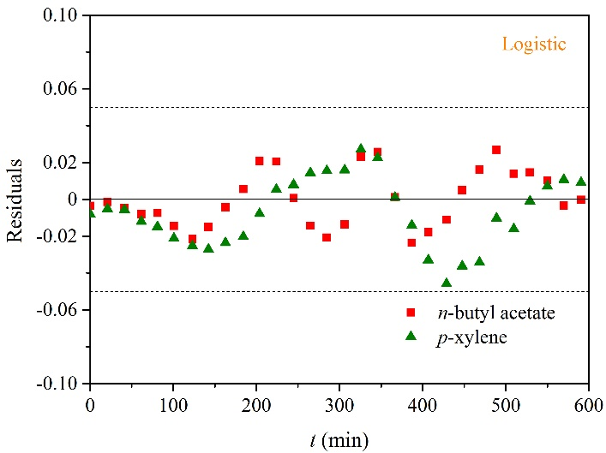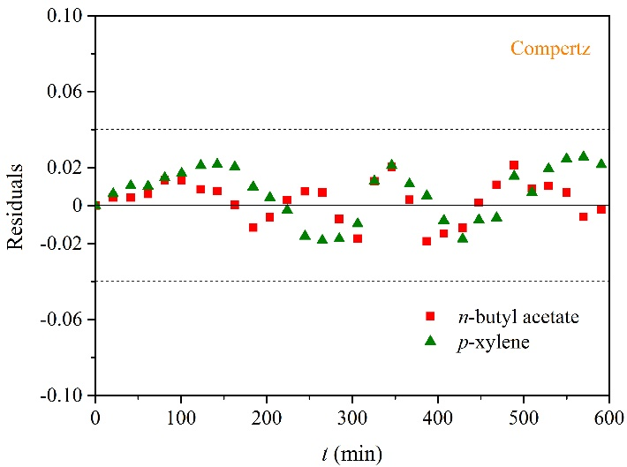

**Fig. S8.** Breakthrough curves and residual plots of *n*-butyl acetate and *p*-xylene binary system (0.90 Ndm3 min−1): (a) Eq. (7) and (b) Eq. (8).

**Table S3** Fitting results of *n*-butyl acetate and *p*-xylene binary system (0.90 Ndm3 min−1).

|  |  |  |  |  |  |  |  |
| --- | --- | --- | --- | --- | --- | --- | --- |
| Models | Adsorbate | *k* (min−1) | *τ* (min) | *k*\* (min−1) | *τ*\* (min−1) | *c* | *R*2 |
| Logistic | *n*-butyl acetate | 2.30 × 10−2 | 253 | 2.23 × 10−2 | 340 | 47.6 | 0.999 |
|  | *p*-xylene | 1.66 × 10−2 | 290 | 0 | 0 | 0 | 0.997 |
| Gompertz | *n*-butyl acetate | 1.43 × 10−2 | 214 | 1.77 × 10−2 | 342 | 46.8 | 0.999 |
|  | *p*-xylene | 1.16 × 10−2 | 250 | 0 | 0 | 0 | 0.999 |

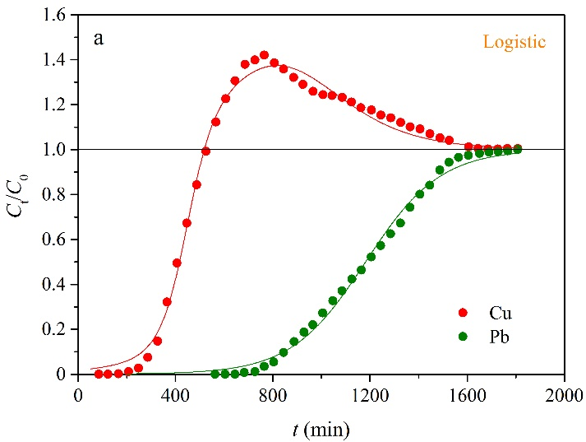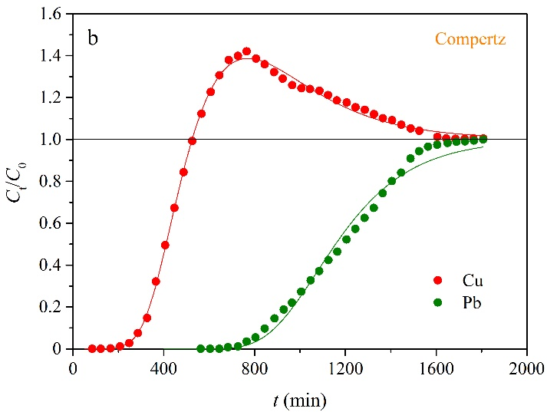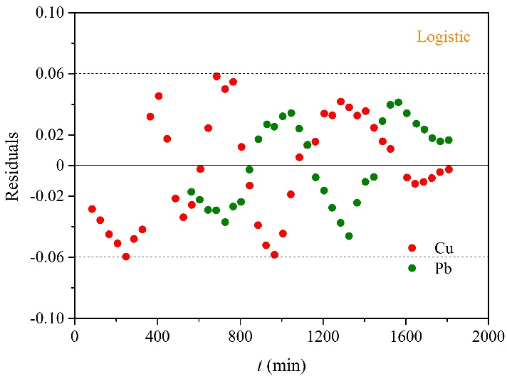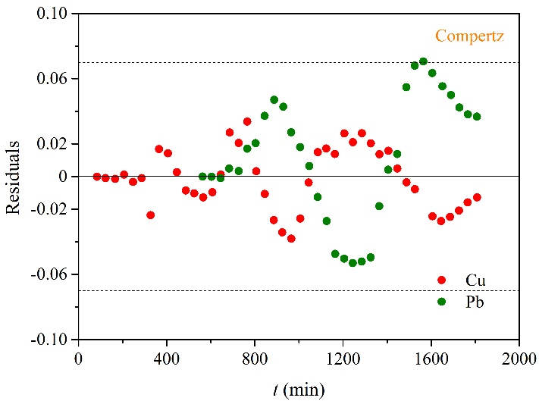

**Fig. S9.** Breakthrough curves and residual plots of Cu and Pb binary system: (a) Eq. (7) and (b) Eq. (8).

**Table S4** Fitting results of Cu and Pb binary system.

|  |  |  |  |  |  |  |  |
| --- | --- | --- | --- | --- | --- | --- | --- |
| Models | Adsorbate | *k* (min−1) | *τ* (min) | *k*\* (min−1) | *τ*\* (min−1) | *c* | *R*2 |
| Logistic | Cu | 1.87 × 10−2 | 447 | 5.43 × 10−3 | 814 | 276 | 0.994 |
|  | Pb | 6.53 × 10−3 | 1182 | 0 | 0 | 0 | 0.995 |
| Gompertz | Cu | 8.94 × 10−3 | 421 | 3.85 × 10−3 | 704 | 313 | 0.998 |
|  | Pb | 4.49 × 10−3 | 1076 | 0 | 0 | 0 | 0.989 |

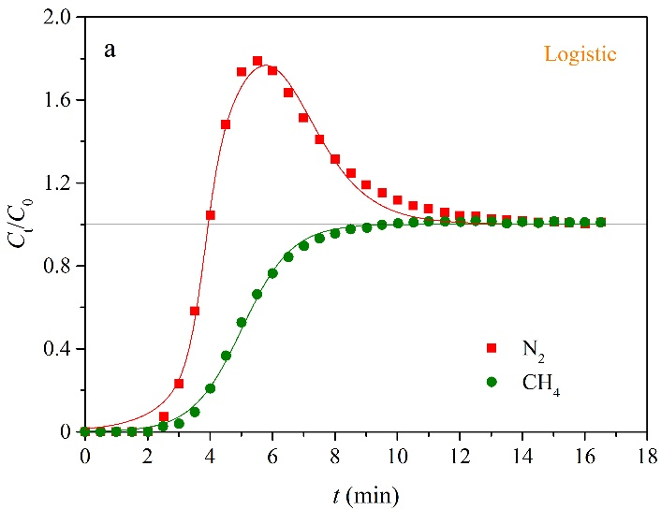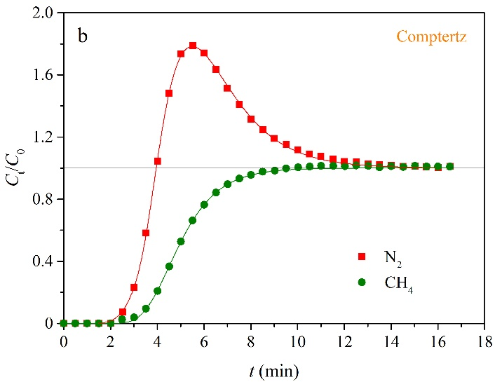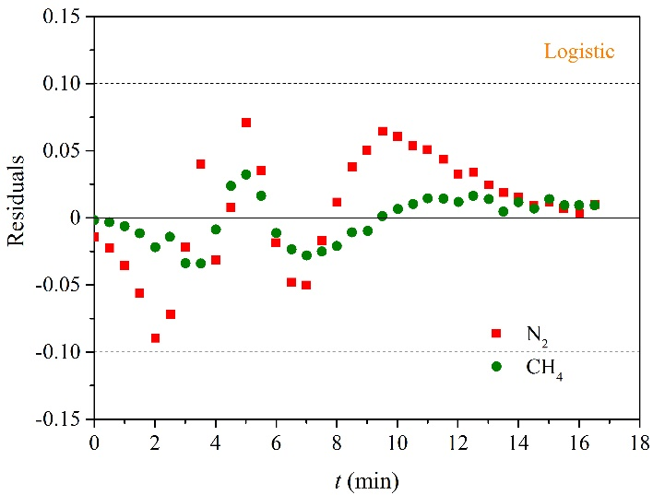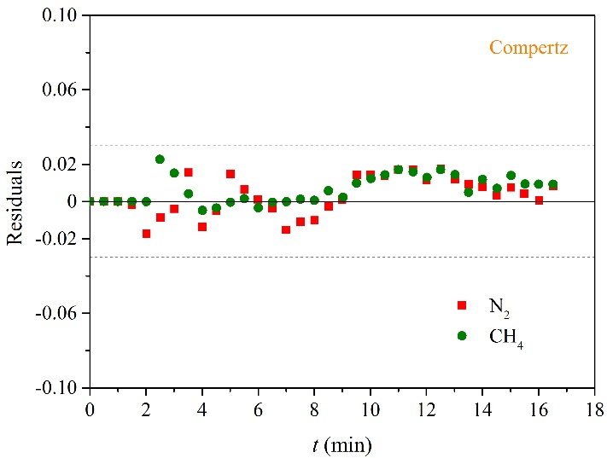

**Fig. S10.** Breakthrough curves and residual plots of N2 and CH4 binary system: (a) Eq. (7) and (b) Eq. (8).

**Table S5** Fitting results of N2 and CH4 binary system.

|  |  |  |  |  |  |  |  |
| --- | --- | --- | --- | --- | --- | --- | --- |
| Models | Adsorbate | *k* (min−1) | *τ* (min) | *k*\* (min−1) | *τ*\* (min−1) | *c* | *R*2 |
| Logistic | Cu | 3.59 | 3.83 | 0.93 | 5.77 | 3.31 | 0.994 |
|  | Pb | 1.26 | 5.03 | 0 | 0 | 0 | 0.998 |
| Gompertz | Cu | 1.62 | 3.98 | 0.63 | 5.08 | 3.86 | 1.000 |
|  | Pb | 0.88 | 4.51 | 0 | 0 | 0 | 0.999 |

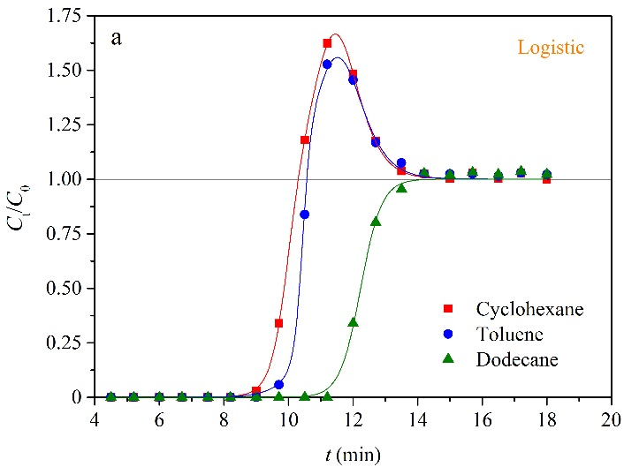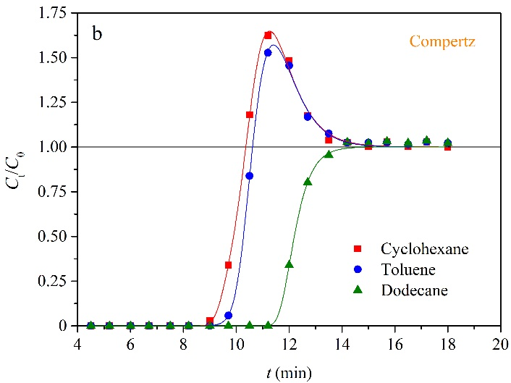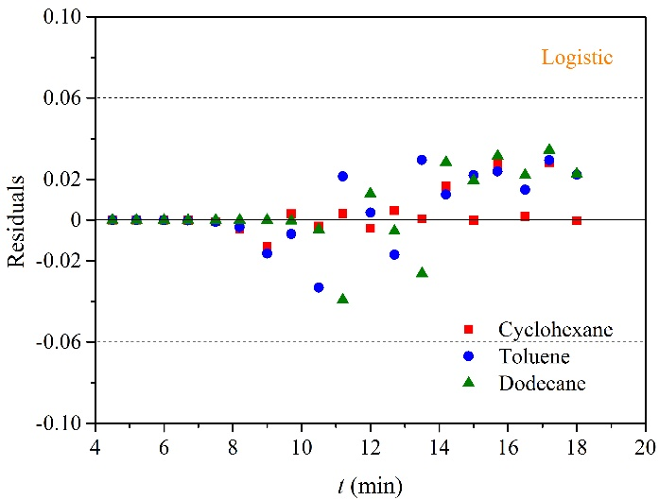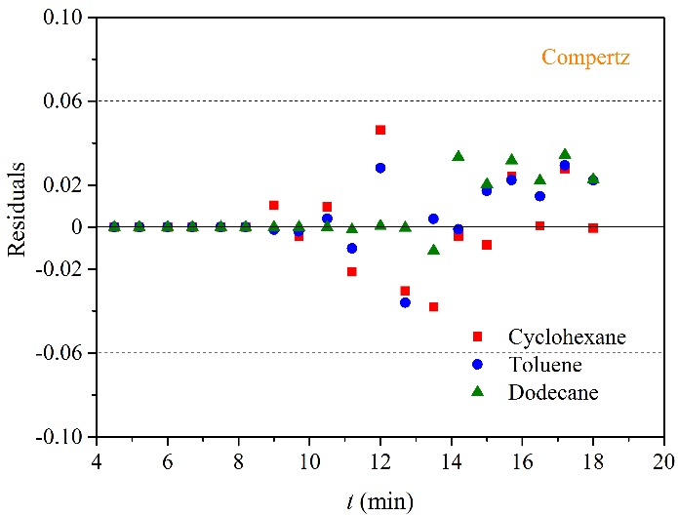

**Fig. S11.** Breakthrough curves and residual plots of cyclohexane, toluene and dodecane ternary adsorption system: (a) Eq. (7) and (b) Eq. (8).

**Table S6** Fitting results of cyclohexane, toluene and dodecane ternary adsorption systems.

|  |  |  |  |  |  |  |  |
| --- | --- | --- | --- | --- | --- | --- | --- |
| Models | Adsorbate | *k* (min−1) | *τ* (min) | *k*\* (min−1) | *τ*\* (min−1) | *c* | *R*2 |
| Logistic | Cyclohexane | 3.90 | 9.96 | 2.07 | 11.4 | 1.29 | 1.000 |
|  | Toluene | 7.96 | 10.4 | 1.94 | 11.5 | 591 | 0.999 |
|  | Dodecane | 3.09 | 12.2 | 0 | 0 | 0 | 0.998 |
| Gompertz | Cyclohexane | 1.89 | 9.75 | 1.37 | 11.2 | 1.40 | 0.999 |
|  | Toluene | 1.09 | 10.7 | 1.33 | 11.2 | 2.04 | 0.999 |
|  | Dodecane | 2.28 | 12.0 | 0 | 0 | 0 | 0.999 |

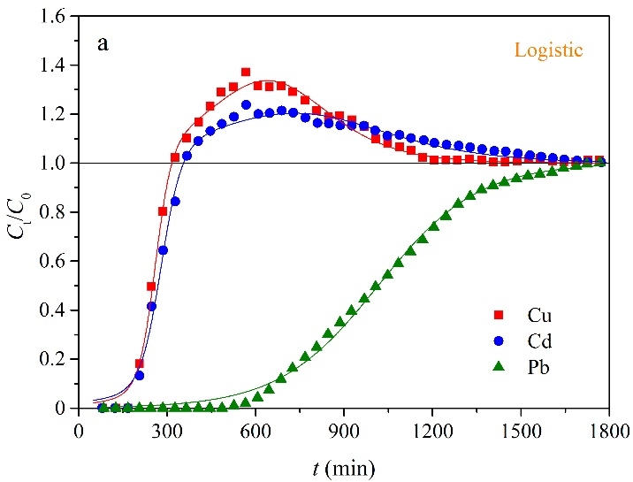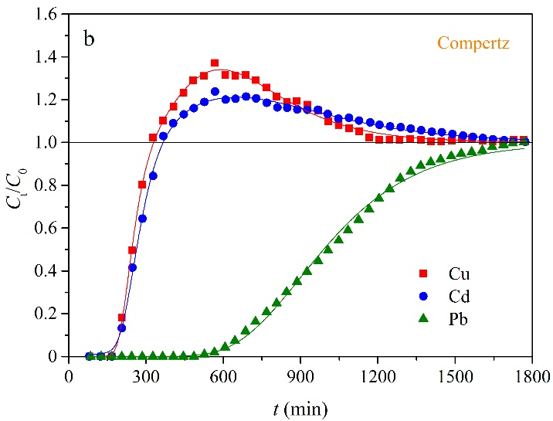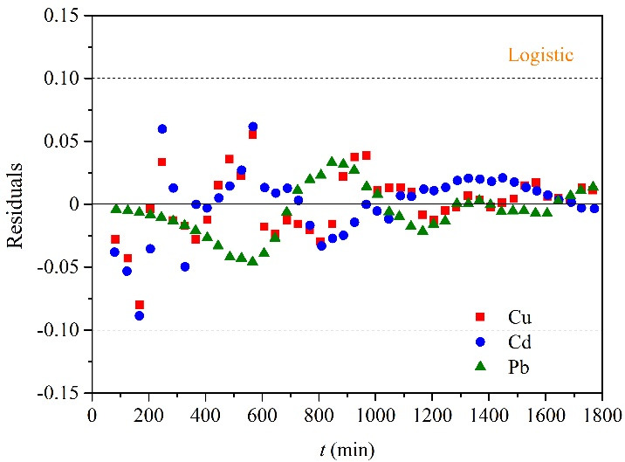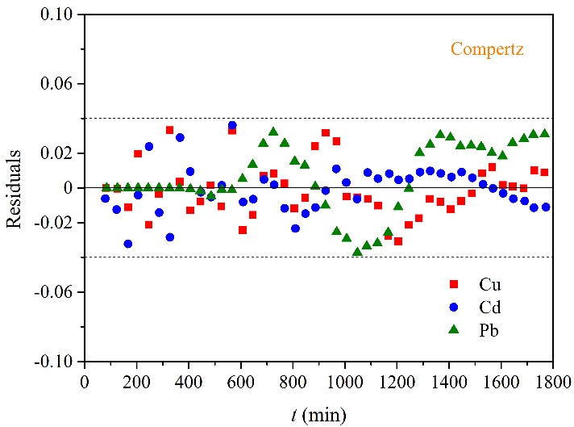

**Fig. S12.** Breakthrough curves and residual plots of Cu, Cd and Pb ternary system: (a) Eq. (7) and (b) Eq. (8).

**Table S7** Fitting results of Cu, Cd and Pb ternary systems.

|  |  |  |  |  |  |  |  |
| --- | --- | --- | --- | --- | --- | --- | --- |
| Models | Adsorbate | *k* (min−1) | *τ* (min) | *k*\* (min−1) | *τ*\* (min−1) | *c* | *R*2 |
| Logistic | Cu | 3.61 × 10−2 | 259 | 7.02 × 10−3 | 639 | 192 | 0.995 |
|  | Cd | 2.86 × 10−2 | 279 | 4.69 × 10−3 | 732 | 173 | 0.994 |
|  | Pb | 5.91 × 10−3 | 1015 | 0 | 0 | 0 | 0.997 |
| Gompertz | Cu | 2.40 × 10−2 | 232 | 4.92 × 10−3 | 589 | 188 | 0.998 |
|  | Cd | 1.81 × 10−2 | 252 | 3.29 × 10−3 | 645 | 175 | 0.998 |
|  | Pb | 4.06 × 10−3 | 899 | 0 | 0 | 0 | 0.997 |

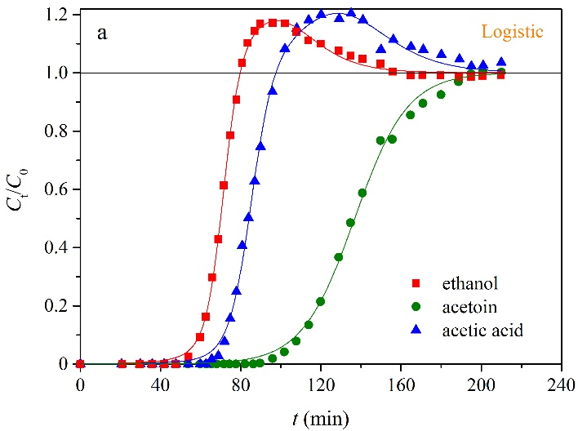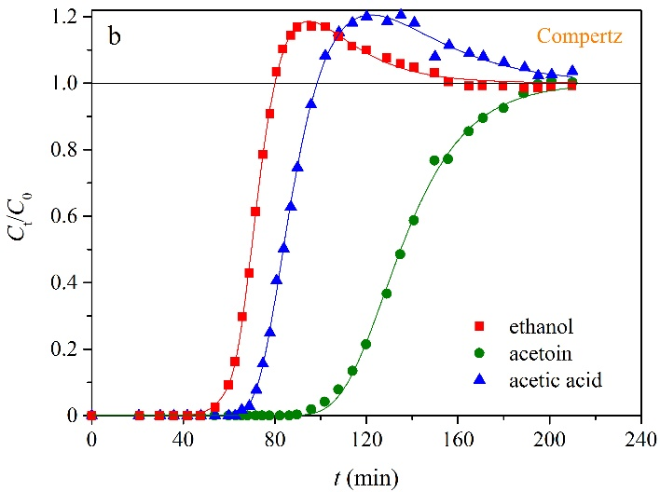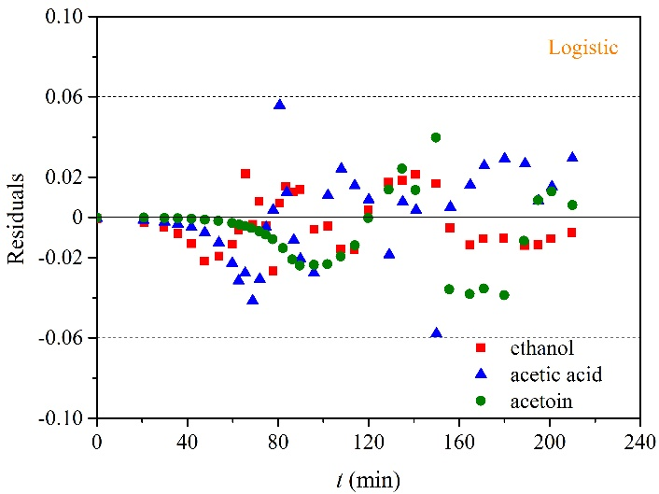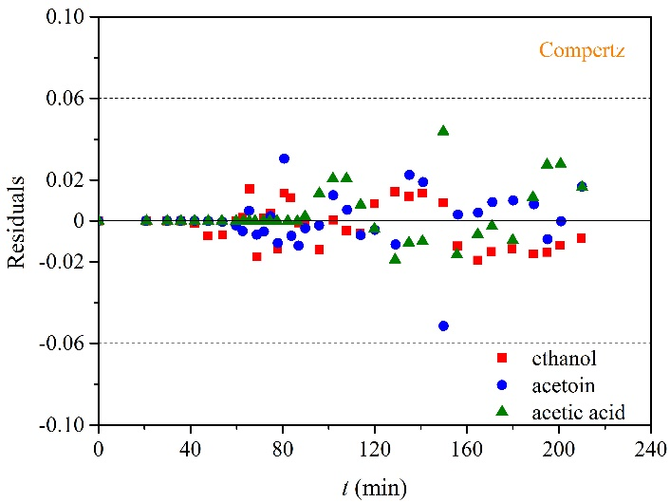

**Fig. S13.** Breakthrough curves and residual plots of ethanol, acetoin and acetic acid ternary adsorption system: (a) Eq. (7) and (b) Eq. (8).

**Table S8** Fitting results of ethanol, acetoin and acetic acid ternary adsorption systems.

|  |  |  |  |  |  |  |  |
| --- | --- | --- | --- | --- | --- | --- | --- |
| Models | Adsorbate | *k* (min−1) | *τ* (min) | *k*\* (min−1) | *τ*\* (min−1) | *c* | *R*2 |
| Logistic | Ethanol | 0.23 | 71.3 | 7.36 × 10−2 | 97.1 | 9.85 | 0.999 |
|  | Acetoin | 0.18 | 85.2 | 6.00 × 10−2 | 128 | 13.7 | 0.998 |
|  | Acetic acid | 7.62 × 10−2 | 137 | 0 | 0 | 0 | 0.998 |
| Gompertz | Ethanol | 0.13 | 70.9 | 5.17 × 10−2 | 80.5 | 13.7 | 0.999 |
|  | Acetoin | 9.99 × 10−2 | 82.3 | 3.68 × 10−2 | 115 | 17.0 | 0.999 |
|  | Acetic acid | 5.18 × 10−2 | 128 | 0 | 0 | 0 | 0.999 |

**References**

1. H. Sui, P. Jiang, X. Li, J. Liu, X. Li, L. He, Binary adsorption equilibrium and breakthrough of *n*-butyl acetate and *p*-xylene on granular activated carbon, Ind. Eng. Chem. Res. 58 (2019) 8279-8289.
2. L. Lv, K. Wang, X.S. Zhao, Effect of operating conditions on the removal of Pb2+ by microporous titanosilicate ETS-10 in a fixed-bed column, J. Colloid Interface Sci. 305 (2007) 218-225.
3. J.A.C. Silva, A. Ferreira, P.A.P. Mendes, A.F. Cunha, K. Gleichmann, A.E. Rodrigues, Adsorption equilibrium and dynamics of fixed bed adsorption of CH4/N2 in binderless beads of 5A zeolite, Ind. Eng. Chem. Res. 54 (2015) 6390-6399.
4. J. Wu, X. Ke, L. Wang, R. Li, X. Zhang, P. Jiao, W. Zhuang, Y. Chen, H. Ying, Recovery of acetoin from the ethanol–acetoin–acetic acid ternary mixture based on adsorption methodology using a hyper-cross-linked resin, Ind. Eng. Chem. Res. 53 (2014) 12411-12419.
5. S. Guo, P. Vengsarkar, K.C. Jayachandrababu, C. Pereira, R.D. Partridge, Y.V. Joshi, S. Nair, Y. Kawajiri, Aromatics/Alkanes separation: Simulated moving bed process model development by a concurrent approach and its validation in a mini-plant, Sep. Purif. Technol. 215 (2019) 410-421.

1. * Corresponding author.

   *E-mail address:* huqili@cdut.edu.cn (Q. Hu); xuli@cdut.edu.cn (L. Xu).