Co-biomass degradation of fluoranthene by marine-derived fungi; Aspergillus aculeatus and Mucor irregularis: comprehensive process optimization, enzyme induction and metabolic analyses
Paul Olusegun Bankole^{a,b}*, Victor Taghoghor Omoni^{b}, Sikandar Imamsab Mulla^{c,d}, Seun Owolabi Adebajo^{e}, Adedotun Adeyinka Adekunle^{f}
ªDepartment of Pure and Applied Botany, College of Biosciences, Federal University of Agriculture P.M.B. 2240 Abeokuta, Ogun State, Nigeria
^{b}Lancaster Environment Centre, Lancaster University, Lancaster LA1 4YQ, United Kingdom
^{c}Department of Biochemistry, School of Applied Sciences, REVA University, Bangalore 560064, India
^{d}Division of Biotechnology, Jeonbuk National University, Iksan 54596, Republic of Korea
^{e}Department of Microbiology, College of Biosciences, Federal University of Agriculture P.M.B. 2240 Abeokuta, Ogun State, Nigeria
^{f}Department of Botany, Faculty of Science, University of Lagos, Lagos State, Nigeria

Corresponding author: bankolepo@funaab.edu.ng

Molecular identification and phylogenetic relationship between AA and MI
Internal Transcribed Spacer (ITS) 1 and 4 sequences were used in the characterization of the marine fungi; A. aculeatus and M. irregularis. The Basic Local Alignment Search Tool (BLAST) analysis of the nucleotide sequences revealed that the molecular data on A. aculeatus had homologous identities with A. aculeatus (MH368116) by 99.47%, A. aculeatus (KJ958359) by 99.61%, A. aculeatus (KJ439163) by 96.55%, A. aculeatus strain 4-4 (MF196878) by 95.00%, and A. aculeatus (AJ279995) by 92.78% (Fig. SM1). Similarly, the BLAST query revealed that M. irregularis sequence data had homologous similarities with M. irregularis strain LZ02 (MN533715) by 93.67%, M. irregularis strain LZ04 (MN533717) by 91.77%, M. irregularis (MH102381) by 90.87%, M. irregularis strain Bpf-19 (MH397495) by 97.21% and M. irregularis strain E22F (KY425732) by 90.54%.

Table SM1. GC-MS data of obtained fluoranthene metabolites after degradation by Aspergillus aculeatus, Mucor irregularis and AA+MI co-culture
Peak | Rt  (min) | m/z | Mol. Weight  (g moL⁻¹) | Description | Mass spectrum
aI | 15.794 | 225 | 224.21 | 2-formylacenaphthylene-1-carboxylic acid
aII | 12.511 | 182 | 182.22 | 9H-fluoren-9-ol
aIII | 11.324 | 171 | 170.21 | 1,2-dihydroacenaphthylen-1-ol
aIV, bI | 9.122 | 155 | 154.21 | 1,2-dihydroacenaphthylene
bII | 8.679 | 186 | 186.32 | 1,2-dihydroacenaphthylene-1,2-diol |  | 11.34 | 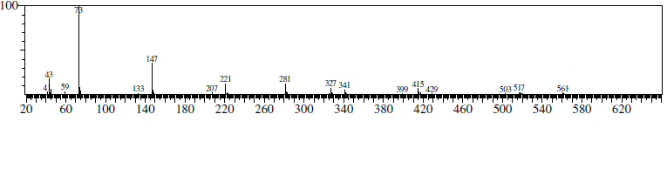
bIII | 7.999 | 181 | 180.55 | 9H-fluoren-9-one
cI | 7.924 | 237 | 238.28 | 1,2- dihydroxyfluoranthene
cII | 7.672 | 256 | 254.23 | 9H-fluorene-1,9-dicarboxylic acid
cIII | 7.101 | 211 | 210.14 | benzene-1,2,4-tricarboxylic acid
cIV | 6.907 | 166 | 166.13 | benzene-1,3-dicarboxylic acid
cV | 4.966 | 121 | 122.12 | benzoic acid

.
Aspergillus aculeatus (KJ439163)
Aspergillus aculeatus (KJ958359)
Aspergillus aculeatus (MH368116)
Aspergillus aculeatus strain bpo2 (MT492456)
Aspergillus aculeatus (AJ279995)
Aspergillus aculeatus strain 4-4 (MF196878)
Aspergillus aculeatus strain KU20018.78 (MT487837)
Aspergillus japonicus (KF493862)
Aspergillus sp. strain 79-B7 (MT594360)
Aspergillus aculeatus (KF493861)
Mucor irregularis strain E22F (KY425732)
Rhizomucor sp. UFMGCB 3507 (JQ418437)
Mucor irregularis strain Bpf-19 (MH397495)
Mucor sp. (MN968723)
Rhizomucor sp. JJP-2009a (FJ210508)
Rhizomucor sp. JJP-2009a (FJ210515)
Mucor irregularis (MH102381)
Mucor sp. (MN853752)
Mucor irregularis strain LZ04 (MN533717)
Mucor irregularis strain LZ02 (MN533715)
Aspergillus aculeatus strain AN5 (KY859793)
Mucor irregularis bpo1 (MK373020)
Aspergillus sp. (MK332589)
Aspergillus aculeatus strain A1.9 (EU833205)
Aspergillus aculeatus strain MR10 (KY320594)
Aspergillus aculeatus (EU326206)

Aspergillus japonicus (KX621981)
Mucor circinelloides strain SD-8 (KY807767)
Rhizomucor sp. strain SH-16 (MN521812)
Mucor circinelloides strain LZ27 (MN533740)
99
98
98
90
98
98
90
96
94
96
91
97
94
95
90
96
99
100
96
91
90
93
90
90
87
99
0.5

Fig. SM1. Evolutionary relationships of the marine-derived fungi, A. aculeatus bpo 2 and M. irregularis bpo 1. The tree was constructed by bootstrap analysis and inferred through the Neighbor-Joining tree method using MEGA X Software.

a  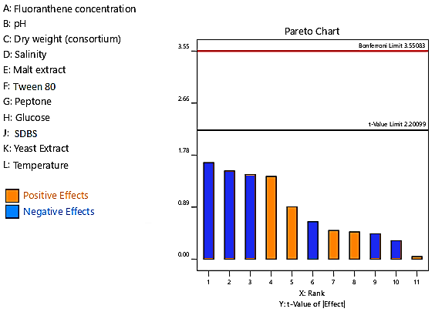  c | b  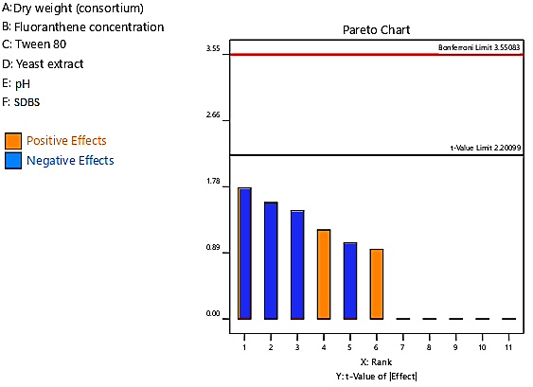
Fig. SM2. Pareto chart showing the influence of (a) 11 standard variables (b) 6 standard variables (c) 4 standard variables (Plackett-Burman Designs) in fluoranthene degradation by AA+MI co-culture (p≤0.05)

Fig. SM3. Validation of the FFD using growth-linked experiment of the optimized culture conditions

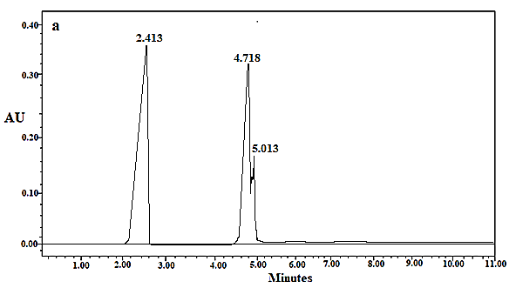 | 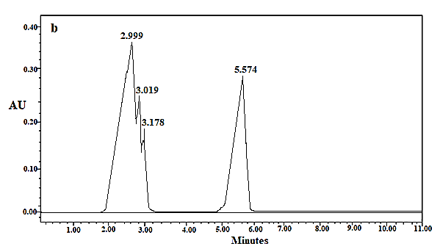
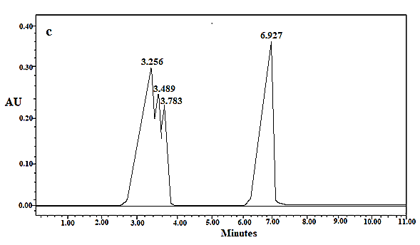 | 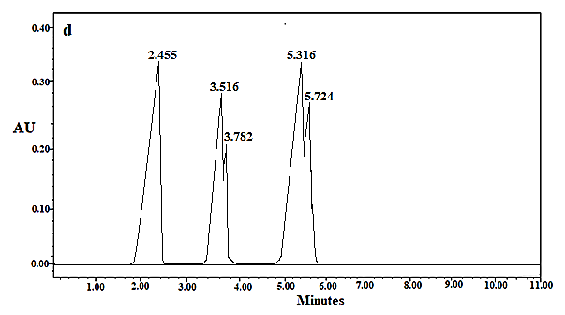
Fig. SM4. HPLC Chromatogram of fluoranthene (a) untreated (b) after degradation by AA (c) after degradation by M1 (d) after degradation by AA+MI

