Supporting Information

Amiloride-modulated phosphorescence turn-off/on method for the detection of abasic site-containing dsRNA based on uridine triphosphate-capped Mn-doped ZnS quantum dots

Jie Zhao, Zhefeng Fan*
School of Chemistry and Materials Science, Shanxi Normal University, Linfen 041004, PR China

Experimental section
Materials and chemicals
Sequences of dsRNA/ssRNA and dsDNA/ssDNA, with and without AP sites. X=AP site (spacer C3, a propyl residue).
AP-dsRNA: 5’-r(UUC UCC UUU UXU UUU CCC UCC)-3’
3’-r(AAG AGG AAA AUA AAA GGG AGG)-5’
AP-dsDNA: 5’-r(TTC TCC TTT TXT TTT CCC TCC)-3’
3’-r(AAG AGG AAA ATA AAA GGG AGG)-5’
AP-ssRNA: 5’-r(UUC UCC UUU UXU UUU CCC UCC)-3’
AP-ssDNA: 5’-r(TTC TCC TTT TXT TTT CCC TCC)-3’
dsRNA: 5’-r(UUC UCC UUU UAU UUU CCC UCC)-3’
3’-r(AAG AGG AAA AUA AAA GGG AGG)-5’
dsDNA: 5’-r(TTC TCC TTT TAT TTT CCC TCC)-3’
3’-r(AAG AGG AAA ATA AAA GGG AGG)-5’
ssDNA: 5’-r(UUC UCC UUU UAU UUU CCC UCC)-3’
ssRNA: 5’-r(TTC TCC TTT TAT TTT CCC TCC)-3’

Figures
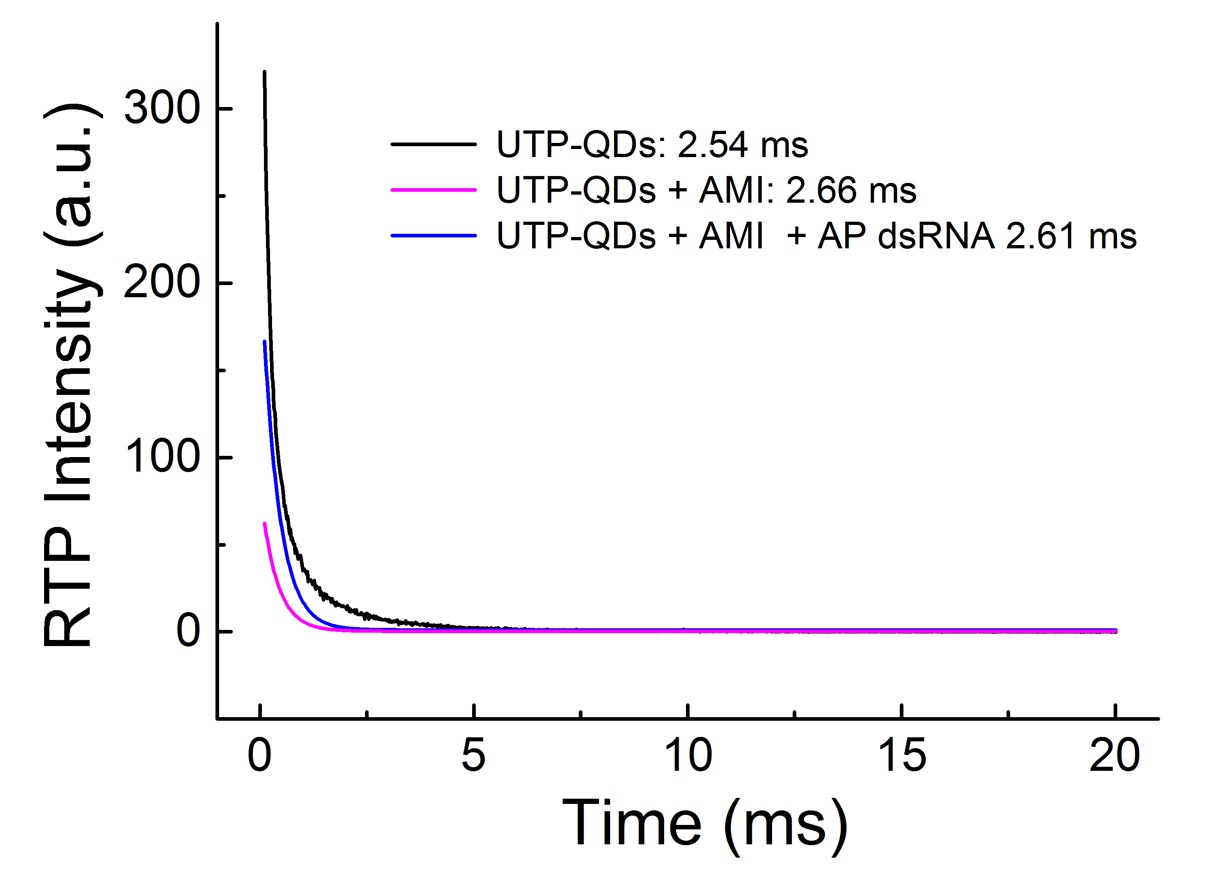
Figure S1. RTP lifetime the UTP-QDs without/with AMI and AP-dsRNA.

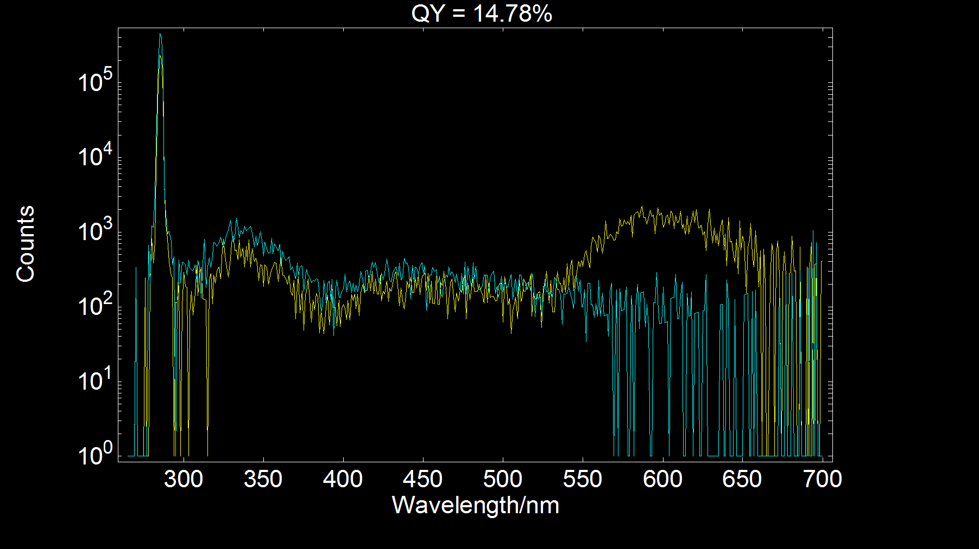
Figure S2. Absolute quantum yield of the UTP-QDs.

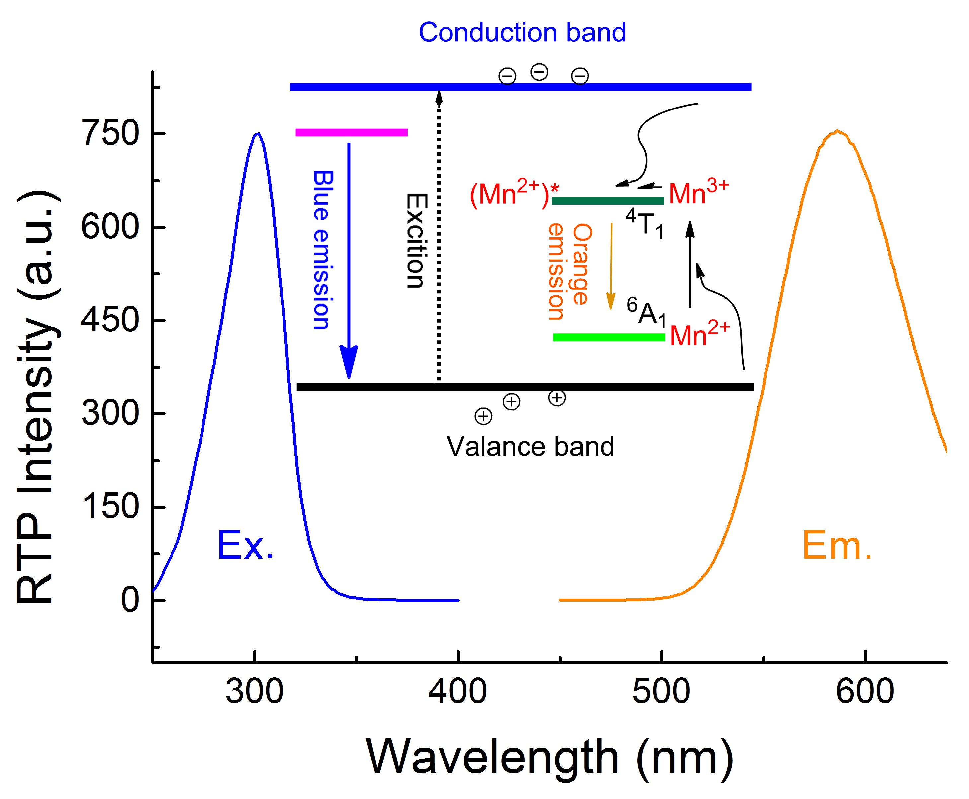
Figure S3. Maximum excitation and emission peak of the UTP-QDs.

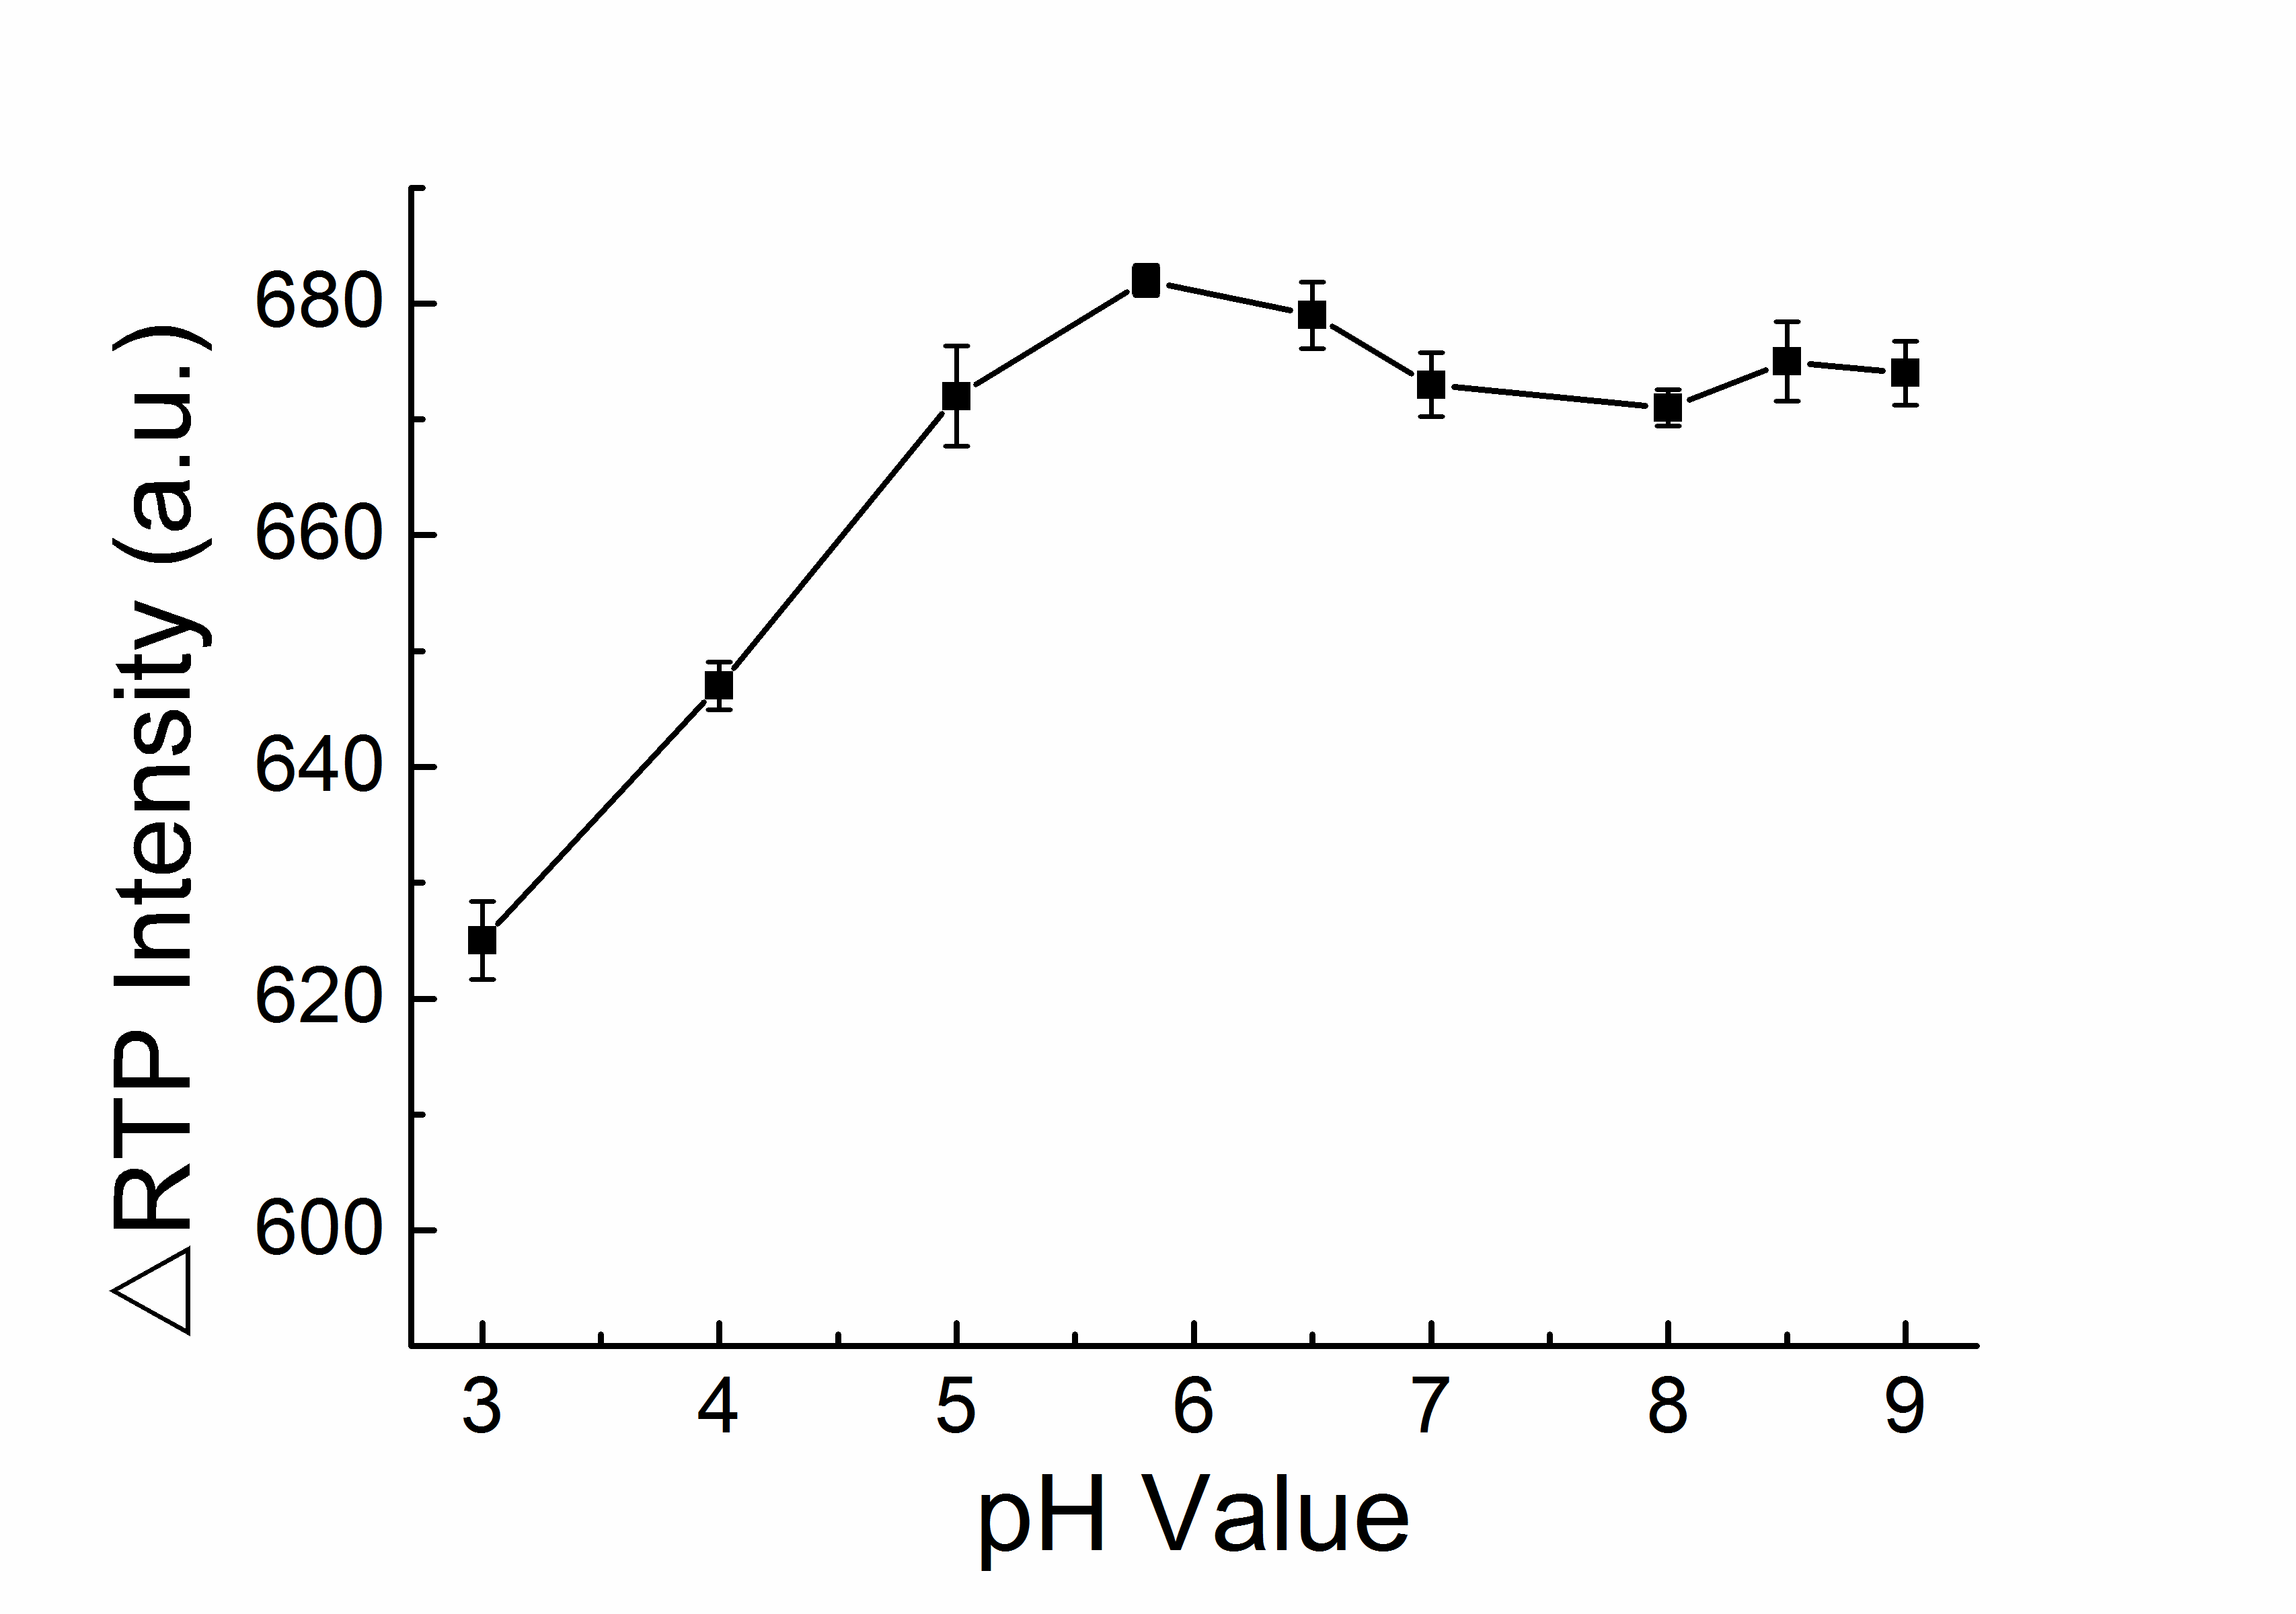
Figure S4. pH dependence of AMI on RTP quenching effect of UTP-QDs.

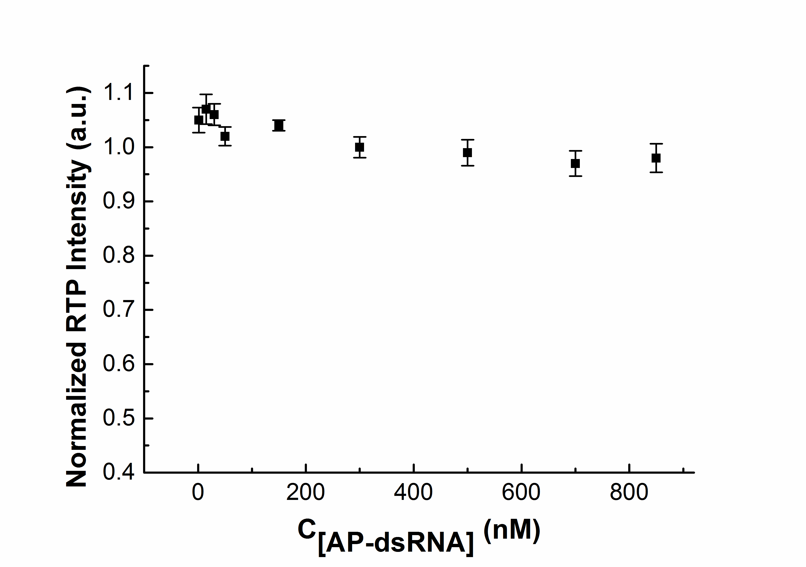
Figure S5. Effect of the concentration of AP-dsRNA on the RTP intensity of UTP-QDs (60 mg L⁻¹) without AMI (in 50 mM BR buffer, pH 5.8, containing 100 mM NaCl).

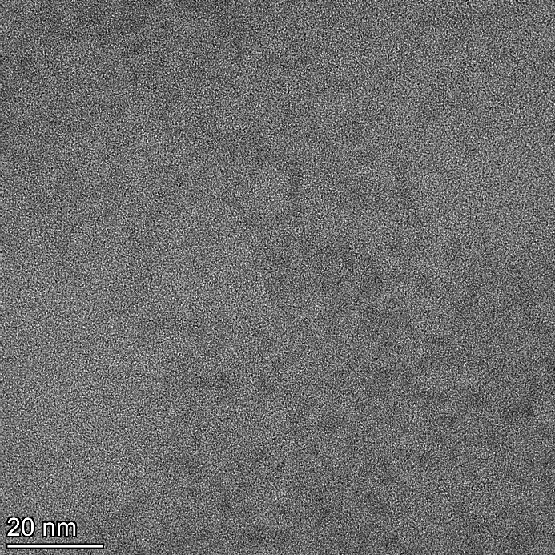
Figure S6. TEM image of AMI (300 nM)-modulated UTP-QDs (60 mg L⁻¹) in the presence of AP-dsRNA (300 nM). All solutions were prepared in 50 mM BR buffer at pH 5.8 containing 100 mM NaCl.

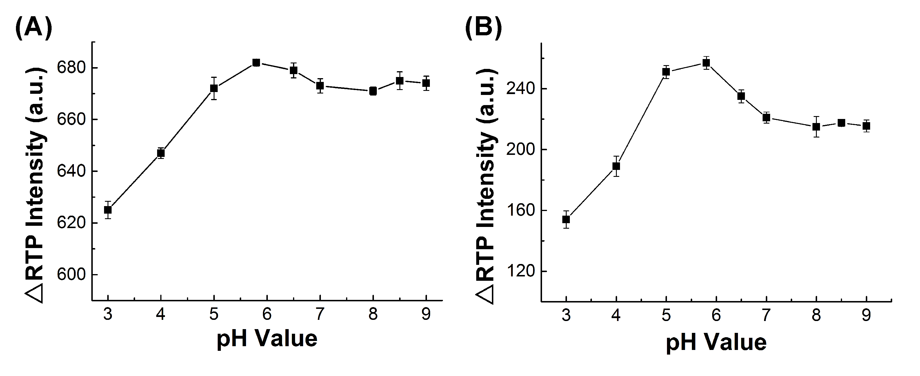
Figure S7. RTP-quenching variables caused by AMI (A), and subsequent AP-dsRNA-induced RTP recovery variables (B) in response to pH value. All solutions were prepared in 50 mM BR buffer containing 100 mM NaCl.

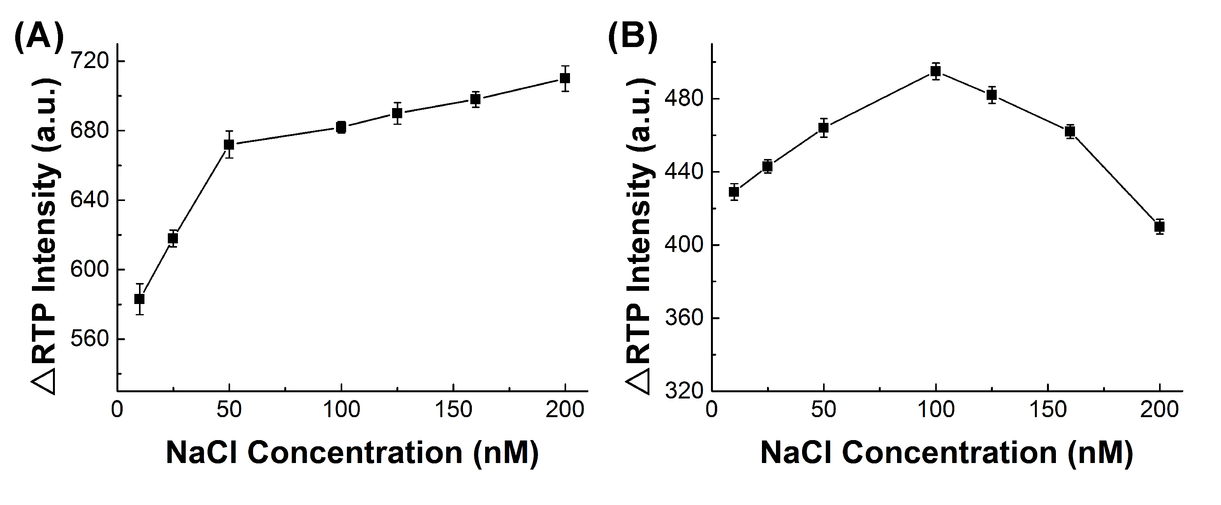
Figure S8. RTP-quenching variables caused by AMI (A) and subsequent AP-dsRNA-induced RTP recovery variables (B) in response to NaCl concentration. All solutions were prepared in 50 mM BR buffer at pH 5.8.

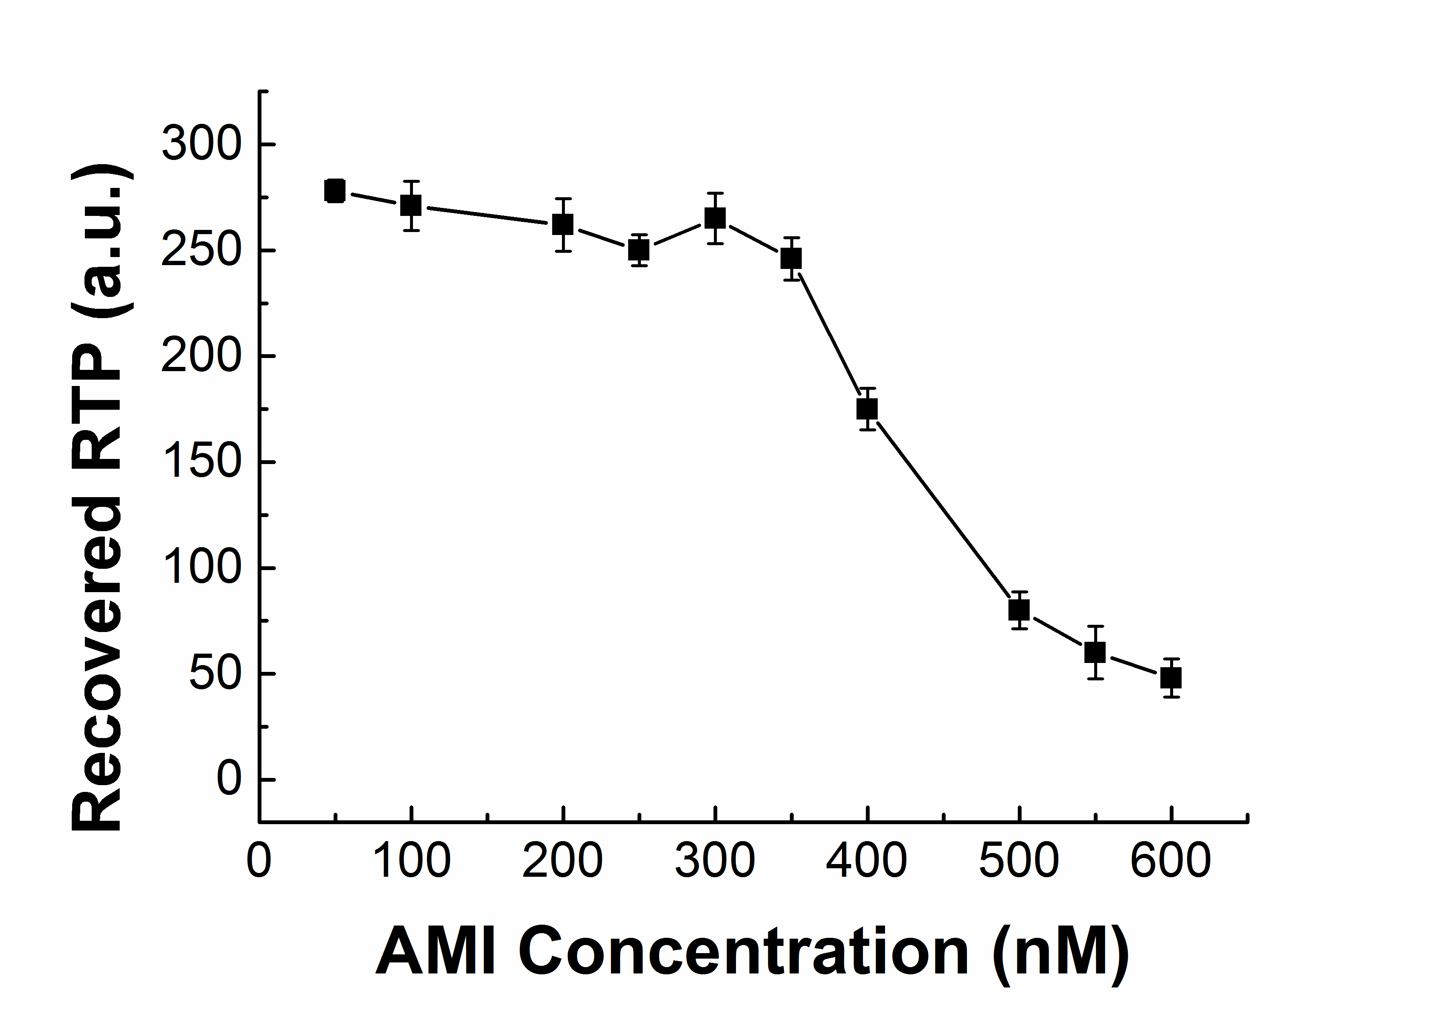
Figure S9. Effect of the concentration of AMI added on the recovered RTP intensity. All solutions were prepared in 50 mM BR buffer at pH 5.8 containing 100 mM NaCl.

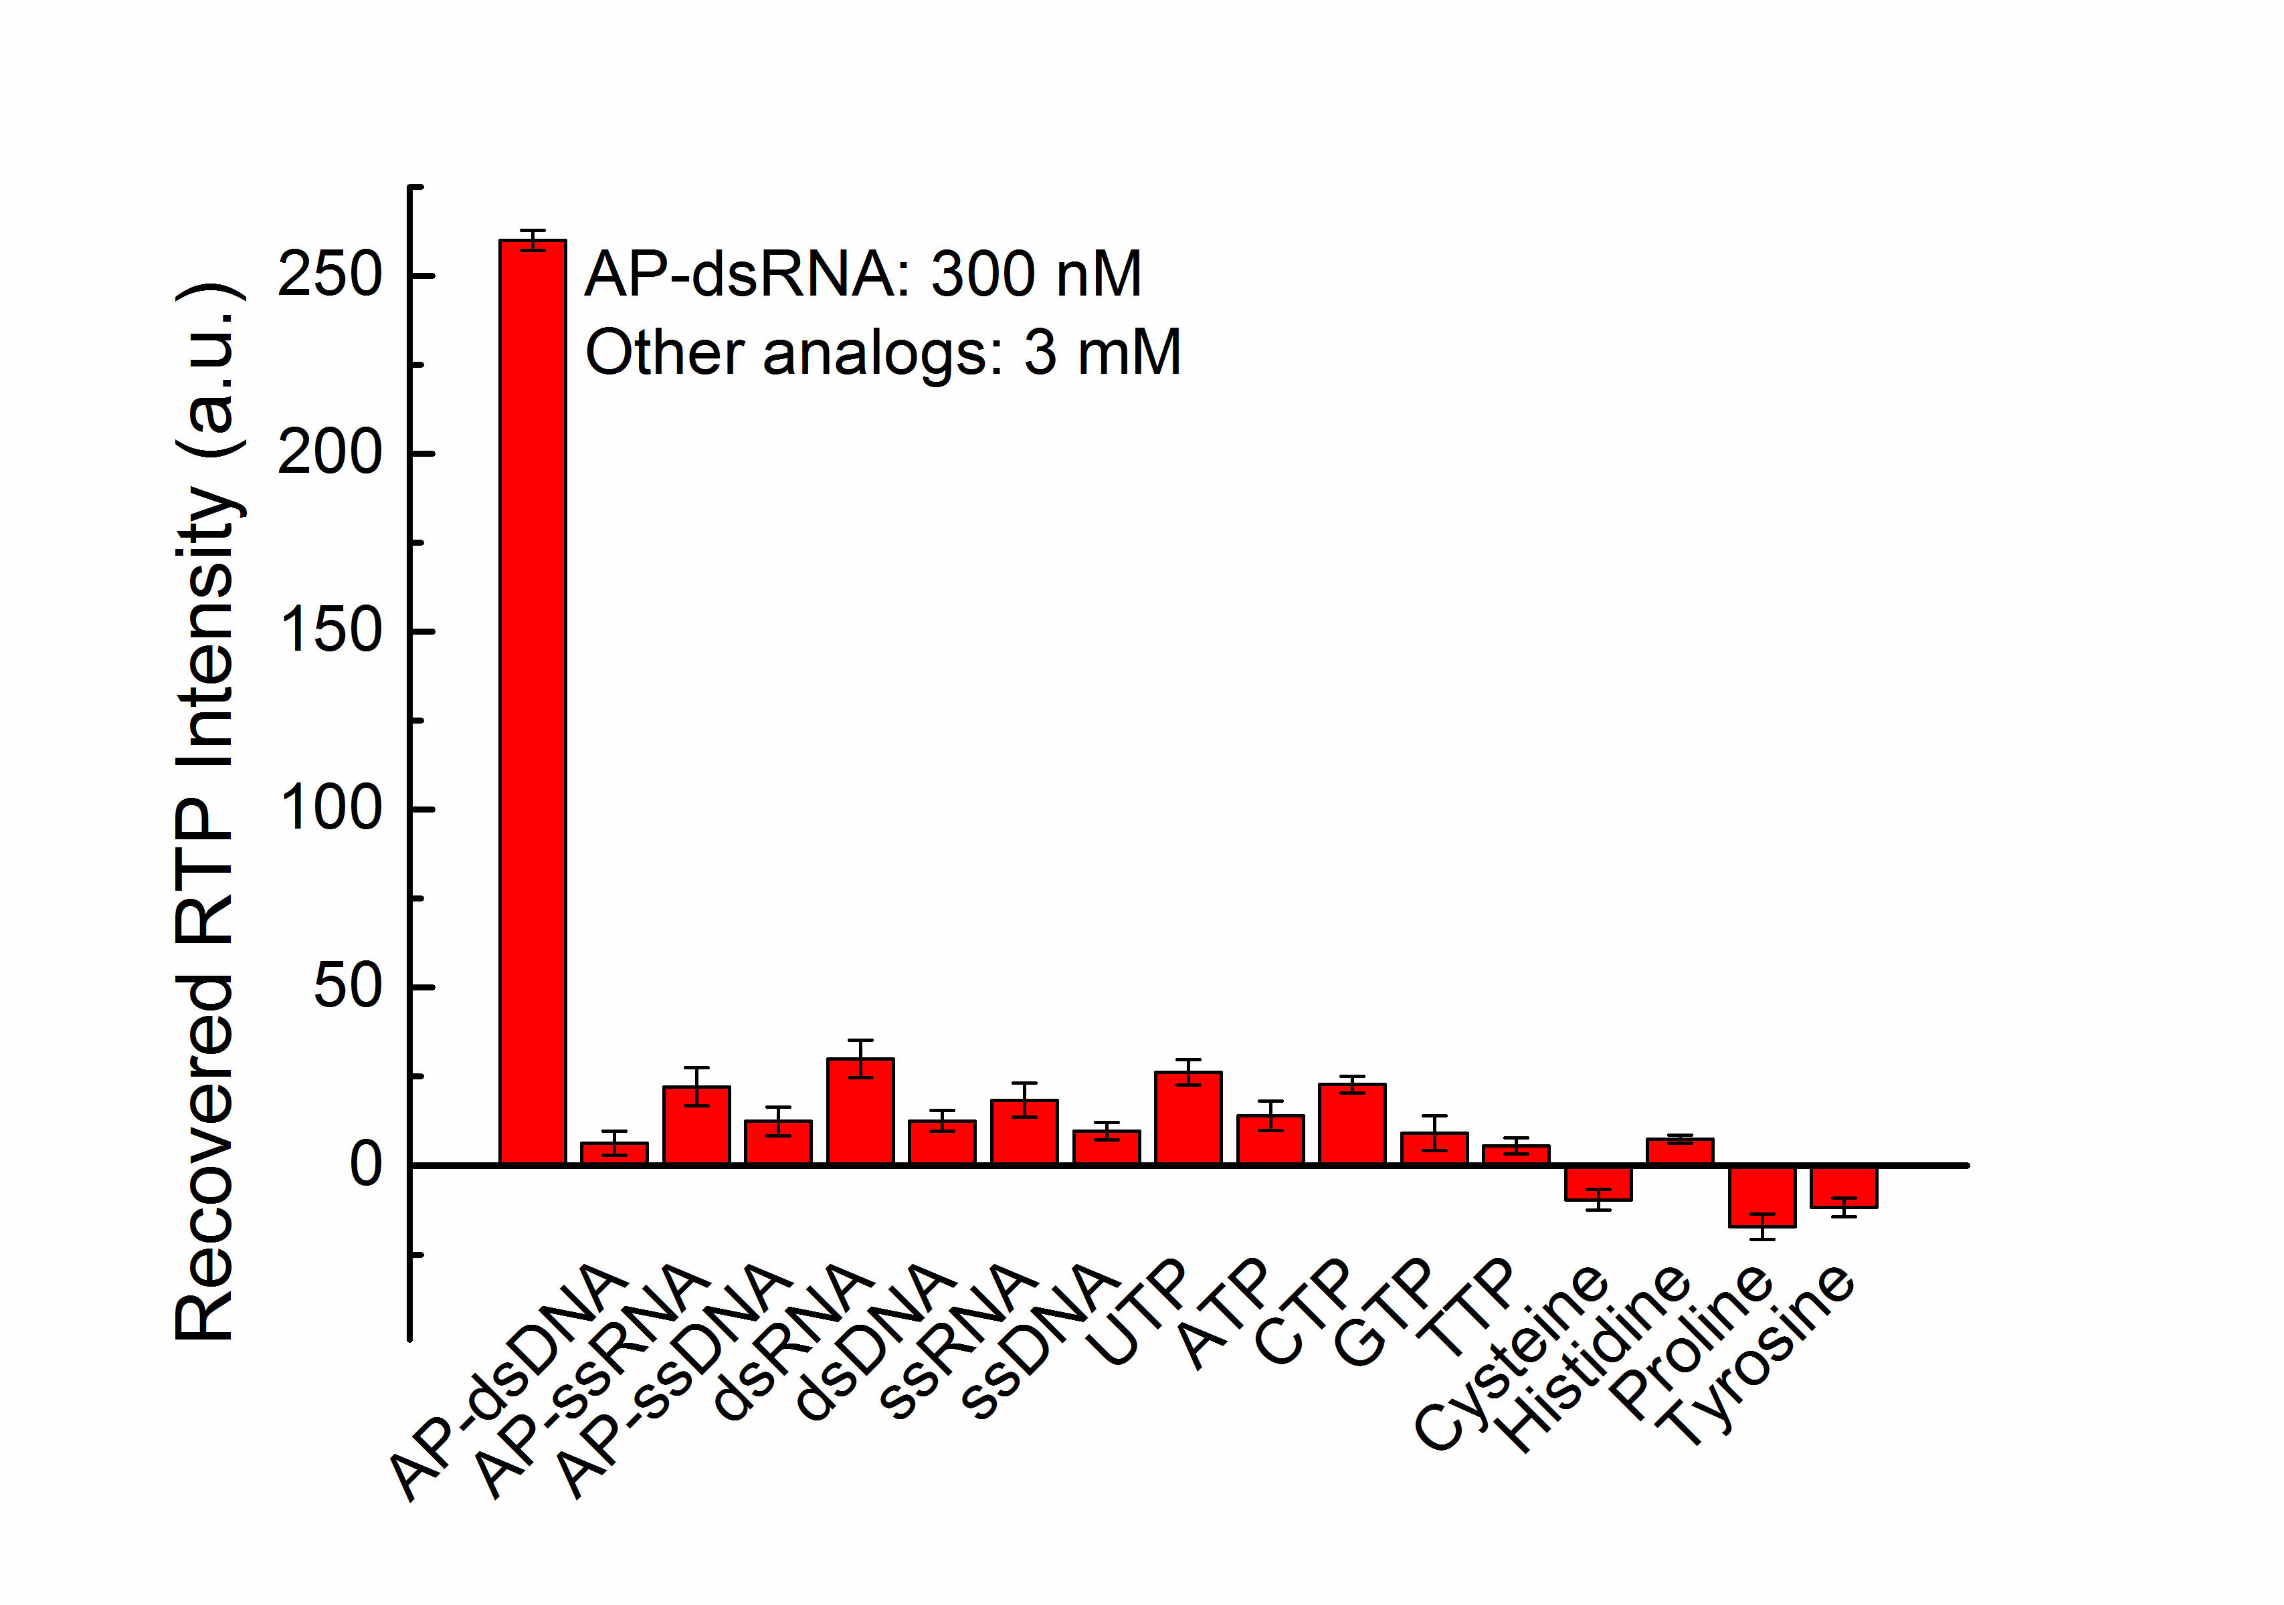

Figure S10. The response of AMI (300 nM)-modulated UTP-QDs (60 mg L⁻¹) in BR buffer (50 mM, pH 5.8) to potential coexisting substances.

Tables
Table S1. Infrared spectroscopy absorption of UTP-QDs and UTP.
UTP-QDs |  | UTP
Absorption (cm⁻¹) | Group | Absorption (cm⁻¹) | Group
3434 | O-H / N-H stretching | 3428 | O-H / N-H stretching
2937 | C-H stretching | 2908 | C-H stretching
1675 | C=O stretching | 2837 | C-H stretching
1637 | C=O stretching | 1702 | C=O stretching
1509 | N-H stretching | 1473 | C-H bending
1461 | C-H bending | 1428 | C-N / C=C stretching
1400 | P=O stretching | 1400 | P=O stretching
1236 | PO²⁻ stretching | 1255 | PO²⁻ stretching
1116 | C-O stretching | 1120 | C-O stretching
 |  | 1081 | C-OH stretching

Table S2. Recovery (Mean±s; n=3) for the determination of AP-dsRNA in real samples.
Type of samples | AP-dsRNA spiked  (nM) | AP-dsRNA found  (nM) | RSD  (%) | Recovery  (%)
Human serum | 0 | - | - | -
Human serum | 50 | 51.5±1.1 | 2.1 | 102
Human serum | 100 | 103±2.1 | 2.0 | 103
Plant lysate | 0 | 10.2±0.28 | 2.7 | -
Plant lysate | 50 | 58.8±1.6 | 2.7 | 97
Plant lysate | 100 | 104±2.4 | 2.3 | 95

* Corresponding author. Fax: (86) 351-2051091. E-mail: crush_bc@163.com.

