Supporting Information
Bioassay and UPLC-Q-Orbitrap-MS/MS guided isolation of polycyclic polyprenylated acylphloroglucinols from St. John's wort and their neuroprotective activity

Table of Contents
Table S1. The neuroprotective activity of the different concentration of the water (WT) and ethyl acetate (EA) extracts of SWJ 3
Table S3. The neuroprotective activity of compounds 1-10 4
Table S4. Experimental and calculated ¹³C (150 MHz) NMR data for 2 in CDCl₃ (δ in ppm) 5
Table S5. Gibbs free energiesª and equilibrium populations^{b} of low-energy conformers of 2. 6
Table S6. Cartesian coordinates for the low-energy reoptimized MMFF conformers of 2 at B3LYP/6-31+G(d,p) level of theory in CH₃OH. 6
Figure S1. The TIC spectrogram of Fr. A for the ethyl acetate extract of SJW. 18
Figure S2. Product ion scan of the selected precursor compounds X1–X35 at m/z [M + H]⁺ or [M + Na]⁺ (40% NCE). 21
Spectra of physico-chemical properties of 2 22
Figure S3. ¹H NMR spectrum of hyperforen A (2) (600 MHz, CDCl₃). 22
Figure S4. ¹³C NMR spectrum of hyperforen A (2) (150 MHz, CDCl₃). 22
Figure S5. DEPT spectrum of hyperforen A (2) (150 MHz, CDCl₃). 23
Figure S6. ¹H–¹H COSY spectrum of hyperforen A (2). 23
Figure S7. HMQC spectrum of hyperforen A (2). 24
Figure S8. HMBC spectrum of hyperforen A (2). 24
Figure S9. ROESY spectrum of hyperforen A (2). 25
Figure S10. HR-ESI-MS spectrum of hyperforen A (2). 25
Figure S11. CD spectrum of hyperforen A (2). 26
Figure S12. UV spectrum of hyperforen A (2). 26
Figure S13. IR spectrum of hyperforen A (2). 27

Table S1. The neuroprotective activity of the different concentration of the water (WT) and ethyl acetate (EA) extracts of SWJ
No. | Cell viability | Standard Deviation  (SD, %) | P
Blank | 100.00 | 0.58 | ***
NC | 59.71 | 0.52
DIM | 89.17 | 0.26 | ***
100 μg/ml (WT) | 60.04 | 0.51
5 μg/ml (WT) | 59.99 | 0.39
5 μg/ml (EA) | 61.79 | 0.27 | **
2 μg/ml (EA) | 61.02 | 0.36 | *
1 μg/ml (EA) | 60.86 | 0.38 | *
Note: ***P＜0.001, **P＜0.01, *P ＜ 0.05 vs. model.

Table S3. The neuroprotective activity of compounds 1-10
No. | Cell viability (± SD, %)
No. | 20 µM | 10 µM | 5 µM
2 | 65.56 ± 0.50*** | 64.19 ± 1.37** | 61.01 ± 1.25
1 | 62.92 ± 0.82** | 62.94 ± 0.84** | 61.20 ± 2.09
3 | 67.66 ± 0.93*** | 65.15 ± 0.59*** | 64.06 ± 0.72**
4 | 60.82± 1.21 | -
5 | 59.70 ± 0.53 | -
6 | 63.28 ± 1.07** | 63.18 ± 0.82** | 61.21 ± 1.02
7 | 60.49 ± 0.70
8 | 59.88 ± 0.80
9 | 61.01 ± 0.91
10 | 63.64 ± 1.14** | 62.83 ± 0.96** | 59.66 ± 0.59
Blank | 100.00 ± 0.32***
NC | 59.65 ± 0.92
DIM | 88.70 ± 0.26***
Note: ***P＜0.001, **P＜0.01, *P ＜ 0.05 vs. model.

Table S4. Experimental and calculated ¹³C (150 MHz) NMR data for 2 in CDCl₃ (δ in ppm)
No. | δ_{exp} | δ_{cal}
1 | 67.5 | 68.4
2 | 201.3 | 209.9
3 | 88.2 | 95.4
4 | 210.3 | 226.7
5 | 47.1 | 50.8
6 | 30.8 | 31.1
7 | 31.1 | 27.6
8 | 41.6 | 59.9
9 | 47.2 | 56.3
10 | 206.7 | 214.3
11 | 42.7 | 47.2
12 | 18.2 | 16.7
13 | 18.5 | 20.4
14 | 33.4 | 37.2
15 | 115.4 | 117.3
16 | 137.1 | 144
17 | 18.2 | 17.2
18 | 25.9 | 25.8
19 | 25.4 | 31.8
20 | 121.7 | 123.6
21 | 133.5 | 139.6
22 | 18.1 | 16.8
23 | 25.8 | 25.9
24 | 46.6 | 47.9
25 | 128.6 | 130.3
26 | 131.3 | 138.1
27 | 25.8 | 25.9
28 | 17.9 | 17.5
29 | 34.1 | 43.6
30 | 47.6 | 51.9
31 | 27.8 | 30.9
32 | 15.9 | 14.9
33 | 21.4 | 22.8
34 | 12.3 | 16.8

Table S5. Gibbs free energiesª and equilibrium populations^{b} of low-energy conformers of 2.

Conformers | In MeOH
Conformers | ∆G | P (%)/100
2-1 | 0.00 | 0.382
2-2 | 0.10 | 0.321
2-3 | 0.79 | 0.101
2-4 | 1.09 | 0.061
2-5 | 1.09 | 0.061
ªB3LYP/6-31+G(d,p), in kcal/mol. ^{b}From ∆G values at 298.15K.

Table S6. Cartesian coordinates for the low-energy reoptimized MMFF conformers of 2 at B3LYP/6-31+G(d,p) level of theory in CH₃OH.

2-1 |  | Standard Orientation  (Ångstroms)
Center number | Atomic number | Atomic Type | X | Y | Z
1. | 6. | 0. | 1.208924 | -0.799024 | -1.049511
2. | 6. | 0. | 2.111472 | 0.354737 | -0.512748
3. | 6. | 0. | 1.209803 | 1.565302 | -0.110145
4. | 6. | 0. | 0.826718 | 2.582632 | -1.182532
5. | 6. | 0. | -0.701038 | 2.582685 | -1.427910
6. | 6. | 0. | -1.289349 | 1.210817 | -1.824861
7. | 6. | 0. | -1.732461 | 0.328473 | -0.625950
8. | 6. | 0. | -1.354192 | -1.187644 | -0.669181
9. | 6. | 0. | 0.140667 | -1.410328 | -0.165418
10. | 6. | 0. | -3.282246 | 0.379599 | -0.353890
11. | 6. | 0. | -3.674599 | -1.076155 | 0.123960
12. | 6. | 0. | -2.322218 | -1.758019 | 0.395457
13. | 6. | 0. | 1.318850 | 3.984149 | -0.737823
14. | 6. | 0. | 2.815957 | 4.079911 | -0.609279
15. | 6. | 0. | 3.538466 | 4.339477 | 0.492442
16. | 6. | 0. | 5.045394 | 4.411997 | 0.421609
17. | 6. | 0. | 2.964210 | 4.591096 | 1.865479
18. | 8. | 0. | 0.827127 | 1.679268 | 1.040780
19. | 8. | 0. | 2.979982 | 0.739271 | -1.552051
20. | 6. | 0. | 2.939316 | -0.078024 | 0.731115
21. | 6. | 0. | 3.926634 | -1.176266 | 0.452687
22. | 6. | 0. | 4.229900 | -2.222098 | 1.239583
23. | 6. | 0. | 5.311353 | -3.195247 | 0.834787
24. | 6. | 0. | 3.574311 | -2.530393 | 2.562803
25. | 8. | 0. | 1.428082 | -1.178339 | -2.194569
26. | 6. | 0. | 0.436378 | -2.908702 | 0.139942
27. | 8. | 0. | 0.450971 | -3.255448 | 1.306266
28. | 6. | 0. | 0.681713 | -3.929514 | -0.978334
29. | 6. | 0. | 2.152698 | -4.388988 | -0.935829
30. | 6. | 0. | -0.260566 | -5.132425 | -0.796005
31. | 6. | 0. | -1.639830 | -1.798553 | -2.054879
32. | 6. | 0. | -4.709938 | -1.192638 | 1.265246
33. | 6. | 0. | -6.094524 | -0.703795 | 0.810580
34. | 6. | 0. | -4.820033 | -2.632651 | 1.794595
35. | 6. | 0. | -3.587290 | 1.494146 | 0.615287
36. | 6. | 0. | -4.322860 | 2.602963 | 0.427499
37. | 6. | 0. | -4.465021 | 3.626357 | 1.529729
38. | 6. | 0. | -5.065220 | 2.951446 | -0.839749
39. | 1. | 0. | -1.259280 | 0.725598 | 0.276684
40. | 1. | 0. | -3.798197 | 0.575267 | -1.297856
41. | 1. | 0. | -4.123574 | -1.580878 | -0.742947
42. | 1. | 0. | 1.333990 | 2.307779 | -2.111185
43. | 1. | 0. | -1.214396 | 2.960602 | -0.536846
44. | 1. | 0. | -0.889761 | 3.305962 | -2.230270
45. | 1. | 0. | -2.151586 | 1.372406 | -2.481367
46. | 1. | 0. | -0.557798 | 0.683712 | -2.447664
47. | 1. | 0. | 0.192384 | -0.929309 | 0.813188
48. | 1. | 0. | -1.959933 | -1.494754 | 1.398135
49. | 1. | 0. | -2.386395 | -2.849188 | 0.360786
50. | 1. | 0. | 0.817481 | 4.238925 | 0.199518
51. | 1. | 0. | 0.971407 | 4.706259 | -1.490430
52. | 1. | 0. | 3.362719 | 3.902446 | -1.535432
53. | 1. | 0. | 5.508112 | 3.674407 | 1.090315
54. | 1. | 0. | 5.416090 | 4.231916 | -0.590899
55. | 1. | 0. | 5.408171 | 5.395864 | 0.748268
56. | 1. | 0. | 3.447855 | 3.941227 | 2.605414
57. | 1. | 0. | 1.889927 | 4.413088 | 1.925522
58. | 1. | 0. | 3.161173 | 5.623234 | 2.185107
59. | 1. | 0. | 2.781388 | 0.128741 | -2.289187
60. | 1. | 0. | 3.479309 | 0.830805 | 1.029728
61. | 1. | 0. | 2.263575 | -0.311752 | 1.553121
62. | 1. | 0. | 4.489047 | -1.050209 | -0.471037
63. | 1. | 0. | 4.918851 | -4.218394 | 0.770988
64. | 1. | 0. | 6.116508 | -3.218154 | 1.580995
65. | 1. | 0. | 5.752082 | -2.937837 | -0.132164
66. | 1. | 0. | 3.098201 | -3.517885 | 2.535813
67. | 1. | 0. | 4.325769 | -2.562003 | 3.362498
68. | 1. | 0. | 2.808755 | -1.808416 | 2.848939
69. | 1. | 0. | 0.503889 | -3.455039 | -1.944456
70. | 1. | 0. | 2.334018 | -5.118472 | -1.731453
71. | 1. | 0. | 2.374949 | -4.862685 | 0.024963
72. | 1. | 0. | 2.841223 | -3.552570 | -1.073670
73. | 1. | 0. | -0.119396 | -5.572831 | 0.194595
74. | 1. | 0. | -0.048531 | -5.894697 | -1.552081
75. | 1. | 0. | -1.314245 | -4.850802 | -0.891065
76. | 1. | 0. | -1.706334 | -2.888515 | -2.009879
77. | 1. | 0. | -2.596788 | -1.434968 | -2.439988
78. | 1. | 0. | -0.870455 | -1.541663 | -2.784573
79. | 1. | 0. | -4.379726 | -0.557479 | 2.098610
80. | 1. | 0. | -6.816996 | -0.758189 | 1.632208
81. | 1. | 0. | -6.066571 | 0.330257 | 0.459460
82. | 1. | 0. | -6.475317 | -1.331119 | -0.005273
83. | 1. | 0. | -5.594542 | -2.698472 | 2.566242
84. | 1. | 0. | -5.096944 | -3.328096 | 0.992146
85. | 1. | 0. | -3.884142 | -2.986673 | 2.236193
86. | 1. | 0. | -3.101352 | 1.390264 | 1.586660
87. | 1. | 0. | -4.095439 | 4.608804 | 1.207061
88. | 1. | 0. | -5.519093 | 3.767381 | 1.803414
89. | 1. | 0. | -3.916222 | 3.337228 | 2.429940
90. | 1. | 0. | -6.137138 | 3.074515 | -0.636760
91. | 1. | 0. | -4.958715 | 2.202326 | -1.626083
92. | 1. | 0. | -4.715580 | 3.912076 | -1.239866
2-2 |  | Standard Orientation  (Ångstroms)
Center number | Atom number | Type | X | Y | Z
1. | 6. | 0. | -1.496795 | -1.031321 | -0.797369
2. | 6. | 0. | -1.053161 | -2.233605 | 0.089858
3. | 6. | 0. | 0.390692 | -1.952051 | 0.612882
4. | 6. | 0. | 1.561907 | -2.286440 | -0.302492
5. | 6. | 0. | 2.389403 | -1.022407 | -0.619635
6. | 6. | 0. | 1.597191 | 0.076747 | -1.361285
7. | 6. | 0. | 0.865882 | 1.094283 | -0.441954
8. | 6. | 0. | -0.620635 | 1.446216 | -0.779234
9. | 6. | 0. | -1.616984 | 0.352515 | -0.191992
10. | 6. | 0. | 1.615988 | 2.473763 | -0.336265
11. | 6. | 0. | 0.481174 | 3.567778 | -0.206512
12. | 6. | 0. | -0.800289 | 2.750897 | 0.033828
13. | 6. | 0. | 2.411918 | -3.396671 | 0.379184
14. | 6. | 0. | 3.499092 | -3.933254 | -0.510859
15. | 6. | 0. | 4.826737 | -3.923063 | -0.311280
16. | 6. | 0. | 5.761903 | -4.544037 | -1.321727
17. | 6. | 0. | 5.514740 | -3.333860 | 0.895365
18. | 8. | 0. | 0.557533 | -1.486216 | 1.725894
19. | 8. | 0. | -1.029713 | -3.386962 | -0.719614
20. | 6. | 0. | -1.998430 | -2.464345 | 1.301453
21. | 6. | 0. | -3.397306 | -2.854287 | 0.911965
22. | 6. | 0. | -4.546252 | -2.458748 | 1.484840
23. | 6. | 0. | -5.867639 | -3.018425 | 1.014789
24. | 6. | 0. | -4.653566 | -1.473354 | 2.621621
25. | 8. | 0. | -1.747332 | -1.277235 | -1.971744
26. | 6. | 0. | -3.094222 | 0.849171 | -0.197432
27. | 8. | 0. | -3.566288 | 1.230723 | 0.857114
28. | 6. | 0. | -3.931633 | 0.881145 | -1.482263
29. | 6. | 0. | -5.055126 | -0.170311 | -1.384771
30. | 6. | 0. | -4.531545 | 2.285289 | -1.675210
31. | 6. | 0. | -0.806501 | 1.709019 | -2.286635
32. | 6. | 0. | 0.718935 | 4.722295 | 0.793411
33. | 6. | 0. | 1.865344 | 5.634441 | 0.328525
34. | 6. | 0. | -0.551514 | 5.561837 | 1.010493
35. | 6. | 0. | 2.615566 | 2.414095 | 0.791145
36. | 6. | 0. | 3.953928 | 2.524839 | 0.743050
37. | 6. | 0. | 4.782263 | 2.382600 | 1.998274
38. | 6. | 0. | 4.761601 | 2.796103 | -0.503030
39. | 1. | 0. | 0.850349 | 0.684287 | 0.572834
40. | 1. | 0. | 2.147611 | 2.652347 | -1.274814
41. | 1. | 0. | 0.385446 | 4.040588 | -1.194011
42. | 1. | 0. | 1.163428 | -2.690070 | -1.237792
43. | 1. | 0. | 2.811838 | -0.619292 | 0.307658
44. | 1. | 0. | 3.234066 | -1.346117 | -1.236832
45. | 1. | 0. | 2.286934 | 0.625888 | -2.011790
46. | 1. | 0. | 0.890376 | -0.406275 | -2.045432
47. | 1. | 0. | -1.372802 | 0.278370 | 0.869363
48. | 1. | 0. | -0.897152 | 2.506788 | 1.099982
49. | 1. | 0. | -1.705805 | 3.296242 | -0.246803
50. | 1. | 0. | 1.735990 | -4.222243 | 0.642087
51. | 1. | 0. | 2.802216 | -3.001355 | 1.320767
52. | 1. | 0. | 3.137510 | -4.398407 | -1.429624
53. | 1. | 0. | 6.353351 | -5.350235 | -0.867802
54. | 1. | 0. | 5.222514 | -4.960052 | -2.176922
55. | 1. | 0. | 6.483055 | -3.806676 | -1.698650
56. | 1. | 0. | 6.251467 | -2.580154 | 0.588254
57. | 1. | 0. | 6.073520 | -4.108033 | 1.437416
58. | 1. | 0. | 4.827107 | -2.862713 | 1.599168
59. | 1. | 0. | -1.330175 | -3.087875 | -1.600354
60. | 1. | 0. | -1.534650 | -3.285530 | 1.864948
61. | 1. | 0. | -1.966924 | -1.596724 | 1.960009
62. | 1. | 0. | -3.450438 | -3.590546 | 0.111675
63. | 1. | 0. | -6.544015 | -2.217062 | 0.690440
64. | 1. | 0. | -6.380645 | -3.545474 | 1.830119
65. | 1. | 0. | -5.744029 | -3.718244 | 0.183885
66. | 1. | 0. | -5.266153 | -0.612523 | 2.327848
67. | 1. | 0. | -5.149867 | -1.937820 | 3.483622
68. | 1. | 0. | -3.690017 | -1.087084 | 2.955094
69. | 1. | 0. | -3.298347 | 0.621812 | -2.331904
70. | 1. | 0. | -5.709792 | 0.052899 | -0.537280
71. | 1. | 0. | -4.655934 | -1.178259 | -1.253841
72. | 1. | 0. | -5.655572 | -0.154257 | -2.299796
73. | 1. | 0. | -5.127145 | 2.561965 | -0.801204
74. | 1. | 0. | -5.178004 | 2.299538 | -2.558141
75. | 1. | 0. | -3.760891 | 3.050647 | -1.812351
76. | 1. | 0. | -1.723715 | 2.267781 | -2.488332
77. | 1. | 0. | 0.023906 | 2.306752 | -2.673394
78. | 1. | 0. | -0.846269 | 0.783921 | -2.863903
79. | 1. | 0. | 0.999330 | 4.288264 | 1.762954
80. | 1. | 0. | 2.051465 | 6.429445 | 1.058812
81. | 1. | 0. | 2.796930 | 5.080589 | 0.193151
82. | 1. | 0. | 1.612637 | 6.115490 | -0.624859
83. | 1. | 0. | -0.347021 | 6.398901 | 1.686702
84. | 1. | 0. | -0.910729 | 5.985413 | 0.064018
85. | 1. | 0. | -1.366835 | 4.977370 | 1.446228
86. | 1. | 0. | 2.177986 | 2.207695 | 1.769253
87. | 1. | 0. | 5.506551 | 1.562735 | 1.902797
88. | 1. | 0. | 5.367975 | 3.291567 | 2.189821
89. | 1. | 0. | 4.162781 | 2.186121 | 2.877309
90. | 1. | 0. | 5.350301 | 3.715585 | -0.386968
91. | 1. | 0. | 4.152786 | 2.902137 | -1.402377
92. | 1. | 0. | 5.483892 | 1.988275 | -0.678688
2-3 |  | Standard Orientation  (Ångstroms)
Center number | Atom number | Type | X | Y | Z
1. | 6. | 0. | -1.813273 | -0.898060 | -0.754524
2. | 6. | 0. | -1.592806 | -2.171817 | 0.109770
3. | 6. | 0. | -0.143300 | -2.178659 | 0.690169
4. | 6. | 0. | 0.960752 | -2.722123 | -0.202001
5. | 6. | 0. | 1.134610 | -1.855903 | -1.482213
6. | 6. | 0. | 1.740677 | -0.447480 | -1.322419
7. | 6. | 0. | 1.083835 | 0.618658 | -0.415266
8. | 6. | 0. | -0.304535 | 1.250178 | -0.810204
9. | 6. | 0. | -1.536751 | 0.466205 | -0.167150
10. | 6. | 0. | 2.084297 | 1.833231 | -0.257323
11. | 6. | 0. | 1.203802 | 3.137234 | -0.324912
12. | 6. | 0. | -0.222481 | 2.624060 | -0.094061
13. | 6. | 0. | 2.265871 | -2.955689 | 0.585668
14. | 6. | 0. | 3.249151 | -3.790318 | -0.191203
15. | 6. | 0. | 4.555898 | -3.573994 | -0.407519
16. | 6. | 0. | 5.381022 | -4.560161 | -1.199745
17. | 6. | 0. | 5.330682 | -2.387358 | 0.109938
18. | 8. | 0. | 0.055394 | -1.767183 | 1.818976
19. | 8. | 0. | -1.765481 | -3.293563 | -0.726229
20. | 6. | 0. | -2.604313 | -2.221068 | 1.294034
21. | 6. | 0. | -4.039765 | -2.328821 | 0.862695
22. | 6. | 0. | -5.104012 | -1.716769 | 1.408191
23. | 6. | 0. | -6.496468 | -2.002701 | 0.898559
24. | 6. | 0. | -5.046741 | -0.737099 | 2.554007
25. | 8. | 0. | -2.239975 | -1.066518 | -1.891218
26. | 6. | 0. | -2.834725 | 1.329635 | -0.129759
27. | 8. | 0. | -3.166044 | 1.801990 | 0.941725
28. | 6. | 0. | -3.681090 | 1.586662 | -1.384120
29. | 6. | 0. | -5.052856 | 0.903824 | -1.214045
30. | 6. | 0. | -3.860561 | 3.101375 | -1.590983
31. | 6. | 0. | -0.422776 | 1.435544 | -2.333443
32. | 6. | 0. | 1.625243 | 4.322596 | 0.572391
33. | 6. | 0. | 2.971980 | 4.910477 | 0.122583
34. | 6. | 0. | 0.559301 | 5.431001 | 0.594806
35. | 6. | 0. | 2.887699 | 1.653786 | 1.006125
36. | 6. | 0. | 4.219303 | 1.543473 | 1.154447
37. | 6. | 0. | 4.824296 | 1.332635 | 2.522789
38. | 6. | 0. | 5.231786 | 1.634683 | 0.038184
39. | 1. | 0. | 0.961749 | 0.191428 | 0.584184
40. | 1. | 0. | 2.764157 | 1.837697 | -1.113909
41. | 1. | 0. | 1.258219 | 3.505852 | -1.359116
42. | 1. | 0. | 0.585734 | -3.689567 | -0.559226
43. | 1. | 0. | 1.811083 | -2.414607 | -2.139479
44. | 1. | 0. | 0.182031 | -1.815507 | -2.015865
45. | 1. | 0. | 2.764267 | -0.566418 | -0.948168
46. | 1. | 0. | 1.853039 | -0.029997 | -2.331042
47. | 1. | 0. | -1.282709 | 0.339815 | 0.887253
48. | 1. | 0. | -0.404183 | 2.487628 | 0.980332
49. | 1. | 0. | -0.984917 | 3.320723 | -0.453484
50. | 1. | 0. | 2.001871 | -3.477858 | 1.515232
51. | 1. | 0. | 2.693435 | -2.000693 | 0.900899
52. | 1. | 0. | 2.824596 | -4.704190 | -0.612184
53. | 1. | 0. | 6.210697 | -4.954352 | -0.597889
54. | 1. | 0. | 4.783553 | -5.406910 | -1.548392
55. | 1. | 0. | 5.836360 | -4.080418 | -2.076423
56. | 1. | 0. | 5.840652 | -1.870587 | -0.713712
57. | 1. | 0. | 6.117761 | -2.714955 | 0.802182
58. | 1. | 0. | 4.708430 | -1.659330 | 0.633298
59. | 1. | 0. | -2.118762 | -2.933579 | -1.563395
60. | 1. | 0. | -2.324905 | -3.118012 | 1.863374
61. | 1. | 0. | -2.425009 | -1.376706 | 1.958867
62. | 1. | 0. | -4.216444 | -3.037736 | 0.055479
63. | 1. | 0. | -6.986756 | -1.083184 | 0.553349
64. | 1. | 0. | -7.129721 | -2.410282 | 1.697603
65. | 1. | 0. | -6.491264 | -2.718184 | 0.071816
66. | 1. | 0. | -5.518162 | 0.212465 | 2.273574
67. | 1. | 0. | -5.607440 | -1.124463 | 3.414891
68. | 1. | 0. | -4.032925 | -0.512162 | 2.886657
69. | 1. | 0. | -3.187402 | 1.144402 | -2.250257
70. | 1. | 0. | -5.576198 | 1.317501 | -0.346927
71. | 1. | 0. | -4.950627 | -0.174465 | -1.072894
72. | 1. | 0. | -5.664957 | 1.078236 | -2.104479
73. | 1. | 0. | -4.294760 | 3.554584 | -0.695715
74. | 1. | 0. | -4.530471 | 3.287269 | -2.436223
75. | 1. | 0. | -2.912176 | 3.606577 | -1.799878
76. | 1. | 0. | -1.245949 | 2.103834 | -2.596832
77. | 1. | 0. | 0.492107 | 1.882227 | -2.732690
78. | 1. | 0. | -0.584625 | 0.489694 | -2.853663
79. | 1. | 0. | 1.741322 | 3.951484 | 1.599854
80. | 1. | 0. | 3.281372 | 5.727827 | 0.783071
81. | 1. | 0. | 3.765665 | 4.160269 | 0.127061
82. | 1. | 0. | 2.895578 | 5.318944 | -0.893034
83. | 1. | 0. | 0.905629 | 6.282969 | 1.189596
84. | 1. | 0. | 0.352336 | 5.800557 | -0.417568
85. | 1. | 0. | -0.385799 | 5.090391 | 1.026935
86. | 1. | 0. | 2.287799 | 1.572401 | 1.914037
87. | 1. | 0. | 5.412155 | 0.405888 | 2.556611
88. | 1. | 0. | 5.515898 | 2.146786 | 2.777312
89. | 1. | 0. | 4.060939 | 1.278405 | 3.303368
90. | 1. | 0. | 5.900773 | 2.490840 | 0.197310
91. | 1. | 0. | 4.782258 | 1.743010 | -0.950326
92. | 1. | 0. | 5.871015 | 0.743240 | 0.021796
2-4 |  | Standard Orientation  (Ångstroms)
Center number | Atom number | Type | X | Y | Z
1. | 6. | 0. | -1.660522 | -0.858833 | -0.778494
2. | 6. | 0. | -1.288411 | -2.140055 | 0.019525
3. | 6. | 0. | 0.154600 | -2.013979 | 0.597582
4. | 6. | 0. | 1.311899 | -2.399122 | -0.311602
5. | 6. | 0. | 1.353536 | -1.505496 | -1.582707
6. | 6. | 0. | 1.817063 | -0.047083 | -1.407733
7. | 6. | 0. | 1.082968 | 0.916778 | -0.448401
8. | 6. | 0. | -0.370194 | 1.425506 | -0.783746
9. | 6. | 0. | -1.499052 | 0.501508 | -0.138215
10. | 6. | 0. | 1.968508 | 2.214803 | -0.268688
11. | 6. | 0. | 0.969094 | 3.428739 | -0.283652
12. | 6. | 0. | -0.394012 | 2.777722 | -0.020281
13. | 6. | 0. | 2.640311 | -2.457685 | 0.477147
14. | 6. | 0. | 3.796761 | -2.968807 | -0.342278
15. | 6. | 0. | 4.335117 | -4.198888 | -0.331479
16. | 6. | 0. | 5.502860 | -4.540320 | -1.225848
17. | 6. | 0. | 3.861999 | -5.337101 | 0.538751
18. | 8. | 0. | 0.310097 | -1.628117 | 1.742333
19. | 8. | 0. | -1.339350 | -3.232879 | -0.868946
20. | 6. | 0. | -2.283437 | -2.353534 | 1.202180
21. | 6. | 0. | -3.687829 | -2.660165 | 0.763962
22. | 6. | 0. | -4.830524 | -2.219178 | 1.315645
23. | 6. | 0. | -6.165312 | -2.705041 | 0.803199
24. | 6. | 0. | -4.915878 | -1.260966 | 2.478104
25. | 8. | 0. | -2.105547 | -1.021008 | -1.908920
26. | 6. | 0. | -2.874046 | 1.226469 | -0.022885
27. | 8. | 0. | -3.220254 | 1.604902 | 1.080865
28. | 6. | 0. | -3.778371 | 1.457359 | -1.240551
29. | 6. | 0. | -5.075440 | 0.642350 | -1.064498
30. | 6. | 0. | -4.104034 | 2.955968 | -1.373631
31. | 6. | 0. | -0.552455 | 1.652081 | -2.295401
32. | 6. | 0. | 1.315183 | 4.632339 | 0.620235
33. | 6. | 0. | 2.600933 | 5.328112 | 0.146014
34. | 6. | 0. | 0.165338 | 5.651597 | 0.683016
35. | 6. | 0. | 2.801151 | 2.071641 | 0.980113
36. | 6. | 0. | 4.137012 | 1.984299 | 1.100720
37. | 6. | 0. | 4.774677 | 1.793038 | 2.456769
38. | 6. | 0. | 5.123521 | 2.071009 | -0.038984
39. | 1. | 0. | 1.030815 | 0.447446 | 0.538244
40. | 1. | 0. | 2.632219 | 2.308161 | -1.132704
41. | 1. | 0. | 0.954151 | 3.817300 | -1.311804
42. | 1. | 0. | 1.073241 | -3.406439 | -0.673777
43. | 1. | 0. | 2.054817 | -1.982540 | -2.277119
44. | 1. | 0. | 0.384238 | -1.553788 | -2.083880
45. | 1. | 0. | 2.858306 | -0.067991 | -1.063267
46. | 1. | 0. | 1.854250 | 0.406766 | -2.406213
47. | 1. | 0. | -1.199092 | 0.356806 | 0.901709
48. | 1. | 0. | -0.521978 | 2.590401 | 1.054279
49. | 1. | 0. | -1.231610 | 3.409188 | -0.329239
50. | 1. | 0. | 2.479307 | -3.077912 | 1.362658
51. | 1. | 0. | 2.876174 | -1.458812 | 0.862161
52. | 1. | 0. | 4.241190 | -2.244939 | -1.026217
53. | 1. | 0. | 5.256137 | -5.372983 | -1.897939
54. | 1. | 0. | 5.811319 | -3.689264 | -1.839257
55. | 1. | 0. | 6.369610 | -4.866638 | -0.635690
56. | 1. | 0. | 3.535384 | -6.184045 | -0.078718
57. | 1. | 0. | 3.033669 | -5.065305 | 1.195172
58. | 1. | 0. | 4.681627 | -5.710936 | 1.166184
59. | 1. | 0. | -1.763035 | -2.882678 | -1.676851
60. | 1. | 0. | -1.880603 | -3.210515 | 1.758745
61. | 1. | 0. | -2.228235 | -1.504298 | 1.883718
62. | 1. | 0. | -3.758418 | -3.375799 | -0.053216
63. | 1. | 0. | -6.783864 | -1.866698 | 0.457208
64. | 1. | 0. | -6.733985 | -3.201062 | 1.600900
65. | 1. | 0. | -6.054091 | -3.411671 | -0.023649
66. | 1. | 0. | -5.620371 | -0.449974 | 2.258510
67. | 1. | 0. | -5.299199 | -1.774224 | 3.370181
68. | 1. | 0. | -3.960418 | -0.802960 | 2.736370
69. | 1. | 0. | -3.271960 | 1.100364 | -2.138213
70. | 1. | 0. | -5.729128 | 0.797757 | -1.928488
71. | 1. | 0. | -5.606333 | 0.966936 | -0.164714
72. | 1. | 0. | -4.870147 | -0.427155 | -0.977081
73. | 1. | 0. | -4.554340 | 3.326350 | -0.448612
74. | 1. | 0. | -4.811312 | 3.114419 | -2.193686
75. | 1. | 0. | -3.213552 | 3.557866 | -1.581102
76. | 1. | 0. | -1.432905 | 2.262876 | -2.509345
77. | 1. | 0. | 0.311375 | 2.181972 | -2.706170
78. | 1. | 0. | -0.658322 | 0.714956 | -2.844816
79. | 1. | 0. | 1.486205 | 4.259669 | 1.639257
80. | 1. | 0. | 2.862460 | 6.160211 | 0.808660
81. | 1. | 0. | 3.449875 | 4.640723 | 0.123533
82. | 1. | 0. | 2.468637 | 5.739209 | -0.862790
83. | 1. | 0. | 0.454460 | 6.519831 | 1.284906
84. | 1. | 0. | -0.092084 | 6.018483 | -0.318716
85. | 1. | 0. | -0.740097 | 5.229272 | 1.128195
86. | 1. | 0. | 2.221929 | 1.982826 | 1.900562
87. | 1. | 0. | 5.371322 | 0.871869 | 2.486167
88. | 1. | 0. | 5.464045 | 2.616154 | 2.687438
89. | 1. | 0. | 4.029697 | 1.739625 | 3.254973
90. | 1. | 0. | 5.809768 | 2.915046 | 0.110110
91. | 1. | 0. | 4.652418 | 2.192882 | -1.015804
92. | 1. | 0. | 5.748783 | 1.169687 | -0.076754
2-5 |  | Standard Orientation  (Ångstroms)
Center number | Atom number | Type | X | Y | Z
1. | 6. | 0. | -1.654911 | -0.819601 | -0.964743
2. | 6. | 0. | -1.265705 | -2.163270 | -0.276108
3. | 6. | 0. | 0.253295 | -2.083120 | 0.076611
4. | 6. | 0. | 1.246541 | -2.373068 | -1.041228
5. | 6. | 0. | 2.197546 | -1.180392 | -1.270824
6. | 6. | 0. | 1.483900 | 0.103207 | -1.747829
7. | 6. | 0. | 0.945124 | 1.026205 | -0.618168
8. | 6. | 0. | -0.526017 | 1.548882 | -0.739401
9. | 6. | 0. | -1.569065 | 0.478635 | -0.188478
10. | 6. | 0. | 1.836696 | 2.306678 | -0.403411
11. | 6. | 0. | 0.834079 | 3.467779 | -0.022794
12. | 6. | 0. | -0.493900 | 2.740966 | 0.248518
13. | 6. | 0. | 2.006731 | -3.708943 | -0.769424
14. | 6. | 0. | 2.949376 | -3.685529 | 0.403324
15. | 6. | 0. | 4.262273 | -3.967046 | 0.414319
16. | 6. | 0. | 5.045564 | -3.912522 | 1.704811
17. | 6. | 0. | 5.080789 | -4.365120 | -0.789604
18. | 8. | 0. | 0.598065 | -1.784610 | 1.206644
19. | 8. | 0. | -1.468727 | -3.204599 | -1.204018
20. | 6. | 0. | -2.081394 | -2.444551 | 1.013577
21. | 6. | 0. | -3.553463 | -2.629675 | 0.769541
22. | 6. | 0. | -4.569355 | -2.198432 | 1.535403
23. | 6. | 0. | -5.995797 | -2.539305 | 1.175956
24. | 6. | 0. | -4.420114 | -1.379225 | 2.792852
25. | 8. | 0. | -2.031661 | -0.886950 | -2.129304
26. | 6. | 0. | -2.981843 | 1.102998 | 0.025560
27. | 8. | 0. | -3.307094 | 1.390660 | 1.162119
28. | 6. | 0. | -3.932392 | 1.369003 | -1.148088
29. | 6. | 0. | -5.133717 | 0.406078 | -1.061464
30. | 6. | 0. | -4.414296 | 2.829592 | -1.101952
31. | 6. | 0. | -0.832108 | 2.031354 | -2.171014
32. | 6. | 0. | 1.278653 | 4.455547 | 1.079806
33. | 6. | 0. | 2.469068 | 5.309137 | 0.613991
34. | 6. | 0. | 0.127967 | 5.374748 | 1.523186
35. | 6. | 0. | 2.915300 | 2.001930 | 0.605129
36. | 6. | 0. | 4.248531 | 1.983699 | 0.437674
37. | 6. | 0. | 5.160847 | 1.601500 | 1.579344
38. | 6. | 0. | 4.970543 | 2.328352 | -0.842504
39. | 1. | 0. | 0.989300 | 0.471349 | 0.324031
40. | 1. | 0. | 2.305310 | 2.569082 | -1.355528
41. | 1. | 0. | 0.694440 | 4.072763 | -0.929688
42. | 1. | 0. | 0.669524 | -2.534595 | -1.956059
43. | 1. | 0. | 2.773692 | -0.981997 | -0.361906
44. | 1. | 0. | 2.918064 | -1.494287 | -2.036223
45. | 1. | 0. | 2.185043 | 0.678578 | -2.362434
46. | 1. | 0. | 0.678343 | -0.181633 | -2.434287
47. | 1. | 0. | -1.235225 | 0.243482 | 0.823753
48. | 1. | 0. | -0.513623 | 2.362464 | 1.279155
49. | 1. | 0. | -1.362799 | 3.395947 | 0.138755
50. | 1. | 0. | 2.532679 | -3.967991 | -1.693489
51. | 1. | 0. | 1.251215 | -4.493018 | -0.620812
52. | 1. | 0. | 2.489510 | -3.408894 | 1.349872
53. | 1. | 0. | 5.875923 | -3.197289 | 1.632952
54. | 1. | 0. | 4.417539 | -3.619921 | 2.550301
55. | 1. | 0. | 5.496620 | -4.886988 | 1.935760
56. | 1. | 0. | 5.932109 | -3.684047 | -0.918756
57. | 1. | 0. | 4.513139 | -4.370769 | -1.721718
58. | 1. | 0. | 5.507046 | -5.367715 | -0.652448
59. | 1. | 0. | -1.810958 | -2.767792 | -2.008672
60. | 1. | 0. | -1.656863 | -3.374534 | 1.416238
61. | 1. | 0. | -1.867939 | -1.674616 | 1.754377
62. | 1. | 0. | -3.790691 | -3.236797 | -0.102554
63. | 1. | 0. | -6.599409 | -1.631405 | 1.048162
64. | 1. | 0. | -6.473177 | -3.118207 | 1.977564
65. | 1. | 0. | -6.057506 | -3.122585 | 0.253181
66. | 1. | 0. | -4.929026 | -0.413758 | 2.686225
67. | 1. | 0. | -4.889033 | -1.894882 | 3.640916
68. | 1. | 0. | -3.382520 | -1.172850 | 3.057115
69. | 1. | 0. | -3.409574 | 1.174099 | -2.085554
70. | 1. | 0. | -5.816886 | 0.594848 | -1.895487
71. | 1. | 0. | -5.678167 | 0.562612 | -0.125695
72. | 1. | 0. | -4.820670 | -0.639325 | -1.104309
73. | 1. | 0. | -4.896431 | 3.035726 | -0.142748
74. | 1. | 0. | -5.135828 | 3.013503 | -1.903921
75. | 1. | 0. | -3.590541 | 3.540338 | -1.222731
76. | 1. | 0. | -1.701667 | 2.692862 | -2.196798
77. | 1. | 0. | 0.014332 | 2.598316 | -2.568998
78. | 1. | 0. | -1.024928 | 1.200968 | -2.852347
79. | 1. | 0. | 1.597180 | 3.874599 | 1.956151
80. | 1. | 0. | 2.803563 | 5.980579 | 1.412265
81. | 1. | 0. | 3.320732 | 4.692749 | 0.317608
82. | 1. | 0. | 2.183946 | 5.932538 | -0.242963
83. | 1. | 0. | 0.478524 | 6.094501 | 2.270712
84. | 1. | 0. | -0.266546 | 5.948903 | 0.675293
85. | 1. | 0. | -0.702675 | 4.818135 | 1.966230
86. | 1. | 0. | 2.543398 | 1.715343 | 1.590057
87. | 1. | 0. | 5.773013 | 0.727558 | 1.320104
88. | 1. | 0. | 5.862961 | 2.413205 | 1.812121
89. | 1. | 0. | 4.601130 | 1.365151 | 2.488131
90. | 1. | 0. | 5.654998 | 3.172039 | -0.683625
91. | 1. | 0. | 4.300587 | 2.592646 | -1.662503
92. | 1. | 0. | 5.591668 | 1.486041 | -1.173707

Figure S1. The TIC spectrogram of Fr. A for the ethyl acetate extract of SJW.

X1
X2
X3
X4
X5
X6
X7
X8
X9
X10
X11
X12
X13
X14
X15
X16
X17
X18
X19
X20
X21
X24
X22
X23
X26
X25
X28
X27
X30
X29

Figure S2. Product ion scan of the selected precursor compounds X1–X35 at m/z [M + H]⁺ or [M + Na]⁺ (40% NCE).
X31
X32
X35
X34
X33

Spectra of physico-chemical properties of 2

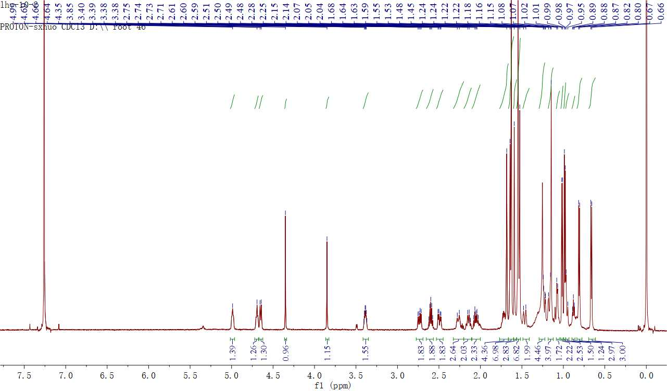

Figure S3. ¹H NMR spectrum of hyperforen A (2) (600 MHz, CDCl₃).

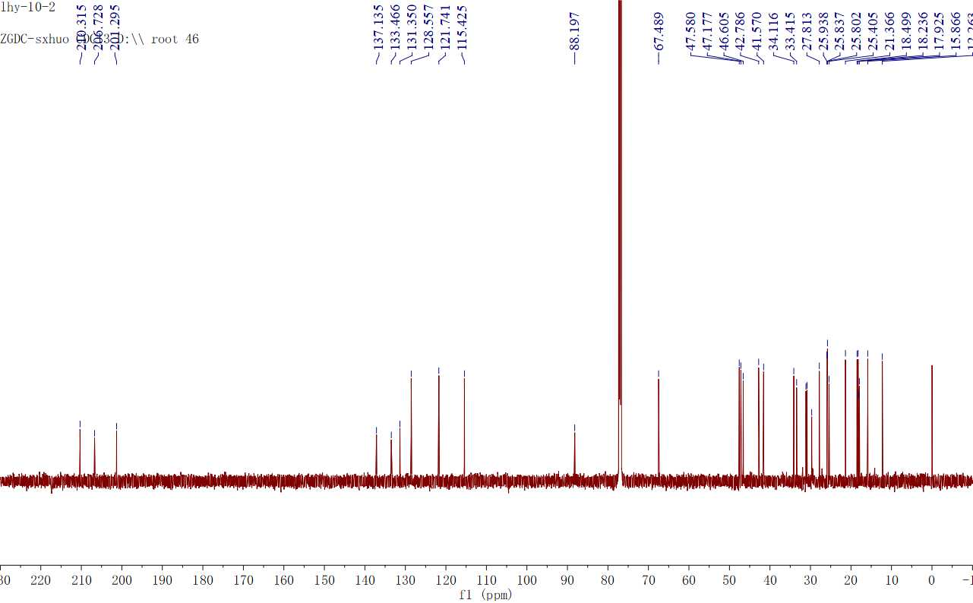

Figure S4. ¹³C NMR spectrum of hyperforen A (2) (150 MHz, CDCl₃).

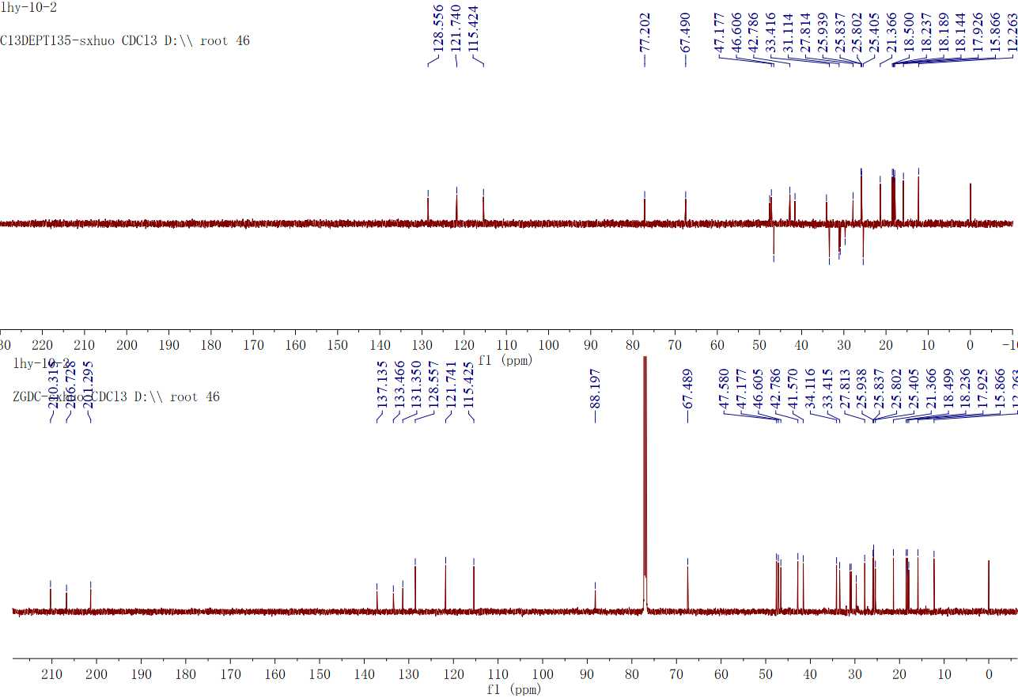

Figure S5. DEPT spectrum of hyperforen A (2) (150 MHz, CDCl₃).

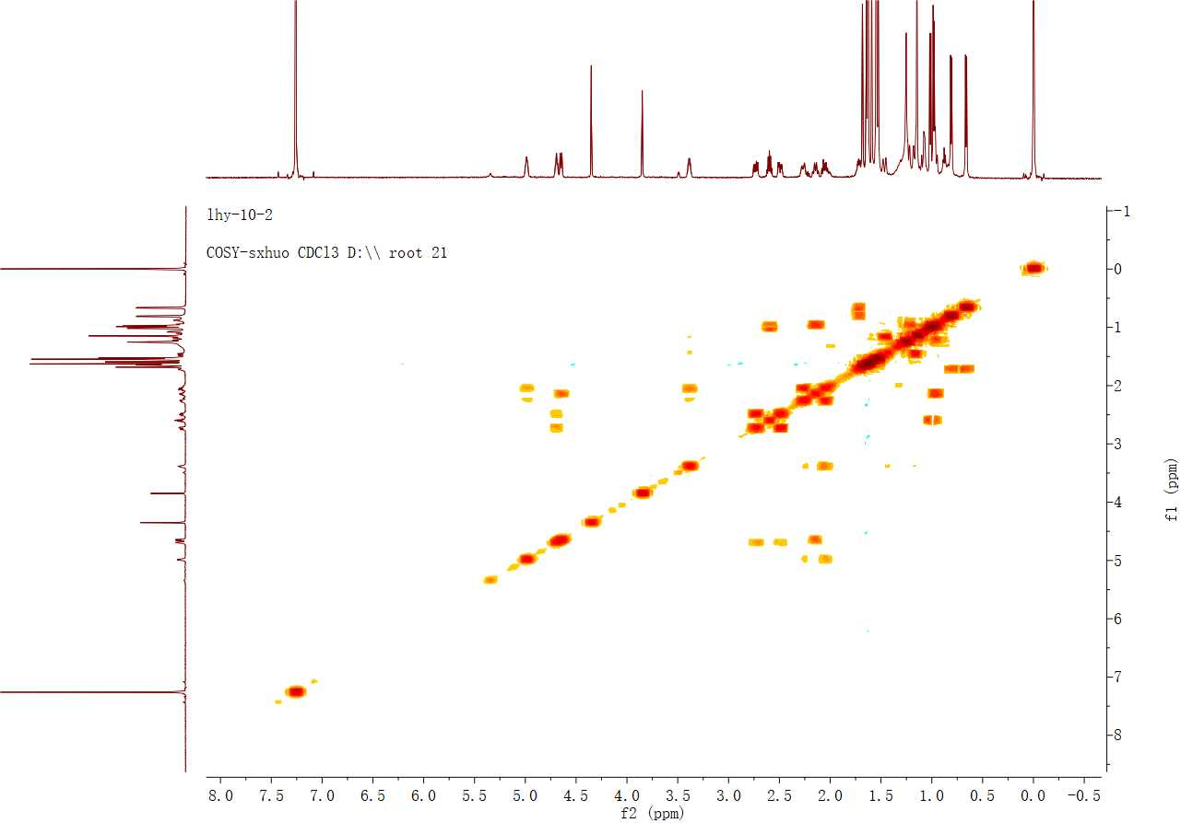

Figure S6. ¹H–¹H COSY spectrum of hyperforen A (2).

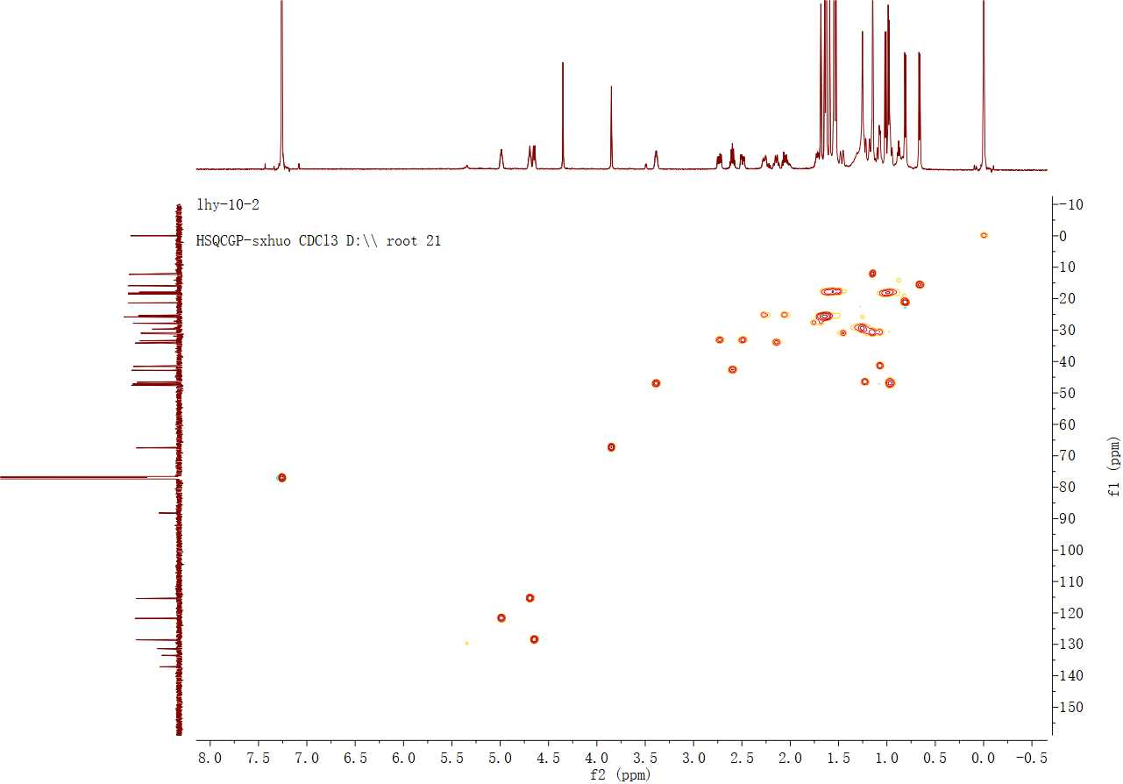

Figure S7. HMQC spectrum of hyperforen A (2).
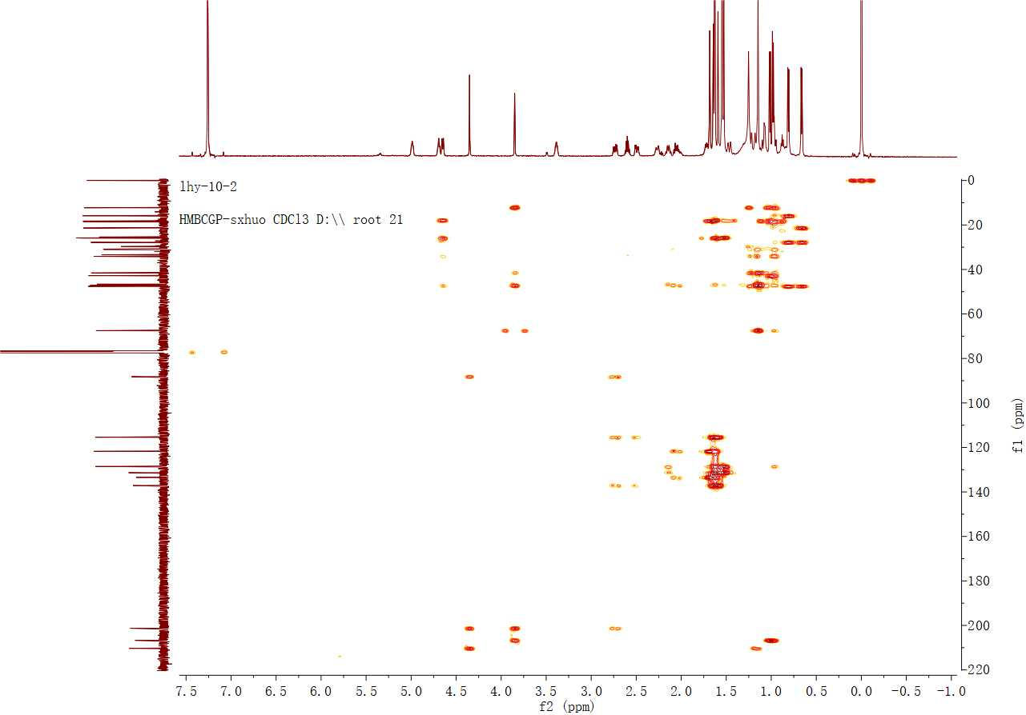

Figure S8. HMBC spectrum of hyperforen A (2).

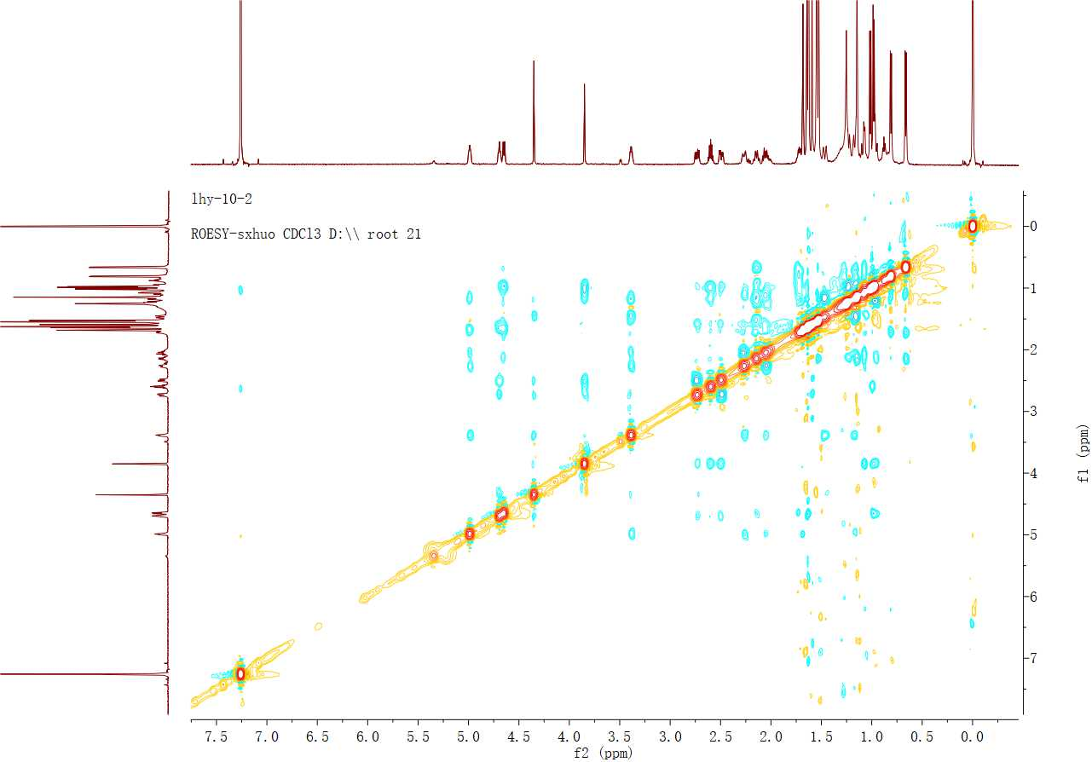

Figure S9. ROESY spectrum of hyperforen A (2).

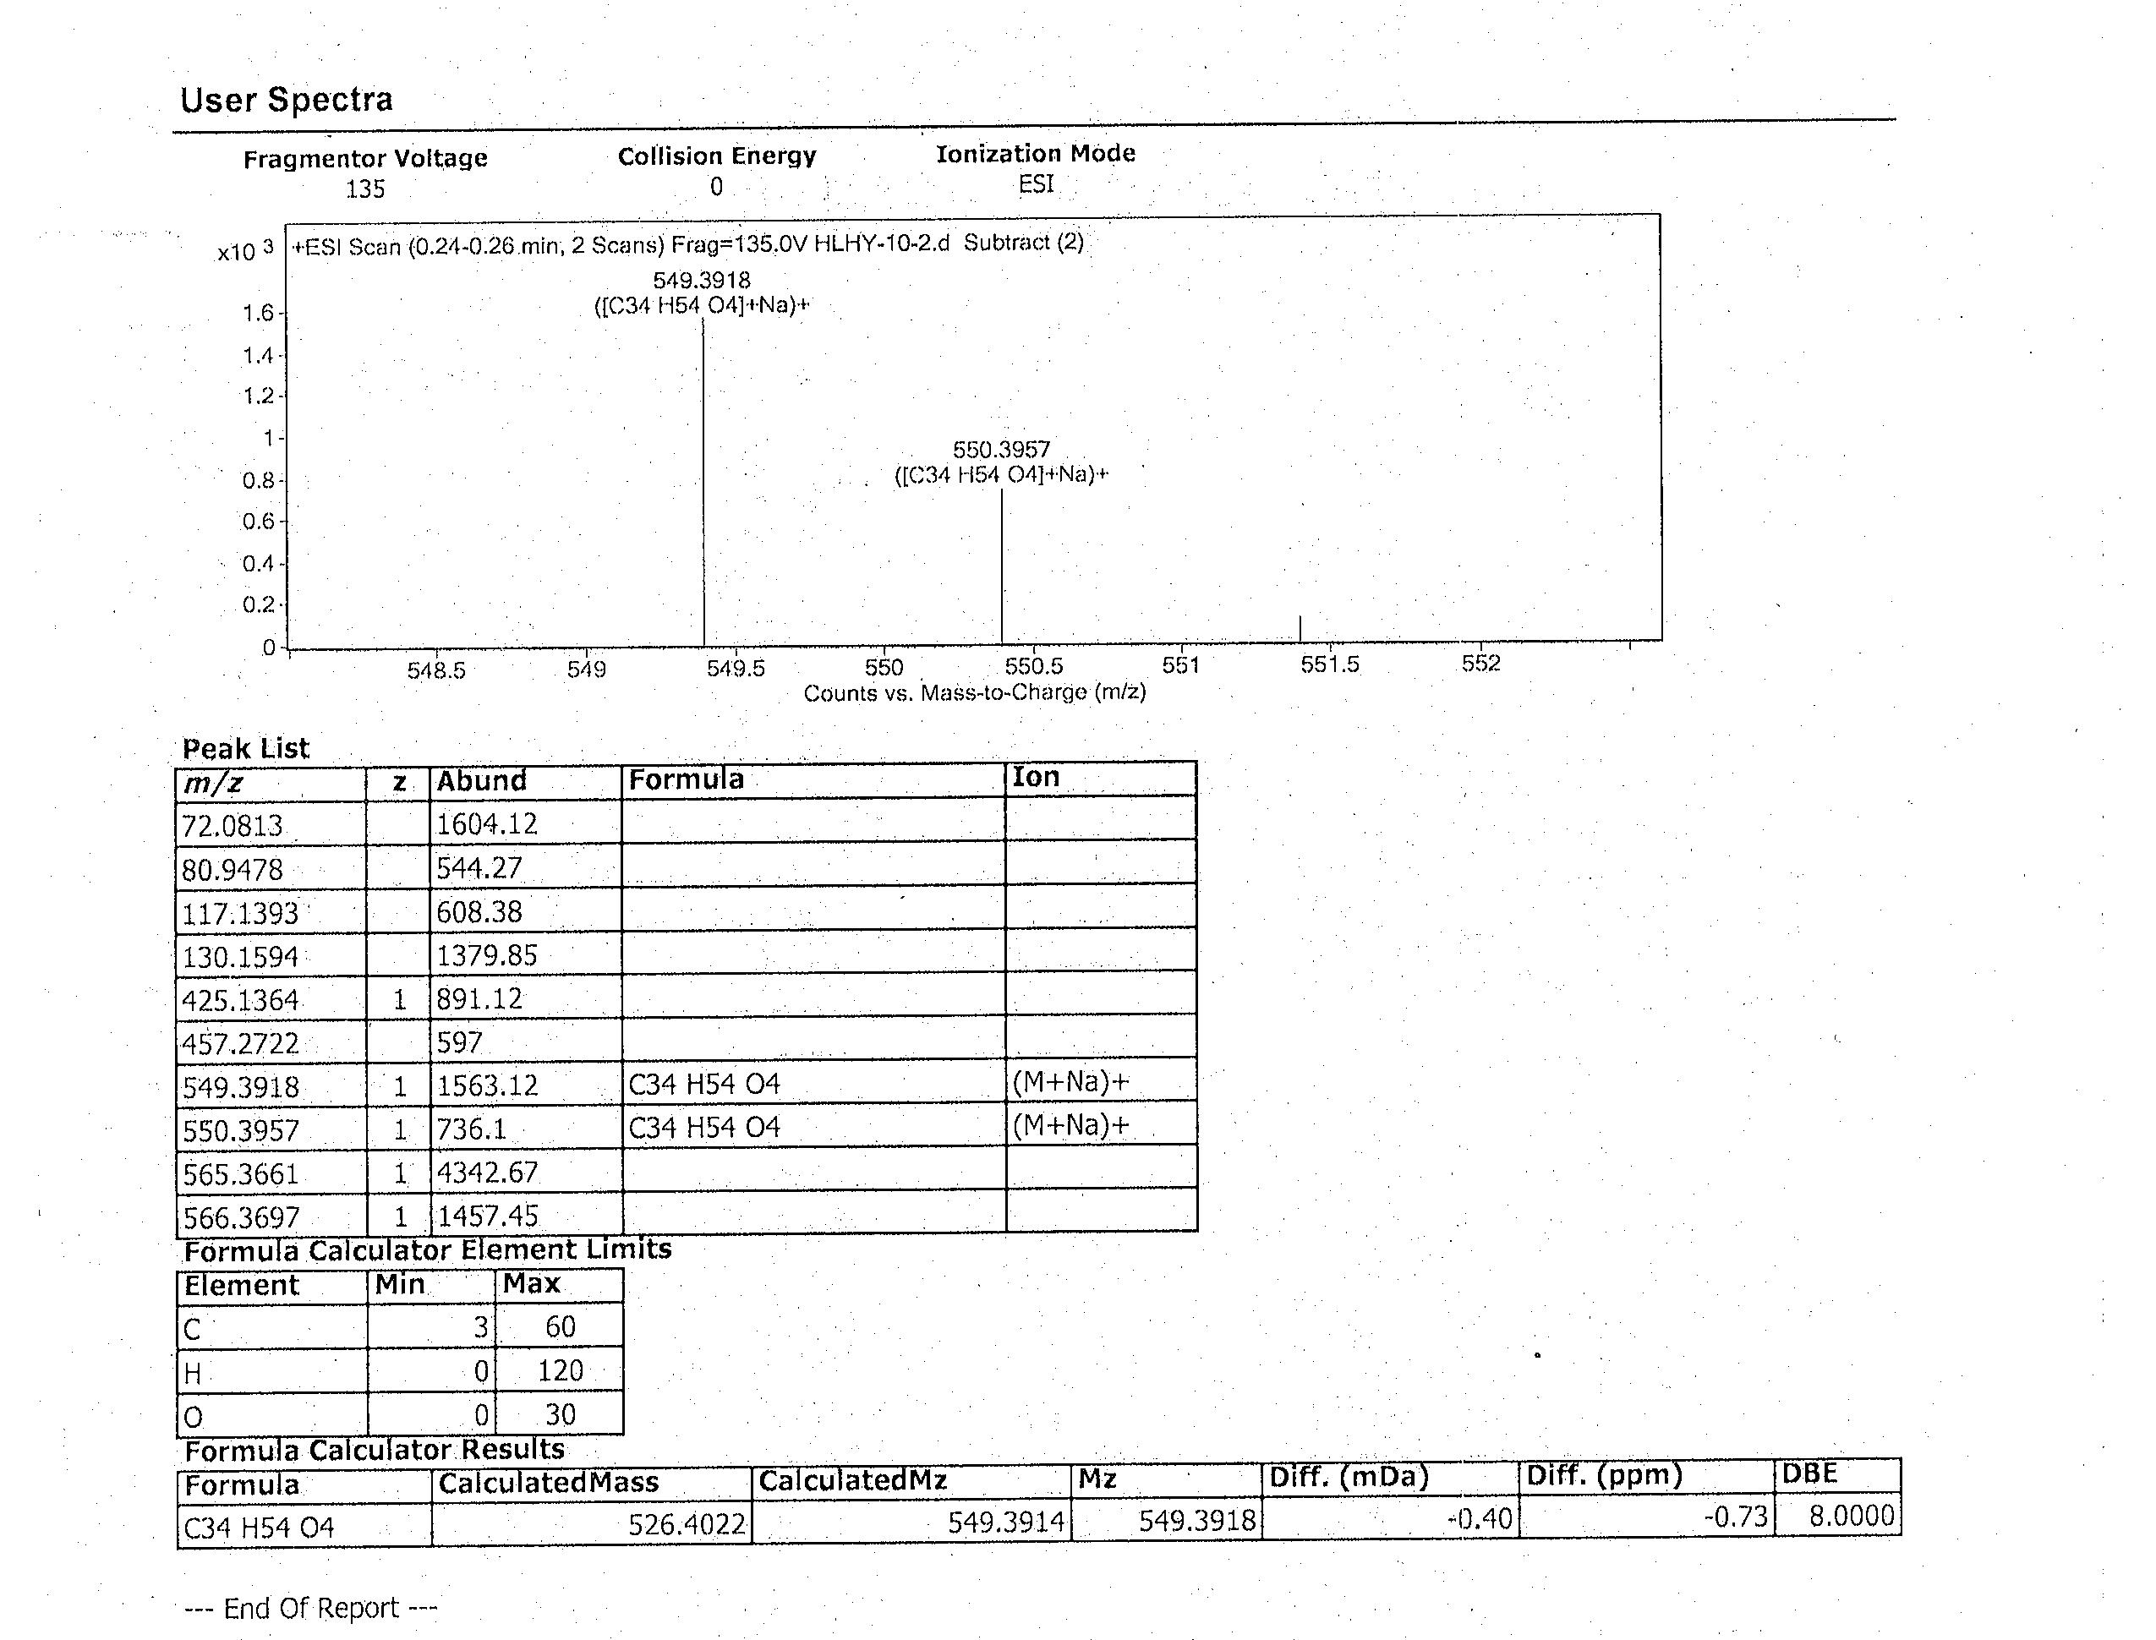

Figure S10. HR-ESI-MS spectrum of hyperforen A (2).

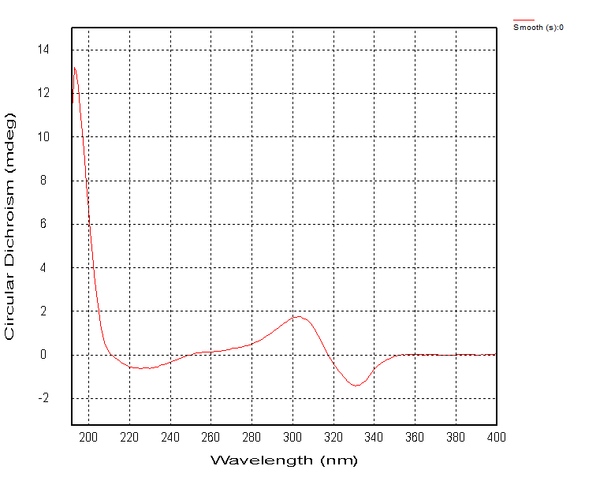

Figure S11. CD spectrum of hyperforen A (2).

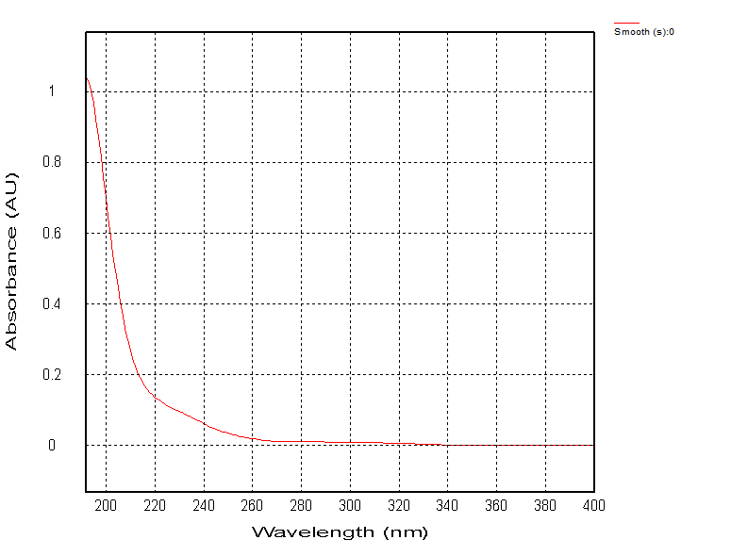

Figure S12. UV spectrum of hyperforen A (2).

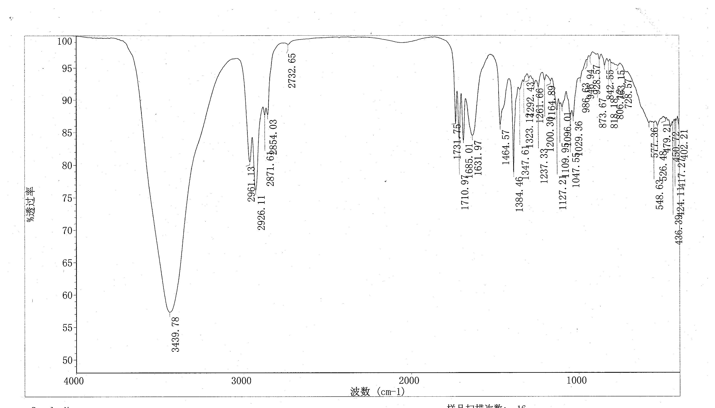

Figure S13. IR spectrum of hyperforen A (2).

