**Supporting Information**

**Ruthenium Tetroxide Oxidation of *N*-Methyl-Isoxazolidine: Computational Mechanistic Study.**

Maria Assunta Chiacchio,a Daniela Iannazzo,b Salvatore V. Giofrè,c Roberto Romeo,c and Laura Legnani*,d

a Dipartimento di Scienze del Farmaco e della Salute, Università di Catania, Viale A. Doria 6, 95125 Catania, Italy.

b Dipartimento di Ingegneria, Università di Messina, Contrada Di Dio, 98166 Messina, Italy.

c Dipartimento di Scienze chimiche, biologiche, farmaceutiche ed ambientali, Università di Messina, Viale Annunziata, 98168 Messina, Italy.

d Dipartimento di Biotecnologie e Bioscienze, Università di Milano-Bicocca, Piazza della Scienza 2, 20126 Milano, Italy. E-mail: laura.legnani@unimib.it



**Figure S1.** IRC analysis for the transition structure **TS1_*endo*.**

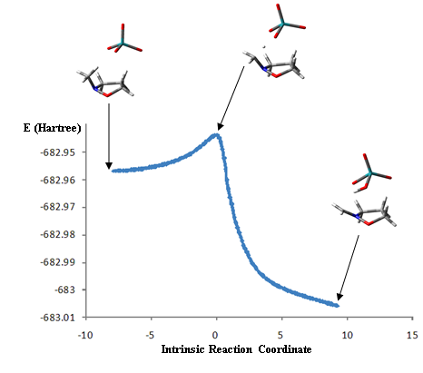

**Figure S2.** IRC analysis for transition structure **TS1_*exo***.

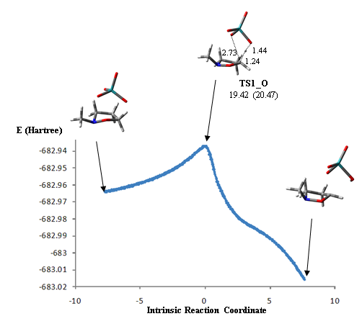

**Figure S3.** IRC analysis for transition structure **TS1_O**. For the transition state, the corresponding relative Gibbs energies (kcal/mol) in solvent and in *vacuo* (in parentheses), with respect to the isolated reacting species, are reported and the bond distances of the forming bonds(Å) are indicated on the 3D plot

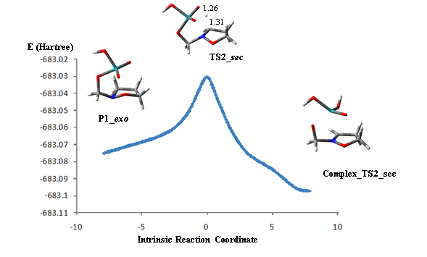

**Figure S4.** IRC analysis for transition structure **TS2_*sec***. For the transition state the bond distances (Å) are indicated on the 3D plot.

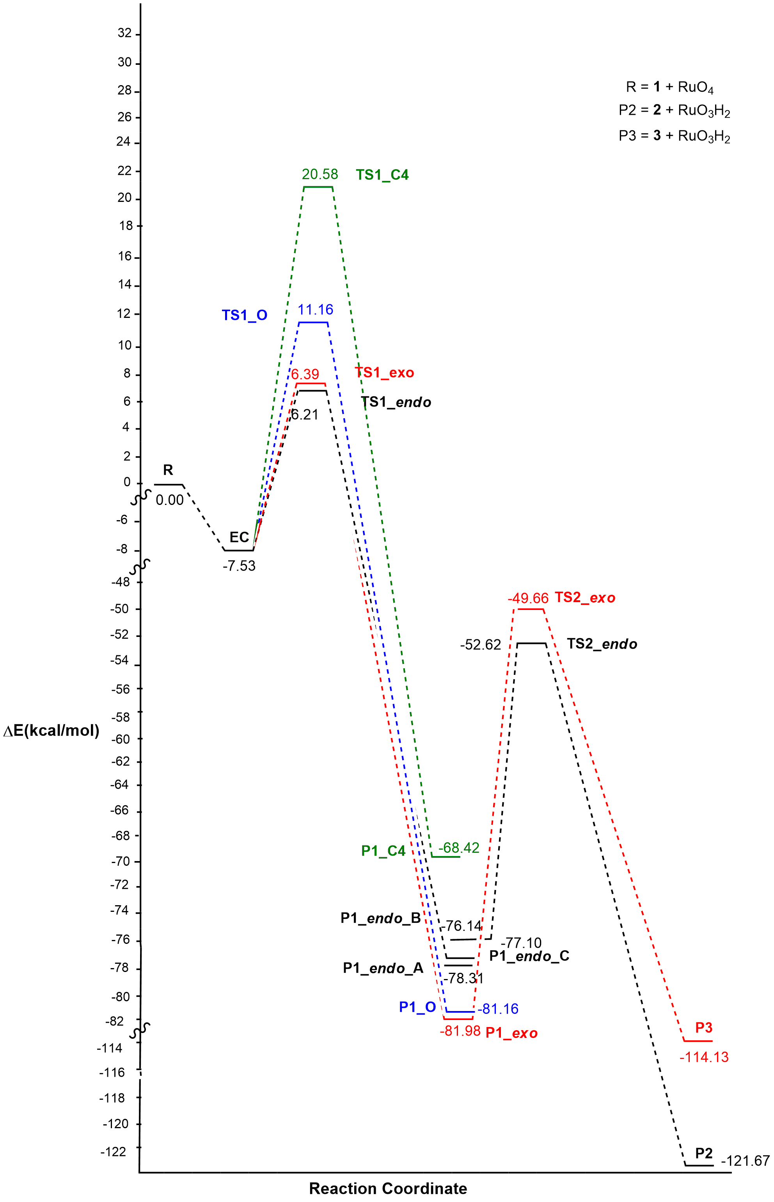

**A**

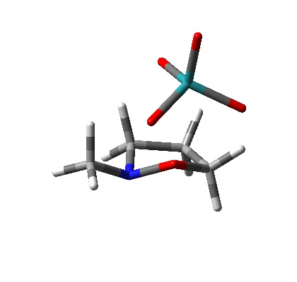

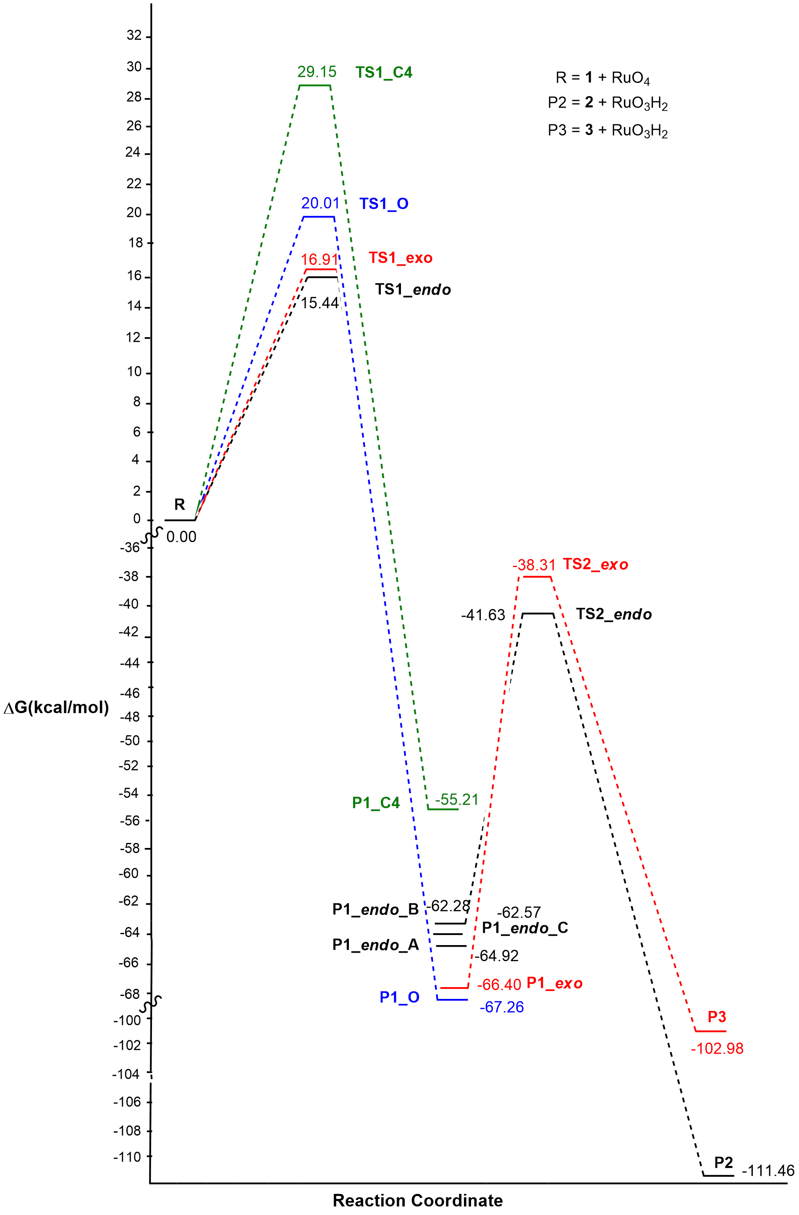

**B**

**Figure S5.** Energy (**A**) and free energy profiles (**B**) in *vacuo* for the reaction pathway of the oxidation reaction of 2-methylisoxazolidine with Ruthenium Tetroxide at m062x/6-31+G(d,p) level.

.

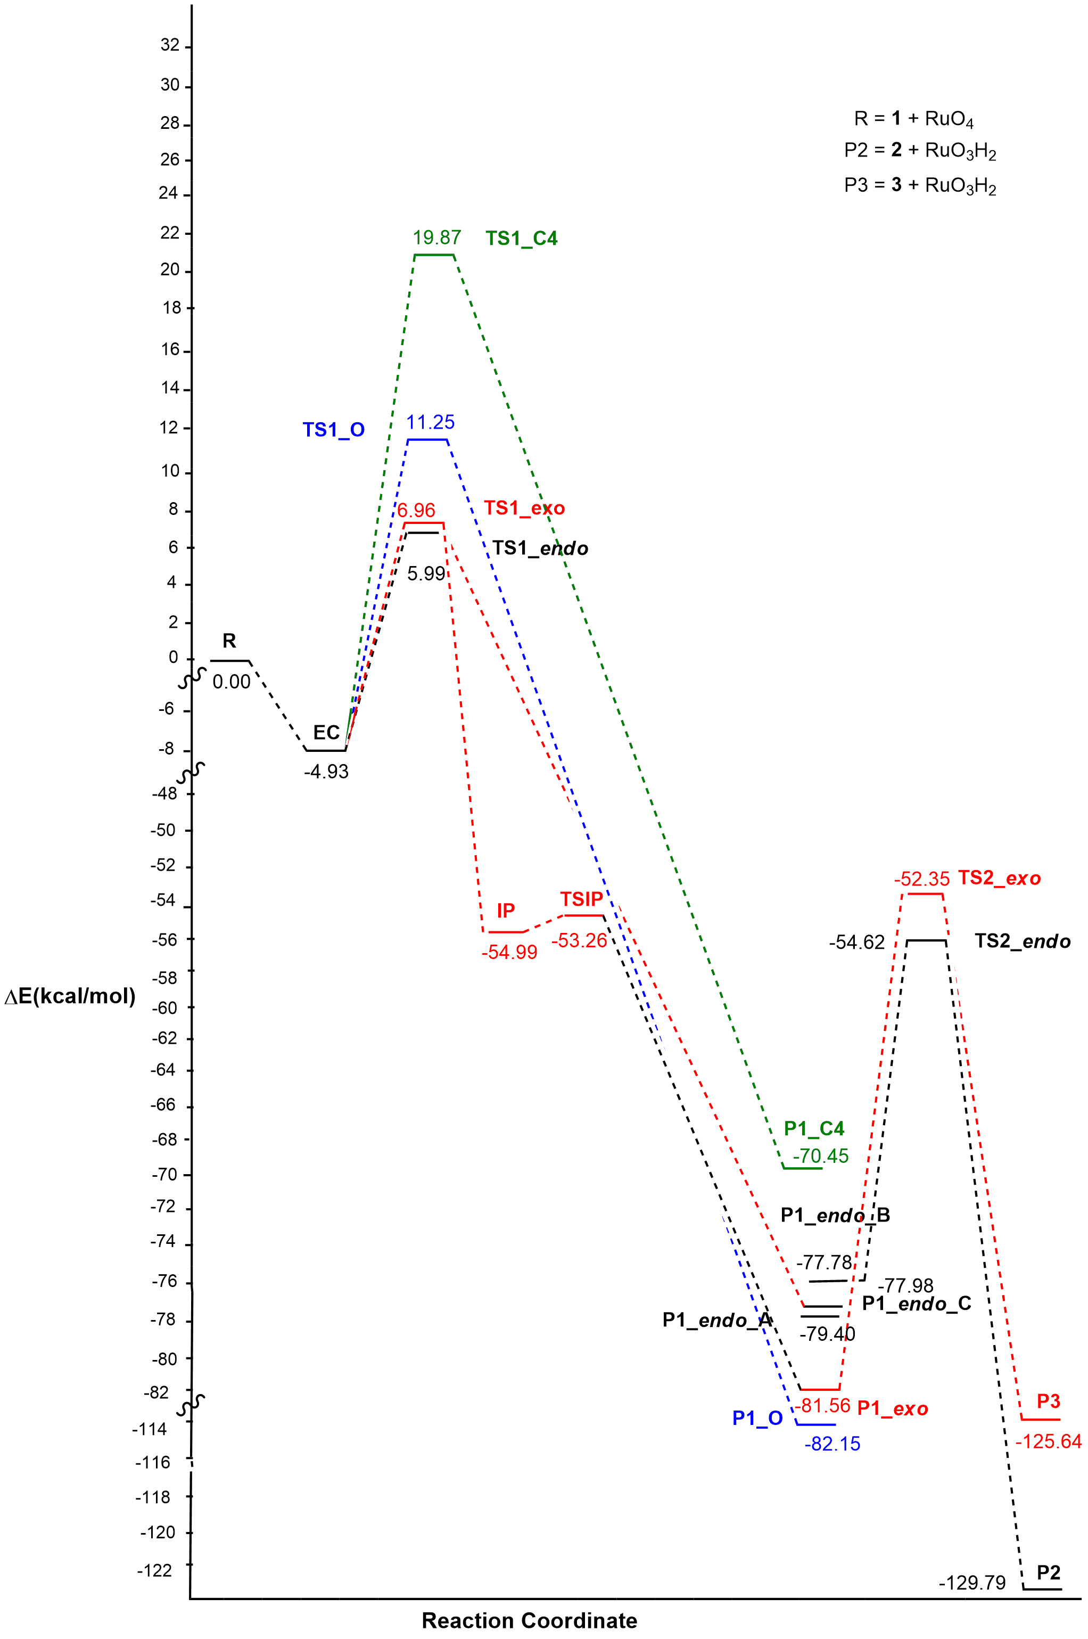

**A**

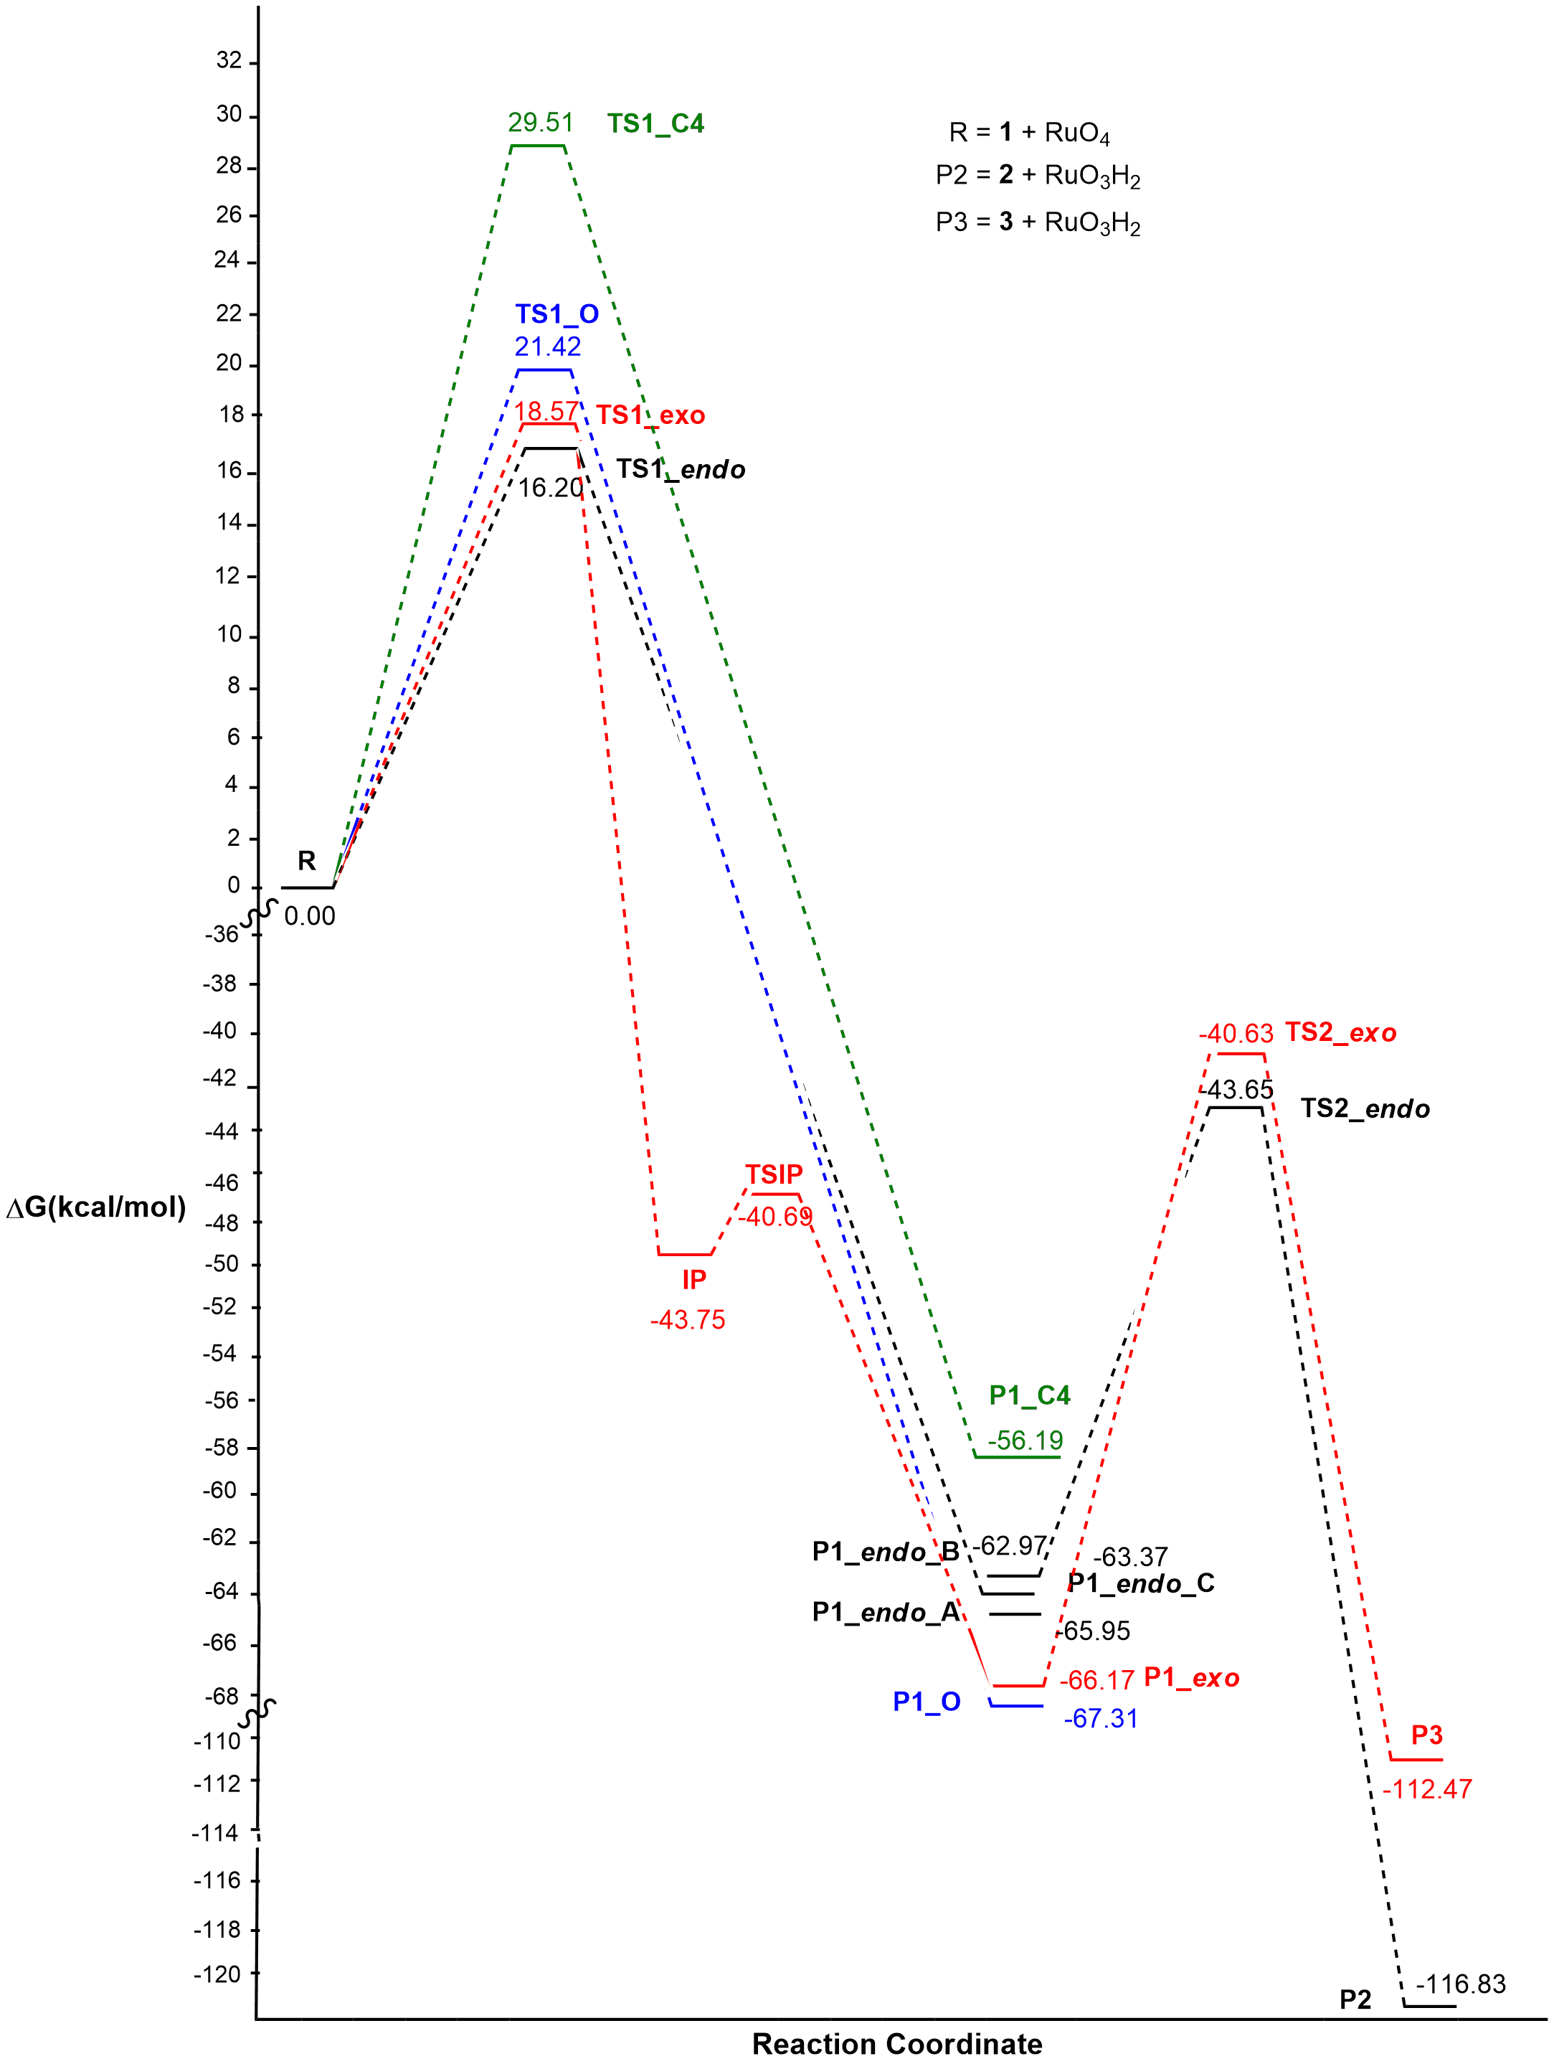

**B**

**Figure S6.** Energy (**A**) and free energy profiles (**B**) in methylpropanoate for the reaction pathway of the oxidation reaction of 2-methylisoxazolidine with Ruthenium Tetroxide at m062x/6-31+G(d,p) level.

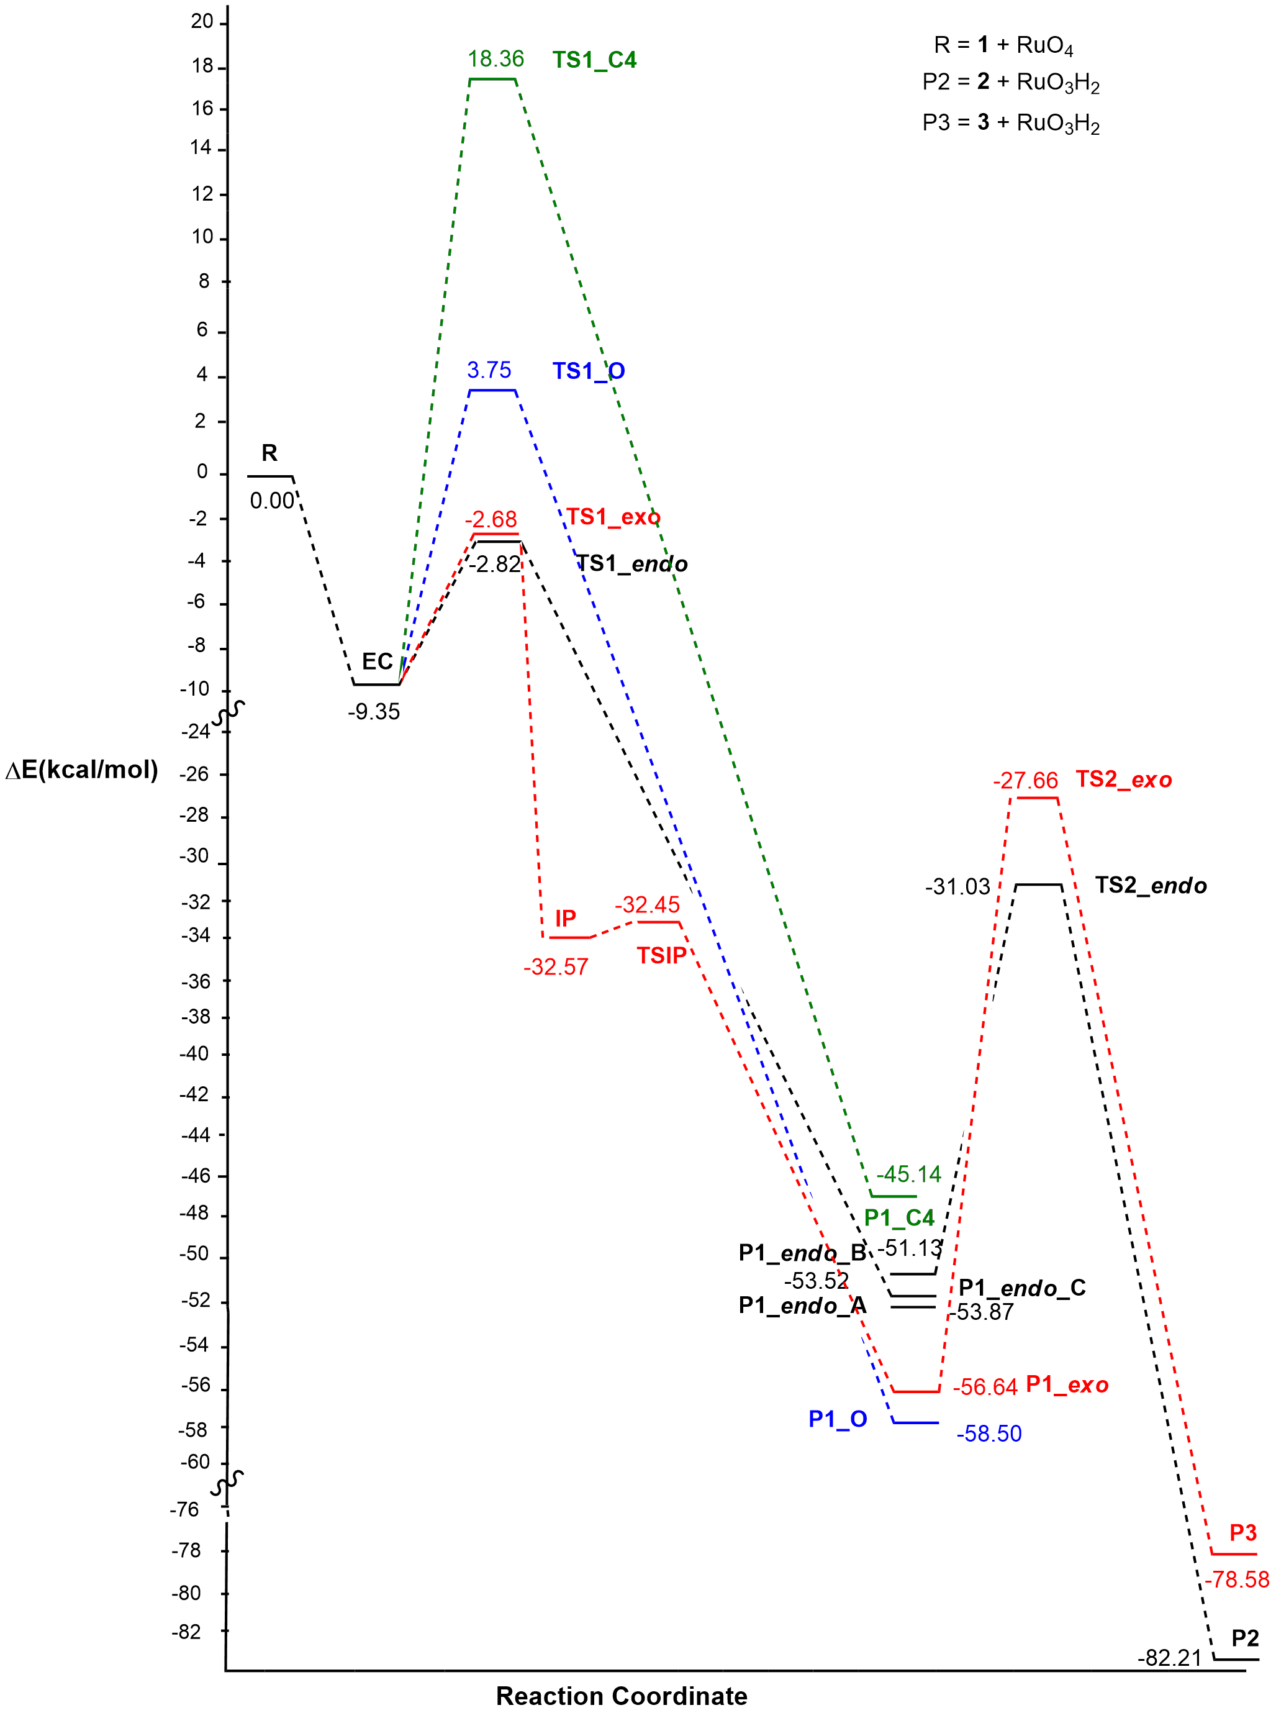.

**A**

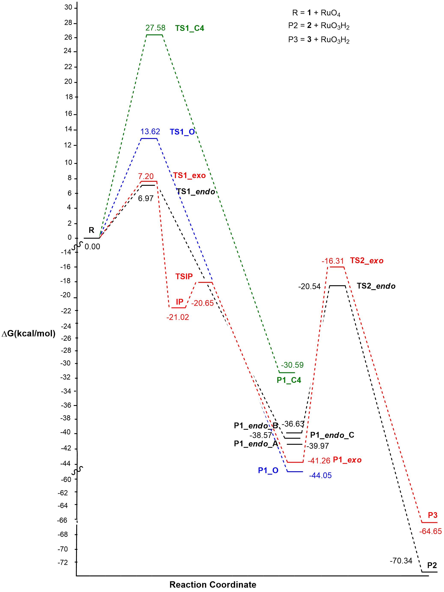

**B**

**Figure S7.** Energy (**A**) and free energy profiles (**B**) for the reaction pathway of the oxidation reaction of 2-methylisoxazolidine with Ruthenium Tetroxide at b3lyp/def2svp/emp=gd3bj/int=ultrafine/solvent =water level.