SUPPORTING INFORMATION

A novel fluorescent aptasensor based on mesoporous silica nanoparticles for the selective detection of sulfadiazine in edible tissue

Jiaming Tang†, Qiming Kou†, Xingyue Chen, Yarong Wang, Lulan Yang, Xu Wen, Xiaoling Zheng, Xueling Yan, Tao Le∗
College of Life Science, Chongqing Normal University, Chongqing 401331, P. R. China

Figures

Fig. S1. The fluorescence emission spectra of FAM-aptamer in the presence of various ssDNA/GO ratio.

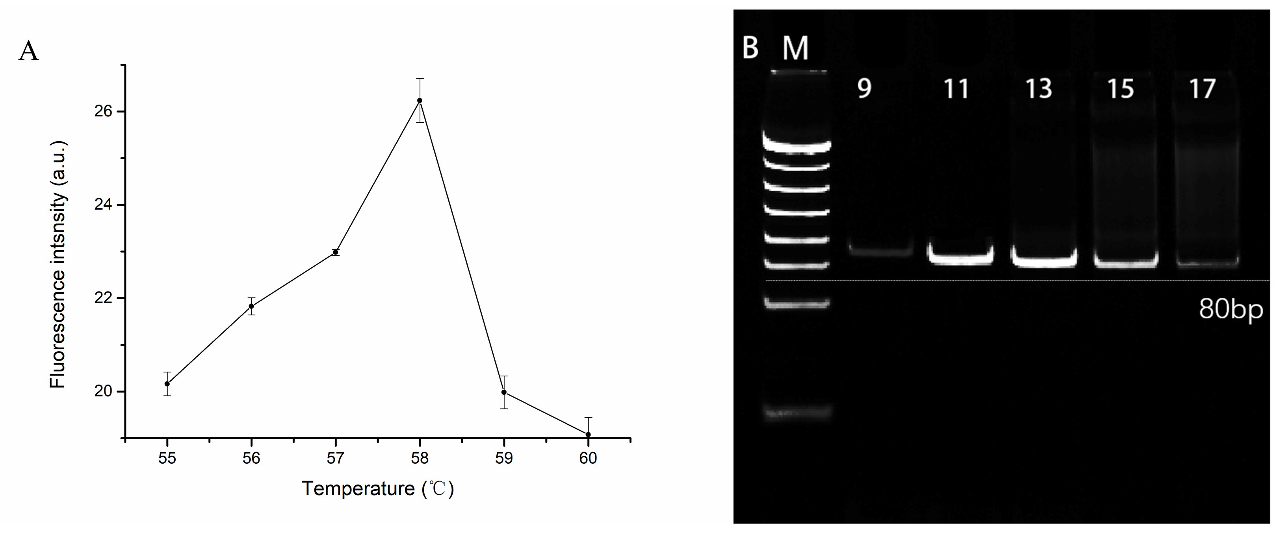
Fig. S2. Representative gel images showing PCR amplification at (A) different annealing temperatures and (B) different cycle numbers (Lane 1-6: 9, 11, 13, 15, 17 rounds)

Fig. S3. Recovery ratio of aptamers after each round of screening

Fig. S4. Verification of the specificity of SDZ15 (1 µM) to SDZ, (1) SDZ, (2) SN, (3) SMR, (4) SMZ, (5) Kanamycin, (6) Chloramphenicol, (7) Oxytetracycline, (8) Doxycycline. The concentration of SDZ and other antibiotics was 50 ng/mL.

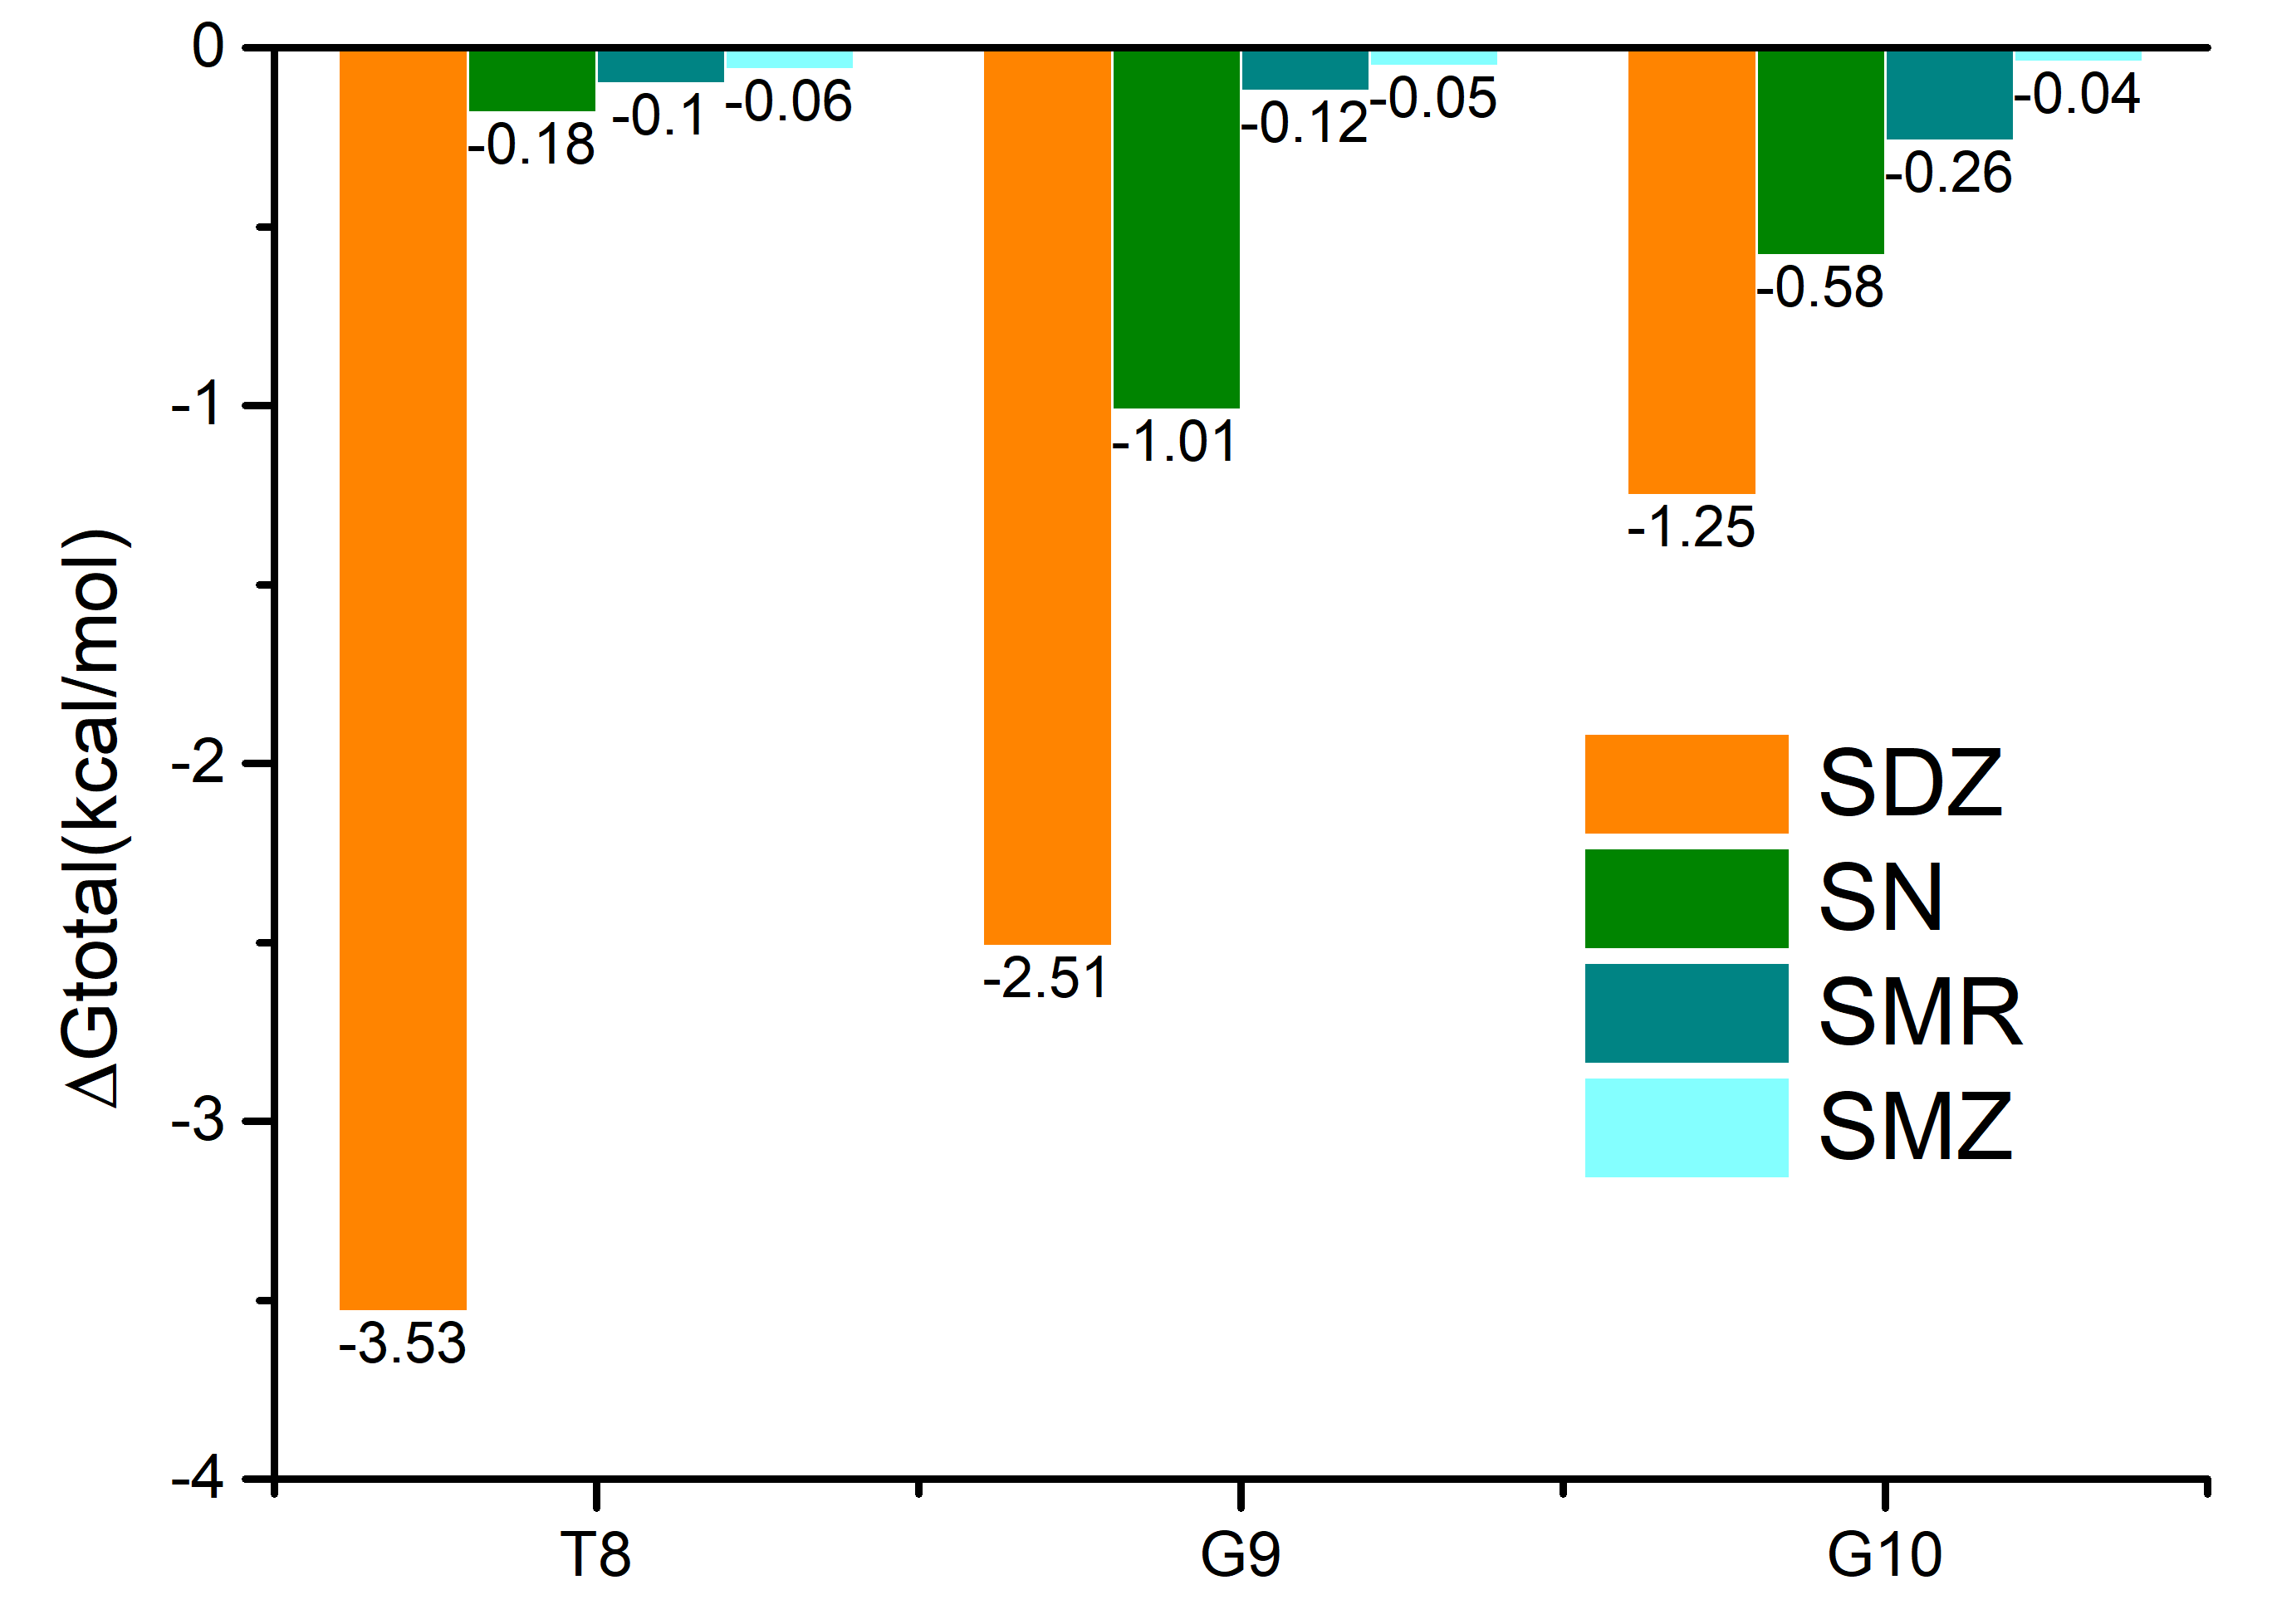
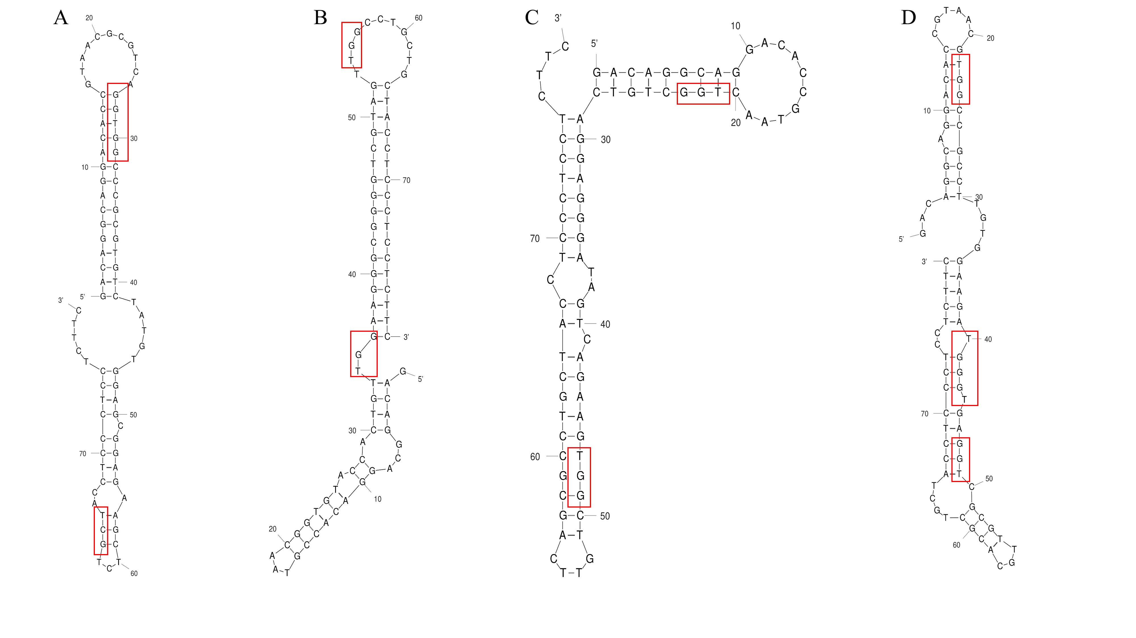
Fig. S5. Candidate aptamers (A) SDZ-1, (B) SDZ-15, (C) SDZ-22 and (D) SDZ-30 secondary structure.

Fig. S6. Free energy contribution of key bases to SDZ30-1/ligand.

Table:
Table. S1. 40 nt random regions of the candidate sequence and their classification.
Classification | 40 nt random sequences in the screened SDZamers | Number
Family Ⅰ | TGCCTGGCTTGGAATTGGGGGTGCGGTTGCAGTTGTTTTG | SDZ12
Family Ⅰ | GGCCTGGCACTGTTGGAAGGGCGGGGTCGTAGTTGGCCTG | SDZ15
Family Ⅰ | TGCCTGGGAGAGGGACAGGAGTAGCGGGTCGGCATGCATA | SDZ16
Family Ⅰ | GTCCTGGCTGGCAAGTAGGGGGGGGTAGGAACAGCTCCGA | SDZ17
Family Ⅰ | TGCCTGTGATAGAGGTTCGGGGGGCACAGGGCATGCTGGT | SDZ19
Family Ⅰ | TGCGTGCCGGAGGGGAGGGGGAAGGAGATGTGCTTAACGG | SDZ20
Famliy Ⅱ | TGTCCTGTCGTGGAGGGTGGAGTCAGGCGTCAACCACGTC | SDZ9
Famliy Ⅱ | TGCCTGGGCGGAAGAGGAGTTTGTGGAGGTGGTCTGCGCT | SDZ10
Famliy Ⅱ | TGCCTGGCTGCCAGAGGACCGGGCTGAGGTAGCTGATAGT | SDZ11
Famliy Ⅱ | TGGCCTGGCTGTCGGGGATGAGAGAGGAGGTGCAGTGAT | SDZ13
Famliy Ⅱ | TGGCCTGGCAGGAGGGATAGTCAGAGGTGGCTGTTCAGCGC | SDZ22
Family Ⅲ | CTGGCTGTCCGAAGAGCAGGGGGTGGCATGTTCTTGGCA | SDZ23
Family Ⅲ | GTGGCGTGCCGGGAGAAGGGGAGGTGGCACATCGTTAGCT | SDZ24
Family Ⅲ | GTGGCCGCCTTGTGGAAGATGGGTGAGGTCGCGTTGCACG | SDZ25
Family Ⅲ | TTGGTTGGCTCTGCCTGTTGCAGAGGTGGGGAATTGCGTA | SDZ26
Family Ⅲ | ATGGTCAGGTGACGGGCTGTCAGTGGAGTGGTGTGTGCGA | SDZ27
Family Ⅳ | GGTTCAGGTGGCCCGCGTGTCTATGTGGAGCGGAGAAGCT | SDZ1
Family Ⅳ | GGTTGGCCTGACGGTTTCGGAGAGGTGGGGGCTGTGTTCA | SDZ2
Family Ⅳ | GGTTAGTACGGTGCCACTGGCGTGGCGGAAAGGTGAGGTG | SDZ6
Family Ⅳ | GAAGGTGGACCGGCCTGGCTGATGGGTGGGTTTGTAGCA | SDZ28
Family Ⅴ | AACGGTTGTCTCCTGTCCAGGGGTGGAGGTTGCCGAGGTG | SDZ3
Family Ⅴ | ACTGGGTGTACGGCGAACTGTCGTGGAGGGTGTAGGGTCT | SDZ4
Family Ⅴ | ACGACGTGTCACTGCTGTCGAGGATGGGATTAGCGCATCG | SDZ5
Family Ⅴ | CAACGGTGAAGGTGCGTGCCTCTCTGGGGAGTGAAGGTAG | SDZ7
Family Ⅴ | CGATGGCGTCGGGTGGTGGCCGGCTGGGTGAGGAGGTGGG | SDZ8
Family Ⅴ | CGACGGTAGGTGTACGGCGTGGCGTGGGGAGGGCTTAGCG | SDZ14
Family Ⅴ | TGCAGAGGGACGGGTGTGTGCCGTGGAAGAAGGGGAGGTC | SDZ18
Family Ⅴ | TGTGGGGTCCGGCCGGTCGTTTTCCGAGGCGGGAGTGGTC | SDZ21
Family Ⅴ | CAACGGGGTAACCTGCCGTGTTGGCGTAGGGAGTCTGCGT | SDZ29
Family Ⅴ | CCAATGGGATGGAGGGTGGAGTCTGGCGTCAACCACGTC | SDZ30

3. Sample pretreatment
Honey was bought from local supermarkets. 2 g of honey was dissolved in 10ml of distilled water, then 1 mL of acetonitrile was added as a dispersant, then 40 uL of chloroform was added and vortexed for 1min on a vortex shaker to make it fully mixed to form a homogeneous emulsion, and then add 4000 rpm for 2 min and retain the supernatant. The supernatant was filtered through a 0.22 μm filter, and the filtrate was stored for later use.

Milk was bought from local supermarkets .Mix 10 mL of milk and 20 mL of acetonitrile evenly, then centrifuge at 8 000 rpm for 5 min, take the supernatant into a 100 mL conical flask, add 20 mL of acetonitrile to the precipitate, repeat the extraction once, and combine the two extracts. The conical flask was placed at 45°C and rotary evaporated until the extract was completely evaporated, then the conical flask was washed with 0.10.1 mol/L hydrochloric acid solution and n-hexane in turn, and the washing solution was transferred to a centrifuge tube, and vortexed. Mix for 30 s, centrifuge at 8 000 r/min for 5 min, discard the n-hexane layer and remove the lower layer. The extract was then filtered with a 0.22 micron filter, and the filtrate was stored for later use.

Corresponding author. Tel.: +86 23 65910119; Fax: +86 23 65910119; E-mail address: letao@cqnu.edu.cn † These authors contributed equally to the work

