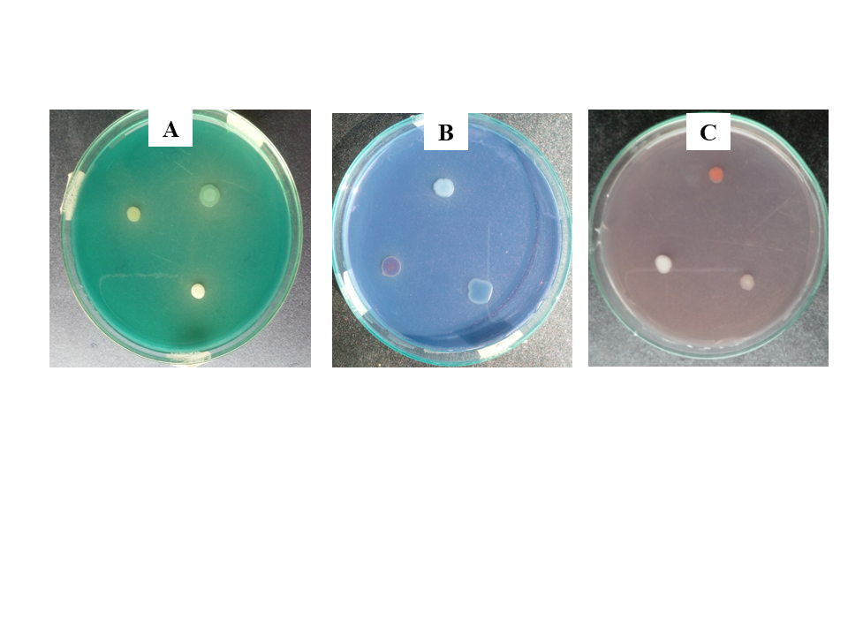

**Supplementary Figure 1**: Dye degradation on LB agar media, A-showing methylene green, B- showing acid blue & C- showing basic violet.

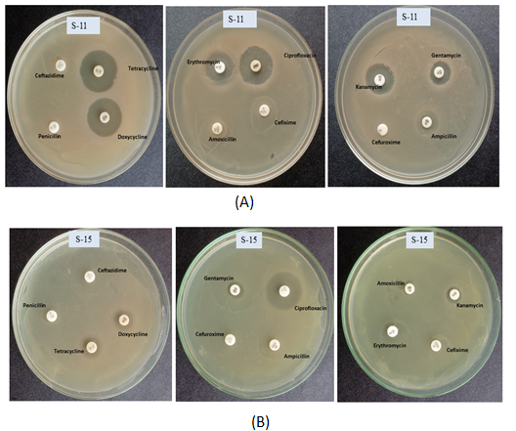

**Supplementary Figure 2:** Antibiotic sensitivity test results of Isolate S-11 and isolate S-15: (A) showing *Bacillus psudomycoides* and (B) showing *Acinetobacter haemolyticus*.

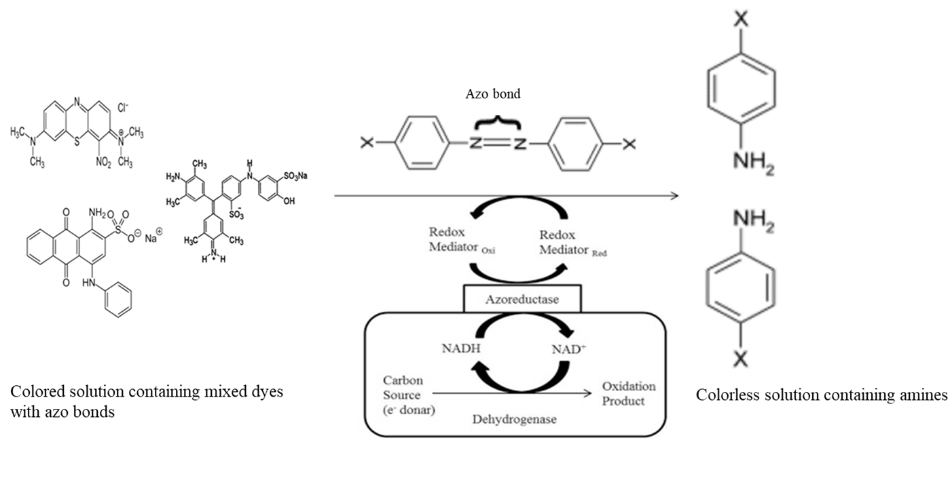

**Supplementary Figure 3**: A schematic diagram of proposed mechanism of bacterial degradation of mixed dyes (ASdapted and modified from Pearce et. al. 2003, Singh et. al. 2015 and Azaj et. al 2020)

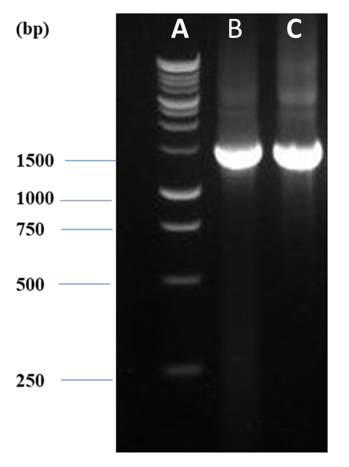

**Supplementary Figure 4:** Gel electropherogram showing a band of approximately of 1.5 kb length of the amplified PCR product of 16s rRNA gene of *Bacillus psudomycoides* & *Acinetobacter haemolyticus*, [A denotes DNA ladder (marker). B denotes *Bacillus psudomycoides* and C denotes Isolate *Acinetobacter haemolyticus*].

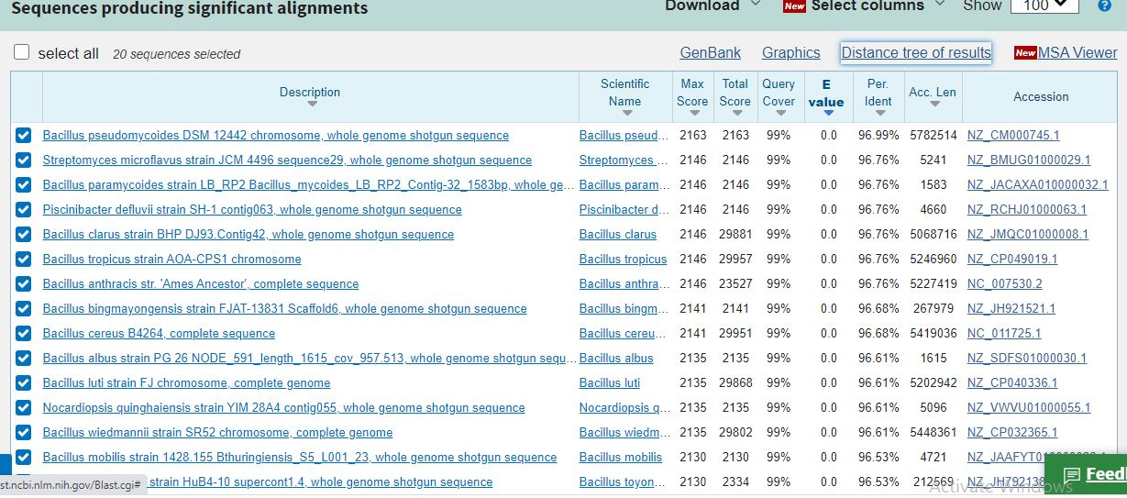

**Supplementary Figure 5:** *Bacillus psudomycoides* produced significant 96.99% identity with the 16S rDNA gene sequencing of the isolate S-11.

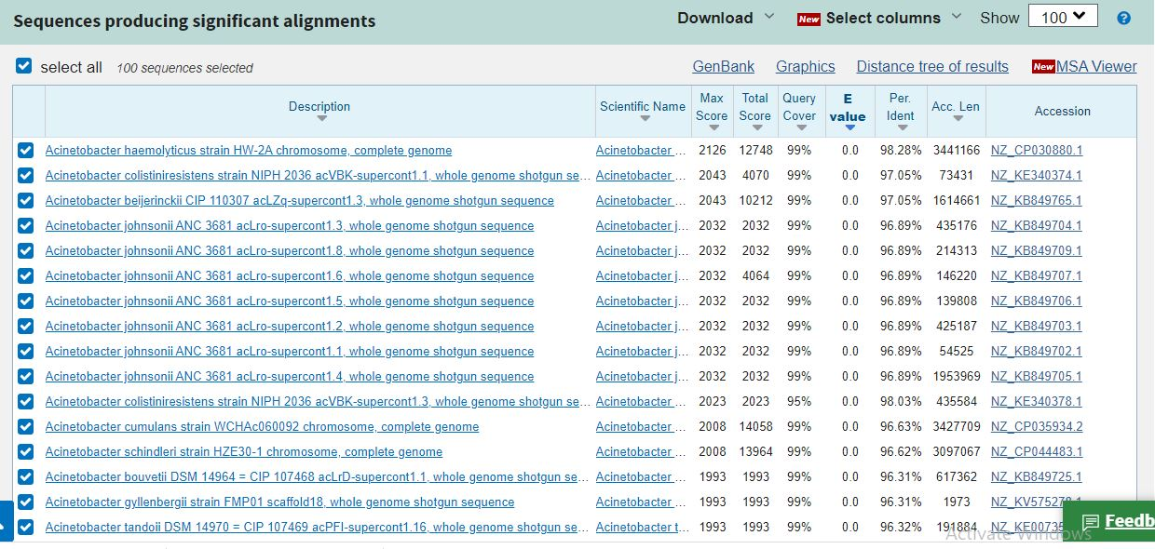

**Supplementary Figure 6:** *Acinetobacter haemolyticus* produced significant 98.28% identity with the 16S rDNA gene sequencing of the isolate S-15.

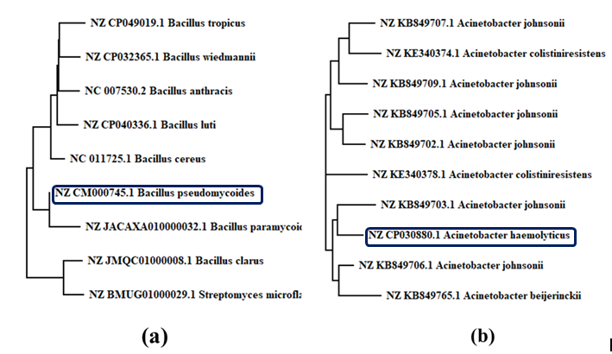

**Supplementary Figure 7:** By using fast minimum evolution method phylogenetic trees showing relationships between isolate (A) *Bacillus psudomycoides* and (B) *Acinetobacter haemolyticus* with several other strains based on their 16s rRNA gene sequences.

References:

Ajaz, M., Shakeel, S. and Rehman, A., 2020. Microbial use for azo dye degradation—a strategy for dye bioremediation. *International Microbiology*, *23*(2), pp.149-159.

Pearce, C.I., Lloyd, J.R. and Guthrie, J.T., 2003. The removal of colour from textile wastewater using whole bacterial cells: a review. *Dyes and pigments*, *58*(3), pp.179-196.

Singh, R.L., Singh, P.K. and Singh, R.P., 2015. Enzymatic decolorization and degradation of azo dyes–A review. International Biodeterioration & Biodegradation, 104, pp.21-31.