-*Supporting Information*-

**Dual recognition strategy for ultra-sensitive fluorescent detection of Hg2+ at femto-molar level based on aptamer functionalized sulfur quantum dots**

Xiaobin Wang1, Wei Guo*,2, Xiaoling Wang1, Qing Hua1, Feiyan Tang1, Xin Li1, Feng Luan1, Zhiyang Zhang3, Chunyuan Tian1, Xuming Zhuang*,1, Lijun Zhao*,1

1 College of Chemistry and Chemical Engineering, Yantai University, Yantai 264005, China.

2 Shandong Dyne Marine Biopharmaceutical Co., Ltd, Weihai 264300, China.

3 Shandong Key Laboratory of Coastal Environmental Processes, Yantai Institute of Coastal Zone Research, Chinese Academy of Sciences, Yantai, 264003, China.

*Corresponding author.

E-mail address: guodawei0298@163.com (W. Guo); xmzhuang@iccas.ac.cn (X. Z.); zhaoljytu@ytu.edu.cn (L. Z.)

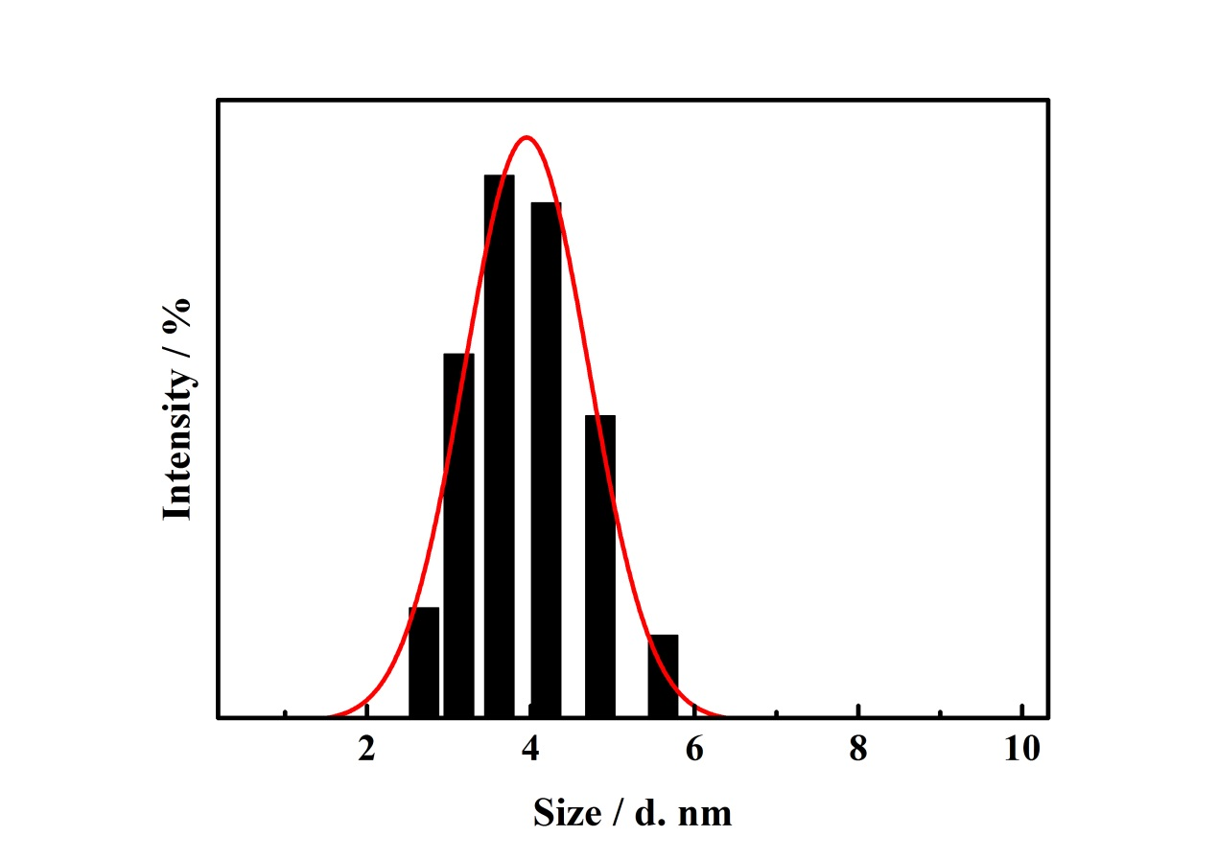

**Fig. S1.** The DLS spectra of SQDs.

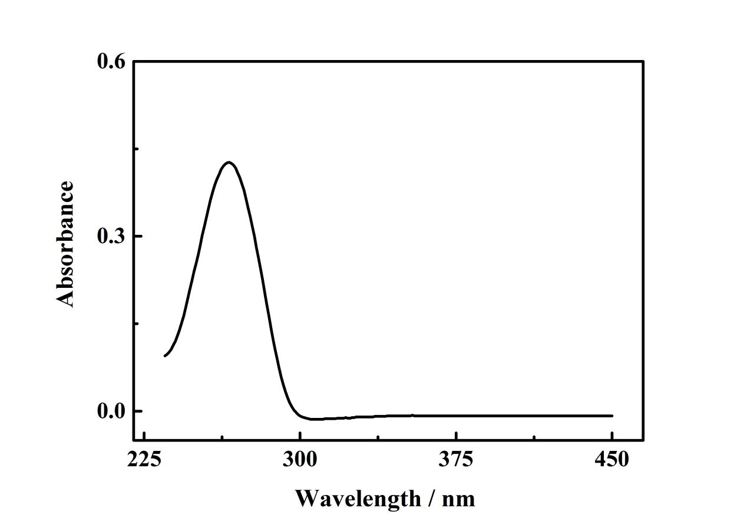

**Fig. S2.** UV-vis absorption spectra of aptamer.

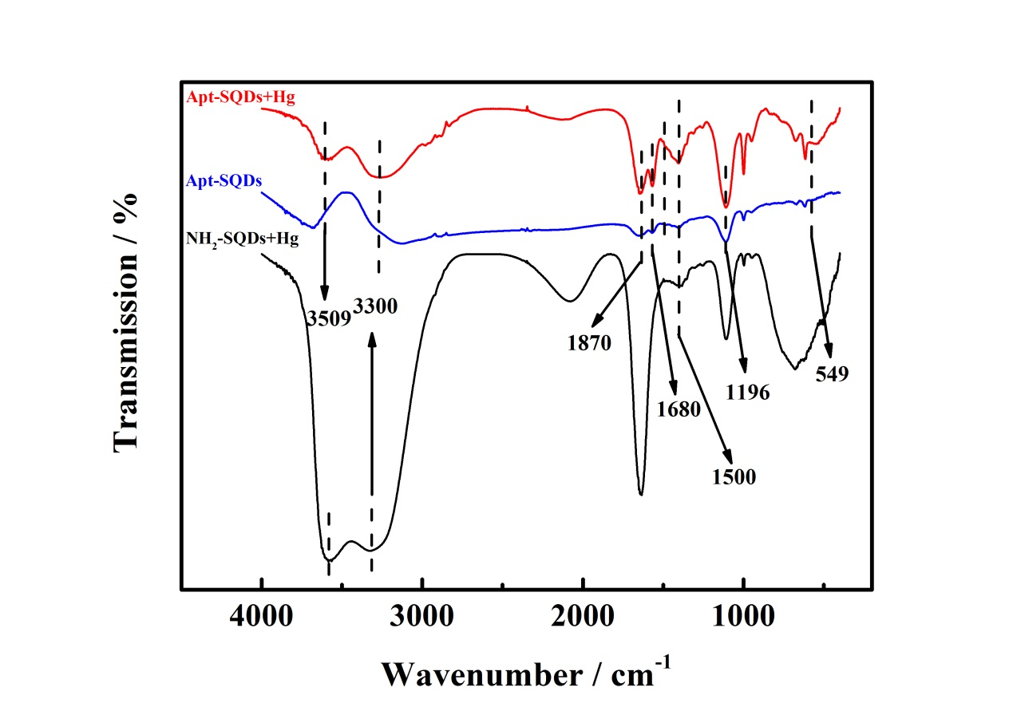

**Fig. S3.** FT-IR spectra of the Apt-SQDs (blue curve), NH2-SQDs after adding into Hg2+ (black curve) and Apt-SQDs after adding into Hg2+ (red curve).

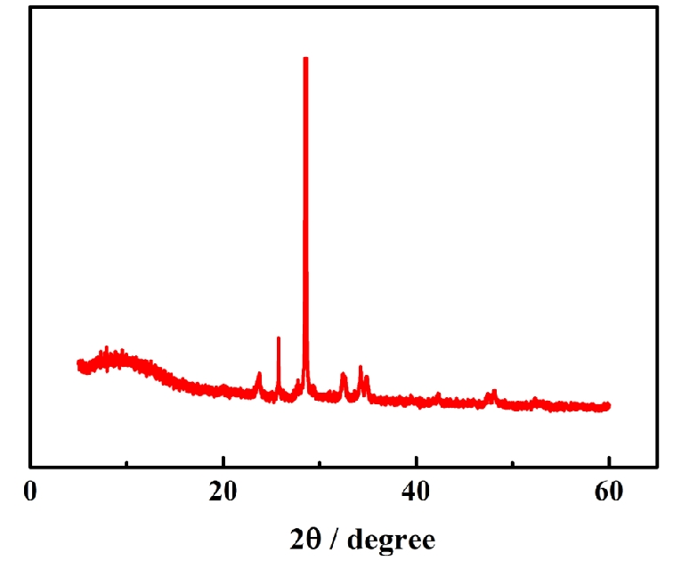

**Fig. S4.** XRD spectra of SQDs.

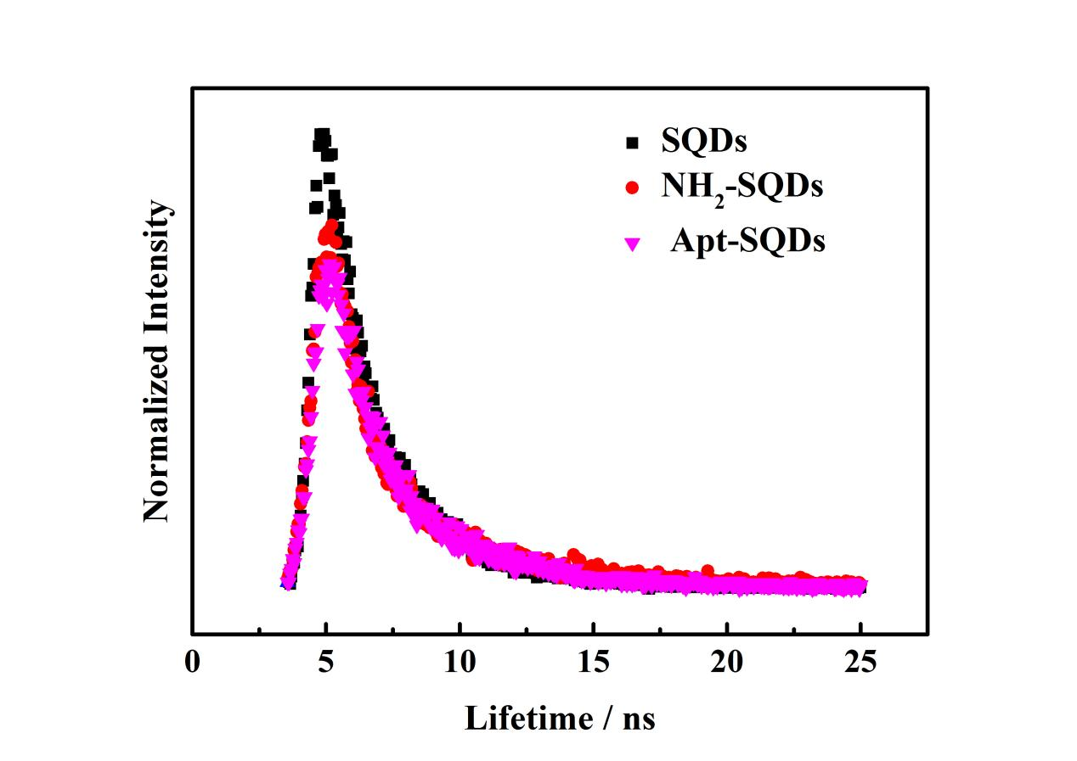

**Fig. S5.** The lifetime spectra of SQDs, NH2-SQDs and Apt-SQDs.

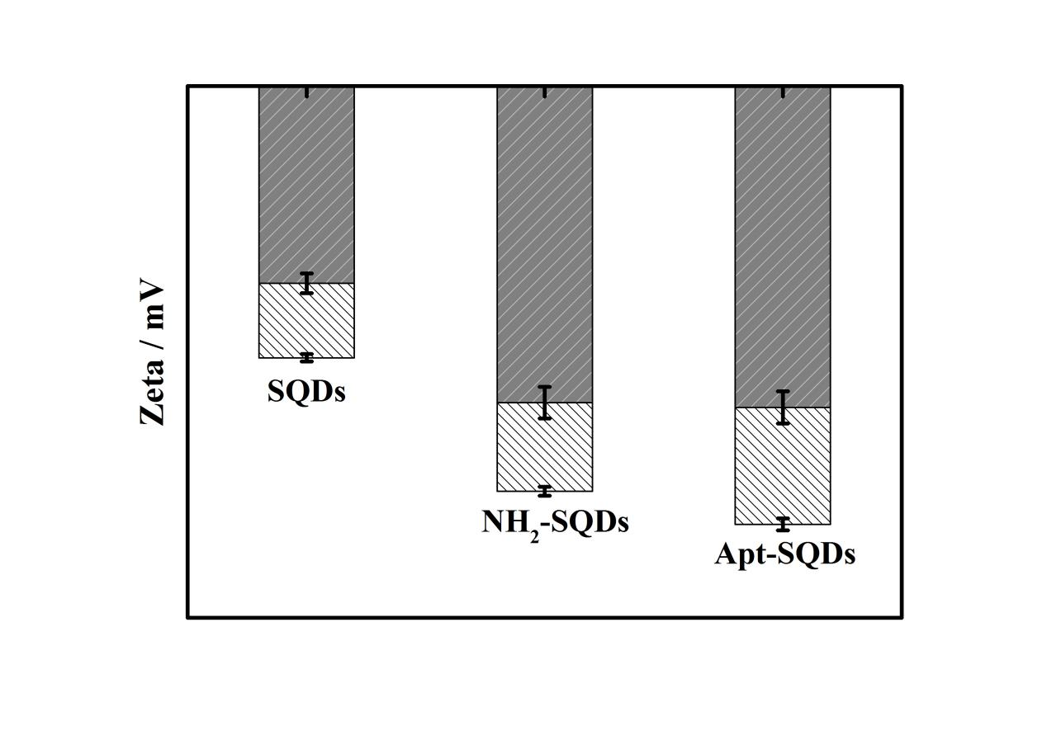

**Fig. S6.** Zeta potential of SQDs, NH2-SQDs and Apt-SQDs without Hg2+ (white column) and zeta potential of SQDs, NH2-SQDs and Apt-SQDs with Hg2+ (gray column).

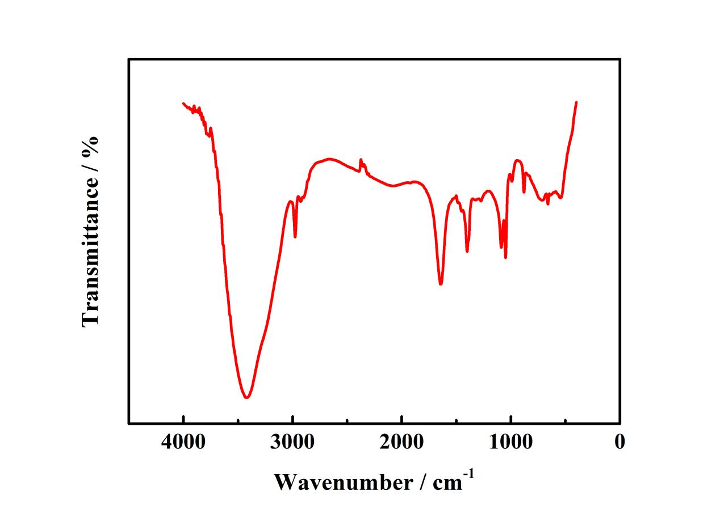**Fig. S7.** FT-IR spectra of aptamer.

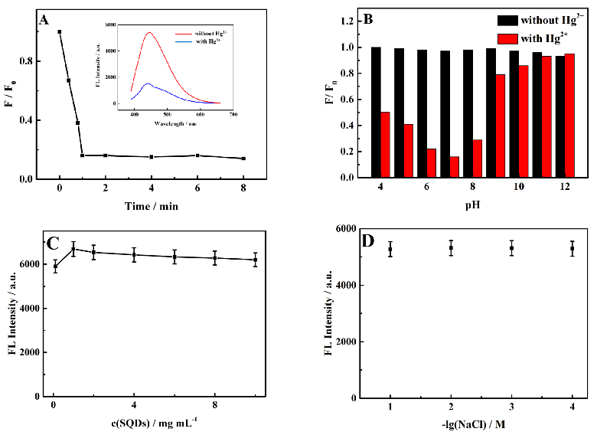

**Fig. S8.** Optimization results for different experimental conditions: (A) different reaction time and inset was the fluorescence spectra of Apt-SQDs without Hg2+ (red curve) and with Hg2+ (blue curve). (B) different pH of this sensing platform. (C) the fluorescence spectra of SQDs with different concentration (10-1, 1, 2, 4, 6, 8 and 10 mg mL-1). (D) the influence of ion strength.

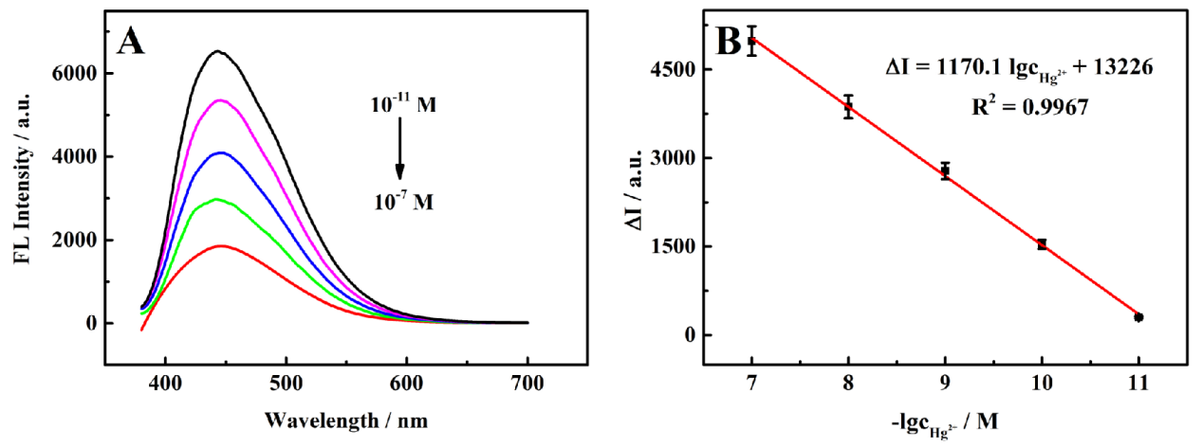

**Fig. S9.** (A) The signal response of the proposed fluorescent aptasensor for detecting various concentrations of Hg2+ and the corresponding concentrations of Hg2+ (10-11, 10-10, 10-9, 10-8 and 10-7 M, from top to bottom, n = 8). (B) Linear relationship between the fluorescence intensity and the logarithm of Hg2+ concentrations.

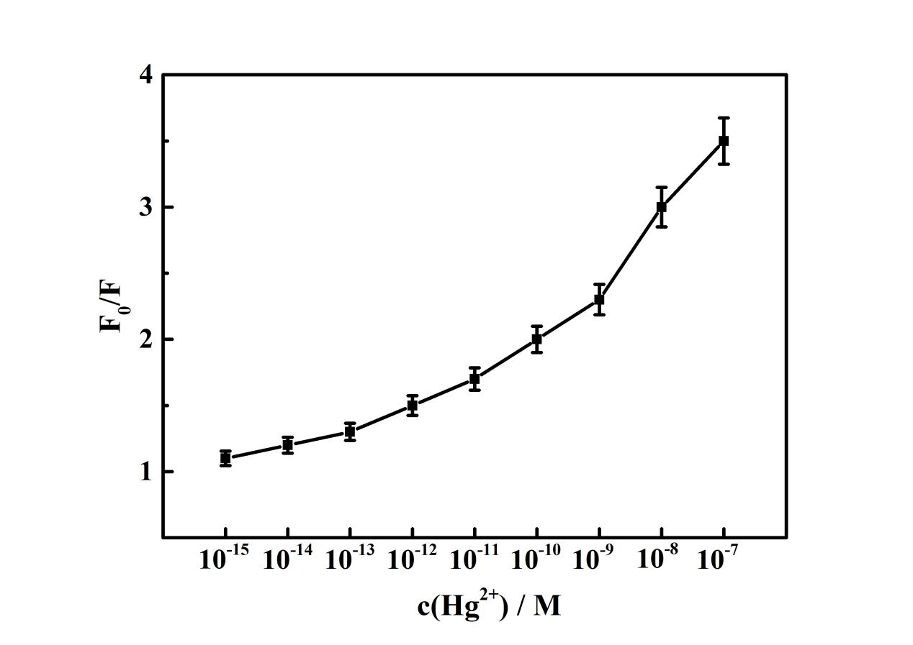

**Fig. S10.** The dependence of F0/F on the concentrations of Hg2+.

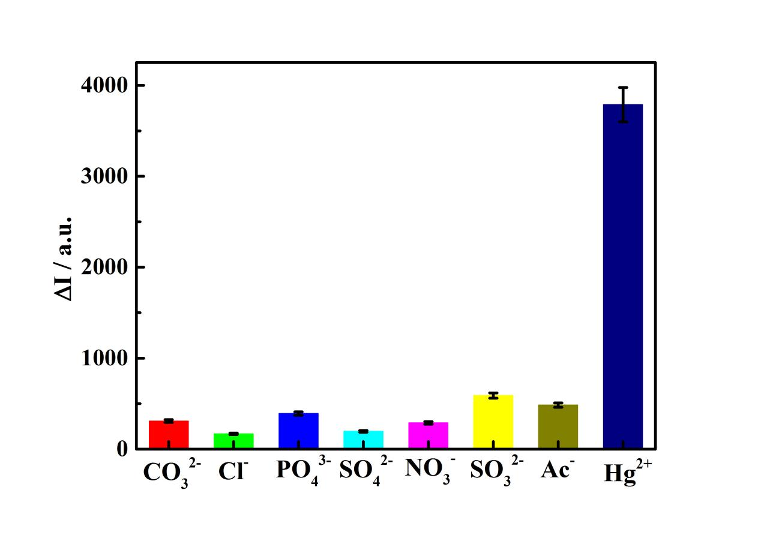

**Fig. S11.** Selectivity toward other interfering substances in the presence 1.0 × 10-8 M Hg2+: CO32-, Cl-, PO43-, SO42-, NO3-, SO32- and Ac- (the concentration of each of the aforementioned interferents was 1.0 × 10-7 M).

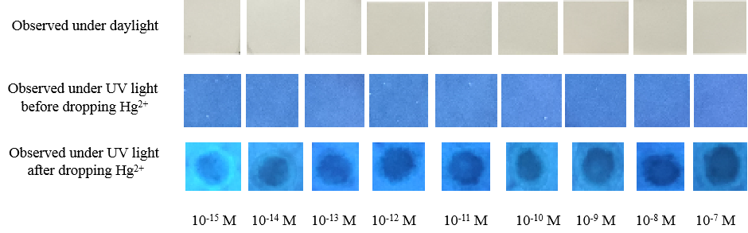

**Fig. S12.** Photographs of the test paper based on Apt-SQDs toward Hg2+ with different concentrations.

**Table S1.** Comparison of parameters of other published methods used for Hg2+ detection.

|  |  |  |  |
| --- | --- | --- | --- |
| Method | Linear range | LOD | Ref. |
| SERSa | 0.1 pM-10 nM | 80 fM | [Zhang et al., 2018] |
| Electrochemiluminescence | 0.8 fM-1 nM | 0.3 fM | [Jian et al., 2018] |
| Electrochemistry | 1 fM-1 nM | 0.62 fM | [Zhang et al., 2018] |
| Electrochemistry | 10 fM-100 nM | 4.8 fM | [Zhang et al., 2020] |
| Fluorescence | 0.035-0.2 and 8.0-120.0 pM | 0.035 pM | [Zhou et al., 2021] |
| Fluorescence | 1 fM-0.1 µM | 0.3 fM | This work |

a Surface Enhancement Raman Spectroscopy

**References**

1. Jian, Y.N., Wang, H., Lan, F.F., Liang, L.L., Ren, N., Liu, H.Y., Ge S.G., Yu, J.H., 2018. Electrochemiluminescence based detection of microRNA by applying an amplification strategy and Hg(II)-triggered disassembly of a metal organic frameworks functionalized with ruthenium(II)tris(bipyridine). Microchimica Acta 185, 133. https://doi.org/10.1007/s00604-018-2693-x.

2. Zhang, R.Y., Lv, S.P., Gong, Y., Li, Y.X., Ding, C.F., 2018. Sensitive determination of Hg(II) based on a hybridization chain recycling amplification reaction and surface-enhanced Raman scattering on gold nanoparticles. Microchimica Acta 185, 363-340. https://doi.org/10.1007/s00604-018-2907-2.

3. Zhang, X.A., Huang, C.Y., Jiang, Y.J., Jiang, Y.X., Shen, J.Z., Han, E., 2018. Structure-switching electrochemical aptasensor for singlestep and specific detection of trace mercury in dairy product. Journal of Agricultural and Food Chemistry 66, 10106-10112. https://doi.org/10.1021/acs.jafc.8b03259.

4. Zhang, X.A., Zhu, M.C., Jiang, Y.J., Wang, X., Guo, Z.M., Shi, J.Y., Zou, X.B., Han, E., 2020. Simple electrochemical sensing for mercury ions in dairy product using optimal Cu2+-based metal-organic frameworks as signal reporting. Journal Of Hazardous Materials 400, 123222. https://doi.org/10.1016/j.jhazmat.2020.123222.

5. Zhou, Z., Ding, Y.L., Si, S.H., Wu, W.M., Deng, C.Y., Wu, H.Y., Xiang, J., 2021. Wide-field determination of aqueous mercury(II) based on tail-extensible DNA fluorescent probe with tunable dynamic range. Journal Of Hazardous Materials 417, 125975. https://doi.org/10.1016/j.jhazmat.2021.125975.

**Table S2.** The method of Hg2+ detection based on carbon quantum dots.

|  |  |  |  |
| --- | --- | --- | --- |
| Material | Linear range | LOD | Ref. |
| PP-CQDsa | 0.1 µM-1.4 µM | 2.0 nM | [Duan et al., 2019] |
| N-CQDsb | 1 nM-100 nM | 7.7 nM | [Li et al., 2017] |
| Au/N-CQDsc | 0 nM-41.86 nM | 0.12 nM | [Meng et al., 2018] |
| N-CQDsd | 15 nM-104 nM | 8.0 nM | [Zou et al., 2021] |
| CQDse | 0 nM-5 µM | 3.2 nM | [Zhou et al., 2021] |

a Pyrophosphate-modified carbon quantum dots.

b N doped carbon quantum dots

c Au/N doped carbon quantum dots.

d N doped carbon quantum dots.

e carbon quantum dots

Duan, Q.Q., Wang, X.Y., Zhang, B.Y., Li, Y., Zhang, W.D., Zhang, Y.X., Sang, S.B., 2019. A fluorometric method for mercury(II) detection based on the use of pyrophosphate-modified carbon quantum dots. Microchimica Acta 186, 736. https://doi.org/10.1007/s00604-019-3872-0.

Li, Y.M., Wang, N., He, Z.H., 2017. Gas assisted method synthesis nitrogen-doped carbon quantum dots and Hg (II) sensing. Environmental Technology 38, 1507-1513. https://doi.org/10.1080/09593330.2016.1235231.

Meng, A., Xu, Q.H., Zhao, K., Li, Z.J., Liang, J., Li, Q.D., 2018. A highly selective and sensitive "on-off-on" fluorescent probe for detecting Hg(II) based on Au/N-doped carbon quantum dots. Sensors and Actuators B: Chemical 255, 657-665. https://doi.org/10.1016/j.snb.2017.08.028.

Zou, C.Y., Liu, Z.P., Wang, X.F., Liu, H., Yang, M., Huo, D.Q., Hou, C.J., 2021. A paper-based visualization chip based on nitrogen-doped carbon quantum dots nanoprobe for Hg(II) detection. Spectrochimica Acta, Part A: Molecular and Biomolecular Spectroscopy 265, 120346. https://doi.org/10.1016/j.saa.2021.120346.

Tanwar, L.K.S., Sharma, S., Ghosh, K.K., 2021. Spectroscopic detection of Hg2+ in water samples using fluorescent carbon quantum dots as sensing probe. Main Group Chemistry 20, 1-18. https://doi.org/10.3233/MGC-183967.