**Table S1** Reagents required for the experiments.

|  |  |  |  |  |
| --- | --- | --- | --- | --- |
| Materials | Source | Purification method | Mass fraction (purity) | CAS number |
| O-Phenanthroline | Beijing Innochem | Without purification | 97% | 66-71-7 |
| 2,4-Difluorobenzoic acid | Beijing Innochem | Without purification | 98% | 1583-58-0 |
| La(NO3)3⋅6H2O | Alfa Aesar | Without purification | 99.90% | 10277-43-7 |
| Gd(NO3)3⋅6H2O | Beijing Bailingwei Technology Co., LTD | Without purification | 99.90% | 19598-90-4 |
| Tb(NO3)3⋅6H2O | Beijing Innochem | Without purification | 99.90% | 57584-27-7 |
| Dy(NO3)3⋅6H2O | Alfa Aesar | Without purification | 99.90% | 10031-49-9 |
| Ho(NO3)3⋅6H2O | Beijing Innochem | Without purification | 99.90% | 14483-18-2 |
| NaOH | Tianjin Senchang Industrial Co., Ltd. | Without purification | 96% | 1310-73-2 |
| C2H5OH | Damao chemical reagent factory | Without purification | AR | 64-17-5 |

**Table S2**Selected bond lengths for the complexes **1-5.**

|  |  |  |  |  |  |  |  |  |  |
| --- | --- | --- | --- | --- | --- | --- | --- | --- | --- |
| Complex 1 | | Complex 2 | | Complex 3 | | Complex 4 | | Complex 5 | |
| Selected bond | Bond lengths/ Å | Selected bond | Bond lengths/ Å | Selected bond | Bond lengths/ Å | Selected bond | Bond lengths/ Å | Selected bond | Bond lengths/ Å |
| La(1)-O(3) | 2.412(3) | Gd(1)-O(3) | 2.299(4) | Tb(1)-O(3) | 2.277(3) | Dy(1)-O(3) | 2.273(4) | Ho(1)-O(3) | 2.247(5) |
| La(1)-O(4)#1 | 2.457(4) | Gd(1)-O(4)#1 | 2.340(4) | Tb(1)-O(1) | 2.330(4) | Dy(1)-O(1) | 2.322(5) | Ho(1)-O(1) | 2.299(5) |
| La(1)-O(1) | 2.476(3) | Gd(1)-O(1) | 2.350(5) | Tb(1)-O(4)#1 | 2.340(3) | Dy(1)-O(4)#1 | 2.327(4) | Ho(1)-O(4)#1 | 2.305(5) |
| La(1)-O(5) | 2.529(3) | Gd(1)-O(2)#1 | 2.387(5) | Tb(1)-O(2)#1 | 2.363(4) | Dy(1)-O(2)#1 | 2.347(4) | Ho(1)-O(2)#1 | 2.333(5) |
| La(1)-O(2)#1 | 2.534(3) | Gd(1)-O(6) | 2.436(5) | Tb(1)-O(6) | 2.417(4) | Dy(1)-O(6) | 2.404(4) | Ho(1)-O(6) | 2.394(5) |
| La(1)-O(6) | 2.536(4) | Gd(1)-O(5) | 2.437(5) | Tb(1)-O(5) | 2.435(3) | Dy(1)-O(5) | 2.430(4) | Ho(1)-O(5) | 2.416(5) |
| La(1)-N(2) | 2.670(4) | Gd(1)-N(2) | 2.554(5) | Tb(1)-N(2) | 2.544(4) | Dy(1)-N(2) | 2.530(5) | Ho(1)-N(2) | 2.515(6) |
| La(1)-N(1) | 2.698(4) | Gd(1)-N(1) | 2.583(5) | Tb(1)-N(1) | 2.563(4) | Dy(1)-N(1) | 2.562(5) | Ho(1)-N(1) | 2.532(6) |
| La(1)-O(1)#1 | 2.801(3) | Gd(1)-O(1)#1 | 2.904(5) |  |  |  |  |  |  |

(Symmetry codes: #1 -x+1,-y+1,-z+1)

**Table S3(a)**Selected bond angles for the complexes **1-5.**

|  |  |  |  |
| --- | --- | --- | --- |
| Complex 1 |  | Complex 2 |  |
| Selectedangle | Bond angle/° | Selectedangle | Bond angle/° |
| O(3)-La(1)-O(4)#1 | 132.54(11) | O(3)-Gd(1)-O(4)#1 | 129.95(15) |
| O(3)-La(1)-O(1) | 73.11(12) | O(3)-Gd(1)-O(1) | 74.03(16) |
| O(4)#1-La(1)-O(1) | 76.85(12) | O(4)#1-Gd(1)-O(1) | 77.49(14) |
| O(3)-La(1)-O(5) | 73.93(12) | O(3)-Gd(1)-O(2)#1 | 78.05(16) |
| O(4)#1-La(1)-O(5) | 133.48(12) | O(4)#1-Gd(1)-O(2)#1 | 86.05(16) |
| O(1)-La(1)-O(5) | 77.97(11) | O(1)-Gd(1)-O(2)#1 | 125.02(17) |
| O(3)-La(1)-O(2)#1 | 77.74(13) | O(3)-Gd(1)-O(6) | 127.00(15) |
| O(4)#1-La(1)-O(2)#1 | 90.05(13) | O(4)#1-Gd(1)-O(6) | 88.91(16) |
| O(1)-La(1)-O(2)#1 | 123.99(11) | O(1)-Gd(1)-O(6) | 83.81(18) |
| O(5)-La(1)-O(2)#1 | 136.33(13) | O(2)#1-Gd(1)-O(6) | 148.52(16) |
| O(3)-La(1)-O(6) | 123.55(12) | O(3)-Gd(1)-O(5) | 74.94(15) |
| O(4)#1-La(1)-O(6) | 88.23(13) | O(4)#1-Gd(1)-O(5) | 135.26(16) |
| O(1)-La(1)-O(6) | 84.24(12) | O(1)-Gd(1)-O(5) | 76.07(16) |
| O(5)-La(1)-O(6) | 50.73(12) | O(2)#1-Gd(1)-O(5) | 138.65(17) |
| O(2)#1-La(1)-O(6) | 150.43(12) | O(6)-Gd(1)-O(5) | 52.96(15) |
| O(3)-La(1)-N(2) | 85.12(13) | O(3)-Gd(1)-N(2) | 82.25(17) |
| O(4)#1-La(1)-N(2) | 136.39(12) | O(4)#1-Gd(1)-N(2) | 139.03(16) |
| O(1)-La(1)-N(2) | 144.61(12) | O(1)-Gd(1)-N(2) | 142.46(15) |
| O(5)-La(1)-N(2) | 69.22(12) | O(2)#1-Gd(1)-N(2) | 76.02(17) |
| O(2)#1-La(1)-N(2) | 75.93(12) | O(6)-Gd(1)-N(2) | 87.92(18) |
| O(6)-La(1)-N(2) | 85.13(13) | O(5)-Gd(1)-N(2) | 69.83(16) |
| O(3)-La(1)-N(1) | 136.48(13) | O(3)-Gd(1)-N(1) | 137.57(17) |
| O(4)#1-La(1)-N(1) | 75.84(13) | O(4)#1-Gd(1)-N(1) | 76.10(16) |
| O(1)-La(1)-N(1) | 149.68(13) | O(1)-Gd(1)-N(1) | 148.09(17) |
| O(5)-La(1)-N(1) | 112.53(12) | O(2)#1-Gd(1)-N(1) | 70.50(16) |
| O(2)#1-La(1)-N(1) | 68.99(12) | O(6)-Gd(1)-N(1) | 78.12(16) |
| O(6)-La(1)-N(1) | 82.00(12) | O(5)-Gd(1)-N(1) | 111.72(16) |
| N(2)-La(1)-N(1) | 60.55(13) | N(2)-Gd(1)-N(1) | 63.28(17) |
| O(3)-La(1)-O(1)#1 | 70.55(11) | O(3)-Gd(1)-O(1)#1 | 66.85(13) |
| O(4)#1-La(1)-O(1)#1 | 67.46(11) | O(4)#1-Gd(1)-O(1)#1 | 67.51(14) |
| O(1)-La(1)-O(1)#1 | 77.06(11) | O(1)-Gd(1)-O(1)#1 | 77.94(16) |
| O(5)-La(1)-O(1)#1 | 141.11(11) | O(2)#1-Gd(1)-O(1)#1 | 47.51(14) |
| O(2)#1-La(1)-O(1)#1 | 48.19(11) | O(6)-Gd(1)-O(1)#1 | 152.69(16) |
| O(6)-La(1)-O(1)#1 | 152.00(12) | O(5)-Gd(1)-O(1)#1 | 138.31(14) |
| N(2)-La(1)-O(1)#1 | 121.90(11) | N(2)-Gd(1)-O(1)#1 | 118.79(15) |
| N(1)-La(1)-O(1)#1 | 104.03(11) | N(1)-Gd(1)-O(1)#1 | 107.62(14) |

(Symmetry codes: #1 -x+1,-y+1,-z+1)

**Table S3(b)**Selected bond angles for the complexes **1-5.**

|  |  |  |  |  |  |
| --- | --- | --- | --- | --- | --- |
| Complex 3 |  | Complex 4 |  | Complex 5 |  |
| Selectedangle | Bond angle/° | Selectedangle | Bond angle/° | Selectedangle | Bond angle/° |
| O(3)-Tb(1)-O(1) | 74.79(13) | O(3)-Dy(1)-O(1) | 74.87(16) | O(3)-Ho(1)-O(1) | 74.8(2) |
| O(3)-Tb(1)-O(4)#1 | 128.83(12) | O(3)-Dy(1)-O(4)#1 | 127.87(15) | O(3)-Ho(1)-O(4)#1 | 127.29(18) |
| O(1)-Tb(1)-O(4)#1 | 77.47(12) | O(1)-Dy(1)-O(4)#1 | 77.43(14) | O(1)-Ho(1)-O(4)#1 | 77.42(18) |
| O(3)-Tb(1)-O(2)#1 | 77.77(13) | O(3)-Dy(1)-O(2)#1 | 77.85(16) | O(3)-Ho(1)-O(2)#1 | 77.34(19) |
| O(1)-Tb(1)-O(2)#1 | 124.86(14) | O(1)-Dy(1)-O(2)#1 | 124.93(17) | O(1)-Ho(1)-O(2)#1 | 124.3(2) |
| O(4)#1-Tb(1)-O(2)#1 | 84.25(13) | O(4)#1-Dy(1)-O(2)#1 | 83.28(16) | O(4)#1-Ho(1)-O(2)#1 | 82.87(19) |
| O(3)-Tb(1)-O(6) | 127.65(12) | O(3)-Dy(1)-O(6) | 127.84(14) | O(3)-Ho(1)-O(6) | 128.25(18) |
| O(1)-Tb(1)-O(6) | 83.09(14) | O(1)-Dy(1)-O(6) | 82.79(18) | O(1)-Ho(1)-O(6) | 82.7(2) |
| O(4)#1-Tb(1)-O(6) | 89.80(12) | O(4)#1-Dy(1)-O(6) | 90.55(15) | O(4)#1-Ho(1)-O(6) | 90.67(19) |
| O(2)#1-Tb(1)-O(6) | 148.86(13) | O(2)#1-Dy(1)-O(6) | 148.88(16) | O(2)#1-Ho(1)-O(6) | 149.4(2) |
| O(3)-Tb(1)-O(5) | 75.10(12) | O(3)-Dy(1)-O(5) | 75.10(15) | O(3)-Ho(1)-O(5) | 75.53(18) |
| O(1)-Tb(1)-O(5) | 75.58(12) | O(1)-Dy(1)-O(5) | 75.18(16) | O(1)-Ho(1)-O(5) | 75.38(19) |
| O(4)#1-Tb(1)-O(5) | 136.32(12) | O(4)#1-Dy(1)-O(5) | 136.90(15) | O(4)#1-Ho(1)-O(5) | 137.19(18) |
| O(2)#1-Tb(1)-O(5) | 139.43(13) | O(2)#1-Dy(1)-O(5) | 139.82(16) | O(2)#1-Ho(1)-O(5) | 139.94(19) |
| O(6)-Tb(1)-O(5) | 53.44(12) | O(6)-Dy(1)-O(5) | 53.62(15) | O(6)-Ho(1)-O(5) | 53.69(18) |
| O(3)-Tb(1)-N(2) | 82.05(13) | O(3)-Dy(1)-N(2) | 82.32(17) | O(3)-Ho(1)-N(2) | 82.4(2) |
| O(1)-Tb(1)-N(2) | 142.28(12) | O(1)-Dy(1)-N(2) | 142.06(15) | O(1)-Ho(1)-N(2) | 142.28(19) |
| O(4)#1-Tb(1)-N(2) | 139.33(12) | O(4)#1-Dy(1)-N(2) | 139.62(15) | O(4)#1-Ho(1)-N(2) | 139.54(18) |
| O(2)#1-Tb(1)-N(2) | 77.03(13) | O(2)#1-Dy(1)-N(2) | 77.62(16) | O(2)#1-Ho(1)-N(2) | 77.7(2) |
| O(6)-Tb(1)-N(2) | 88.20(14) | O(6)-Dy(1)-N(2) | 88.00(17) | O(6)-Ho(1)-N(2) | 88.5(2) |
| O(5)-Tb(1)-N(2) | 69.86(12) | O(5)-Dy(1)-N(2) | 69.82(16) | O(5)-Ho(1)-N(2) | 69.97(19) |
| O(3)-Tb(1)-N(1) | 137.49(13) | O(3)-Dy(1)-N(1) | 138.02(16) | O(3)-Ho(1)-N(1) | 138.2(2) |
| O(1)-Tb(1)-N(1) | 147.48(13) | O(1)-Dy(1)-N(1) | 146.87(17) | O(1)-Ho(1)-N(1) | 146.7(2) |
| O(4)#1-Tb(1)-N(1) | 76.46(12) | O(4)#1-Dy(1)-N(1) | 76.44(16) | O(4)#1-Ho(1)-N(1) | 76.44(19) |
| O(2)#1-Tb(1)-N(1) | 71.16(13) | O(2)#1-Dy(1)-N(1) | 71.44(16) | O(2)#1-Ho(1)-N(1) | 72.07(19) |
| O(6)-Tb(1)-N(1) | 77.72(13) | O(6)-Dy(1)-N(1) | 77.45(16) | O(6)-Ho(1)-N(1) | 77.32(19) |
| O(5)-Tb(1)-N(1) | 111.72(13) | O(5)-Dy(1)-N(1) | 112.03(16) | O(5)-Ho(1)-N(1) | 111.82(19) |
| N(2)-Tb(1)-N(1) | 63.44(13) | N(2)-Dy(1)-N(1) | 63.86(17) | N(2)-Ho(1)-N(1) | 63.9(2) |

(Symmetry codes: #1 -x+1,-y+1,-z+1)

**Table S4**Hydrogen bonding data of complexes **1**-**5.**

|  |  |  |  |  |  |
| --- | --- | --- | --- | --- | --- |
|  | hydrogen bonding | D-H | H···A | D···A | D-H···A |
| Complex 1 | C(7)-H(7)···O(5) | 0.93 | 2.52 | 3.233(8) | 133 |
| C(22)-H(22)···F(3) | 0.93 | 2.55 | 3.366(7) | 147 |
| C(22)-H(22)···O(4) | 0.93 | 2.37 | 3.071(7) | 132 |
| C(30)-H(30)···F(5) | 0.93 | 2.47 | 3.233(18) | 139 |
| C(32)-H(32)···O(6) | 0.93 | 2.45 | 3.324(7) | 158 |
| Complex 2 | C(7)-H(7)···O(5) | 0.93 | 2.55 | 3.273(11) | 135 |
| C(14)-H(14)···O(5) | 0.93 | 2.56 | 3.454(8) | 163 |
| C(20)-H(20)···F(4) | 0.93 | 2.52 | 3.127(11) | 123 |
| C(22)-H(22)···F(3) | 0.93 | 2.51 | 3.382(9) | 156 |
| C(22)-H(22)···O(4) | 0.93 | 2.34 | 2.986(8) | 126 |
| C(30)-H(30)···F(5) | 0.93 | 2.43 | 3.274(12) | 151 |
| C(32)-H(32)···O(6) | 0.93 | 2.49 | 3.333(10) | 151 |
| Complex 3 | C(7)-H(7)···O(5) | 0.93 | 2.58 | 3.318(8) | 137 |
| C(11)-H(11)···F(1) | 0.93 | 2.53 | 3.131(8) | 122 |
| C(14)-H(14)···O(5) | 0.93 | 2.53 | 3.429(6) | 162 |
| C(20)-H(20)···F(4) | 0.93 | 2.54 | 3.153(8) | 124 |
| C(22)-H(22)···F(3) | 0.93 | 2.52 | 3.396(7) | 157 |
| C(22)-H(22)···O(4) | 0.93 | 2.34 | 2.990(6) | 126 |
| C(30)-H(30)···F(5) | 0.93 | 2.46 | 3.298(9) | 150 |
| C(32)-H(32)···O(6) | 0.93 | 2.51 | 3.346(7) | 149 |
| Complex 4 | C(7)-H(7)···O(5) | 0.93 | 2.57 | 3.325(11) | 138 |
| C(11)-H(11)···F(1) | 0.93 | 2.55 | 3.146(10) | 123 |
| C(14)-H(14)···O(5) | 0.93 | 2.52 | 3.422(8) | 163 |
| C(20)-H(20)···F(4) | 0.93 | 2.54 | 3.143(11) | 123 |
| C(22)-H(22)···F(3) | 0.93 | 2.51 | 3.385(9) | 157 |
| C(22)-H(22)···O(4) | 0.93 | 2.34 | 2.982(8) | 126 |
| C(30)-H(30)···F(5) | 0.93 | 2.45 | 3.293(11) | 151 |
| C(32)-H(32)···O(6) | 0.93 | 2.50 | 3.332(9) | 149 |
| Complex 5 | C(7)-H(7)···O(5) | 0.93 | 2.60 | 3.342(12) | 137 |
| C(11)-H(11)···F(1) | 0.93 | 2.53 | 3.134(11) | 123 |
| C(14)-H(14)···O(5) | 0.93 | 2.50 | 3.400(10) | 163 |
| C(20)-H(20)···F(4) | 0.93 | 2.52 | 3.129(13) | 124 |
| C(21)-H(21)···O(5) | 0.93 | 2.45 | 2.761(12) | 100 |
| C(22)-H(22)···F(3) | 0.93 | 2.49 | 3.363(10) | 156 |
| C(22)-H(22)···O(4) | 0.93 | 2.32 | 2.962(10) | 125 |
| C(30)-H(30)···F(5) | 0.93 | 2.43 | 3.275(13) | 152 |
| C(32)-H(32)···O(6) | 0.93 | 2.51 | 3.351(11) | 150 |

**Table S5**Continuous shape measures analysis of lanthanide coordination spheres in compounds **1**-**5**. Lowest CShM values are highlighted in yellow.

|  |  |  |  |  |  |  |
| --- | --- | --- | --- | --- | --- | --- |
|  | 1,La | 2,Gd |  | 3,Tb | 4,Dy | 5,Ho |
| EP-9 | 32.169 | 32.640 | OP-8 | 31.444 | 31.577 | 31.719 |
| OPY-9 | 20.128 | 21.018 | HPY-8 | 21.778 | 21.744 | 21.750 |
| HBPY-9 | 17.304 | 17.482 | HBPY-8 | 15.771 | 15.815 | 15.802 |
| JTC-9 | 14.148 | 14.629 | CU-8 | 10.765 | 10.661 | 10.507 |
| JCCU-9 | 10.651 | 10.194 | SAPR-8 | 1.745 | 1.727 | 1.678 |
| CCU-9 | 10.161 | 10.267 | TDD-8 | 2.581 | 2.583 | 2.534 |
| JCSAPR-9 | 3.201 | 2.652 | JGBF-8 | 14.304 | 14.443 | 14.556 |
| CSAPR-9 | 2.227 | 2.576 | JETBPY-8 | 28.265 | 28.328 | 28.443 |
| JTCTPR-9 | 3.384 | 2.857 | JBTPR-8 | 2.065 | 1.980 | 2.028 |
| TCTPR-9 | 3.274 | 3.150 | BTPR-8 | 1.229 | 1.200 | 1.246 |
| JTDIC-9 | 13.252 | 13.818 | JSD-8 | 4.844 | 4.812 | 4.875 |
| HH-9 | 10.639 | 10.455 | TT-8 | 11.571 | 11.481 | 11.322 |
| MFF-9 | 2.158 | 2.229 | ETBPY-8 | 23.383 | 23.711 | 23.725 |

Abbreviations:EP-9, Enneagon; OPY-9, Octagonal pyramid; HBPY-9, Heptagonal bipyramid; JTC-9, Johnson triangular cupola J3; JCCU-9, Capped cube J8; CCU-9, Spherical-relaxed capped cube; JCSAPR-9, Capped square antiprism J10; CSAPR-9, Spherical capped square antiprism; JTCTPR-9, Tricapped trigonal prism J51;TCTPR-9, Spherical tricapped trigonal prism; JTDIC-9, Tridiminished icosahedron J63;HH-9, Hula-hoop; MFF-9; Muffin;OP-8, Octagon; HPY-8; Heptagonal pyramid; HBPY-8, Hexagonal bipyramid; CU-8, Cube; SAPR-8, Square antiprism; TDD-8, Triangular dodecahedron; JGBF-8, Johnson gyrobifastigium J26;JETBPY-8, Johnson elongated triangular bipyramid J14; JBTPR-8, Biaugmented trigonal prism J50; BTPR-8, Biaugmented trigonal prism; JSD-8, Snub diphenoid J84; TT-8, Triakis tetrahedron; ETBPY-8, Elongated trigonal bipyramid.

**Table S6**(a) Infrared spectral data of the complexes **1-5.**

|  |  |  |  |  |  |  |
| --- | --- | --- | --- | --- | --- | --- |
| ligands/complexes | νC=N | δC-H | νC=O | νas(coo-) | νs(coo-) | νLn-O |
| 2,4-DFBA |  |  | 1691 |  |  |  |
| phen | 1560 | 854,738 |  |  |  |  |
| 1 | 1582 | 849,731 |  | 1616 | 1427 | 417 |
| 2 | 1589 | 848,731 |  | 1614 | 1429 | 419 |
| 3 | 1591 | 849,731 |  | 1614 | 1429 | 419 |
| 4 | 1577 | 849,731 |  | 1614 | 1431 | 418 |
| 5 | 1593 | 850,733 |  | 1610 | 1431 | 419 |
|  |  |  |  |  |  |  |

**Table S6**(b) Raman spectral data of complexes **1-5.**

|  |  |  |  |  |  |  |  |
| --- | --- | --- | --- | --- | --- | --- | --- |
| ligands/complexes | νC=N | δC-H | νC=O | νas(coo-) | νs(coo-) | νLn-O | νLn-N |
| 2,4-DFBA |  |  | 1634 |  |  |  |  |
| phen | 1507 | 719 |  |  |  |  |  |
| 1 | 1503 | 732 |  | 1614 | 1416 | 417 | 240 |
| 2 | 1521 | 725 |  | 1614 | 1416 | 421 | 241 |
| 3 | 1522 | 726 |  | 1615 | 1416 | 420 | 241 |
| 4 | 1525 | 727 |  | 1615 | 1415 | 423 | 240 |
| 5 | 1525 | 722 |  | 1620 | 1416 | 419 | 242 |

**Table S7** Thermal decomposition data of complexes **1-5.**

|  |  |  |  |  |  |  |  |
| --- | --- | --- | --- | --- | --- | --- | --- |
|  | Steps | Temperature/K | DTG Tp/K | Mass loss rate/% | | Probably expelled groups | Intermediate and residue |
|  |  |  |  | Found | Calcd |  |  |
| 1 | I | 494.15-691.15 | 627.25 | 60.58 | 22.80a | 2phen+x 2,4-DFBA | [La2(2,4-DFBA)6-x] |
|  | II | 691.15-1009.15 | 709.75 | 18.21 | 56.59b | (6-x)2,4-DFBA | La2O3 |
|  | Sum |  |  | 78.79 | 79.39c |  |  |
| 2 | I | 393.15-714.15 | 612.65 | 57.28 | 22.28a | 2phen+x 2,4-DFBA | [Gd2(2,4-DFBA)6-x] |
|  | II | 714.15-1036.15 | 768.55 | 18.88 | 55.31b | (6-x)2,4-DFBA | Gd2O3 |
|  | Sum |  |  | 76.16 | 77.59c |  |  |
| 3 | I | 428.15-718.15 | 610.25 | 57.78 | 22.24a | 2phen+x 2,4-DFBA | [Tb2(2,4-DFBA)6-x] |
|  | II | 718.15-1043.15 | 769.15 | 18.44 | 54.70b | (6-x)2,4-DFBA | 1/2Tb4O7 |
|  | Sum |  |  | 76.22 | 76.94c |  |  |
| 4 | I | 510.15-668.15 | 617.15 | 54.33 | 22.13a | 2phen+x 2,4-DFBA | [Dy2(2,4-DFBA)6-x] |
|  | II | 668.15-784.15 | 763.65 | 13.03 |  | y 2,4-DFBA | [Dy2(2,4-DFBA)6-x-y] |
|  | III | 784.15-1009.15 | 803.05 | 9.04 | 54.95b | (6-x-y)2,4-DFBA | Dy2O3 |
|  | Sum |  |  | 76.4 | 77.08c |  |  |
| 5 | I | 431.15-664.15 | 615.25 | 54.25 | 22.07a | 2phen+x 2,4-DFBA | [Ho2(2,4-DFBA)6-x] |
|  | II | 664.15-788.15 | 775.15 | 10.32 |  | y 2,4-DFBA | [Ho2(2,4-DFBA)6-x-y] |
|  | III | 788.15-1035.15 | 820.65 | 12.21 | 54.79b | (6-x-y)2,4-DFBA | Ho2O3 |
|  | Sum |  |  | 76.78 | 76.86c |  |  |

a: Theoretical total mass loss ofphen.

b: Theoretical total mass loss of 2,4-DFBA.

c: The total loss rate.

**Table S8** HOMO and LUMO energy levels of ligands.

|  |  |  |  |
| --- | --- | --- | --- |
| Ligand | Energy level/eV | | ΔＥ/eV |
| HOMO | LUMO |
| Phen | -6.4861 | -1.6708 | 4.8153 |
| 2,4-DFBA | -7.4815 | -1.7676 | 5.7139 |

**Table S9** Single and triplet state energy levels of ligands.

|  |  |  |  |  |
| --- | --- | --- | --- | --- |
| Ligand | Excited states | Multiplicity | Excitation energy | |
| eV | cm-1 |
| Phen | 1 | T | 2.8659 | 23095 |
| 2 | T | 3.4589 | 27896 |
| 3 | T | 3.5517 | 28644 |
| 1 | S | 3.9906 | 32206 |
| 2 | S | 4.0164 | 32392 |
| 3 | S | 4.0918 | 33000 |
| 2,4-DFBA | 1 | T | 3.5697 | 28766 |
| 2 | T | 4.2700 | 34437 |
| 3 | T | 4.5023 | 36311 |
| 1 | S | 4.9750 | 40123 |
| 2 | S | 5.0044 | 40338 |
| 3 | S | 5.5310 | 44607 |

**Table S10** Average molar heat capacity values and smooth molar heat capacity values of complexes **4** and **5.**

|  |  |  |  |  |
| --- | --- | --- | --- | --- |
| **T(K)** | **Complex 4**  **Cp.m(J.K-1.mol-1)** | | **Complex 5**  **Cp.m(J.K-1.mol-1)** | |
| **Exp. a** | **Smooth b** | **Exp. a** | **Smooth b** |
| 260.15  263.15  266.15  269.15  272.15  275.15  278.15  281.15  284.15  287.15  290.15  293.15  296.15  299.15  302.15  305.15  308.15  311.15  314.15  317.15  320.15  323.15  326.15  329.15  332.15  335.15  338.15  341.15  344.15  347.15  350.15  353.15  356.15  359.15  362.15  365.15  368.15  371.15  374.15  377.15  380.15  383.15  386.15 | 1151.267825  1164.063669  1173.798929  1187.278521  1198.413836  1208.572369  1224.298559  1236.557173  1247.448292  1262.279099  1276.051725  1288.212661  1301.041065  1313.071763  1324.207078  1335.879623  1346.689343  1356.424604  1367.104087  1380.339483  1391.89807  1403.619454  1415.178041  1425.499371  1437.741706  1448.746783  1459.442546  1468.347542  1483.341145  1490.618171  1504.586154  1513.686506  1525.717204  1538.740964  1550.91818  1563.92566  1574.26327  1586.049773  1599.18749  1609.899533  1620.058066  1632.235281  1641.889144 | 1152.04  1162.75  1174.15  1186.09  1198.42  1211.01  1223.76  1236.57  1249.39  1262.14  1274.78  1287.28  1299.61  1311.77  1323.74  1335.53  1347.15  1358.61  1369.93  1381.13  1392.24  1403.29  1414.3  1425.3  1436.31  1447.37  1458.48  1469.68  1480.96  1492.36  1503.86  1515.47  1527.17  1538.96  1550.82  1562.7  1574.58  1586.39  1598.09  1609.61  1620.86  1631.76  1642.21 | 1152.320788  1166.232499  1176.584641  1191.116828  1202.024133  1212.278305  1227.512609  1239.693521  1251.319271  1264.986058  1278.424249  1290.278594  1301.708404  1315.015969  1326.560077  1337.663321  1349.844233  1360.539269  1371.397589  1385.554225  1396.673797  1406.405464  1417.753632  1428.660937  1440.090747  1450.393904  1461.448163  1472.110543  1488.112277  1495.247744  1509.453365  1519.952462  1529.651472  1542.338561  1553.964311  1564.855287  1576.921901  1590.621345  1601.561306  1612.093059  1625.43328  1636.830434  1648.537825 | 1153.35  1165  1177.02  1189.33  1201.83  1214.45  1227.13  1239.81  1252.46  1265.03  1277.51  1289.87  1302.11  1314.21  1326.17  1337.99  1349.69  1361.27  1372.74  1384.11  1395.41  1406.64  1417.84  1429  1440.16  1451.32  1462.5  1473.72  1484.99  1496.31  1507.7  1519.16  1530.7  1542.31  1553.99  1565.73  1577.53  1589.38  1601.25  1613.13  1624.99  1636.8  1648.55 |

a:Average molar heat capacity value.

b:smooth molar heat capacity value.

**Table 11** Thermodynamic function values for complexes **4** and **5.**

|  |  |  |  |  |
| --- | --- | --- | --- | --- |
| **T(K)** | **HT-H298.15/(KJ·mol-1)** | | **ST-S298.15/(J·mol-1·K-1)** | |
| **Complex4** | **Complex 5** | **Complex 4** | **Complex 5** |
| 260.15  263.15  266.15  269.15  272.15  275.15  278.15  281.15  284.15  287.15  290.15  293.15  296.15  299.15  302.15  305.15  308.15  311.15  314.15  317.15  320.15  323.15  326.15  329.15  332.15  335.15  338.15  341.15  344.15  347.15  350.15  353.15  356.15  359.15  362.15  365.15  368.15  371.15  374.15  377.15  380.15  383.15  386.15 | -46.696  -43.224  -39.719  -36.178  -32.602  -28.988  -25.336  -21.645  -17.916  -14.149  -10.344  -6.501  -2.62  1.323  5.276  9.265  13.289  17.348  21.441  25.568  29.728  33.921  38.148  42.407  46.699  51.025  55.384  59.776  64.202  68.662  73.156  77.685  82.249  86.849  91.483  96.154  100.86  105.601  110.378  115.19  120.036  124.915  129.826 | -46.806  -43.329  -39.816  -36.266  -32.68  -29.055  -25.393  -21.693  -17.954  -14.178  -10.364  -6.513  -2.625  1.325  5.286  9.282  13.314  17.38  21.482  25.617  29.786  33.989  38.226  42.496  46.8  51.138  55.508  59.913  64.351  68.823  73.329  77.869  82.444  87.054  91.698  96.378  101.093  105.843  110.629  115.451  120.308  125.201  130.129 | -167.29  -154.02  -140.78  -127.55  -114.34  -101.13  -87.93  -74.73  -61.54  -48.35  -35.17  -21.99  -8.82  4.43  17.58  30.72  43.84  56.95  70.04  83.11  96.16  109.2  122.22  135.22  148.2  161.17  174.11  187.04  199.96  212.86  225.75  238.63  251.5  264.36  277.21  290.06  302.89  315.72  328.54  341.34  354.14  366.93  379.69 | -167.69  -154.4  -141.12  -127.86  -114.61  -101.36  -88.13  -74.89  -61.67  -48.45  -35.24  -22.03  -8.84  4.44  17.61  30.77  43.92  57.05  70.17  83.27  96.35  109.42  122.47  135.5  148.52  161.52  174.5  187.47  200.42  213.36  226.28  239.19  252.09  264.98  277.86  290.73  303.59  316.44  329.28  342.12  354.94  367.76  380.58 |

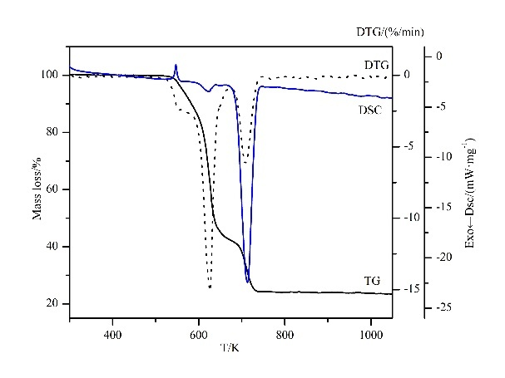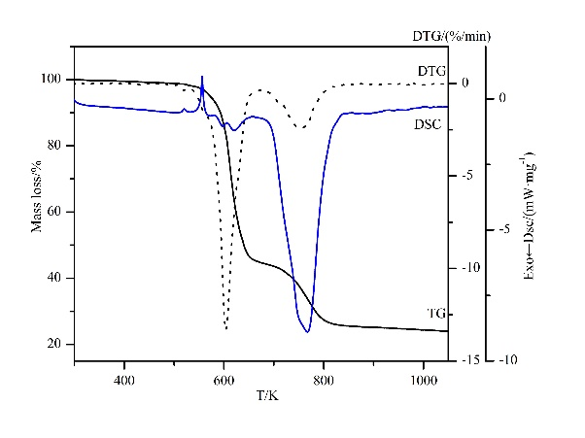

(a) (b)

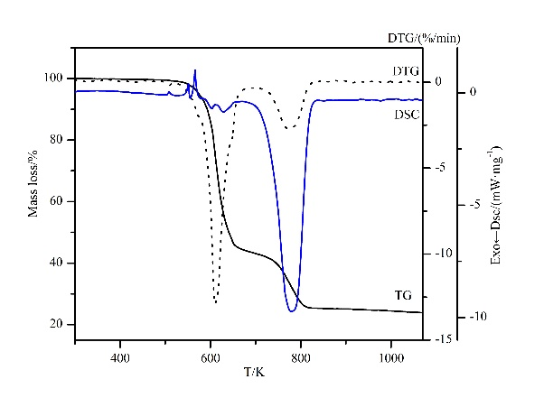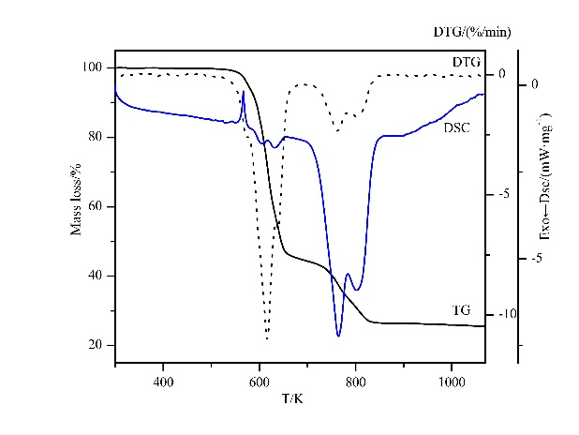

(c) (d)

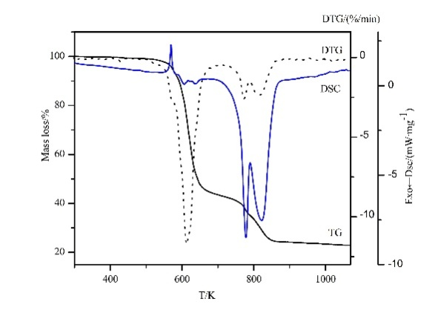

(e)

**Fig. S1**(a-e) TG-DTG/DSC curves of complexes **1-5** (a-e represent complexes **1-5**, respectively).

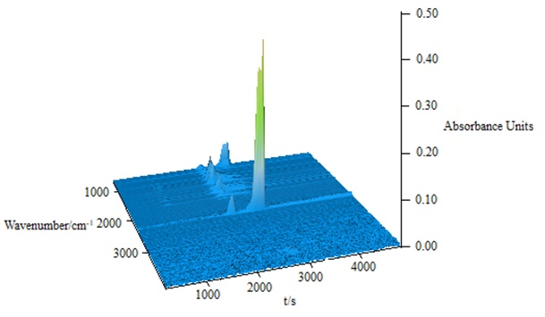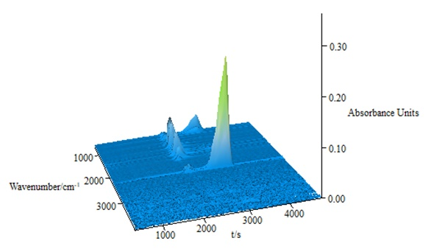

(a) (b)

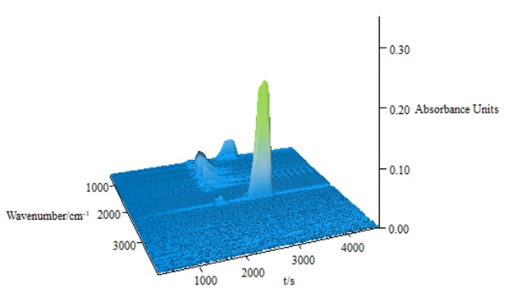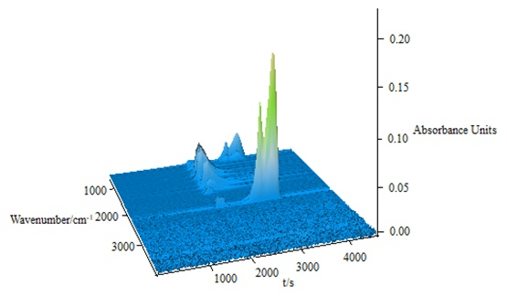

(c) (d)

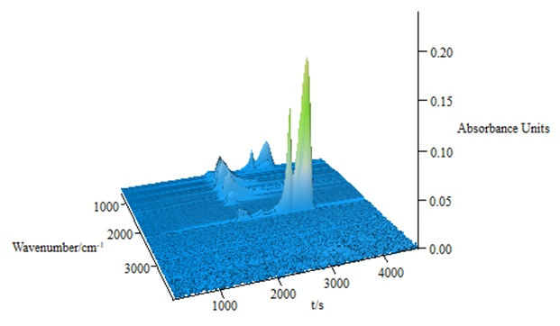

(e)

**Fig. S2**(a-e) Three-dimensional infrared maps of the fugitive gases of complexes **1-5** (a-e represent complexes **1-5**, respectively).

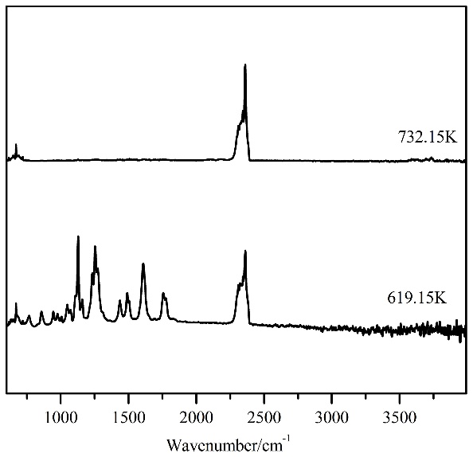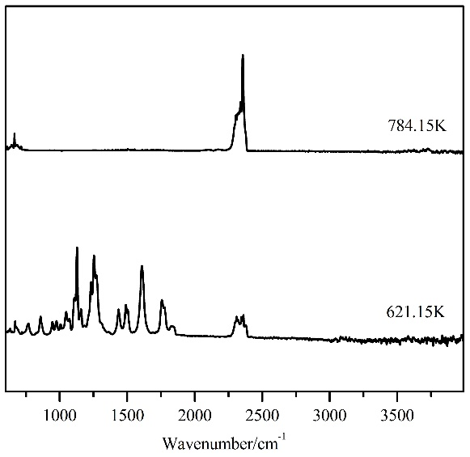

(a) (b)

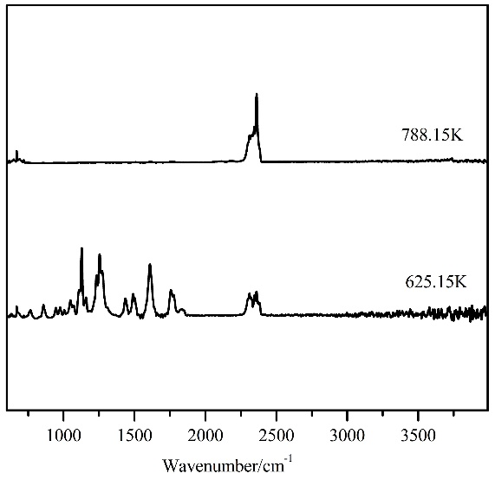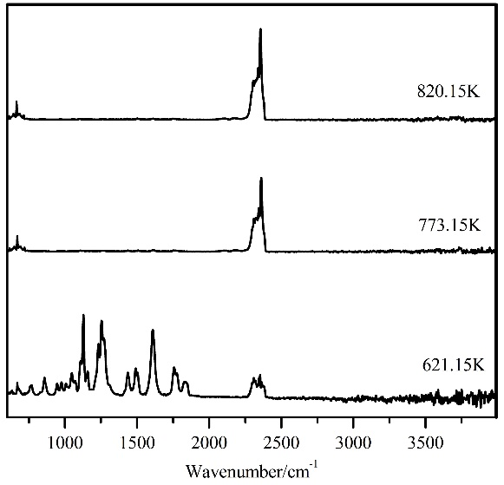

(c) (d)

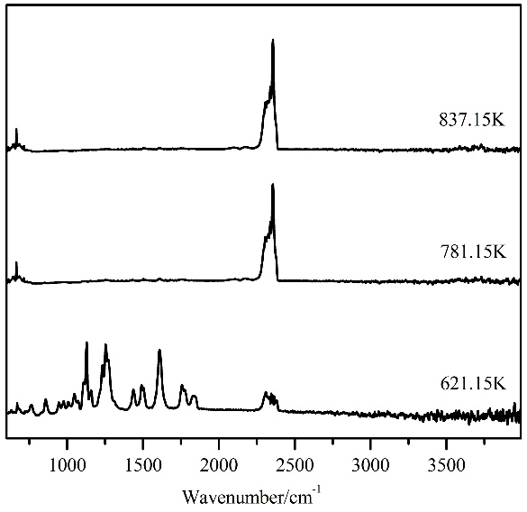

(e)

**Fig. S3** (a-e) Infrared spectra of fugitive gases of complexes **1-5** at different temperatures (a-e represent complexes **1-5**, respectively).