**Supplementary information**

**A comprehensive review of liquid chromatography hyphenated to post-column photoinduced fluorescence detection system for determination of analytes**

Nadeem Muhammada, b, *, Irshad Hussian b, Amjad Alid, Azeem Intisard, Iftikhar Ul Haqd, Qamar Subhani b, e, Mateen Hedard, Jia-Lun Zhongf,*, Muhammad Asifg,*, Dandan Guob, h, *, Hairong Cuia, Yan Zhub

aDepartment of Environmental Engineering, Wuchang University of Technology, Wuhan, China.

bDepartment of Chemistry, Zhejiang University, Hangzhou 310028, China.

cResearch School of polymeric Materials, School of Material Science & Engineering, Jiangsu University, Zhenjiang, 202113, PR China.

dSchool of Chemistry, University of the Punjab, Lahore, Pakistan.

eHigher Education Department, Lahore, Punjab, Pakistan.

fGuangzhou Institute of Advanced Technology, Chinese Academy of Sciences, Haibin Road no. 1121, Nansga district, Guangzhou, 511458, China.

gSchool of Chemistry and Chemical engineering, Huazhong University of Science and Technology, Wuhan, China.

hInstitute of Drug Discovery and Technology, Ningbo University, Ningbo 315211, China

(*) Corresponding author:

Tel.: +86 571 88273637 Fax: +86 571 88823446.

*E-mail address*: [nadeem@zju.edu.cn](mailto:nadeem@zju.edu.cn) (N. Nadeem); [jl.zhong@giat.ac.cn](mailto:jl.zhong@giat.ac.cn) (J. Zhong); [asif83chemist@hust.edu.cn](mailto:asif83chemist@hust.edu.cn) (M.Asif); [327061889@qq.com](mailto:327061889@qq.com) (D. Guo).

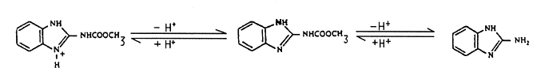

**Figure S1** carbendazim photo-dissociation behavior in alkaline and acidic pH.

**Table S1** Comparison between pre-column and post-column photo derivatization techniques.

|  |  |  |
| --- | --- | --- |
| **Pre-column derivatization** | **Post-column derivatization** | **Ref.** |
| Analytes aren’t separated in their original form, and separation condition need to optimize considering each analytes and their photoproducts. | Analytes are separated in their original form, which allow to adopt the optimized and published separation conditions. | ([Brinkman 198](#_ENREF_3" \o "Brinkman, 1987 #4)7)**Error! Hyperlink reference not valid.** |
| Derivatization might be complete, but derivatives limited time stability, and generation of interfering species from target analytes can cause various quantification problems such as background signal, decrease in the signal intensity of the derivatives. | Derivatization reaction doesn’t need to complete, and derivatized products also don’t need to be stable as long as the reaction is deemed reproducible. | (Brinkman 1987, Ibrahim et al., 2010, Rigas 2012) |
| Time consuming, poor reproducibility, and formation of many interfering species and side products. | Efficient, highly reproducible formation of fluorescent active product, minimum formation of side-product. | (Shen and Tomellini 2007) |
| Generally, photoderivatives are less stable as a result entail poor reproducibility, because the product is normally formed (sample storage & chromatographic separation time) long before its detection. | This provide excellent reproducibility, because photoproducts are formed just before the detection. | (Jones et al., 2015) |
| These reactions are normally slow and complete in minutes to hours. | These reactions are generally rapid and finish in seconds. | (Parlar and Surmann 2000) |
| Pre-column derivatization most of the time is carried out offline in batch mode. | It is performed only in on-line and automated mode for the efficient conversion of the target analytes into fluorescent form. | (Rigas 2012) |
| Separation conditions have minimum or no effect on the photoderivatization reactions and PIF signals of target analytes. | The optimized chromatographic separation conditions may be not very suitable for the detection step. For instance, various parameters such as solvent composition, pH, oxygen, presence of buffers, ion-paring reagents, temperature, residence time, intensity and wavelength of the light source may have critical effects on the reaction and PIF signals of target analytes. | (Lores et al., 1999) |
| More than one photoproducts are formed for a compound can be easily separated in pre-column mode, and it helps to understand the extent to which the photochemical reaction took place. | Sometime more than one photoproduct formed for a compound can’t be separated in post-column mode, and are often difficult to understand to the extent the photochemical reaction took place. | (Lores et al., 1999, Fedorowski and LaCourse 2010) |
| This mode of derivatization can assist to understand the degradation rate constants and characterize the photoproducts of target analytes. | This mode of derivatization is comparatively less informative to understand the degradation rate constants and characterization of the photoproducts of target analytes. | (Parlar and Surmann 2000) |

**Table S2** Application of LC-*uv*-FLD for determination of wide range of analytes in various matrice.

|  |  |  |  |  |  |  |  |
| --- | --- | --- | --- | --- | --- | --- | --- |
| **Analytes** | **Application** | **Extraction** | **Technique** | **Characteristics** | **Recoveries (%)** | **LODs (µg/kg)** | **Ref.** |
| **Pharmacetical drugs** | | | | | | | |
| Tamoxifen-DNA adduct | HL-60 cells | Mannheim Boehringer DNA isolation kit | HPLC-*hv*-UV/FLD | Column: Radial-Pak 8MBC18 L (10 mm, 8 mm ID, 10 cm); photochemical reactor: a PTEF knitted reactor coil (0.25 mm ID, 5-m) mounted around UV lamp (254-nm); fluorescence detector: λex/ λem = 260/375 nm; | -------- | ------ | (Sharma 2000) |
| Cyclooxygenase inhibitor: 5-chloro-3-(4-methanesulfonylphenyl)-69-methyl-bipyridinyl |  | Plasma and urine | HPLC-*hv*-FLD | Column: Keystone Prism® RP analytical column (15 cm × 4.6 mm, 5 µm); photochemical reactor: a PTFE reaction coil (5.0-m x 0.3-mm ID) mounted around UV lamp (254-nm); fluorescence detector: λex/ λem = 260/375 nm. | 66.9 – 108.2 | ≤ 5 | (Matthews et al., 2001) |
| Efavirenz | LLE | Human plasma | HPLC-*hv*-FLD | Column: Dinitrobenzoyl leucine column (4.6 × 250 mm); photochemical reactor: a KOTR PTFE coil (10 m × 0.3 mm ID) mounted around 254 nm UV lamp, fluorescence detector: λex/ λem = 310/390 nm | 95.0 – 104.0 | ------- | (Matthews et al., 2002) |
| Carbamazepine, dihydrocarbamazepine, diazepam, ketoprofen, ibuprofen, aspirin, nap roxen, bezafibrate, diclofenac | SPE | Waste water | HPLC-*hv*-FLD | Column: Nova-Pak C18 (150 × 3.9 mm) ; photochemical reactor: a homemade photo reactor was made of 40 W xenon lamp providing 254 nm wavelength of radiations. | ----------- | --------------- | ([González-Barreiro et al., 2003](#_ENREF_11" \o "González-Barreiro, 2003 #73)) |
|  |  |  |  |  |  |  |  |
| **Pesticides** | | | | | | | |
| Insecticides: iflubenzuron, ufenuron, triflumuron, hexaflumuron, flufenoxuron | Tomato | SPE | HPLC-*hv*-FLD | Column: Silica-based column (150 × 3.9 mm); photochemical reactor: a knitted open tube reactor (KOTR) with PTFE coil (5 m × 1.6 mm OD × 0.3 mm ID) mounted around 4 W Xe lamp; fluorescence detector: λex/λem = 330/410 nm. | 79 - 102 | 5 - 21 | (Martı́nez-Galera et al., 2001) |
| Pyrethroids insecticides: cyfluthrin,  tau-fluvalinate,  fenpropathrin, acrinathrin, bifenthrin  fenvalerate, deltamethrin, |  | Cucumber | HPLC*-hv*-FLD | Column: Bondapack C18 (300 × 3.9 mm); photochemical reactor: a KOTR PTFE coil (5 m × 1.6 mm OD × 0.3 mm ID) mounted around 4 W Xe lamp; fluorescence detector: λex/λem = 283/300 nm. | 95 - 116 | 0.24 – 2.70 | (López-López et al., 2001) |
| 2,4-dichlorophenoxyacetic acid, mecoprop |  | water | FIA-*hv*-FLD | photochemical reactor: a PTFE tubing (0.5 mm ID) mounted around a germicide UV-lamp (254 nm, 8 W); fluorescence detector: λex/ λem = 270/298 nm. | 97.0 - 107.8 | 33.5 - 73.2 | (Garcı́a-Campaña et al., 2001) |
| Acetamiprid | SPE | Vegetables | HPLC-*hv*-FLD | Column: Silica-based column (15 cm × 3.9 mm); photochemical reactor: a KOTR PTFE coil (5 m × 1.6 mm OD × 0.3 mm ID) mounted around a 4 W xenon lampl; fluorescence detector: λex/ λem = 283/300 nm. | 65.0 – 75.0 | 6.0 | (Martínez Vidal et al., 2002) |
| Diuron, isoproturon  ,linuron, neburon | ------- | ------- | HPLC-*hv*-FLD | Column: Nova-Pak C18 (150 × 3.9 mm); photochemical reactor: a KOTR PTFE coil (5 m × 1.6 mm OD × 0.3 mm ID) mounted around a 4 W Xe lamp; fluorescence detector: λex/ λem = 324/403; 301/433; and 326/385 335/411; nm for diuron, isoproturon, neburon, and linuron, respectively. | ------- | 0.07 - 0.46 | (Muñoz de la Peña et al., 2002) |
| Propanil, diuron, isoproturon, linuron, neburon | SPE | River water | HPLC-*hv*-FLD | Column: Nova-Pak C18 (150 × 3.9 mm); photochemical reactor: a KOTR PTFE coil (5 m × 1.6 mm OD × 0.3 mm ID) knitted around 4 W xenon lamp; fluorescence detector: λex/ λem 368/455 nm for propanil, λex/ λem = 275/ 333 nm for diuron; λex/ λem = 295/428 or 274/331 for isoproturon, λex/ λem = 335/411 nm for linuron and 326/385 nm for neburon. | -------------- | 0.08 – 0.80 | (de la Peña et al., 2003) |
|  |  |  |  |  |  |  | **Error! Hyperlink reference not valid.** |
| Triflumuron, flufenoxuron, diflubenzuron, lufenuron, hexaflumuron | LLE | vegetables | LC-LC-*hv*-FLD | Column: C18 (30 × 4.6 mm) were used as the first dimension separation column; whereas, lmChrompack C18 (50 × 4.6 mm) was used as second dimension column; photochemical reactor: a KOTR PTFE coil (5 m × 1.6 mm OD × 0.3 mm ID) knitted around 4 W Xe lamp; fluorescence detector: λex/ λem = 344/4148 nm. | 80.0 – 119.2 | 0.14 – 0.98 | (Gil García et al., 2004) |
| Diuron, monolinuron, neburon, linuron, and propanil | SPME | Groundwater | HPLC–PIF–FLD | Column: AQUASIL C18 (150 × 4.6 mm ID, 5 µm); photochemical reactor: a KOTR PTFE coil (5 m × 1.66 mm OD × 0.3 mm ID) knitted around 4 W xenon lamp; fluorescence detector: λex/ λem = 300/400 nm. | 86.0 – 105.0 | 0.019 – 034 | (Mughari et al., 2007) |
| Fenpropathrin, *λ*- permethrin, fenvalerate, deltamethrin, cyhalothrin, bifenthrin and *π*- fluvalinate | SPME | Groundwater | HPLC–PIF–FLD | Column: C18 (250 × 4.6 mm ID, 3.5 µm); photochemical reactor: a KOTR PTFE coil (5 m × 1.66 mm O.D. × 0.3 mm ID) knitted around 4 W xenon lamp, fluorescence detector: λex/ λem =283/330 nm. | 92 – 109 | 0.03 – 0.075 | (Vázquez et al., 2008) |
| cis-combretastatins | ---------- | ---------- | HPLC–PIF–FLD | Column: C18 (15 cm × 3 mm ID, 3 µm); photochemical reactor: a PTFE tubing (75 cm × 1/16 in. O.D × 0.006 in. ID) wound around mercury lamp (19 mm × 7 mm); fluorescence detector: λex/ λem = 320/390 nm. | ---------- | ---------- | (Stratford 2008) |
|  |  |  |  |  |  |  |  |
| Bifenthrin, *π*-fluvalinate, fenvalerate, deltamethrin,  λ-cyhalothrin,  permethrin, fenpropathrin | SPME | Cucumber& watermelon | HPLC–PIF–FLD | Column: C18 (250 × 4.6 mm ID, 3.5 µm) ; photochemical reactor: a KOTR PTFE coil (5 m × 1.66 mm OD × 0.3 mm ID) knitted around 4 W Xenon lamp, fluorescence detector: λex/ λem = 283/330 nm. | 91 – 110 | 1.3 – 5 | (Vázquez et al., 2008) |
| Flufenoxuron teflubenzuron, hexaflumuron, triflumuron, lufenuron, diflubenzuron, and | SPME | Orange juice | HPLC–PIF–FLD | Column: C18 (350 × 3 mm ID, 3 µm); photochemical reactor: a KOTR PTFE coil (5 m × 1.66 mm OD × 0.3 mm ID) knitted around 4 W Xenon lamp, fluorescence detector: λex/ λem = 330/410 nm. | 85 – 110 | 0.05 -0.15 | (Parrilla Vázquez et al., 2008) |
| Thiacloprid | Simple filtration | Water | IC–PIF–FLD | Column: Ion Pac® AS 11 (250 × 4 mm ID, 3.5 µm, 13 µm p.s); photochemical reactor: a KOTR PTFE coil (2 m × 1.5 mm OD × 0.5 mm ID) knitted around germicide UV-lamp (254 nm), fluorescence detector: λex/ λem = 236/353. | 95.5 - 114.0 | 9.9 | (Subhani et al., 2014) |
| Isoproturon,  rimsulfuron, monuron, MCPA,  thiabendazole, fuberidazole, carbaryl | Filtration | Water samples | HPLC-PIF-FLD & second-order  chemometric algorithms. | Column: C18 (15 cm × 4.6 mm ID, 5 µm); photochemical reactor: a KOTR PTFE coil (3 m × 0.8 mm OD × 0.3 mm ID) knitted around 8 W mercury lamp; fluorescence detector: λex/λem= 272/288-460 nm. | 79 – 110 | 19 - 280 | (Arancibia and Escandar 2014) |
| Carboxin, monalide, propanil | SPE | Water samples | DL-PIF–HPLC | Column: C18 (15 cm × 3.9 mm ID, 5 µm; photochemical reactor: 450 µL flow cell irradiated by Nd: YAG tunable laser: fluorescence detector λex/λem= 245/370 nm for carboxin; λex/λem= 245/354 nm for monalide and λex/λem= 255/464 nm for propanil. | 89.5 - 115.9 | 0.53 – 3.64 | (Mbaye et al., 2015) |
| **Miscellaneous analytes** | | | | | | | |
| Pteridins, biopterin,  Tetrahydrobiopterin, dihydrobiopterin | ---------- | Urine | HPLC–DAD–PIF–FLD | Column: C18 (250 × 4.6 mm ID, 5 µm) and (150 × 4.6 mm ID, 5 µm); photochemical reactor: a KOTR PTFE coil (4.5 m × 1.66 mm OD × 0.3 mm ID) knitted around 8 W Xenon lamp; fluorescence detector: λex/λem= 272/445 nm. | ---------- | ---------- | (Cañada-Cañada et al., 2009) |
| Resveratrol  & piceid isomers | Simple dilution | wine | HPLC–PIF–FLD | Column: C18 (150 × 3.9 mm ID, 4 µm); photochemical reactor: a KOTR PTFE coil (3 m × 1.66 mm OD × 0.3 mm ID) knitted around 4 W Xenon lamp; fluorescence detector: λex/ λem = 260/364 nm.. | ---------- | 0.001 - 0.01 mg/L | (Durán-Merás et al., 2008) |
| Aflatoxin B1 | LLE and Immunoaffinity column clean-up | Eggs | HPLC–PIF–FLD | Column: Phenomenex Prodigy column C18 (25 cm × 4.6 mm ID, 5 µm) for lab 1 and Phenomenex Kinetex C18 (150 × 4.6 mm ID, 2.6 µm) for lab 2; photochemical reactor: Kobra cell; fluorescence detector:λex/λem=362/425 nm. | 70 | 0.001 – 0.005 | (Pavšič-Vrtač et al., 2014) |
| Aflatoxins ( G1,G2, B1, B2), zearalenone, ochratoxin A | SPE | Cereals | HPLC–PIF–FLD | Column: C18 (150 × 4.6 mm ID, 3.5 µm); photochemical reactor: a KOTR PTFE coil (4.5 m × 1.66 mm OD × 0.3 mm ID) knitted around 8 W Xenon lamp; fluorescence detector: λex/λem= 60/455 nm for 0 – 18 min for Aflatoxins, λex/ λem = 276/460 nm for 18 – 29 min for zearalenone and λex/ λem = 335 /460 nm for 29 – 35 min for ochratoxin. | 77.31– 104.1 | 0.004 – 0.5 | (Rahmani et al., 2013) |
| Aflatoxin B1, B2, G1, G2 | SPE | Grains and Cereals | HPLC–PIF–FLD | Column: C18 (250 × 4.0 mm ID, 5 µm) photochemical reactor: Kobra cell™; fluorescence detector: λex/λem=365/435 nm | 89.2 – 97.8 | 0.062 - 0.080 | (Asghar et al., 2016) |
| Saxitoxin, neosaxitoxin, decarbamoylsaxitoxin, gonyautoxins 1 and 4, gonyautoxins (GTX )2 and 3, decarbamoylgonyautoxins 2, 3,  GTX5 (B1), C1, C2 | LLE | Mussels, clams, scallops, razor clam | HPLC–PIF–FLD | Column: C8 column (25 × 4.6 mm, 5 µm p.s) for C toxins, Zorbax Bonus-RP column (15 cm × 4.6 mm ID, 3.5 μm) for STX and GTX toxins; photochemical reactor: homemade; fluorescence detector : λex/ λem = 330/395. | ------ | 0.1 - 0.1464 | (Rey et al., 2015) |
| Aminosulfide and nitrosulfide impurities | Simple extraction | Vortioxetine  Manufacturing Process | HPLC–PIF–FLD | Column: XSELECT Charged Surface Hybrid Phenyl-Hexyl column (100 × 4.6 mm ID, 2.5 µm);photochemical reactor: a KOTR PTFE coil (7.5 m × 1.66 mm OD × 0.3 mm ID) knitted around UV lamp (254 nm);fluorescence detector: λex/λem = 272/300 nm. | ----------------- | 0.026 – 0.015 | (Douša et al., 2016) |
| Aflatoxins AFB1, AFB2, AFG1, AFG2, AFM1 | DLLE | Yogurt | HPLC–PIF–FLD | Column: C18 Kinetex (150 × 4.6 mm ID, 2.6 µm); photochemical reactor: homemade; fluorescence detector: λex/λem = 360/430 nm | 76.5 - 99.7 | 0.0015 – 0.0055 | (Hamed et al., 2017) |
| Aflatoxins G1, G2, B1, B2, and Ochratoxin A | LLE | Animal  feed | HPLC–PIF–FLD | Column: C18 UG120 (25 cm × 4.6 mm ID, 5 µm); photochemical reactor: homemade; fluorescence detector: λex/λem = 360/450 nm for all aflatoxins except λex/λem = 330/460 for Ochratoxin A, | 78.1 - 94.4 | 0.20 – 1.01 | (Kim et al., 2017) |
| Aflatoxin M1 | LLE & immunoaffinity AFLATEST column clean-up | Milk and dairy products | HPLC–PIF–FLD | Column: C18 (250 × 4.6 mm ID, 5 µm); photochemical reactor: a KOTR PTFE coil (5 m × 0.25 mm OD × 0.3 mm ID) knitted around mercury lamp (k = 254 nm), fluorescence detector: λex/λem = 360/440 nm | 85.2 – 107.0 | 0.0085 - 0.025 | (Shuib et al., 2017) |
| Aflatoxins AFB1, AFB2, AFG1, AFG2 | Solid-liquid extraction | Rice | HPLC–PIF–FLD | Column: C18 (50 × 2.1 mm ID, 1.8 µm); photochemical reactor: a KOTR PTFE coil (5 m × 0.25 mm OD × 0.3 mm ID) knitted around mercury lamp (k = 254 nm): fluorescence detector: λex/ λem = 365/46 nm. | 84.5 – 105.3 | 0.07 – 0.28 | (Huertas-Pérez et al., 2018) |
| Rimsulfuron, fuberidazole, carbaryl, naproxen, albendazole, carbamate,tamoxifen | SPE | Environmental Water | Third-order LC–PIF–FLD | Column: C8 (30 mm × 4.6 mm, 5 µm p.s); photochemical reactor: a PTFE coil (5 m × 0.3 mm OD × 0.5 mm ID) knitted around tubular 8 W mercury lamp (k = 254 nm), fluorescence detector: λex/λem = 227-277 (4 nm increment) /310-400 nm (2 nm. increment for all aflatoxins | ----------- | 0.02 – 0.27 | (Pellegrino Vidal et al., 2018) |
| Aflatoxins AFB1, AFB2 | Fe3O4/rGO Magnetic SPE | Vegetable oils | HPLC–PIF–FLD | Column:Kromasil C18 column (150 mm × 4.6 mm, 5 µm p.s); photochemical reactor: Pribolab Pte. Ltd., Singapore: fluorescence detector: λex/λem = 360/440 | 80.4 - 106.0 | 0.01- 0.02 | (Yu et al., 2019) |
| Aflatoxins B1, B2, G1, G2, zearalenone Ochratoxin A, Ochratoxin B | OASIS PRIME HLB SPE cartridge & DLLME | Poultry and meat | HPLC–PIF–FLD | Column: C18 (150 mm × 4.6 mm ×2.7 µm); photochemical reactor: UV lamp (254 nm), fluorescence detector: λex/λem = 365/440 nm for all aflatoxins, except λex/λem = 234/469 nm for Ochratoxin A, Ochratoxin B, zearalenone. | 73.6 - 88.0 | 0.64 - 42 | (Muñoz-Solano and González-Peñas 2020) |
| Aflatoxins AFB1, AFB2, AFG1, AFG2 | Fe3O4 nanoparticles based extraction | Vegetable  Oils | HPLC–PIF–FLD | Column: Insert ODS-3 (250 × 4.6 mm, 5 µm); photochemical reactor: a ethylene tetrafluoroethylene tube (2.5 m × 500 µm ID) knitted around 8 W Hg lamp (30 cm × 3 cm × 3 cm); fluorescence detector: λex/λem = 384/406 nm. | 82.6 - 106.2 | 0.01 - 0.16 | (Zhang et al., 2020) |

D-PF:First-derivative photochemically induced fluorescence; FIA–MEPIF: Flow injection analysis micellar-enhanced photochemically induced fluorescence; SPME: solid-phase microextraction; HPLC–PIF–FD: High performance liquid chromatography combined with post-column photochemically induced fluorimetric derivatization and fluorescence detection.

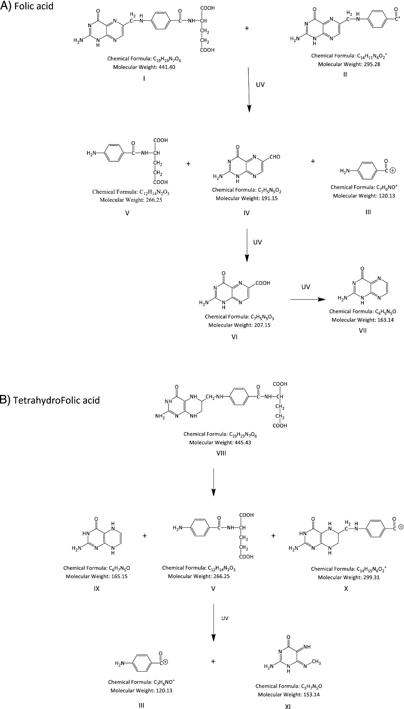

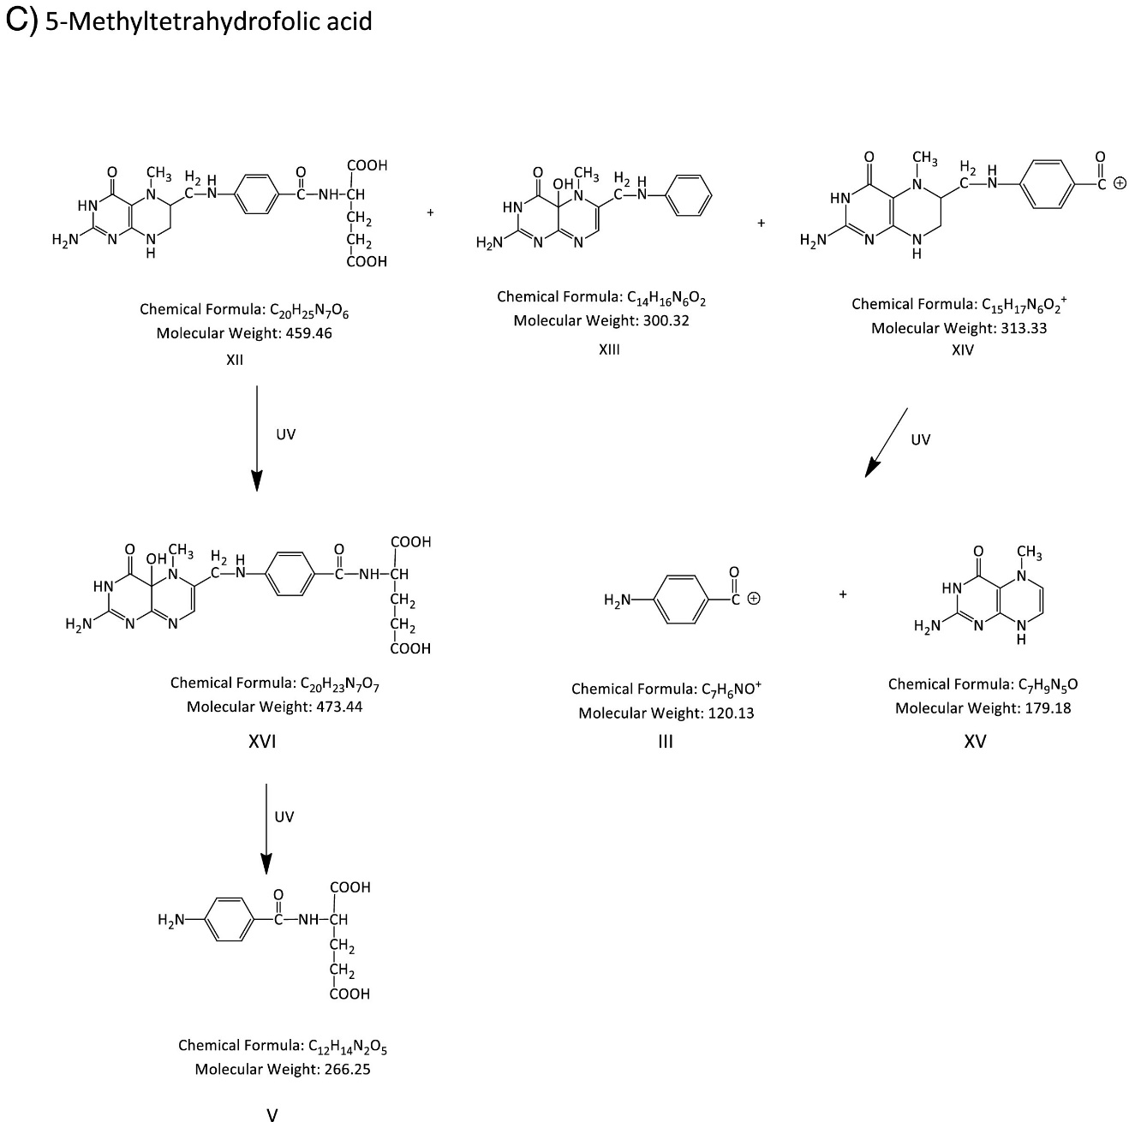

**Fig. S2 (A-C)** Schematic mass-spectrometric data based photo-degradation pathway of AF, THF and MTHF. From (Martín Tornero et al., 2017)**Error! Hyperlink reference not valid.***with permission from Elsevier.*

**Error! Hyperlink reference not valid.**

**Refernces**

Arancibia, J. A. and G. M. Escandar, 2014. Second-order chromatographic photochemically induced fluorescence emission data coupled to chemometric analysis for the simultaneous determination of urea herbicides in the presence of matrix co-eluting compounds. Anal. Methods. 6, 5503-5511. <https://doi.org/10.1039/C4AY00705K>

Asghar, M. A., J. Iqbal, A. Ahmed, et al., 2016. Development and validation of a high-performance liquid chromatography method with post-column derivatization for the detection of aflatoxins in cereals and grains. Toxicol. Ind. Health. 32, 1122-1134. <https://doi.org/10.1177/0748233714547732>

Brinkman, U. A. T., 1987. A review of reaction detection in HPLC. Chromatographia. 24, 190-200. <https://doi.org/10.1007/BF02688480>

Cañada-Cañada, F., A. Espinosa-Mansilla, A. Muñoz de la Peña, et al., 2009. Determination of marker pteridins and biopterin reduced forms, tetrahydrobiopterin and dihydrobiopterin, in human urine, using a post-column photoinduced fluorescence liquid chromatographic derivatization method. Anal. Chim. Acta. 648, 113-122. <https://doi.org/https://doi.org/10.1016/j.aca.2009.06.045>

de la Peña, A. M., M. C. Mahedero and A. Bautista-Sánchez, 2003. Monitoring of phenylurea and propanil herbicides in river water by solid-phase-extraction high performance liquid chromatography with photoinduced-fluorimetric detection. Talanta. 60, 279-285. <https://doi.org/https://doi.org/10.1016/S0039-9140(03)00072-9>

Douša, M., J. Doubský and J. Srbek, 2016. Utilization of Photochemically Induced Fluorescence Detection for HPLC Determination of Genotoxic Impurities in the Vortioxetine Manufacturing Process. J. Chromatogr. Sci. 54, 1625-1630. <https://doi.org/10.1093/chromsci/bmw116>

Durán-Merás, I., T. Galeano-Díaz and D. Airado-Rodríguez, 2008. Post-column on-line photochemical derivatization for the direct isocratic-LC-FLD analysis of resveratrol and piceid isomers in wine. Food Chem. 109, 825-833. <https://doi.org/https://doi.org/10.1016/j.foodchem.2007.12.080>

Fedorowski, J. and W. R. LaCourse, 2010. A review of post-column photochemical reaction systems coupled to electrochemical detection in HPLC. Anal. Chim. Acta. 657, 1-8. <https://doi.org/https://doi.org/10.1016/j.aca.2009.10.011>

Garcı́a-Campaña, A. M., J.-J. Aaron and J. M. Bosque-Sendra, 2001. Micellar-enhanced photochemically induced fluorescence detection of chlorophenoxyacid herbicides. Flow injection analysis of mecoprop and 2,4-dichlorophenoxyacetic acid. Talanta. 55, 531-539. <https://doi.org/https://doi.org/10.1016/S0039-9140(01)00470-2>

Gil García, M. D., D. Barranco Martínez, M. Martínez Galera, et al., 2004. Coupled-column liquid chromatography method with photochemically induced derivatization for the direct determination of benzoylureas in vegetables. J. Sep. Sci. 27, 1173-1180. <https://doi.org/10.1002/jssc.200301661>

González-Barreiro, C., M. Lores, M. C. Casais, et al., 2003. Simultaneous determination of neutral and acidic pharmaceuticals in wastewater by high-performance liquid chromatography–post-column photochemically induced fluorimetry. J. Chromatogr. A. 993, 29-37. <https://doi.org/https://doi.org/10.1016/S0021-9673(03)00392-3>

Hamed, A. M., D. Moreno-González, A. M. García-Campaña, et al., 2017. Determination of Aflatoxins in Yogurt by Dispersive Liquid–Liquid Microextraction and HPLC with Photo-Induced Fluorescence Detection. Food Anal. Methods. 10, 516-521. <https://doi.org/10.1007/s12161-016-0611-6>

Huertas-Pérez, J. F., N. Arroyo-Manzanares, D. Hitzler, et al., 2018. Simple determination of aflatoxins in rice by ultra-high performance liquid chromatography coupled to chemical post-column derivatization and fluorescence detection. Food Chem. 245, 189-195. <https://doi.org/https://doi.org/10.1016/j.foodchem.2017.10.041>

Ibrahim, H., E. Caudron, A. Kasselouri, et al., 2010. Interest of Fluorescence Derivatization and Fluorescence Probe Assisted Post-column Detection of Phospholipids: A Short Review. Molecules. 15, 352-373.

Jones, A., S. Pravadali-Cekic, G. R. Dennis, et al., 2015. Post column derivatisation analyses review. Is post-column derivatisation incompatible with modern HPLC columns? Anal. Chim. Acta. 889, 58-70. <https://doi.org/https://doi.org/10.1016/j.aca.2015.07.003>

Kim, H. J., M. J. Lee, H. J. Kim, et al., 2017. Analytical method development and monitoring of Aflatoxin B1, B2, G1, G2 and Ochratoxin A in animal feed using HPLC with Fluorescence detector and photochemical reaction device. Cogent Food Agric. 3, 1419788. <https://doi.org/10.1080/23311932.2017.1419788>

López-López, T., M. D. Gil-Garcia, J. L. Martı́nez-Vidal, et al., 2001. Determination of pyrethroids in vegetables by HPLC using continuous on-line post-elution photoirradiation with fluorescence detection. Anal. Chim. Acta. 447, 101-111. <https://doi.org/https://doi.org/10.1016/S0003-2670(01)01305-8>

Lores, M., O. Cabaleiro and R. Cela, 1999. Post-column photochemical derivatization in high-performance liquid chromatography. TrAC, Trends Anal. Chem. 18, 392-400. <https://doi.org/https://doi.org/10.1016/S0165-9936(98)00121-6>

Martín Tornero, E., A. Espinosa-Mansilla and I. Durán Merás, 2017. High-performance liquid chromatography with fast-scanning fluorescence detection and post-column on-line photoderivatization for the analysis of folic acid and its metabolites in vegetables. Microchem. J. 133, 333-345. <https://doi.org/https://doi.org/10.1016/j.microc.2017.03.044>

Martı́nez-Galera, M., T. López-López, M. D. Gil-Garcı́a, et al., 2001. Determination of benzoylureas in tomato by high-performance liquid chromatography using continuous on-line post-elution photoirradiation with fluorescence detection. J. Chromatogr. A. 918, 79-85. <https://doi.org/https://doi.org/10.1016/S0021-9673(01)00653-7>

Martínez Vidal, J. L., M. D. Gil García, M. Martínez Galera, et al., 2002. DETERMINATION OF ACETAMIPRID BY HPLC-FLUORESCENCE WITH POST-COLUMN PHOTODERIVATIZATION AND HPLC-MASS SELECTIVE DETECTION. J. Liq. Chromatogr. Relat. Technol. 25, 2695-2707. <https://doi.org/10.1081/JLC-120014386>

Matthews, C. Z., E. J. Woolf, L. Lin, et al., 2001. High-throughput, semi-automated determination of a cyclooxygenase II inhibitor in human plasma and urine using solid-phase extraction in the 96-well format and high-performance liquid chromatography with post-column photochemical derivatization-fluorescence detection. J. Chromatogr. B: Biomed. Sci. Appl. 751, 237-246. <https://doi.org/https://doi.org/10.1016/S0378-4347(00)00475-8>

Matthews, C. Z., E. J. Woolf, R. S. Mazenko, et al., 2002. Determination of efavirenz, a selective non-nucleoside reverse transcriptase inhibitor, in human plasma using HPLC with post-column photochemical derivatization and fluorescence detection. J. Pharm. Biomed. Anal. 28, 925-934. <https://doi.org/https://doi.org/10.1016/S0731-7085(01)00709-9>

Mbaye, O. M. A., A. Maroto, M. D. Gaye-Seye, et al., 2015. A new direct laser photo-induced fluorescence method coupled on-line with liquid chromatographic separation for the simultaneous determination of anilides pesticides. Talanta. 132, 909-914. <https://doi.org/https://doi.org/10.1016/j.talanta.2014.08.052>

Mughari, A. R., P. P. Vázquez and M. M. Galera, 2007. Analysis of phenylurea and propanil herbicides by solid-phase microextraction and liquid chromatography combined with post-column photochemically induced fluorimetry derivatization and fluorescence detection. Anal. Chim. Acta. 593, 157-163. <https://doi.org/https://doi.org/10.1016/j.aca.2007.04.061>

Muñoz-Solano, B. and E. González-Peñas, 2020. Mycotoxin Determination in Animal Feed: An LC-FLD Method for Simultaneous Quantification of Aflatoxins, Ochratoxins and Zearelanone in This Matrix. Toxins. 12, 374.

Muñoz de la Peña, A., M. C. Mahedero and A. Bautista-Sánchez, 2002. High-performance liquid chromatographic determination of phenylureas by photochemically-induced fluorescence detection. J. Chromatogr. A. 950, 287-291. <https://doi.org/https://doi.org/10.1016/S0021-9673(02)00042-0>

Parlar, S. N. and J. P. Surmann, 2000. Pre-column (hν-HPLC) photochemical reaction for the on-line characterization of photoproducts using p-aminobenzoic acid as a model substance. Fresenius' J. Anal. Chem. 367, 129-131. <https://doi.org/10.1007/s002160051612>

Parrilla Vázquez, P., A. R. Mughari and M. Martínez Galera, 2008. Solid-phase microextraction for the determination of benzoylureas in orange juice using liquid chromatography combined with post-column photochemically induced fluorimetry derivatization and fluorescence detection. J. Sep. Sci. 31, 56-63. <https://doi.org/https://doi.org/10.1002/jssc.200700289>

Pavšič-Vrtač, K., S. Ojanperä, J. Apajalahti, et al., 2014. Analytical Procedures for the Determination of Aflatoxin B1 in Eggs of Laying Hens Using Immunoaffinity Columns and Liquid Chromatography with Post-Column Derivatisation and Fluorescence Detection. Food Anal. Methods. 7, 1917-1924. <https://doi.org/10.1007/s12161-014-9836-4>

Pellegrino Vidal, R. B., A. C. Olivieri, G. A. Ibañez, et al., 2018. Online Third-Order Liquid Chromatographic Data with Native and Photoinduced Fluorescence Detection for the Quantitation of Organic Pollutants in Environmental Water. ACS Omega. 3, 15771-15779. <https://doi.org/10.1021/acsomega.8b02439>

Rahmani, A., S. Jinap, A. Khatib, et al., 2013. SIMULTANEOUS DETERMINATION OF AFLATOXINS, OCHRATOXIN A, AND ZEARALENONE IN CEREALS USING A VALIDATED RP-HPLC METHOD AND PHRED DERIVATIZATION SYSTEM. J. Liq. Chromatogr. Relat. Technol. 36, 600-617. <https://doi.org/10.1080/10826076.2012.670182>

Rey, V., A. Alfonso, L. M. Botana, et al., 2015. Influence of Different Shellfish Matrices on the Separation of PSP Toxins Using a Postcolumn Oxidation Liquid Chromatography Method. Toxins. 7, 1324-1340.

Rigas, P. G., 2012. REVIEW: LIQUID CHROMATOGRAPHY—POST-COLUMN DERIVATIZATION FOR AMINO ACID ANALYSIS: STRATEGIES, INSTRUMENTATION, AND APPLICATIONS. Instrumentation Science & Technology. 40, 161-193. <https://doi.org/10.1080/10739149.2011.651669>

Sharma, M., 2000. Analysis of Tamoxifen–DNA Adducts by High-Performance Liquid Chromatography Using Postcolumn Online Photochemical Activation. Biochem. Biophys. Res. Commun. 273, 40-44. <https://doi.org/https://doi.org/10.1006/bbrc.2000.2896>

Shen, X. and S. A. Tomellini, 2007. Indirect Photometric and Fluorometric Detection in High-Performance Liquid Chromatography: A Tutorial Review. Critical Reviews in Analytical Chemistry. 37, 107-126. <https://doi.org/10.1080/10408340600976531>

Shuib, N. S., A. Makahleh, S. M. Salhimi, et al., 2017. Determination of aflatoxin M1 in milk and dairy products using high performance liquid chromatography-fluorescence with post column photochemical derivatization. J. Chromatogr. A. 1510, 51-56. <https://doi.org/https://doi.org/10.1016/j.chroma.2017.06.054>

Stratford, M. R. L., 2008. Enhanced fluorescence detection of cis-combretastatins by post-column photolysis. J. Chromatogr. A. 1181, 162-165. <https://doi.org/https://doi.org/10.1016/j.chroma.2007.12.068>

Subhani, Q., Z.-P. Huang, Z.-Y. Zhu, et al., 2014. Analysis of insecticide thiacloprid by ion chromatography combined with online photochemical derivatisation and fluorescence detection in water samples. Chin. Chem. Lett. 25, 415-418. <https://doi.org/https://doi.org/10.1016/j.cclet.2013.11.014>

Vázquez, P. P., A. R. Mughari and M. M. Galera, 2008. Application of solid-phase microextraction for determination of pyrethroids in groundwater using liquid chromatography with post-column photochemically induced fluorimetry derivatization and fluorescence detection. J. Chromatogr. A. 1188, 61-68. <https://doi.org/https://doi.org/10.1016/j.chroma.2008.02.030>

Vázquez, P. P., A. R. Mughari and M. M. Galera, 2008. Solid-phase microextraction (SPME) for the determination of pyrethroids in cucumber and watermelon using liquid chromatography combined with post-column photochemically induced fluorimetry derivatization and fluorescence detection. Anal. Chim. Acta. 607, 74-82. <https://doi.org/https://doi.org/10.1016/j.aca.2007.11.027>

Yu, L., F. Ma, L. Zhang, et al., 2019. Determination of Aflatoxin B1 and B2 in Vegetable Oils Using Fe3O4/rGO Magnetic Solid Phase Extraction Coupled with High-Performance Liquid Chromatography Fluorescence with Post-Column Photochemical Derivatization. Toxins. 11, 621.

Zhang, H.-X., P. Zhang, X.-F. Fu, et al., 2020. Rapid and Sensitive Detection of Aflatoxin B1, B2, G1 and G2 in Vegetable Oils Using Bare Fe3O4 as Magnetic Sorbents Coupled with High-Performance Liquid Chromatography with Fluorescence Detection. J. Chromatogr. Sci. 58, 678-685. <https://doi.org/10.1093/chromsci/bmaa026>