**Supplementary material**

**Construction of Hydroxyethyl Cellulose/Silica/Graphitic Carbon Nitride Solid Foam for Adsorption and Photocatalytic Degradation of Dyes**

*Zhong-Zheng Gao1, Na Qi2, Wen-Jie Chen1, Hui Zhao1\**

1College of Chemical and Biological Engineering, Shandong University of Science and Technology, 579 Qianwangang Road, Huangdao District, 266590, Qingdao, Shandong Province, P. R. China

2School of Chemistry and Chemical Engineering, Shandong University, 27 South Road of ShanDa, 250100, Jinan, Shandong Province, P. R. China

*1Dr Hui Zhao

College of Chemical and Biological Engineering, Shandong University of Science and Technology, 579 Qianwangang Road, Huangdao District, Qingdao, Shandong Province, P.R. China

Email: [zhaohui7592@sdust.edu.cn](mailto:zhaohui7592@sdust.edu.cn)

**S1. Adsorption of organic dye**

***S1.1 Adsorption kinetics***

The pseudo-first-order kinetic model, pseudo-second-order kinetic model and intra-particle diffusion model were employed to analyze the dye adsorption kinetics onto the foam. These three models can be expressed as the following equations, respectively:







Where qe (mg/g) and qt (mg/g) were the adsorption capacity of the adsorbent at equilibrium time and time t, t (min) was the adsorption time. And *k*1 (min-1) and *k*2 (g**.**mg-1**.**min-1) were the pseudo-first-order kinetic rate constant and pseudo-second-order kinetic rate constant, respectively. *K*id was the intra-particle diffusion rate constant.

***S1.2 Adsorption isotherms***

The Langmuir and Freundlich adsorption isotherm models were employed to gain insight into the adsorption mechanism of the dyes and the corresponding mathematical expressions of the models were given as the following equations:





Where Ce was the equilibrium concentration of the dyes (mg/L); qe was the equilibrium adsorption capacity of dyes adsorbed onto the hydrogel (mg/g); qm denoted maximum adsorption capacity; KL and KF were the Langmuir constant (L/mg) and Freundlich constant (g mg-1 min-1), respectively.

**Table S1.** Pseudo-first-order kinetic model and Pseudo-second-order kinetic model parameters for the adsorption of MB

|  |  |  |  |  |  |  |
| --- | --- | --- | --- | --- | --- | --- |
| Solid foam | Pseudo-first-order kinetics model | | | Pseudo-second-order kinetics model | | |
|  | R2 | k1  (min-1) | qe  (mg/g) | R2 | k2  (g mg-1 min-1) | qe  (mg/g) |
| HEC/SiO2/C3N4-50 | 0.96114 | 0.0178 | 2.3777 | 0.99905 | 0.0148 | 3.6475 |
| HEC/SiO2/C3N4-80 | 0.27434 | 0.0061 | 1.5515 | 0.99911 | 0.1431 | 3.6019 |

**Table S2.** Langmuir and Freundlich isotherm fitting parameters for the adsorption of MB

|  |  |  |  |
| --- | --- | --- | --- |
| Models | Parameters | HEC/SiO2/C3N4-50 | HEC/SiO2/C3N4-80 |
| Langmuir | R2 | 0.97859 | 0.99914 |
| KL (L/mg) | 0.4679 | 0.1240 |
| qm (mg/g) | 93.1966 | 132.4503 |
| Freundlich | R2 | 0.717 | 060038 |
| KF ((mg/g)/(mg/L)1/n) | 30.4346 | 26.9192 |
| n | 4.7479 | 3.6248 |

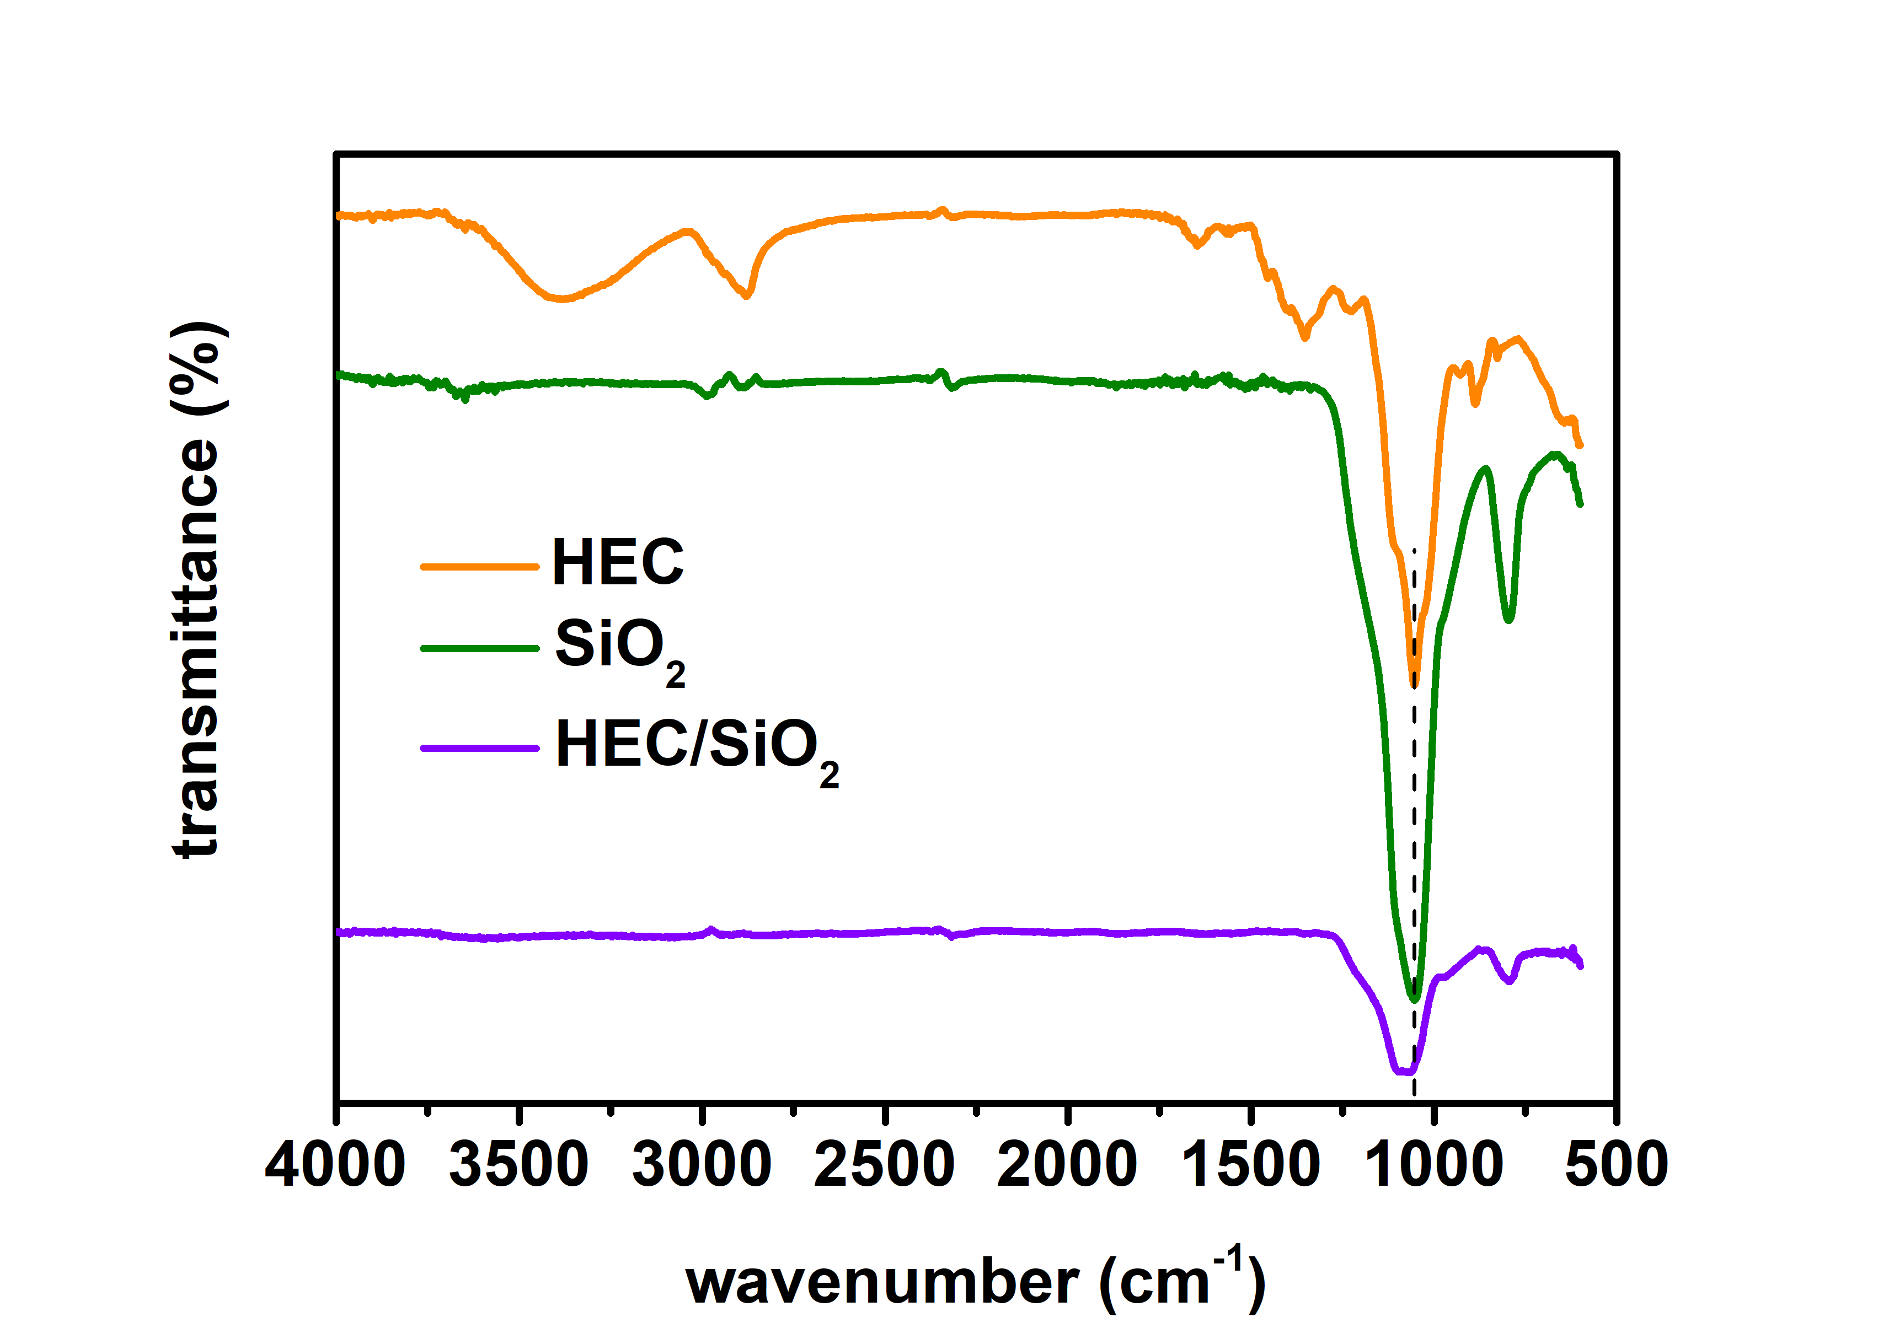

**Figure S1.** FT-IR spectrum of HEC powder, SiO2 powder and HEC/SiO2 hydrogel

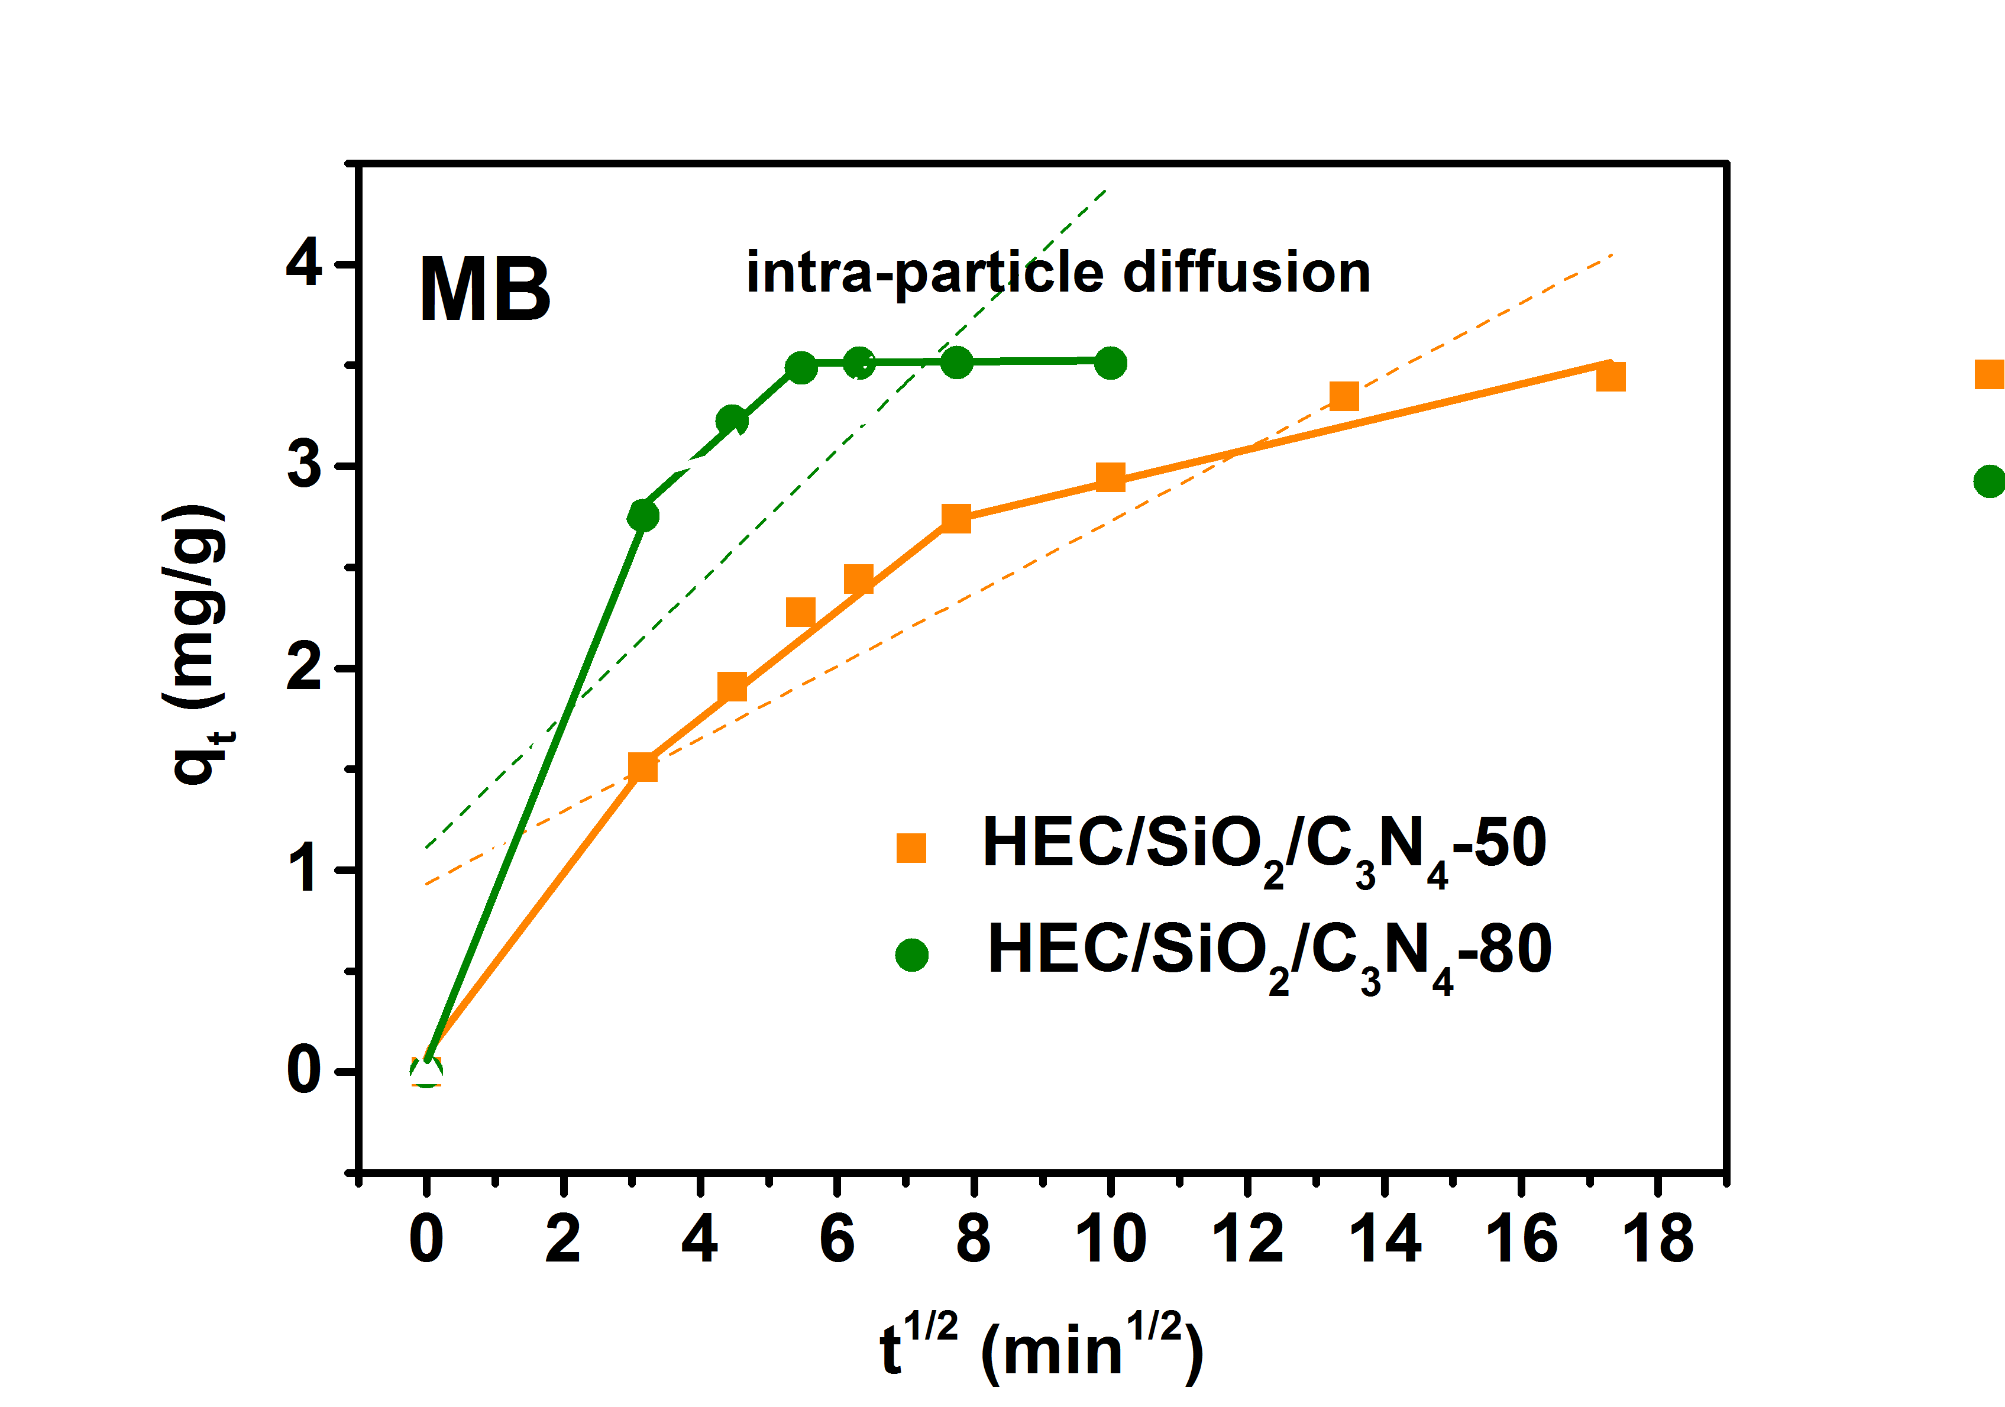

**Figure S2.** Plots of the intra-particle diffusion model for the adsorption of MB



**Figure S3.** (a) Effect of contact time on the adsorption capacity of MV; Plots of the (b) pseudo-second-order kinetics model and (c) intra-particle diffusion model for the adsorption of MV



**Figure S4.** (a) Adsorption isotherms of MV; (b) Plots of Langmuir adsorption isotherm model for the adsorption of MV



**Figure S5.** Removal efficiencies of MV (10 mg/L, 30 mL) by the HEC/SiO2/C3N4-50 and HEC/SiO2/C3N4-80 solid foams and bare g-C3N4 powder



**Figure S6.** Removal efficiencies of MV by HEC/SiO2/C3N4-80 under visible light irradiation

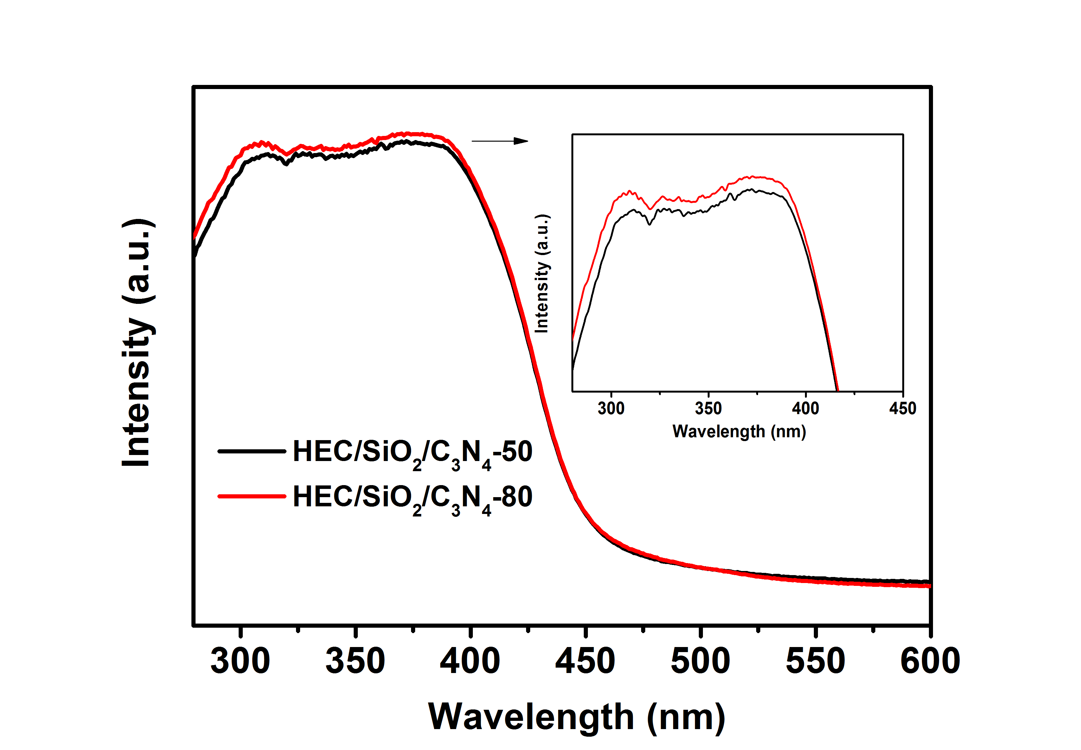

**Figure S7.** UV–vis DRS spectra of HEC/SiO2/C3N4 solid foams



**Figure S8.** Removal efficiencies of MB (10 mg/L, 20 mL) by HEC/SiO2/C3N4-50 during 4 cycles

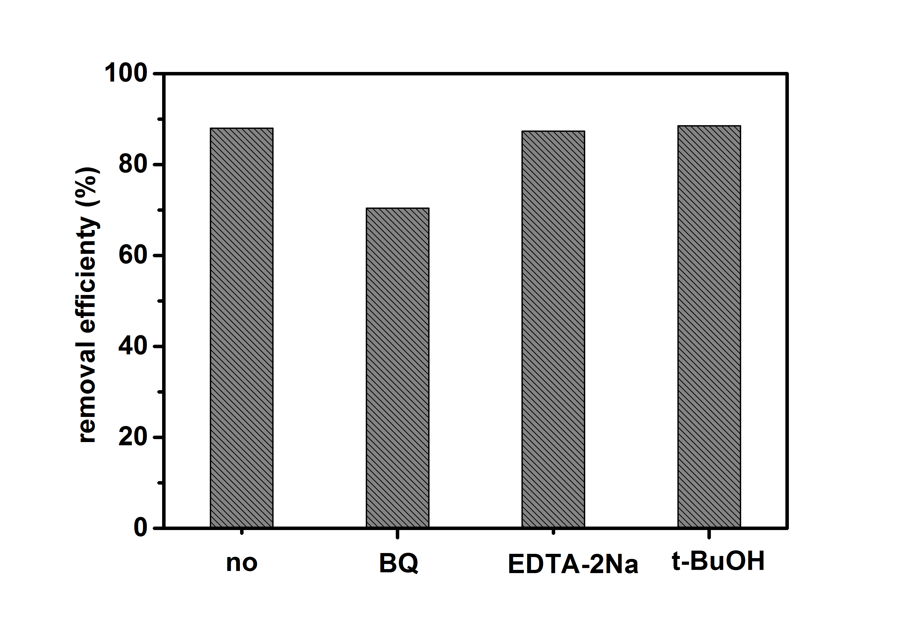

**Figure S9.** Effect of different radical scavengers on photocatalytic degradation of MB