Study on the Corrosion behavior of polymeric nanocomposite coatings containing halloysite nanotubes loaded with multicomponent inhibitor
Norhan Ashraf Ismail ^{1,2}, Abdraman M. Moussa³, Ramazan Kahraman ^{2,}* and R. A. Shakoor ^{1,}*
¹Center for Advanced Materials, Qatar University, Doha 2713, Qatar
² Department of Chemical Engineering, College of Engineering, Qatar University, Doha 2713, Qatar
³ Qatar University Young Scientist Center (QUYSC), Qatar University, Doha 2713, Qatar

Supporting information
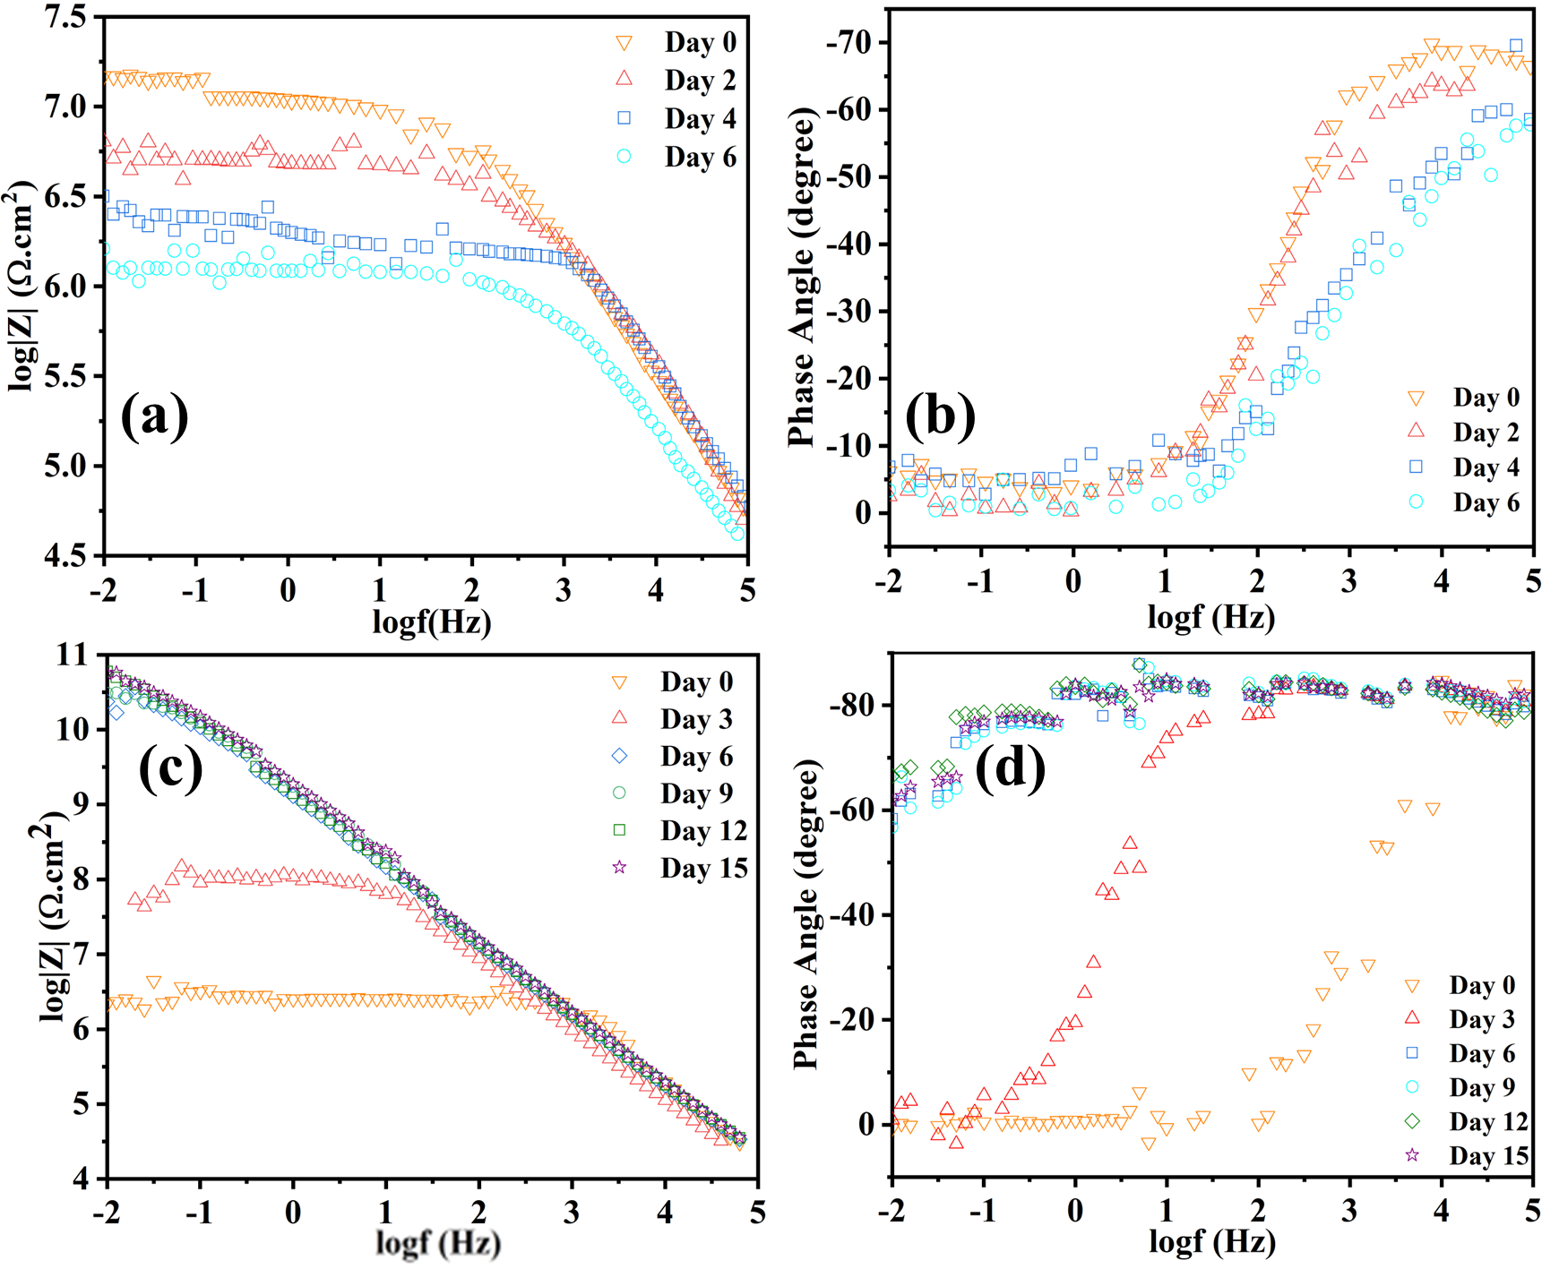
Figure S1 Raw date of (a) bode graph of ULHNT COAT, (b) phase angle of ULHNT COAT, (c) bode graph of LHNT COAT and (d) phase angle of LHNT COAT

