**Supporting Information**

Synthesis, Bioactivity and Preliminary Mechanism of Action of Novel Trifluoromethyl Pyrimidine Derivatives

Xuemei Tanga,†, Wenliang Zhana,†, Shuai Chena, Ran Zhoua, Die Hua, Nan Suna, Qiang Feib, Wenneng Wub,*, Wei Xuea,*

aState Key Laboratory Breeding Base of Green Pesticide and Agricultural Bioengineering; Key Laboratory of Green Pesticide and Agricultural Bioengineering, Ministry of Education; Research and Development Center for Fine Chemicals, Guizhou University, Guiyang 550025, P.R. China

bFood and Pharmaceutical Engineering Institute, Guiyang University, Guiyang 550003, P.R. China

†These authors contributed equally to this work.

*Corresponding author: Tel.: 0086-851-88292090, Fax: 0086-851-88292090, E-mail: wxue@gzu.edu.cn (Wei Xue), wuwenneng123@126.com (Wenneng Wu)

Abbreviation

|  |  |  |
| --- | --- | --- |
|  | abbreviation | full name |
| 1 | 1H NMR | 1H nuclear magnetic resonance |
| 2 | 13C NMR | 13C nuclear magnetic resonance |
| 3 | 19F NMR | 19F nuclear magnetic resonance |
| 4 | HRMS | High-resolution mass spectroscopy |
| 5 | TMV | tobacco mosaic virus |
| 6 | MST | Microscale thermophoresis |
| 7 | *AB* | *Alternaria brassicae* |
| 8 | *FF* | *Fusarium fujikuroi* |
| 9 | *FO* | *Fusarium oxysporum f.sp.cucumerinum* |
| 10 | *CT* | *Colletotrichum truncatum* |
| 11 | *PC* | *Phytophthora capsici* |
| 12 | *CG* | *Colletotrichum gloeosporioides* |
| 13 | *RS* | *Rhizoctonia solani* |
| 14 | *FG* | *Fusarium graminearum* |
| 15 | *PS* | *Phytophthora soja* |
| 16 | *PP* | *Phytophthora* *palmivora* |
| 17 | *BC* | *Botrytis cinerea* |
| 18 | *PL* | *Phytophthora litchii* |
| 19 | DMSO | Dimethylsulfoxide |
| 20 | DMF | *N*,*N*-dimethylformamide |
| 21 | TLC | Thin Layer Chromatography |
| 22 | m.p. | Melting point |
| 23 | EC50 | 50% effective concentration |
| 24 | NB | Nutrient broth |
| 25 | OD | Optical density |
| 26 | PDA | Potato dextrose agar |
| 27 | TC | Thiodiazole-copper |
| 28 | BT | Bismerthiazol |
| 29 | SEM | Scanning electron microscope |

**Chemical synthesis**

***General Procedures for Preparing Target Compounds 5a–5v***

Intermediates **4** (1.69mmol), K2CO3 (2.30mmol) and DMF (20mL) were added to a 50mL round-bottom flask and stirred in ice bath for 30min, then DMF-dissolved chloride (1.53mmol) was added drop by drop for 6-8h reaction at room temperature, The reaction was monitored using TLC. Once the reaction was complete, the reaction solution was dumped into 30mL water and extracted with ethyl acetate for 3 times. The organic layer was combined and the solvent was removed by decompression to obtain the crude product. The crude product was purified using column chromatography (*V/V*, ethyl acetate: petroleum ether = 15:1 to 8:1) to obtain compounds **5a-5v** with a yield of 42% ~ 85%.

Crystal data of partly of the target compound **5d** and **5f**

|  |  |  |
| --- | --- | --- |
| compound | **5d** | **5f** |
| Empirical formula | C20H14N2O3F3Cl | C20H13N2O3F4Cl |
| Formula weight | 422.78 | 440.77 |
| Temperature/K | 293(2) | 298.15 |
| Crystal system | monoclinic | monoclinic |
| Space group | C2/c | C2/c |
| a/Å | 33.696(3) | 29.278(3) |
| b/Å | 8.3255(8) | 9.6715(8) |
| c/Å | 16.0615(15) | 15.1518(14) |
| α/° | 90 | 90 |
| β/° | 112.950(5) | 111.425(5) |
| γ/° | 90 | 90 |
| Volume/Å3 | 4149.1(7) | 3993.9(6) |
| Z | 8 | 8 |
| ρcalcg/cm3 | 1.354 | 1.466 |
| μ/mm‑1 | 0.233 | 0.252 |
| F(000) | 1728.0 | 1792.0 |
| Crystal size/mm3 | 0.42 × 0.17 × 0.08 | 0.4 × 0.18 × 0.07 |
| Radiation | MoKα (λ = 0.71073) | MoKα (λ = 0.71073) |
| 2Θ range for data collection/° | 5.066 to 50.048 | 5.016 to 50.04 |
| Index ranges | -19 ≤ h ≤ 40, -9 ≤ k ≤ 9, -18 ≤ l ≤ 19 | -30 ≤ h ≤ 34, -11 ≤ k ≤ 11, -17 ≤ l ≤ 18 |
| Reflections collected | 9887 | 9466 |
| Independent reflections | 3643 [Rint = 0.1318, Rsigma = 0.1115] | 3478 [Rint = 0.0818, Rsigma = 0.0815] |
| Data/restraints/parameters | 3643/0/263 | 3478/354/301 |
| Goodness-of-fit on F2 | 0.897 | 0.886 |
| Final R indexes [I>=2σ (I)] | R1 = 0.0764, wR2 = 0.1597 | R1 = 0.0726, wR2 = 0.1869 |
| Final R indexes [all data] | R1 = 0.2100, wR2 = 0.2142 | R1 = 0.1608, wR2 = 0.2322 |
| Largest diff. peak/hole / e Å-3 | 0.29/-0.27 | 0.35/-0.31 |

**1H NMR, 13C NMR, 19F NMR and HRMS spectrum of the title compounds**

|  |  |
| --- | --- |
|  | **Physical and chemical data** |
|  | **1H NMR (400 MHz, CDCl3)** δ 8.19 – 8.18 (m, 1H, Ph-H), 8.17 – 8.15 (m, 1H, Ph-H), 7.46 (dd, *J* = 5.2, 3.0 Hz, 2H, Ph-H), 7.29 (dd, *J* = 8.3, 2.1 Hz, 1H, Ph-H), 7.26 (s, 1H, Ph-H), 7.25 – 7.23 (m, 1H, Ph-H), 7.08 (s, 1H, Pyr-H), 5.45 (s, 2H, O-CH2-Ph), 2.62 (s, 3H, Pyr-CH3) ;  **13C NMR (101 MHz, CDCl3)** δ 170.17, 169.62, 165.27, 155.77, 134.97, 134.67, 132.18, 131.72, 130.97, 129.60, 127.49, 127.30, 121.58, 102.37, 63.69, 25.82;  **19F NMR (376 MHz, CDCl3)** δ-70.18;  **HRMS** (ESI) [M+H]+ calcd for C20H14O3N2Cl2F3: 457.0328, found: 457.0315; White solid; m.p.: 82.1-83.3. oC; yield, 50%. |
|  | **1H NMR (400 MHz, CDCl3)** δ 8.19 – 8.14 (m, 2H, Ph-H), 7.49 (td, *J* = 7.5, 1.7 Hz, 1H, Ph-H), 7.36 (tdd, *J* = 7.3, 5.3, 1.8 Hz, 1H, Ph-H), 7.24 (d, *J* = 2.0 Hz, 1H, Ph-H), 7.22 (d, *J* = 2.0 Hz, 1H, Ph-H), 7.18 (td, *J* = 7.5, 1.1 Hz, 1H, Ph-H), 7.12 (ddd, *J* = 9.5, 8.3, 1.0 Hz, 1H, Ph-H), 7.07 (s, 1H, Pyr-H), 5.45 (s, 2H, O-CH2-Ph), 2.62 (s, 3H, Pyr-CH3);  **13C NMR (101 MHz, CDCl3)** δ170.18 , 169.68, 165.46 , 162.41 , 159.93 , 157.71 , 155.66 , 131.72 , 130.76, 130.40 , 127.76 , 124.23 , 122.96 , 121.51 , 115.52, 102.34 , 60.99, 25.82;  **19F NMR (376 MHz, CDCl3)** δ-70.18, -117.79;  **HRMS** (ESI) [M+H]+ calcd for C20H15O3N2F4: 407.1013, found: 407.1003; Yellow oil; yield, 65%. |
|  | **1H NMR (400 MHz, CDCl3)** δ8.18 – 8.16 (m, 1H, Ph-H), 8.16 – 8.14 (m, 1H, Ph-H), 7.35 (d, *J* = 8.0 Hz, 2H, Ph-H), 7.24 – 7.23 (m, 1H, Ph-H), 7.22 – 7.21 (m, 2H, Ph-H), 7.20 (d, *J* = 2.0 Hz, 1H, Ph-H), 7.06 (s, 1H, Pyr-H), 5.34 (s, 2H, O-CH2-Ph), 2.62 (s, 3H, Ph-CH3), 2.37 (s, 3H, Pyr-CH3);  **13C NMR (101 MHz, CDCl3)** δ170.18 , 169.71 , 165.61 , 157.35 , 155.56 , 138.30, 132.85, 131.67, 129.34, 128.50 , 128.04, 121.45, 102.35, 102.32, 66.95, 25.82, 21.26;  **19F NMR (376 MHz, CDCl3)** δ-70.18;  **HRMS** (ESI) [M+H]+ calcd for C21H18O3N2F3: 403.1264, found: 403.1257; White solid; m.p.: 47.3-48.9 oC; yield, 54%. |
|  | **1H NMR (400 MHz, CDCl3)** δ 8.21 – 8.19 (m, 1H, Ph-H), 8.19 – 8.17 (m, 1H, Ph-H), 7.54 – 7.50 (m, 1H, Ph-H), 7.46 – 7.41 (m, 1H, Ph-H), 7.34 – 7.29 (m, 2H, Ph-H), 7.26 (d, *J* = 2.0 Hz, 1H, Ph-H), 7.24 (d, *J* = 2.0 Hz, 1H, Ph-H), 7.08 (s, 1H, Pyr-H), 5.49 (s, 2H, O-CH2-Ph), 2.62 (s, 3H, Pyr-CH3);  **13C NMR (101 MHz, CDCl3)** δ170.19, 169.67, 165.39, 157.35, 155.68, 133.96, 133.54, 131.75, 130.10, 129.73 , 127.73, 126.99, 121.56, 102.40, 64.3, 25.85;  **19F NMR (376 MHz, CDCl3)** δ -70.17;  **HRMS** (ESI) [M+H]+ calcd for C20H15O3N2ClF3: 423.0717, found: 423.0701; Brown solid; m.p.: 77.8-79.7 oC; yield, 67%. |
|  | **1H NMR (400 MHz, CDCl3)** δ 8.29 – 8.27 (m, 1H, Ph-H), 8.26 – 8.25 (m, 1H, Ph-H), 8.20 (d, *J* = 2.0 Hz, 1H, Ph-H), 8.19 – 8.17 (m, 1H, Ph-H), 7.64 (s, 1H, Ph-H), 7.62 (s, 1H, Ph-H), 7.29 (d, *J* = 2.0 Hz, 1H, Ph-H), 7.27 (d, *J* = 2.1 Hz, 1H, Ph-H), 7.09 (s, 1H, Pyr-H), 5.48 (s, 2H, O-CH2-Ph), 2.63 (s, 3H, Pyr-CH3);  **13C NMR (101 MHz, CDCl3)** δ170.17, 169.60, 165.24, 157.78, 155.95, 147.82, 143.13, 131.73 , 128.48, 127.21, 123.94, 121.69, 102.43, 65.42, 25.83;  **19F NMR (376 MHz, CDCl3)** δ -70.18;  **HRMS** (ESI) [M+H]+ calcd for C20H15O5N3F3: 434.0958, found: 434.0941; Yellow solid; m.p.: 116.4-117.9 oC; yield, 42%. |
|  | **1H NMR (400 MHz, CDCl3)** δ 8.16 – 8.14 (m, 1H, Ph-H), 8.13 – 8.12 (m, 1H, Ph-H), 7.37 – 7.27 (m, 2H, Ph-H), 7.24 – 7.22 (m, 1H, Ph-H), 7.22 – 7.20 (m, 1H, Ph-H), 7.10 – 7.07 (m, 1H, Ph-H), 7.06 – 7.05 (m, 1H, Pyr-H), 5.54 (s, 2H, O-CH2-Ph), 2.62 (s, 3H, Pyr-CH3);  **13C NMR (101 MHz, CDCl3)** δ170.18, 169.67, 165.39, 163.34, 157.68, 155.63, 136.58, 131.77, 130.95, 127.63, 125.61, 121.50, 118.94, 114.52, 102.37, 57.95, 25.84;  **19F NMR (376 MHz, CDCl3)** δ -70.18, -112.68;  **HRMS** (ESI) [M+H]+ calcd for C20H14O3N2ClF4: 441.0623, found: 441.0608; White solid; m.p.: 73.8-75.0 oC; yield, 45%. |
|  | **1H NMR (400 MHz, CDCl3)** δ 8.20 – 8.18 (m, 1H, Ph-H), 8.18 – 8.16 (m, 1H, Ph-H), 7.32 (t, *J* = 7.9 Hz, 1H, Ph-H), 7.26 – 7.24 (m, 1H, Ph-H), 7.24 – 7.22 (m, 1H, Ph-H), 7.07 (s, 1H, , Pyr-H), 7.04 (d, *J* = 7.6 Hz, 1H, Ph-H), 7.01 – 6.99 (m, 1H, Ph-H), 6.92 – 6.88 (m, 1H, Ph-H), 5.36 (s, 2H, Ph-O-CH2), 3.84 (s, 3H, Ph-O-CH3), 2.62 (s, 3H, Pry-CH3);  **13C NMR (101 MHz, CDCl3)** δ170.19, 169.69, 165.54, 159.78, 157.69, 155.62, 137.38, 131.71, 129.76, 127.89, 121.51, 120.45, 118.94, 113.88, 113.65, 102.38, 66.81, 55.31, 25.85;  **19F NMR (376 MHz, CDCl3)** δ -70.17;  **HRMS** (ESI) [M+H]+ calcd for C21H18O4N2F3: 419.1213, found: 419.1199; Yellow oil; yield, 50%. |
|  | **1H NMR (400 MHz, CDCl3)** δ 8.16 – 8.15 (m, 1H, Ph-H), 8.14 – 8.13 (m, 1H, Ph-H), 7.26 – 7.25 (m, 1H, Ph-H), 7.24 – 7.22 (m, 1H, Ph-H), 7.07 (s, 1H, Pyr-H), 3.95 (s, 3H, O-CH3), 2.63 (s, 3H, Pry-CH3);  **13C NMR (101 MHz, CDCl3)** δ170.19 , 169.71, 166.24, 157.69, 155.51, 131.56, 127.95, 121.47, 118.94, 102.33, 52.34, 25.84;  **19F NMR (376 MHz, CDCl3)** δ -70.18;  **HRMS** (ESI) [M+H]+ calcd for C14H12O3N2F3: 313.0794, found: 313.0785; White solid; m.p.: 111.1–112.4 oC; yield, 57%. |
|  | **1H NMR (400 MHz, CDCl3)** δ 8.52 (d, *J* = 2.2 Hz, 1H, Ph-H), 8.17 – 8.15 (m, 1H, Ph-H), 8.14 – 8.13 (m, 1H, Ph-H), 7.78 (dd, *J* = 8.2, 2.5 Hz, 1H, Ph-H), 7.38 (d, *J* = 8.2 Hz, 1H, Ph-H), 7.26 (d, *J* = 2.0 Hz, 1H, Ph-H), 7.25 – 7.24 (m, 1H, Ph-H), 7.08 (s, 1H, Pyr-H), 5.38 (s, 2H, Ph-O-CH2), 2.62 (s, 3H, Pry-CH3);  **13C NMR (101 MHz, CDCl3)** δ170.17, 169.60, 165.31, 157.74, 155.88, 151.65, 149.74, 139.04, 131.71, 127.22, 124.38, 121.66, 118.92, 102.42, 63.50, 25.84;  **19F NMR (376 MHz, CDCl3)** δ -70.18;  **HRMS** (ESI) [M+H]+ calcd for C19H14O3N3ClF3: 424.0670, found: 424.0653; White solid; m.p.: 98.6–99.4 oC; yield, 49%; |
|  | **1H NMR (400 MHz, CDCl3)** δ 8.19 – 8.17 (m, 1H, Ph-H), 8.17 – 8.15 (m, 1H, Ph-H), 7.26 (d, *J* = 2.0 Hz, 1H, Ph-H), 7.25 – 7.23 (m, 1H, Ph-H), 7.08 (s, 1H, Pyr-H), 6.06 (ddt, *J* = 17.1, 10.5, 5.7 Hz, 1H, Ph-H), 5.44 (dq, *J* = 17.2, 1.5 Hz, 1H, Ph-H), 5.32 (ddd, *J* = 10.5, 2.5, 1.2 Hz, 1H, Ph-H), 4.86 (t, *J* = 1.4 Hz, 1H, O-CH2), 4.85 (t, *J* = 1.4 Hz, 1H, O-CH2), 2.63 (s, 3H, Pyr-CH3);  **13C NMR (101 MHz, CDCl3)** δ170.19, 169.70, 165.40, 157.69, 155.57, 132.07, 131.63, 127.95, 121.49, 118.94, 118.54, 102.37, 65.81, 25.85;  **19F NMR (376 MHz, CDCl3)** δ -70.18;  **HRMS** (ESI) [M+H]+ calcd for C16H14O3N2F3: 339.0951, found: 339.0943; Yellow oil; yield, 41%. |
|  | **1H NMR (400 MHz, CDCl3)** δ 8.16 – 8.14 (m, 1H, Ph-H), 8.13 (d, *J* = 2.1 Hz, 1H, Ph-H), 7.63 (s, 1H, Thia-H), 7.27 (d, *J* = 2.5 Hz, 1H, Ph-H), 7.25 – 7.24 (m, 1H, Ph-H), 7.08 (s, 1H, Pyr-H), 5.46 (s, 2H, O-CH2), 2.62 (s, 3H, Pyr-CH3);  **13C NMR (101 MHz, CDCl3)** δ170.17, 169.59, 165.36, 157.39, 155.99, 153.86, 141.90, 134.69, 131.78, 126.94, 121.68, 102.42, 58.57, 25.84;  **19F NMR (376 MHz, CDCl3)** δ -70.18;  **HRMS** (ESI) [M+H]+ calcd for C17H11O7NF3S: 430.0202, found: 430.0212; Brown solid; m.p.: 70.2–72.1 oC; yield, 62%. |
|  | **1H NMR (400 MHz, CDCl3)** δ 8.88 (s, 1H, Pyr-H), 8.22 – 8.20 (m, 1H, Ph-H), 8.20 – 8.18 (m, 1H, Ph-H), 7.47 – 7.43 (m, 2H, Ph-H), 7.33 (d, *J* = 0.9 Hz, 1H, Ph-H), 7.30 (d, *J* = 2.1 Hz, 1H, Ph-H), 7.28 (t, *J* = 2.2 Hz, 1H, Ph-H), 7.26 – 7.25 (m, 1H, Pyr-H), 5.44 (s, 2H, Ph-O-CH2);  **13C NMR (101 MHz, CDCl3)** δ169.81, 165.12, 159.31, 157.34, 155.47, 134.95, 134.63, 132.13, 131.86, 130.91, 129.59, 127.87, 127.29, 121.66, 118.81, 105.82, 63.72;  **19F NMR (376 MHz, CDCl3)** δ -70.14;  **HRMS** (ESI) [M+H]+ calcd for C19H12O3N2Cl2F3: 443.0171, found: 443.0164; Brown solid; m.p.: 81.0–82.4 oC; yield, 71%. |
|  | **1H NMR (400 MHz, CDCl3)** δ 8.88 (s, 1H, Pyr-H), 8.22 – 8.19 (m, 1H, Ph-H), 8.19 – 8.17 (m, 1H, Ph-H), 7.48 (td, *J* = 7.5, 1.6 Hz, 1H, Ph-H), 7.39 – 7.32 (m, 2H, Ph-H), 7.26 (d, *J* = 2.0 Hz, 1H, Ph-H), 7.25 – 7.23 (m, 1H, Ph-H), 7.17 (td, *J* = 7.5, 1.0 Hz, 1H, Ph-H), 7.14 – 7.09 (m, 1H, Pyr-H), 5.45 (s, 2H, Ph-O-CH2);  **13C NMR (101 MHz, CDCl3)** δ169.87, 165.32, 162.38, 159.91, 159.35, 157.33, 155.38, 131.87, 130.73, 130.42, 128.16, 124.34, 124.25, 122.93, 121.60, 115.52, 105.81, 60.98;  **19F NMR (376 MHz, CDCl3)** δ -70.16, -117.67;  **HRMS** (ESI) [M+H]+ calcd for C19H13O3N2F4: 393.0856, found: 393.0847; Brown solid; m.p.: 108.4–110.5 oC; yield, 66%. |
|  | **1H NMR (400 MHz, CDCl3)** δ 8.87 (s, 1H, Pyr-H), 8.20 – 8.19 (m, 1H, Ph-H), 8.18 – 8.16 (m, 1H, Ph-H), 7.34 (d, *J* = 8.0 Hz, 2H, Ph-H), 7.31 (d, *J* = 0.9 Hz, 1H, Ph-H), 7.24 (d, *J* = 2.0 Hz, 1H, Ph-H), 7.23 (d, *J* = 2.0 Hz, 1H, Ph-H), 7.20 (d, *J* = 7.8 Hz, 2H, Ph-H, Pyr-H), 5.34 (s, 2H, Ph-O-CH2), 2.37 (s, 3H, Ph-CH3);  **13C NMR (101 MHz, CDCl3)** δ169.90, 165.46, 159.34, 157.71, 155.31, 138.28, 132.83, 131.80, 129.33, 128.44, 121.51, 118.85, 105.80, 66.96, 21.24;  **19F NMR (376 MHz, CDCl3)** δ -70.16;  **HRMS** (ESI) [M+H]+ calcd for C20H16O3N2F3: 389.1107, found: 389.1101; Yellow oil; yield, 57%. |
|  | **1H NMR (400 MHz, CDCl3)** δ 8.88 (s, 1H, Pyr-H), 8.23 – 8.21 (m, 1H, Ph-H), 8.21 – 8.19 (m, 1H, Ph-H), 7.52 – 7.49 (m, 1H, Ph-H), 7.45 – 7.41 (m, 1H, Ph-H), 7.31 (ddd, *J* = 7.1, 3.9, 1.6 Hz, 3H, Ph-H), 7.28 – 7.27 (m, 1H, Ph-H), 7.26 – 7.24 (m, 1H, Pyr-H), 5.49 (s, 2H, Ph-O-CH2);  **13C NMR (101 MHz, CDCl3)** δ169.87, 165.24, 159.34, 157.37, 155.43, 133.94, 133.53, 131.87, 130.05, 129.72, 128.14, 126.97, 121.61, 118.85, 105.80, 64.39;  **19F NMR (376 MHz, CDCl3)** δ -70.16;  **HRMS** (ESI) [M+H]+ calcd for C19H13O3N2ClF3: 409.0561, found: 409.0546; White solid; m.p.: 99.6–100.6 oC; yield, 63%. |
|  | **1H NMR (400 MHz, CDCl3)** δ 8.89 (s, 1H, Pyr-H), 8.29 – 8.27 (m, 1H, Ph-H), 8.26 – 8.25 (m, 1H, Ph-H), 8.24 – 8.22 (m, 1H, Ph-H), 8.21 – 8.20 (m, 1H, Ph-H), 7.63 (s, 1H, Ph-H), 7.61 (s, 1H, Ph-H), 7.35 (d, *J* = 0.9 Hz, 1H, Ph-H), 7.31 – 7.30 (m, 1H, Ph-H), 7.29 – 7.27 (m, 1H, Pyr-H), 5.49 (s, 2H, Ph-O-CH2);  **13C NMR (101 MHz, CDCl3)** δ169.77, 165.09, 159.30, 157.74, 155.63, 147.77, 143.07, 131.86, 128.42, 127.58, 123.93, 121.77, 105.86, 65.42;  **19F NMR (376 MHz, CDCl3)** δ -70.14;  **HRMS** (ESI) [M+H]+ calcd for C19H13O5N3F3: 420.0801, found: 420.0792; White solid; m.p.: 93.5–95.4 oC; yield, 68%. |
|  | **1H NMR (400 MHz, CDCl3)** δ 8.87 (s, 1H, Pyr-H), 8.18 – 8.16 (m, 1H, Ph-H), 8.15 (d, *J* = 2.5 Hz, 1H, Ph-H), 7.39 – 7.32 (m, 1H, Ph-H), 7.32 (s, 1H, Ph-H), 7.24 (d, *J* = 2.6 Hz, 1H, Ph-H), 7.23 – 7.21 (m, 1H, Ph-H), 7.15 – 6.99 (m, 1H, Ph-H), 6.99 – 6.94 (m, 1H, Pyr-H), 5.54 (d, *J* = 1.7 Hz, 1H, O-CH2-Ph), 5.48 (s, 1H, O-CH2-Ph);  **13C NMR (101 MHz, CDCl3)** δ 169.87, 165.24, 163.33, 159.34, 157.32, 155.37, 136.62, 131.90, 131.04, 128.03, 125.60, 121.56, 118.84, 114.51, 114.28, 111.63, 105.79, 57.98, 54.85;  **19F NMR (376 MHz, CDCl3)** δ -70.16, -114.15;  **HRMS** (ESI) [M+H]+ calcd for C19H12O3N2ClF4: 427.0449, found: 427.0467; Yellow oil; yield, 73%. |
|  | **1H NMR (400 MHz, CDCl3)** δ 8.88 (s, 1H, Pyr-H), 8.22 – 8.21 (m, 1H, Ph-H), 8.20 – 8.19 (m, 1H, Ph-H), 7.34 – 7.30 (m, 2H, Ph-H), 7.27 (d, *J* = 2.6 Hz, 1H, Ph-H), 7.25 – 7.23 (m, 1H, Ph-H), 7.03 (d, *J* = 7.6 Hz, 1H, Ph-H), 6.99 (d, *J* = 2.2 Hz, 1H, Ph-H), 6.90 (dd, *J* = 8.2, 2.1 Hz, 1H, Pyr-H), 5.36 (s, 2H, Ph-O-CH2), 3.83 (s, 3H, Ph-O-CH3);  **13C NMR (101 MHz, CDCl3)** δ169.85, 165.37, 159.75, 159.33, 157.66, 155.32, 137.32, 131.82, 129.73, 128.26, 121.56, 120.38, 118.82, 113.78, 113.67, 105.79, 66.81, 55.28;  **19F NMR (376 MHz, CDCl3)** δ -70.14;  **HRMS** (ESI) [M+H]+ calcd for C20H16O4N2F3: 405.1056, found: 405.1045; White solid; m.p.: 56.8–58.3 oC; yield, 55%. |
|  | **1H NMR (400 MHz, CDCl3)** δ 8.89 (s, 1H, Pyr-H), 8.19 – 8.17 (m, 1H, Ph-H), 8.16 – 8.15 (m, 1H, Ph-H), 7.33 (d, *J* = 0.9 Hz, 1H, Ph-H), 7.27 (d, *J* = 2.7 Hz, 1H, Ph-H), 7.25 – 7.24 (m, 1H, Pyr-H), 3.95 (s, 3H, O-CH3);  **13C NMR (101 MHz, CDCl3)** δ169.88, 166.12, 159.36, 157.33, 155.25, 131.71, 128.33, 121.53, 118.85, 105.85, 52.39.;  **19F NMR (376 MHz, CDCl3)** δ -70.15;  **HRMS** (ESI) [M+H]+ calcd for C13H10O3N2F3: 299.0638, found: 299.0635; Yellow oil; yield, 82%. |
|  | **1H NMR (400 MHz, CDCl3)** δ 8.88 (s, 1H, Pyr-H), 8.51 (d, *J* = 2.3 Hz, 1H, Ph-H), 8.19 – 8.18 (m, 1H, Ph-H), 8.17 – 8.15 (m, 1H, Ph-H), 7.77 (dd, *J* = 8.2, 2.5 Hz, 1H, Ph-H), 7.38 (d, *J* = 8.2 Hz, 1H, Ph-H), 7.34 (d, *J* = 0.8 Hz, 1H, Ph-H), 7.28 (d, *J* = 2.6 Hz, 1H, Ph-H), 7.27 (d, *J* = 1.3 Hz, 1H, Pyr-H), 5.38 (s, 2H, Ph-O-CH2);  **13C NMR (101 MHz, CDCl3)** δ169.80, 165.19, 159.33, 157.39, 155.61, 151.67, 149.72, 139.01, 131.85, 130.46, 127.62, 124.39, 121.75, 105.87, 63.54;  **19F NMR (376 MHz, CDCl3)** δ -70.14;  **HRMS** (ESI) [M+H]+ calcd for C18H12O3N2ClF3: 410.0513, found: 410.0502; Brown solid; m.p.: 85.3–86.9 oC; yield, 47%. |
|  | **1H NMR (400 MHz, CDCl3)** δ 8.89 (s, 1H, Pyr-H), 8.22 – 8.19 (m, 1H, Ph-H), 8.19 – 8.17 (m, 1H, Ph-H), 7.33 (d, *J* = 0.9 Hz, 1H, Pyr-H), 7.27 (d, *J* = 2.6 Hz, 1H, Ph-H), 7.26 – 7.23 (m, 1H, Ph-H), 6.05 (ddt, *J* = 17.1, 10.5, 5.7 Hz, 1H, CH2=CH=CH2), 5.43 (dq, *J* = 17.2, 1.5 Hz, 1H, CH2=CH=CH2), 5.31 (ddd, *J* = 10.4, 2.5, 1.2 Hz, 1H, CH2=CH=CH2), 4.85 (dt, *J* = 5.7, 1.4 Hz, 2H, CH2=CH=CH2);  **13C NMR (101 MHz, CDCl3)** δ 169.89, 165.25, 159.36, 157.34, 155.31, 132.04, 131.76, 128.36, 121.55, 118.85, 118.51, 105.80, 65.81;  **19F NMR (376 MHz, CDCl3)** δ -70.15;  **HRMS** (ESI) [M+H]+ calcd for C15H12O3N2F3: 325.0794, found: 325.0786; Yellow oil; yield, 43%. |
|  | **1H NMR (400 MHz, CDCl3)** δ 8.88 (s, 1H, Pyr-H), 8.17 (s, 1H, Ph-H), 8.15 (s, 1H, Ph-H), 7.63 (s, 1H, Thia-H), 7.33 (s, 1H, Ph-H), 7.28 (s, 1H, Ph-H), 7.26 (s, 1H, Pyr-H), 5.46 (s, 2H, O-CH2).  **13C NMR (101 MHz, CDCl3)** δ169.79 165.23, 159.32, 155.72, 153.86, 141.90, 134.65, 131.91, 127.36, 121.76, 105.88, 58.61.  **19F NMR (376 MHz, CDCl3)** δ -70.15;  **HRMS** (ESI) [M+H]+ calcd for C16H10O3N3ClF3S: 416.0078, found: 416.0066; Yellow oil; yield, 57%. |

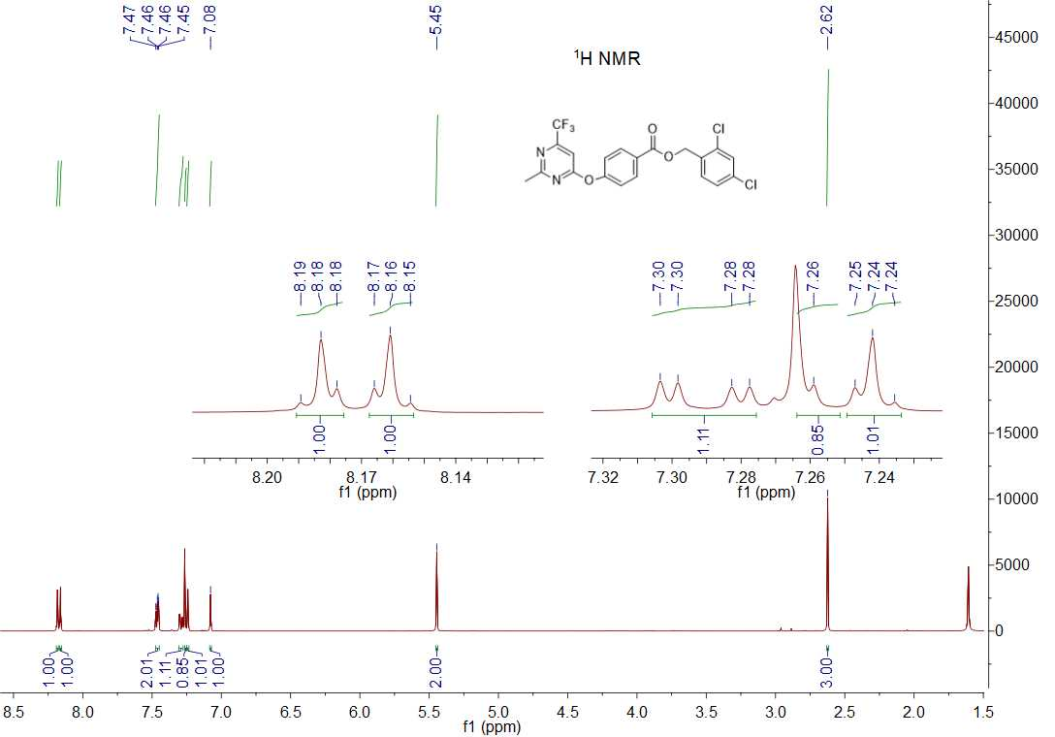

1H NMR spectrum of compound **5a**

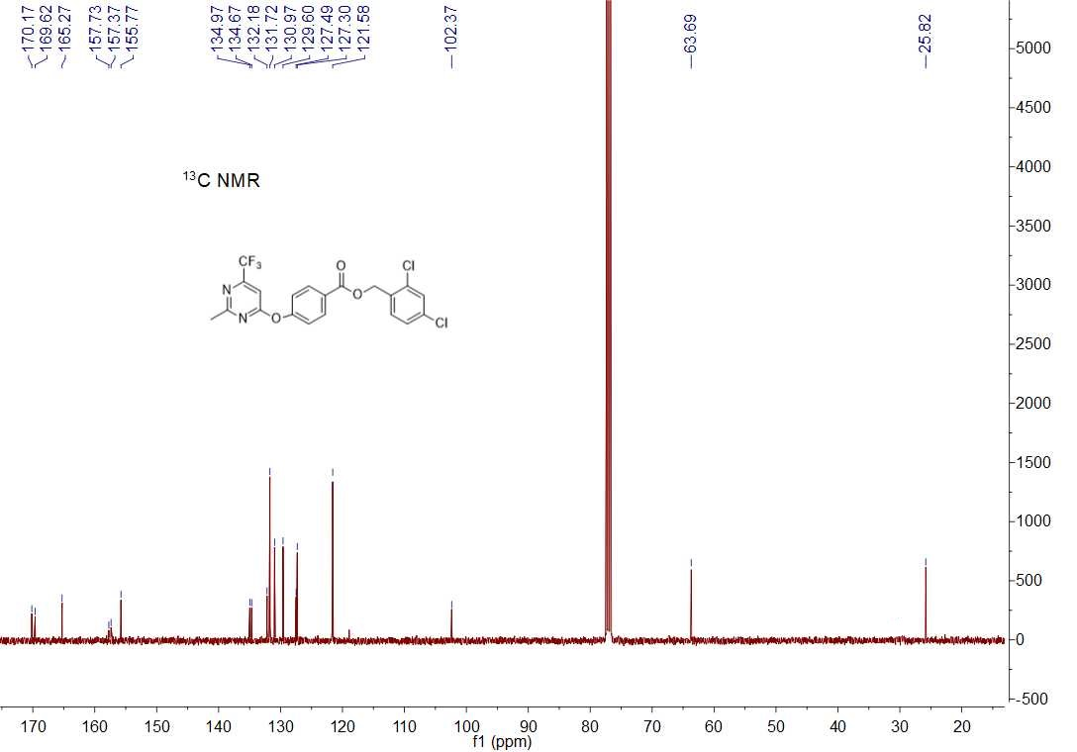

13C NMR spectrum of compound **5a**

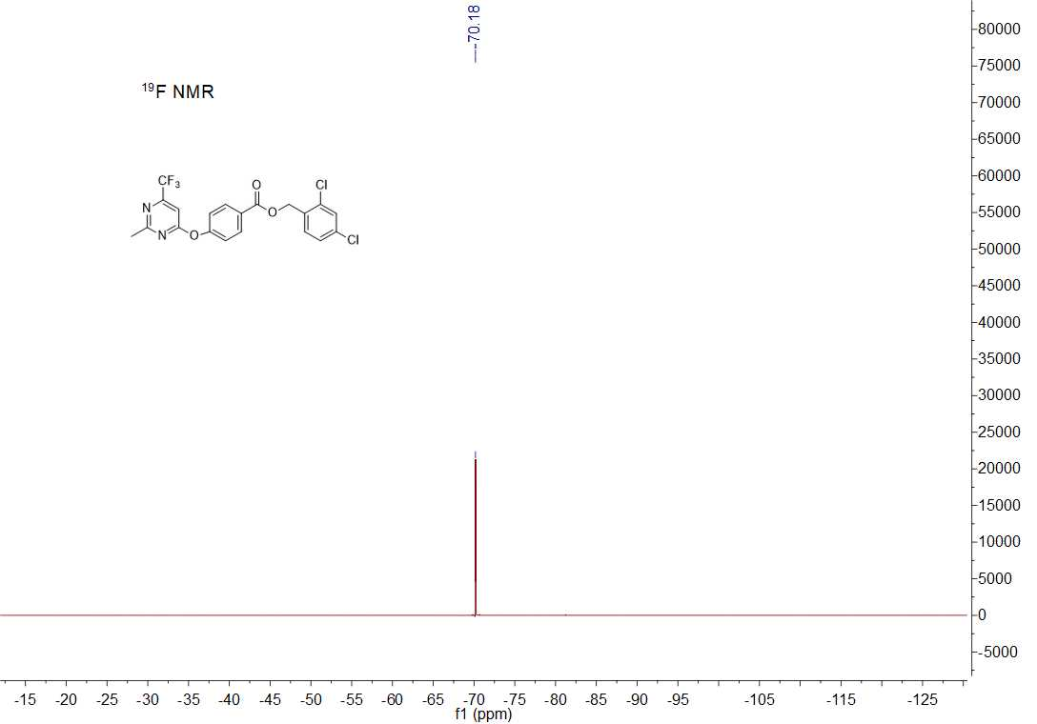

19F NMR spectrum of compound **5a**



HRMS (ESI) spectrum of compound **5a**

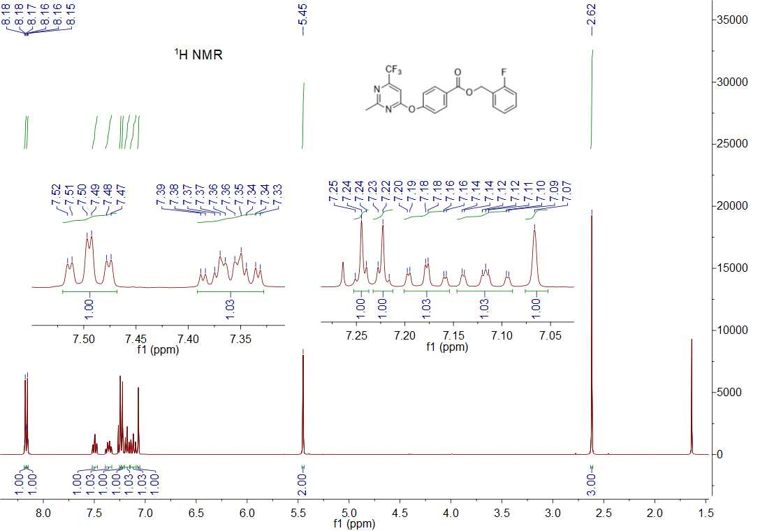

1H NMR spectrum of compound **5b**

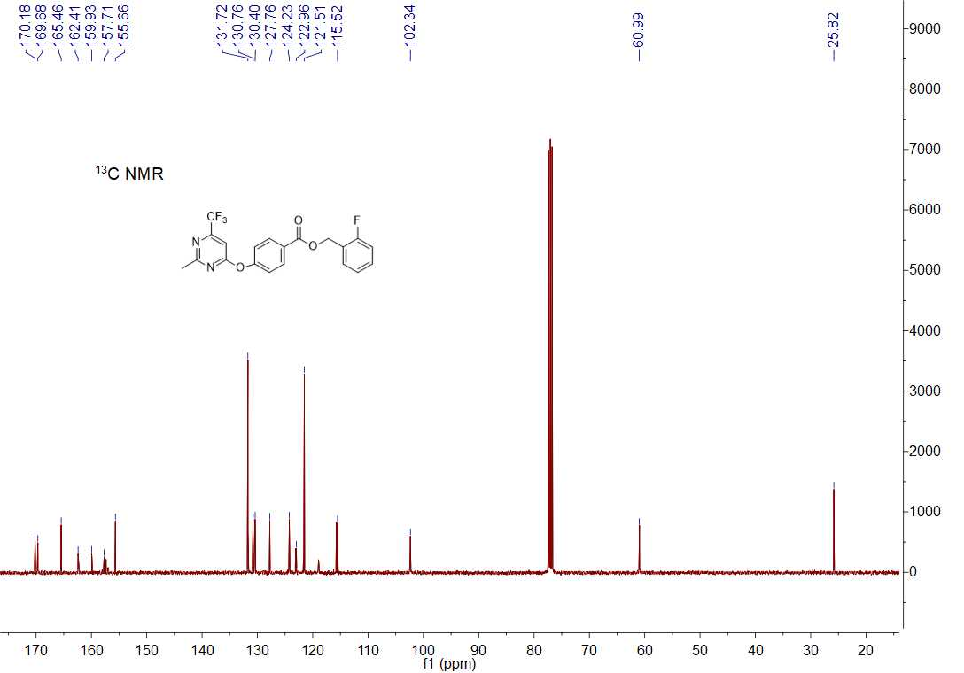

13C NMR spectrum of compound **5b**

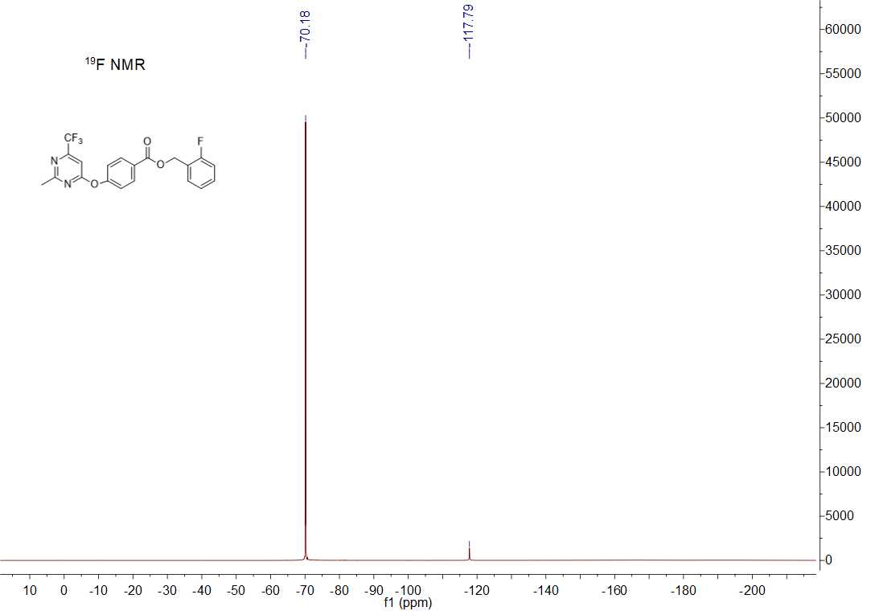

19F NMR spectrum of compound **5b**



HRMS (ESI) spectrum of compound **5b**

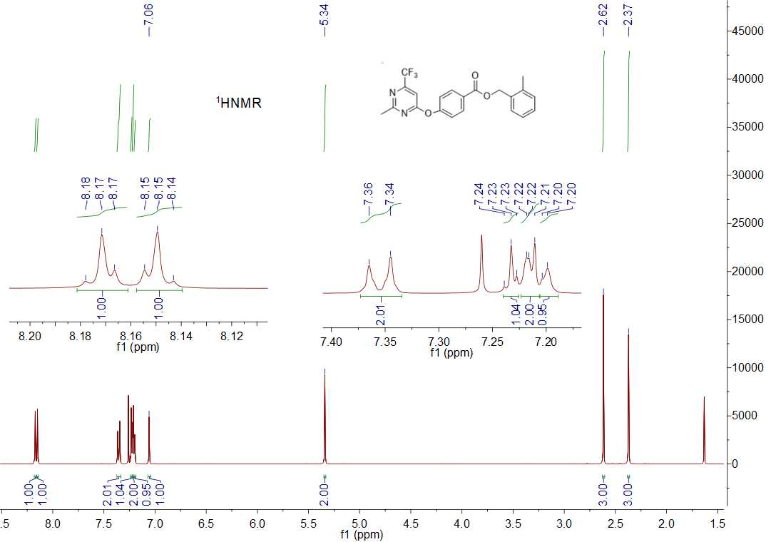

1H NMR spectrum of compound **5c**

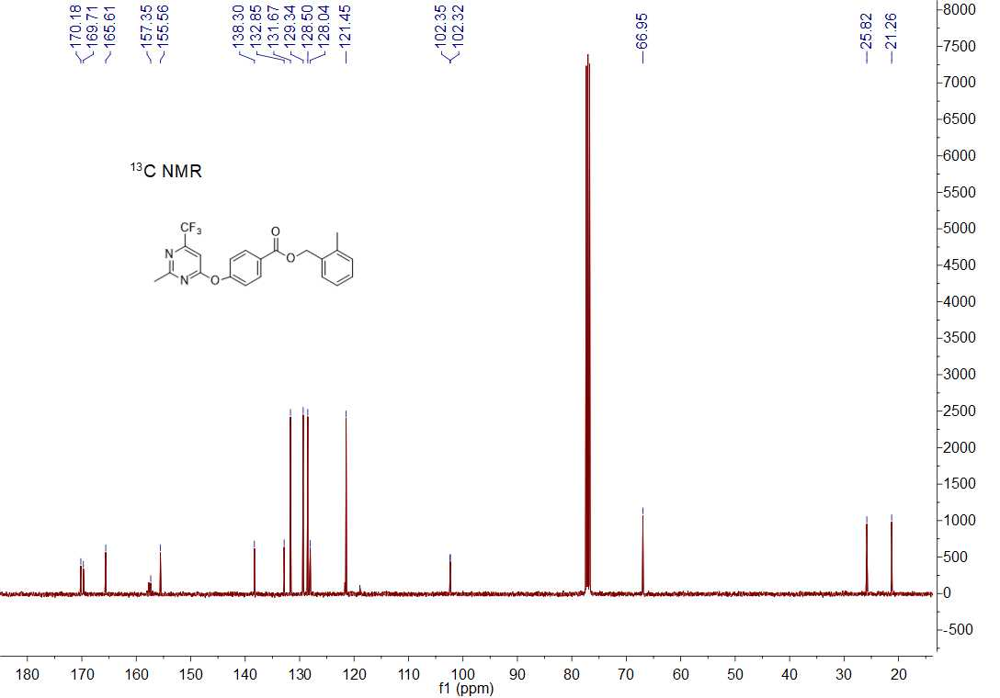

13C NMR spectrum of compound **5c**

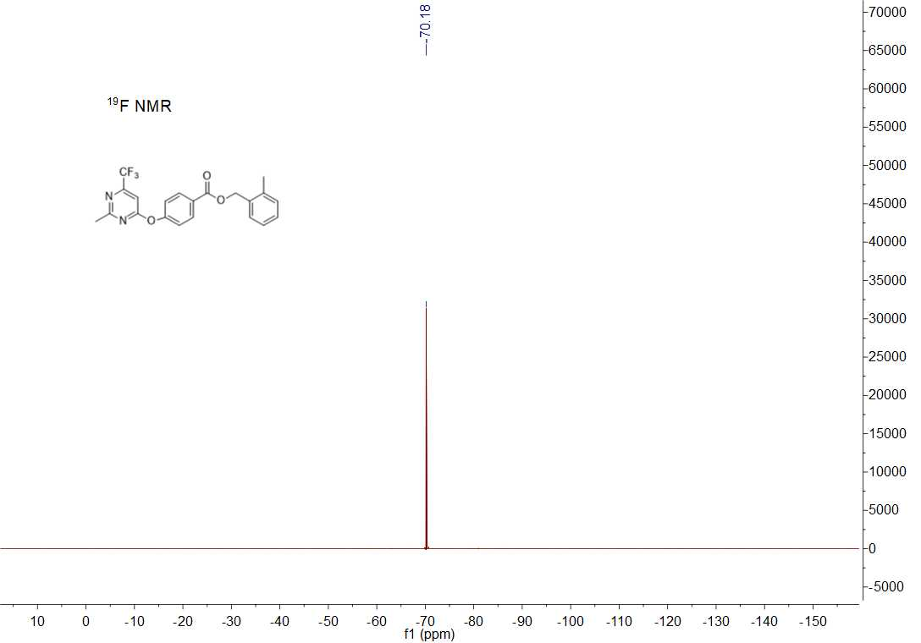

19F NMR spectrum of compound **5c**



HRMS (ESI) spectrum of compound **5c**

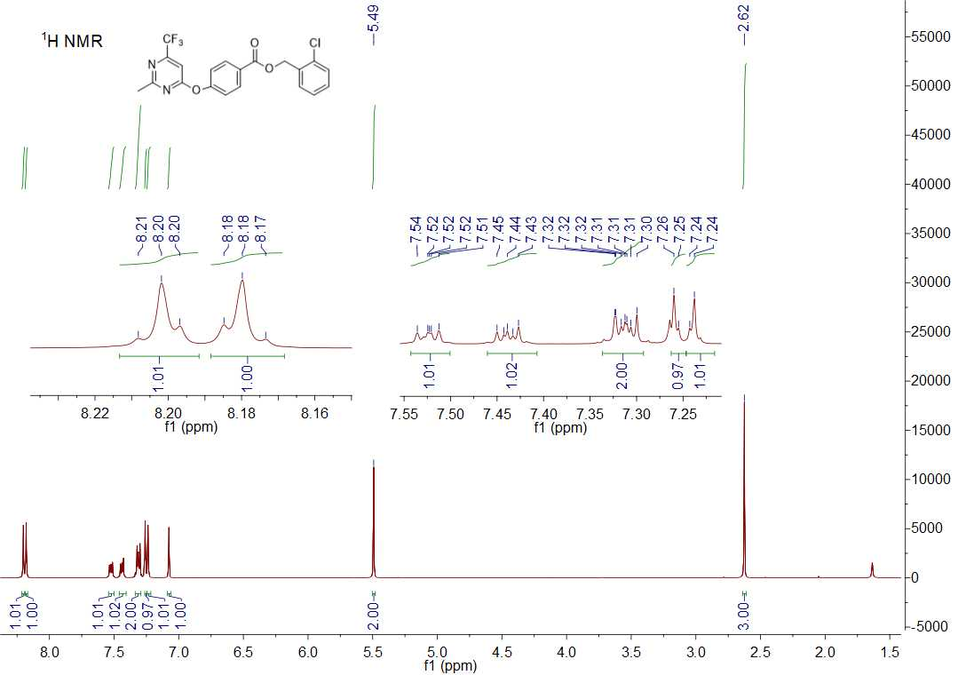

1H NMR spectrum of compound **5d**

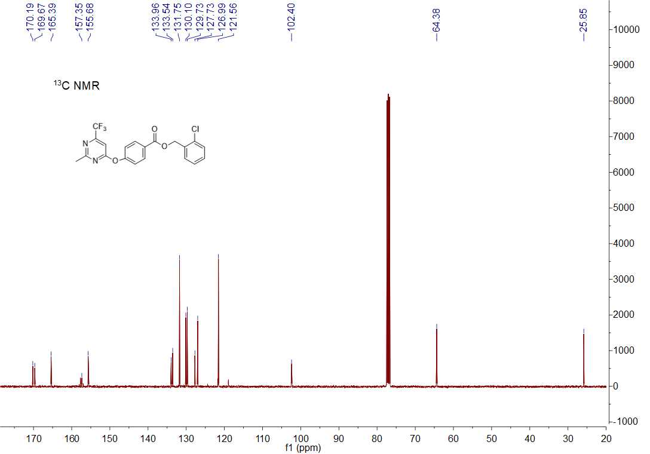

13C NMR spectrum of compound **5d**

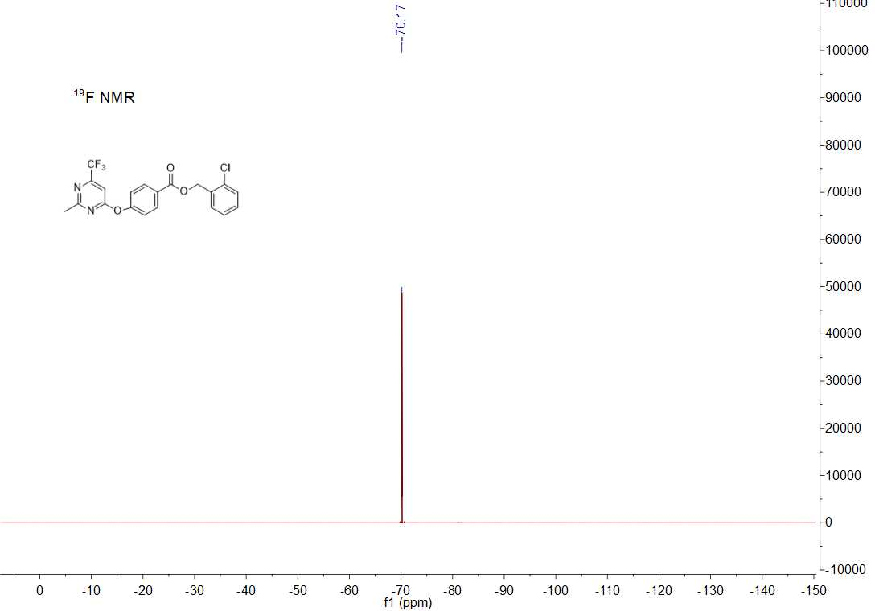

19F NMR spectrum of compound **5d**



HRMS (ESI) spectrum of compound **5d**

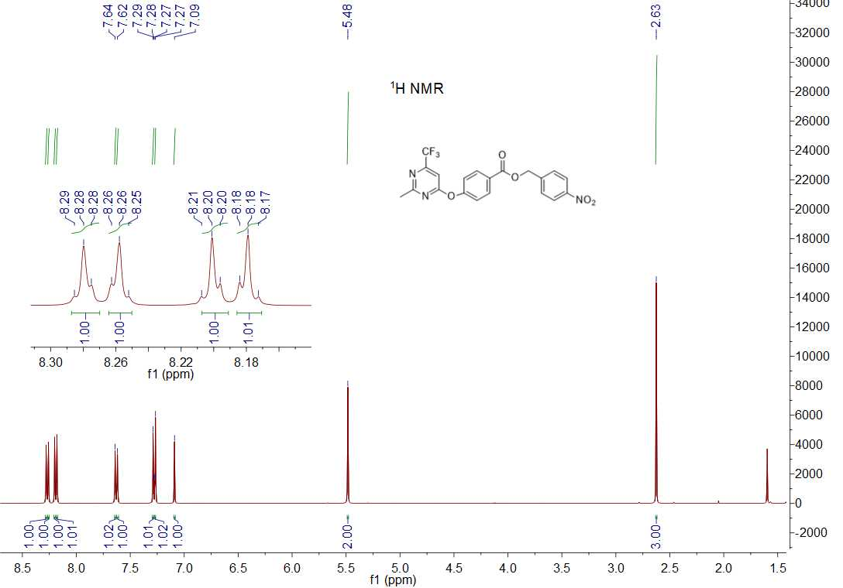

1H NMR spectrum of compound **5e**

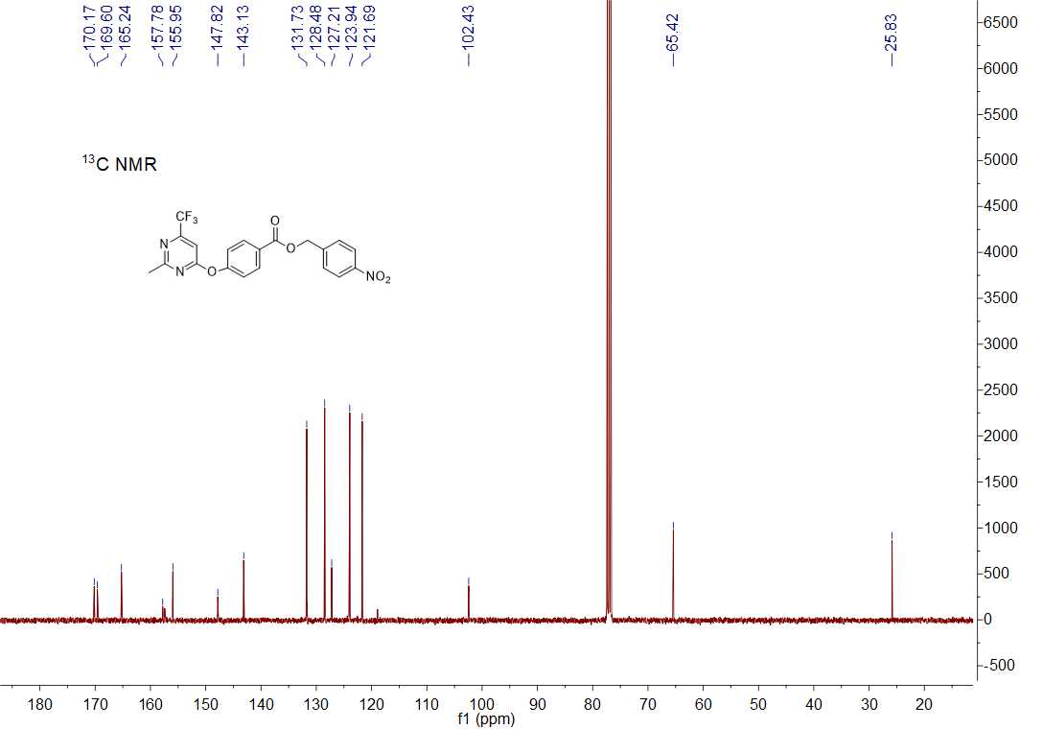

13C NMR spectrum of compound **5e**

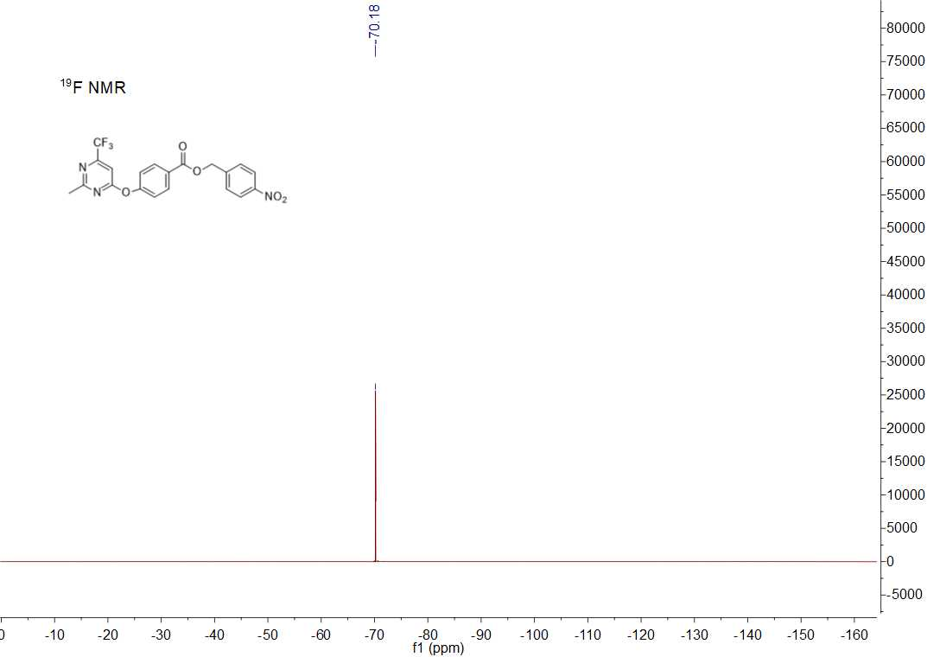

19F NMR spectrum of compound **5e**



HRMS (ESI) spectrum of compound **5e**

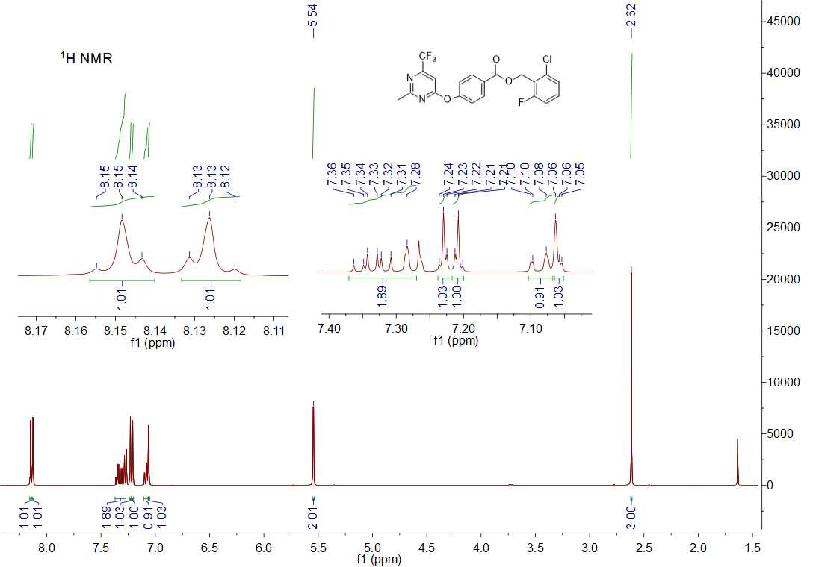

1H NMR spectrum of compound **5f**

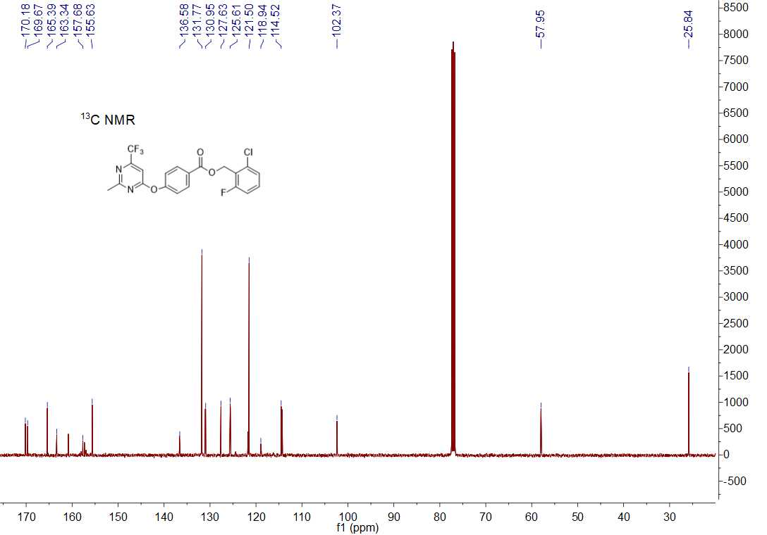

13C NMR spectrum of compound **5f**

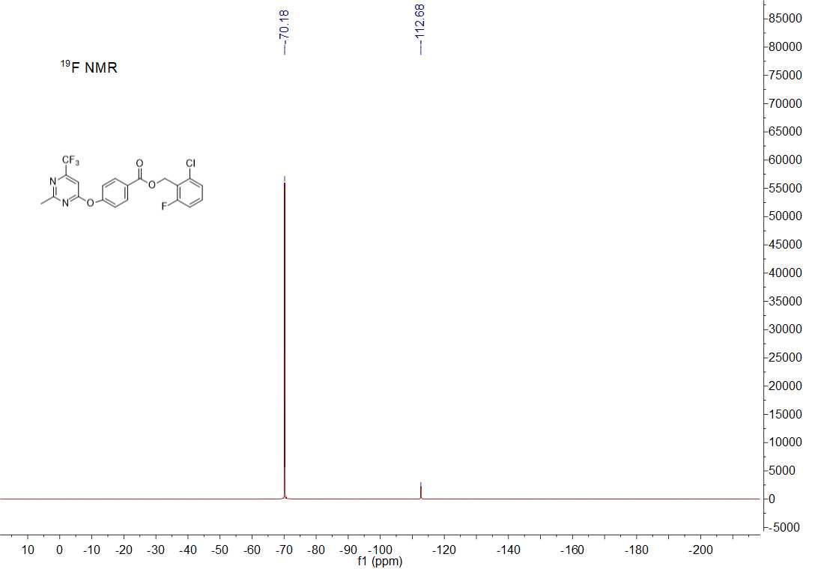

19F NMR spectrum of compound **5f**



HRMS (ESI) spectrum of compound **5f**

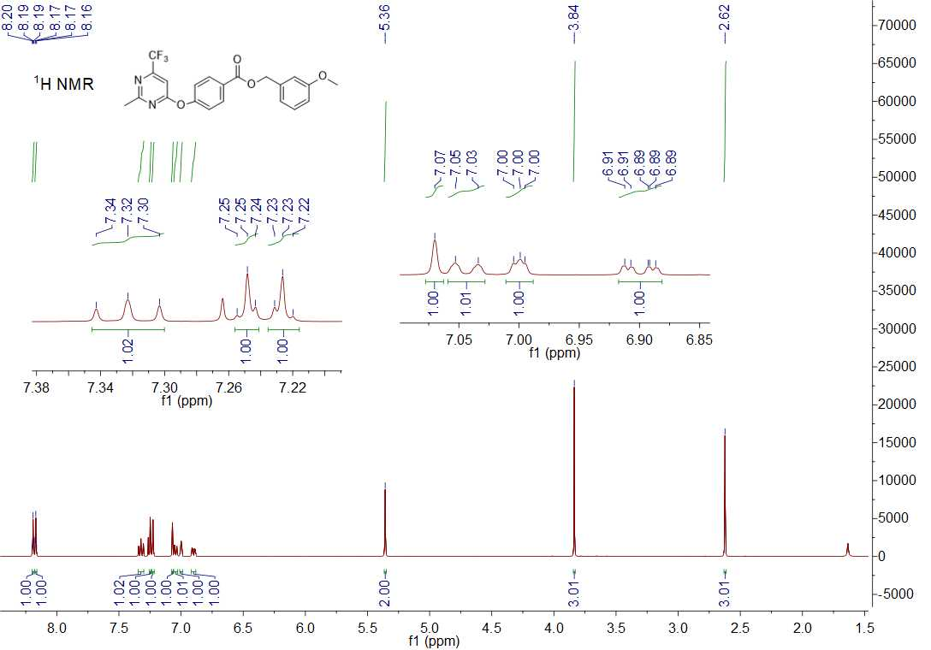

1H NMR spectrum of compound **5g**

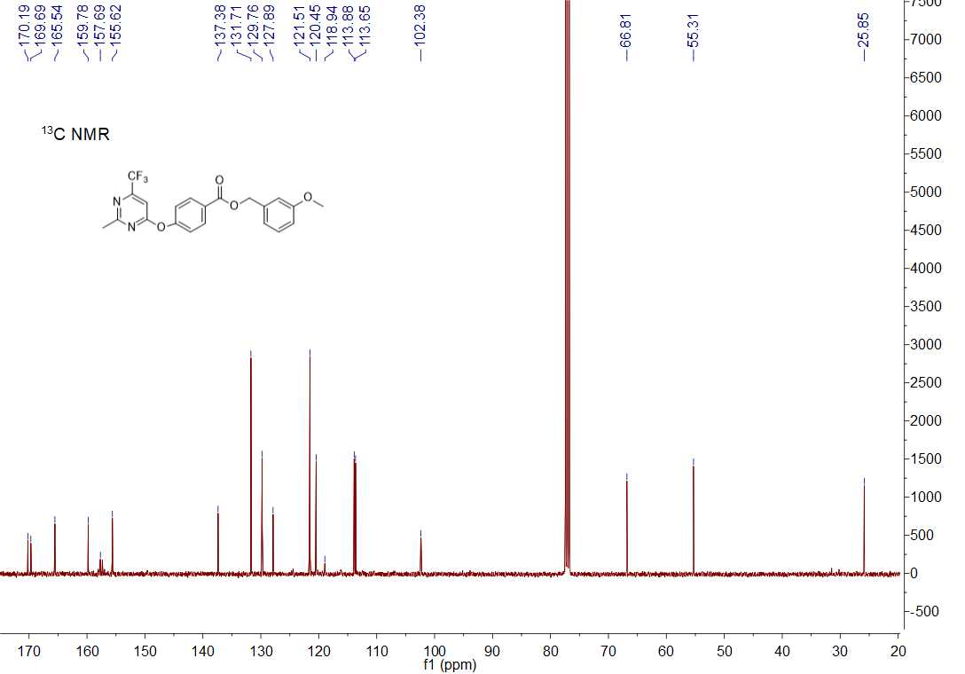

13C NMR spectrum of compound **5g**

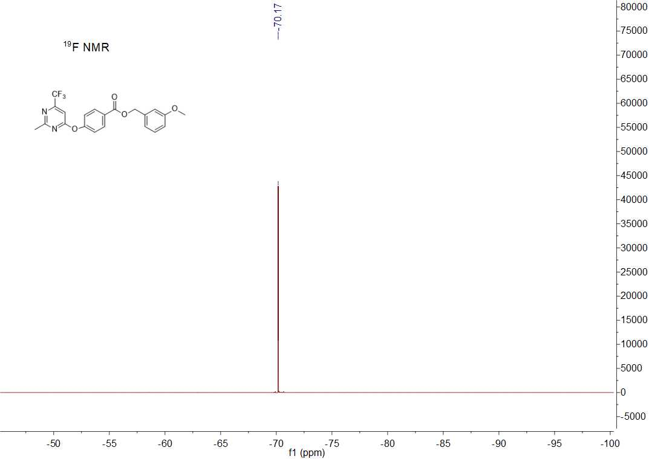

19F NMR spectrum of compound **5g**



HRMS (ESI) spectrum of compound **5g**

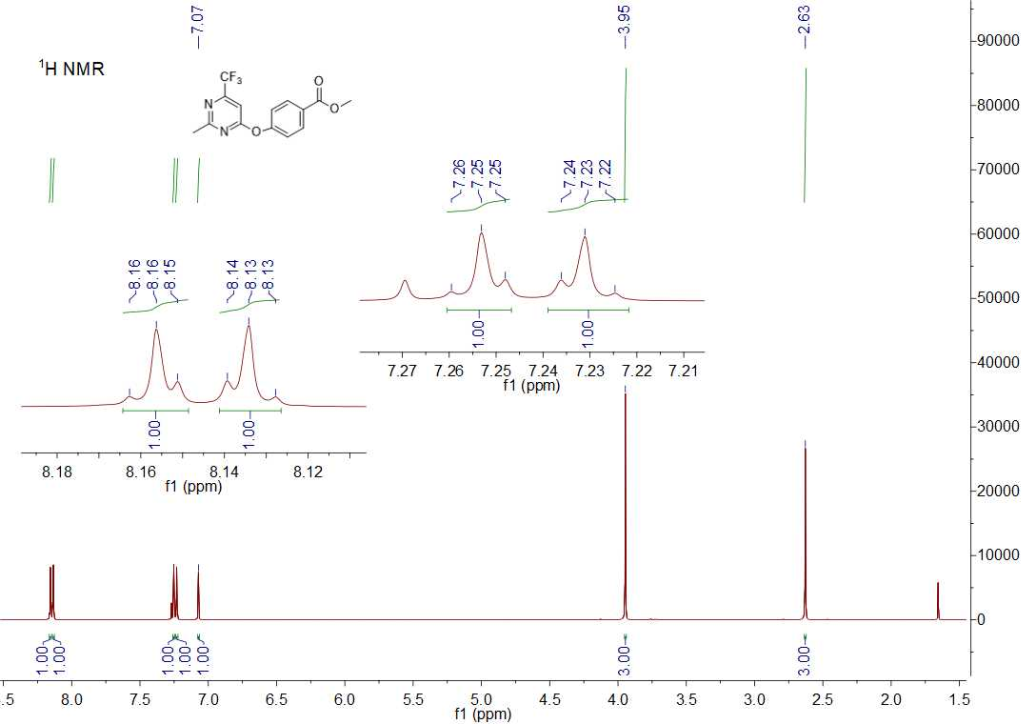

1H NMR spectrum of compound **5h**

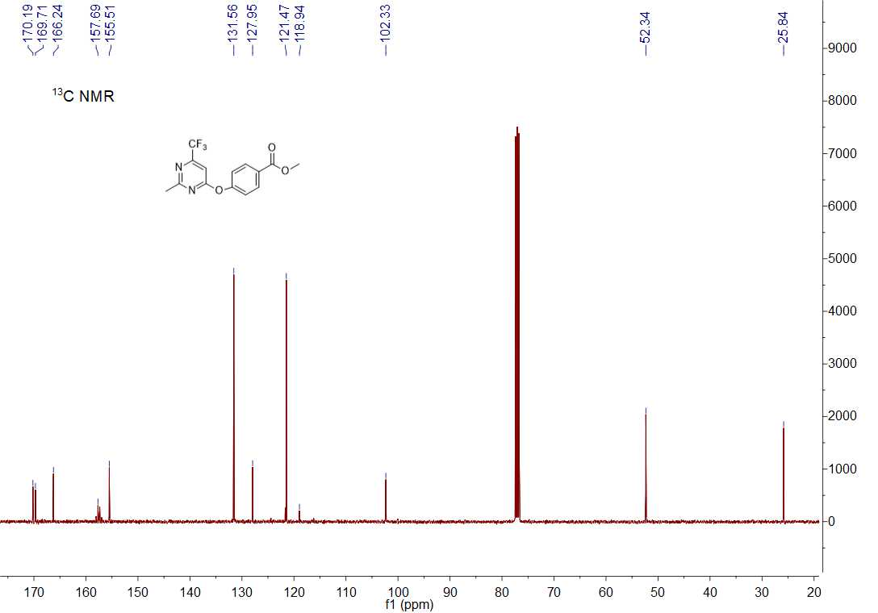

13C NMR spectrum of compound **5h**

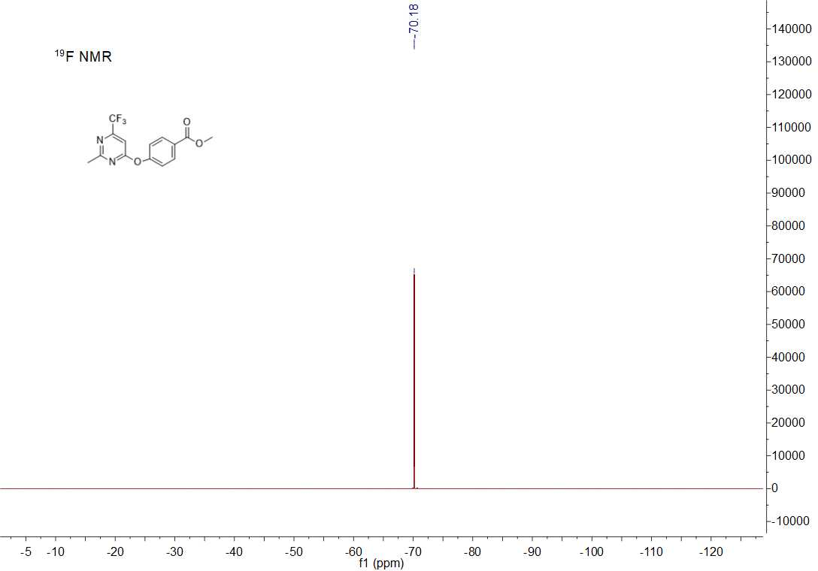

19F NMR spectrum of compound **5h**



HRMS (ESI) spectrum of compound **5h**

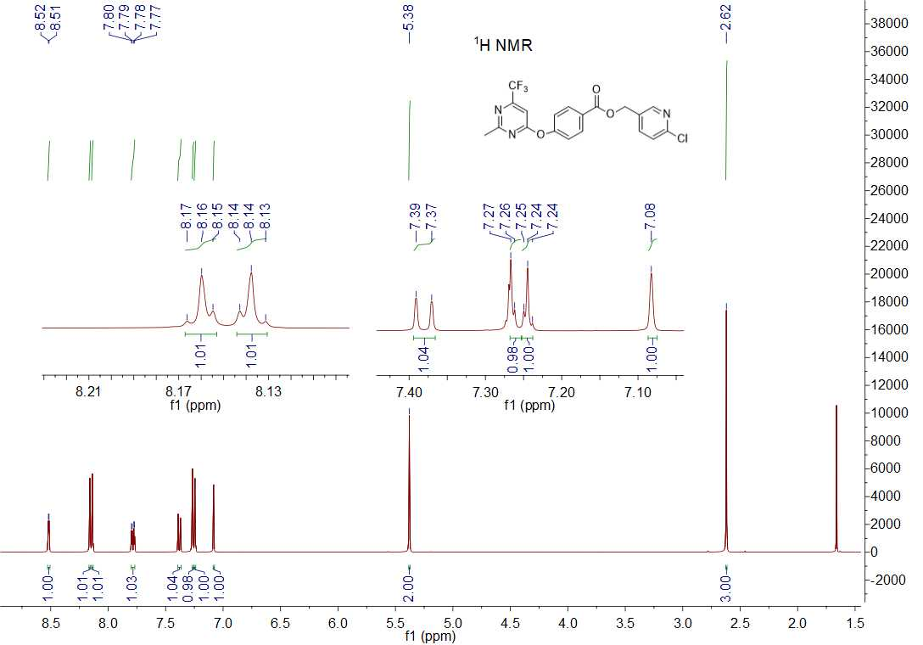

1H NMR spectrum of compound **5i**

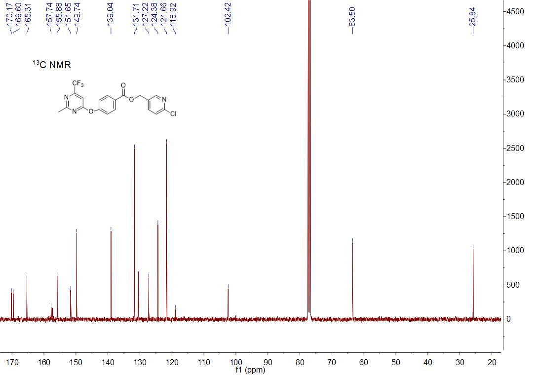

13C NMR spectrum of compound **5i**

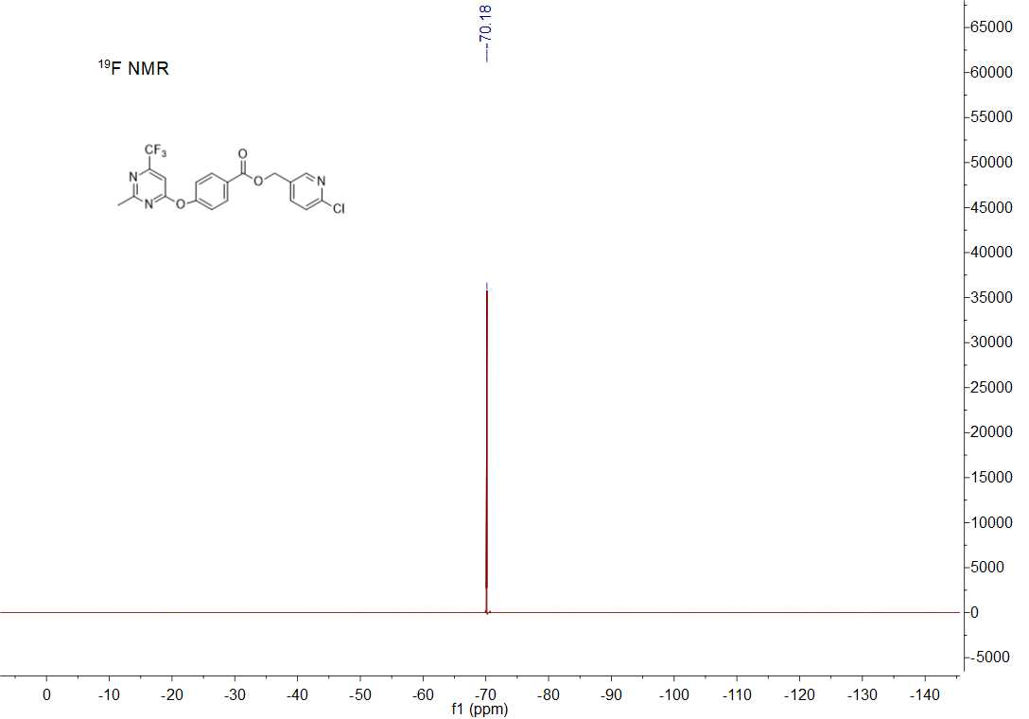

19F NMR spectrum of compound **5i**



HRMS (ESI) spectrum of compound **5i**

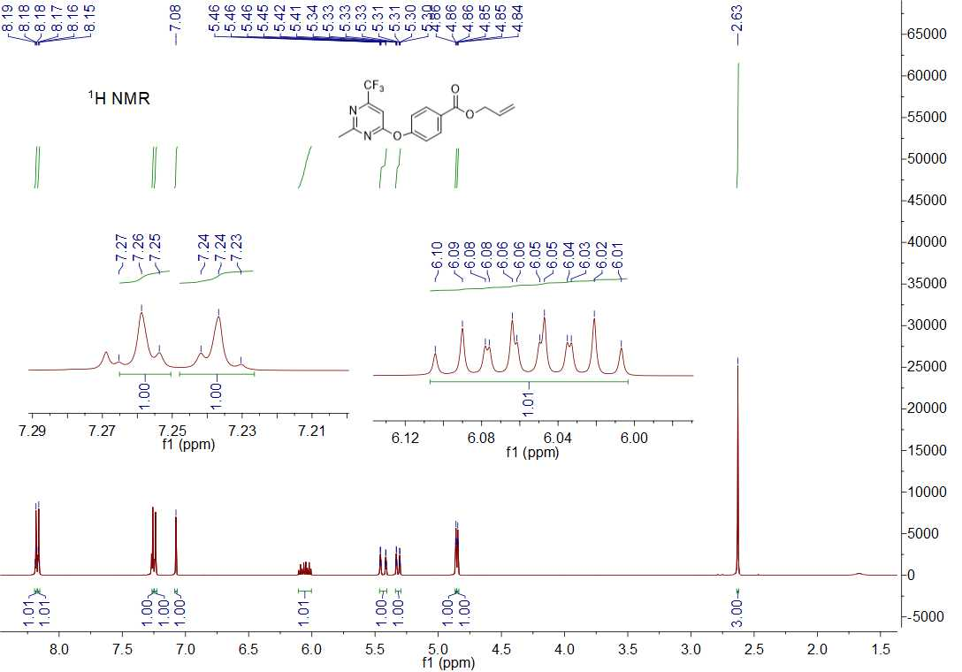

1H NMR spectrum of compound **5j**

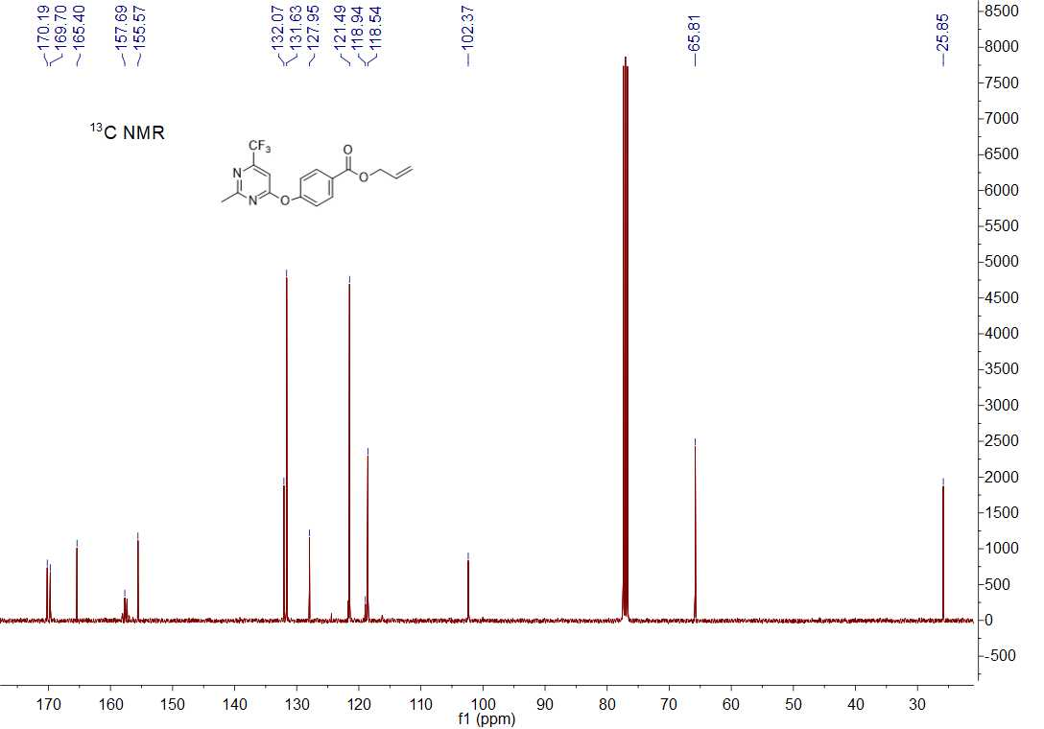

13C NMR spectrum of compound **5j**

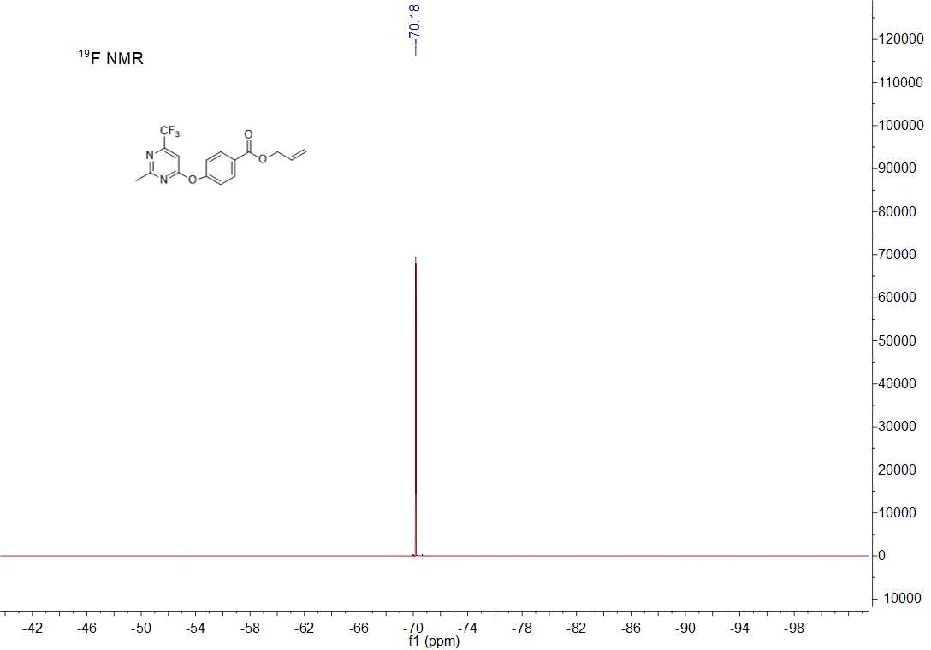

19F NMR spectrum of compound **5j**



HRMS (ESI) spectrum of compound **5j**

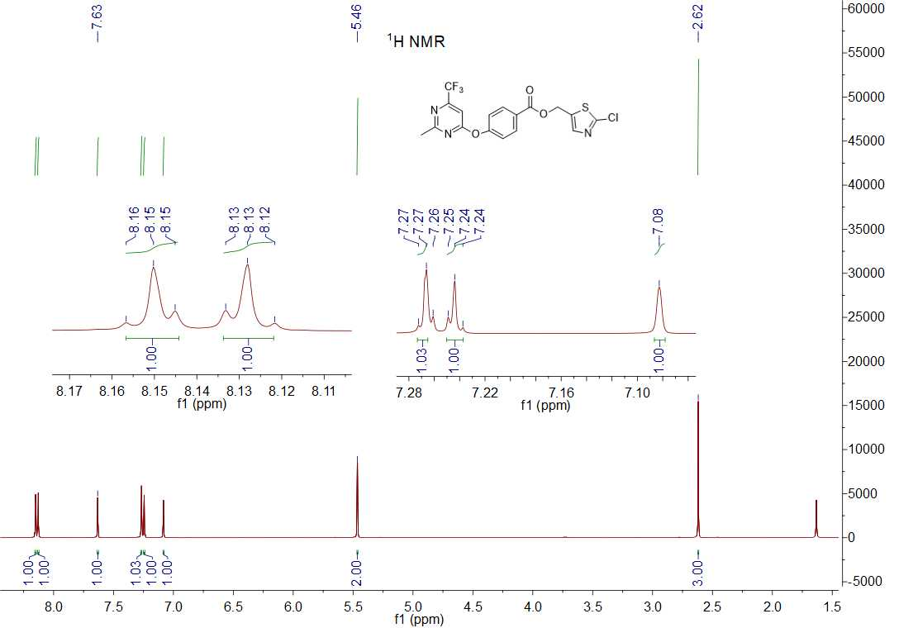

1H NMR spectrum of compound **5k**

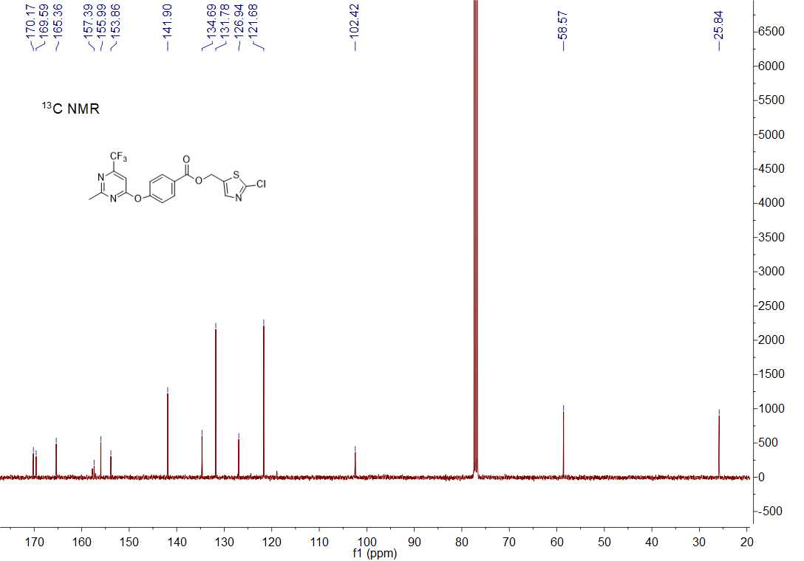

13C NMR spectrum of compound **5k**

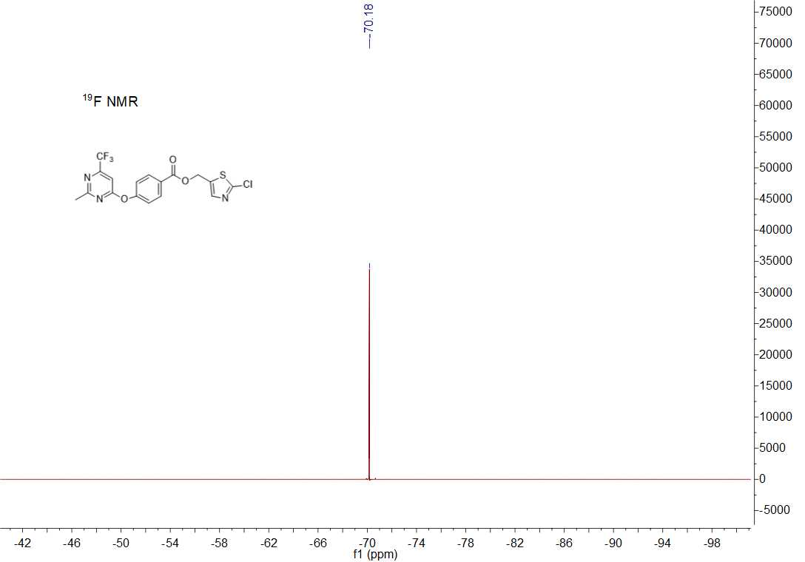

19F NMR spectrum of compound **5k**



HRMS (ESI) spectrum of compound **5k**

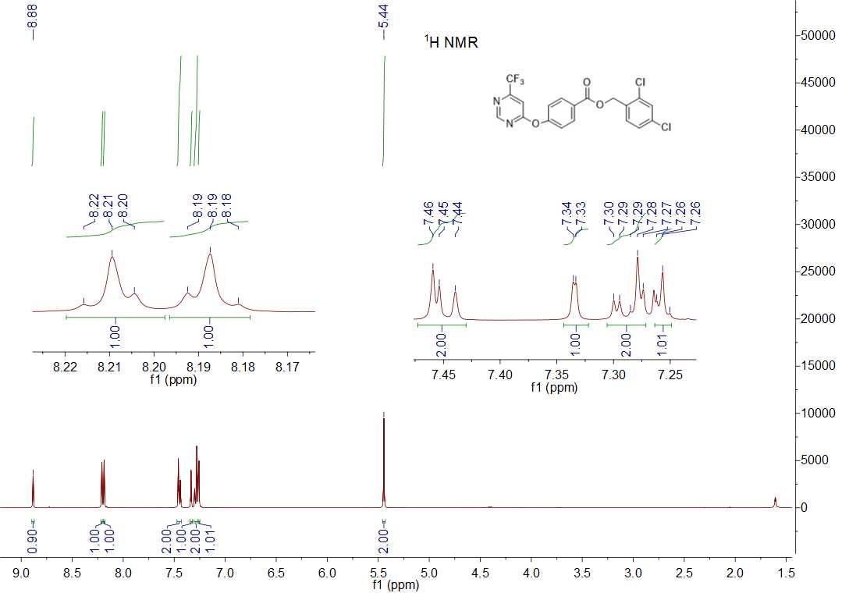

1H NMR spectrum of compound **5l**

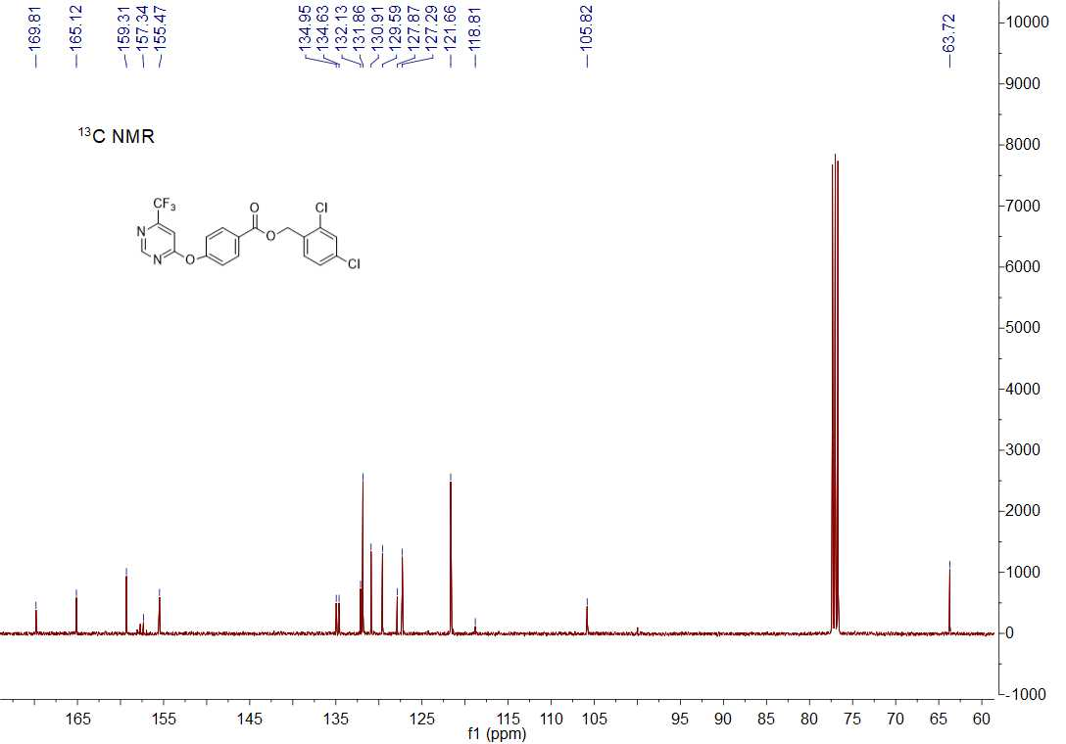

13C NMR spectrum of compound **5l**

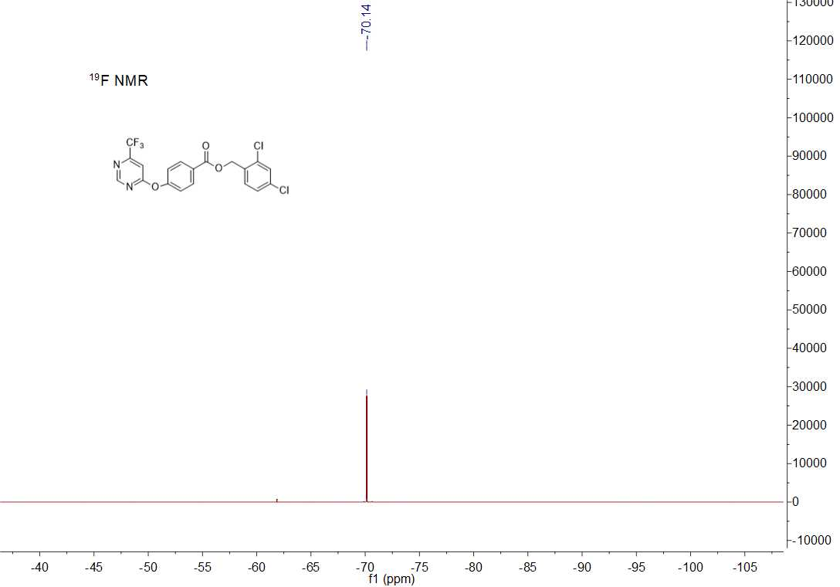

19F NMR spectrum of compound **5l**



HRMS (ESI) spectrum of compound **5l**

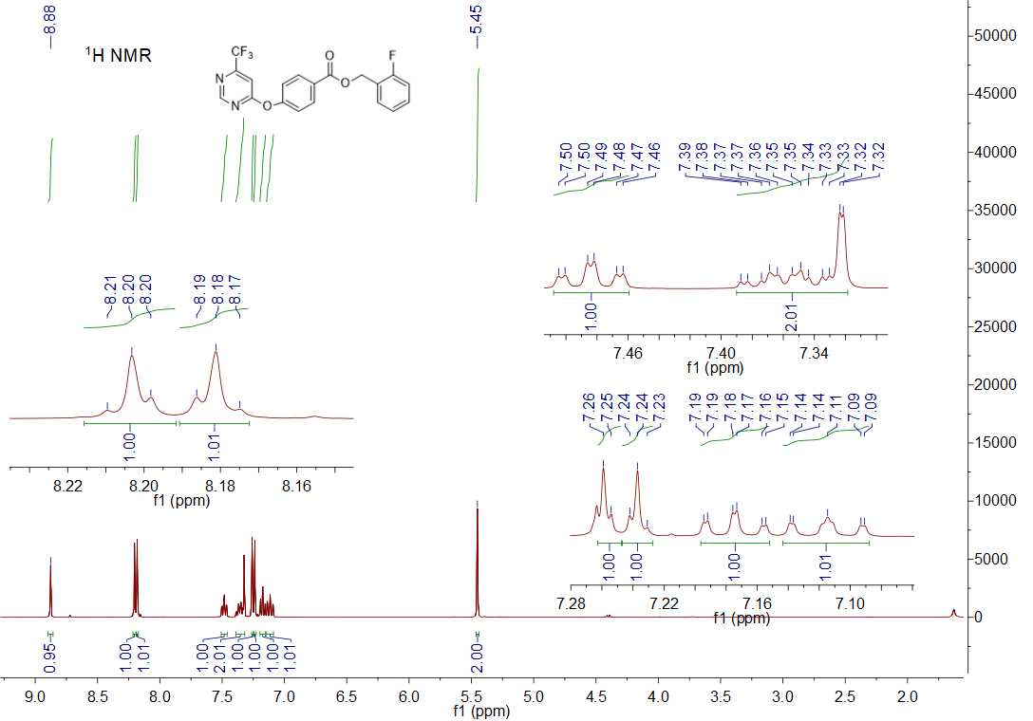

1H NMR spectrum of compound **5m**

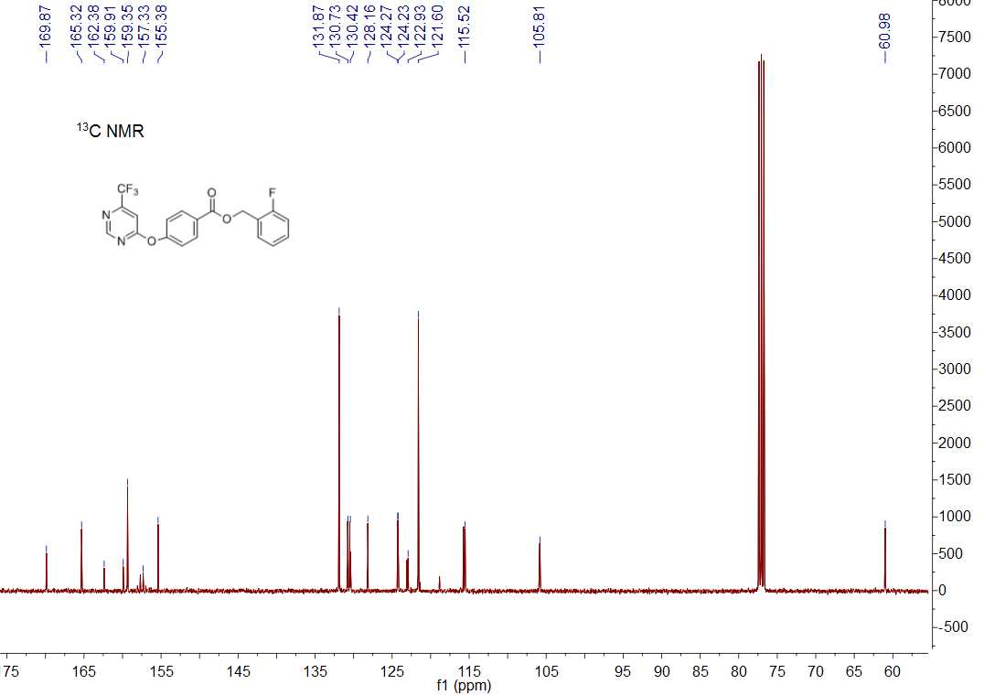

13C NMR spectrum of compound **5m**

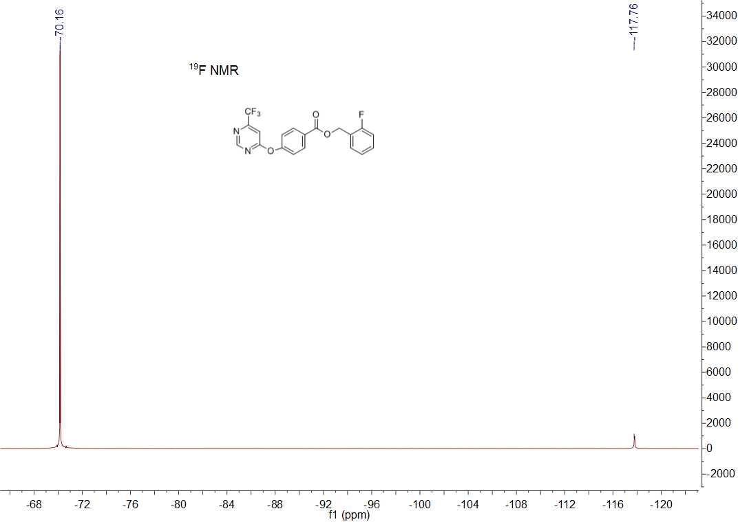

19F NMR spectrum of compound **5m**



HRMS (ESI) spectrum of compound **5m**

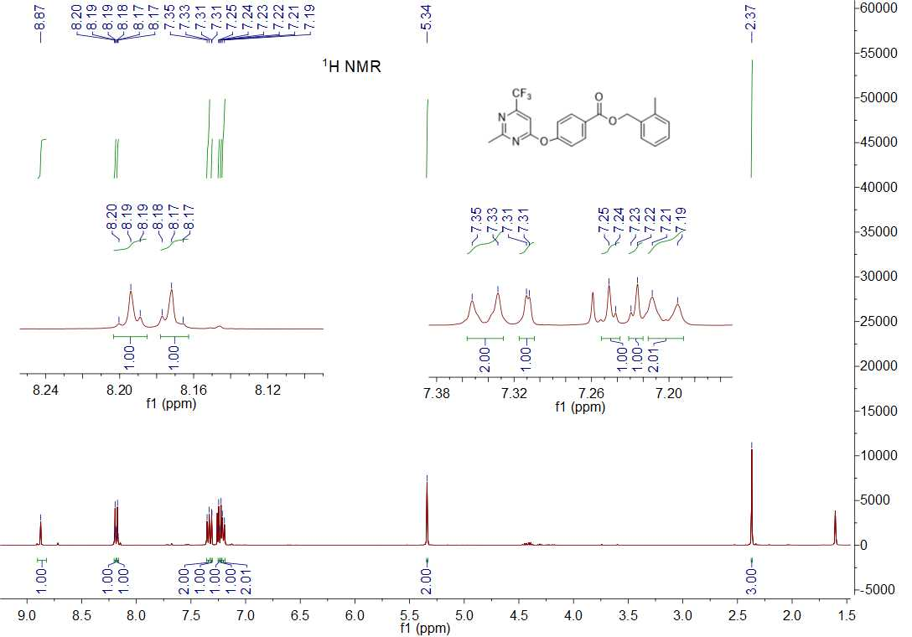

1H NMR spectrum of compound **5n**

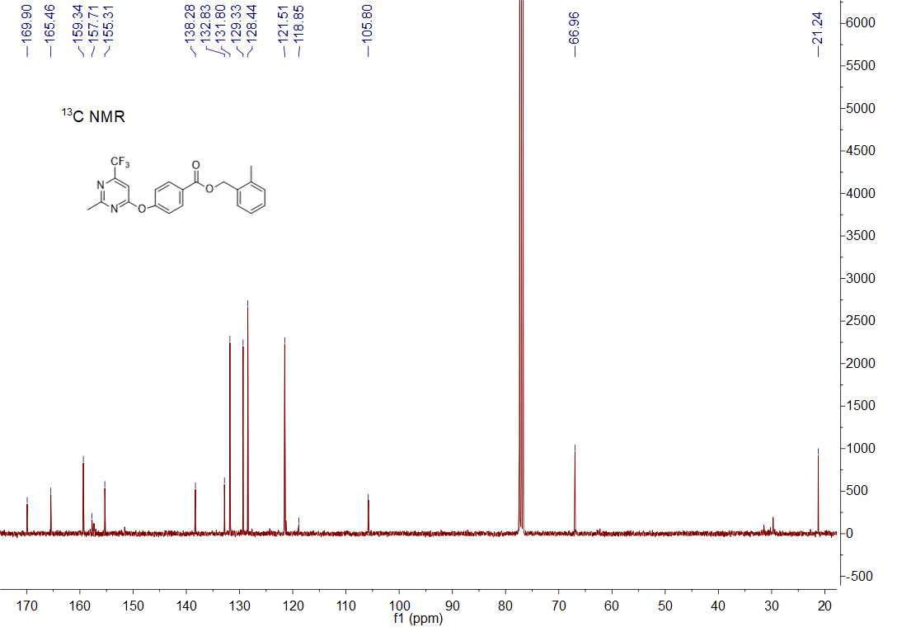

13C NMR spectrum of compound **5n**

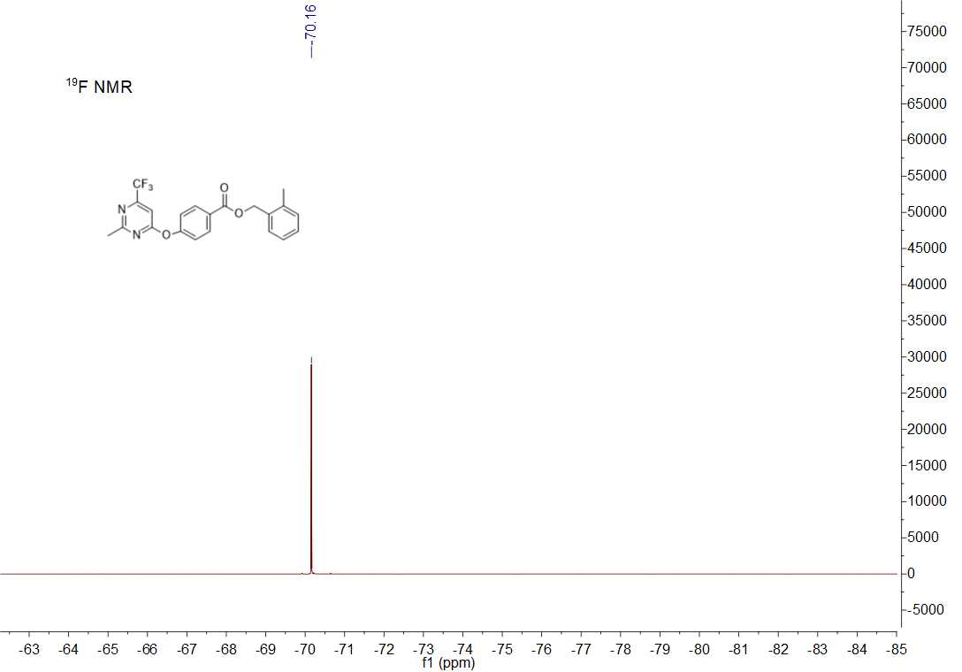

19F NMR spectrum of compound **5n**



HRMS (ESI) spectrum of compound **5n**

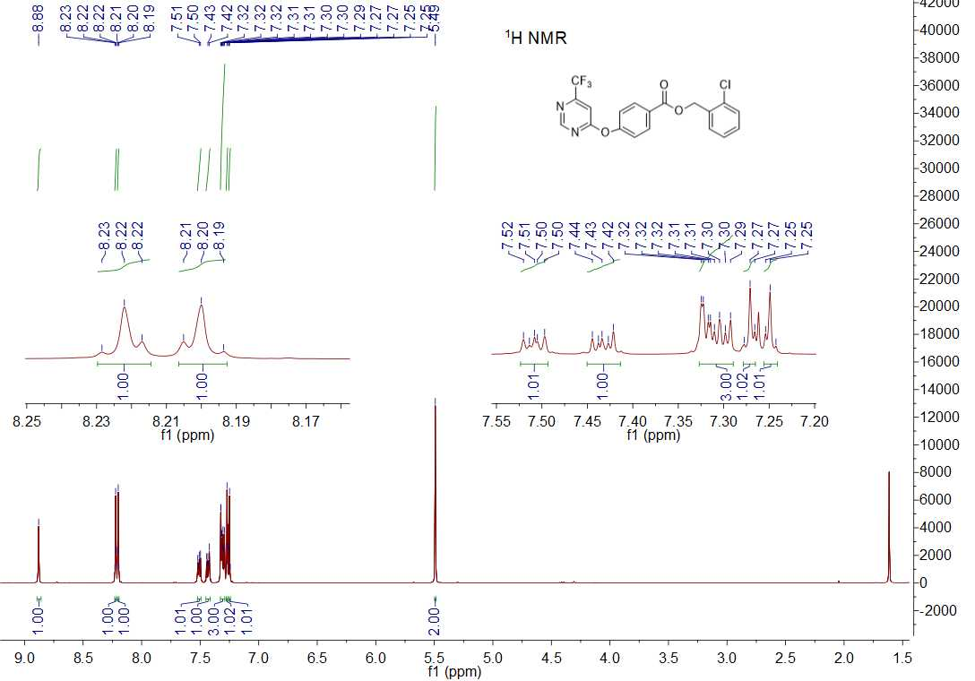

1H NMR spectrum of compound **5o**

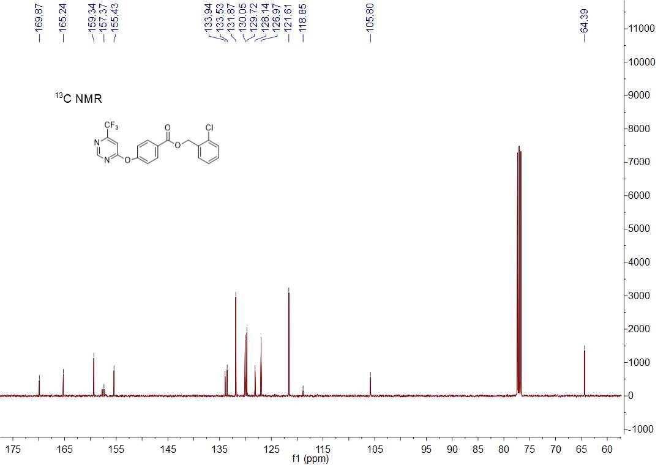

13C NMR spectrum of compound **5o**

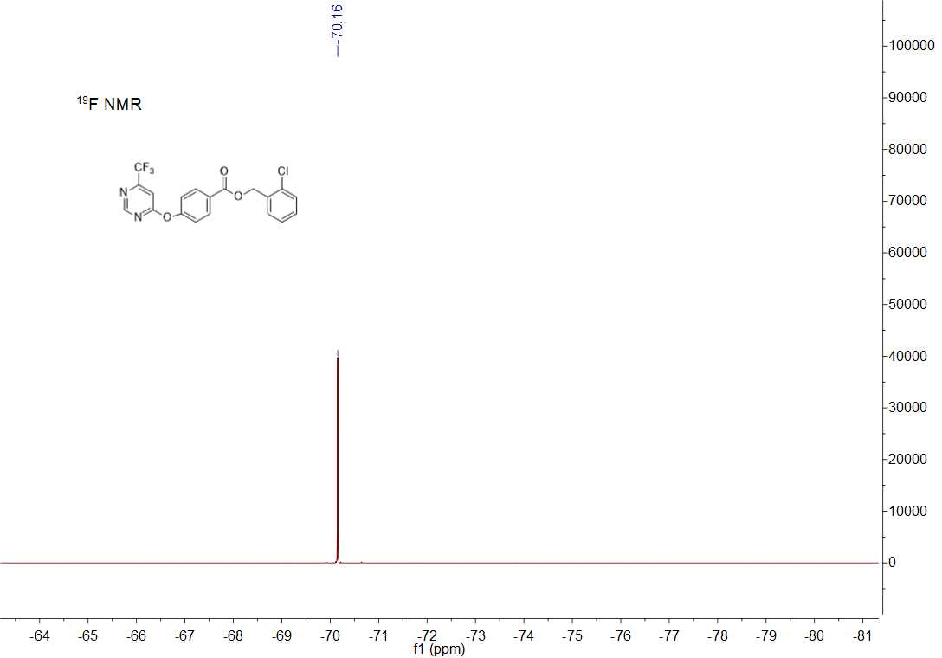

19F NMR spectrum of compound **5o**



HRMS (ESI) spectrum of compound **5o**

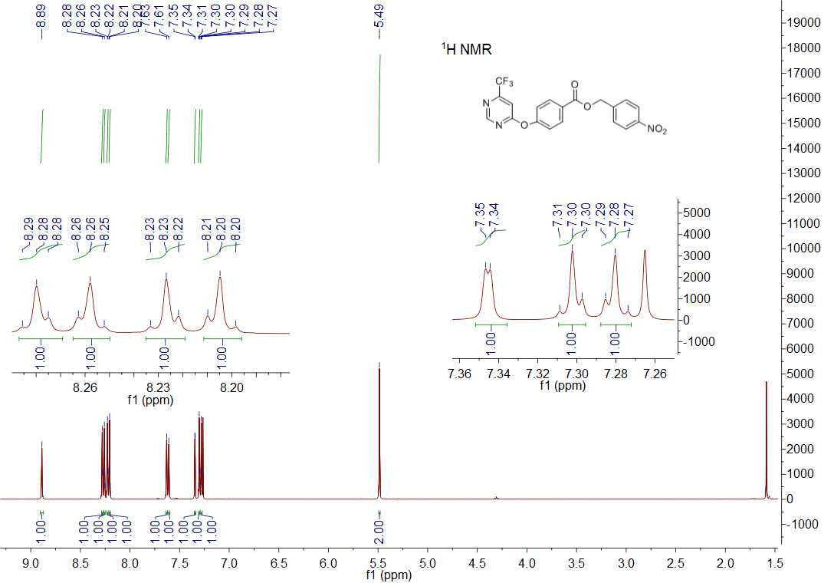

1H NMR spectrum of compound **5p**

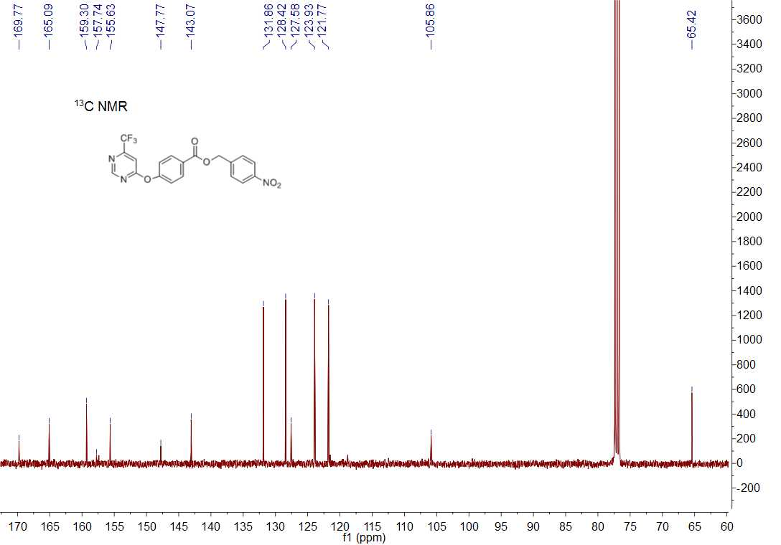

13C NMR spectrum of compound **5p**

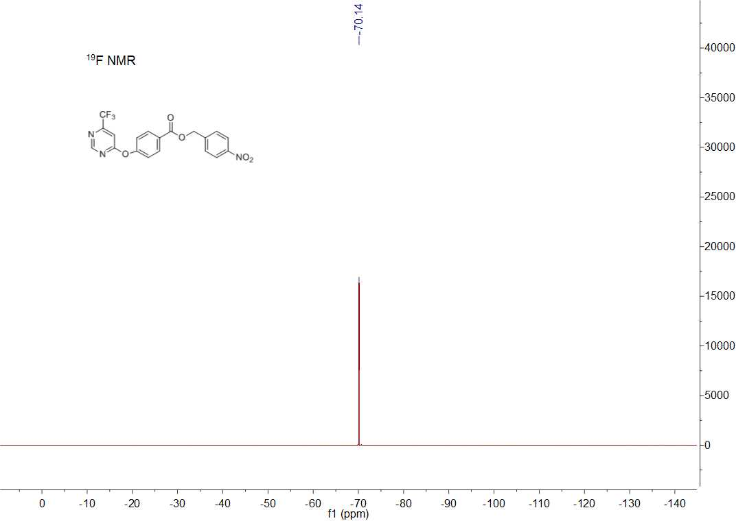

19F NMR spectrum of compound **5p**



HRMS (ESI) spectrum of compound **5p**

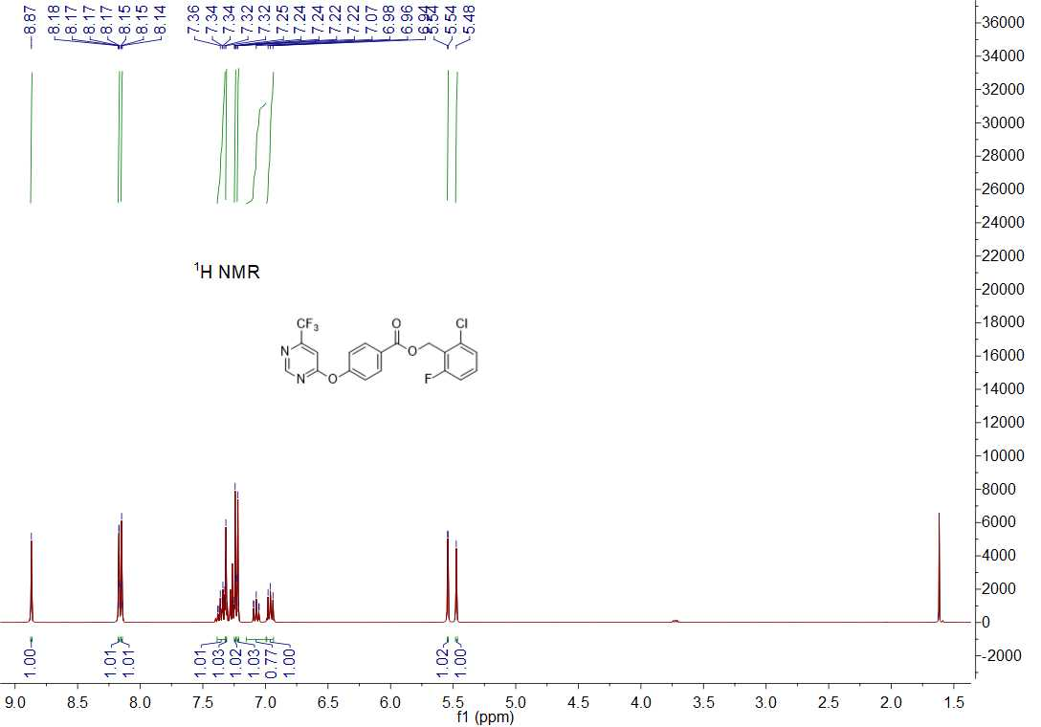

1H NMR spectrum of compound **5q**

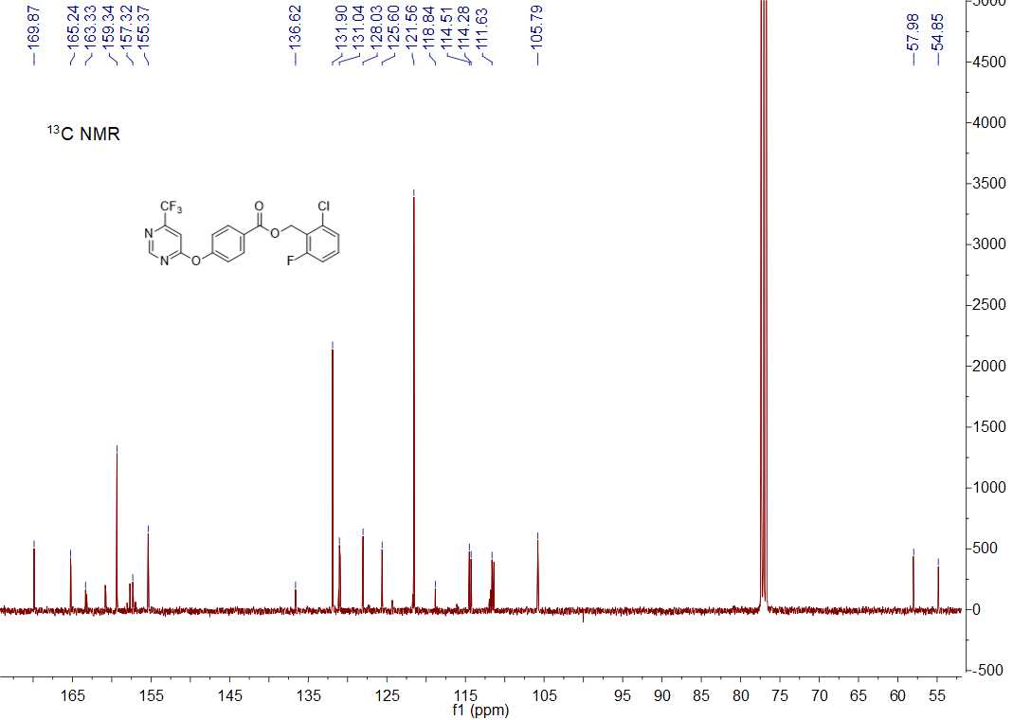

13C NMR spectrum of compound **5q**

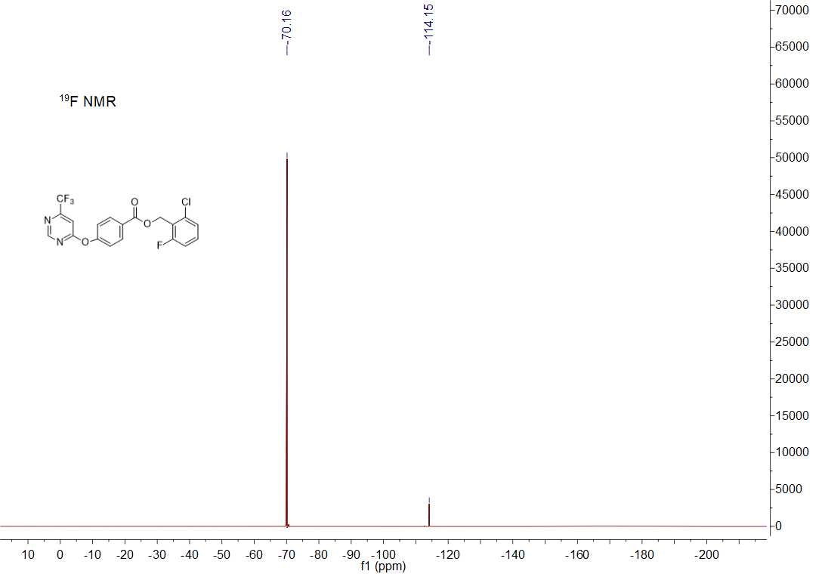

19F NMR spectrum of compound **5q**



HRMS (ESI) spectrum of compound **5q**

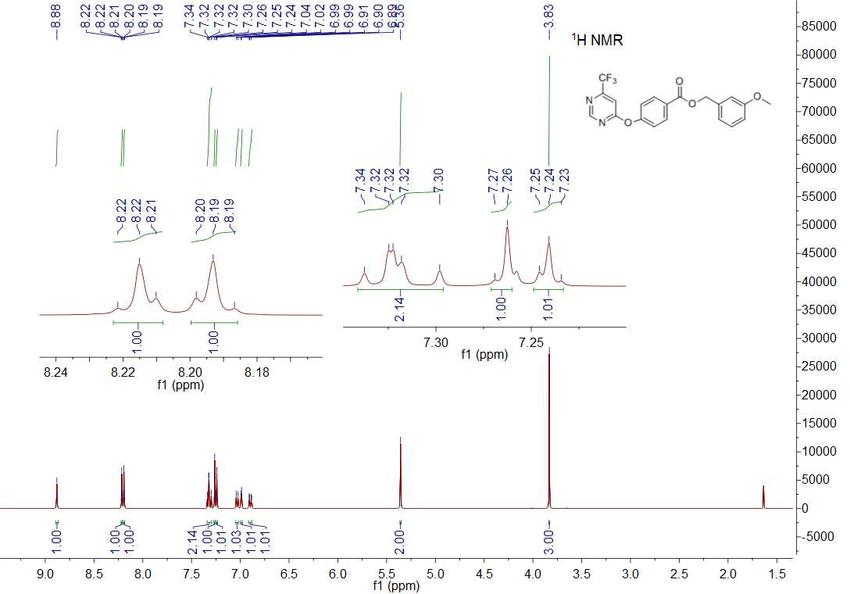

1H NMR spectrum of compound **5r**

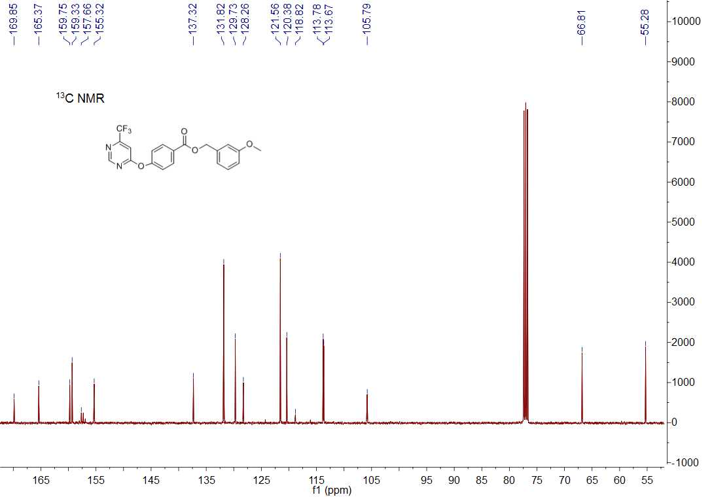

13C NMR spectrum of compound **5r**

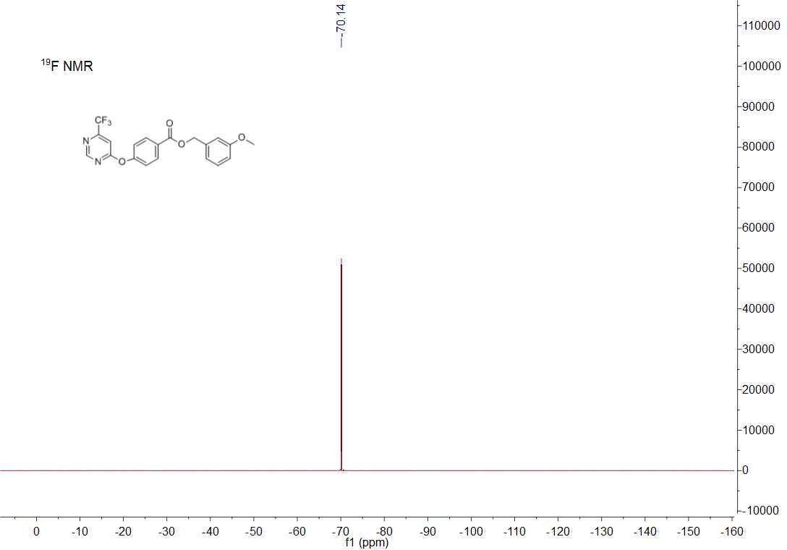

19F NMR spectrum of compound **5r**



HRMS (ESI) spectrum of compound **5r**

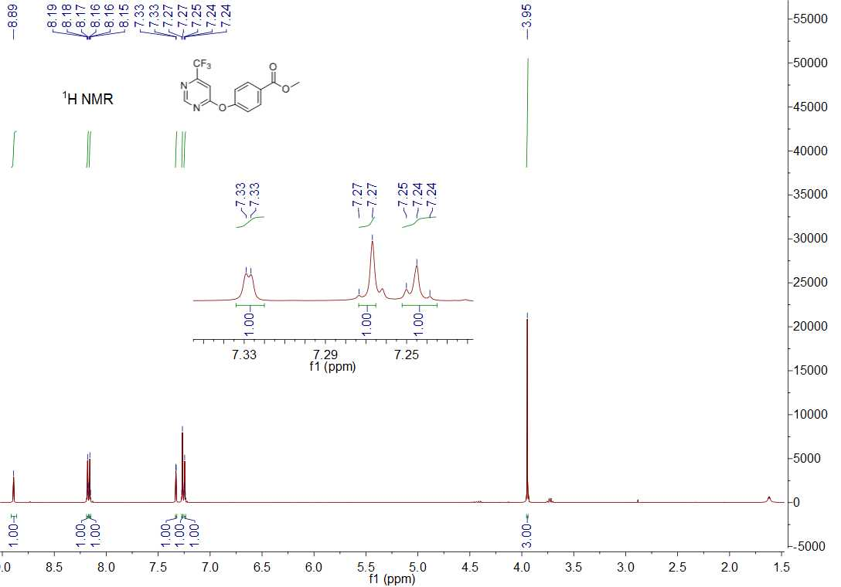

1H NMR spectrum of compound **5s**

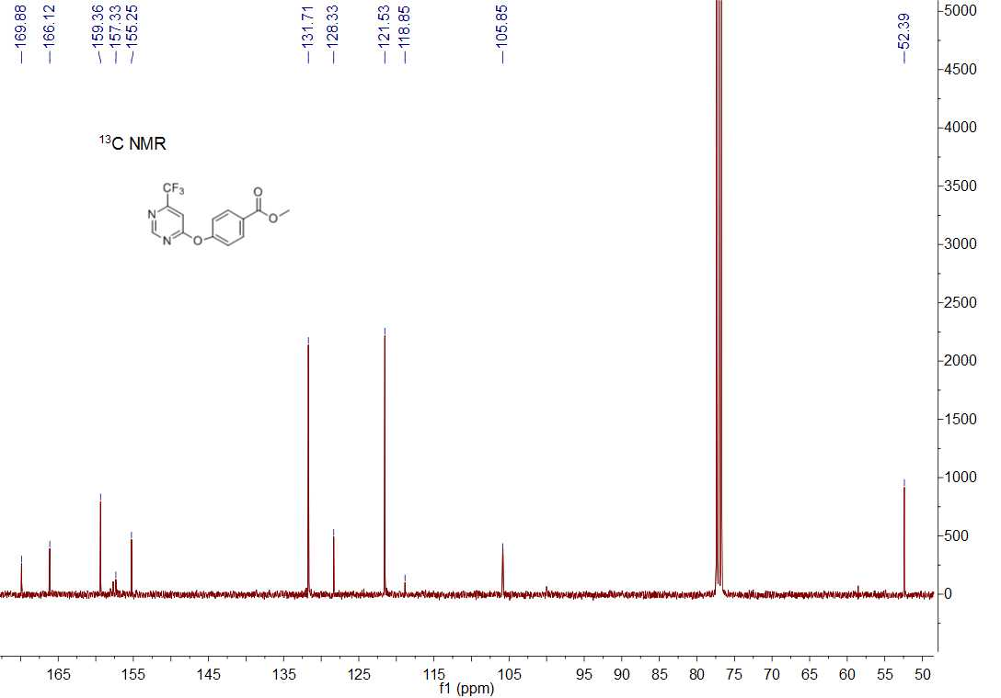

13C NMR spectrum of compound **5s**

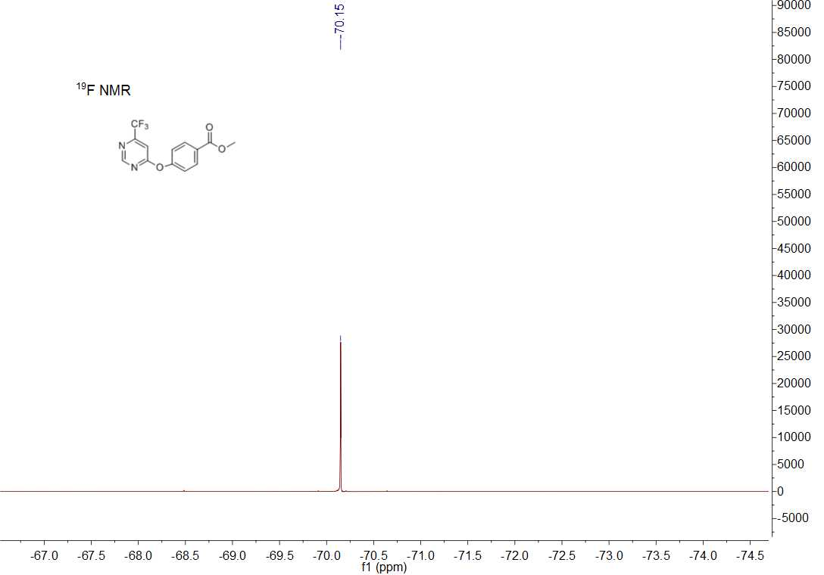

19F NMR spectrum of compound **5s**



HRMS (ESI) spectrum of compound **5s**

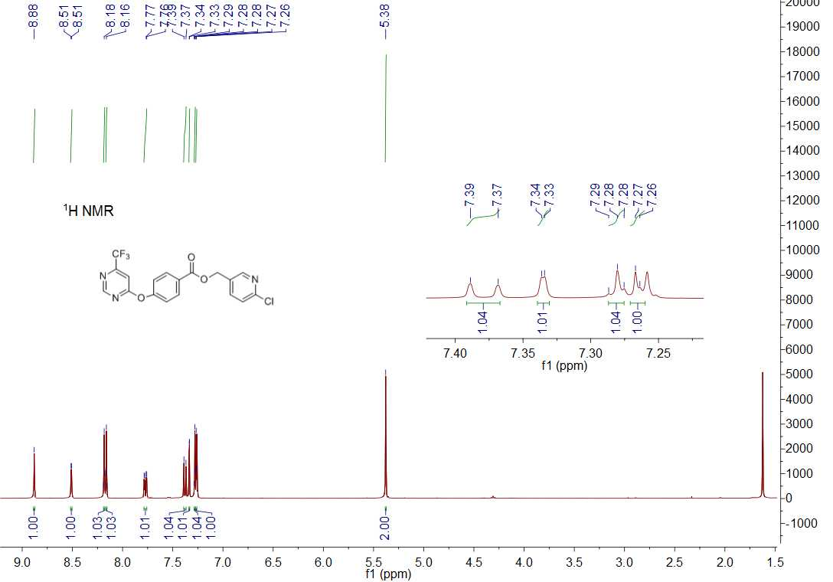

1H NMR spectrum of compound **5t**

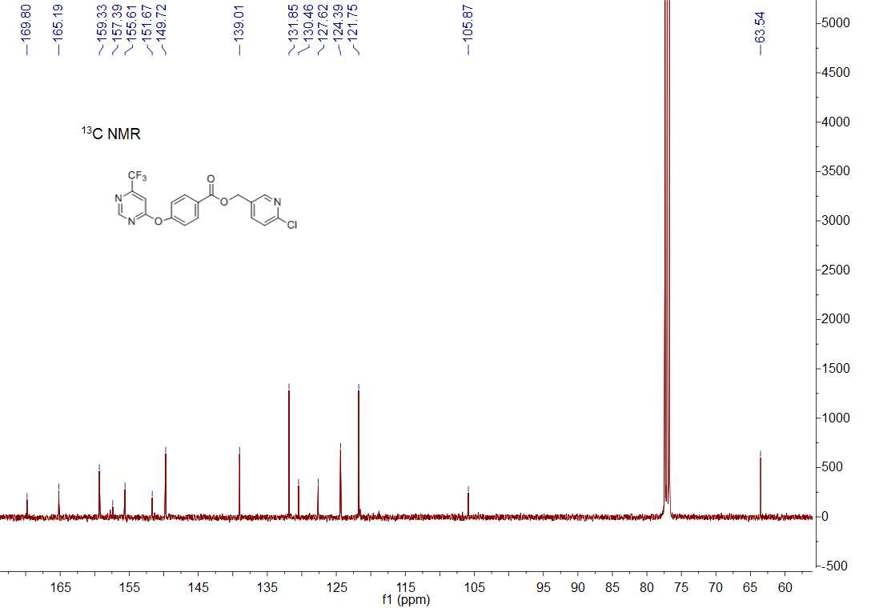

13C NMR spectrum of compound **5t**

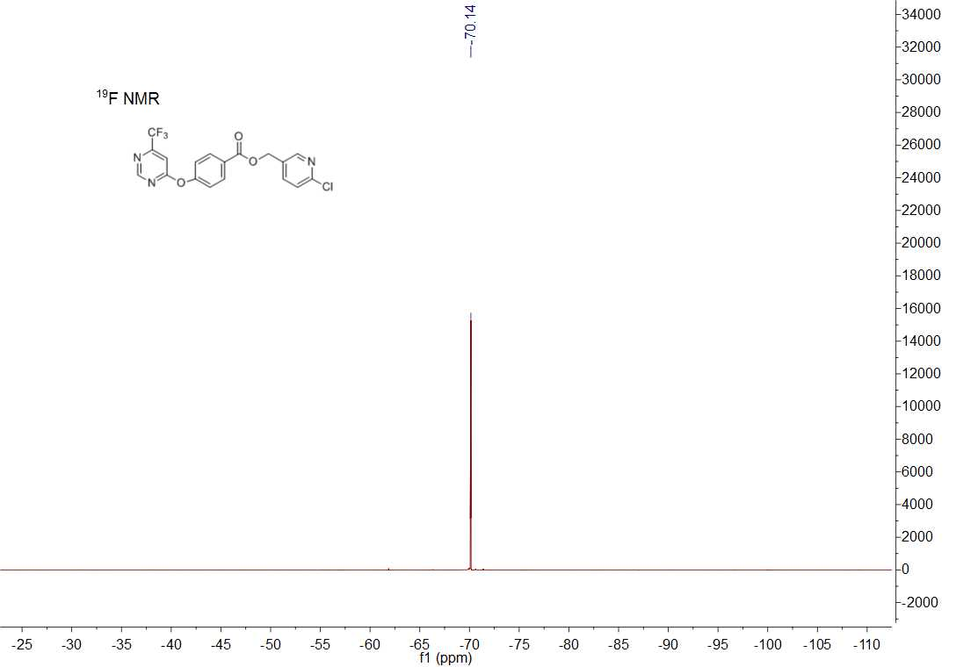

19F NMR spectrum of compound **5t**



HRMS (ESI) spectrum of compound **5t**

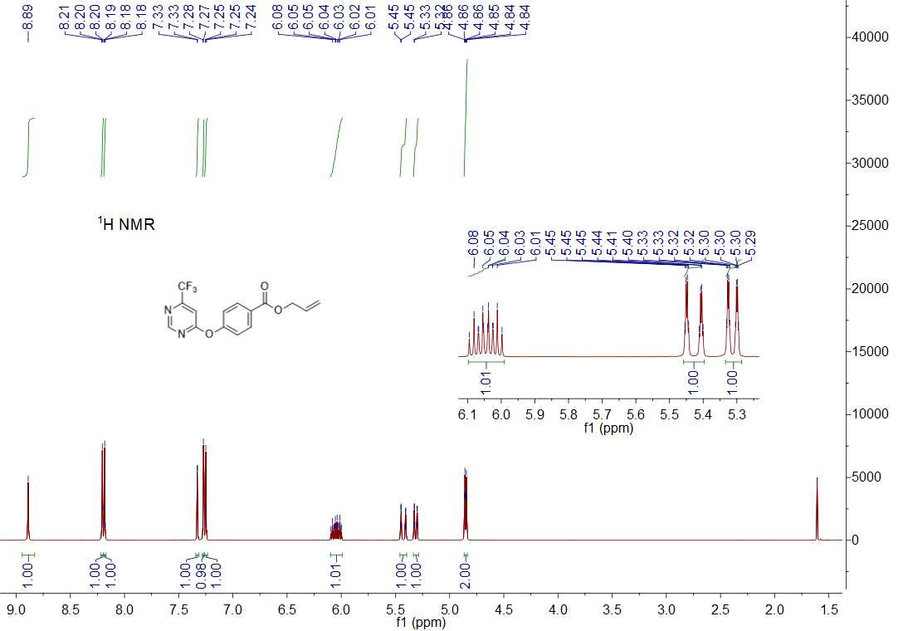

1H NMR spectrum of compound **5u**

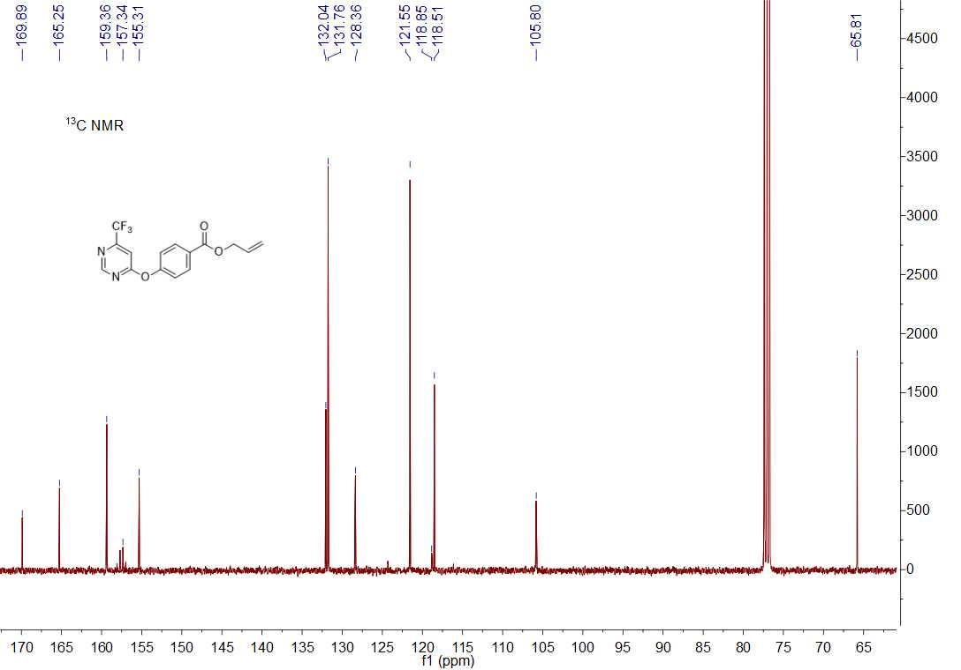

13C NMR spectrum of compound **5u**

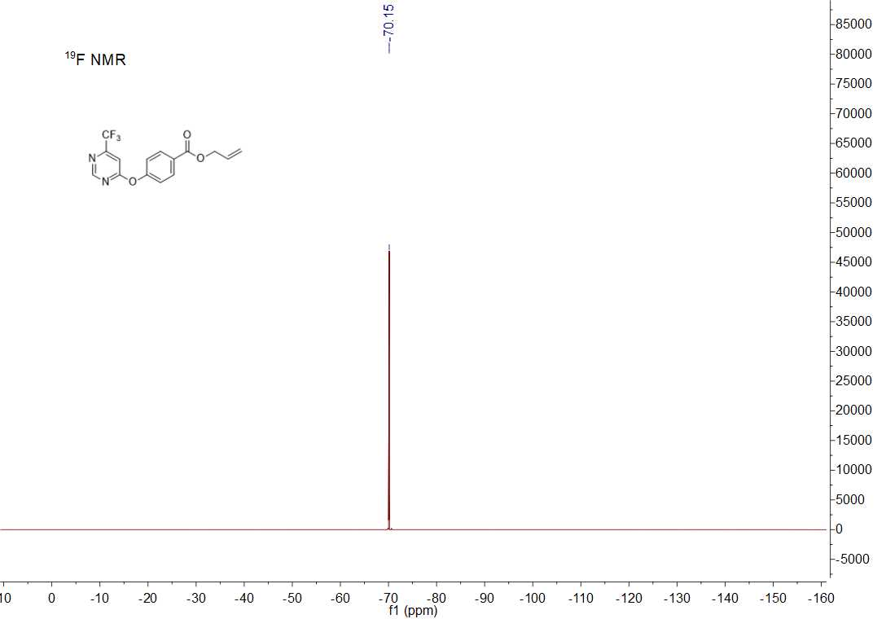

19F NMR spectrum of compound **5u**



HRMS (ESI) spectrum of compound **5u**

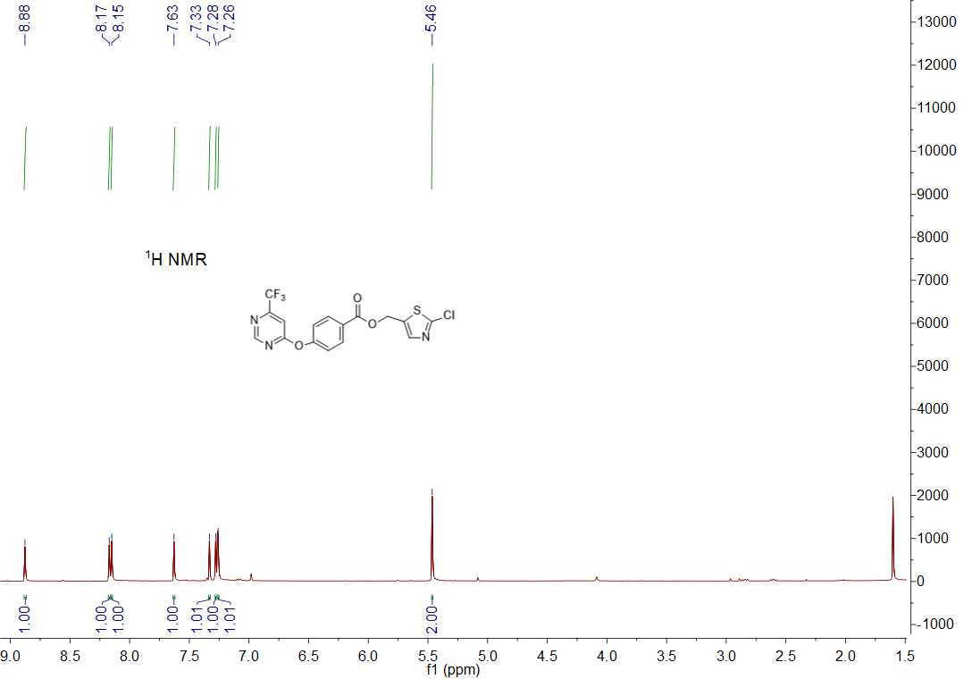

1H NMR spectrum of compound **5v**

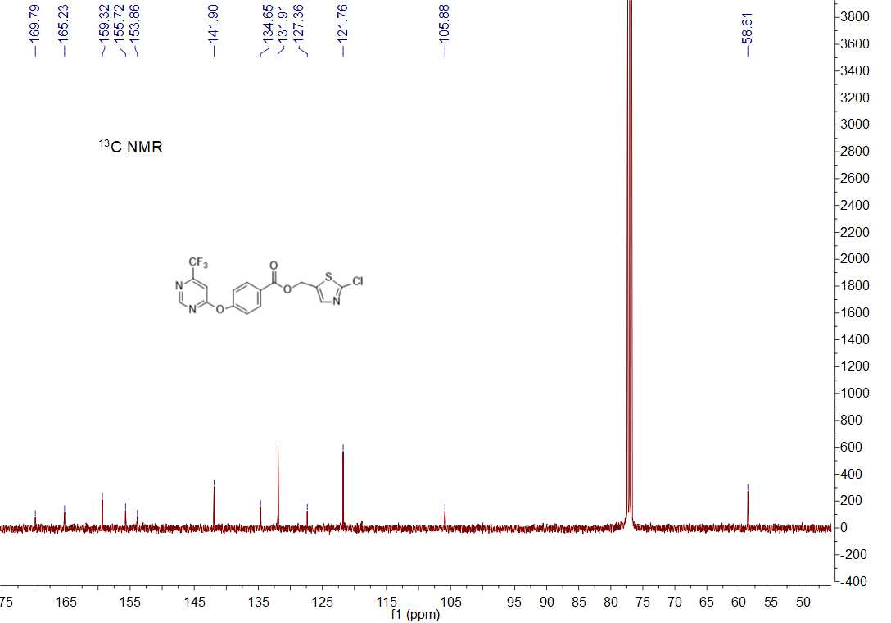

13C NMR spectrum of compound **5v**

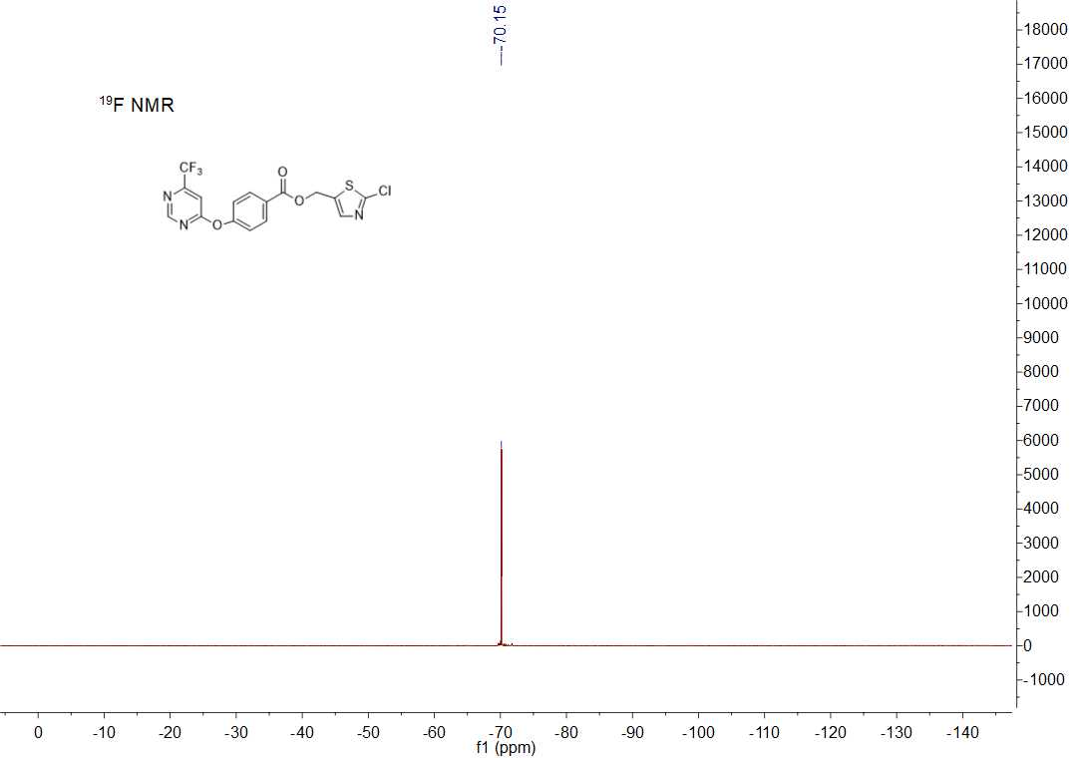

19F NMR spectrum of compound **5v**



HRMS (ESI) spectrum of compound **5v**