**Supplementary material**

**3D hierarchical** **structure collaborating with 2D/2D interface interaction in BiVO4/ZnCr-LDH heterojunction with superior visible-light photocatalytic** **removal efficiency for tetracycline hydrochloride**

Ruofan Yang a, b, Baiping Liang a, Shizheng Zheng a*, Changyuan Hu a*, Yajuan Xu c,Yanting Ma a, Yangyang Bai a, Kejie Dai a, Yan Tang a, Cuiqing Zhang d, Miao Chang a

*a Jiangxi Key Laboratory of Surface Engineering (School of Materials and Mechanical & Electrical Engineering), Jiangxi Science and Technology Normal University, Nanchang 330013, PR China*

*b Key Laboratory of Bio-based Material Science and Technology (Ministry of Education), Northeast Forestry University, 26 Hexing Road, Harbin, 150040, P. R. China*

*c Institute of foreign languages, Jiangxi Science and Technology Normal University, Nanchang 330013, PR China*

*d School of Pharmacy, Jiangxi Science and Technology Normal University, Nanchang 330013, PR China*

**\*Corresponding author.** Tel/Fax: + 86-791-83831266. E-mail:zhengsz1990@163.com (S. Zheng), hcy6257@163.com (C. Hu)

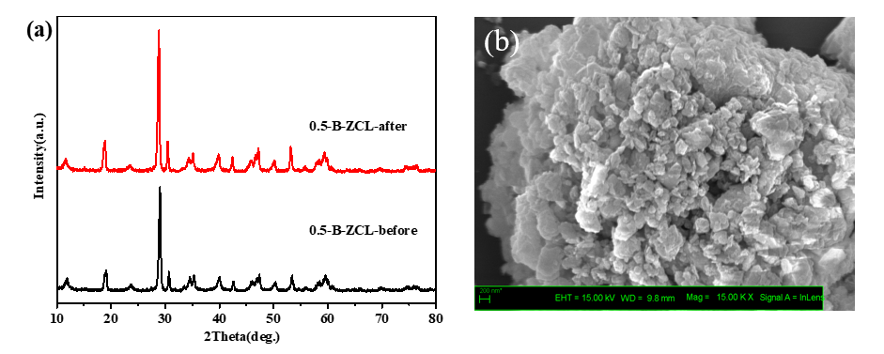

**Fig. S1** The XRD patterns (a) and SEM image (b) of 0.5-B-ZCL before and after cycling.



**Fig. S2** TOC removal efficiency of TC over 0.5-B-ZCL.