Surface Modification of Date Palm Activated Carbonaceous Materials for Heavy Metal Removal and CO₂ adsorption
A. Bumajdad* and P. Hasila
Chemistry Department, Faculty of Science, Kuwait University, P.O. Box 5969, Safat 13060, Kuwait

* Corresponding Author: Ali Bumajdad (a.bumajdad@ku.edu.kw)

3. Results and Discussion
3.1 Structural Properties
Electron Microscopy Analysis
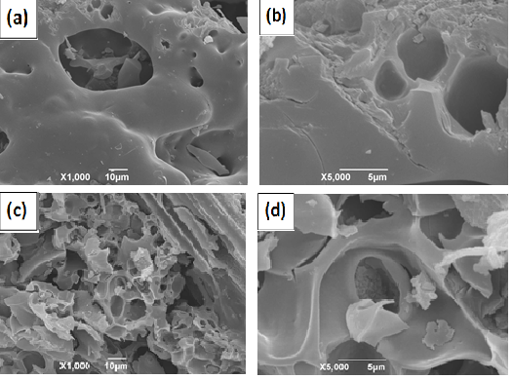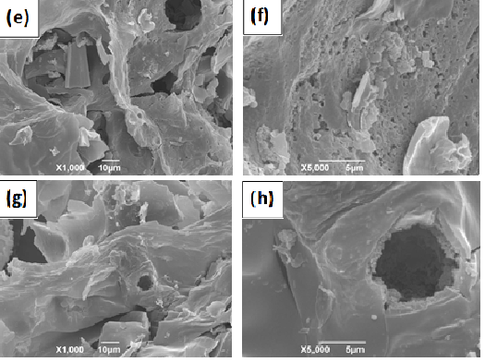
Figure S1. SEM micrographs of Urea enriched Pa-K₂CO₃ AC before (a,b) and after (c,d) adsorption and that of urea enriched Pa-Cs₂CO₃ AC before (e,f) and after (g,h) adsorption for Pb (II).

X-Ray Diffraction

Figure S2. XRD patterns of Ps-ACs activated with K₂CO₃ before (not enriched) and after functionalization (N-enriched).

3.2 Thermal Analysis

Figure S3. TGA curves of (a) raw palm samples where upper curve (L) for leafy part and lower curve (S) for stem part and (b) different N enriched Ps-ACs activated with K₂CO₃.

3.4. Identification of Functionalities
FTIR and Raman

Figure S4. Raman spectra of the indicated samples.

3.5 Quantitative assessment of acid surface functional groups - Boehm titrations
Figure S5. Potentiometric (a) and first derivative curve (b) of the titration. The activating agent is Cs₂CO₃.

3.7.4 Thermodynamics of Lead Adsorption
Figure S6. The thermodynamic plot for adsorption of Pb(II) on to Ps-Cs₂CO₃ enriched by Urea at varying initial concentrations (10-80 ppm).

