Supplementary Materials

Table 1. Antibodies used in the Western blotting, IHC and IF.
Antibody | Catalog No. | Predicted size (kDa) | Manufacturers
Anti-NMDAR2A (phospho Y1325) | ab16646 | 163 | Abcam
Anti-NMDAR2B (phospho S1303) | ab81271 | 166 | Abcam
Anti-NMDAR2B (phospho S1303) | bs-19292R | 166 | Bioss
Anti-GluR2 (phospho S880) | ab52180 | 97 | Abcam
Anti-GluR1 (phospho Ser863) | bs-11632R | 98 | Bioss
Anti-NMDAR2A | ab254356 | 163 | Abcam
Anti-NMDAR2B | ab124913 | 166 | Abcam
Anti-GluR1 | bs-10042R | 98 | Bioss
Anti-GluR2 | bs-1798R | 97 | Bioss
Anti-phospho-GluA2(Tyr869/Tyr873/Tyr876) | #3921 | 100 | CST
Anti-PKC alpha [Y124] | ab32376 | 77 | Abcam
Anti-GFAP(GA5) mAb | #3670 | 50 | CST
Anti-IBA1 mAb | NCNP224 | 16 | WAKO
Anti-IBA1 polyclonal | AF7143 | 16 | Beyotime
Anti-MAP2 | 17490-1-AP | 75 | Proteintech
Anti-HIF-1 alpha | bs-20399R | 120 | Bioss
Anti-CD68 mAb | BD-PM3050 | 70 | Biodragon
Anti-Synaptophysin | 17785-1-AP | 38 | Proteintech
Anti-PSD95-specific, DLG4 | 20665-1-AP | 95 | Proteintech
Anti-beta-actin | bsm-33036M | 45 | Bioss
Alexa Fluor® 488 | ZF-0511 | - | ZSGB-Bio
Alexa Fluor® 488 | ZF-0512 | - | ZSGB-Bio
Alexa Fluor® 594 | ZF-0513 | - | ZSGB-Bio
Alexa Fluor® 594 | ZF-0516 | - | ZSGB-Bio
DyLight 680 | BD9008 | - | Biodragon
DyLight 800 | BD9008 | - | Biodragon

Table 2. Primers used for the RT-PCR.
Gene | Primers (5’→3’)
Actin-F | GGCTGTATTCCCCTCCATCG
Actin-R | CCAGTTGGTAACAATGCCATGT
TNF-α-F | CTATGGCCCAGACCCTCACA
TNF-α-R | TCTTGACGGCAGAGAGGAGG
IL-6-F | GCTACCAAACTGGATATAATCAGGA
IL-6-R | CCAGGTAGCTATGGTACTCCAGAA
IL-1β-F | GAAATGCCACCTTTTGACAGTG
IL-1β-R | TGGATGCTCTCATCAGGACAG
IL-10-F | GCTCTTACTGACTGGCATGAG
IL-10-R | CGCAGCTCTAGGAGCATGTG
IFN-γ-F | CAGCAACAGCAAGGCGAAAAAGG
IFN-γ-R | TTTCCGCTTCCTGAGGCTGGAT

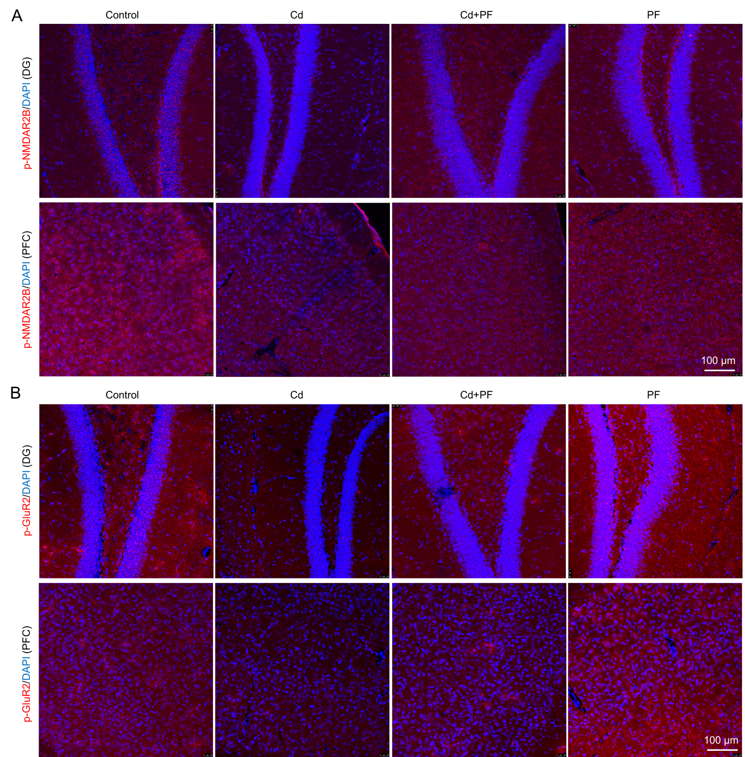
Fig. S1. Cd induced toxicity impaired the activity of glutamate receptors NMDAR2B and GluR2 in hippocampal DG and prefrontal cortex (PFC), but can be rescued by PF treatment. Scale bar, 100 μm..

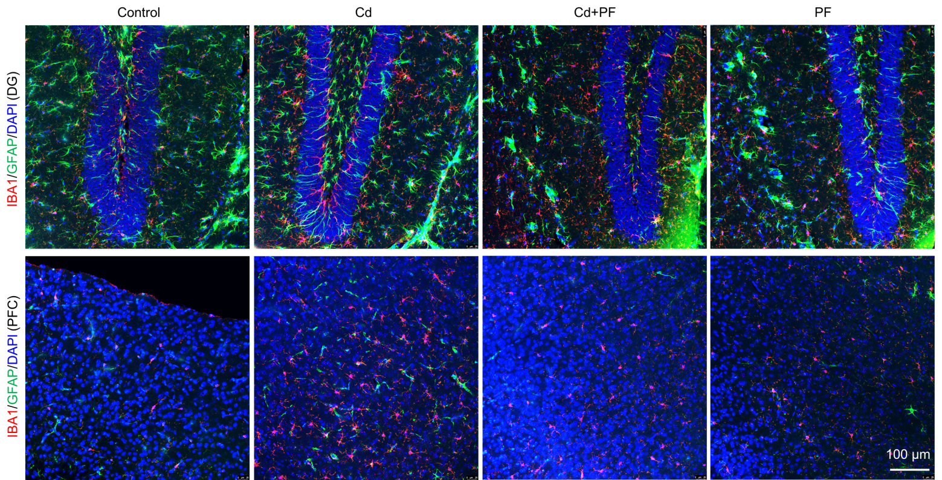
Fig. S2. Immunofluorescence images of GFAP and IBA1 in hippocampal region DG and prefrontal cortex (PFC). Scale bar, 100 μm.

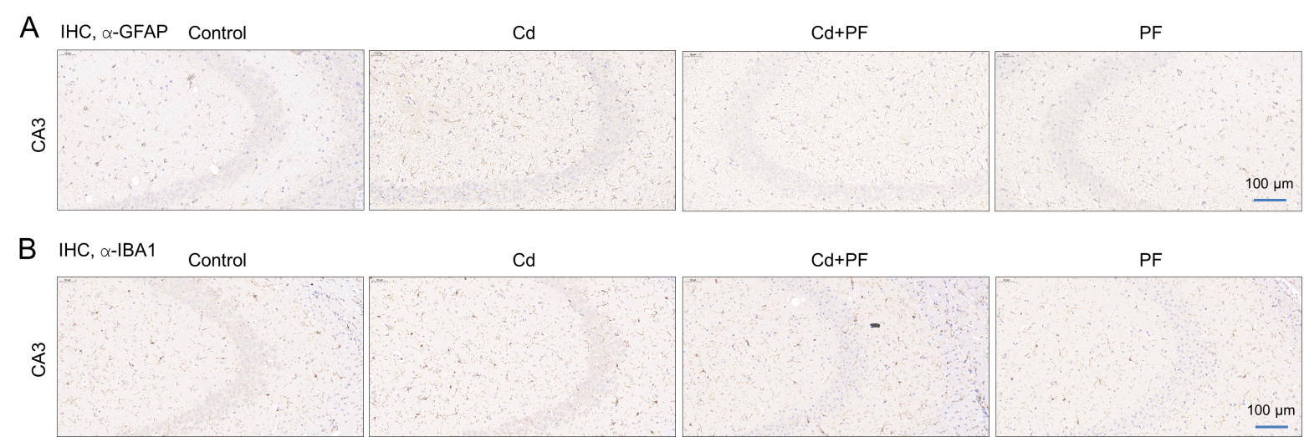
Fig. S3. IHC staining of GFAP and IBA1 in hippocampal region CA1. Scale bar, 100 μm.

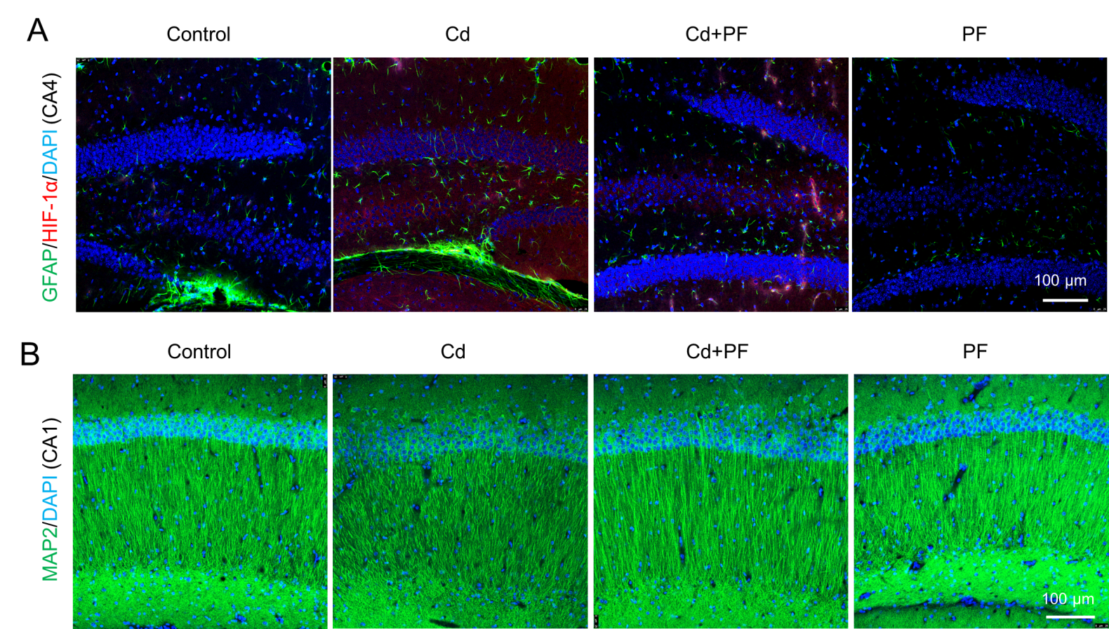
Fig. S4. (A) Immunofluorescence images of GFAP and HIF-1α in hippocampal region CA4. (B) Immunofluorescence images of MAP2 in hippocampal region CA1. Scale bar, 100 μm.

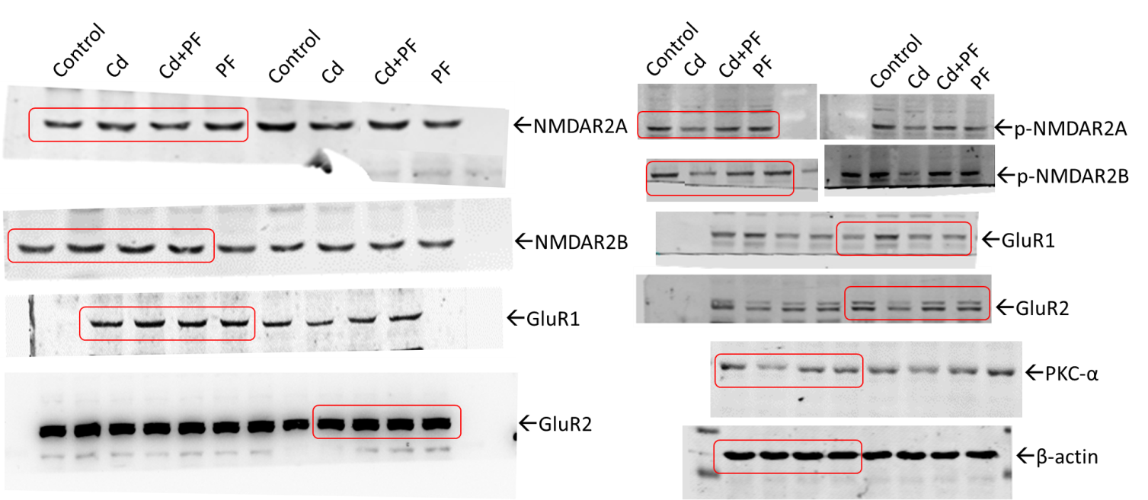
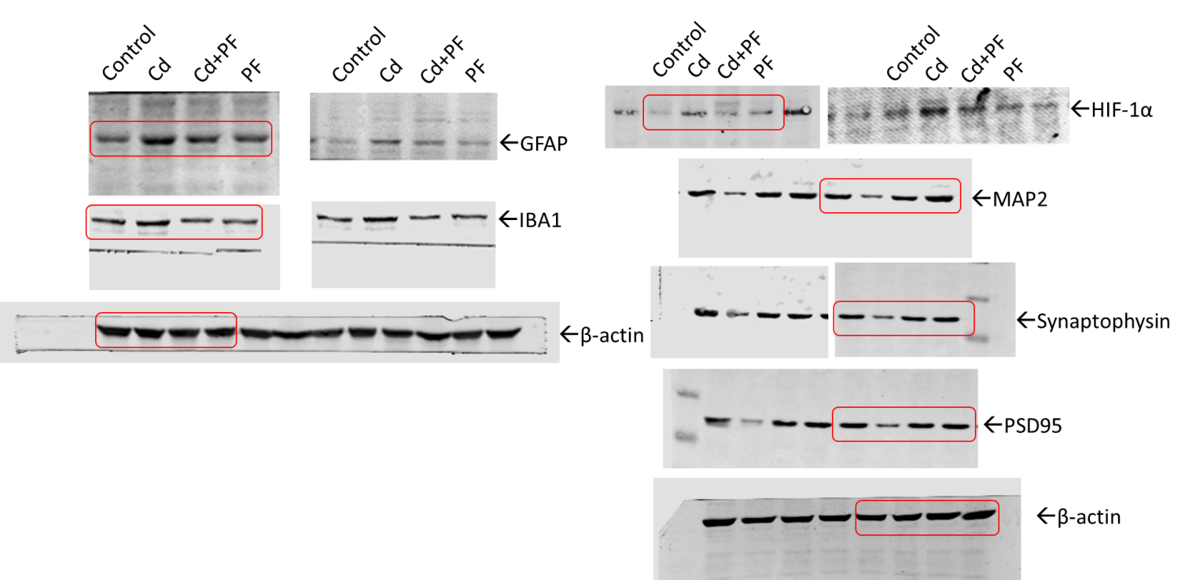
Fig. S5. Raw data of Western blots in Fig. 3B, Fig. 4C and Fig. 6C.

