*Supporting Information*

*for*

Hierarchical TiO2 Microspheres Supported Ultrasmall Palladium Nanocrystals: a Highly Efficient Catalyst for Suzuki Reaction

Shiguang Pan,a,b,* Cong Gao,a,c Jiatong Gui,a,b Beibei Hu,a,b Lifeng Gai,d Changsheng Qiao,d Chengwei Liua,c

*a* State Key Laboratory of Separation Membranes and Membrane Processes, Tianjin Key Laboratory of Green Chemical Technology and Process Engineering, Tianjin 300387, China.

*b* School of Chemistry, Tiangong University, Tianjin, 300387, P. R. China

*c* School of Chemical Engineering & Technology, Tiangong University, Tianjin, 300387, P. R. China

*d* Tianjin Beiyang Baichuan Biotechnologies Co., ltd., Tianjin, 300457, P. R. China

Correspondence: pan@tiangong.edu.cn (Shiguang Pan);

Present addresses: School of Chemistry, Tiangong University, No.399 BinShuiXi Road, XiQing District, Tianjin, 300387, P. R. China

**Contents**

1. Experimental Section········································································3
2. Preparation procedure for TiO2 microspheres············································3
3. Preparation procedure for Pd/TiO2-350···················································3
4. General procedure for the Suzuki-Miyaura reaction····································3
5. Table S1. The catalytic activities of Pd/TiO2 that calcinated at different temperatures··················································································4
6. Spectral data for all compounds····························································5
7. 1H and 13C NMR spectra for all compounds··············································9

**Experimental Section**

**General.** 1H and 13C NMR spectra were recorded on a AVANCE AV 400MHz (6-440Hz) spectrometers. The chemical shifts were reported in parts per million (*δ*) relative to internal standard TMS (0.03%) for CDCl3. The peak patterns are indicated as follows: s, singlet; d, doublet; dd, doublet of doublet; t, triplet; m, multiplet; q, quartet. The coupling constants, *J*, are reported in Hertz (Hz). CDCl3 was used as an NMR solvent. GC analysis was carried out on a GC-2010 Pro (FID). The model of the scanning electron microscope is Gemini SEM500, Resolution: 0.6nm@15KV; 1.1nm@1KV; 1.4nm@500V. Accelerating voltage: 0.02~30 KV. Gain: 12-2000000 X. Beam current: 3 pA-20 nA. Electron gun: thermal field emission Schottky electron gun, beam stability due to 0.2% h-1. The model of the transmission electron microscope (TEM) is Hitachi H7650. Accelerating voltage: 120KV, Resolution: 0.204 nm (Lattice image), Gain: 200-600000 X, Sample tilt: ±20°, Image is tilted ±90°.

**Preparation procedure for TiO2 microspheres:** a mixture of titanium tetraisopropoxide (1.5 mL), diethylenetriamine (0.025 mL) and isopropanol (33 mL) stirred at room temperature for 3 min and then transformed into a 50 mL Teflon autoclave, heated to 200 °C in an oven for 24 h. After cooling, the precipitate was separated by centrifugation, washed with methanol and water, dried at 80 °C for 12 hours, to give TiO2 microspheres.

**Preparation procedure for Pd/TiO2-350:** using wet-impregnation method, an aqueous solution of palladium nitrate was impregnated into the prepared TiO2 microspheres (0.2 g) at a concentration of 1.0 wt% Pd. Then dried at 80 °C for 12 hours, followed by calcined at 350 °C for 4 hours a rate of 2 °C/min under a nitrogen atmosphere, to give the desired Pd/TiO2-350.

**General procedure for the Suzuki-Miyaura reaction:** A mixture of catalyst (1.0 mg of Pd/TiO2-350, 0.01 mmol of Pd), aryl iodides (0.5 mmol) and arylboronic acids (0.75 mmol) in EtOH/H2O (1.0 mL/1.0 mL) was stirred at 80 ℃ for 3 h under air. After cooling, the mixture was extracted with ethyl acetate (3 mL x 3). The combined organic phases were concentrated in vacuo and the crude products were purified by column chromatography (hexane/AcOEt) to give the corresponding product.

**Table S1**. The catalytic activities of Pd/TiO2 that calcinated at different temperatures



|  |  |  |
| --- | --- | --- |
| Entry | Pd catalyst (1.0 mg) | GC yield(%) |
| 1 | Pd/TiO2-300 | 65 |
| 2 | Pd/TiO2-350 | 99 |
| 3 | Pd/TiO2-400 | 34 |
| 4 | Pd/TiO2-450 | 6 |

**Spectral data for all compounds**



**1,1'-Biphenyl (3a)**.Isolated by column chromatography (hexane/AcOEt = 25: 1, Rf = 0.7). The title compound was obtained as colorless flake crystal (99%).1H NMR (ppm) *δ* 7.43(dd, 4 H, *J* = 3.2 Hz, *J* = 7.2 Hz), 7.49(q, 4 H, *J* = 15.2 Hz), 7.41-7.38 (m, 2 H); 13C NMR (ppm) *δ* 141.2, 128.7, 127.2, 127.1.



**4-Methoxy-1,1'-biphenyl (3b)**.Isolated by column chromatography (hexane/AcOEt = 25: 1, Rf = 0.7). The title compound was obtained as light-yellow powder (99%). 1H NMR (ppm) *δ* 7.65 (dq, 4 H, *J* = 8.4 Hz, *J* = 8.4 Hz), 7.59 (dd, 1 H, *J* = 193.2 Hz, *J* = 193.2 Hz), 7.53 (dd, 2 H, *J* = 6.8 Hz, *J* = 6.8 Hz), 7.00 (dd, 2 H, *J* = 6.8 Hz, *J* = 6.8 Hz), 3.86 (s, 3 H); 13C NMR (ppm) *δ* 159.1, 140.8, 133.7, 128.7, 128.1, 126.7, 126.6, 114.2, 55.3.



**4-Methyl-1,1'-biphenyl (3c)**.Isolated by column chromatography (hexane/AcOEt = 25: 1, Rf = 0.7). The title compound was obtained as white powder (85%).1H NMR (ppm) *δ* 7.59 (t, 2 H, *J* = 8.4 Hz), 7.50 (d, 2 H, *J* = 8.8 Hz), 7.43 (dd, 2 H, *J* = 7.2 Hz, *J* = 13.2 Hz), 7.33 (t, 1 H, 14.4 Hz) 7.265 (s, 1 H), 7.246 (s, 1 H), 2.40 (s, 3 H); 13C NMR (ppm) *δ* 141.2, 140.1, 137.0, 131.3, 129.5, 128.7, 127.0, 126.9, 122.0, 21.1.



**4-Chloro-1,1'-biphenyl (3d)**.Isolated by column chromatography (hexane/AcOEt = 25: 1, Rf = 0.7). The title compound was obtained as light-yellow powder (99%).1H NMR (ppm) *δ* 7.54 (q, 4 H, *J* = 6 Hz), 7.48-7.36 (m, 5 H); 13C NMR (ppm) *δ* 134.0, 139.6, 133.4, 128.9, 128.8, 128.4, 127.6, 127.0.



**[1,1'-Biphenyl]-4-carbonitrile (3e)**.Isolated by column chromatography (hexane/AcOEt = 25: 1, Rf = 0.7). The title compound was obtained as white powder (99%).1H NMR (ppm) *δ* 7.71 (q, 4 H, *J* = 26.4 Hz), 7.59 (d, 2 H, *J* = 7.2 Hz), 7.51-7.41 (m, 3 H); 13C NMR (ppm) *δ* 145.6, 139.1, 132.6, 129.1, 128.6, 127.7, 127.2, 118.9, 110.9.



**1-([1,1'-Biphenyl]-4-yl)ethan-1-one (3f)**.Isolated by column chromatography (hexane/AcOEt = 25: 1, Rf = 0.7). The title compound was obtained as white powder (99%). 1H NMR (ppm) *δ* 8.04 (d, 2 H, *J* = 8.4 Hz), 7.65 (dd, 4 H, *J* = 23.2 Hz, *J* = 22 Hz), 7.50-7.39 (m,3 H), 2.64 (s, 3 H); 13C NMR (ppm) *δ* 197.7, 145.7, 139.8, 135.8, 128.9, 128.9, 128.2, 127.2, 127.1, 26.6.



**4-Methoxy-4'-methyl-1,1'-biphenyl (3g)**.Isolated by column chromatography (hexane/AcOEt = 25: 1, Rf = 0.7). The title compound was obtained as yellow-green flake solid (99%).1H NMR (ppm) *δ* 7.49 (dd, 4 H, *J* = 24.8 Hz, *J* = 24Hz), 7.24 (d, 2 H, *J* = 7.6 Hz), 6.98 (d, 2 H, *J* = 8.4Hz), 3.86 (s, 3 H), 2.40 (s, 3H); 13C NMR (ppm) *δ* 158.9, 137.9, 136.3, 133.7, 129.4, 127.9, 126.6, 114.1, 55.3, 21.0.



**4-Chloro-4'-methoxy-1,1'-biphenyl (3h)**.Isolated by column chromatography (hexane/AcOEt = 25: 1, Rf = 0.7). The title compound was obtained as white powder (96%). 1H NMR (ppm) *δ* 7.52-7.46 (m, 4 H), 7.39 (dt, 2 H, *J* = 4.8 Hz, *J* = 4.8 Hz), 6.99 (dt, 2 H, *J* = 5.2 Hz, *J* = 5.2 Hz), 3.86 (s, 3 H); 13C NMR (ppm) *δ* 159.3, 139.2, 132.6, 132.5, 128.8, 128.0, 127.9,114.3, 55.3.



**4'-Methoxy-[1,1'-biphenyl]-4-carbonitrile (3i)**.Isolated by column chromatography (hexane/AcOEt = 25: 1, Rf = 0.7). The title compound was obtained as white powder (91%). 1H NMR (ppm) *δ* 7.50-7.47 (m, 4 H), 7.39 (dt, 2 H, *J* = 4.4 Hz, *J* = 4.4 Hz), 6.99 (dt, 2 H, *J* = 5.2 Hz, *J* = 5.2 Hz), 3.86 (s, 3 H); 13C NMR (ppm) *δ* 159.4, 139.3, 132.7, 132.5, 128.9, 128.1, 128.0, 114.4, 55.4.



**4,4'-Dimethyl-1,1'-biphenyl (3j)**.Isolated by column chromatography (hexane/AcOEt = 25: 1, Rf = 0.7). The title compound was obtained as white powder (90%). 1H NMR (ppm) *δ* 7.46 (d, 4 H, *J* = 8Hz), 7.2 (t, 4 H, *J* = 28.8 Hz), 2.36 (s, 6 H); 13C NMR (ppm) *δ* 138.3, 136.6, 129.4, 126.8, 21.0.



**4'-Methyl-[1,1'-biphenyl]-4-carbonitrile (3k)**.Isolated by column chromatography (hexane/AcOEt = 25: 1, Rf = 0.7). The title compound was obtained as white powder (99%). 1H NMR (ppm) *δ* 7.72-7.65 (m, 4 H), 7.51-7.49 (m, 2 H), 7.29 (d, 2 H, *J* = 7.6 Hz), 2.42 (s, 3 H); 13C NMR (ppm) *δ* 145.5, 138.7, 136.2, 132.5, 129.8, 127.4, 127.0, 119.0, 110.5, 21.1.



**1-(4'-Methyl-[1,1'-biphenyl]-4-yl)ethan-1-one (3l)**.Isolated by column chromatography (hexane/AcOEt = 25: 1, Rf = 0.7). The title compound was obtained as white powder (96%). 1H NMR (ppm) *δ* 8.02 (d, 2 H, *J* = 8 Hz), 7.67 (d, 2 H, *J* = 8 Hz), 7.54 (d, 2 H, *J* = 12 Hz), 7.28 (d, 2 H, *J* = 8 Hz), 2.64 (s, 3 H), 2.42 (s, 3 H); 13C NMR (ppm) *δ* 197.8, 145.7, 138.2, 136.9, 135.5, 129.7, 128.9, 127.1, 126.9, 29.7, 26.7, 21.2.



**4'-Chloro-[1,1'-biphenyl]-4-carbonitrile (3m)**.Isolated by column chromatography (hexane/AcOEt = 25: 1, Rf = 0.7). The title compound was obtained as white powder (86%). 1H NMR (ppm) *δ* 7.70 (dd, 4 H, *J* = 32.8 Hz, *J* = 32.8 Hz), 7.49 (dd, 4 H, *J* = 27.6 Hz, *J* = 28 Hz); 13C NMR (ppm) *δ* 144.3, 137.5, 134.9, 132.7, 129.3, 128.4, 127.5, 118.8, 111.2.



**4'-Acetyl-[1,1'-biphenyl]-4-carbonitrile (3n)**.Isolated by column chromatography (hexane/AcOEt = 25: 1, Rf = 0.7). The title compound was obtained as white powder (89%). 1H NMR (ppm) *δ* 8.06 (d, 2 H, *J* = 8.4 Hz), 7.76-7.67 (m, 6 H)，2.64 (s, 3 H); 13C NMR (ppm) *δ* 197.5, 144.2, 143.5, 136.8, 132.7, 129.1, 127.9, 127.4, 118.6, 111.8, 29.6, 26.7.



**1-(4'-Chloro-[1,1'-biphenyl]-4-yl)ethan-1-one (3o)**.Isolated by column chromatography (hexane/AcOEt = 25: 1, Rf = 0.7). The title compound was obtained as light yellow powder (99%). 1H NMR (ppm) *δ* 8.03 (dt, 2 H, *J* = 3.6 Hz, *J* = 4 Hz), 7.64 (dt, 2 H, *J* = 3.6 Hz, *J* = 4 Hz), 7.55 (dt, 2 H, *J* = 4.4 Hz, *J* = 4.4 Hz), 7.43 (dt, 2 H, *J* = 4.4 Hz, *J* = 4.4 Hz), 2.64 (s, 3 H); 13C NMR (ppm) *δ* 197.6, 144.4, 138.3, 136.1, 134.4, 129.1, 129.0, 128.5, 127.0, 26.6.

**1H and 13C NMR spectra for all compounds**

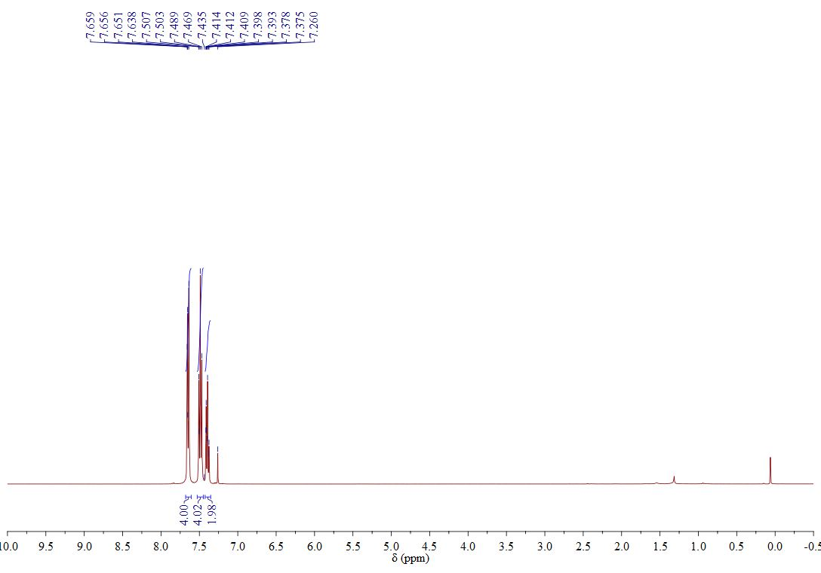



**3a**

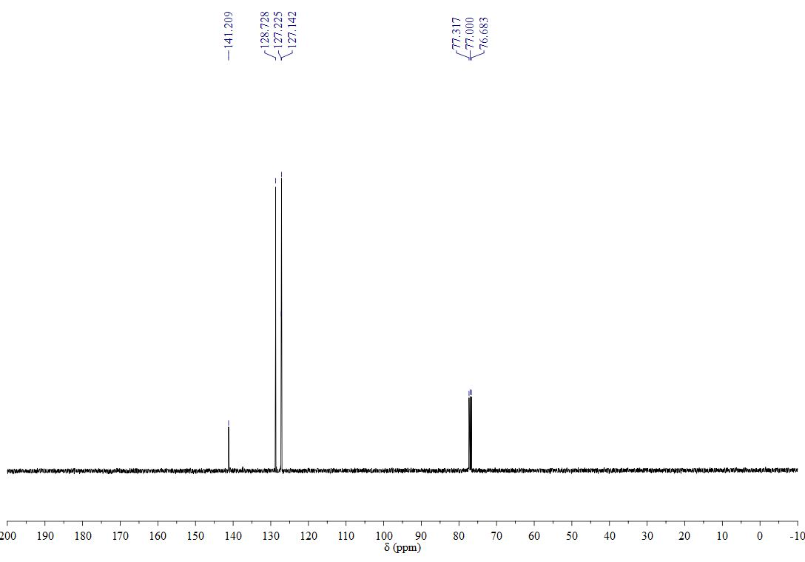

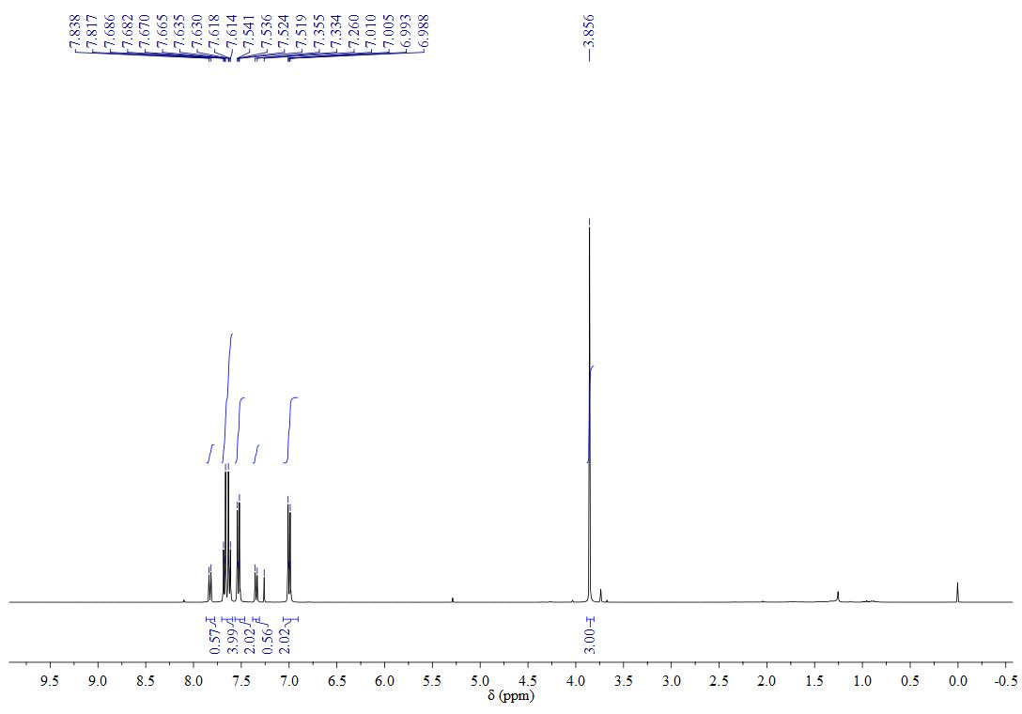



**3b**

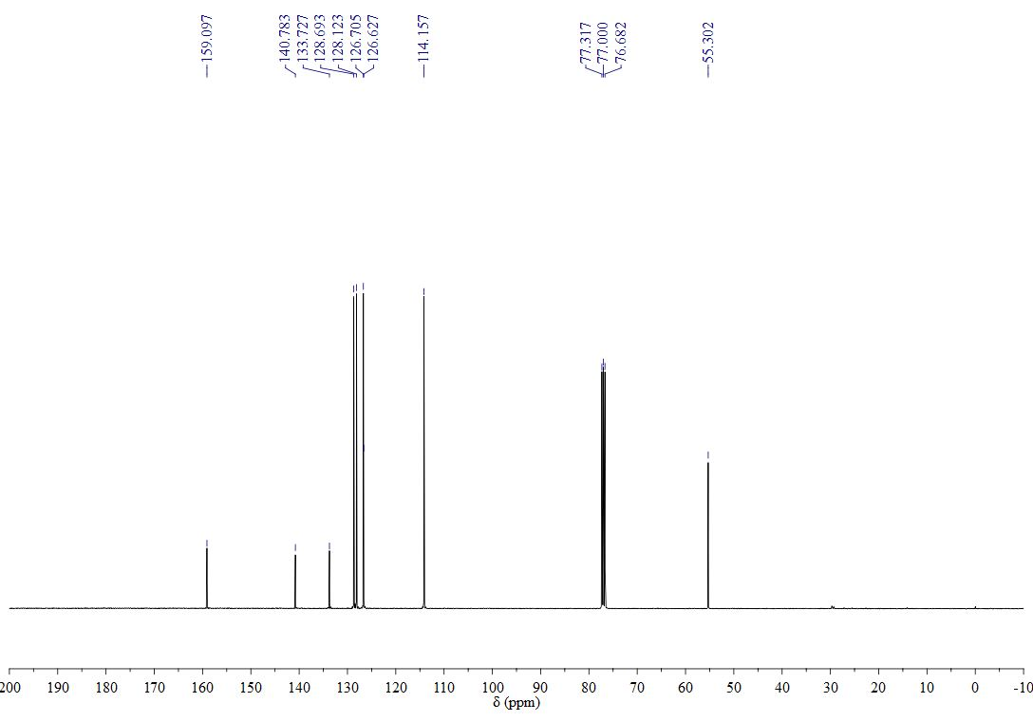

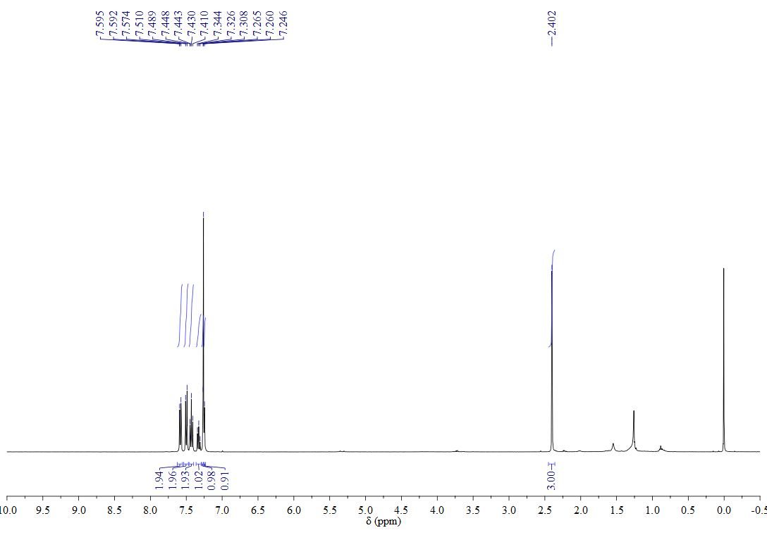



**3c**

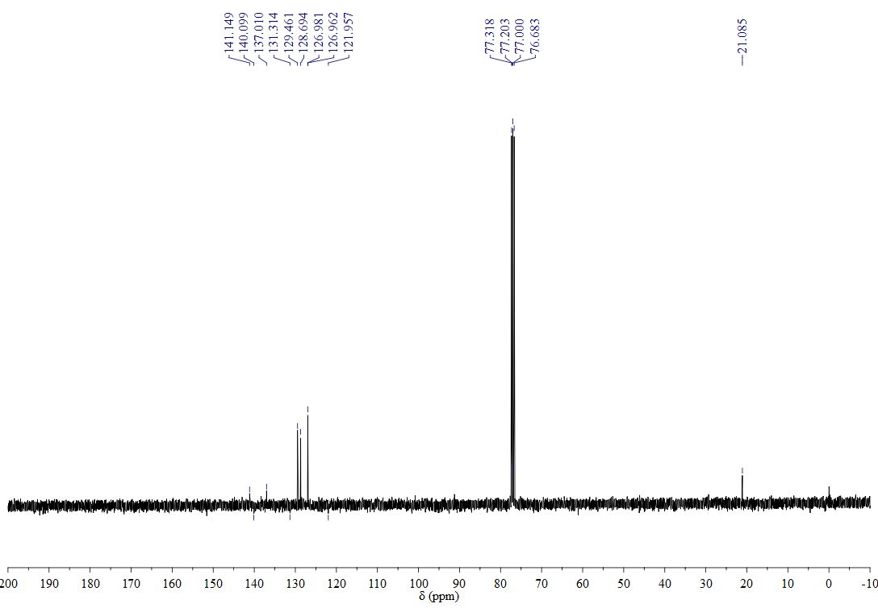

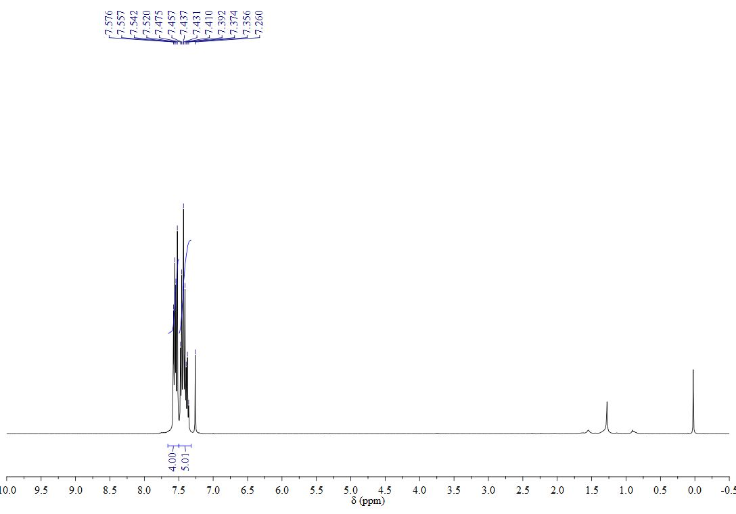



**3d**

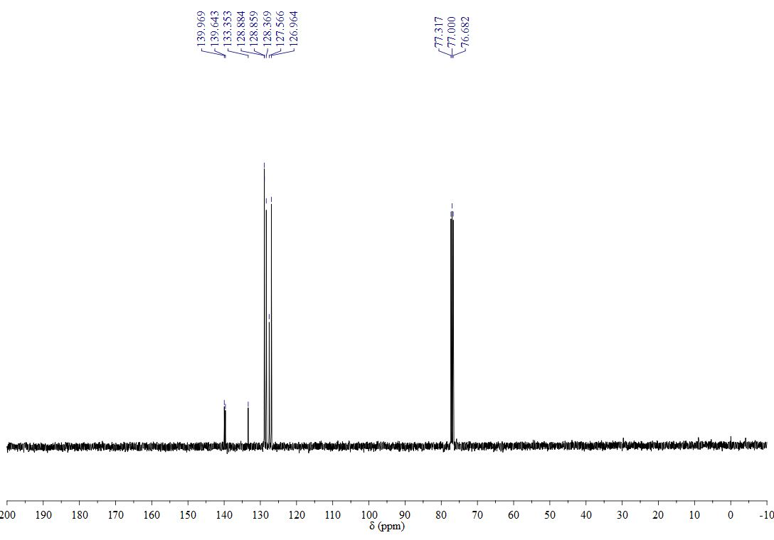

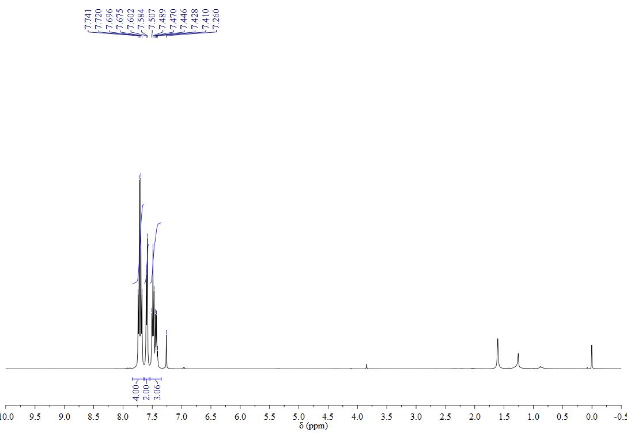



**3e**

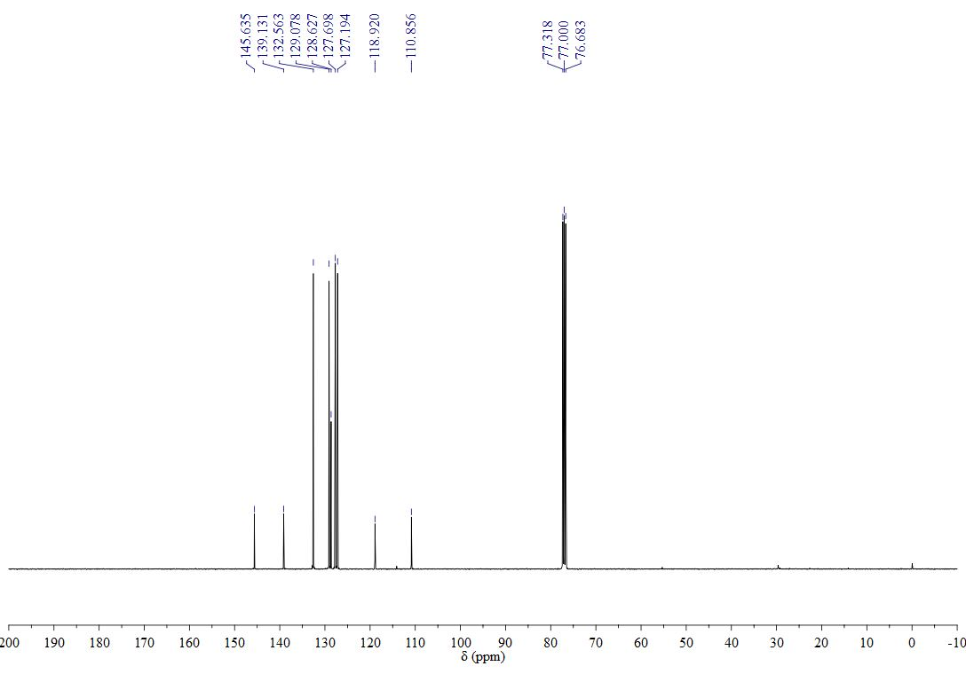

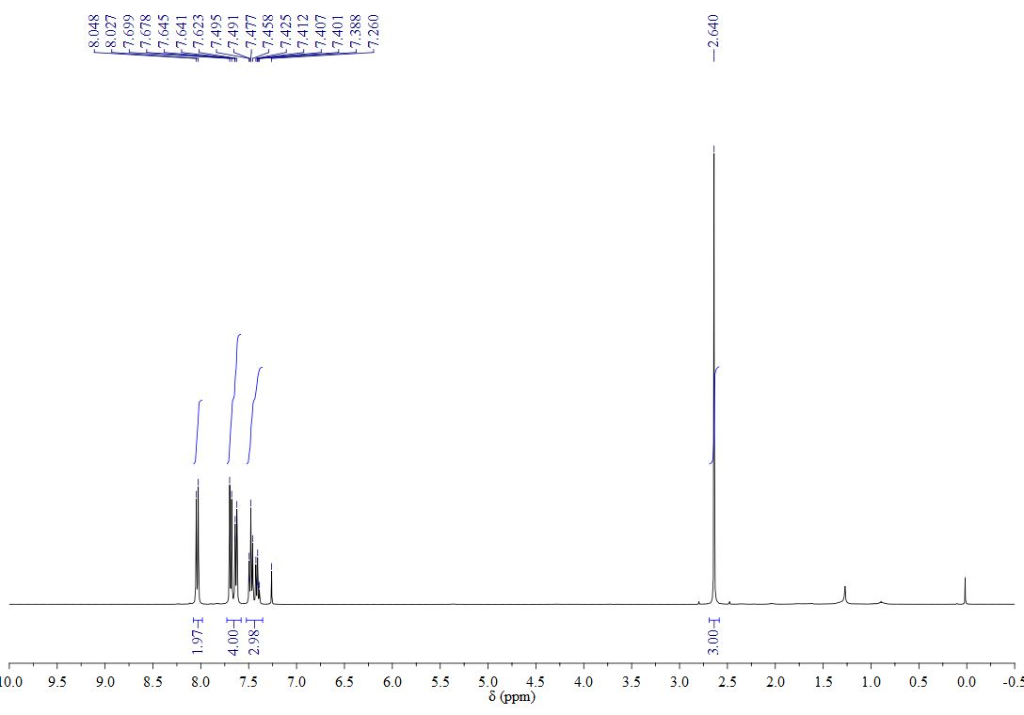



**3f**

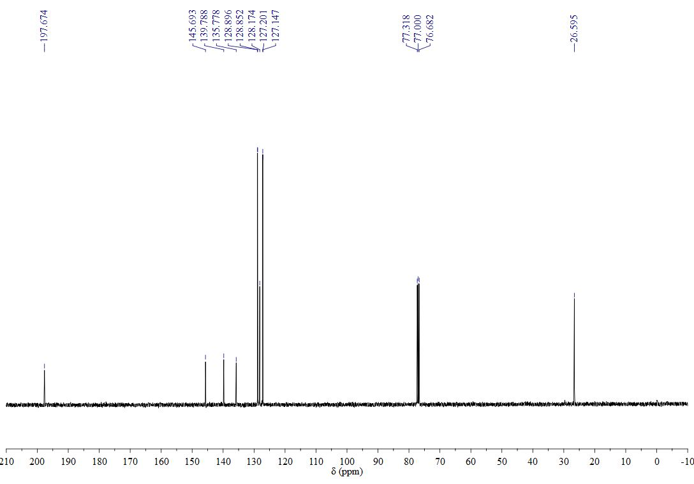

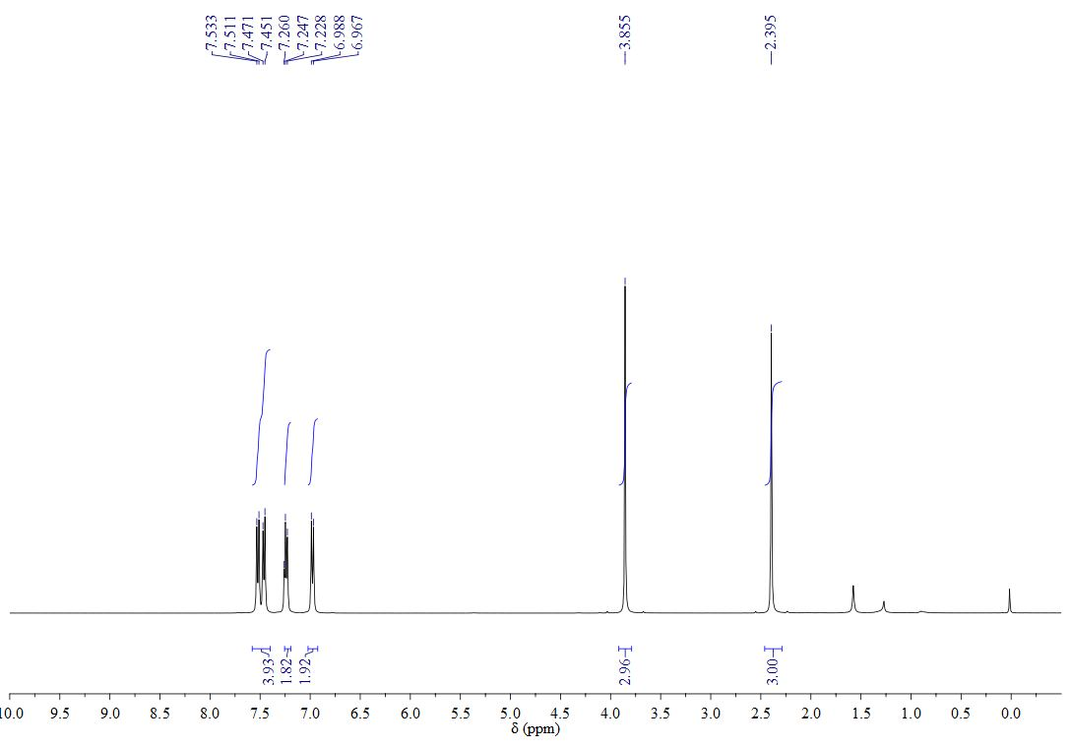



**3g**

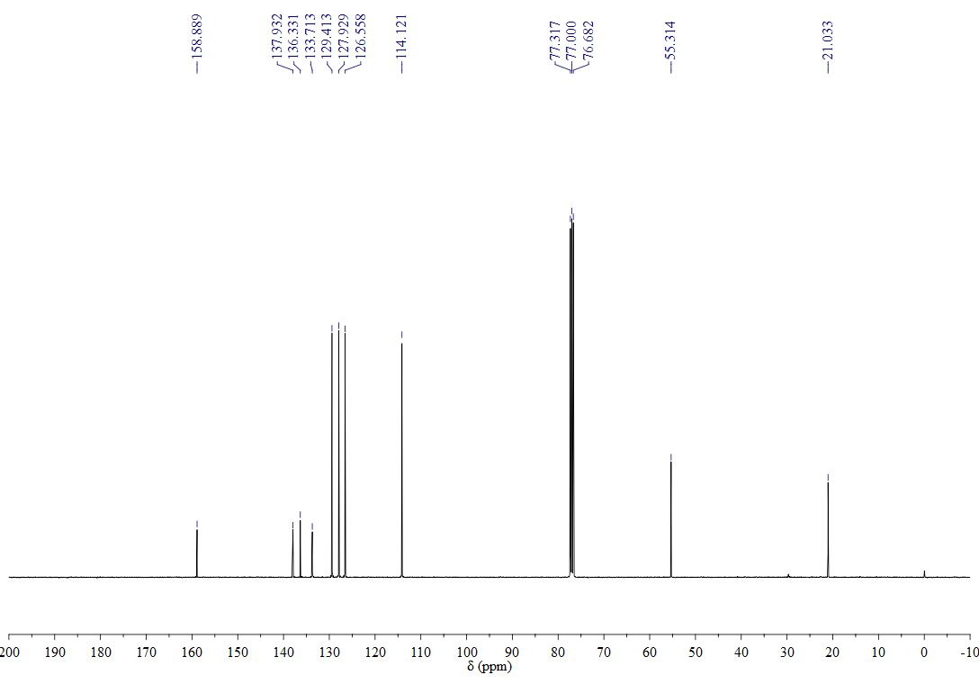

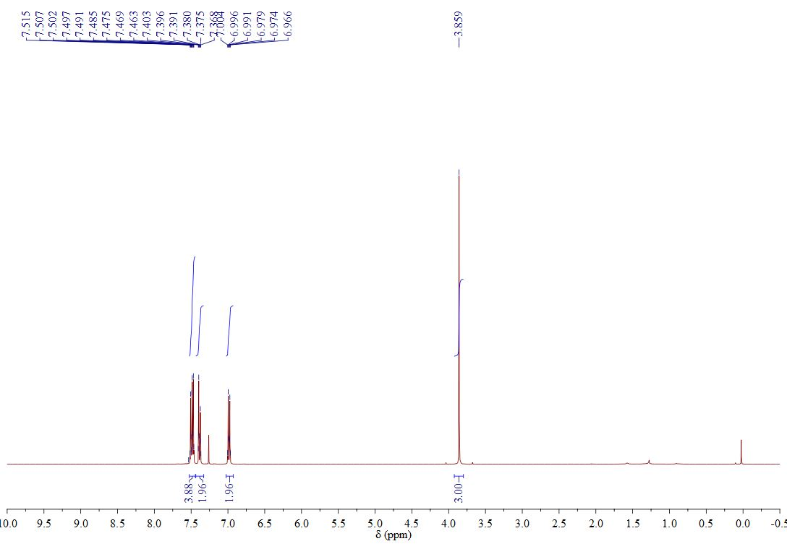



**3h**



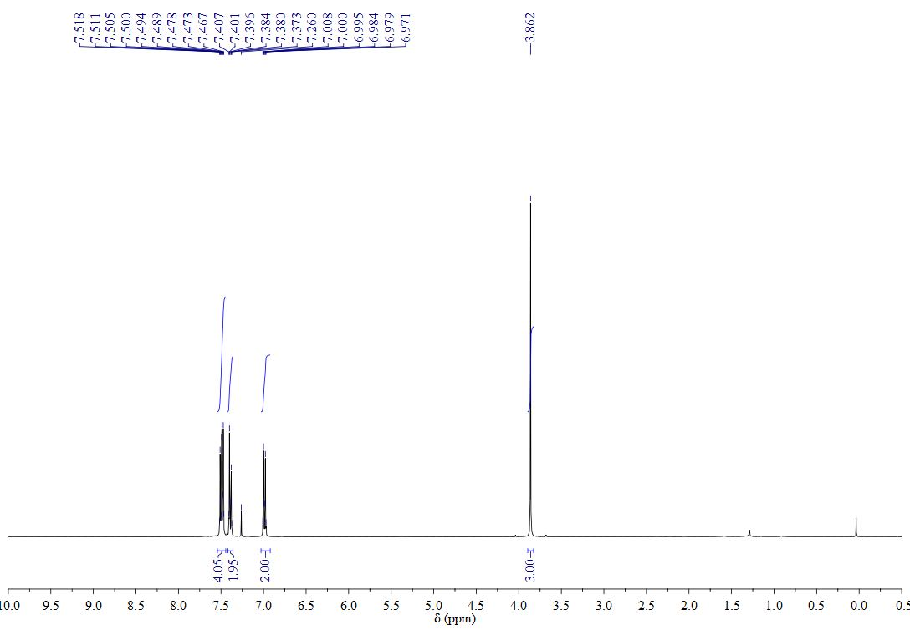



**3i**

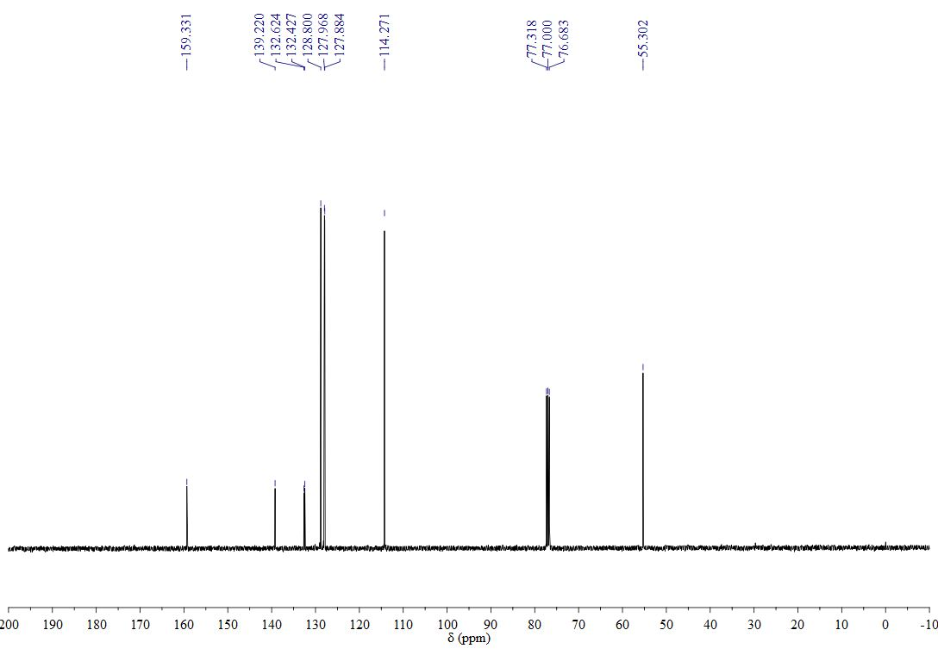

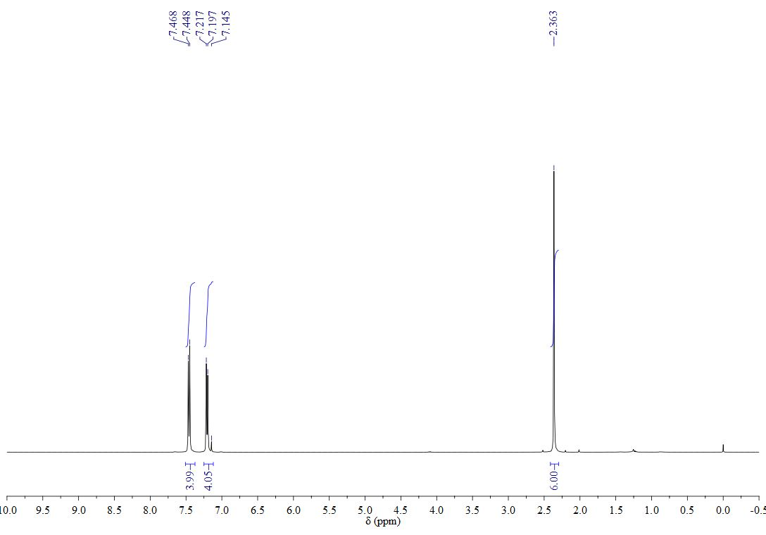



**3j**

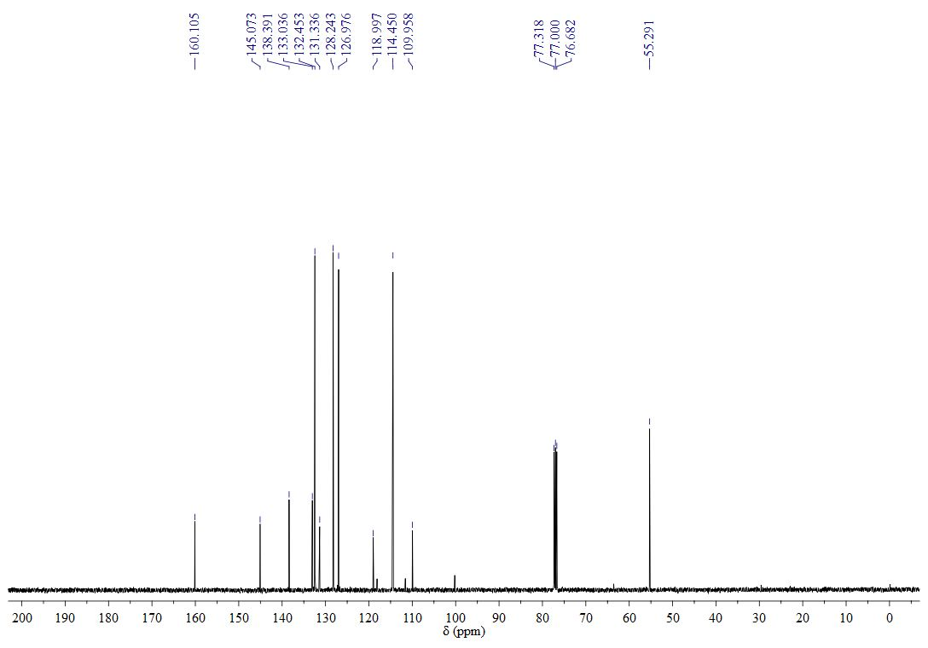

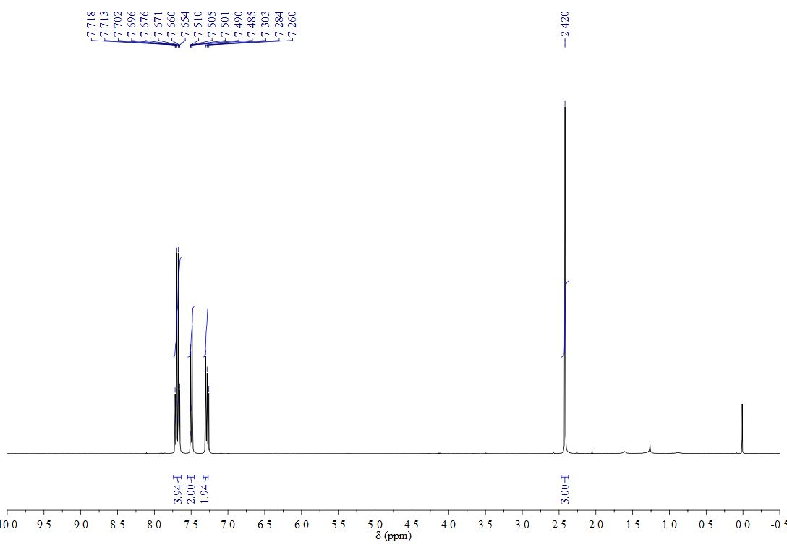



**3k**

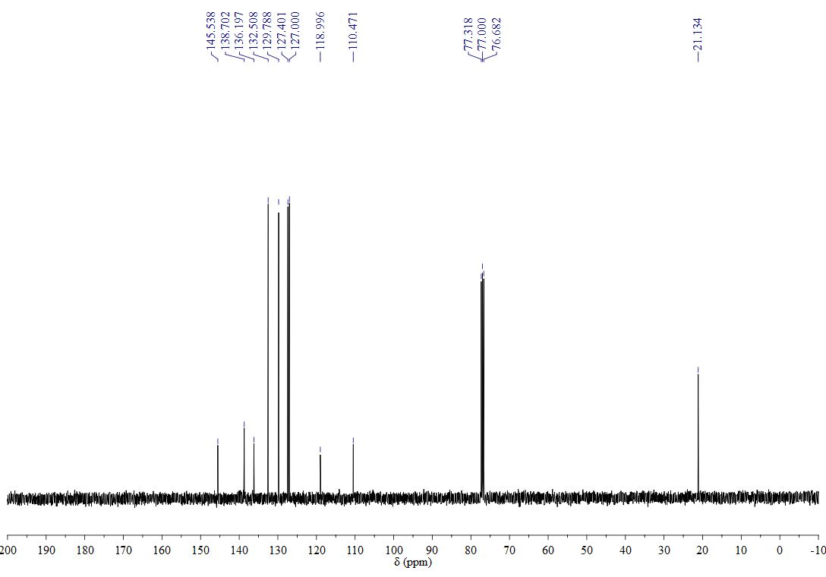

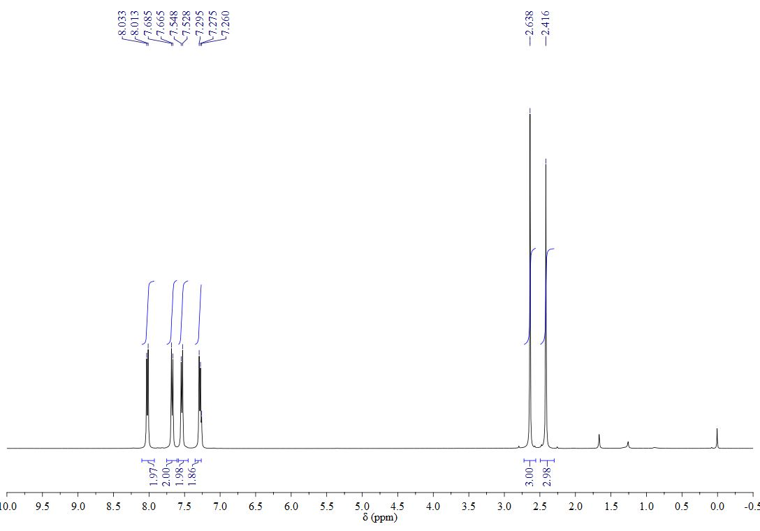



**3l**

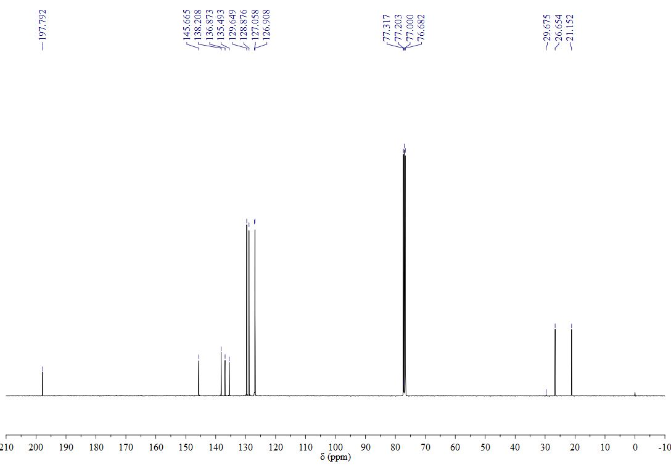

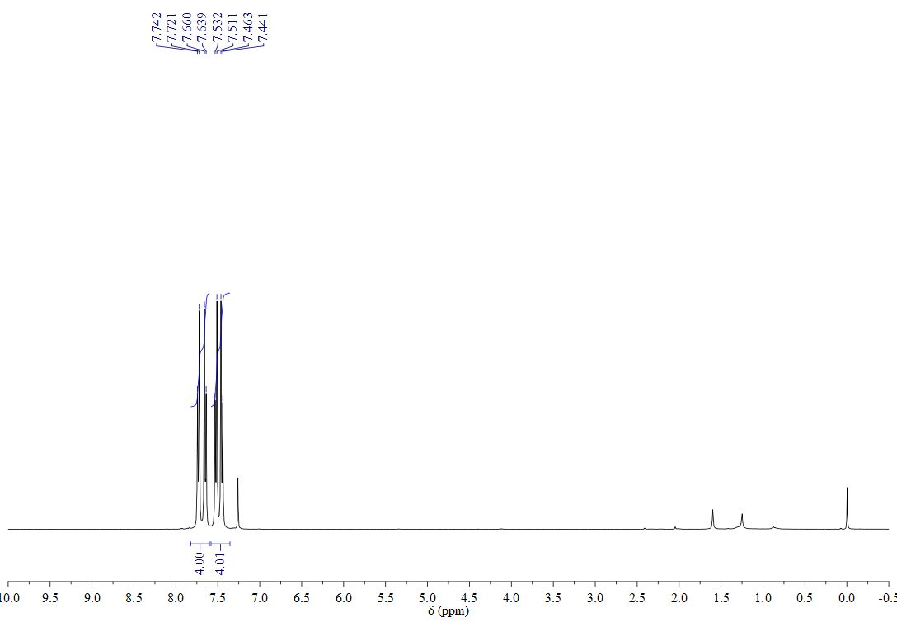



**3m**

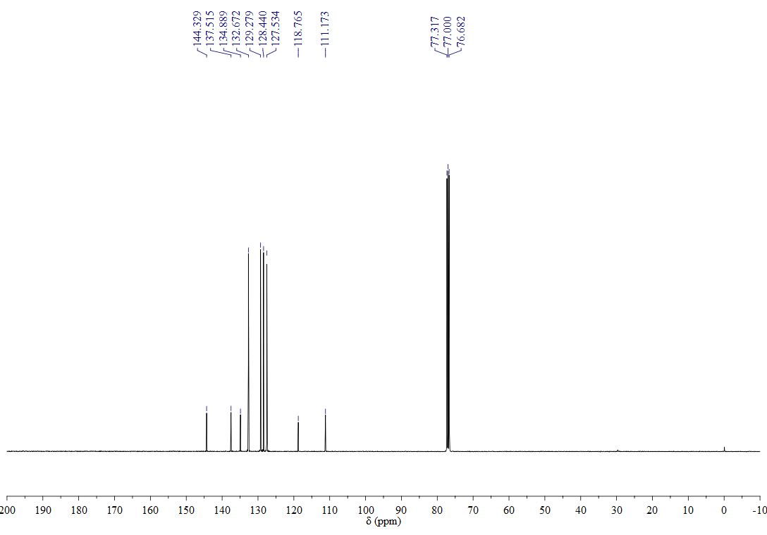

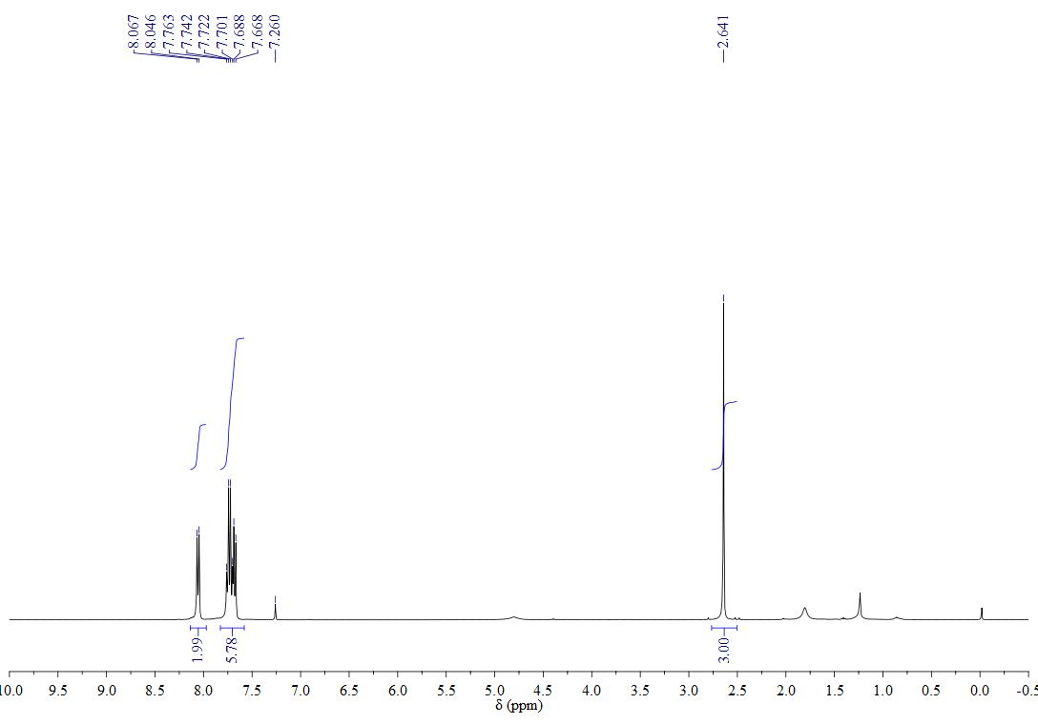



**3n**

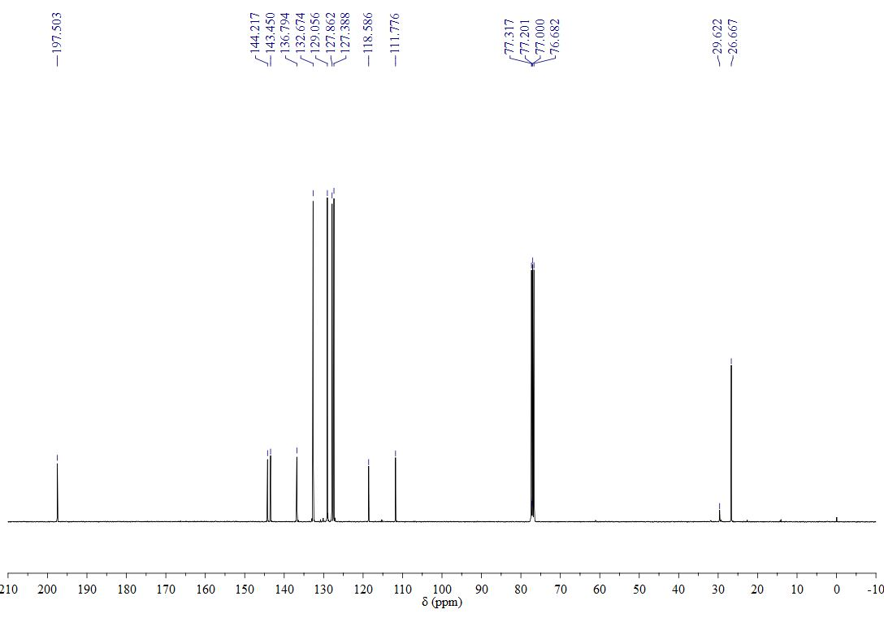

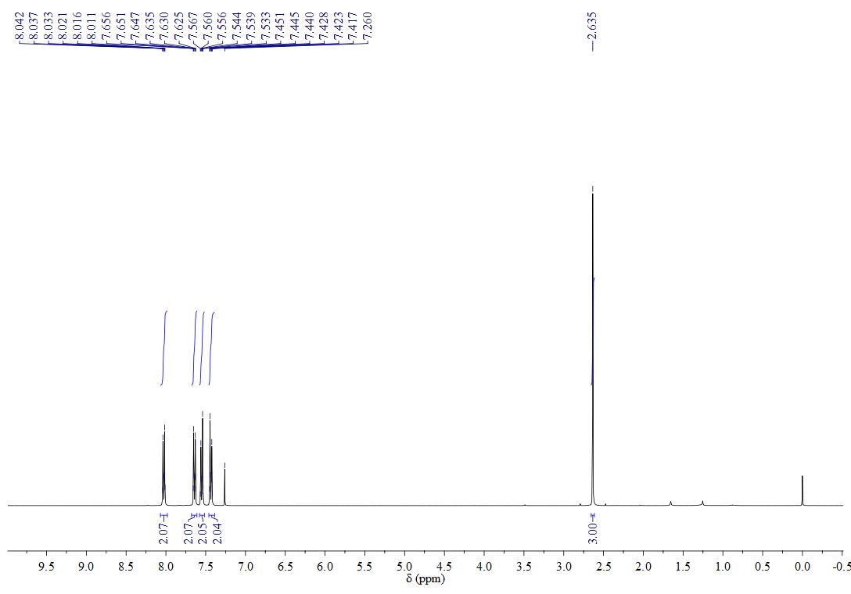



**3o**

