**Supporting materials**

**Anticancer and Microbicide Action of Carbon Quantum Dots Derived from Microcrystalline Cellulose: Hydrothermal versus Infrared Assisted Techniques**

**Amal T. Mogharbel1, Sraa Abu-Melha2, Ahmed Hameed3, Roba M. S. Attar4, Abdulmajeed F. Alrefaei5, Albandary Almahri6, Nashwa M. El-Metwaly3,7\***

*1Department of Chemistry, College of Science, University of Tabuk, 71474 Tabuk, Saudi Arabia*

*2Department of Chemistry, Faculty of Science, King Khalid University, Abha 62529, Saudi Arabia*

*3Department of Chemistry, Faculty of Applied Sciences, Umm Al-Qura University, Makkah, Saudi Arabia*

*4Department of Microbiology, Faculty of Science, University of Jeddah, P.O. Box 2360S, Saudi Arabia*

*5Department of biology/Genetic and Molecular Biology Central Laboratory (GMCL), Jamoum University College, Umm Al Qura University, Makkah 2203, Saudi Arabia*

*6Department of Chemistry, College of Science and Humanities in Al-Kharj, Prince Sattam Bin Abdulaziz University, Al-Kharj 11942, Saudi Arabia*

*7Department of Chemistry, Faculty of Science, Mansoura University, El-Gomhoria Street 35516, Egypt*

|  |  |
| --- | --- |
| **[a]** |  |
| **[b]** |  |
| **[c]** |  |
| **[d]** |  |

**Figure S1:** Spectral analysis for the prepared CQDs; **[a, b]** 1H-NMR, **[c, d]** 13C-NMR, **[a, c]** CQDs-HT and **[b, d]** CQDs-IR.

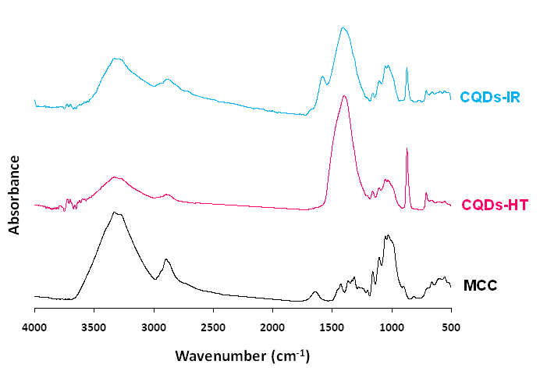

**Figure S2:** FTIR spectra for MCC and the prepared CQDs.

|  |  |
| --- | --- |
| **[a]** |  |
| **[b]** |  |
| **[c]** |  |
| **[d]** |  |
| **[e]** |  |

**Figure S3:** Anticancer activity for the prepared CQDs against Hepatocellular Carcinoma (HepG2); **[a, b]** formula, **[c, d]** CQDs, **[a, c]** optical density, **[b, d]** the percentage of cell mortality and **[e]** IC50.