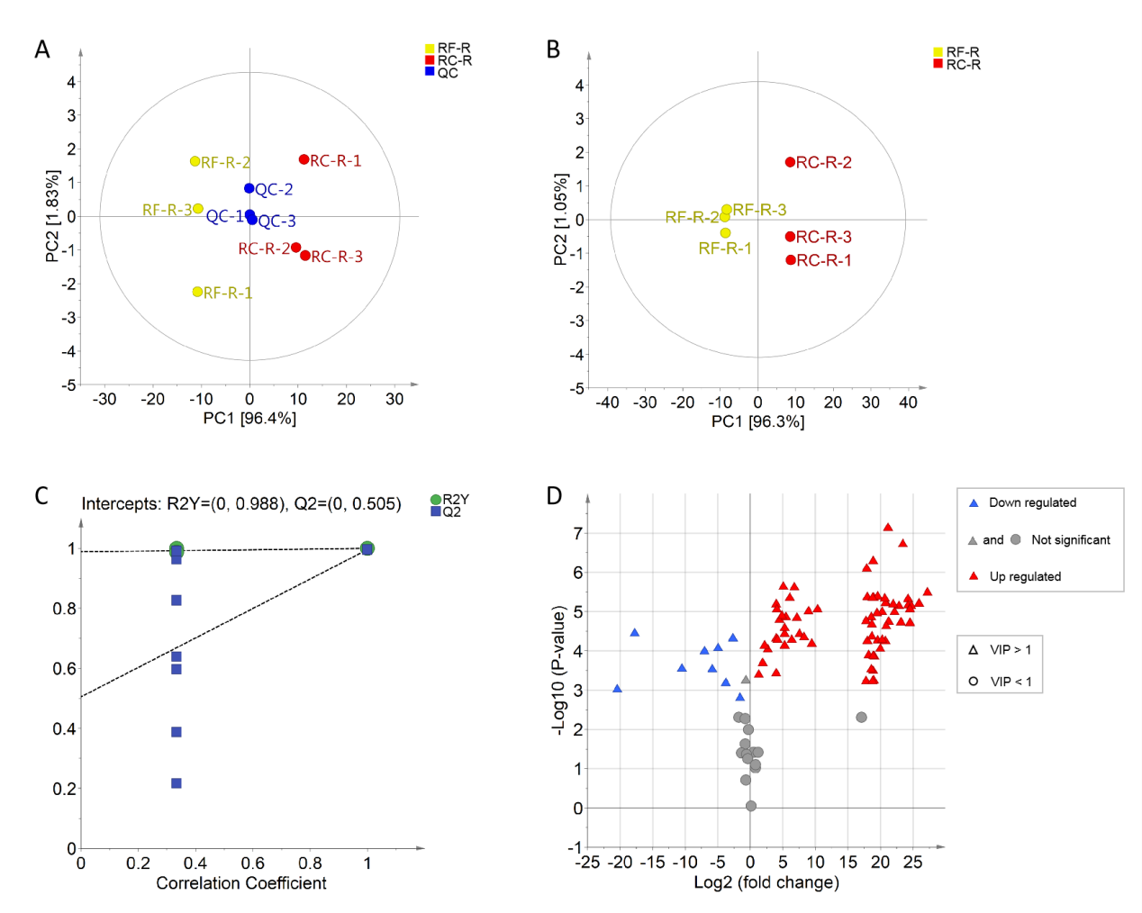

**Figure S1.** Principal component analysis (PCA) plots, orthogonal projections to latent structures discriminant analysis (OPLS-DA), OPLS-DA permutation plots and volcano maps of volatile compounds for RC-R vs. RF-R. **(A)** Two-dimensional scatter plot of the PCA for RC-R, RF-R, and the quality control (QC). The QC was a mixture of RC-R and RF-R; **(B)** Score scatter plots of the OPLS-DA for RC-R vs. RF-R; **(C)** OPLS-DA permutation plots for RC-R vs. RF-R; and **(D)** volcano maps for RC-R vs. RF-R. Red and blue triangles denoted upregulated and downregulated differential metabolites, respectively; Gray triangles and dots both represented non-differential metabolites.

A total of 92 volatile compounds were identified by comparing RC-R and RF-R using a HS-SPME-GC-MS metabolomics approach. The volatile compounds differences between the samples were assessed using principle component analysys (PCA). PCA plots of RC-R, RF-R and quality control (QC) samples showed that the two groups clustered to different regions (Figure S1A), indicating significant differences in volatile compounds between RC-R and RF-R samples. The two principal components, PC1 and PC2, contributed to an overall explanation rate of variance of 98.23% (Figure S1A), which indicates that the roots of Rhodiola Crenulata and those of Rhodiola Fastigiata are significantly different from each other in terms of volatile compounds.

The characteristics of volatile compounds between the two groups of samples, RC-R and RF-R, were then compared using an OPLS-DA model. As shown in figure S1B, there were significant differences between the two groups of samples, RC-R and RF-R. The values of R2Y and Q2 obtained by the permutation test of the OPLS-DA model confirmed excellent reliability of this model (Figure S1C).

Subsequently, 77 differential metabolites of volatile compounds were screened out and visualized as volcano plots as illustrated in figure S1D. Compared with RF-R, 68 volatile differential metabolites exhibited upregulation and 9 presented downregulation in RC-R.

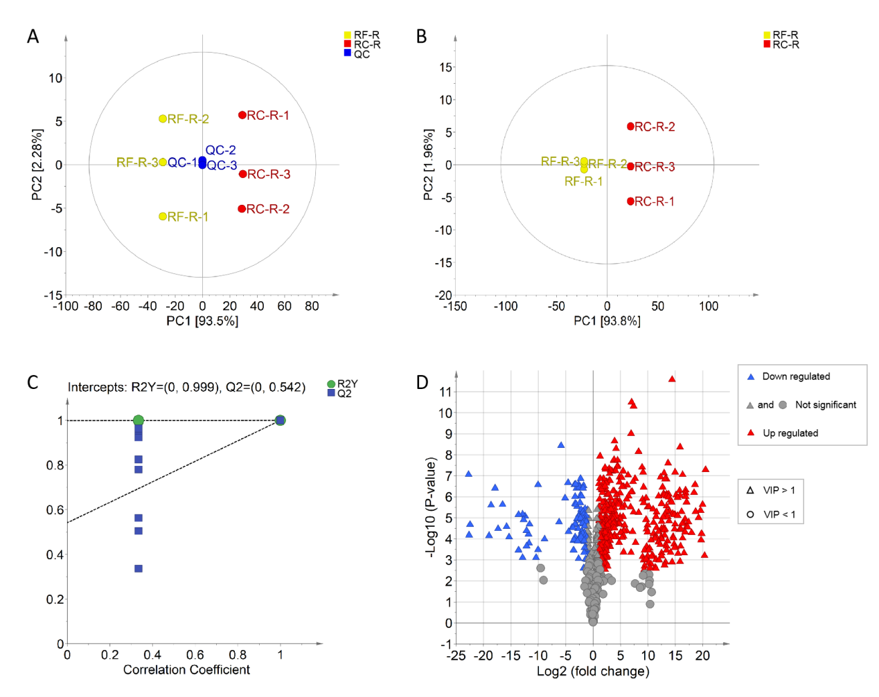

**Figure S2.** PCA, OPLS-DA, OPLS-DA permutation plots and volcano maps of non-volatile compounds for RC-R vs. RF-R. **(A)** Two-dimensional scatter plot of the PCA for RC-R, RF-R, and the QC. The QC was a mixture of RC-R and RF-R; **(B)** Score scatter plots of the OPLS-DA for RC-R vs. RF-R; **(C)** OPLS-DA permutation plots for RC-R vs. RF-R; and **(D)** volcano maps for RC-R vs. RF-R.

A total of 680 non-volatile compounds were identified by comparing RC-R and RF-R using a LC-ESI-MS/MS metabolomics approach. The PCA plots, with an overall explanation rate of variance of 95.78% (Figure S2A), indicates that the roots of Rhodiola Crenulata and those of Rhodiola Fastigiata are significantly different from each other in terms of non-volatile compounds.

OPLS-DA model exhibit a significant differences between RC-R and RF-R (Figure S2B). The values of R2Y and Q2 obtained by the permutation test of the OPLS-DA model confirmed excellent reliability of this model (Figure S2C).

491 differential metabolites of non-volatile compounds were screened out and visualized as volcano plots as illustrated in figure S2D. Compared with RF-R, 380 non-volatile differential metabolites exhibited upregulation and 111 presented downregulation in RC-R.

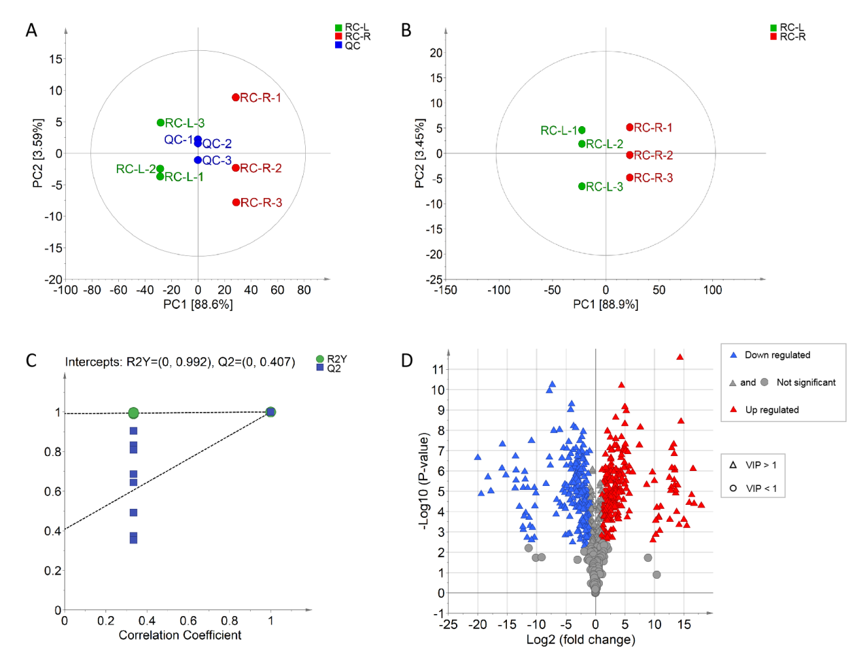

**Figure S3.** PCA, OPLS-DA, OPLS-DA permutation plots and volcano maps of non-volatile compounds for RC-R vs. RC-L. **(A)** Two-dimensional scatter plot of the PCA for RC-R, RC-L, and the QC. The QC was a mixture of RC-R and RC-L; **(B)** Score scatter plots of the OPLS-DA for RC-R vs. RC-L; **(C)** OPLS-DA permutation plots for RC-R vs. RC-L; and **(D)** volcano maps for RC-R vs. RC-L.

A total of 685 non-volatile compounds were identified by comparing RC-R and RC-L using a LC-ESI-MS/MS metabolomics approach. The PCA plots, with an overall explanation rate of variance of 92.19% (Figure S3A), indicates that the roots of Rhodiola Crenulata and its leaves are significantly different from each other in terms of non-volatile compounds.

OPLS-DA model exhibit a significant differences between RC-R and RC-L (Figure S3B). The values of R2Y and Q2 obtained by the permutation test of the OPLS-DA model confirmed excellent reliability of this model (Figure S3C).

450 differential metabolites of non-volatile compounds were screened out and visualized as volcano plots as illustrated in figure S3D. Compared with RC-L, 238 non-volatile differential metabolites exhibited upregulation and 212 presented downregulation in RC-R.

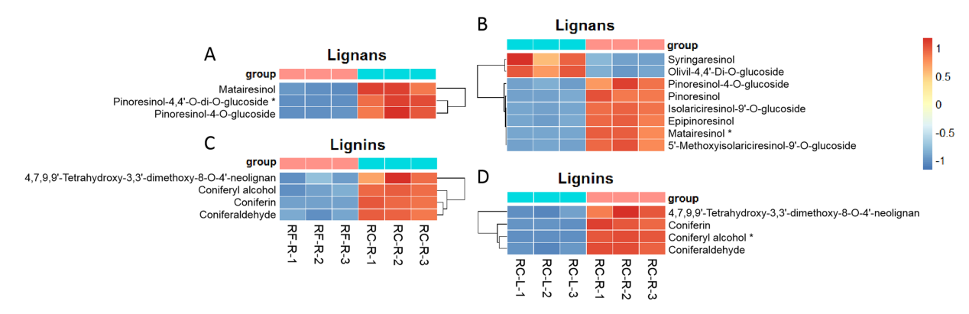

**Figure S4.** The changes of differential metabolites of lignans and lignins displaying by heat map. There were 1 biomarker and 2 CDMs for lignans between RF-R and RC-R **(A)**, 1 biomarker and 7 CDMs for lignans between RC-L and RC-R **(B)**, 0 biomarker and 4 CDMs for lignins between RF-R and RC-R **(C)**, and 1 biomarker and 3 CDMs for lignins between RC-L and RC-R **(D)**. Three independent replicates were performed.

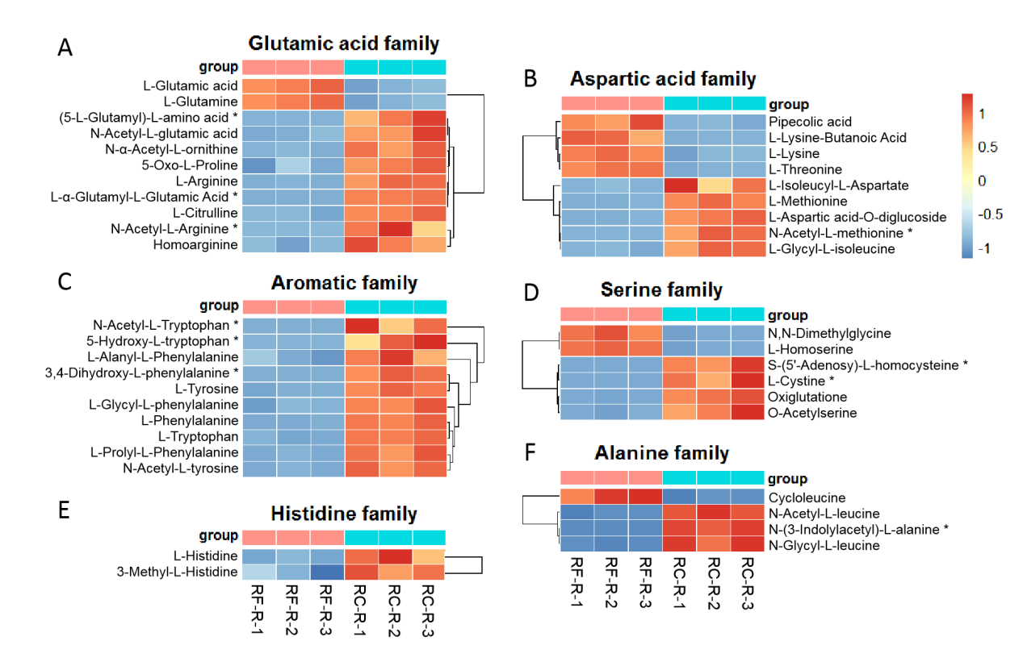

**Figure S5.** The changes of differential metabolites of amino acids between RF-R and RC-R displaying by heat map. There were 3 biomarkers and 8 CDMs for glutamic acid family **(A)**, 1 biomarker and 8 CDMs for aspartic acid family **(B)**, 3 biomarkers and 7 CDMs for aromatic family **(C)**, 2 biomarkers and 4 CDMs for serine family **(D)**, 0 biomarker and 2 CDMs for histidine family **(E)**, and 1 biomarker and 3 CDMs for alanine family **(F)**. Three independent replicates were performed.

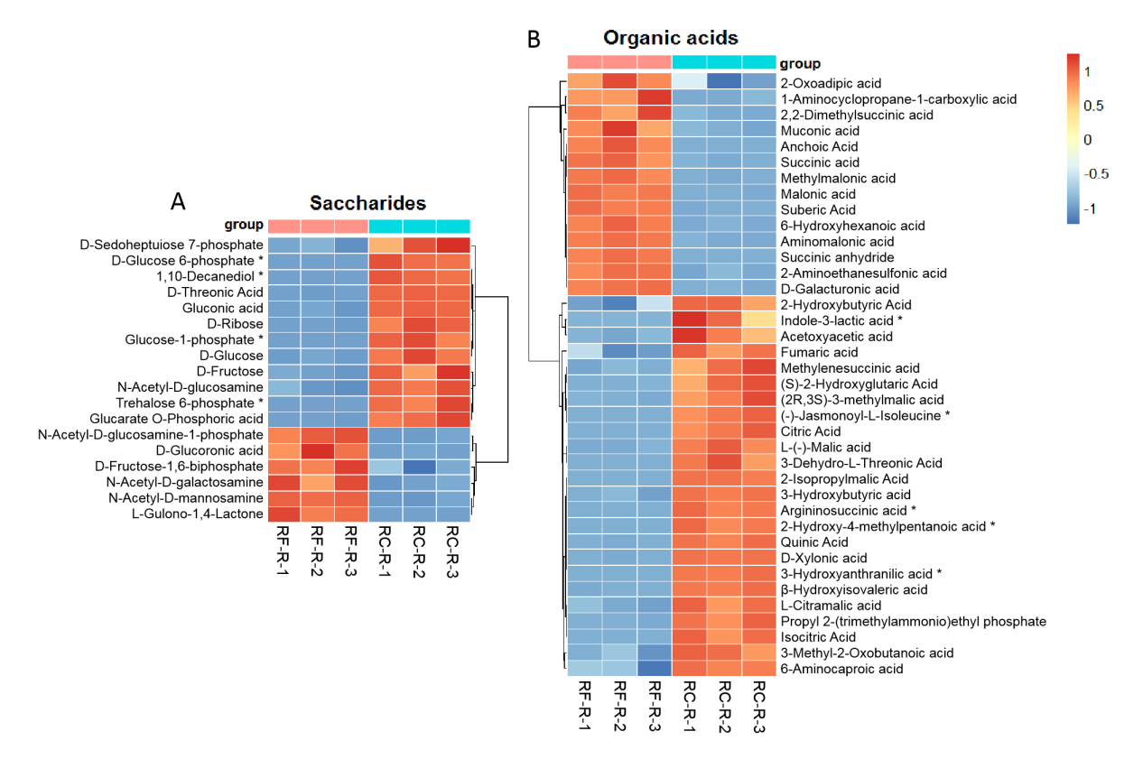

**Figure S6.** The changes of differential metabolites of saccharides and organic acids between RF-R and RC-R displaying by heat map. There were 4 biomarkers and 14 CDMs for saccharides **(A)**, and 5 biomarkers and 33 CDMs for organic acids **(B)**. Three independent replicates were performed.

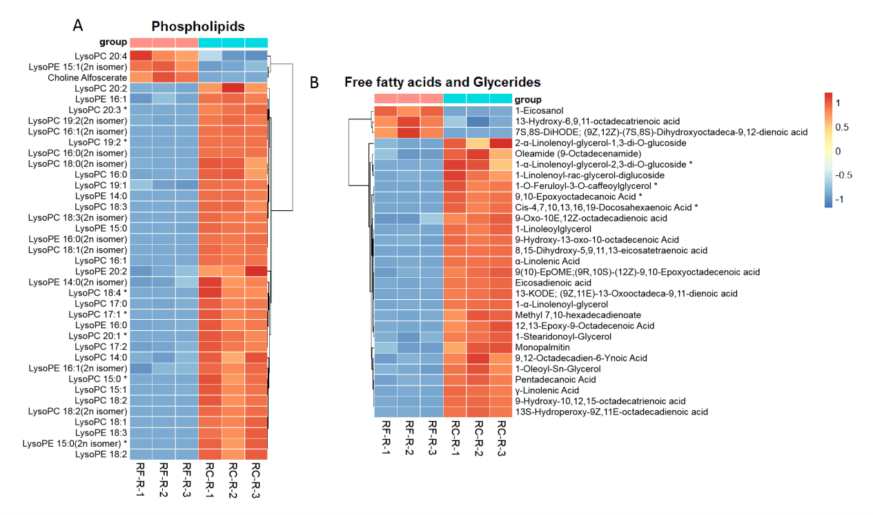

**Figure S7.** The changes of differential metabolites of lipids between RF-R and RC-R displaying by heat map. There were 7 biomarkers and 31 CDMs for phospholipids **(A)**, and 4 biomarkers and 25 CDMs for free fatty acids and glycerides **(B)**. Three independent replicates were performed.