**Supporting Information**

**Synthesis, anticancer evaluation, and molecular modeling study of new 2-(phenylamino)pyrazolo[1,5-*a*]pyrimidine analogues**

### **Omer A. Azher1, Aisha Hossan2, Rami A. Pashameah3, Amerah Alsoliemy3, Arwa Alharbi3, Turki M. Habeebullah4, Nashwa M. El-Metwaly3,5\***

*1Department of laboratory Medicine, Faculty of Applied Biomedical Sciences, Al-Baha University, Saudi Arabia*

*2Department of Chemistry, Faculty of science, King Khalid University, Abha, Saudi Arabia*

*3Department of Chemistry, Faculty of Applied Science, Umm Al Qura University, Makkah 24230, Saudi Arabia*

*4Department of Environment and Health Research, The Custodian of the two holy mosques Institute for Hajj and Umrah Research, Umm Al Qura University, Makkah*

*5Department of Chemistry, Faculty of Science, Mansoura University, El-Gomhoria Street 35516, Egypt*

**Table S1**. The DFT dihedral angle data of the investigated compounds.

|  |  |  |  |  |  |
| --- | --- | --- | --- | --- | --- |
|  | **4a** |  | **4b** |  | **4c** |
| **Dihedral** | **(°)** | **Dihedral** | **(°)** | **Dihedral** | **(°)** |
| C(25)-C(26)-C(27)-C(16) | 0.1 | C(26)-C(27)-C(28)-C(16) | 0.1 | C(25)-C(26)-C(27)-C(16) | 0.1 |
| C(24)-C(25)-C(26)-C(27) | -0.1 | C(25)-C(26)-C(27)-C(28) | 0.0 | C(24)-C(25)-C(26)-C(27) | -0.1 |
| C(23)-C(24)-C(25)-C(26) | 0.0 | C(24)-C(25)-C(26)-C(27) | -0.1 | C(23)-C(24)-C(25)-C(26) | 0.0 |
| C(16)-C(23)-C(24)-C(25) | 0.1 | C(16)-C(24)-C(25)-C(26) | 0.1 | C(16)-C(23)-C(24)-C(25) | 0.1 |
| C(19)-C(20)-C(21)-C(14) | 0.1 | C(19)-C(20)-C(21)-C(14) | 0.3 | C(19)-C(20)-C(21)-C(14) | 0.3 |
| C(18)-C(19)-C(20)-C(21) | 0.4 | C(18)-C(19)-O(22)-C(23) | 180.0 | C(18)-C(19)-C(20)-C(21) | 0.1 |
| C(22)-C(19)-C(20)-C(21) | -178.8 | C(20)-C(19)-O(22)-C(23) | 0.1 | Cl(22)-C(19)-C(20)-C(21) | 179.9 |
| C(17)-C(18)-C(19)-C(20) | -0.6 | C(18)-C(19)-C(20)-C(21) | 0.1 | C(17)-C(18)-C(19)-C(20) | -0.3 |
| C(17)-C(18)-C(19)-C(22) | 178.7 | O(22)-C(19)-C(20)-C(21) | 179.9 | C(17)-C(18)-C(19)-Cl(22) | 179.9 |
| C(14)-C(17)-C(18)-C(19) | 0.3 | C(17)-C(18)-C(19)-C(20) | -0.3 | C(14)-C(17)-C(18)-C(19) | 0.2 |
| N(11)-C(16)-C(27)-C(26) | 178.9 | C(17)-C(18)-C(19)-O(22) | 179.8 | N(11)-C(16)-C(27)-C(26) | 178.7 |
| C(23)-C(16)-C(27)-C(26) | 0.0 | C(14)-C(17)-C(18)-C(19) | 0.2 | C(23)-C(16)-C(27)-C(26) | -0.1 |
| N(11)-C(16)-C(23)-C(24) | -179.1 | N(11)-C(16)-C(28)-C(27) | 178.8 | N(11)-C(16)-C(23)-C(24) | -178.9 |
| C(27)-C(16)-C(23)-C(24) | -0.1 | C(24)-C(16)-C(28)-C(27) | -0.1 | C(27)-C(16)-C(23)-C(24) | 0.0 |
| N(12)-C(14)-C(21)-C(20) | 178.8 | N(11)-C(16)-C(24)-C(25) | -179.0 | N(12)-C(14)-C(21)-C(20) | 178.4 |
| C(17)-C(14)-C(21)-C(20) | -0.4 | C(28)-C(16)-C(24)-C(25) | 0.0 | C(17)-C(14)-C(21)-C(20) | -0.4 |
| N(12)-C(14)-C(17)-C(18) | -179.0 | N(12)-C(14)-C(21)-C(20) | 178.4 | N(12)-C(14)-C(17)-C(18) | -178.7 |
| C(21)-C(14)-C(17)-C(18) | 0.2 | C(17)-C(14)-C(21)-C(20) | -0.4 | C(21)-C(14)-C(17)-C(18) | 0.2 |
| C(10)-N(12)-C(14)-C(17) | -174.1 | N(12)-C(14)-C(17)-C(18) | -178.7 | C(10)-N(12)-C(14)-C(17) | -173.5 |
| C(10)-N(12)-C(14)-C(21) | 6.7 | C(21)-C(14)-C(17)-C(18) | 0.2 | C(10)-N(12)-C(14)-C(21) | 7.7 |
| H(32)-N(12)-C(14)-C(17) | -10.3 | C(10)-N(12)-C(14)-C(17) | -174.1 | H(32)-N(12)-C(14)-C(17) | -9.4 |
| H(32)-N(12)-C(14)-C(21) | 170.5 | C(10)-N(12)-C(14)-C(21) | 7.0 | H(32)-N(12)-C(14)-C(21) | 171.8 |
| C(8)-N(11)-C(16)-C(23) | -173.7 | H(33)-N(12)-C(14)-C(17) | -10.7 | C(8)-N(11)-C(16)-C(23) | -172.9 |
| C(8)-N(11)-C(16)-C(27) | 7.3 | H(33)-N(12)-C(14)-C(21) | 170.5 | C(8)-N(11)-C(16)-C(27) | 8.3 |
| H(31)-N(11)-C(16)-C(23) | -1.5 | C(8)-N(11)-C(16)-C(24) | -174.1 | H(31)-N(11)-C(16)-C(23) | -1.6 |
| H(31)-N(11)-C(16)-C(27) | 179.5 | C(8)-N(11)-C(16)-C(28) | 6.9 | H(31)-N(11)-C(16)-C(27) | 179.6 |
| C(7)-C(10)-N(12)-C(14) | -176.7 | H(32)-N(11)-C(16)-C(24) | -1.2 | C(7)-C(10)-N(12)-C(14) | -176.5 |
| C(7)-C(10)-N(12)-H(32) | 19.5 | H(32)-N(11)-C(16)-C(28) | 179.8 | C(7)-C(10)-N(12)-H(32) | 19.5 |
| O(13)-C(10)-N(12)-C(14) | 1.2 | C(7)-C(10)-N(12)-C(14) | -176.5 | O(13)-C(10)-N(12)-C(14) | 1.7 |
| O(13)-C(10)-N(12)-H(32) | -162.5 | C(7)-C(10)-N(12)-H(33) | 20.1 | O(13)-C(10)-N(12)-H(32) | -162.4 |
| C(7)-C(8)-N(11)-C(16) | -180.0 | O(13)-C(10)-N(12)-C(14) | 1.1 | C(7)-C(8)-N(11)-C(16) | -179.8 |
| C(7)-C(8)-N(11)-H(31) | 7.7 | O(13)-C(10)-N(12)-H(33) | -162.4 | C(7)-C(8)-N(11)-H(31) | 8.7 |
| N(9)-C(8)-N(11)-C(16) | 2.1 | C(7)-C(8)-N(11)-C(16) | 180.0 | N(9)-C(8)-N(11)-C(16) | 2.3 |
| N(9)-C(8)-N(11)-H(31) | -170.2 | C(7)-C(8)-N(11)-H(32) | 7.0 | N(9)-C(8)-N(11)-H(31) | -169.2 |
| C(7)-C(8)-N(9)-N(2) | -0.1 | N(9)-C(8)-N(11)-C(16) | 2.0 | C(7)-C(8)-N(9)-N(2) | -0.2 |
| C(7)-C(8)-N(9)-H(47) | 179.9 | N(9)-C(8)-N(11)-H(32) | -171.0 | C(7)-C(8)-N(9)-H(44) | 179.8 |
| N(11)-C(8)-N(9)-N(2) | 178.0 | C(7)-C(8)-N(9)-N(2) | -0.2 | N(11)-C(8)-N(9)-N(2) | 178.0 |
| N(11)-C(8)-N(9)-H(47) | -2.0 | C(7)-C(8)-N(9)-H(48) | 179.8 | N(11)-C(8)-N(9)-H(44) | -2.1 |
| C(1)-C(7)-C(10)-N(12) | -146.7 | N(11)-C(8)-N(9)-N(2) | 178.0 | C(1)-C(7)-C(10)-N(12) | -147.1 |
| C(1)-C(7)-C(10)-O(13) | 35.3 | N(11)-C(8)-N(9)-H(48) | -2.0 | C(1)-C(7)-C(10)-O(13) | 34.8 |
| C(8)-C(7)-C(10)-N(12) | 37.7 | C(1)-C(7)-C(10)-N(12) | -146.1 | C(8)-C(7)-C(10)-N(12) | 36.9 |
| C(8)-C(7)-C(10)-O(13) | -140.2 | C(1)-C(7)-C(10)-O(13) | 36.3 | C(8)-C(7)-C(10)-O(13) | -141.2 |
| C(1)-C(7)-C(8)-N(9) | 0.7 | C(8)-C(7)-C(10)-N(12) | 38.8 | C(1)-C(7)-C(8)-N(9) | 0.8 |
| C(1)-C(7)-C(8)-N(11) | -177.4 | C(8)-C(7)-C(10)-O(13) | -138.8 | C(1)-C(7)-C(8)-N(11) | -177.3 |
| C(10)-C(7)-C(8)-N(9) | 177.0 | C(1)-C(7)-C(8)-N(9) | 0.8 | C(10)-C(7)-C(8)-N(9) | 177.5 |
| C(10)-C(7)-C(8)-N(11) | -1.1 | C(1)-C(7)-C(8)-N(11) | -177.4 | C(10)-C(7)-C(8)-N(11) | -0.6 |
| C(4)-C(5)-N(6)-C(1) | -0.1 | C(10)-C(7)-C(8)-N(9) | 176.7 | C(4)-C(5)-N(6)-C(1) | 0.0 |
| C(3)-C(4)-C(28)-N(29) | -0.4 | C(10)-C(7)-C(8)-N(11) | -1.5 | C(3)-C(4)-C(28)-N(29) | -0.6 |
| C(5)-C(4)-C(28)-N(29) | 179.4 | C(4)-C(5)-N(6)-C(1) | -0.1 | C(5)-C(4)-C(28)-N(29) | 179.2 |
| C(3)-C(4)-C(5)-N(6) | -0.6 | C(3)-C(4)-C(29)-N(30) | -0.5 | C(3)-C(4)-C(5)-N(6) | -0.6 |
| C(28)-C(4)-C(5)-N(6) | 179.6 | C(5)-C(4)-C(29)-N(30) | 179.3 | C(28)-C(4)-C(5)-N(6) | 179.6 |
| N(2)-C(3)-N(15)-H(33) | 2.9 | C(3)-C(4)-C(5)-N(6) | -0.5 | N(2)-C(3)-N(15)-H(33) | 3.2 |
| N(2)-C(3)-N(15)-H(34) | 177.9 | C(29)-C(4)-C(5)-N(6) | 179.7 | N(2)-C(3)-N(15)-H(34) | 177.8 |
| C(4)-C(3)-N(15)-H(33) | -177.3 | N(2)-C(3)-N(15)-H(34) | 3.0 | C(4)-C(3)-N(15)-H(33) | -177.1 |
| C(4)-C(3)-N(15)-H(34) | -2.3 | N(2)-C(3)-N(15)-H(35) | 177.9 | C(4)-C(3)-N(15)-H(34) | -2.5 |
| N(2)-C(3)-C(4)-C(5) | 0.4 | C(4)-C(3)-N(15)-H(34) | -177.3 | N(2)-C(3)-C(4)-C(5) | 0.3 |
| N(2)-C(3)-C(4)-C(28) | -179.8 | C(4)-C(3)-N(15)-H(35) | -2.4 | N(2)-C(3)-C(4)-C(28) | -179.9 |
| N(15)-C(3)-C(4)-C(5) | -179.4 | N(2)-C(3)-C(4)-C(5) | 0.3 | N(15)-C(3)-C(4)-C(5) | -179.4 |
| N(15)-C(3)-C(4)-C(28) | 0.4 | N(2)-C(3)-C(4)-C(29) | -179.9 | N(15)-C(3)-C(4)-C(28) | 0.4 |
| C(1)-N(2)-N(9)-C(8) | -0.5 | N(15)-C(3)-C(4)-C(5) | -179.4 | C(1)-N(2)-N(9)-C(8) | -0.6 |
| C(1)-N(2)-N(9)-H(47) | 179.5 | N(15)-C(3)-C(4)-C(29) | 0.4 | C(1)-N(2)-N(9)-H(44) | 179.4 |
| C(3)-N(2)-N(9)-C(8) | 179.9 | C(1)-N(2)-N(9)-C(8) | -0.5 | C(3)-N(2)-N(9)-C(8) | -180.0 |
| C(3)-N(2)-N(9)-H(47) | -0.1 | C(1)-N(2)-N(9)-H(48) | 179.5 | C(3)-N(2)-N(9)-H(44) | 0.0 |
| C(1)-N(2)-C(3)-C(4) | 0.4 | C(3)-N(2)-N(9)-C(8) | 179.9 | C(1)-N(2)-C(3)-C(4) | 0.5 |
| C(1)-N(2)-C(3)-N(15) | -179.8 | C(3)-N(2)-N(9)-H(48) | -0.1 | C(1)-N(2)-C(3)-N(15) | -179.7 |
| N(9)-N(2)-C(3)-C(4) | 179.9 | C(1)-N(2)-C(3)-C(4) | 0.4 | N(9)-N(2)-C(3)-C(4) | 179.9 |
| N(9)-N(2)-C(3)-N(15) | -0.3 | C(1)-N(2)-C(3)-N(15) | -179.8 | N(9)-N(2)-C(3)-N(15) | -0.4 |
| N(2)-C(1)-C(7)-C(8) | -0.9 | N(9)-N(2)-C(3)-C(4) | 179.9 | N(2)-C(1)-C(7)-C(8) | -1.1 |
| N(2)-C(1)-C(7)-C(10) | -177.3 | N(9)-N(2)-C(3)-N(15) | -0.3 | N(2)-C(1)-C(7)-C(10) | -177.8 |
| N(6)-C(1)-C(7)-C(8) | -179.0 | N(2)-C(1)-C(7)-C(8) | -1.0 | N(6)-C(1)-C(7)-C(8) | -179.1 |
| N(6)-C(1)-C(7)-C(10) | 4.6 | N(2)-C(1)-C(7)-C(10) | -177.0 | N(6)-C(1)-C(7)-C(10) | 4.2 |
| N(2)-C(1)-N(6)-C(5) | 0.9 | N(6)-C(1)-C(7)-C(8) | -179.1 | N(2)-C(1)-N(6)-C(5) | 0.9 |
| C(7)-C(1)-N(6)-C(5) | 178.7 | N(6)-C(1)-C(7)-C(10) | 4.9 | C(7)-C(1)-N(6)-C(5) | 178.7 |
| N(6)-C(1)-N(2)-C(3) | -1.1 | N(2)-C(1)-N(6)-C(5) | 0.9 | N(6)-C(1)-N(2)-C(3) | -1.2 |
| N(6)-C(1)-N(2)-N(9) | 179.3 | C(7)-C(1)-N(6)-C(5) | 178.7 | N(6)-C(1)-N(2)-N(9) | 179.4 |
| C(7)-C(1)-N(2)-C(3) | -179.5 | N(6)-C(1)-N(2)-C(3) | -1.1 | C(7)-C(1)-N(2)-C(3) | -179.5 |
| C(7)-C(1)-N(2)-N(9) | 1.0 | N(6)-C(1)-N(2)-N(9) | 179.4 | C(7)-C(1)-N(2)-N(9) | 1.1 |
|  |  | C(7)-C(1)-N(2)-C(3) | -179.5 |  |  |
|  |  | C(7)-C(1)-N(2)-N(9) | 1.0 |  |  |
|  | **6a** |  | **6b** |  | **6c** |
| **Dihedral** | **(°)** | **Dihedral** | **(°)** | **Dihedral** | **(°)** |
| C(29)-C(30)-C(31)-C(19) | 0.2 | C(28)-C(29)-C(30)-C(19) | 0.2 | C(28)-C(29)-C(30)-C(19) | 0.239 |
| C(28)-C(29)-C(30)-C(31) | -0.1 | C(27)-C(28)-C(29)-C(30) | -0.1 | C(27)-C(28)-C(29)-C(30) | -0.084 |
| C(27)-C(28)-C(29)-C(30) | -0.1 | C(26)-C(27)-C(28)-C(29) | -0.1 | C(26)-C(27)-C(28)-C(29) | -0.079 |
| C(19)-C(27)-C(28)-C(29) | 0.1 | C(19)-C(26)-C(27)-C(28) | 0.1 | C(19)-C(26)-C(27)-C(28) | 0.085 |
| C(22)-C(23)-C(24)-C(14) | 0.2 | C(22)-C(23)-C(24)-C(14) | 0.2 | C(22)-C(23)-C(24)-C(14) | 0.202 |
| C(21)-C(22)-O(25)-C(26) | 179.6 | C(21)-C(22)-C(23)-C(24) | 0.1 | C(21)-C(22)-C(23)-C(24) | 0.111 |
| C(23)-C(22)-O(25)-C(26) | -0.2 | Cl(25)-C(22)-C(23)-C(24) | 179.9 | Cl(25)-C(22)-C(23)-C(24) | 179.913 |
| C(21)-C(22)-C(23)-C(24) | 0.1 | C(20)-C(21)-C(22)-C(23) | -0.3 | C(20)-C(21)-C(22)-C(23) | -0.274 |
| O(25)-C(22)-C(23)-C(24) | 179.9 | C(20)-C(21)-C(22)-Cl(25) | 179.9 | C(20)-C(21)-C(22)-Cl(25) | 179.924 |
| C(20)-C(21)-C(22)-C(23) | -0.3 | C(14)-C(20)-C(21)-C(22) | 0.1 | C(14)-C(20)-C(21)-C(22) | 0.124 |
| C(20)-C(21)-C(22)-O(25) | 179.9 | N(11)-C(19)-C(30)-C(29) | 178.5 | N(11)-C(19)-C(30)-C(29) | 178.498 |
| C(14)-C(20)-C(21)-C(22) | 0.2 | C(26)-C(19)-C(30)-C(29) | -0.2 | C(26)-C(19)-C(30)-C(29) | -0.229 |
| N(11)-C(19)-C(31)-C(30) | 178.8 | N(11)-C(19)-C(26)-C(27) | -178.7 | N(11)-C(19)-C(26)-C(27) | -178.735 |
| C(27)-C(19)-C(31)-C(30) | -0.2 | C(30)-C(19)-C(26)-C(27) | 0.1 | C(30)-C(19)-C(26)-C(27) | 0.07 |
| N(11)-C(19)-C(27)-C(28) | -179.0 | C(4)-C(16)-N(17)-H(36) | -178.5 | C(4)-C(16)-N(17)-H(36) | -178.506 |
| C(31)-C(19)-C(27)-C(28) | 0.0 | C(4)-C(16)-N(17)-H(37) | -4.7 | C(4)-C(16)-N(17)-H(37) | -4.69 |
| C(4)-C(16)-N(17)-H(37) | -178.6 | O(18)-C(16)-N(17)-H(36) | 1.7 | O(18)-C(16)-N(17)-H(36) | 1.716 |
| C(4)-C(16)-N(17)-H(38) | -4.1 | O(18)-C(16)-N(17)-H(37) | 175.5 | O(18)-C(16)-N(17)-H(37) | 175.531 |
| O(18)-C(16)-N(17)-H(37) | 1.6 | N(12)-C(14)-C(24)-C(23) | 178.7 | N(12)-C(14)-C(24)-C(23) | 178.67 |
| O(18)-C(16)-N(17)-H(38) | 176.1 | C(20)-C(14)-C(24)-C(23) | -0.3 | C(20)-C(14)-C(24)-C(23) | -0.348 |
| N(12)-C(14)-C(24)-C(23) | 178.8 | N(12)-C(14)-C(20)-C(21) | -178.9 | N(12)-C(14)-C(20)-C(21) | -178.885 |
| C(20)-C(14)-C(24)-C(23) | -0.3 | C(24)-C(14)-C(20)-C(21) | 0.2 | C(24)-C(14)-C(20)-C(21) | 0.186 |
| N(12)-C(14)-C(20)-C(21) | -179.0 | C(10)-N(12)-C(14)-C(20) | -174.9 | C(10)-N(12)-C(14)-C(20) | -174.873 |
| C(24)-C(14)-C(20)-C(21) | 0.1 | C(10)-N(12)-C(14)-C(24) | 6.1 | C(10)-N(12)-C(14)-C(24) | 6.093 |
| C(10)-N(12)-C(14)-C(20) | -175.9 | H(33)-N(12)-C(14)-C(20) | -10.0 | H(33)-N(12)-C(14)-C(20) | -9.997 |
| C(10)-N(12)-C(14)-C(24) | 5.0 | H(33)-N(12)-C(14)-C(24) | 171.0 | H(33)-N(12)-C(14)-C(24) | 170.969 |
| H(34)-N(12)-C(14)-C(20) | -12.0 | C(8)-N(11)-C(19)-C(26) | -172.8 | C(8)-N(11)-C(19)-C(26) | -172.819 |
| H(34)-N(12)-C(14)-C(24) | 168.9 | C(8)-N(11)-C(19)-C(30) | 8.4 | C(8)-N(11)-C(19)-C(30) | 8.428 |
| C(8)-N(11)-C(19)-C(27) | -174.2 | H(32)-N(11)-C(19)-C(26) | -2.9 | H(32)-N(11)-C(19)-C(26) | -2.88 |
| C(8)-N(11)-C(19)-C(31) | 6.8 | H(32)-N(11)-C(19)-C(30) | 178.4 | H(32)-N(11)-C(19)-C(30) | 178.368 |
| H(33)-N(11)-C(19)-C(27) | -2.9 | C(7)-C(10)-N(12)-C(14) | -177.1 | C(7)-C(10)-N(12)-C(14) | -177.121 |
| H(33)-N(11)-C(19)-C(31) | 178.1 | C(7)-C(10)-N(12)-H(33) | 18.0 | C(7)-C(10)-N(12)-H(33) | 18.02 |
| C(7)-C(10)-N(12)-C(14) | -177.3 | O(13)-C(10)-N(12)-C(14) | 1.6 | O(13)-C(10)-N(12)-C(14) | 1.604 |
| C(7)-C(10)-N(12)-H(34) | 18.9 | O(13)-C(10)-N(12)-H(33) | -163.3 | O(13)-C(10)-N(12)-H(33) | -163.256 |
| O(13)-C(10)-N(12)-C(14) | 0.9 | C(7)-C(8)-N(11)-C(19) | -178.4 | C(7)-C(8)-N(11)-C(19) | -178.419 |
| O(13)-C(10)-N(12)-H(34) | -162.9 | C(7)-C(8)-N(11)-H(32) | 11.5 | C(7)-C(8)-N(11)-H(32) | 11.505 |
| C(7)-C(8)-N(11)-C(19) | -179.7 | N(9)-C(8)-N(11)-C(19) | 3.6 | N(9)-C(8)-N(11)-C(19) | 3.582 |
| C(7)-C(8)-N(11)-H(33) | 8.9 | N(9)-C(8)-N(11)-H(32) | -166.5 | N(9)-C(8)-N(11)-H(32) | -166.495 |
| N(9)-C(8)-N(11)-C(19) | 2.3 | C(7)-C(8)-N(9)-N(2) | -0.2 | C(7)-C(8)-N(9)-N(2) | -0.175 |
| N(9)-C(8)-N(11)-H(33) | -169.2 | C(7)-C(8)-N(9)-H(47) | 179.8 | N(11)-C(8)-N(9)-N(2) | 178.028 |
| C(7)-C(8)-N(9)-N(2) | -0.2 | N(11)-C(8)-N(9)-N(2) | 178.0 | C(1)-C(7)-C(10)-N(12) | -148.393 |
| C(7)-C(8)-N(9)-H(51) | 179.8 | N(11)-C(8)-N(9)-H(47) | -2.0 | C(1)-C(7)-C(10)-O(13) | 32.894 |
| N(11)-C(8)-N(9)-N(2) | 178.1 | C(1)-C(7)-C(10)-N(12) | -148.4 | C(8)-C(7)-C(10)-N(12) | 33.885 |
| N(11)-C(8)-N(9)-H(51) | -1.9 | C(1)-C(7)-C(10)-O(13) | 32.9 | C(8)-C(7)-C(10)-O(13) | -144.827 |
| C(1)-C(7)-C(10)-N(12) | -147.3 | C(8)-C(7)-C(10)-N(12) | 33.9 | C(1)-C(7)-C(8)-N(9) | 0.796 |
| C(1)-C(7)-C(10)-O(13) | 34.6 | C(8)-C(7)-C(10)-O(13) | -144.8 | C(1)-C(7)-C(8)-N(11) | -177.397 |
| C(8)-C(7)-C(10)-N(12) | 36.2 | C(1)-C(7)-C(8)-N(9) | 0.8 | C(10)-C(7)-C(8)-N(9) | 178.896 |
| C(8)-C(7)-C(10)-O(13) | -142.0 | C(1)-C(7)-C(8)-N(11) | -177.4 | C(10)-C(7)-C(8)-N(11) | 0.704 |
| C(1)-C(7)-C(8)-N(9) | 0.7 | C(10)-C(7)-C(8)-N(9) | 178.9 | C(4)-C(5)-N(6)-C(1) | 0.018 |
| C(1)-C(7)-C(8)-N(11) | -177.5 | C(10)-C(7)-C(8)-N(11) | 0.7 | C(3)-C(4)-C(16)-N(17) | 178.073 |
| C(10)-C(7)-C(8)-N(9) | 177.9 | C(4)-C(5)-N(6)-C(1) | 0.0 | C(3)-C(4)-C(16)-O(18) | -2.153 |
| C(10)-C(7)-C(8)-N(11) | -0.3 | C(3)-C(4)-C(16)-N(17) | 178.1 | C(5)-C(4)-C(16)-N(17) | -2.016 |
| C(4)-C(5)-N(6)-C(1) | -0.1 | C(3)-C(4)-C(16)-O(18) | -2.2 | C(5)-C(4)-C(16)-O(18) | 177.758 |
| C(3)-C(4)-C(16)-N(17) | 178.5 | C(5)-C(4)-C(16)-N(17) | -2.0 | C(3)-C(4)-C(5)-N(6) | -1.197 |
| C(3)-C(4)-C(16)-O(18) | -1.7 | C(5)-C(4)-C(16)-O(18) | 177.8 | C(16)-C(4)-C(5)-N(6) | 178.892 |
| C(5)-C(4)-C(16)-N(17) | -1.7 | C(3)-C(4)-C(5)-N(6) | -1.2 | N(2)-C(3)-N(15)-H(34) | 2.286 |
| C(5)-C(4)-C(16)-O(18) | 178.1 | C(16)-C(4)-C(5)-N(6) | 178.9 | N(2)-C(3)-N(15)-H(35) | 179.814 |
| C(3)-C(4)-C(5)-N(6) | -1.0 | N(2)-C(3)-N(15)-H(34) | 2.3 | C(4)-C(3)-N(15)-H(34) | -177.787 |
| C(16)-C(4)-C(5)-N(6) | 179.2 | N(2)-C(3)-N(15)-H(35) | 179.8 | C(4)-C(3)-N(15)-H(35) | -0.259 |
| N(2)-C(3)-N(15)-H(35) | 1.8 | C(4)-C(3)-N(15)-H(34) | -177.8 | N(2)-C(3)-C(4)-C(5) | 1.034 |
| N(2)-C(3)-N(15)-H(36) | 179.8 | C(4)-C(3)-N(15)-H(35) | -0.3 | N(2)-C(3)-C(4)-C(16) | -179.048 |
| C(4)-C(3)-N(15)-H(35) | -178.2 | N(2)-C(3)-C(4)-C(5) | 1.0 | N(15)-C(3)-C(4)-C(5) | -178.895 |
| C(4)-C(3)-N(15)-H(36) | -0.2 | N(2)-C(3)-C(4)-C(16) | -179.0 | N(15)-C(3)-C(4)-C(16) | 1.023 |
| N(2)-C(3)-C(4)-C(5) | 0.9 | N(15)-C(3)-C(4)-C(5) | -178.9 | C(1)-N(2)-N(9)-C(8) | -0.549 |
| N(2)-C(3)-C(4)-C(16) | -179.2 | N(15)-C(3)-C(4)-C(16) | 1.0 | C(3)-N(2)-N(9)-C(8) | 179.793 |
| N(15)-C(3)-C(4)-C(5) | -179.0 | C(1)-N(2)-N(9)-C(8) | -0.5 | C(1)-N(2)-C(3)-C(4) | 0.15 |
| N(15)-C(3)-C(4)-C(16) | 0.8 | C(1)-N(2)-N(9)-H(47) | 179.5 | C(1)-N(2)-C(3)-N(15) | -179.916 |
| C(1)-N(2)-N(9)-C(8) | -0.5 | C(3)-N(2)-N(9)-C(8) | 179.8 | N(9)-N(2)-C(3)-C(4) | 179.778 |
| C(1)-N(2)-N(9)-H(51) | 179.5 | C(3)-N(2)-N(9)-H(47) | -0.2 | N(9)-N(2)-C(3)-N(15) | -0.288 |
| C(3)-N(2)-N(9)-C(8) | 179.7 | C(1)-N(2)-C(3)-C(4) | 0.2 | N(2)-C(1)-C(7)-C(8) | -1.034 |
| C(3)-N(2)-N(9)-H(51) | -0.3 | C(1)-N(2)-C(3)-N(15) | -179.9 | N(2)-C(1)-C(7)-C(10) | -179.201 |
| C(1)-N(2)-C(3)-C(4) | 0.1 | N(9)-N(2)-C(3)-C(4) | 179.8 | N(6)-C(1)-C(7)-C(8) | -178.581 |
| C(1)-N(2)-C(3)-N(15) | -180.0 | N(9)-N(2)-C(3)-N(15) | -0.3 | N(6)-C(1)-C(7)-C(10) | 3.252 |
| N(9)-N(2)-C(3)-C(4) | 179.8 | N(2)-C(1)-C(7)-C(8) | -1.0 | N(2)-C(1)-N(6)-C(5) | 1.266 |
| N(9)-N(2)-C(3)-N(15) | -0.2 | N(2)-C(1)-C(7)-C(10) | -179.2 | C(7)-C(1)-N(6)-C(5) | 178.472 |
| N(2)-C(1)-C(7)-C(8) | -1.0 | N(6)-C(1)-C(7)-C(8) | -178.6 | N(6)-C(1)-N(2)-C(3) | -1.401 |
| N(2)-C(1)-C(7)-C(10) | -178.2 | N(6)-C(1)-C(7)-C(10) | 3.3 | N(6)-C(1)-N(2)-N(9) | 178.942 |
| N(6)-C(1)-C(7)-C(8) | -178.7 | N(2)-C(1)-N(6)-C(5) | 1.3 | C(7)-C(1)-N(2)-C(3) | -179.3 |
| N(6)-C(1)-C(7)-C(10) | 4.1 | C(7)-C(1)-N(6)-C(5) | 178.5 | C(7)-C(1)-N(2)-N(9) | 1.042 |
| N(2)-C(1)-N(6)-C(5) | 1.2 | N(6)-C(1)-N(2)-C(3) | -1.4 |  |  |
| C(7)-C(1)-N(6)-C(5) | 178.6 | N(6)-C(1)-N(2)-N(9) | 178.9 |  |  |
| N(6)-C(1)-N(2)-C(3) | -1.2 | C(7)-C(1)-N(2)-C(3) | -179.3 |  |  |
| N(6)-C(1)-N(2)-N(9) | 179.0 | C(7)-C(1)-N(2)-N(9) | 1.0 |  |  |
| C(7)-C(1)-N(2)-C(3) | -179.3 |  |  |  |  |
| C(7)-C(1)-N(2)-N(9) | 1.0 |  |  |  |  |

**Table S2**. The DFT bond length data of the investigated compounds.

|  |  |  |  |  |  |  |  |  |
| --- | --- | --- | --- | --- | --- | --- | --- | --- |
|  | **4a** |  |  | **4b** |  |  | **4c** |  |
| **Bond** | **Å** | **Std.** | **Bond** | **Å** | **Std.** | **Bond** | **Å** | **Std.** |
| N(9)-H(47) | 1.05 | 1.05 | N(9)-H(48) | 1.05 | 1.05 | N(9)-H(44) | 1.05 | 1.05 |
| C(28)-N(29) | 1.16 | 1.15 | C(29)-N(30) | 1.16 | 1.15 | C(28)-N(29) | 1.16 | 1.15 |
| C(26)-C(27) | 1.39 | 1.33 | C(27)-C(28) | 1.39 | 1.33 | C(26)-C(27) | 1.39 | 1.33 |
| C(25)-C(26) | 1.39 | 1.39 | C(26)-C(27) | 1.39 | 1.39 | C(25)-C(26) | 1.39 | 1.39 |
| C(24)-C(25) | 1.39 | 1.42 | C(25)-C(26) | 1.39 | 1.42 | C(24)-C(25) | 1.39 | 1.42 |
| C(23)-C(24) | 1.38 | 1.42 | C(24)-C(25) | 1.38 | 1.42 | C(23)-C(24) | 1.38 | 1.42 |
| C(20)-C(21) | 1.38 | 1.33 | O(22)-C(23) | 1.40 | 1.40 | C(20)-C(21) | 1.38 | 1.33 |
| C(19)-C(22) | 1.49 | 1.50 | C(20)-C(21) | 1.39 | 1.42 | C(19)-Cl(22) | 1.73 | 1.70 |
| C(19)-C(20) | 1.39 | 1.39 | C(19)-O(22) | 1.35 | 1.36 | C(19)-C(20) | 1.38 | 1.33 |
| C(18)-C(19) | 1.39 | 1.42 | C(19)-C(20) | 1.39 | 1.42 | C(18)-C(19) | 1.39 | 1.33 |
| C(17)-C(18) | 1.38 | 1.42 | C(18)-C(19) | 1.39 | 1.42 | C(17)-C(18) | 1.38 | 1.39 |
| C(16)-C(27) | 1.39 | 1.39 | C(17)-C(18) | 1.38 | 1.42 | C(16)-C(27) | 1.39 | 1.39 |
| C(16)-C(23) | 1.40 | 1.42 | C(16)-C(28) | 1.39 | 1.39 | C(16)-C(23) | 1.40 | 1.42 |
| N(15)-H(34) | 1.02 | 1.02 | C(16)-C(24) | 1.40 | 1.42 | N(15)-H(34) | 1.02 | 1.02 |
| N(15)-H(33) | 1.02 | 1.02 | N(15)-H(35) | 1.02 | 1.02 | N(15)-H(33) | 1.02 | 1.02 |
| C(14)-C(21) | 1.39 | 1.39 | N(15)-H(34) | 1.02 | 1.02 | C(14)-C(21) | 1.39 | 1.39 |
| C(14)-C(17) | 1.39 | 1.42 | C(14)-C(21) | 1.39 | 1.42 | C(14)-C(17) | 1.40 | 1.42 |
| N(12)-H(32) | 1.02 | 1.01 | C(14)-C(17) | 1.40 | 1.42 | N(12)-H(32) | 1.02 | 1.01 |
| N(12)-C(14) | 1.40 | 1.35 | N(12)-H(33) | 1.02 | 1.01 | N(12)-C(14) | 1.39 | 1.35 |
| N(11)-H(31) | 1.03 | 1.02 | N(12)-C(14) | 1.40 | 1.35 | N(11)-H(31) | 1.02 | 1.02 |
| N(11)-C(16) | 1.39 | 1.46 | N(11)-H(32) | 1.03 | 1.02 | N(11)-C(16) | 1.39 | 1.46 |
| C(10)-O(13) | 1.22 | 1.21 | N(11)-C(16) | 1.39 | 1.46 | C(10)-O(13) | 1.22 | 1.21 |
| C(10)-N(12) | 1.38 | 1.37 | C(10)-O(13) | 1.22 | 1.21 | C(10)-N(12) | 1.38 | 1.37 |
| C(8)-N(11) | 1.36 | 1.26 | C(10)-N(12) | 1.38 | 1.37 | C(8)-N(11) | 1.36 | 1.26 |
| C(8)-N(9) | 1.34 | 1.46 | C(8)-N(11) | 1.36 | 1.26 | C(8)-N(9) | 1.34 | 1.46 |
| C(7)-C(10) | 1.46 | 1.52 | C(8)-N(9) | 1.34 | 1.46 | C(7)-C(10) | 1.46 | 1.52 |
| C(7)-C(8) | 1.42 | 1.50 | C(7)-C(10) | 1.46 | 1.52 | C(7)-C(8) | 1.42 | 1.50 |
| C(5)-N(6) | 1.31 | 1.26 | C(7)-C(8) | 1.42 | 1.50 | C(5)-N(6) | 1.31 | 1.26 |
| C(4)-C(28) | 1.40 | 1.34 | C(5)-N(6) | 1.31 | 1.26 | C(4)-C(28) | 1.40 | 1.34 |
| C(4)-C(5) | 1.41 | 1.50 | C(4)-C(29) | 1.40 | 1.34 | C(4)-C(5) | 1.41 | 1.50 |
| C(3)-N(15) | 1.33 | 1.26 | C(4)-C(5) | 1.41 | 1.50 | C(3)-N(15) | 1.33 | 1.26 |
| C(3)-C(4) | 1.40 | 1.50 | C(3)-N(15) | 1.33 | 1.26 | C(3)-C(4) | 1.40 | 1.50 |
| N(2)-N(9) | 1.34 | 1.31 | C(3)-C(4) | 1.40 | 1.50 | N(2)-N(9) | 1.34 | 1.31 |
| N(2)-C(3) | 1.34 | 1.46 | N(2)-N(9) | 1.34 | 1.31 | N(2)-C(3) | 1.35 | 1.46 |
| C(1)-C(7) | 1.39 | 1.34 | N(2)-C(3) | 1.34 | 1.46 | C(1)-C(7) | 1.39 | 1.34 |
| C(1)-N(6) | 1.33 | 1.46 | C(1)-C(7) | 1.39 | 1.34 | C(1)-N(6) | 1.33 | 1.46 |
| C(1)-N(2) | 1.39 | 1.46 | C(1)-N(6) | 1.33 | 1.46 | C(1)-N(2) | 1.39 | 1.46 |
|  |  |  | C(1)-N(2) | 1.05 | 1.05 |  |  |  |
|  | **6a** |  |  | **6b** |  |  | **6c** |  |
| **Bond** | **Å** | **Std.** | **Bond** | **Å** | **Std.** | **Bond** | **Å** | **Std.** |
| N(9)-H(50) | 1.05 | 1.05 | N(9)-H(51) | 1.05 | 1.05 | N(9)-H(47) | 1.05 | 1.05 |
| C(29)-C(30) | 1.39 | 1.33 | C(30)-C(31) | 1.39 | 1.33 | C(29)-C(30) | 1.39 | 1.33 |
| C(28)-C(29) | 1.39 | 1.39 | C(29)-C(30) | 1.39 | 1.39 | C(28)-C(29) | 1.39 | 1.39 |
| C(27)-C(28) | 1.39 | 1.42 | C(28)-C(29) | 1.39 | 1.42 | C(27)-C(28) | 1.39 | 1.42 |
| C(26)-C(27) | 1.38 | 1.42 | C(27)-C(28) | 1.38 | 1.42 | C(26)-C(27) | 1.38 | 1.42 |
| C(23)-C(24) | 1.38 | 1.33 | O(25)-C(26) | 1.40 | 1.40 | C(23)-C(24) | 1.38 | 1.33 |
| C(22)-C(25) | 1.49 | 1.50 | C(23)-C(24) | 1.39 | 1.42 | C(22)-Cl(25) | 1.73 | 1.70 |
| C(22)-C(23) | 1.39 | 1.39 | C(22)-O(25) | 1.35 | 1.36 | C(22)-C(23) | 1.38 | 1.33 |
| C(21)-C(22) | 1.39 | 1.42 | C(22)-C(23) | 1.39 | 1.42 | C(21)-C(22) | 1.39 | 1.33 |
| C(20)-C(21) | 1.38 | 1.42 | C(21)-C(22) | 1.39 | 1.42 | C(20)-C(21) | 1.38 | 1.39 |
| C(19)-C(30) | 1.39 | 1.39 | C(20)-C(21) | 1.38 | 1.42 | C(19)-C(30) | 1.39 | 1.39 |
| C(19)-C(26) | 1.40 | 1.42 | C(19)-C(31) | 1.39 | 1.39 | C(19)-C(26) | 1.40 | 1.42 |
| N(17)-H(37) | 1.02 | 1.01 | C(19)-C(27) | 1.40 | 1.42 | N(17)-H(37) | 1.02 | 1.01 |
| N(17)-H(36) | 1.02 | 1.01 | N(17)-H(38) | 1.02 | 1.01 | N(17)-H(36) | 1.02 | 1.01 |
| C(16)-O(18) | 1.24 | 1.21 | N(17)-H(37) | 1.02 | 1.01 | C(16)-O(18) | 1.24 | 1.21 |
| C(16)-N(17) | 1.35 | 1.37 | C(16)-O(18) | 1.24 | 1.21 | C(16)-N(17) | 1.35 | 1.37 |
| N(15)-H(35) | 1.04 | 1.02 | C(16)-N(17) | 1.35 | 1.37 | N(15)-H(35) | 1.04 | 1.02 |
| N(15)-H(34) | 1.02 | 1.02 | N(15)-H(36) | 1.04 | 1.02 | N(15)-H(34) | 1.02 | 1.02 |
| C(14)-C(24) | 1.39 | 1.39 | N(15)-H(35) | 1.02 | 1.02 | C(14)-C(24) | 1.40 | 1.39 |
| C(14)-C(20) | 1.39 | 1.42 | C(14)-C(24) | 1.39 | 1.42 | C(14)-C(20) | 1.40 | 1.42 |
| N(12)-H(33) | 1.02 | 1.01 | C(14)-C(20) | 1.40 | 1.42 | N(12)-H(33) | 1.02 | 1.01 |
| N(12)-C(14) | 1.39 | 1.35 | N(12)-H(34) | 1.02 | 1.01 | N(12)-C(14) | 1.39 | 1.35 |
| N(11)-H(32) | 1.02 | 1.02 | N(12)-C(14) | 1.40 | 1.35 | N(11)-H(32) | 1.02 | 1.02 |
| N(11)-C(19) | 1.39 | 1.46 | N(11)-H(33) | 1.02 | 1.02 | N(11)-C(19) | 1.39 | 1.46 |
| C(10)-O(13) | 1.22 | 1.21 | N(11)-C(19) | 1.39 | 1.46 | C(10)-O(13) | 1.22 | 1.21 |
| C(10)-N(12) | 1.38 | 1.37 | C(10)-O(13) | 1.22 | 1.21 | C(10)-N(12) | 1.39 | 1.37 |
| C(8)-N(11) | 1.36 | 1.26 | C(10)-N(12) | 1.38 | 1.37 | C(8)-N(11) | 1.36 | 1.26 |
| C(8)-N(9) | 1.34 | 1.46 | C(8)-N(11) | 1.36 | 1.26 | C(8)-N(9) | 1.34 | 1.46 |
| C(7)-C(10) | 1.46 | 1.52 | C(8)-N(9) | 1.34 | 1.46 | C(7)-C(10) | 1.46 | 1.52 |
| C(7)-C(8) | 1.42 | 1.50 | C(7)-C(10) | 1.46 | 1.52 | C(7)-C(8) | 1.42 | 1.50 |
| C(5)-N(6) | 1.31 | 1.25 | C(7)-C(8) | 1.42 | 1.50 | C(5)-N(6) | 1.32 | 1.25 |
| C(4)-C(16) | 1.46 | 1.52 | C(5)-N(6) | 1.31 | 1.25 | C(4)-C(16) | 1.46 | 1.52 |
| C(4)-C(5) | 1.40 | 1.31 | C(4)-C(16) | 1.46 | 1.52 | C(4)-C(5) | 1.40 | 1.31 |
| C(3)-N(15) | 1.32 | 1.26 | C(4)-C(5) | 1.40 | 1.31 | C(3)-N(15) | 1.32 | 1.26 |
| C(3)-C(4) | 1.41 | 1.50 | C(3)-N(15) | 1.32 | 1.26 | C(3)-C(4) | 1.41 | 1.50 |
| N(2)-N(9) | 1.34 | 1.31 | C(3)-C(4) | 1.41 | 1.50 | N(2)-N(9) | 1.35 | 1.31 |
| N(2)-C(3) | 1.35 | 1.46 | N(2)-N(9) | 1.34 | 1.31 | N(2)-C(3) | 1.35 | 1.46 |
| C(1)-C(7) | 1.39 | 1.34 | N(2)-C(3) | 1.35 | 1.46 | C(1)-C(7) | 1.39 | 1.34 |
| C(1)-N(6) | 1.33 | 1.46 | C(1)-C(7) | 1.39 | 1.34 | C(1)-N(6) | 1.33 | 1.46 |
| C(1)-N(2) | 1.39 | 1.46 | C(1)-N(6) | 1.33 | 1.46 | C(1)-N(2) | 1.39 | 1.46 |
|  |  |  | C(1)-N(2) | 1.39 | 1.46 |  |  |  |

**Table S3.** The DFT bond angle data of the investigated compounds.

|  |  |  |  |  |  |  |  |  |
| --- | --- | --- | --- | --- | --- | --- | --- | --- |
|  | **4a** |  |  | **4b** |  |  | **4c** |  |
| **Angle** | **(°)** | **Std.** | **Angle** | **(°)** | **Std.** | **Angle** | **(°)** | **Std.** |
| C(8)-N(9)-N(2) | 103.6 | 95.0 | C(8)-N(9)-N(2) | 103.6 | 95.0 | C(8)-N(9)-N(2) | 103.6 | 110.0 |
| C(7)-C(1)-N(2) | 104.5 | 120.0 | C(7)-C(1)-N(2) | 104.5 | 95.0 | C(7)-C(1)-N(2) | 104.5 | 105.0 |
| C(8)-C(7)-C(1) | 105.0 | 120.0 | C(8)-C(7)-C(1) | 105.0 | 110.0 | C(8)-C(7)-C(1) | 105.0 | 110.0 |
| N(12)-C(10)-C(7) | 112.4 | 112.7 | N(12)-C(10)-C(7) | 112.3 | 115 | N(12)-C(10)-C(7) | 112.4 | 115 |
| N(9)-C(8)-C(7) | 112.6 | 120.0 | N(9)-C(8)-C(7) | 112.6 | 115.0 | N(9)-C(8)-C(7) | 112.6 | 115.0 |
| H(31)-N(11)-C(8) | 114.3 | 115.0 | H(32)-N(11)-C(8) | 113.5 | 120.0 | H(31)-N(11)-C(8) | 113.7 | 115.0 |
| N(9)-N(2)-C(1) | 115.8 | 120.0 | N(9)-N(2)-C(1) | 114.3 | 115.0 | N(9)-N(2)-C(1) | 114.3 | 115.0 |
| H(32)-N(12)-C(14) | 116.7 | 115.0 | H(33)-N(12)-C(14) | 115.0 | 115.0 | H(32)-N(12)-C(14) | 115.2 | 115.0 |
| H(32)-N(12)-C(10) | 117.2 | 120.0 | H(33)-N(12)-C(10) | 115.3 | 115.0 | H(32)-N(12)-C(10) | 115.3 | 115.0 |
| C(4)-C(3)-N(2) | 117.5 | 126.0 | C(4)-C(3)-N(2) | 115.8 | 120.0 | H(31)-N(11)-C(16) | 115.6 | 115.0 |
| H(31)-N(11)-C(16) | 117.5 | 120.0 | H(32)-N(11)-C(16) | 115.8 | 117.6 | C(4)-C(3)-N(2) | 115.7 | 115.0 |
| C(5)-N(6)-C(1) | 117.6 | 120.0 | O(22)-C(19)-C(18) | 116.3 | 120 | C(5)-N(6)-C(1) | 116.7 | 115.0 |
| C(23)-C(16)-N(11) | 117.6 | 120.0 | C(5)-N(6)-C(1) | 116.7 | 115.0 | C(23)-C(16)-N(11) | 117.1 | 115.0 |
| H(33)-N(15)-C(3) | 118.4 | 120.0 | C(23)-O(22)-C(19) | 117.0 | 117.6 | H(33)-N(15)-C(3) | 117.4 | 115.0 |
| N(15)-C(3)-N(2) | 119.1 | 120.0 | C(24)-C(16)-N(11) | 117.1 | 120.0 | C(17)-C(14)-N(12) | 117.5 | 120.0 |
| C(17)-C(14)-N(12) | 119.2 | 120.0 | H(34)-N(15)-C(3) | 117.3 | 115.0 | N(15)-C(3)-N(2) | 117.5 | 120 |
| C(20)-C(19)-C(18) | 119.3 | 120.0 | C(17)-C(14)-N(12) | 117.5 | 120.0 | C(28)-C(4)-C(3) | 117.6 | 115.0 |
| C(28)-C(4)-C(3) | 119.4 | 120.0 | N(15)-C(3)-N(2) | 117.5 | 120 | C(5)-C(4)-C(3) | 118.4 | 120.0 |
| C(5)-C(4)-C(3) | 119.5 | 120.0 | C(29)-C(4)-C(3) | 117.7 | 122.0 | C(26)-C(25)-C(24) | 119.1 | 120.0 |
| C(26)-C(25)-C(24) | 120.3 | 120.0 | C(5)-C(4)-C(3) | 118.4 | 120.0 | C(19)-C(18)-C(17) | 119.2 | 120.0 |
| C(20)-C(21)-C(14) | 120.5 | 120.0 | C(27)-C(26)-C(25) | 119.1 | 120.0 | C(27)-C(16)-C(23) | 119.4 | 120.0 |
| C(21)-C(14)-C(17) | 120.5 | 120.0 | C(21)-C(14)-C(17) | 119.1 | 120.0 | C(26)-C(27)-C(16) | 119.4 | 120.0 |
| C(27)-C(16)-C(23) | 121.1 | 120.0 | C(28)-C(16)-C(24) | 119.4 | 120.0 | C(21)-C(14)-C(17) | 119.4 | 120.0 |
| C(26)-C(27)-C(16) | 121.1 | 122.0 | C(20)-C(19)-C(18) | 119.4 | 120.0 | Cl(22)-C(19)-C(18) | 119.6 | 121.4 |
| H(34)-N(15)-C(3) | 121.2 | 120.0 | C(27)-C(28)-C(16) | 119.4 | 120.0 | C(20)-C(21)-C(14) | 119.6 | 120.0 |
| C(25)-C(24)-C(23) | 121.3 | 121.4 | C(20)-C(21)-C(14) | 119.9 | 120.0 | Cl(22)-C(19)-C(20) | 119.9 | 122.0 |
| C(24)-C(23)-C(16) | 121.9 | 126.0 | C(19)-C(18)-C(17) | 120.0 | 120.0 | H(34)-N(15)-C(3) | 120.3 | 120.0 |
| C(18)-C(17)-C(14) | 122.3 | 120.0 | H(35)-N(15)-C(3) | 120.3 | 120.0 | C(25)-C(24)-C(23) | 120.3 | 120.0 |
| C(19)-C(18)-C(17) | 122.7 | 124.0 | C(26)-C(25)-C(24) | 120.3 | 120.0 | C(21)-C(20)-C(19) | 120.3 | 120.0 |
| C(22)-C(19)-C(20) | 123.0 | 120.0 | C(25)-C(24)-C(16) | 120.5 | 120.0 | C(24)-C(23)-C(16) | 120.5 | 120.0 |
| C(27)-C(26)-C(25) | 123.2 | 120.0 | C(21)-C(20)-C(19) | 120.7 | 120.0 | C(20)-C(19)-C(18) | 120.6 | 120.0 |
| C(22)-C(19)-C(18) | 123.4 | 120.0 | C(18)-C(17)-C(14) | 120.9 | 120.0 | C(18)-C(17)-C(14) | 120.8 | 120.0 |
| N(6)-C(1)-N(2) | 123.6 | 126.0 | C(28)-C(27)-C(26) | 121.2 | 120.0 | C(27)-C(26)-C(25) | 121.2 | 120.0 |
| H(34)-N(15)-H(33) | 123.7 | 120.0 | N(6)-C(1)-N(2) | 121.8 | 123.0 | N(6)-C(1)-N(2) | 121.9 | 122.6 |
| C(21)-C(20)-C(19) | 123.8 | 122.6 | H(35)-N(15)-H(34) | 122.2 | 120.0 | H(34)-N(15)-H(33) | 122.1 | 120.0 |
| C(3)-N(2)-C(1) | 123.8 | 123.0 | C(3)-N(2)-C(1) | 122.8 | 124.0 | C(3)-N(2)-C(1) | 122.7 | 120.0 |
| N(9)-N(2)-C(3) | 123.9 | 120.0 | N(9)-N(2)-C(3) | 123.0 | 126.0 | N(9)-N(2)-C(3) | 122.9 | 120.0 |
| C(21)-C(14)-N(12) | 124.5 | 123.5 | C(21)-C(14)-N(12) | 123.3 | 120.0 | C(21)-C(14)-N(12) | 123.0 | 120.0 |
| C(27)-C(16)-N(11) | 126.6 | 117.6 | C(28)-C(16)-N(11) | 123.5 | 120.0 | C(27)-C(16)-N(11) | 123.5 | 120.0 |
| N(11)-C(8)-N(9) | 126.7 | 120.0 | N(11)-C(8)-C(7) | 123.7 | 120 | O(13)-C(10)-N(12) | 123.5 | 120 |
| N(11)-C(8)-C(7) | 127.9 | 120.0 | N(11)-C(8)-N(9) | 123.7 | 120 | N(11)-C(8)-N(9) | 123.6 | 120 |
| O(13)-C(10)-N(12) | 128.3 | 117.6 | O(13)-C(10)-N(12) | 123.7 | 120 | N(11)-C(8)-C(7) | 123.8 | 120 |
| O(13)-C(10)-C(7) | 130.2 | 115.0 | O(13)-C(10)-C(7) | 123.9 | 120 | C(28)-C(4)-C(5) | 123.9 | 120.0 |
| C(28)-C(4)-C(5) | 133.6 | 120.0 | C(29)-C(4)-C(5) | 123.9 | 121.4 | O(13)-C(10)-C(7) | 124.0 | 120 |
| N(6)-C(5)-C(4) | 176.4 | 180.0 | O(22)-C(19)-C(20) | 124.3 | 120 | N(6)-C(5)-C(4) | 124.4 | 122.6 |
| C(10)-C(7)-C(1) | 126.6 | 117.6 | N(6)-C(5)-C(4) | 124.5 | 122.6 | C(10)-C(7)-C(1) | 126.5 | 120.0 |
| N(15)-C(3)-C(4) | 126.7 | 120.0 | N(15)-C(3)-C(4) | 126.7 | 120 | N(15)-C(3)-C(4) | 126.7 | 120 |
| C(14)-N(12)-C(10) | 127.9 |  | C(10)-C(7)-C(1) | 127.0 | 120.0 | C(14)-N(12)-C(10) | 127.7 | 120.0 |
| H(47)-N(9)-C(8) | 128.2 | 118.0 | C(14)-N(12)-C(10) | 127.8 | 120.0 | H(44)-N(9)-C(8) | 128.2 | 120.0 |
| H(47)-N(9)-N(2) | 128.2 |  | C(10)-C(7)-C(8) | 127.9 | 120.0 | H(44)-N(9)-N(2) | 128.2 | 126.0 |
| C(10)-C(7)-C(8) | 128.3 | 117.6 | H(48)-N(9)-C(8) | 128.2 | 120.0 | C(10)-C(7)-C(8) | 128.4 | 120.0 |
| C(16)-N(11)-C(8) | 130.2 | 115.0 | H(48)-N(9)-N(2) | 128.2 | 120.0 | C(16)-N(11)-C(8) | 130.2 | 120.0 |
| C(7)-C(1)-N(6) | 133.6 | 120.0 | C(16)-N(11)-C(8) | 130.3 | 120.0 | C(7)-C(1)-N(6) | 133.6 | 120.0 |
| N(29)-C(28)-C(4) | 176.4 |  | C(7)-C(1)-N(6) | 133.6 | 120.0 | N(29)-C(28)-C(4) | 176.4 | 180 |
|  |  |  | N(30)-C(29)-C(4) | 176.4 | 180 |  |  |  |
|  | **6a** |  |  | **6b** |  |  | **6c** |  |
| **Angle** | **(°)** | **Std.** | **Angle** | **(°)** | **Std.** | **Angle** | **(°)** | **Std.** |
| C(8)-N(9)-N(2) | 103.7 | 105.0 | C(8)-N(9)-N(2) | 103.7 | 105.0 | C(8)-N(9)-N(2) | 103.7 | 105.0 |
| C(7)-C(1)-N(2) | 104.7 | 120.0 | C(7)-C(1)-N(2) | 104.7 | 120.0 | C(7)-C(1)-N(2) | 104.7 | 120.0 |
| C(8)-C(7)-C(1) | 104.8 | 120.0 | C(8)-C(7)-C(1) | 104.8 | 120.0 | C(8)-C(7)-C(1) | 104.8 | 120.0 |
| N(12)-C(10)-C(7) | 112.5 | 112.7 | N(12)-C(10)-C(7) | 112.5 | 112.7 | N(12)-C(10)-C(7) | 112.6 | 112.7 |
| N(9)-C(8)-C(7) | 112.6 | 120.0 | N(9)-C(8)-C(7) | 112.6 | 120.0 | N(9)-C(8)-C(7) | 112.6 | 120.0 |
| H(35)-N(15)-C(3) | 114.2 | 115.0 | H(36)-N(15)-C(3) | 114.2 | 115.0 | H(35)-N(15)-C(3) | 114.2 | 115.0 |
| H(32)-N(11)-C(8) | 115.8 | 120.0 | H(33)-N(11)-C(8) | 115.8 | 120.0 | H(32)-N(11)-C(8) | 115.8 | 120.0 |
| N(9)-N(2)-C(1) | 116.0 | 115.0 | N(9)-N(2)-C(1) | 116.0 | 115.0 | N(9)-N(2)-C(1) | 116.0 | 115.0 |
| H(33)-N(12)-C(14) | 117.2 | 120.0 | H(34)-N(12)-C(14) | 116.3 | 124.3 | H(33)-N(12)-C(14) | 117.2 | 120.0 |
| H(33)-N(12)-C(10) | 117.3 | 120.0 | H(34)-N(12)-C(10) | 116.9 | 110.8 | H(33)-N(12)-C(10) | 117.3 | 120.0 |
| H(32)-N(11)-C(19) | 117.5 | 120.0 | H(33)-N(11)-C(19) | 117.2 | 120.0 | H(32)-N(11)-C(19) | 117.6 | 120.0 |
| C(4)-C(3)-N(2) | 117.5 | 120.0 | C(4)-C(3)-N(2) | 117.3 | 120.0 | C(4)-C(3)-N(2) | 117.6 | 117.6 |
| C(5)-N(6)-C(1) | 117.7 | 117.6 | C(5)-N(6)-C(1) | 117.5 | 120.0 | C(5)-N(6)-C(1) | 118.0 | 112.7 |
| H(36)-N(17)-C(16) | 117.9 | 112.7 | O(25)-C(22)-C(21) | 117.6 | 117.6 | H(36)-N(17)-C(16) | 118.5 | 126.0 |
| C(26)-C(19)-N(11) | 118.5 | 126.0 | C(26)-O(25)-C(22) | 118.0 | 112.7 | C(26)-C(19)-N(11) | 119.1 | 120.0 |
| C(5)-C(4)-C(3) | 119.1 | 120.0 | H(37)-N(17)-C(16) | 118.4 | 126.0 | C(5)-C(4)-C(3) | 119.2 | 120.0 |
| C(23)-C(22)-C(21) | 119.2 | 120.0 | C(27)-C(19)-N(11) | 119.1 | 120.0 | C(20)-C(14)-N(12) | 119.3 | 120.0 |
| C(20)-C(14)-N(12) | 119.2 | 120.0 | C(5)-C(4)-C(3) | 119.1 | 120.0 | C(16)-C(4)-C(3) | 119.4 | 120.0 |
| C(16)-C(4)-C(3) | 119.3 | 120.0 | C(20)-C(14)-N(12) | 119.3 | 120.0 | N(17)-C(16)-C(4) | 119.4 | 120.0 |
| N(17)-C(16)-C(4) | 119.4 | 120.0 | C(16)-C(4)-C(3) | 119.4 | 120.0 | H(34)-N(15)-C(3) | 119.6 | 120.0 |
| H(34)-N(15)-C(3) | 120.2 | 122.6 | N(17)-C(16)-C(4) | 119.5 | 120.0 | N(15)-C(3)-N(2) | 119.6 | 120.0 |
| N(15)-C(3)-N(2) | 120.3 | 120.0 | H(35)-N(15)-C(3) | 119.9 | 120.0 | C(29)-C(28)-C(27) | 119.9 | 120.0 |
| C(29)-C(28)-C(27) | 120.5 | 120.0 | N(15)-C(3)-N(2) | 120.0 | 120.0 | C(22)-C(21)-C(20) | 120.2 | 122.6 |
| C(24)-C(14)-C(20) | 120.5 | 120.0 | C(30)-C(29)-C(28) | 120.1 | 122.6 | C(30)-C(19)-C(26) | 120.3 | 120.0 |
| C(23)-C(24)-C(14) | 121.2 | 120.0 | C(24)-C(14)-C(20) | 120.4 | 120.0 | C(24)-C(14)-C(20) | 120.3 | 120.0 |
| C(30)-C(19)-C(26) | 121.2 | 121.4 | C(31)-C(19)-C(27) | 120.5 | 120.0 | C(29)-C(30)-C(19) | 120.5 | 120.0 |
| C(29)-C(30)-C(19) | 121.3 | 120.0 | C(23)-C(22)-C(21) | 120.7 | 120.0 | H(37)-N(17)-H(36) | 120.6 | 120.0 |
| H(37)-N(17)-H(36) | 121.3 | 122.0 | C(30)-C(31)-C(19) | 120.9 | 120.0 | Cl(25)-C(22)-C(21) | 120.9 | 120.0 |
| O(18)-C(16)-N(17) | 121.8 | 126.0 | H(38)-N(17)-H(37) | 121.3 | 120.0 | C(23)-C(24)-C(14) | 121.3 | 120.0 |
| C(28)-C(27)-C(26) | 121.9 | 123.0 | C(23)-C(24)-C(14) | 121.8 | 126.0 | Cl(25)-C(22)-C(23) | 121.8 | 123.0 |
| C(27)-C(26)-C(19) | 122.3 | 120.0 | C(22)-C(21)-C(20) | 121.9 | 123.0 | O(18)-C(16)-N(17) | 121.9 | 126.0 |
| C(21)-C(20)-C(14) | 122.8 | 120.0 | O(18)-C(16)-N(17) | 122.8 | 120.0 | C(24)-C(23)-C(22) | 122.8 | 120.0 |
| C(22)-C(21)-C(20) | 123.1 | 124.0 | C(29)-C(28)-C(27) | 123.0 | 124.0 | C(28)-C(27)-C(26) | 123.0 | 124.0 |
| C(25)-C(22)-C(21) | 123.2 | 120.0 | C(28)-C(27)-C(19) | 123.4 | 120.0 | C(27)-C(26)-C(19) | 123.1 | 120.0 |
| C(30)-C(29)-C(28) | 123.5 | 120.0 | C(24)-C(23)-C(22) | 123.4 | 120.0 | C(23)-C(22)-C(21) | 123.3 | 122.6 |
| C(25)-C(22)-C(23) | 123.5 | 126.0 | C(21)-C(20)-C(14) | 123.5 | 122.6 | C(21)-C(20)-C(14) | 123.4 | 120.0 |
| N(6)-C(1)-N(2) | 123.5 | 122.6 | C(31)-C(30)-C(29) | 123.6 | 126.0 | C(30)-C(29)-C(28) | 123.5 | 126.0 |
| O(18)-C(16)-C(4) | 123.8 | 120.0 | N(6)-C(1)-N(2) | 123.8 | 120.0 | O(18)-C(16)-C(4) | 123.9 | 120.0 |
| C(24)-C(23)-C(22) | 124.0 | 123.0 | O(18)-C(16)-C(4) | 124.0 | 123.0 | N(6)-C(1)-N(2) | 124.1 | 123.0 |
| N(9)-N(2)-C(3) | 125.0 | 120.0 | N(9)-N(2)-C(3) | 124.3 | 124.3 | N(9)-N(2)-C(3) | 125.1 | 120.0 |
| H(37)-N(17)-C(16) | 125.7 | 120.0 | C(3)-N(2)-C(1) | 125.1 | 120.0 | C(3)-N(2)-C(1) | 125.7 | 120.0 |
| C(3)-N(2)-C(1) | 125.9 | 120.0 | H(38)-N(17)-C(16) | 125.7 | 120.0 | C(24)-C(14)-N(12) | 125.9 | 120.0 |
| C(24)-C(14)-N(12) | 126.6 | 117.6 | C(24)-C(14)-N(12) | 125.9 | 126.0 | H(37)-N(17)-C(16) | 126.3 | 117.6 |
| C(30)-C(19)-N(11) | 128.0 | 120.0 | C(31)-C(19)-N(11) | 126.7 | 117.6 | O(13)-C(10)-N(12) | 127.7 | 120.0 |
| N(11)-C(8)-N(9) | 128.6 | 117.6 | O(13)-C(10)-N(12) | 127.8 | 120.0 | C(30)-C(19)-N(11) | 128.9 | 117.6 |
| O(13)-C(10)-N(12) | 130.1 | 115.0 | N(11)-C(8)-N(9) | 128.5 | 117.6 | N(11)-C(8)-N(9) | 129.9 | 115.0 |
| N(11)-C(8)-C(7) | 133.4 | 120.0 | N(11)-C(8)-C(7) | 130.1 | 115.0 | N(11)-C(8)-C(7) | 133.4 | 120.0 |
| O(13)-C(10)-C(7) | 124.0 | 123.0 | O(13)-C(10)-C(7) | 133.4 | 120.0 | O(13)-C(10)-C(7) | 124.1 | 123.0 |
| C(16)-C(4)-C(5) | 125.0 | 120.0 | O(25)-C(22)-C(23) | 124.3 | 124.3 | C(16)-C(4)-C(5) | 125.1 | 120.0 |
| N(15)-C(3)-C(4) | 125.7 | 120.0 | C(16)-C(4)-C(5) | 125.1 | 120.0 | N(15)-C(3)-C(4) | 125.7 | 120.0 |
| N(6)-C(5)-C(4) | 125.9 |  | N(15)-C(3)-C(4) | 125.7 | 120.0 | N(6)-C(5)-C(4) | 125.9 |  |
| C(10)-C(7)-C(1) | 126.6 | 117.6 | N(6)-C(5)-C(4) | 125.9 |  | C(10)-C(7)-C(1) | 126.3 | 117.6 |
| C(14)-N(12)-C(10) | 128.0 |  | C(10)-C(7)-C(1) | 126.7 | 117.6 | C(14)-N(12)-C(10) | 127.7 |  |
| H(50)-N(9)-C(8) | 128.2 | 118.0 | C(14)-N(12)-C(10) | 127.8 |  | H(47)-N(9)-C(8) | 128.1 | 118.0 |
| H(50)-N(9)-N(2) | 128.2 |  | H(51)-N(9)-C(8) | 128.2 | 118.0 | H(47)-N(9)-N(2) | 128.1 |  |
| H(35)-N(15)-H(34) | 128.3 |  | H(51)-N(9)-N(2) | 128.2 |  | H(35)-N(15)-H(34) | 128.3 |  |
| C(10)-C(7)-C(8) | 128.6 | 117.6 | H(36)-N(15)-H(35) | 128.3 |  | C(10)-C(7)-C(8) | 128.9 | 117.6 |
| C(19)-N(11)-C(8) | 130.1 | 115.0 | C(10)-C(7)-C(8) | 128.5 | 117.6 | C(19)-N(11)-C(8) | 129.9 | 115.0 |
| C(7)-C(1)-N(6) | 133.4 | 120.0 | C(19)-N(11)-C(8) | 130.1 | 115.0 | C(7)-C(1)-N(6) | 133.4 | 120.0 |
|  |  |  | C(7)-C(1)-N(6) | 133.4 | 120.0 |  |  |  |

**Table S4.** The Fukui’s indices and the local relative electrophilicity and nucleophilicity descriptors data of the investigated compounds.

|  |  |  |  |  |  |  |  |  |  |  |  |  |  |  |  |  |  |
| --- | --- | --- | --- | --- | --- | --- | --- | --- | --- | --- | --- | --- | --- | --- | --- | --- | --- |
| **4a** | **F(-)** | **F(+)** | **F(0)** | **S+/S-** | **S-/S+** | **4b** | **F(-)** | **F(+)** | **F(0)** | **S+/S-** | **S-/S+** | **4c** | **F(-)** | **F(+)** | **F(0)** | **S+/S-** | **S-/S+** |
| C1(Phcarb) | 0.019 | 0.002 | 0.008 | 0.11 | 9.50 | C1(Phcarb) | 0.050 | 0.004 | 0.023 | 0.08 | 12.50 | C1(Phcarb) | 0.015 | 0.001 | 0.007 | 0.07 | 15.00 |
| C(27) | 0.031 | 0.004 | 0.017 | 0.13 | 7.75 | C(21) | 0.041 | 0.008 | 0.025 | 0.20 | 5.13 | C(27) | 0.033 | 0.004 | 0.018 | 0.12 | 8.25 |
| C1(Pham) | 0.021 | 0.003 | 0.009 | 0.14 | 7.00 | OMe(Phcarb) | 0.064 | 0.015 | 0.040 | 0.23 | 4.27 | C1(Pham) | 0.023 | 0.004 | 0.010 | 0.17 | 5.75 |
| NH(Pham) | 0.051 | 0.012 | 0.031 | 0.24 | 4.25 | C(28) | 0.017 | 0.004 | 0.010 | 0.24 | 4.25 | NH(Pham) | 0.054 | 0.011 | 0.032 | 0.20 | 4.91 |
| C(21) | 0.024 | 0.008 | 0.016 | 0.33 | 3.00 | C(17) | 0.035 | 0.009 | 0.022 | 0.26 | 3.89 | C(23) | 0.032 | 0.010 | 0.021 | 0.31 | 3.20 |
| C(23) | 0.030 | 0.011 | 0.020 | 0.37 | 2.73 | C(20) | 0.040 | 0.012 | 0.026 | 0.30 | 3.33 | C4(Pham) | 0.058 | 0.024 | 0.041 | 0.41 | 2.42 |
| C4(Pham) | 0.055 | 0.024 | 0.039 | 0.44 | 2.29 | C(18) | 0.045 | 0.014 | 0.029 | 0.31 | 3.21 | C(21) | 0.021 | 0.009 | 0.015 | 0.43 | 2.33 |
| C(26) | 0.029 | 0.013 | 0.021 | 0.45 | 2.23 | COMe(Phcarb) | 0.017 | 0.006 | 0.012 | 0.35 | 2.83 | C(26) | 0.030 | 0.013 | 0.021 | 0.43 | 2.31 |
| C(17) | 0.021 | 0.011 | 0.016 | 0.52 | 1.91 | C4(Phcarb) | 0.050 | 0.019 | 0.034 | 0.38 | 2.63 | C(24) | 0.029 | 0.016 | 0.023 | 0.55 | 1.81 |
| C4(Phcarb) | 0.040 | 0.022 | 0.031 | 0.55 | 1.82 | NH(carb) | 0.036 | 0.015 | 0.026 | 0.42 | 2.40 | Cl(Phcarb) | 0.077 | 0.045 | 0.061 | 0.58 | 1.71 |
| C(18) | 0.024 | 0.014 | 0.019 | 0.58 | 1.71 | C1(Pham) | 0.006 | 0.003 | 0.001 | 0.50 | 2.00 | C(20) | 0.022 | 0.014 | 0.018 | 0.64 | 1.57 |
| C(20) | 0.024 | 0.014 | 0.019 | 0.58 | 1.71 | NH(Pham) | 0.022 | 0.012 | 0.017 | 0.55 | 1.83 | C(17) | 0.017 | 0.012 | 0.015 | 0.71 | 1.42 |
| CMe(Phcarb) | 0.012 | 0.007 | 0.009 | 0.58 | 1.71 | C(27) | 0.019 | 0.013 | 0.016 | 0.68 | 1.46 | C(18) | 0.021 | 0.015 | 0.018 | 0.71 | 1.40 |
| NH(carb) | 0.025 | 0.015 | 0.020 | 0.60 | 1.67 | C4(Pham) | 0.032 | 0.025 | 0.028 | 0.78 | 1.28 | NH(carb) | 0.021 | 0.015 | 0.018 | 0.71 | 1.40 |
| C(24) | 0.028 | 0.017 | 0.022 | 0.61 | 1.65 | C(24) | 0.011 | 0.011 | 0.011 | 1.00 | 1.00 | C4(Phcarb) | 0.030 | 0.022 | 0.026 | 0.73 | 1.36 |
| C3(Pp) | 0.033 | 0.040 | 0.037 | 1.21 | 0.83 | C(25) | 0.016 | 0.017 | 0.017 | 1.06 | 0.94 | C3(Pp) | 0.035 | 0.038 | 0.036 | 1.09 | 0.92 |
| OC(carb) | 0.033 | 0.043 | 0.038 | 1.30 | 0.77 | OC(carb) | 0.037 | 0.040 | 0.039 | 1.08 | 0.93 | C6(Pp) | 0.030 | 0.041 | 0.035 | 1.37 | 0.73 |
| C6(Pp) | 0.030 | 0.042 | 0.036 | 1.40 | 0.71 | CO(carb) | 0.017 | 0.024 | 0.020 | 1.41 | 0.71 | C7(Pp) | 0.012 | 0.017 | 0.015 | 1.42 | 0.71 |
| C7(Pp) | 0.012 | 0.018 | 0.015 | 1.50 | 0.67 | C6(Pp) | 0.022 | 0.042 | 0.032 | 1.91 | 0.52 | OC(carb) | 0.030 | 0.046 | 0.038 | 1.53 | 0.65 |
| NH2(Pp) | 0.017 | 0.030 | 0.023 | 1.76 | 0.57 | C7(Pp) | 0.009 | 0.018 | 0.013 | 2.00 | 0.50 | NH2(Pp) | 0.017 | 0.029 | 0.023 | 1.71 | 0.59 |
| N8(Pp) | 0.014 | 0.025 | 0.019 | 1.79 | 0.56 | NH2(Pp) | 0.014 | 0.030 | 0.022 | 2.14 | 0.47 | N4(Pp) | 0.024 | 0.042 | 0.033 | 1.75 | 0.57 |
| NC(Pp) | 0.058 | 0.110 | 0.084 | 1.90 | 0.53 | NC(Pp) | 0.046 | 0.112 | 0.079 | 2.43 | 0.41 | N8(Pp) | 0.014 | 0.025 | 0.020 | 1.79 | 0.56 |
| N4(Pp) | 0.023 | 0.044 | 0.034 | 1.91 | 0.52 | N8(Pp) | 0.010 | 0.025 | 0.017 | 2.50 | 0.40 | NC(Pp) | 0.058 | 0.106 | 0.082 | 1.83 | 0.55 |
| C2(Pp) | 0.009 | 0.022 | 0.016 | 2.44 | 0.41 | N1(Pp) | 0.013 | 0.042 | 0.027 | 3.23 | 0.31 | C2(Pp) | 0.010 | 0.021 | 0.015 | 2.10 | 0.48 |
| N1(Pp) | 0.016 | 0.040 | 0.028 | 2.50 | 0.40 | C3(Pp) | 0.011 | 0.041 | 0.026 | 3.73 | 0.27 | N1(Pp) | 0.016 | 0.038 | 0.027 | 2.38 | 0.42 |
| CN(Pp) | 0.015 | 0.045 | 0.030 | 3.00 | 0.33 | N4(Pp) | 0.011 | 0.045 | 0.028 | 4.09 | 0.24 | CN(Pp) | 0.015 | 0.042 | 0.029 | 2.80 | 0.36 |
| CO(carb) | 0.008 | 0.027 | 0.018 | 3.38 | 0.30 | CN(Pp) | 0.011 | 0.047 | 0.029 | 4.27 | 0.23 | C3a(Pp) | 0.014 | 0.050 | 0.032 | 3.57 | 0.28 |
| C3a(Pp) | 0.014 | 0.051 | 0.033 | 3.64 | 0.27 | C2(Pp) | 0.005 | 0.022 | 0.014 | 4.40 | 0.23 | C5(Pp) | 0.024 | 0.097 | 0.060 | 4.04 | 0.25 |
| C5(Pp) | 0.024 | 0.098 | 0.061 | 4.08 | 0.24 | C3a(Pp) | 0.011 | 0.052 | 0.031 | 4.73 | 0.21 | CO(carb) | 0.007 | 0.032 | 0.020 | 4.57 | 0.22 |
|  |  |  |  |  |  | C5(Pp) | 0.018 | 0.099 | 0.059 | 5.50 | 0.18 |  |  |  |  |  |  |
| **6a** | **F(-)** | **F(+)** | **F(0)** | **S+/S-** | **S-/S+** | **6b** | **F(-)** | **F(+)** | **F(0)** | **S+/S-** | **S-/S+** | **6c** | **F(-)** | **F(+)** | **F(0)** | **S+/S-** | **S-/S+** |
| C(30) | 0.033 | 0.003 | 0.018 | 0.09 | 11.00 | C1(Phcarb) | 0.042 | 0.004 | 0.019 | 0.10 | 10.50 | C(30) | 0.035 | 0.003 | 0.019 | 0.09 | 11.67 |
| C1(Pham) | 0.023 | 0.003 | 0.010 | 0.13 | 7.67 | C(31) | 0.020 | 0.003 | 0.011 | 0.15 | 6.67 | C1(Phcarb) | 0.011 | 0.001 | 0.005 | 0.09 | 11.00 |
| C1(Phcarb) | 0.014 | 0.002 | 0.006 | 0.14 | 7.00 | C(24) | 0.037 | 0.008 | 0.023 | 0.22 | 4.63 | C1(Pham) | 0.025 | 0.003 | 0.011 | 0.12 | 8.33 |
| NH(Pham) | 0.056 | 0.011 | 0.034 | 0.20 | 5.09 | OMe(Phcarb) | 0.057 | 0.014 | 0.035 | 0.25 | 4.07 | NH(Pham) | 0.059 | 0.010 | 0.035 | 0.17 | 5.90 |
| C(26) | 0.033 | 0.010 | 0.022 | 0.30 | 3.30 | C(20) | 0.031 | 0.008 | 0.019 | 0.26 | 3.88 | C(26) | 0.035 | 0.010 | 0.022 | 0.29 | 3.50 |
| C(24) | 0.022 | 0.008 | 0.015 | 0.36 | 2.75 | C(23) | 0.036 | 0.011 | 0.024 | 0.31 | 3.27 | C4(Pham) | 0.061 | 0.023 | 0.042 | 0.38 | 2.65 |
| C4(Pham) | 0.058 | 0.023 | 0.041 | 0.40 | 2.52 | C(26) | 0.016 | 0.005 | 0.011 | 0.31 | 3.20 | C(29) | 0.031 | 0.012 | 0.022 | 0.39 | 2.58 |
| C(29) | 0.030 | 0.012 | 0.021 | 0.40 | 2.50 | C1(Pham) | 0.009 | 0.003 | 0.003 | 0.33 | 3.00 | C(24) | 0.019 | 0.009 | 0.014 | 0.47 | 2.11 |
| C(27) | 0.030 | 0.016 | 0.023 | 0.53 | 1.88 | C(21) | 0.040 | 0.014 | 0.027 | 0.35 | 2.86 | C(27) | 0.031 | 0.016 | 0.023 | 0.52 | 1.94 |
| C(20) | 0.018 | 0.010 | 0.014 | 0.56 | 1.80 | NH(Pham) | 0.029 | 0.011 | 0.020 | 0.38 | 2.64 | Cl(Phcarb) | 0.069 | 0.043 | 0.056 | 0.62 | 1.60 |
| C4(Phcarb) | 0.036 | 0.021 | 0.028 | 0.58 | 1.71 | C4(Phcarb) | 0.046 | 0.018 | 0.032 | 0.39 | 2.56 | C(23) | 0.020 | 0.014 | 0.017 | 0.70 | 1.43 |
| C(23) | 0.022 | 0.013 | 0.017 | 0.59 | 1.69 | NH(carb) | 0.035 | 0.014 | 0.024 | 0.40 | 2.50 | NH(carb) | 0.019 | 0.014 | 0.016 | 0.74 | 1.36 |
| NH(carb) | 0.023 | 0.014 | 0.018 | 0.61 | 1.64 | C(30) | 0.021 | 0.012 | 0.016 | 0.57 | 1.75 | C4(Phcarb) | 0.028 | 0.021 | 0.024 | 0.75 | 1.33 |
| C(21) | 0.022 | 0.014 | 0.018 | 0.64 | 1.57 | C(29) | 0.037 | 0.023 | 0.030 | 0.62 | 1.61 | C(21) | 0.019 | 0.015 | 0.017 | 0.79 | 1.27 |
| CMe(Phcarb) | 0.011 | 0.007 | 0.009 | 0.64 | 1.57 | C(27) | 0.015 | 0.011 | 0.013 | 0.73 | 1.36 | C(20) | 0.015 | 0.012 | 0.013 | 0.80 | 1.25 |
| C3(Pp) | 0.037 | 0.038 | 0.037 | 1.03 | 0.97 | C4(Pham) | 0.019 | 0.016 | 0.017 | 0.84 | 1.19 | C3(Pp) | 0.038 | 0.036 | 0.037 | 0.95 | 1.06 |
| C6(Pp) | 0.029 | 0.035 | 0.032 | 1.21 | 0.83 | OC(carb) | 0.035 | 0.036 | 0.035 | 1.03 | 0.97 | C6(Pp) | 0.030 | 0.035 | 0.032 | 1.17 | 0.86 |
| OC(carb) | 0.032 | 0.039 | 0.035 | 1.22 | 0.82 | CO(carb) | 0.014 | 0.021 | 0.018 | 1.50 | 0.67 | N8(Pp) | 0.016 | 0.021 | 0.018 | 1.31 | 0.76 |
| N8(Pp) | 0.016 | 0.021 | 0.018 | 1.31 | 0.76 | C6(Pp) | 0.023 | 0.035 | 0.029 | 1.52 | 0.66 | C7(Pp) | 0.011 | 0.015 | 0.013 | 1.36 | 0.73 |
| C7(Pp) | 0.011 | 0.015 | 0.013 | 1.36 | 0.73 | N8(Pp) | 0.012 | 0.020 | 0.016 | 1.67 | 0.60 | OC(carb) | 0.030 | 0.042 | 0.036 | 1.40 | 0.71 |
| NH2(Pp) | 0.017 | 0.030 | 0.024 | 1.76 | 0.57 | C7(Pp) | 0.009 | 0.015 | 0.012 | 1.67 | 0.60 | NH2(Pp) | 0.017 | 0.030 | 0.023 | 1.76 | 0.57 |
| N4(Pp) | 0.023 | 0.043 | 0.033 | 1.87 | 0.53 | NH2(Pp) | 0.015 | 0.030 | 0.023 | 2.00 | 0.50 | N4(Pp) | 0.023 | 0.041 | 0.032 | 1.78 | 0.56 |
| C2(Pp) | 0.010 | 0.021 | 0.016 | 2.10 | 0.48 | C3(Pp) | 0.018 | 0.039 | 0.028 | 2.17 | 0.46 | C2(Pp) | 0.010 | 0.020 | 0.015 | 2.00 | 0.50 |
| N1(Pp) | 0.016 | 0.036 | 0.026 | 2.25 | 0.44 | N1(Pp) | 0.014 | 0.037 | 0.025 | 2.64 | 0.38 | N1(Pp) | 0.016 | 0.034 | 0.025 | 2.13 | 0.47 |
| NH2(carb1) | 0.019 | 0.043 | 0.031 | 2.26 | 0.44 | NH2(carb1) | 0.015 | 0.044 | 0.030 | 2.93 | 0.34 | NH2(carb1) | 0.019 | 0.041 | 0.030 | 2.16 | 0.46 |
| OC(carb1) | 0.027 | 0.075 | 0.051 | 2.78 | 0.36 | OC(carb1) | 0.023 | 0.076 | 0.049 | 3.30 | 0.30 | OC(carb1) | 0.026 | 0.071 | 0.049 | 2.73 | 0.37 |
| C3a(Pp) | 0.014 | 0.046 | 0.030 | 3.29 | 0.30 | N4(Pp) | 0.013 | 0.045 | 0.029 | 3.46 | 0.29 | C3a(Pp) | 0.014 | 0.046 | 0.030 | 3.29 | 0.30 |
| CO(carb) | 0.007 | 0.025 | 0.016 | 3.57 | 0.28 | C2(Pp) | 0.006 | 0.022 | 0.014 | 3.67 | 0.27 | C5(Pp) | 0.023 | 0.084 | 0.054 | 3.65 | 0.27 |
| C5(Pp) | 0.023 | 0.085 | 0.054 | 3.70 | 0.27 | C3a(Pp) | 0.012 | 0.046 | 0.029 | 3.83 | 0.26 | CO(carb) | 0.007 | 0.029 | 0.018 | 4.14 | 0.24 |
| CO(carb1) | 0.012 | 0.059 | 0.035 | 4.92 | 0.20 | C5(Pp) | 0.018 | 0.085 | 0.052 | 4.72 | 0.21 | CO(carb1) | 0.012 | 0.055 | 0.033 | 4.58 | 0.22 |
|  |  |  |  |  |  | CO(carb1) | 0.010 | 0.060 | 0.035 | 6.00 | 0.17 |  |  |  |  |  |  |

|  |  |  |
| --- | --- | --- |
| J:\paper 1 project\Dock pyrimidine anticancer\Docking\7a\2d.png |  |  |
| 2D | 3D | Surface Map |

**Figure S1.** The binding interaction of **4a** with (PDB ID: 5IVE).

|  |  |  |
| --- | --- | --- |
| J:\paper 1 project\Dock pyrimidine anticancer\Docking\7b\2d.png |  |  |
| 2D | 3D | Surface Map |

**Figure S2.** The binding interaction of **4b** with (PDB ID: 5IVE).

|  |  |  |
| --- | --- | --- |
| J:\paper 1 project\Dock pyrimidine anticancer\Docking\10a\2d.png |  |  |
| 2D | 3D | Surface Map |

**Figure S3.** The binding interaction of **6a** with (PDB ID: 5IVE).

|  |  |  |
| --- | --- | --- |
| J:\paper 1 project\Dock pyrimidine anticancer\Docking\10b\2d.png |  |  |
| 2D | 3D | Surface Map |

**Figure S4.** The binding interaction of **6b** with (PDB ID: 5IVE).

|  |  |  |
| --- | --- | --- |
|  |  |  |
| 2D | 3D | Surface Map |

**Figure S5.** The binding interaction of **5-Flourouracil** with (PDB ID: 5IVE).

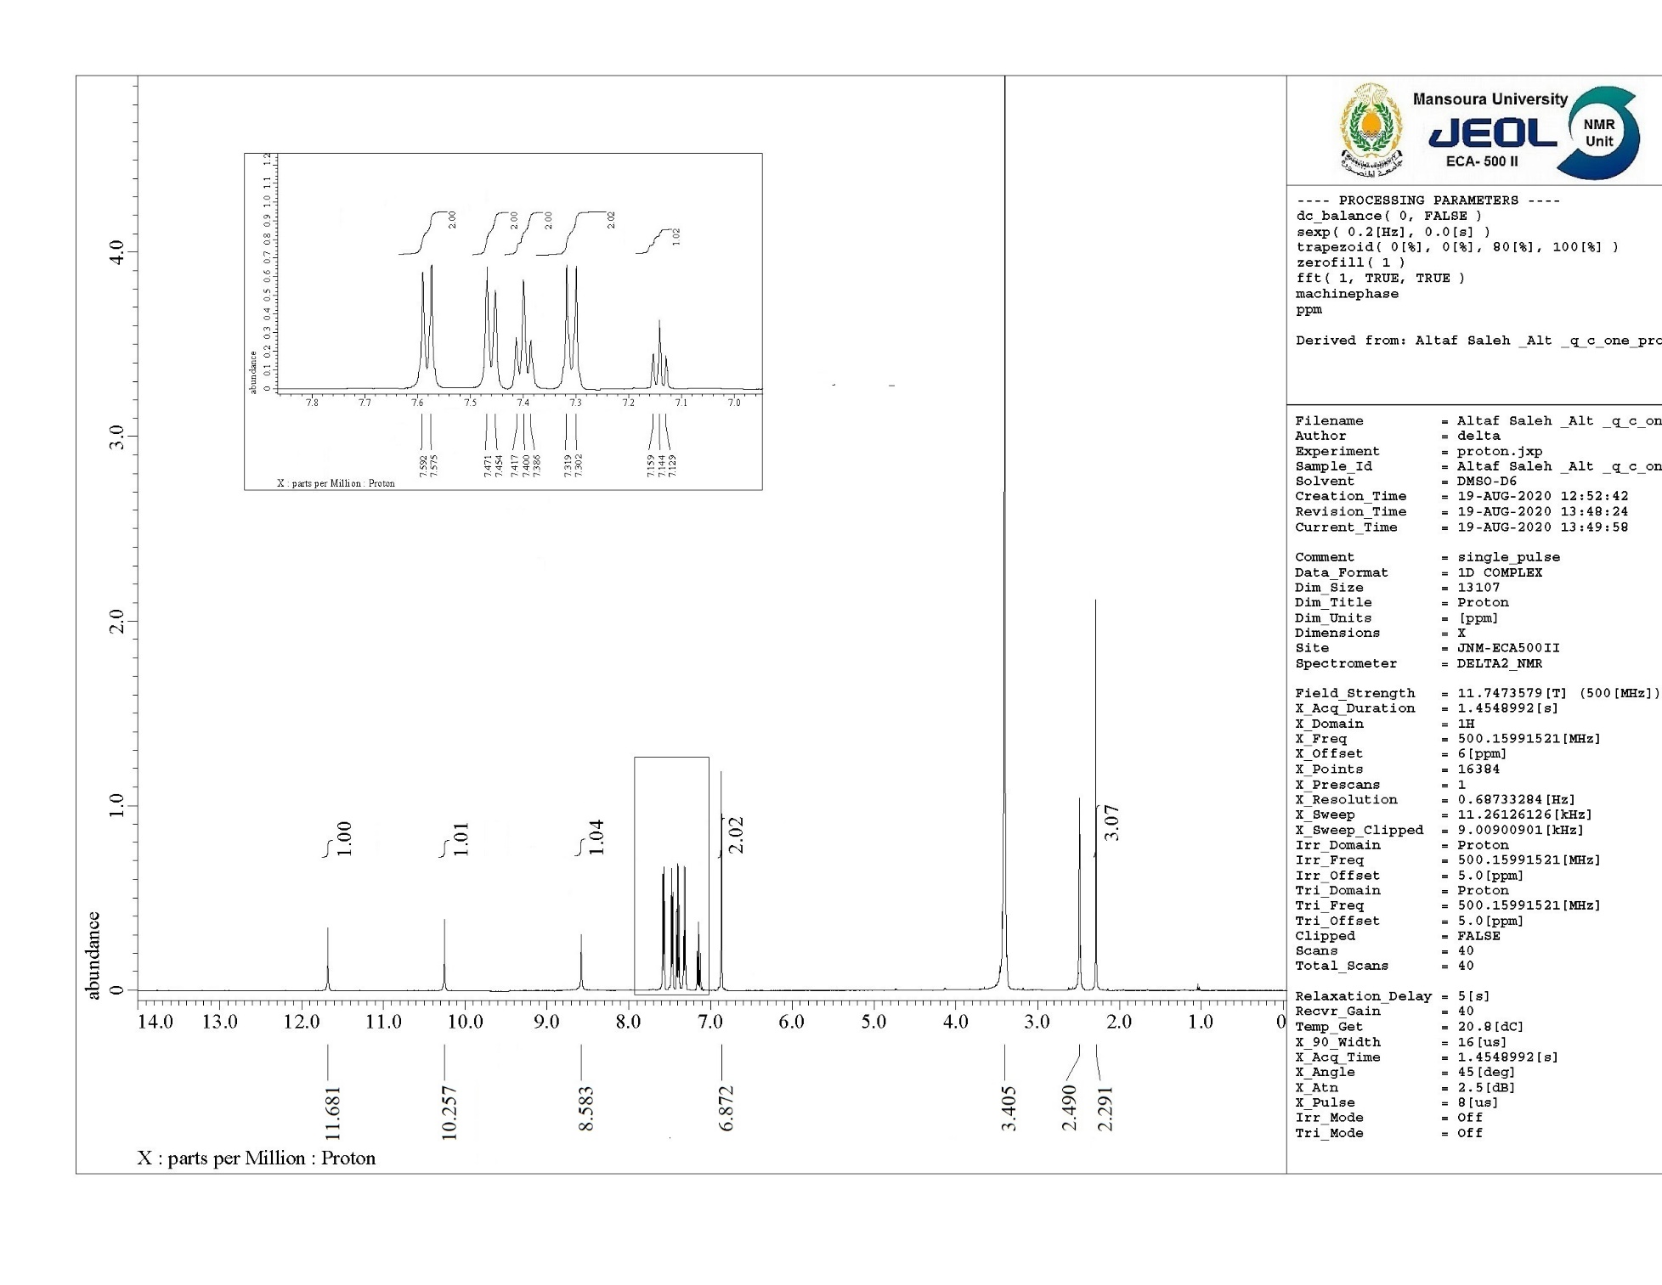



**Figure S6.** 1H NMR spectrum of compound **4a**.

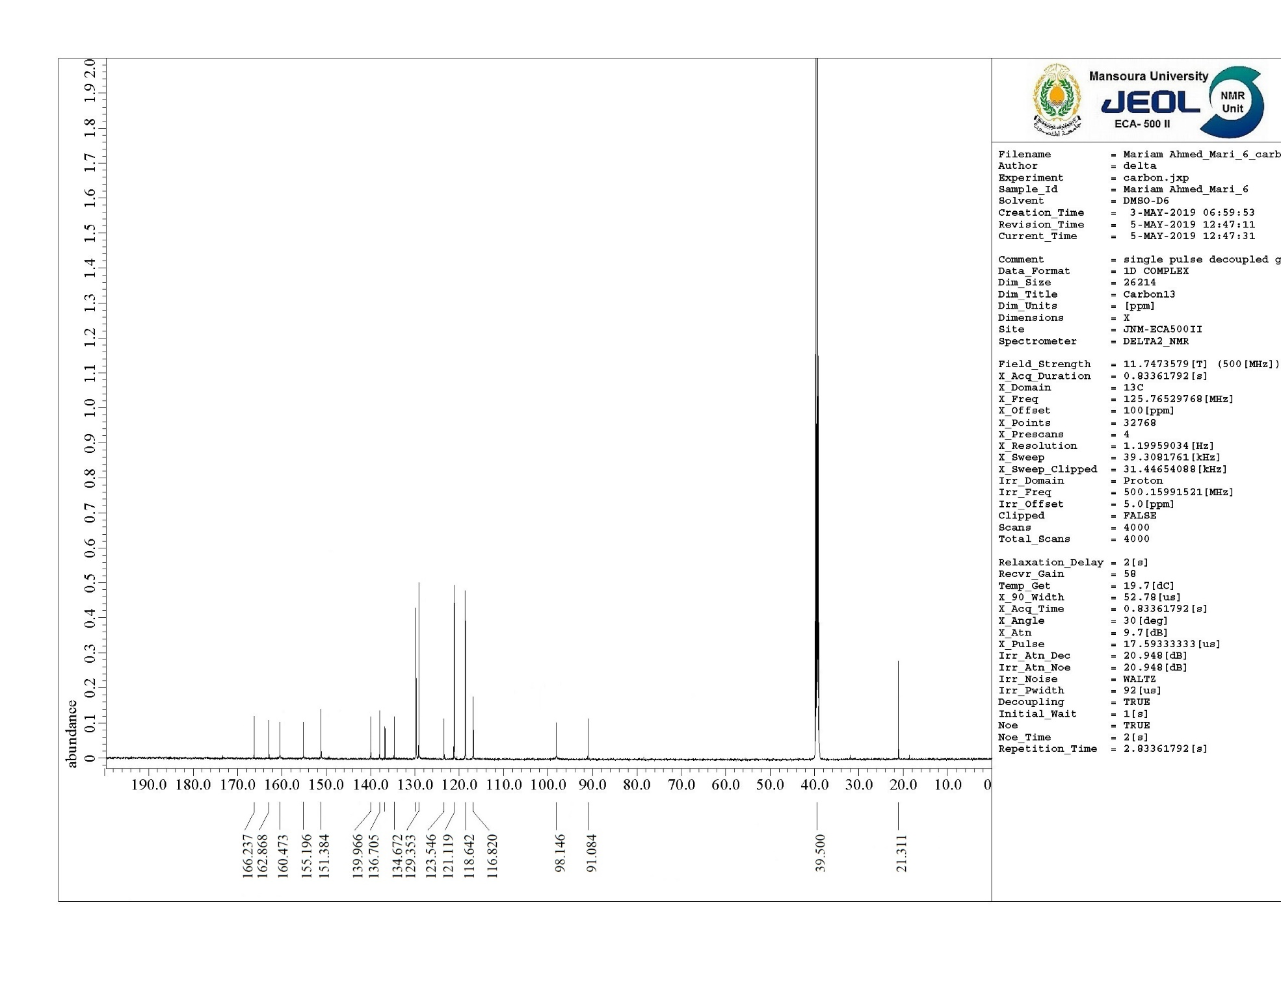



**Figure S7.** 13C NMR spectrum of compound **4a**.

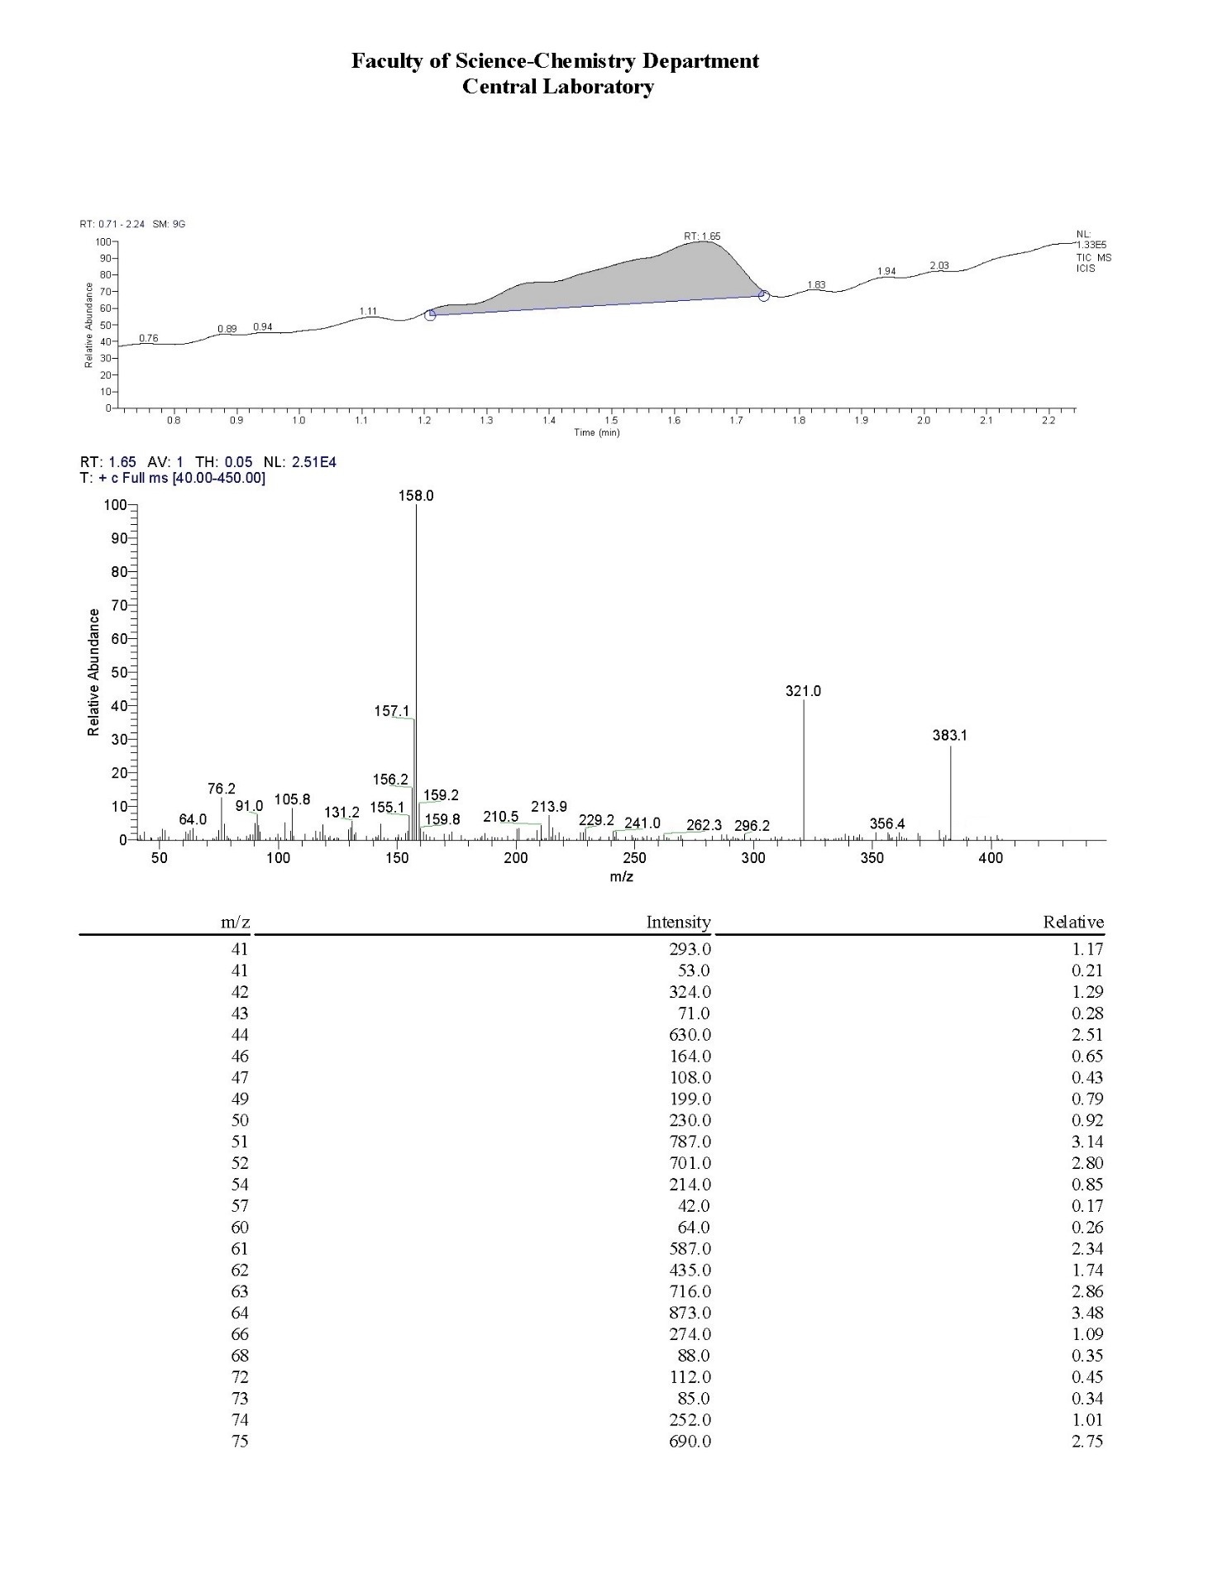



**Figure S8.** Mass analysis of compound **4a**.

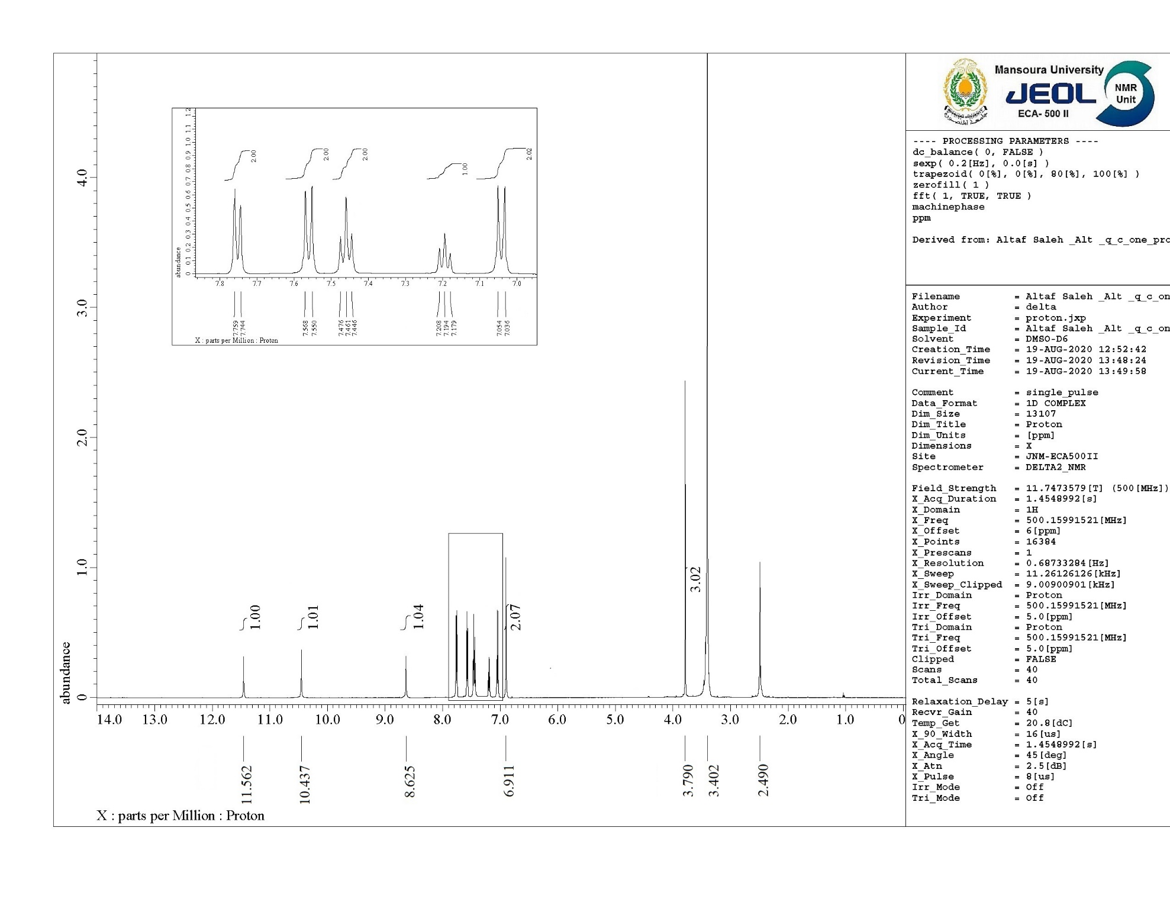



**Figure S9.** 1H NMR spectrum of compound **4b**.

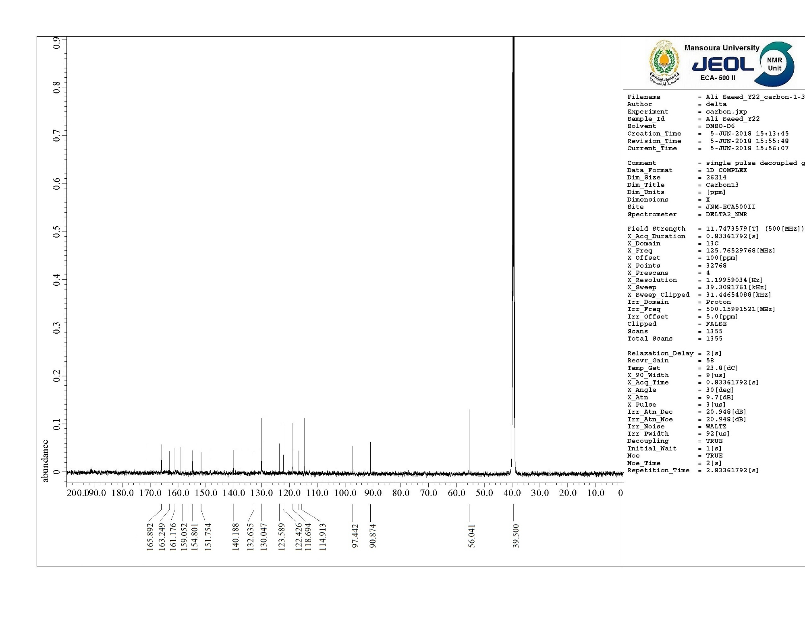



**Figure S10.** 13C NMR spectrum of compound **4b**.

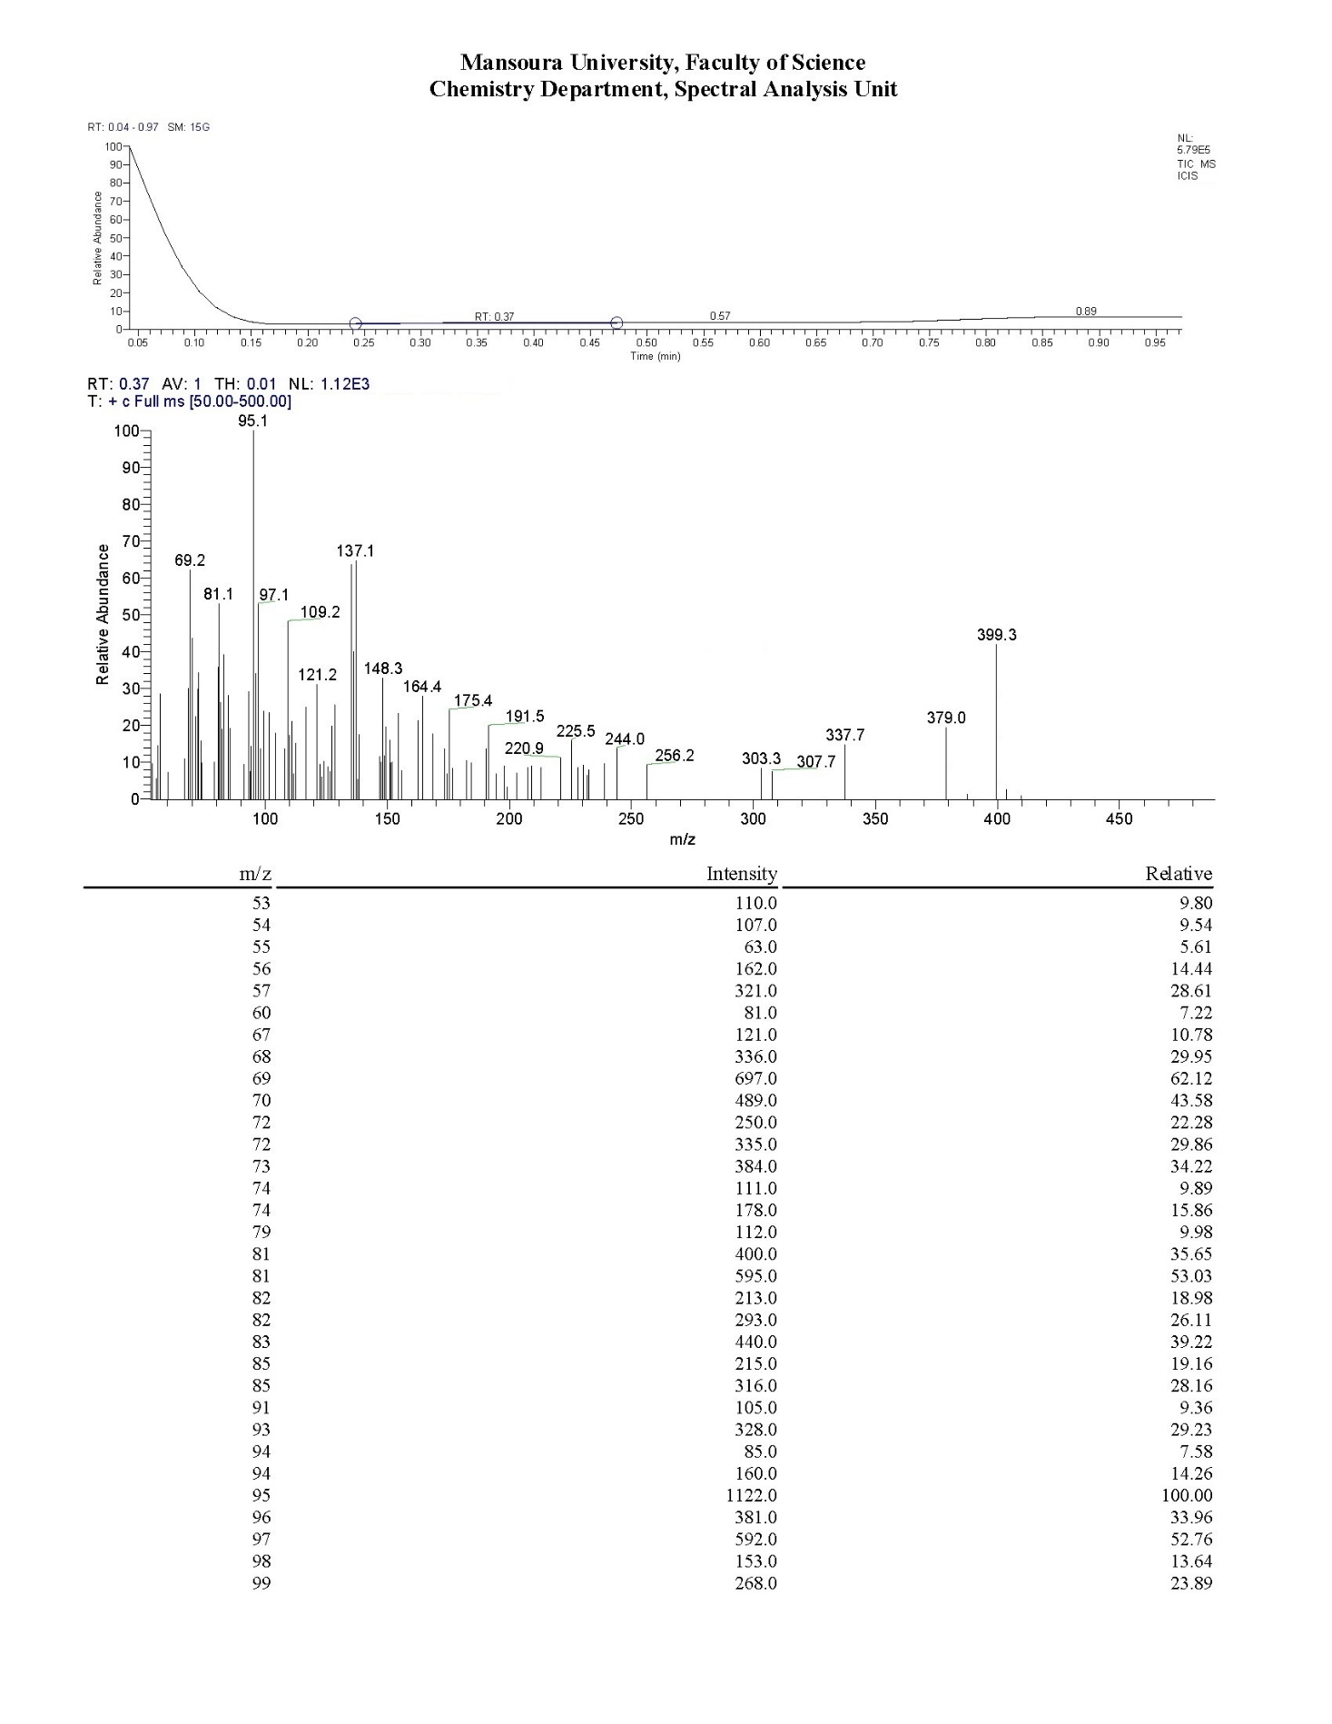



**Figure S11.** Mass analysis of compound **4b**.

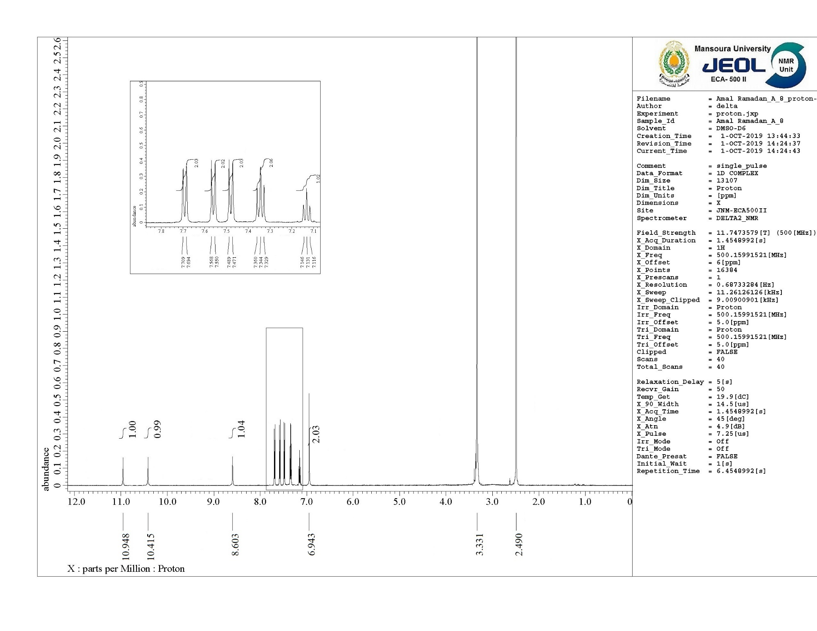



**Figure S12.** 1H NMR spectrum of compound **4c**.

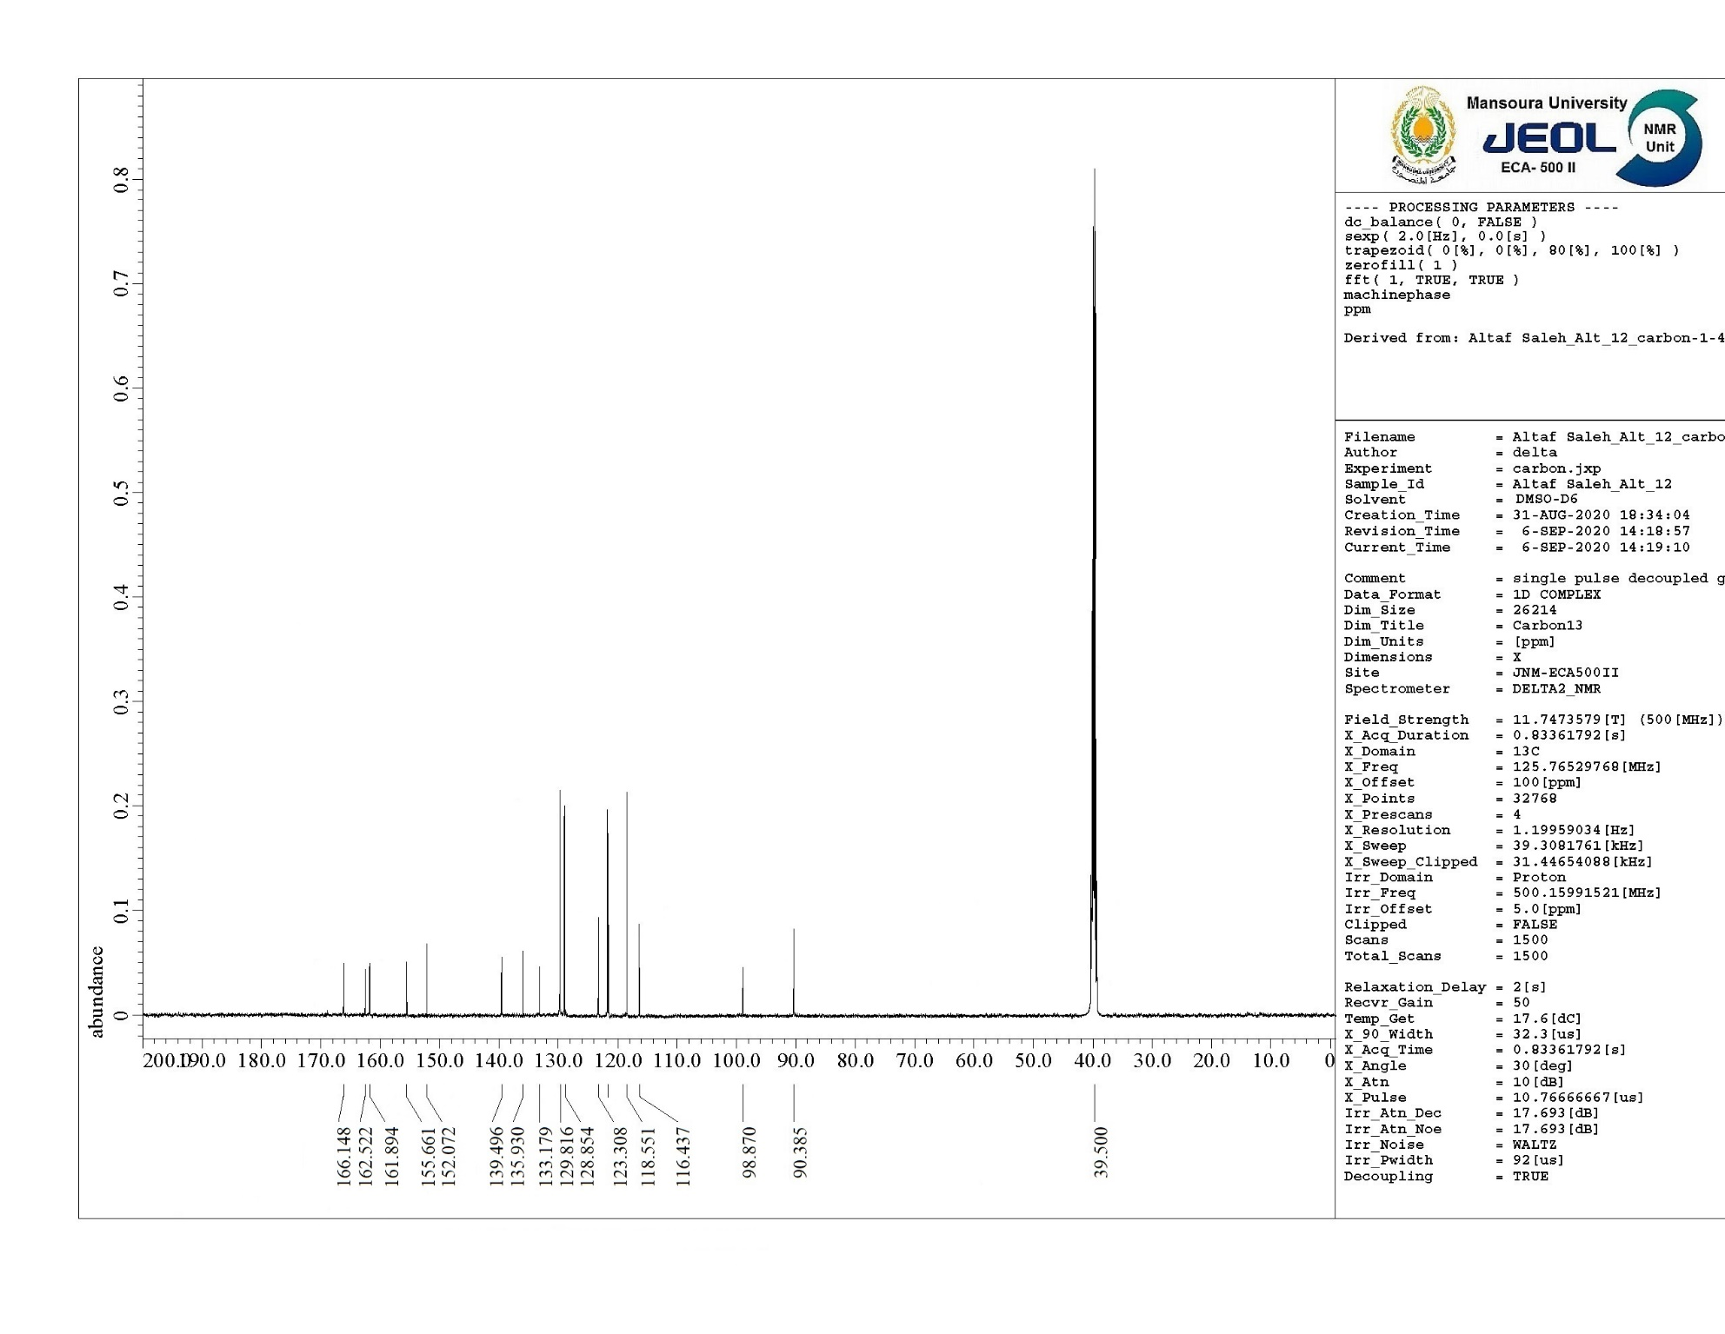



**Figure S13.** 13C NMR spectrum of compound **4c**.

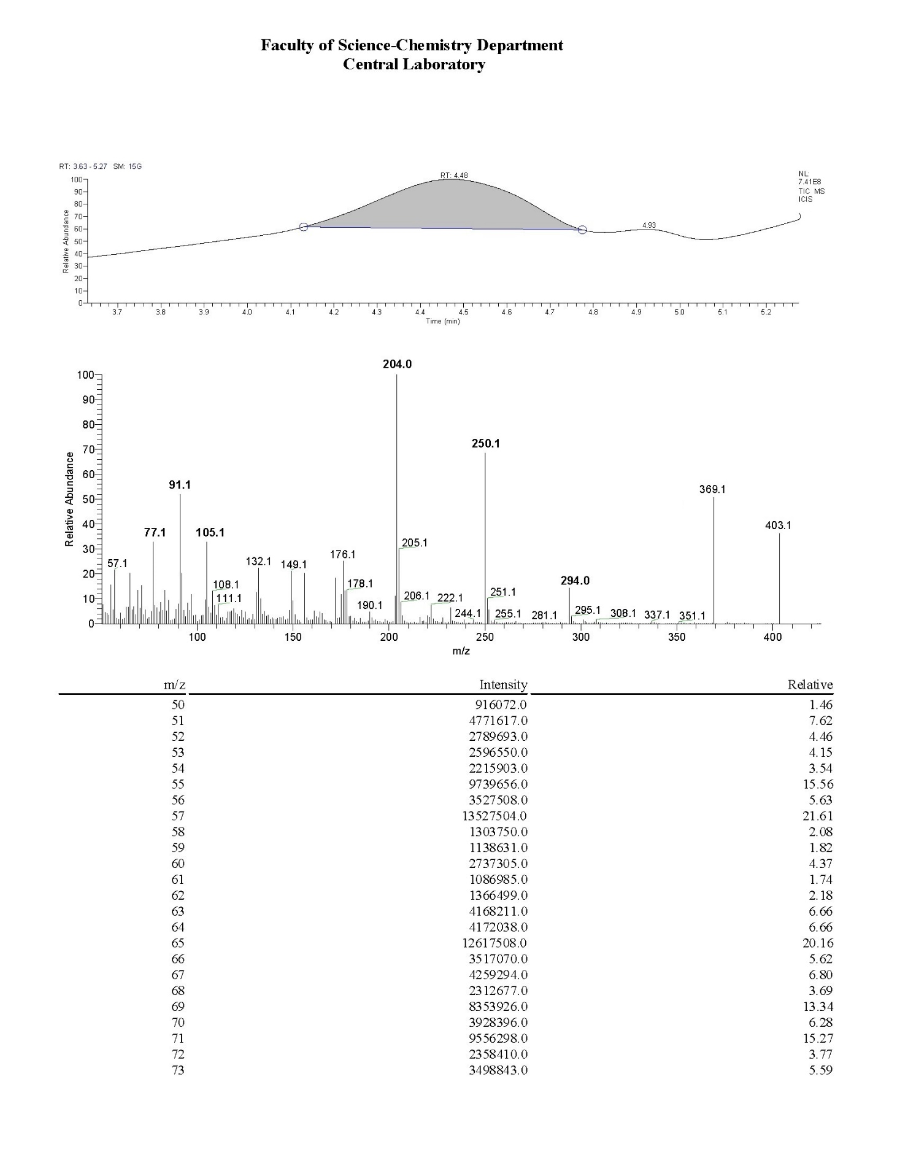



**Figure S14.** Mass analysis of compound **4c**.

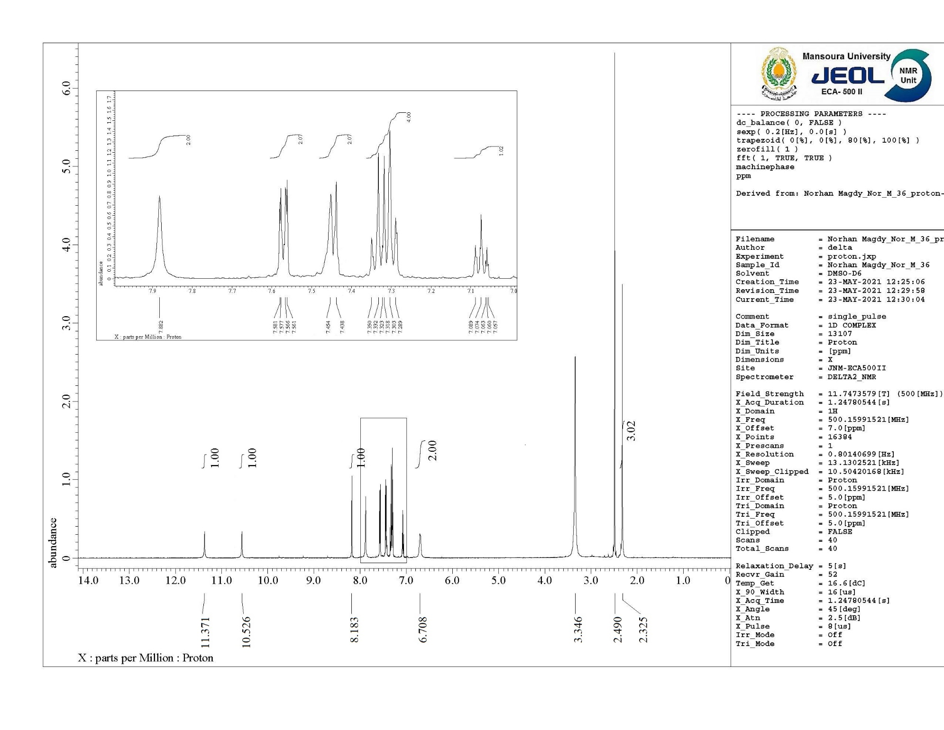



**Figure S15.** 1H NMR spectrum of compound **6a**.

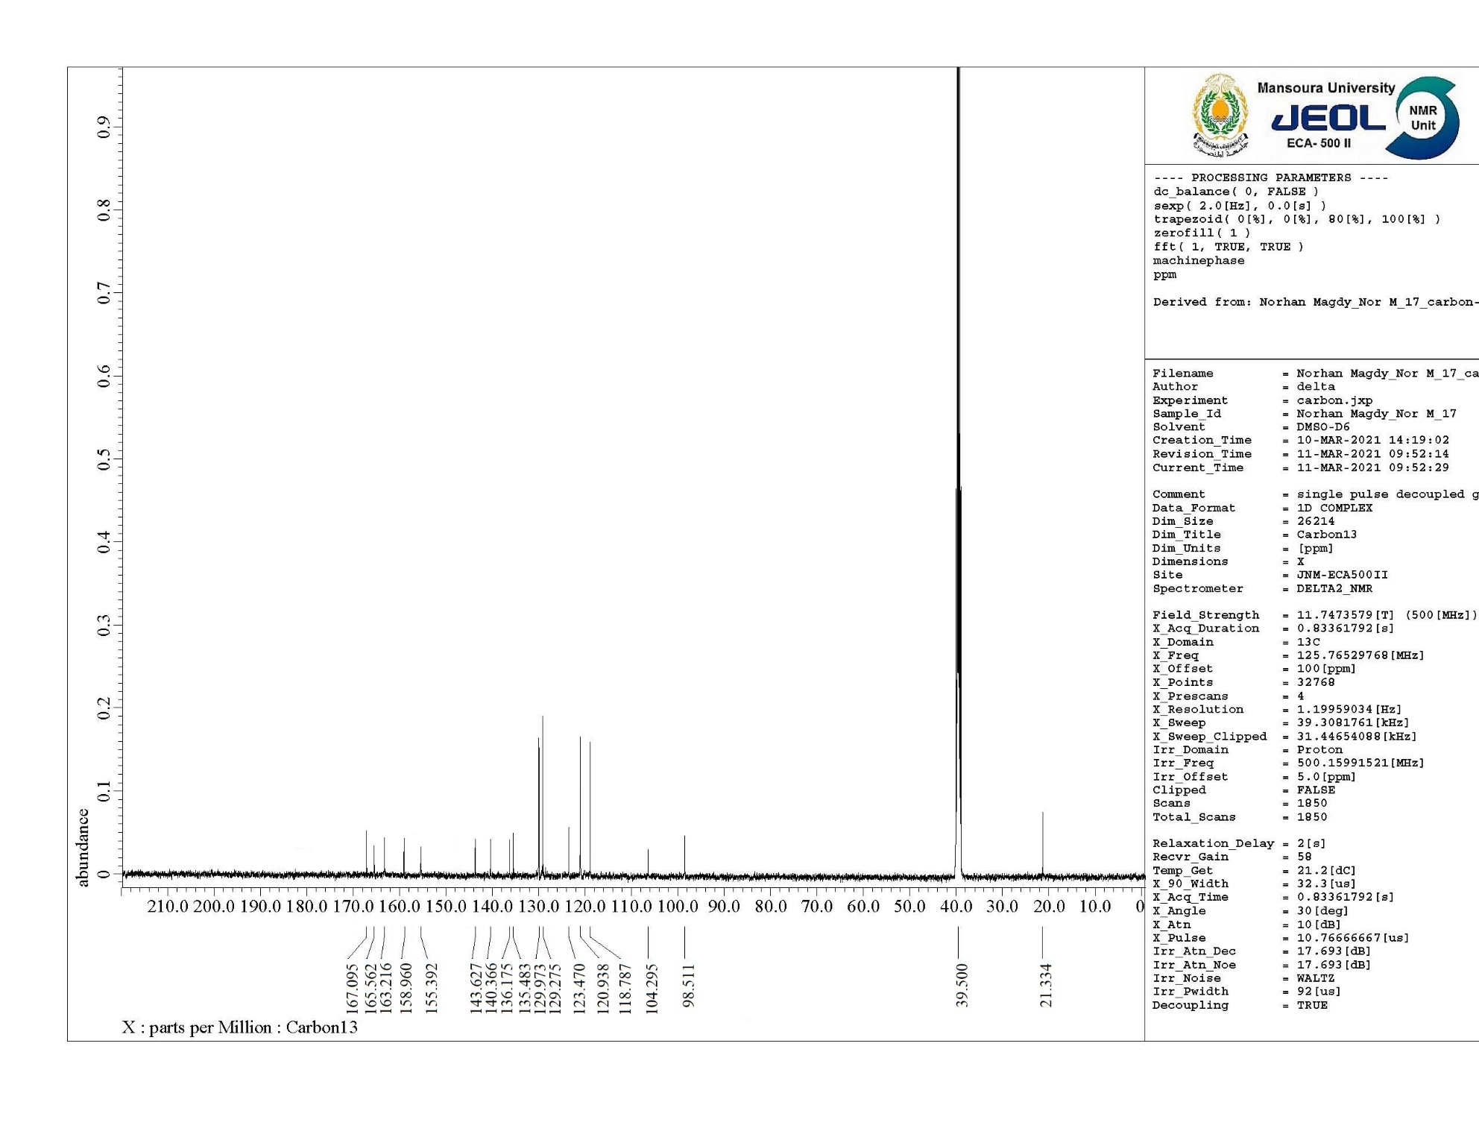



**Figure S16.** 13C NMR spectrum of compound **6a**.

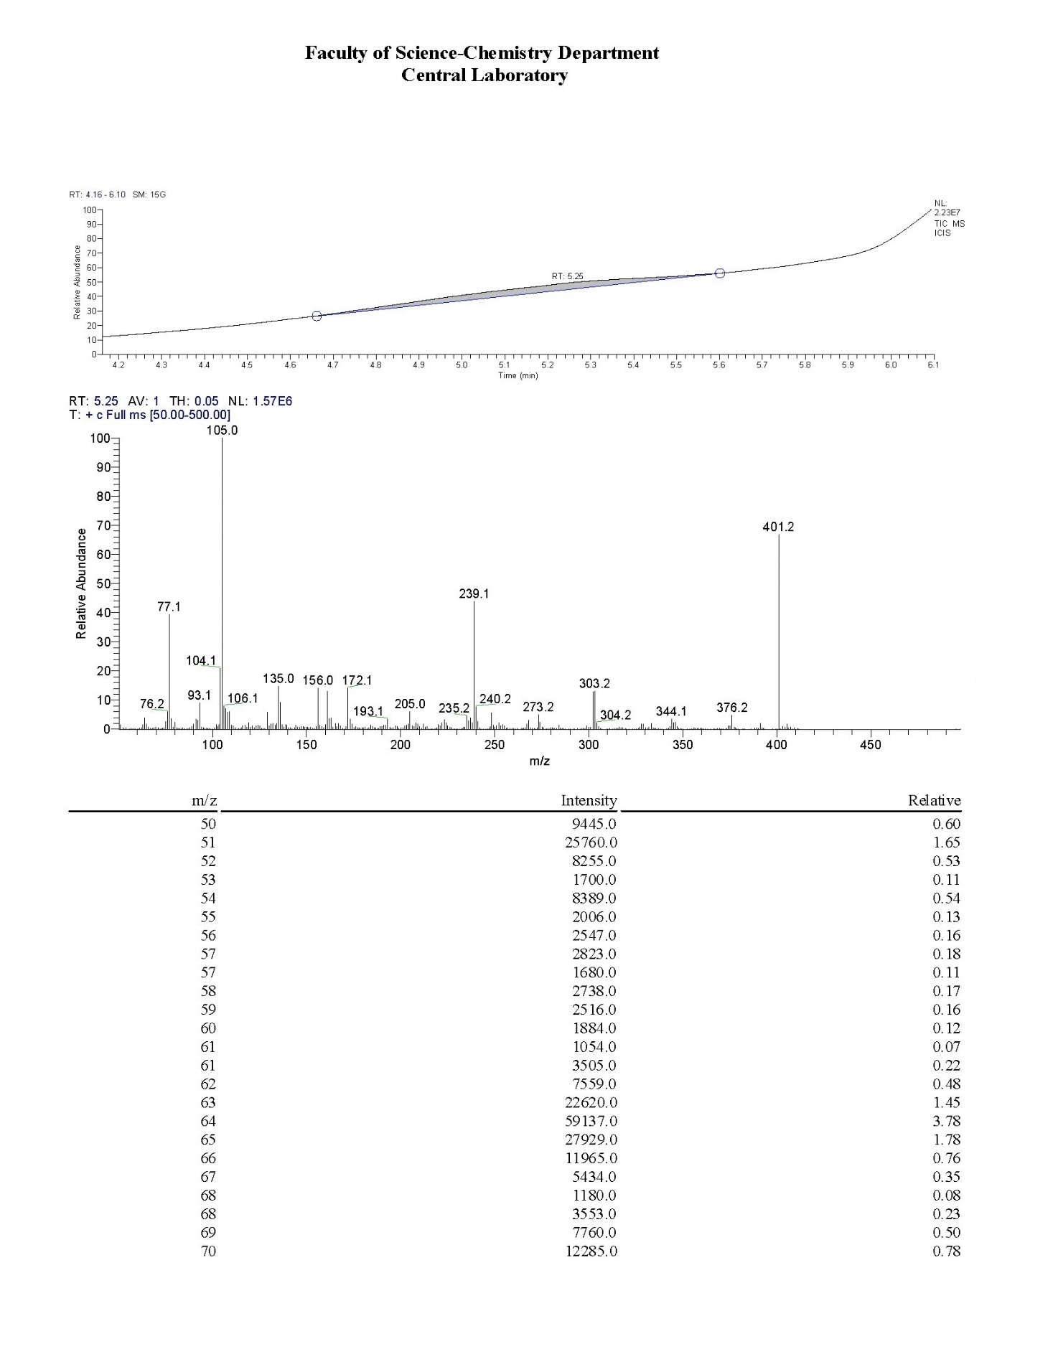



**Figure S17.** Mass analysis of compound **6a**.

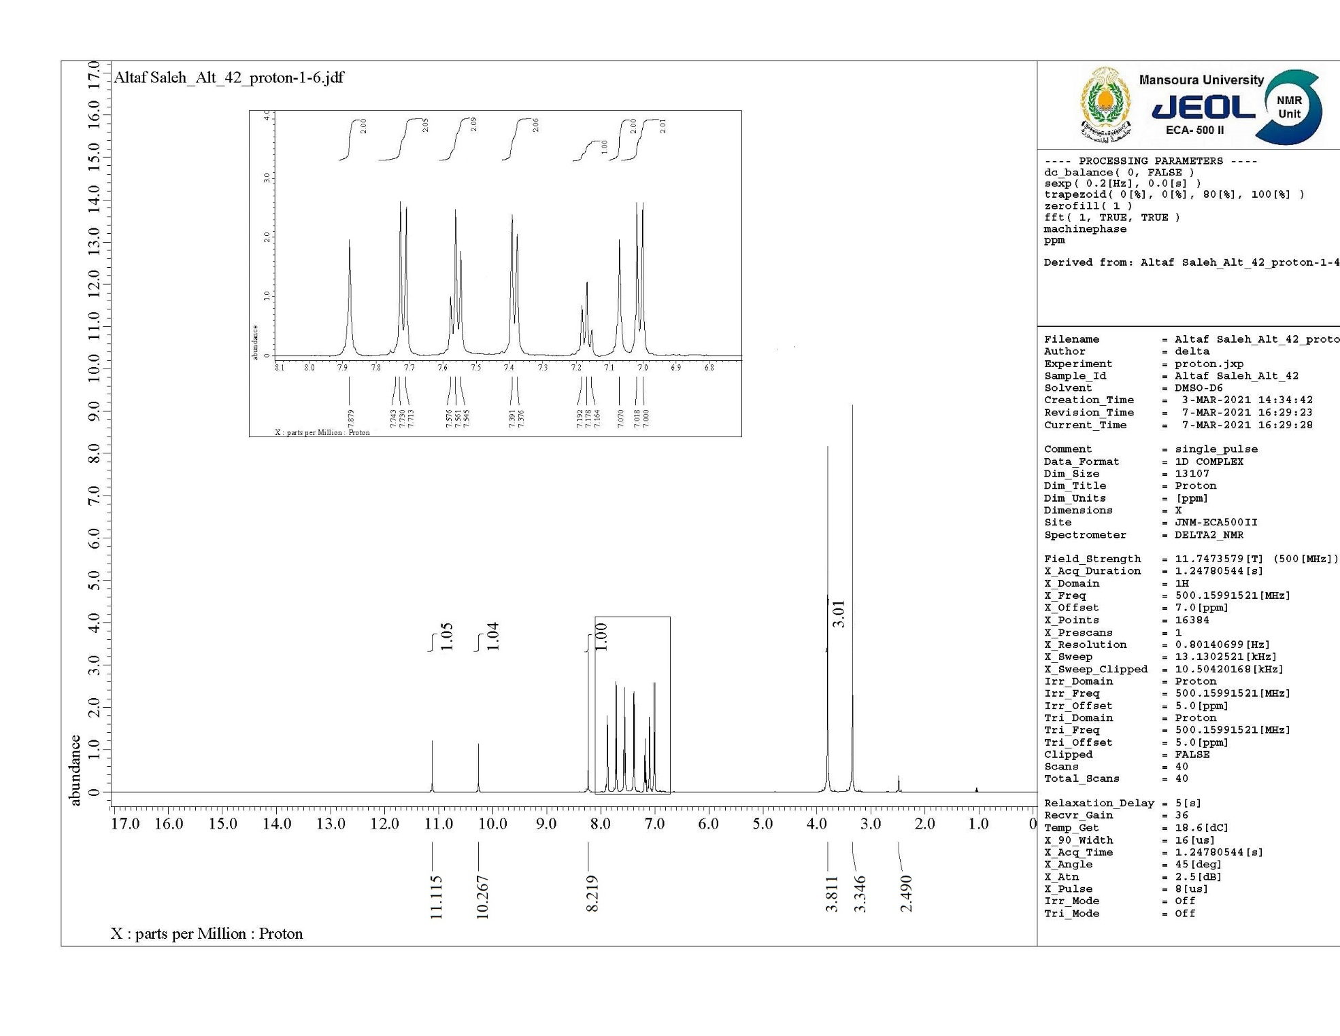



**Figure S18.** 1H NMR spectrum of compound **6b**.

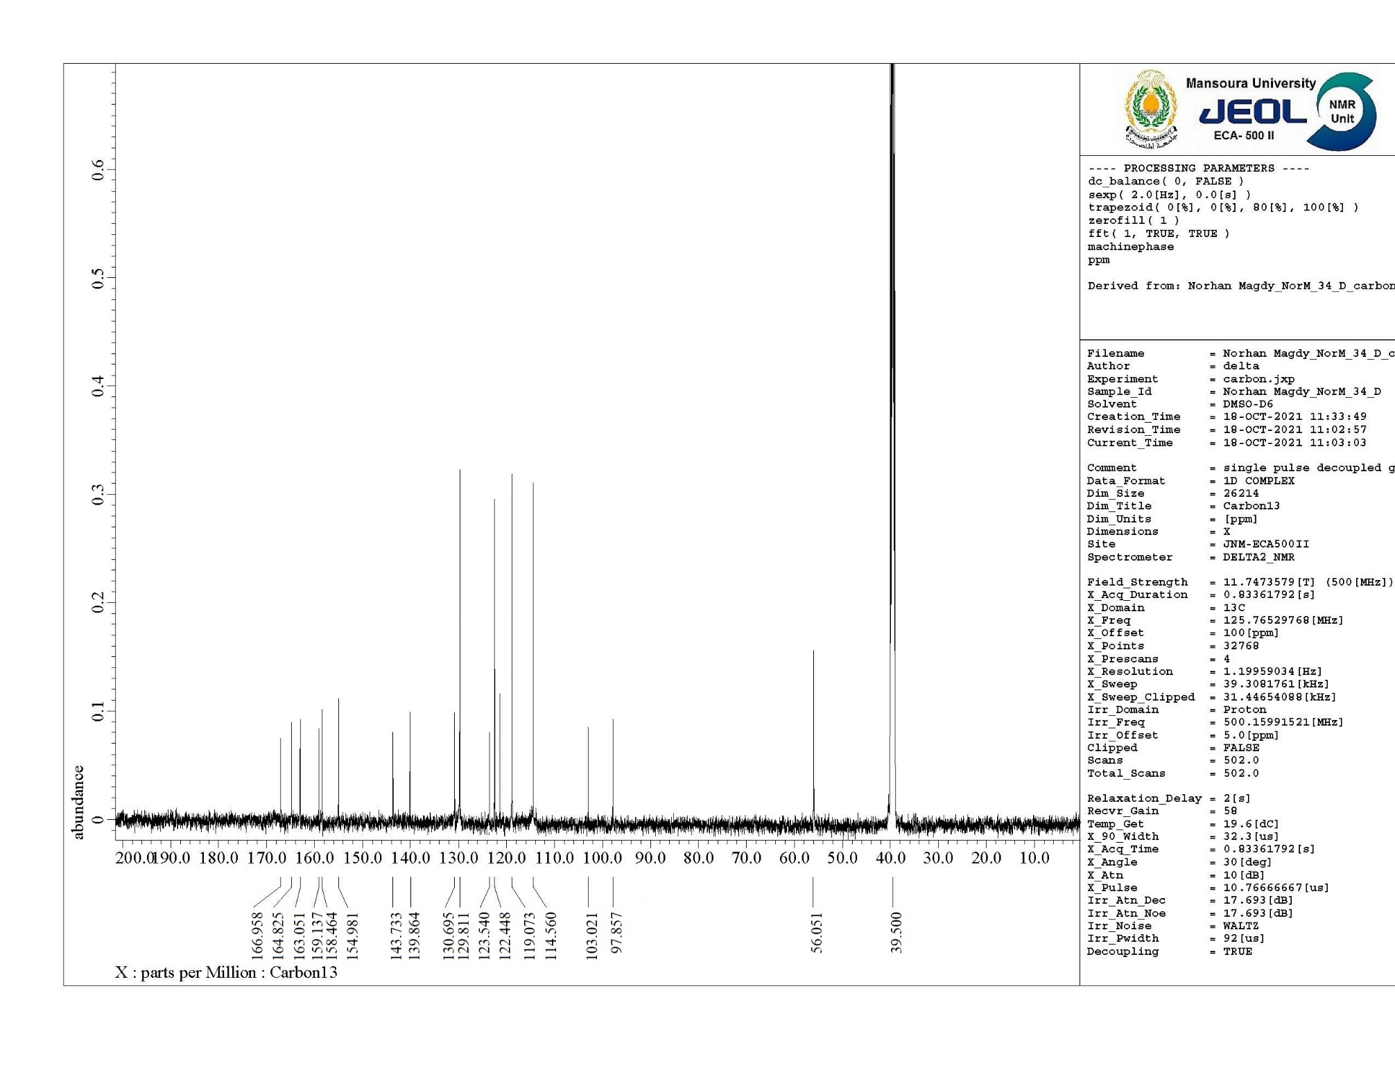



**Figure S19.** 13C NMR spectrum of compound **6b**.

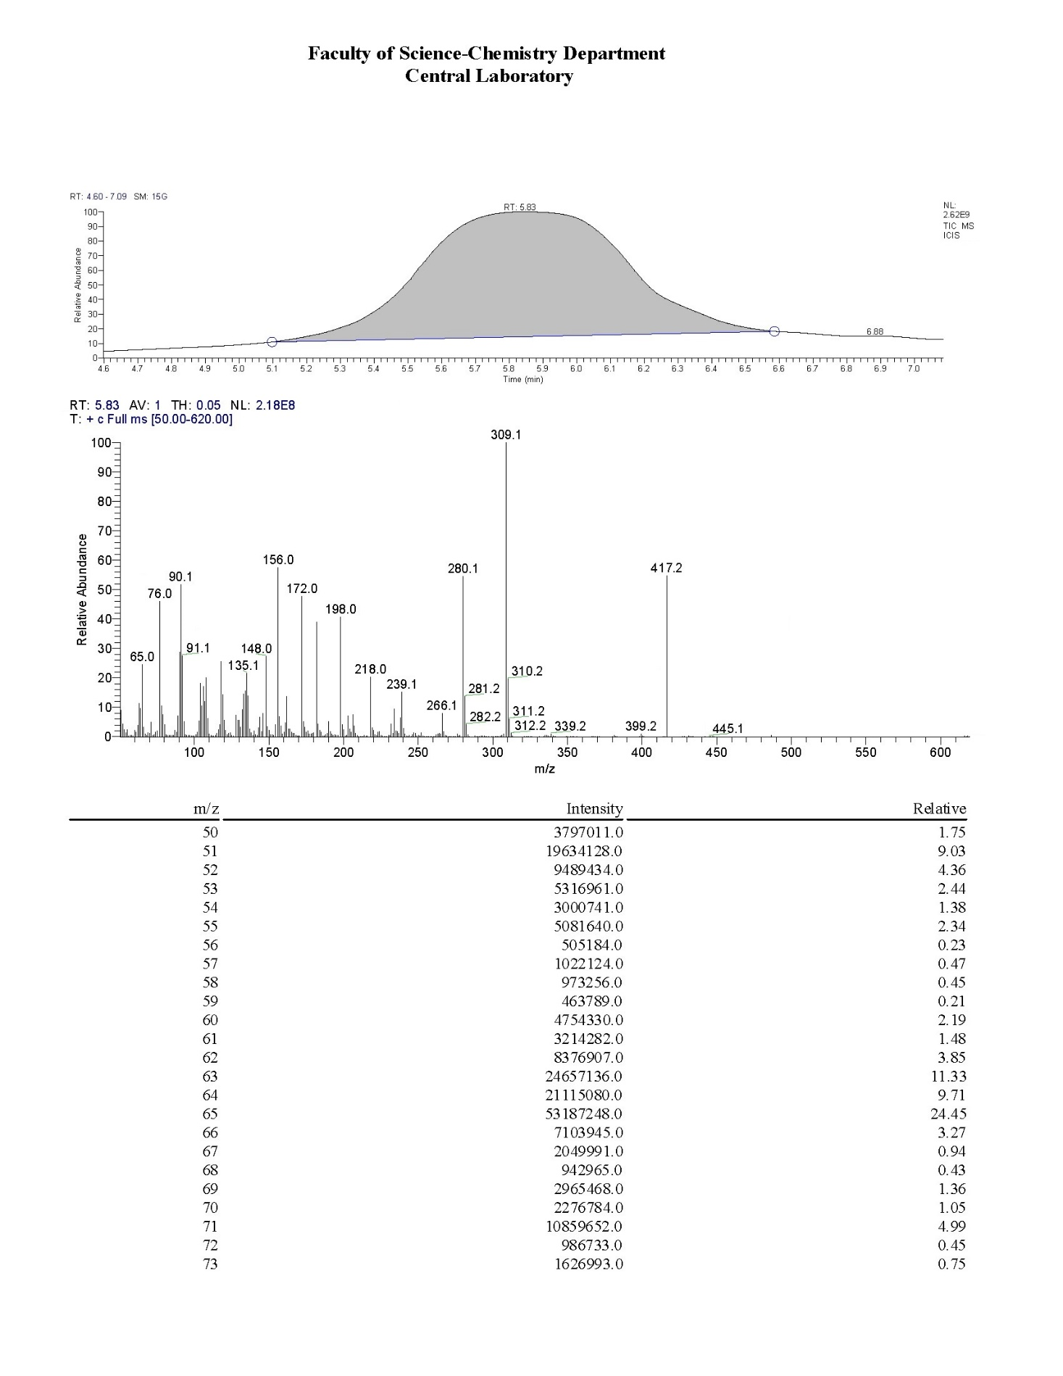



**Figure S20.** Mass analysis of compound **6b**.

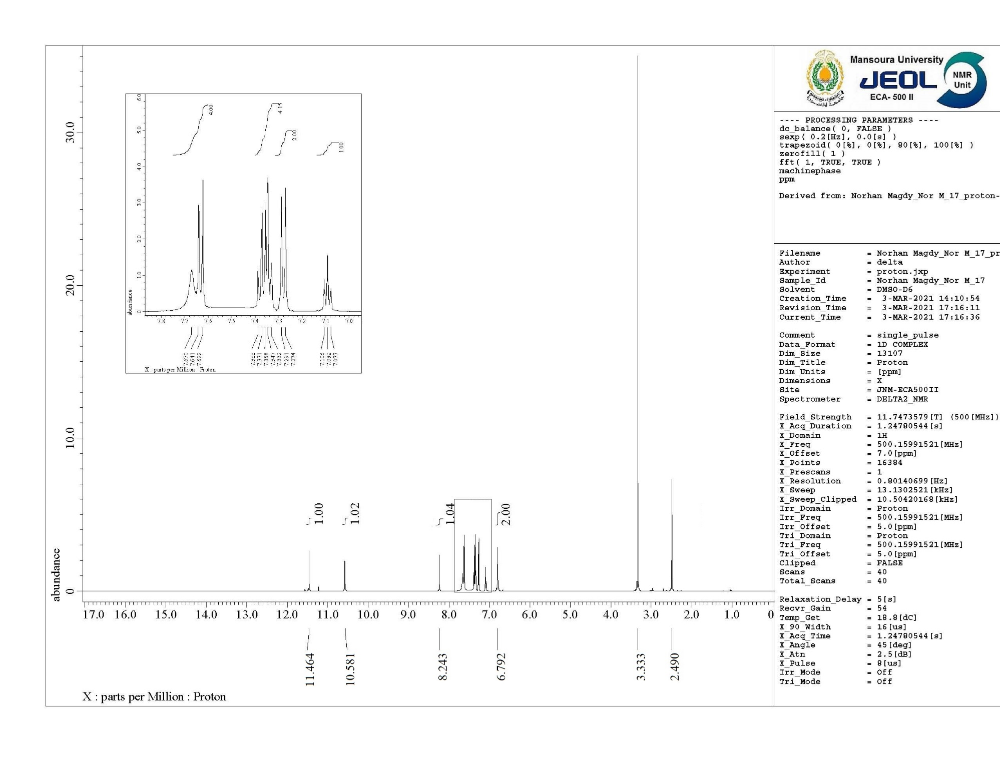



**Figure S21.** 1H NMR spectrum of compound **6c**.

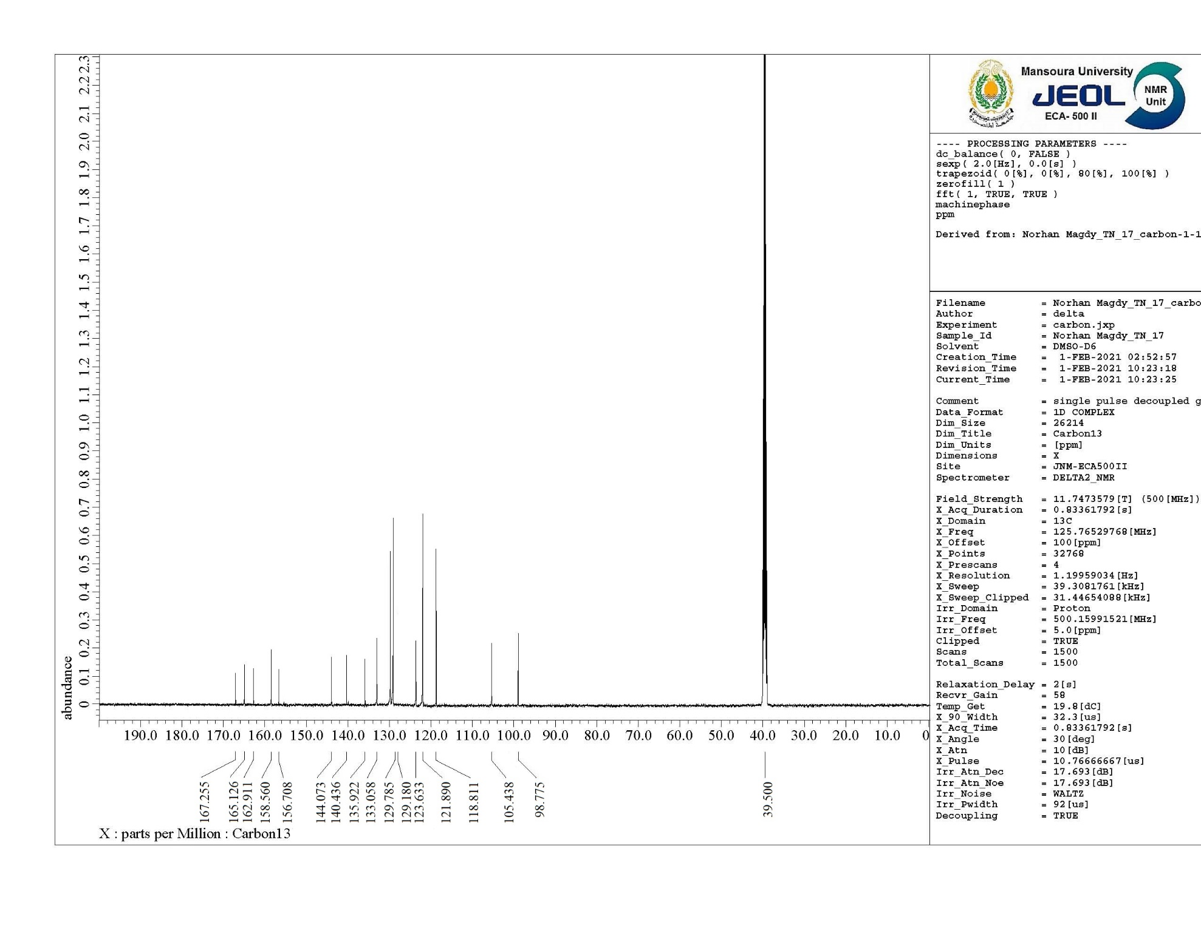



**Figure S22.** 13C NMR spectrum of compound **6c**.

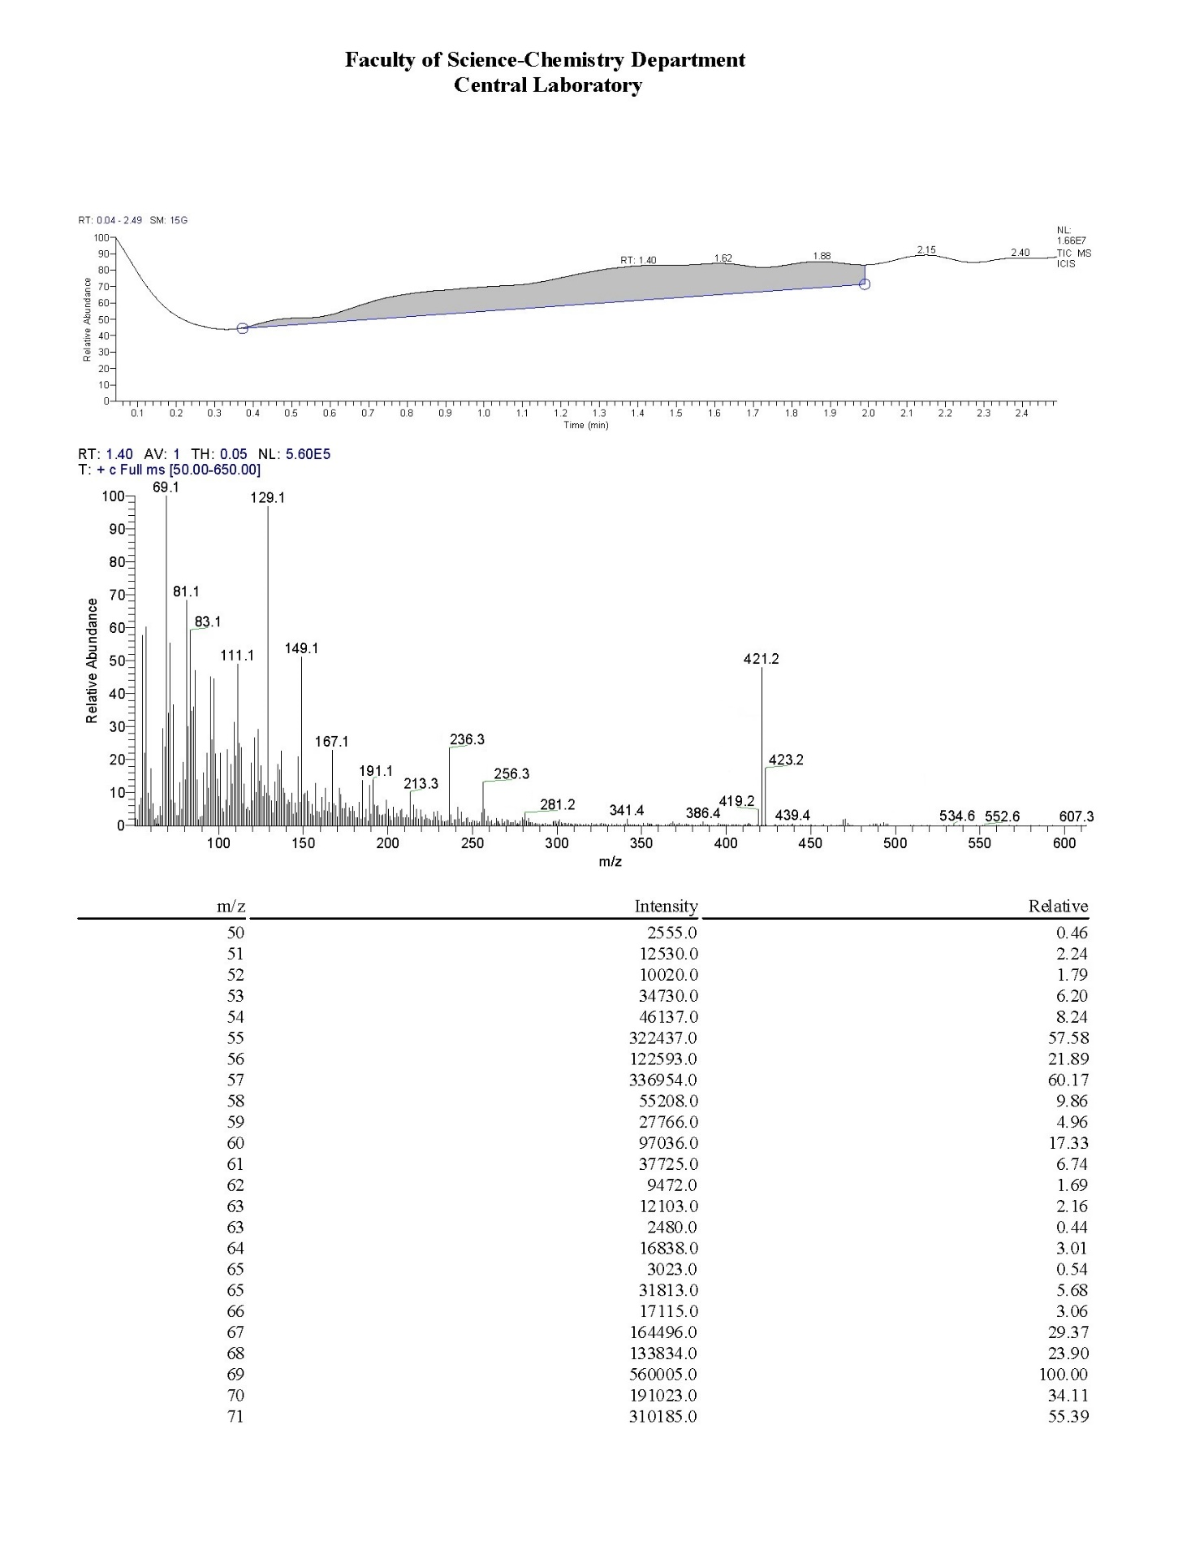



**Figure S23.** Mass analysis of compound **6c**.