Construction of a new 2D coral-like covalent organic framework as CuI nanoparticles carrier for the preparation of diverse triazoles
Morteza Torabi, Mohammad Ali Zolfigol,* Meysam Yarie*
Department of Organic Chemistry, Faculty of Chemistry, Bu‐Ali Sina University, Hamedan, Iran
Correspondence: Email: zolfi@basu.ac.ir, and mzolfigol@yahoo.com (M.A. Zolfigol), myarie.5266@gmail.com (M. Yarie)
1: FT-IR spectrum of 4,4',4''-((1,3,5-triazine-2,4,6-triyl)tris(oxy))tribenzaldehyde.
2: ¹H NMR spectrum of 4,4',4''-((1,3,5-triazine-2,4,6-triyl)tris(oxy))tribenzaldehyde.
3: ¹³C NMR spectrum of 4,4',4''-((1,3,5-triazine-2,4,6-triyl)tris(oxy))tribenzaldehyde.
4: FT-IR spectrum of 1-benzyl-4-phenyl-1H-1,2,3-triazole.
5: ¹H NMR spectrum of 1-benzyl-4-phenyl-1H-1,2,3-triazole.
6: ¹³C NMR spectrum of 1-benzyl-4-phenyl-1H-1,2,3-triazole.
7: FT-IR spectrum of 1-(4-methylbenzyl)-4-phenyl-1H-1,2,3-triazole.
8: FT-IR spectrum of 4-phenyl-1-(phenylsulfonyl)-1H-1,2,3-triazole.
9: FT-IR spectrum of 4-phenyl-1-tosyl-1H-1,2,3-triazole.
10: ¹H NMR spectrum of 4-phenyl-1-tosyl-1H-1,2,3-triazole.
11: ¹³C NMR spectrum of 4-phenyl-1-tosyl-1H-1,2,3-triazole.
12: FT-IR spectrum of (1-benzyl-1H-1,2,3-triazol-4-yl)methanol.
13: ¹H NMR spectrum of (1-benzyl-1H-1,2,3-triazol-4-yl)methanol.
14: ¹³C NMR spectrum of (1-benzyl-1H-1,2,3-triazol-4-yl)methanol.
15: FT-IR spectrum of 1-(5-methyl-1-(4-nitrophenyl)-1H-1,2,3-triazol-4-yl)ethan-1-one.
16: ¹H NMR spectrum of 1-(5-methyl-1-(4-nitrophenyl)-1H-1,2,3-triazol-4-yl)ethan-1-one.
17: ¹³C NMR spectrum of 1-(5-methyl-1-(4-nitrophenyl)-1H-1,2,3-triazol-4-yl)ethan-1-one.
18: FT-IR spectrum of 1-(5-methyl-1-(4-nitrophenyl)-1H-1,2,3-triazol-4-yl)ethan-1-one.
19: FT-IR spectrum of ethyl 5-methyl-1-(4-nitrophenyl)-1H-1,2,3-triazole-4-carboxylate.
20: ¹H NMR spectrum of 5-methyl-1-(4-nitrophenyl)-1H-1,2,3-triazole-4-carboxylate.
21: ¹³C NMR spectrum of 5-methyl-1-(4-nitrophenyl)-1H-1,2,3-triazole-4-carboxylate.
22: FT-IR spectrum of ethyl 5-methyl-1-(4-chlorophenyl)-1H-1,2,3-triazole-4-carboxylate.
23: FT-IR spectrum of 1-(4-phenyl-1H-1,2,3-triazol-1-yl)propan-2-ol.
24: ¹H NMR spectrum of 1-(4-phenyl-1H-1,2,3-triazol-1-yl)propan-2-ol.
25: ¹³C NMR spectrum of 1-(4-phenyl-1H-1,2,3-triazol-1-yl)propan-2-ol.
26: FT-IR spectrum of 2-(4-phenyl-1H-1,2,3-triazol-1-yl)pentan-3-ol.
27: ¹H NMR spectrum of 2-(4-phenyl-1H-1,2,3-triazol-1-yl)pentan-3-ol.
28: ¹³C NMR spectrum of 2-(4-phenyl-1H-1,2,3-triazol-1-yl)pentan-3-ol.
29: FT-IR spectrum of 1-phenyl-2-(4-phenyl-1H-1,2,3-triazol-1-yl)ethan-1-ol.
30: ¹H NMR spectrum of 1-phenyl-2-(4-phenyl-1H-1,2,3-triazol-1-yl)ethan-1-ol.
31: ¹³C NMR spectrum of 1-phenyl-2-(4-phenyl-1H-1,2,3-triazol-1-yl)ethan-1-ol.
32: FT-IR spectrum of 1-phenoxy-3-(4-phenyl-1H-1,2,3-triazol-1-yl)propan-2-ol.
33: ¹H NMR spectrum of 1-phenoxy-3-(4-phenyl-1H-1,2,3-triazol-1-yl)propan-2-ol.
34: ¹³C NMR spectrum of 1-phenoxy-3-(4-phenyl-1H-1,2,3-triazol-1-yl)propan-2-ol.
35: FT-IR spectrum of 1-isopropoxy-3-(4-phenyl-1H-1,2,3-triazol-1-yl)propan-2-ol.
36: ¹H NMR spectrum of 1-isopropoxy-3-(4-phenyl-1H-1,2,3-triazol-1-yl)propan-2-ol.
37: ¹³C NMR spectrum of 1-isopropoxy-3-(4-phenyl-1H-1,2,3-triazol-1-yl)propan-2-ol.
38: FT-IR spectrum of 1-butoxy-3-(4-phenyl-1H-1,2,3-triazol-1-yl)propan-2-ol.
39: ¹H NMR spectrum of 1-butoxy-3-(4-phenyl-1H-1,2,3-triazol-1-yl)propan-2-ol.
40: ¹³C NMR spectrum of 1-butoxy-3-(4-phenyl-1H-1,2,3-triazol-1-yl)propan-2-ol.
41: FT-IR spectrum of 1-phenyl-2-(4-phenyl-1H-1,2,3-triazol-1-yl)ethan-1-one.
42: FT-IR spectrum of recovered catalyst.
43: spectral data

1: FT-IR spectrum of 4,4',4''-((1,3,5-triazine-2,4,6-triyl)tris(oxy))tribenzaldehyde.
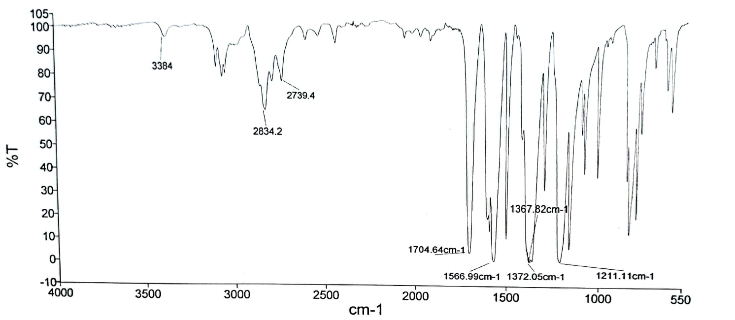
2: ¹H NMR spectrum of 4,4',4''-((1,3,5-triazine-2,4,6-triyl)tris(oxy))tribenzaldehyde.
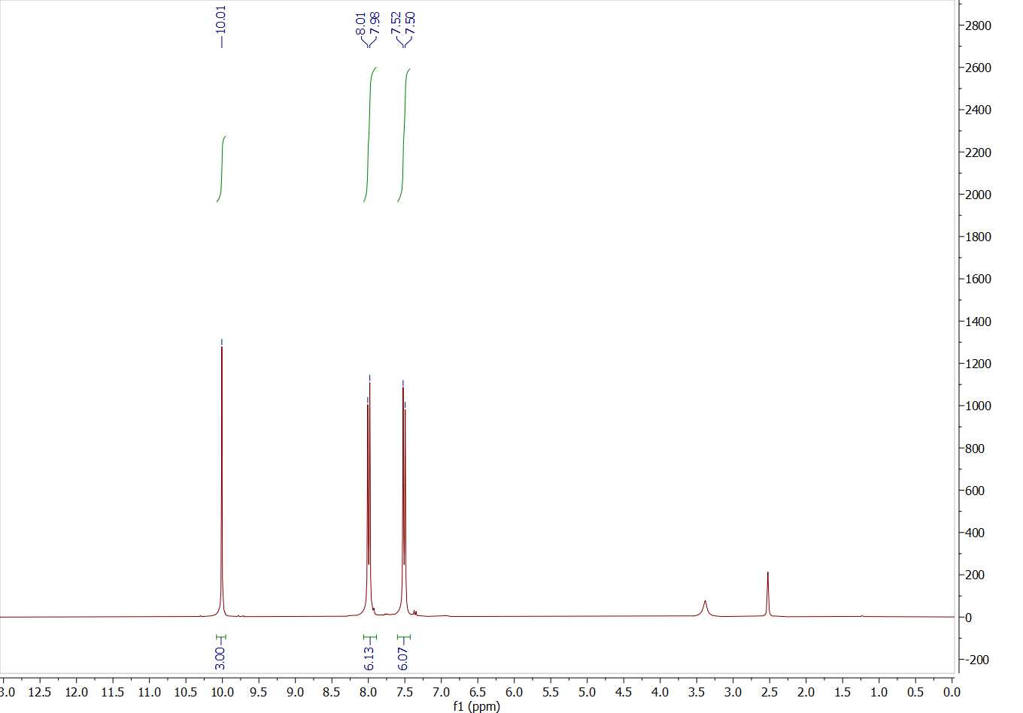

3: ¹³C NMR spectrum of 4,4',4''-((1,3,5-triazine-2,4,6-triyl)tris(oxy))tribenzaldehyde.
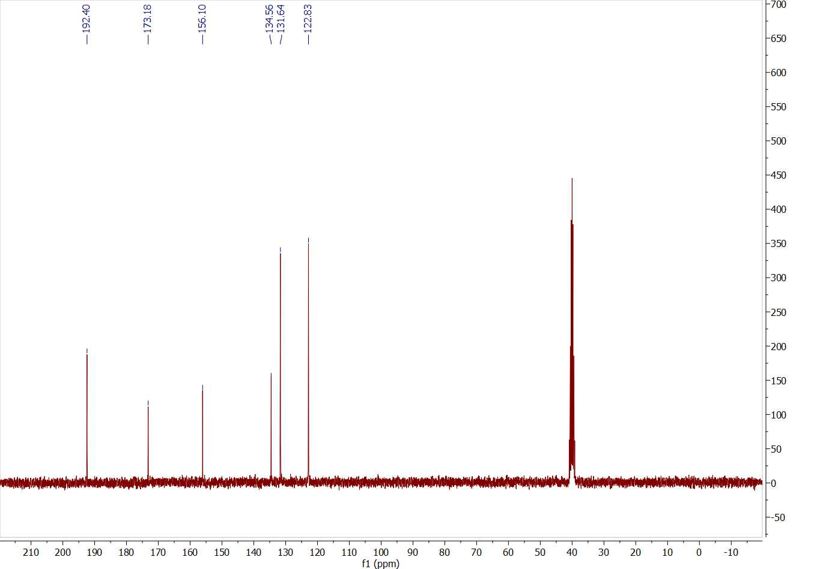

4: FT-IR spectrum of 1-benzyl-4-phenyl-1H-1,2,3-triazole.
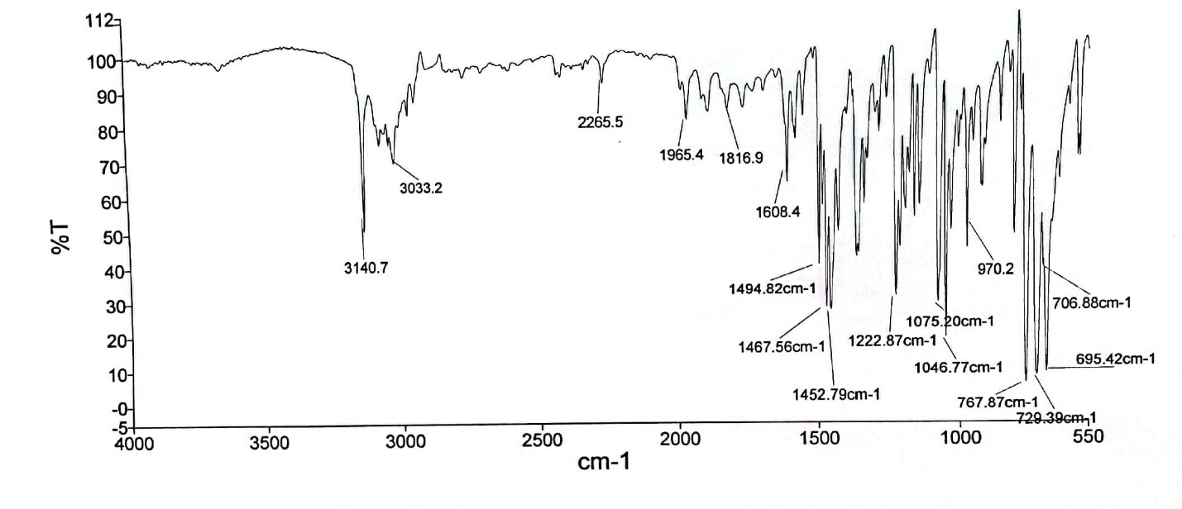

5: ¹H NMR spectrum of 1-benzyl-4-phenyl-1H-1,2,3-triazole.
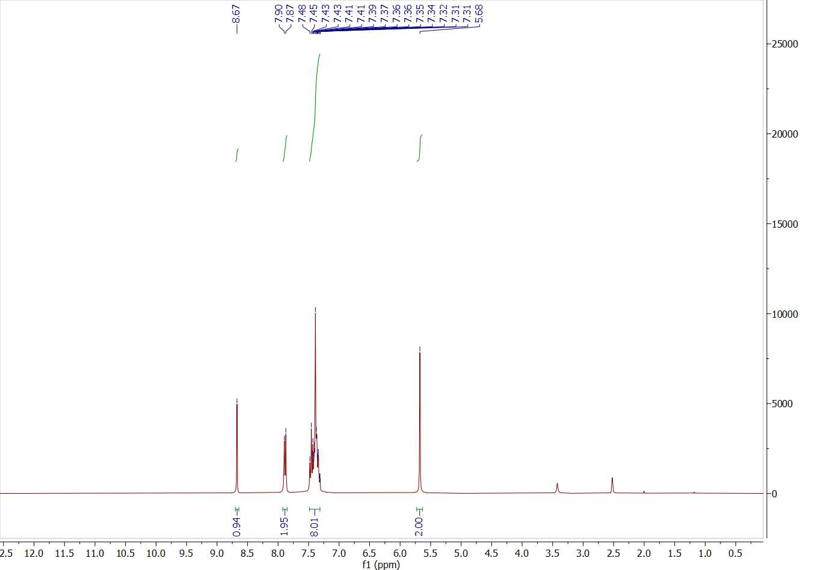
6: ¹³C NMR spectrum of 1-benzyl-4-phenyl-1H-1,2,3-triazole.
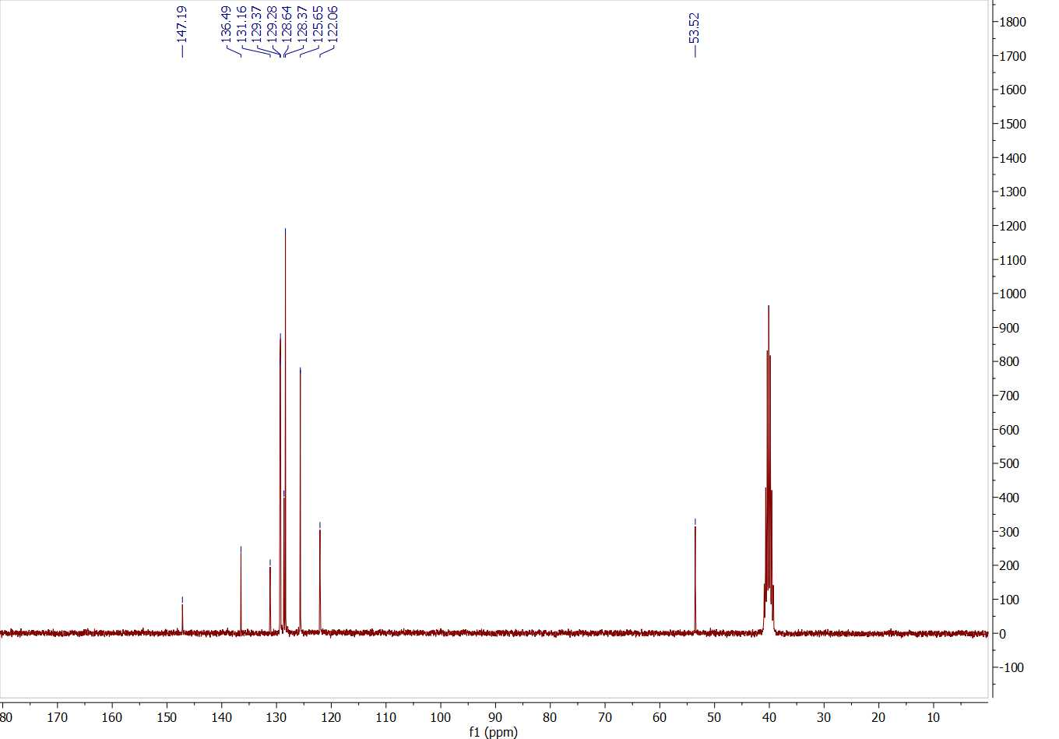

7: FT-IR spectrum of 1-(4-methylbenzyl)-4-phenyl-1H-1,2,3-triazole.
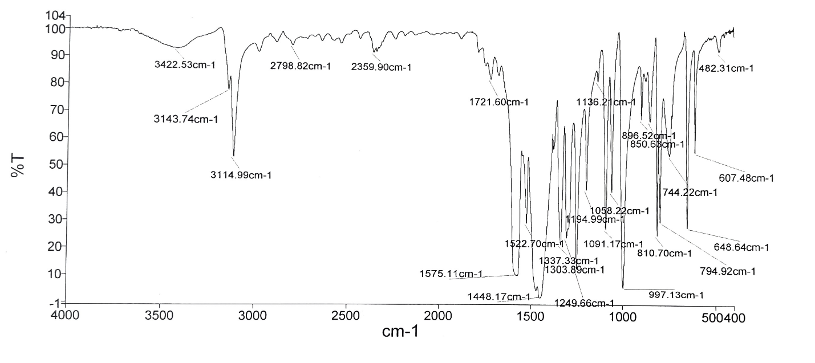
8: FT-IR spectrum of 4-phenyl-1-(phenylsulfonyl)-1H-1,2,3-triazole.
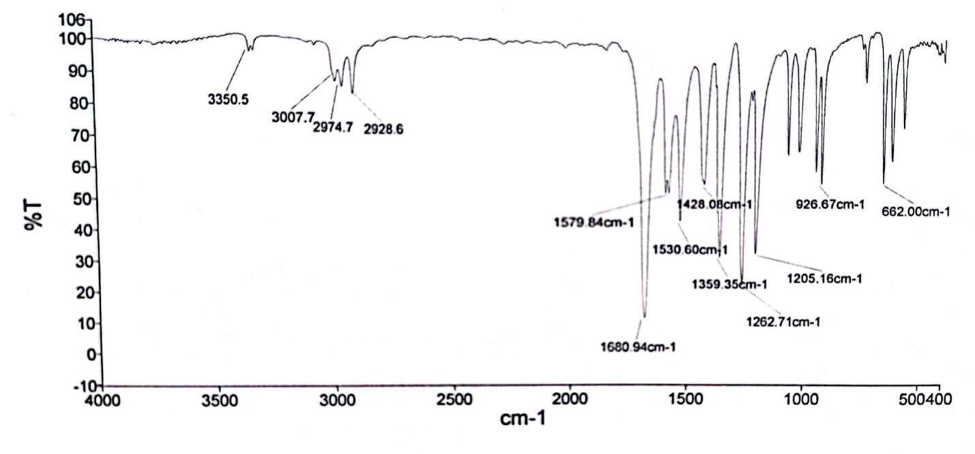

9: FT-IR spectrum of 4-phenyl-1-tosyl-1H-1,2,3-triazole. 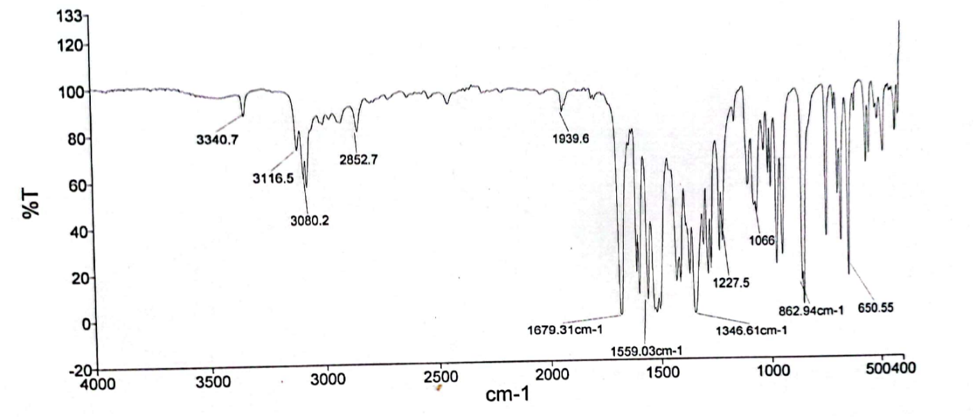

10: ¹H NMR spectrum of 4-phenyl-1-tosyl-1H-1,2,3-triazole.
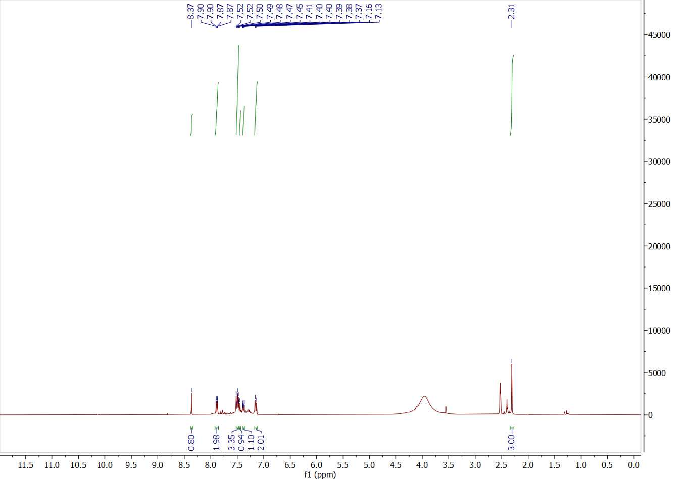

11: ¹³C NMR spectrum of 4-phenyl-1-tosyl-1H-1,2,3-triazole.
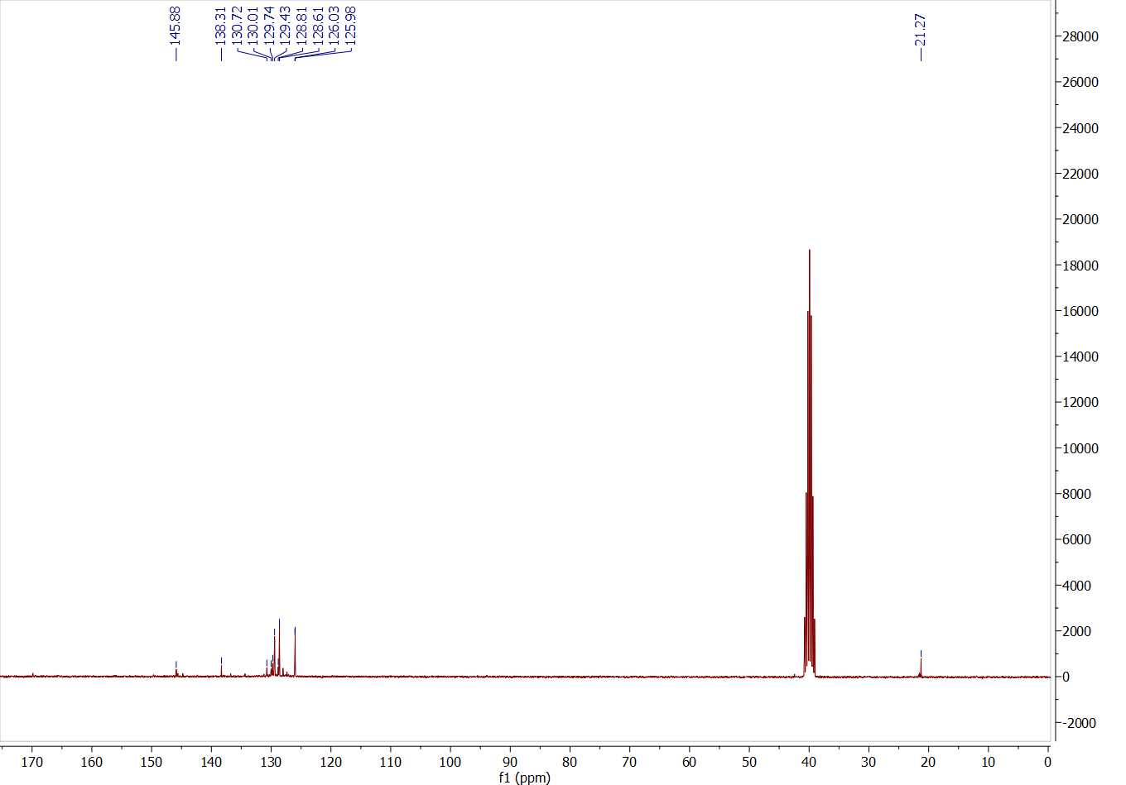

12: FT-IR spectrum of (1-benzyl-1H-1,2,3-triazol-4-yl)methanol.
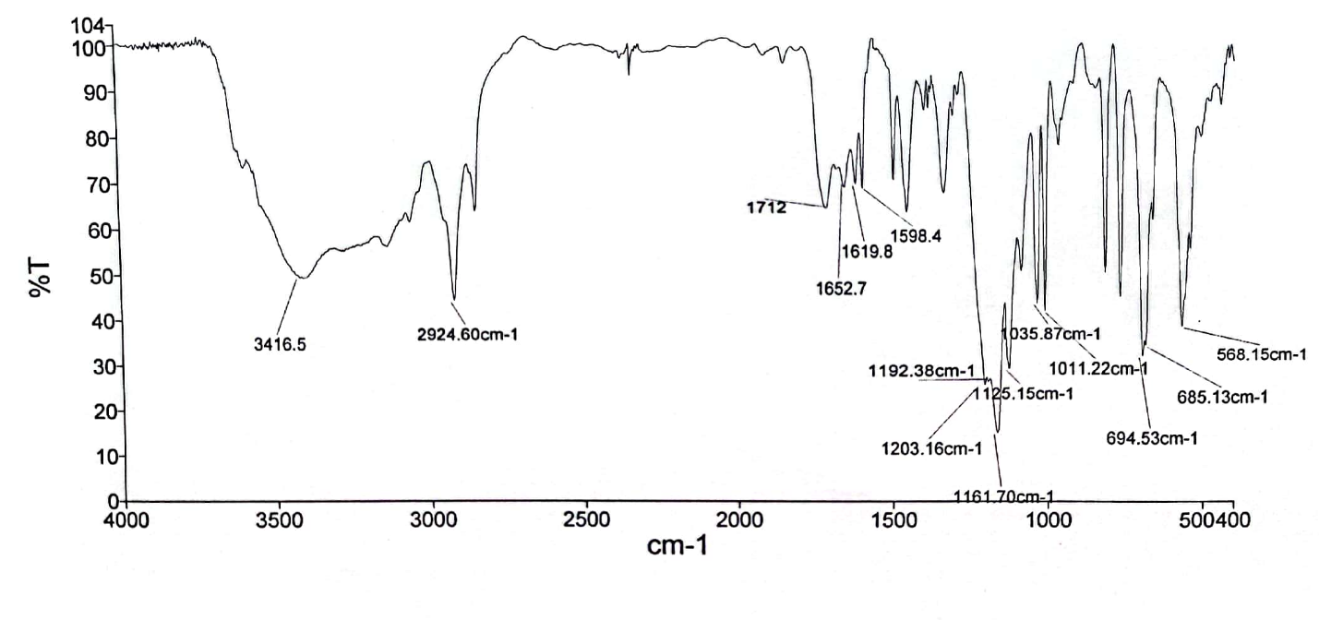

13: ¹H NMR spectrum of (1-benzyl-1H-1,2,3-triazol-4-yl)methanol.
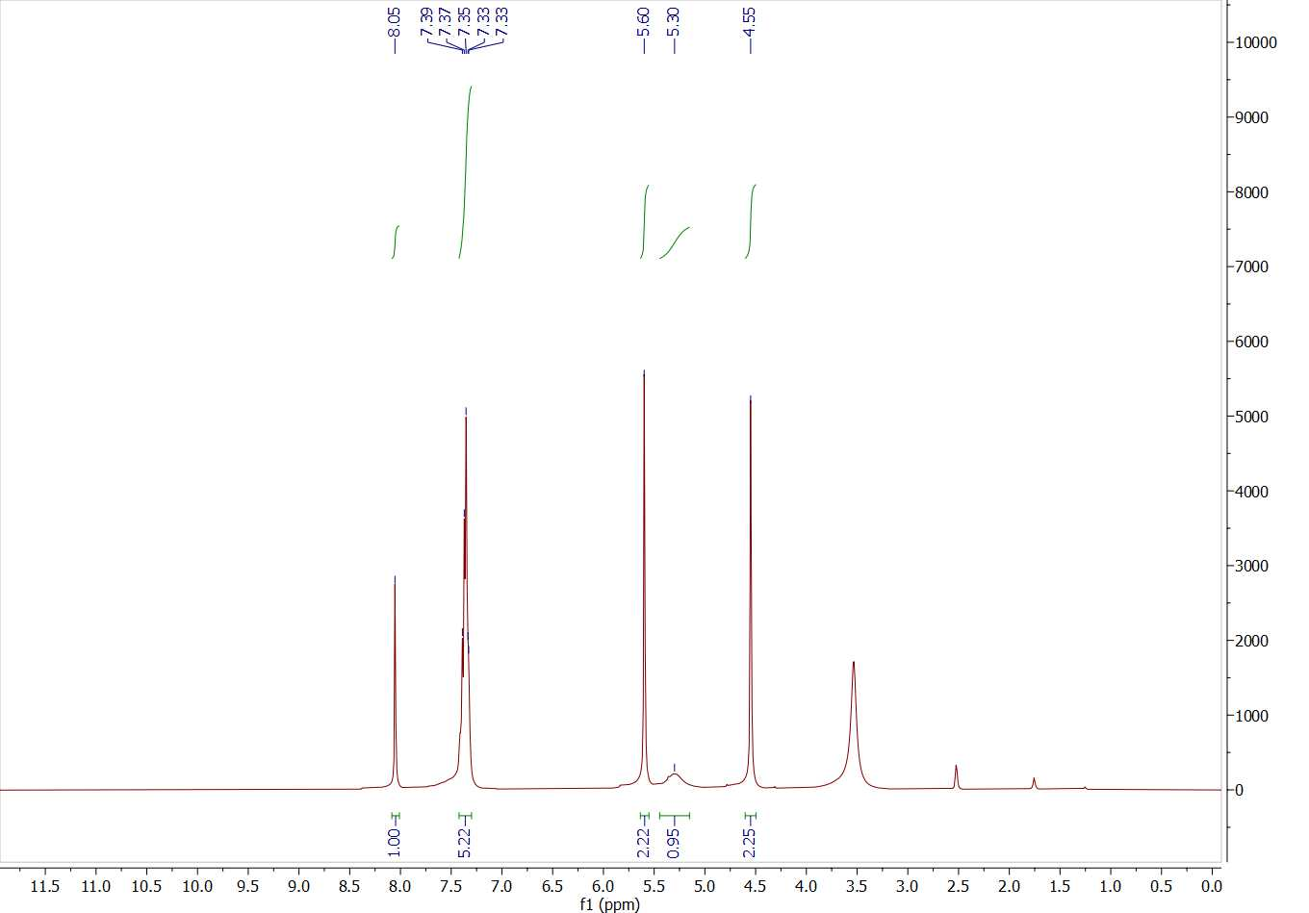
14: ¹³C NMR spectrum of (1-benzyl-1H-1,2,3-triazol-4-yl)methanol.
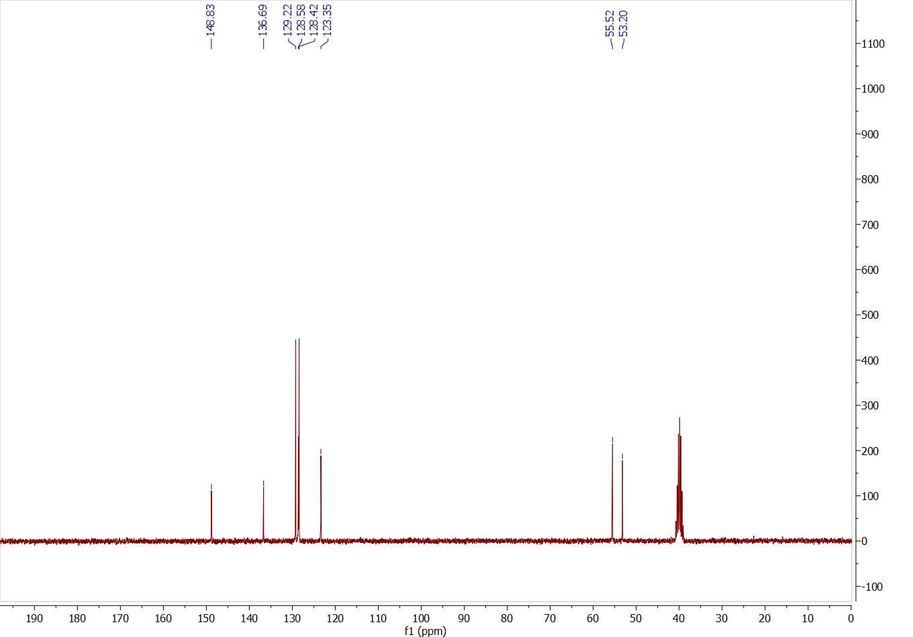

15: FT-IR spectrum of 1-(5-methyl-1-(4-nitrophenyl)-1H-1,2,3-triazol-4-yl)ethan-1-one.
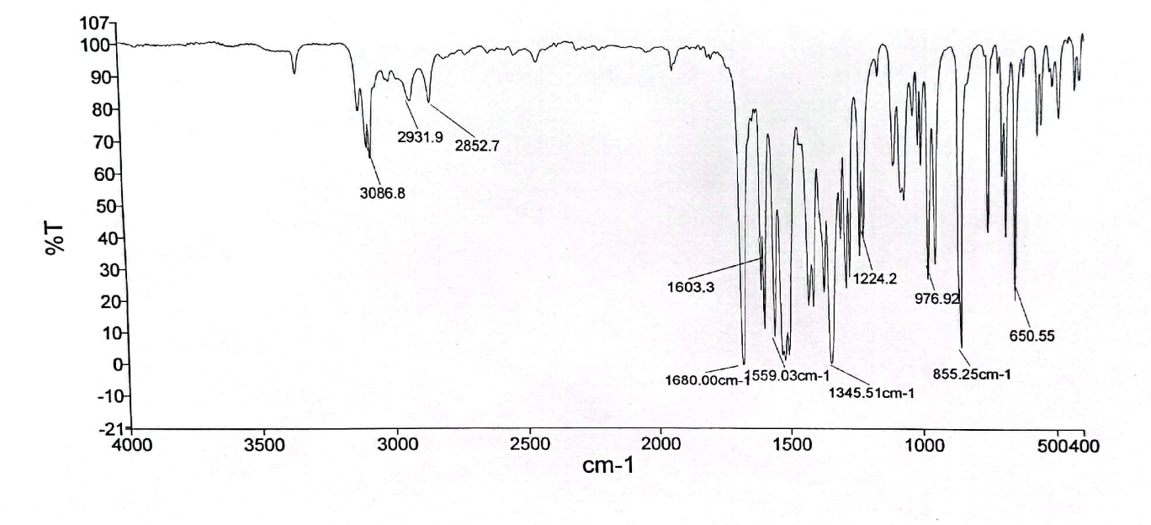

16: ¹H NMR spectrum of 1-(5-methyl-1-(4-nitrophenyl)-1H-1,2,3-triazol-4-yl)ethan-1-one.
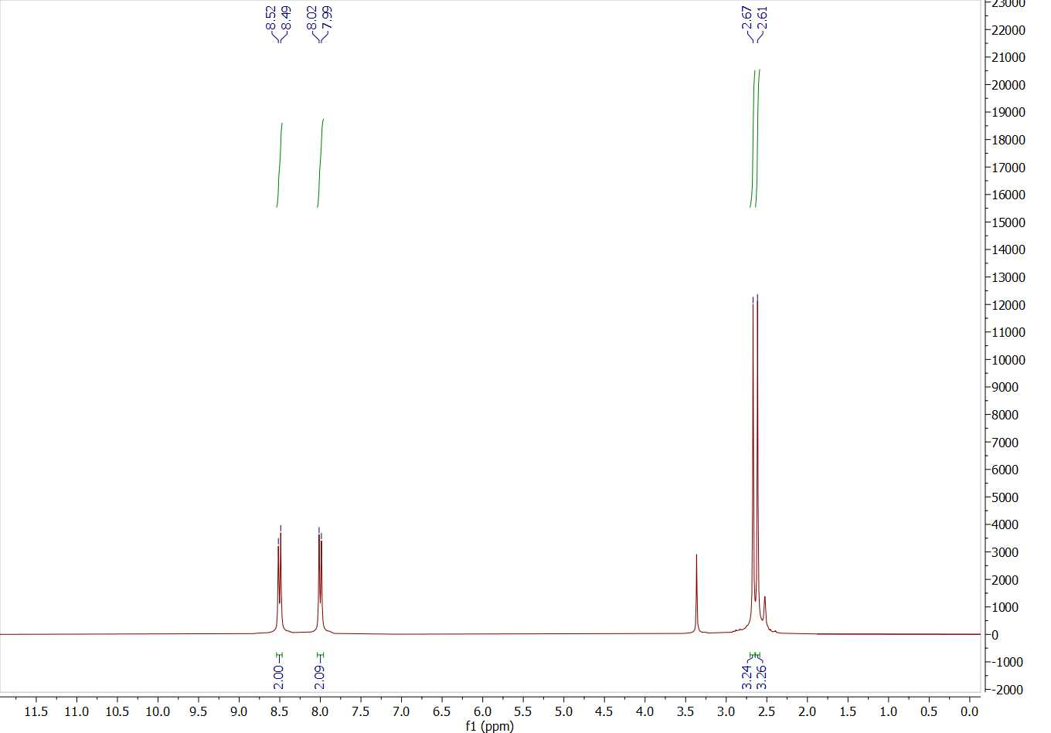

17: ¹³C NMR spectrum of 1-(5-methyl-1-(4-nitrophenyl)-1H-1,2,3-triazol-4-yl)ethan-1-one.
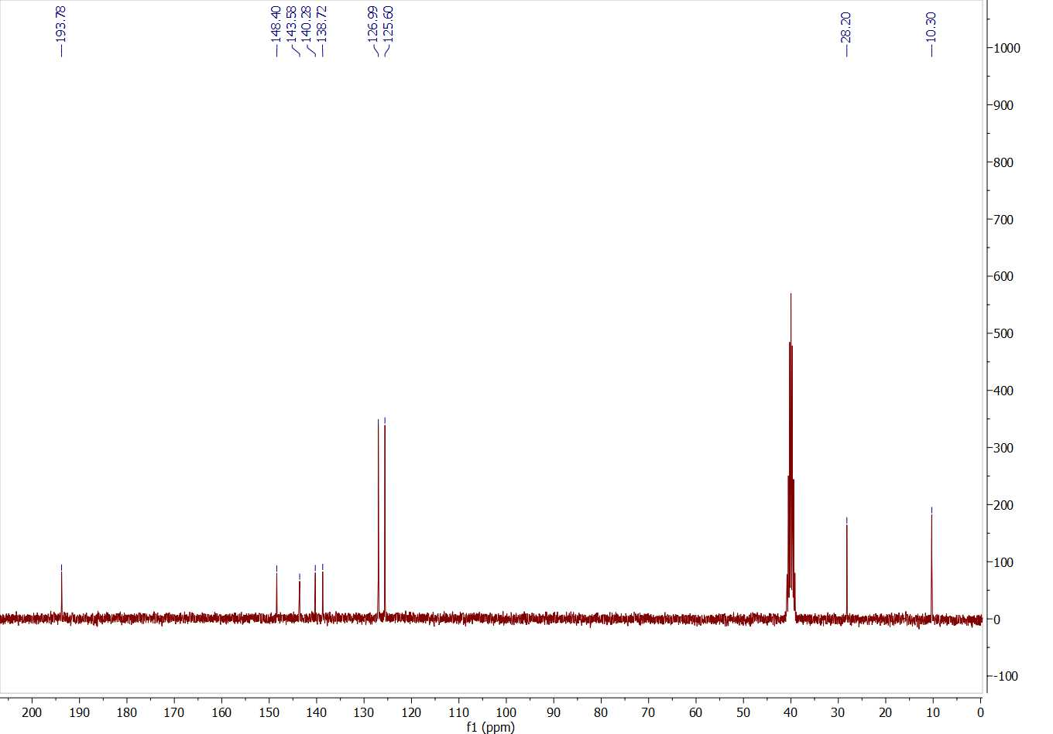

18: FT-IR spectrum of 1-(5-methyl-1-(4-nitrophenyl)-1H-1,2,3-triazol-4-yl)ethan-1-one.
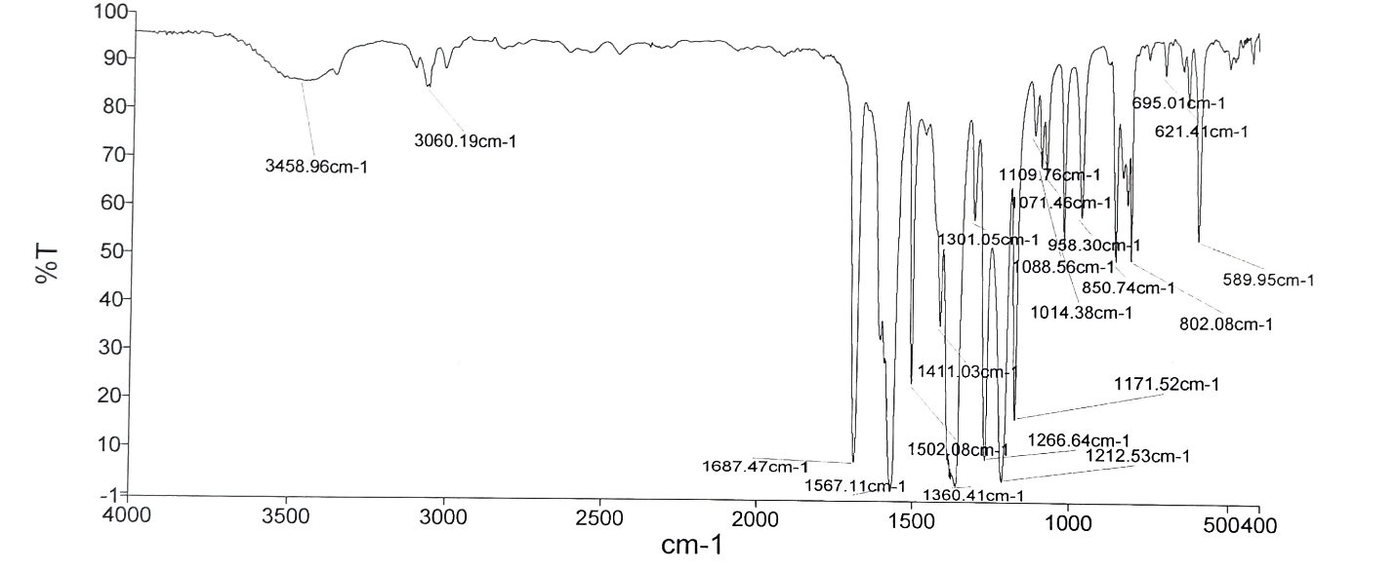

19: FT-IR spectrum of ethyl 5-methyl-1-(4-nitrophenyl)-1H-1,2,3-triazole-4-carboxylate.
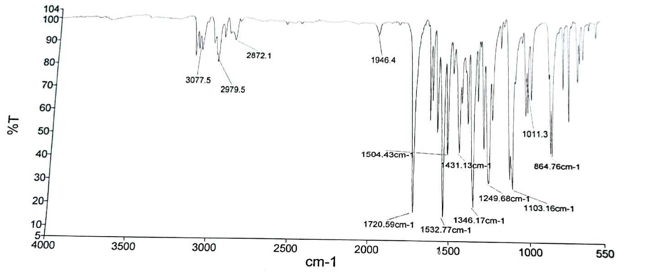
20: ¹H NMR spectrum of 5-methyl-1-(4-nitrophenyl)-1H-1,2,3-triazole-4-carboxylate.
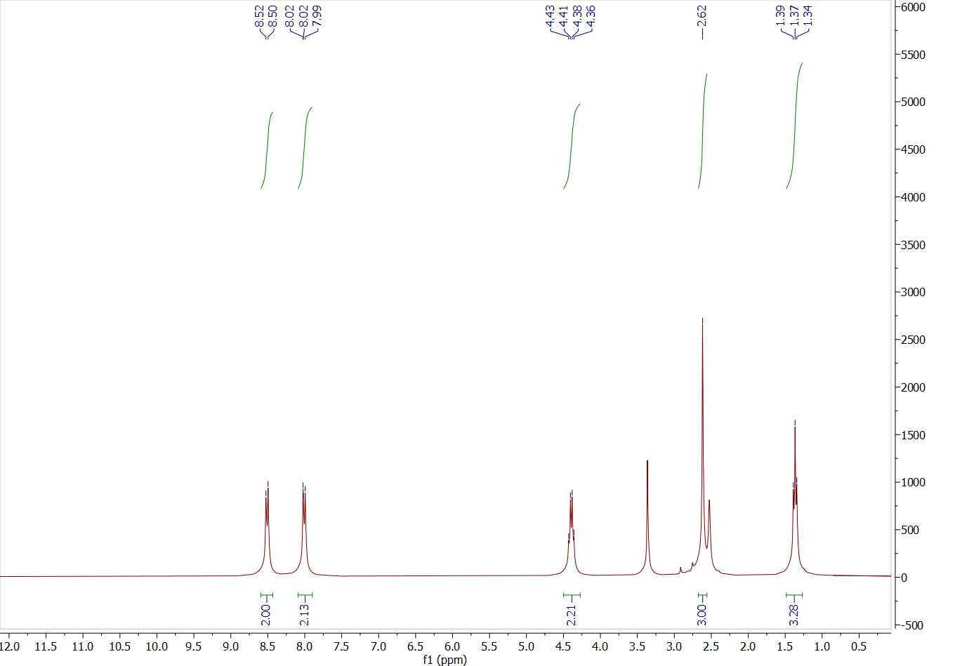

21: ¹³C NMR spectrum of 5-methyl-1-(4-nitrophenyl)-1H-1,2,3-triazole-4-carboxylate.
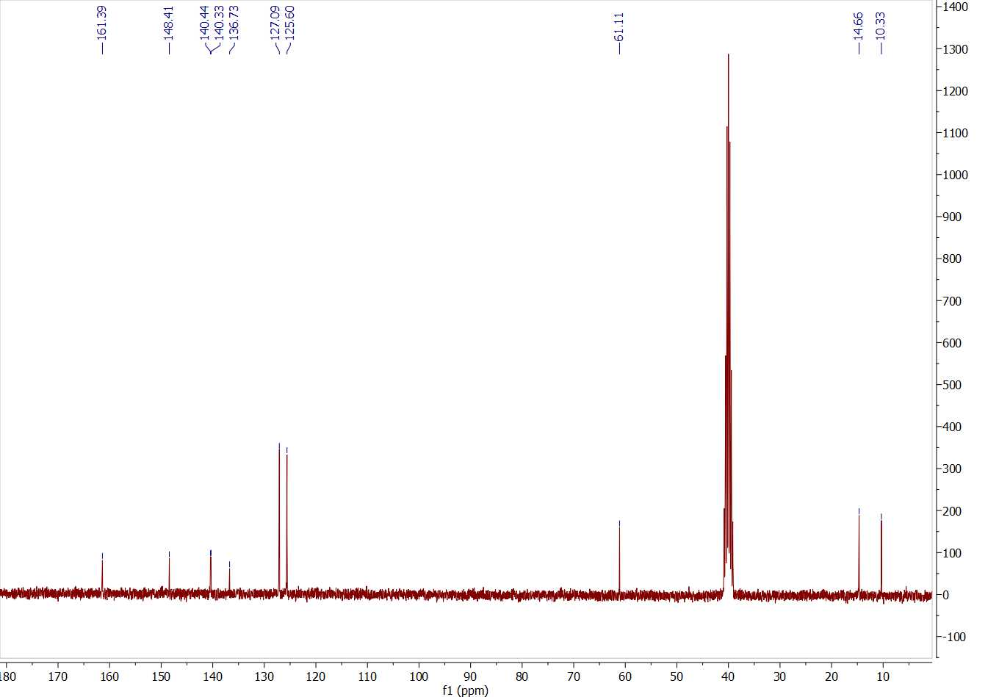
22: FT-IR spectrum of ethyl 5-methyl-1-(4-chlorophenyl)-1H-1,2,3-triazole-4-carboxylate.
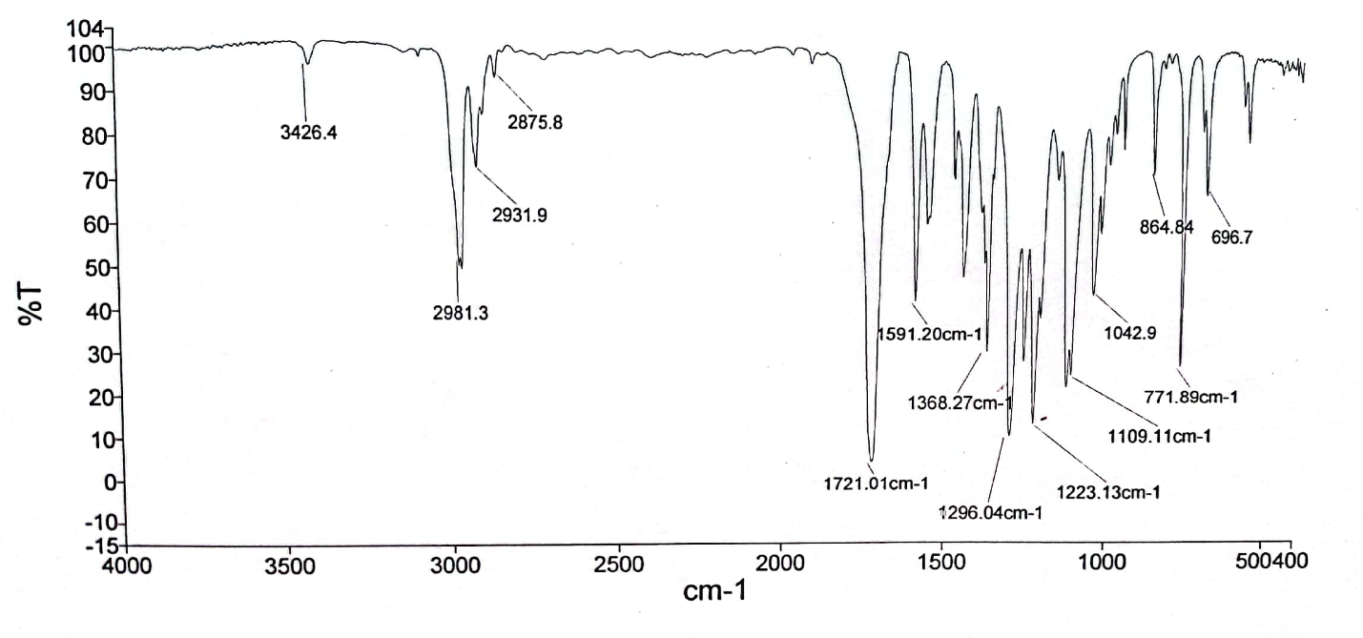

23: FT-IR spectrum of 1-(4-phenyl-1H-1,2,3-triazol-1-yl)propan-2-ol.
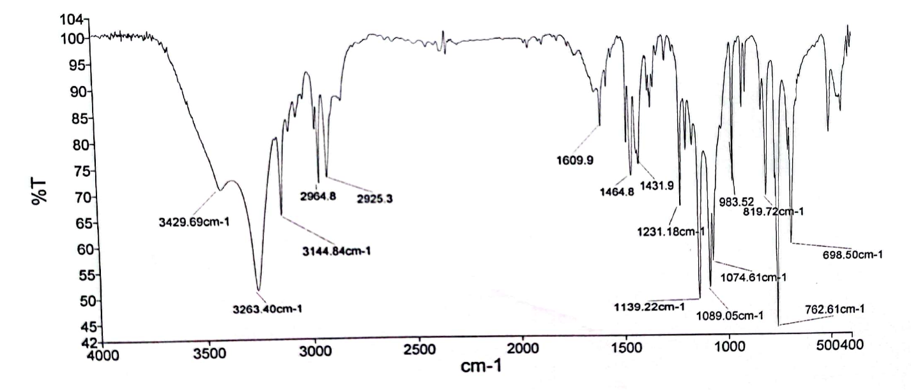
24: ¹H NMR spectrum of 1-(4-phenyl-1H-1,2,3-triazol-1-yl)propan-2-ol.
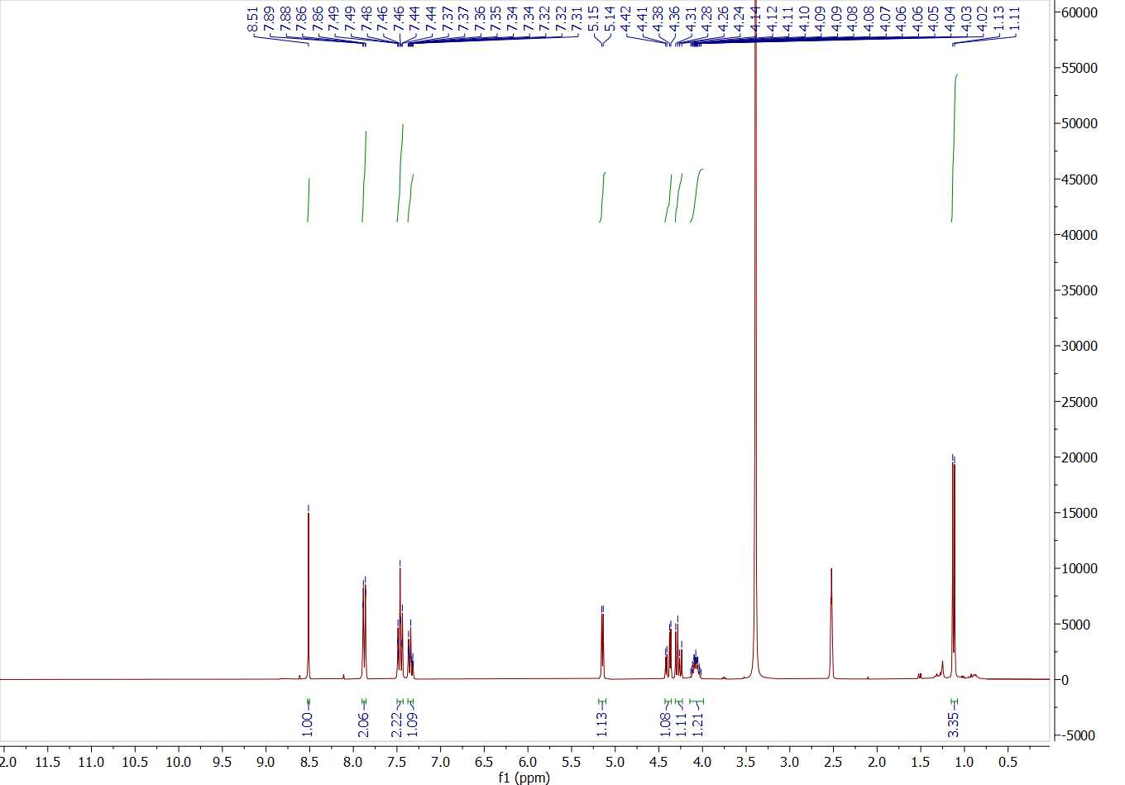

25: ¹³C NMR spectrum of 1-(4-phenyl-1H-1,2,3-triazol-1-yl)propan-2-ol.
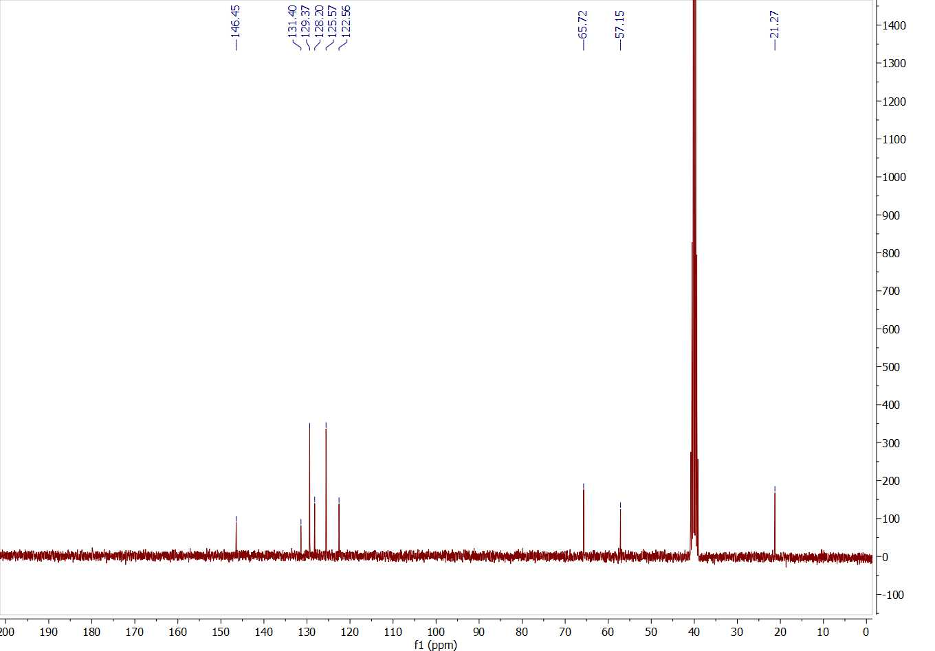
26: FT-IR spectrum of 2-(4-phenyl-1H-1,2,3-triazol-1-yl)pentan-3-ol.
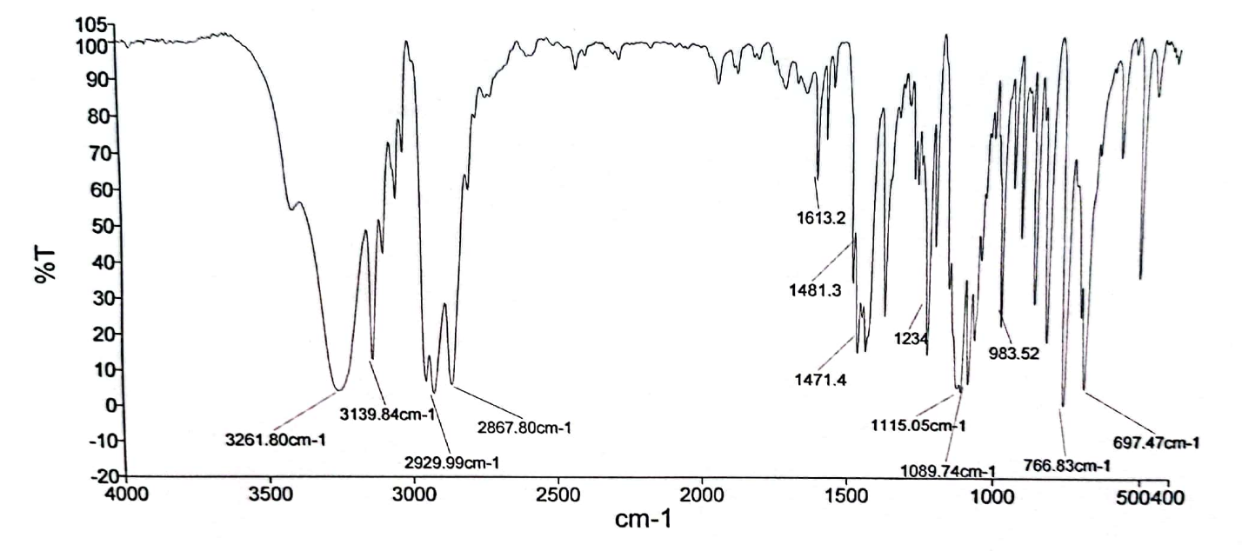

27: ¹H NMR spectrum of 2-(4-phenyl-1H-1,2,3-triazol-1-yl)pentan-3-ol.
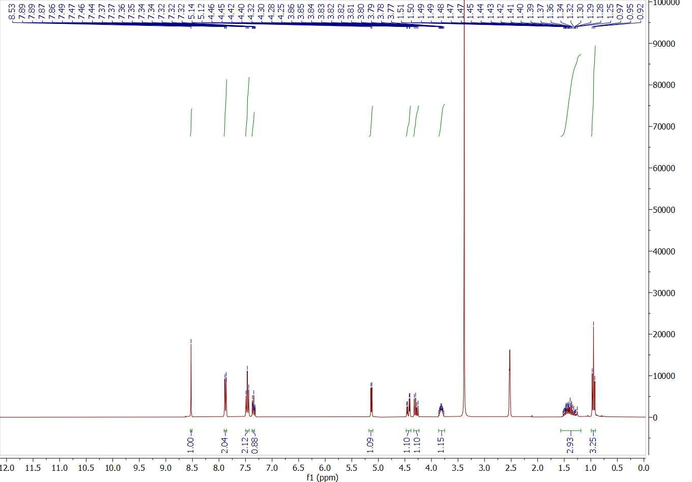
28: ¹³C NMR spectrum of 2-(4-phenyl-1H-1,2,3-triazol-1-yl)pentan-3-ol.
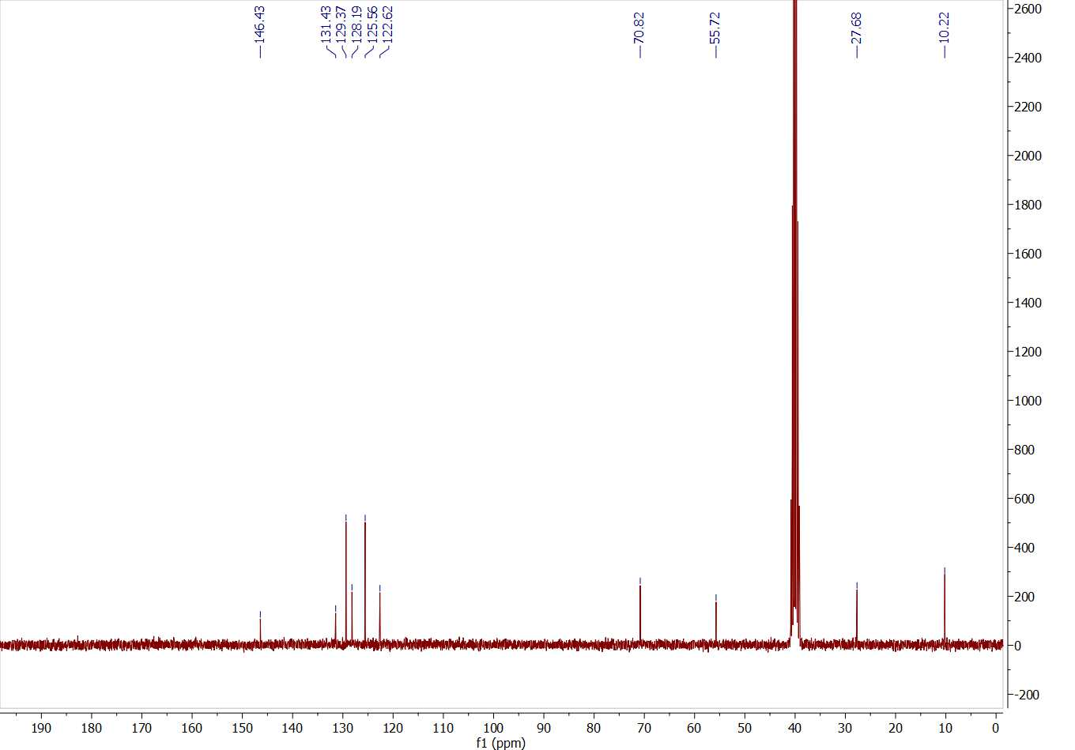

29: FT-IR spectrum of 1-phenyl-2-(4-phenyl-1H-1,2,3-triazol-1-yl)ethan-1-ol.
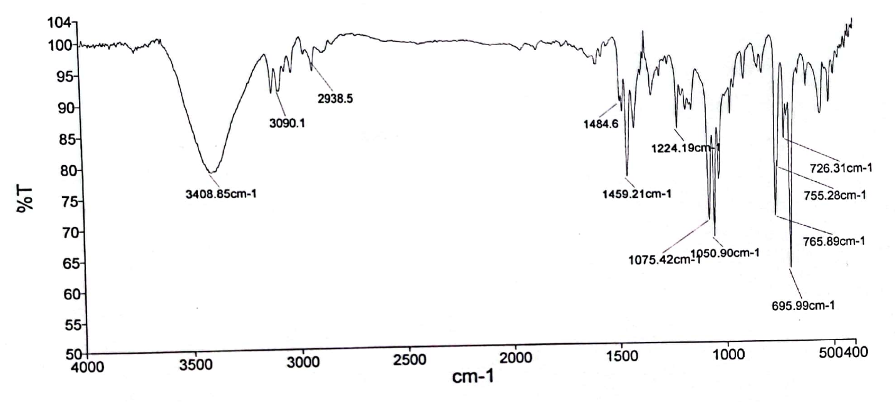
30: ¹H NMR spectrum of 1-phenyl-2-(4-phenyl-1H-1,2,3-triazol-1-yl)ethan-1-ol.
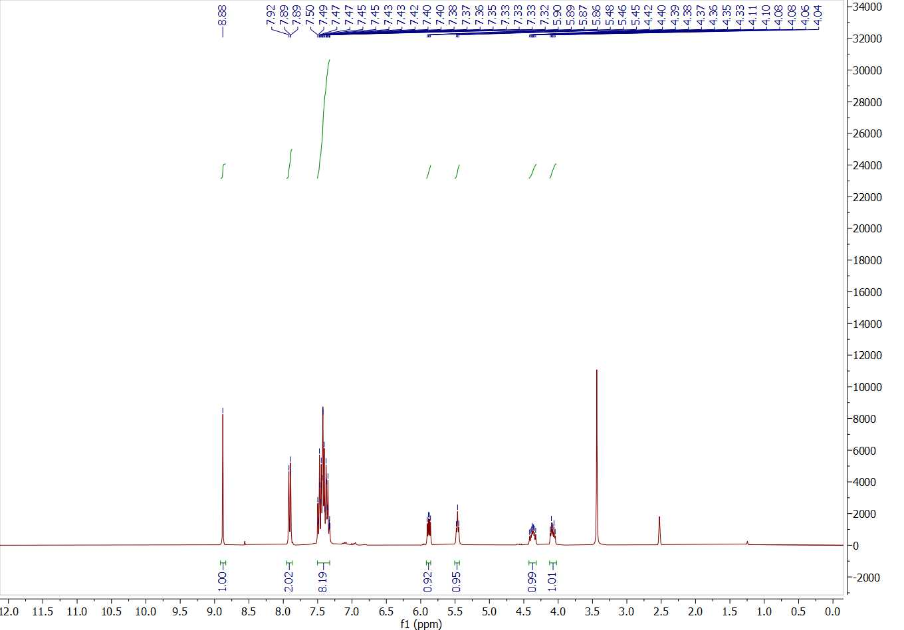

31: ¹³C NMR spectrum of 1-phenyl-2-(4-phenyl-1H-1,2,3-triazol-1-yl)ethan-1-ol.
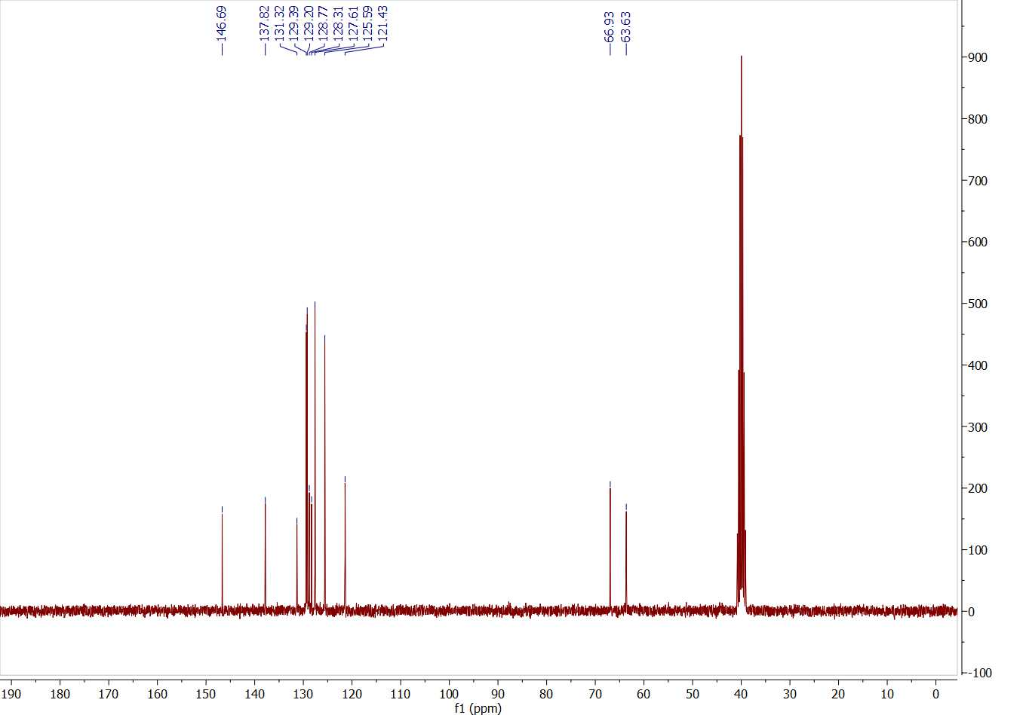
32: FT-IR spectrum of 1-phenoxy-3-(4-phenyl-1H-1,2,3-triazol-1-yl)propan-2-ol.
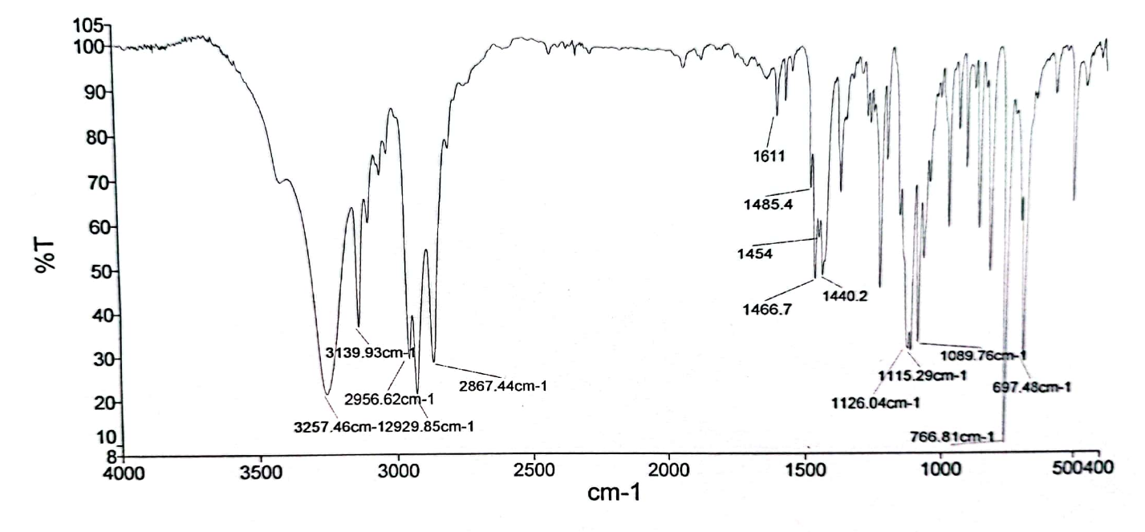

33: ¹H NMR spectrum of 1-phenoxy-3-(4-phenyl-1H-1,2,3-triazol-1-yl)propan-2-ol.
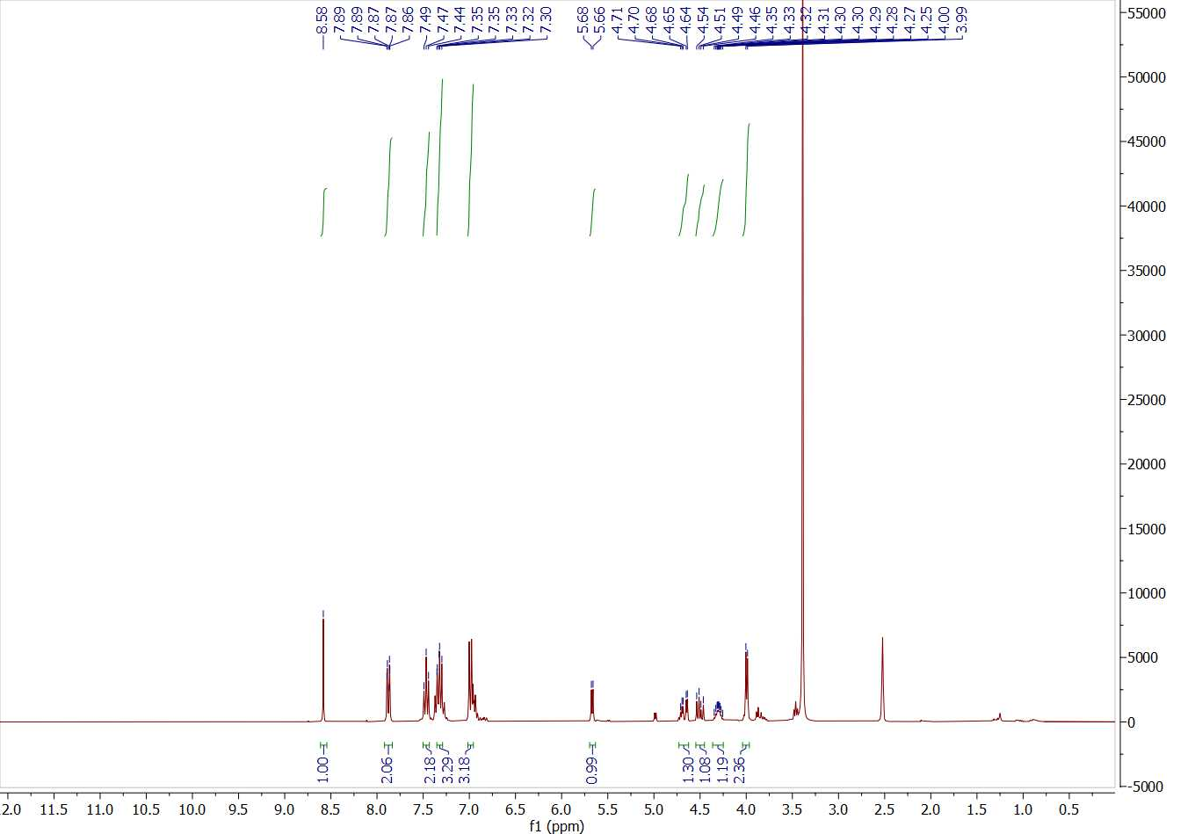
34: ¹³C NMR spectrum of 1-phenoxy-3-(4-phenyl-1H-1,2,3-triazol-1-yl)propan-2-ol.
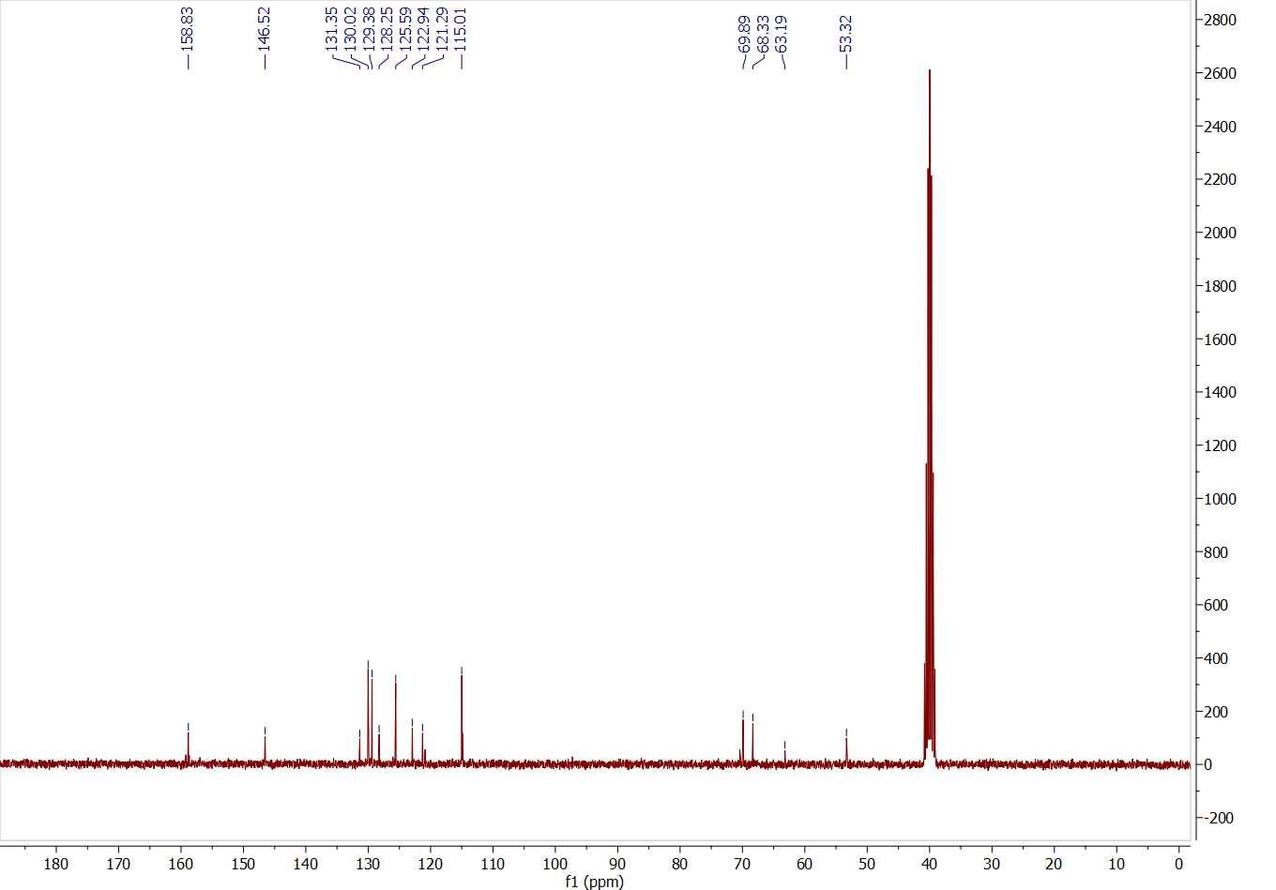

35: FT-IR spectrum of 1-isopropoxy-3-(4-phenyl-1H-1,2,3-triazol-1-yl)propan-2-ol.
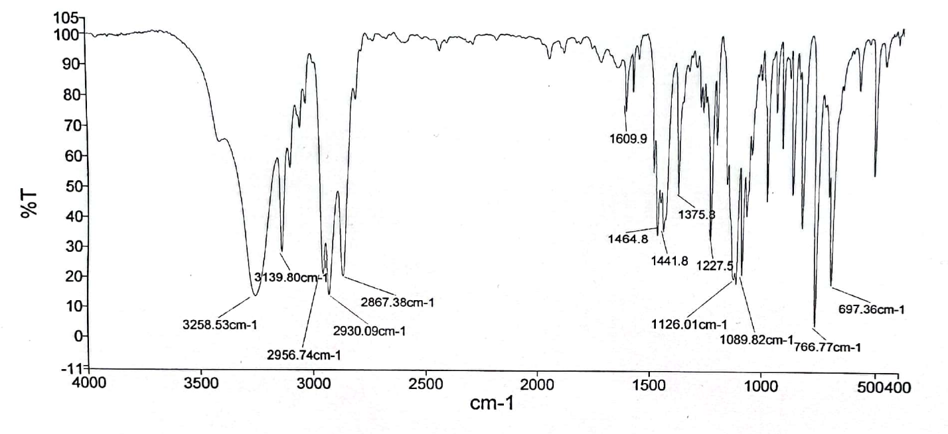
36: ¹H NMR spectrum of 1-isopropoxy-3-(4-phenyl-1H-1,2,3-triazol-1-yl)propan-2-ol.
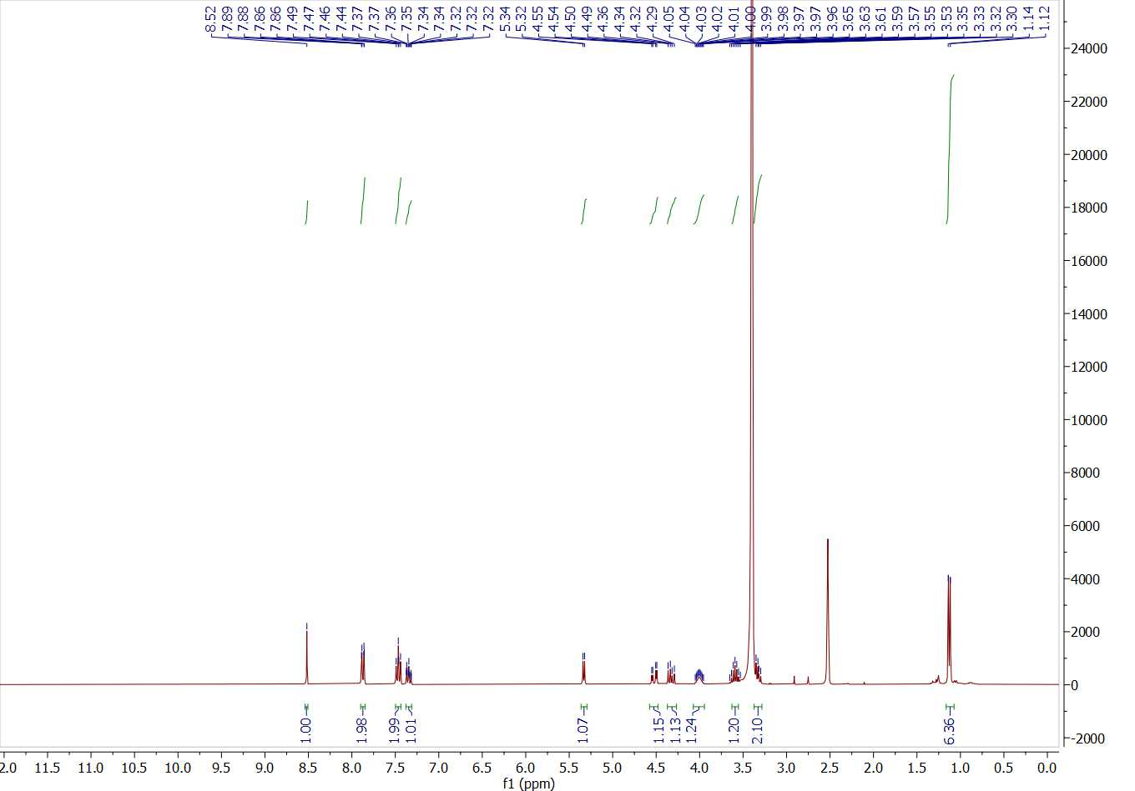

37: ¹³C NMR spectrum of 1-isopropoxy-3-(4-phenyl-1H-1,2,3-triazol-1-yl)propan-2-ol.
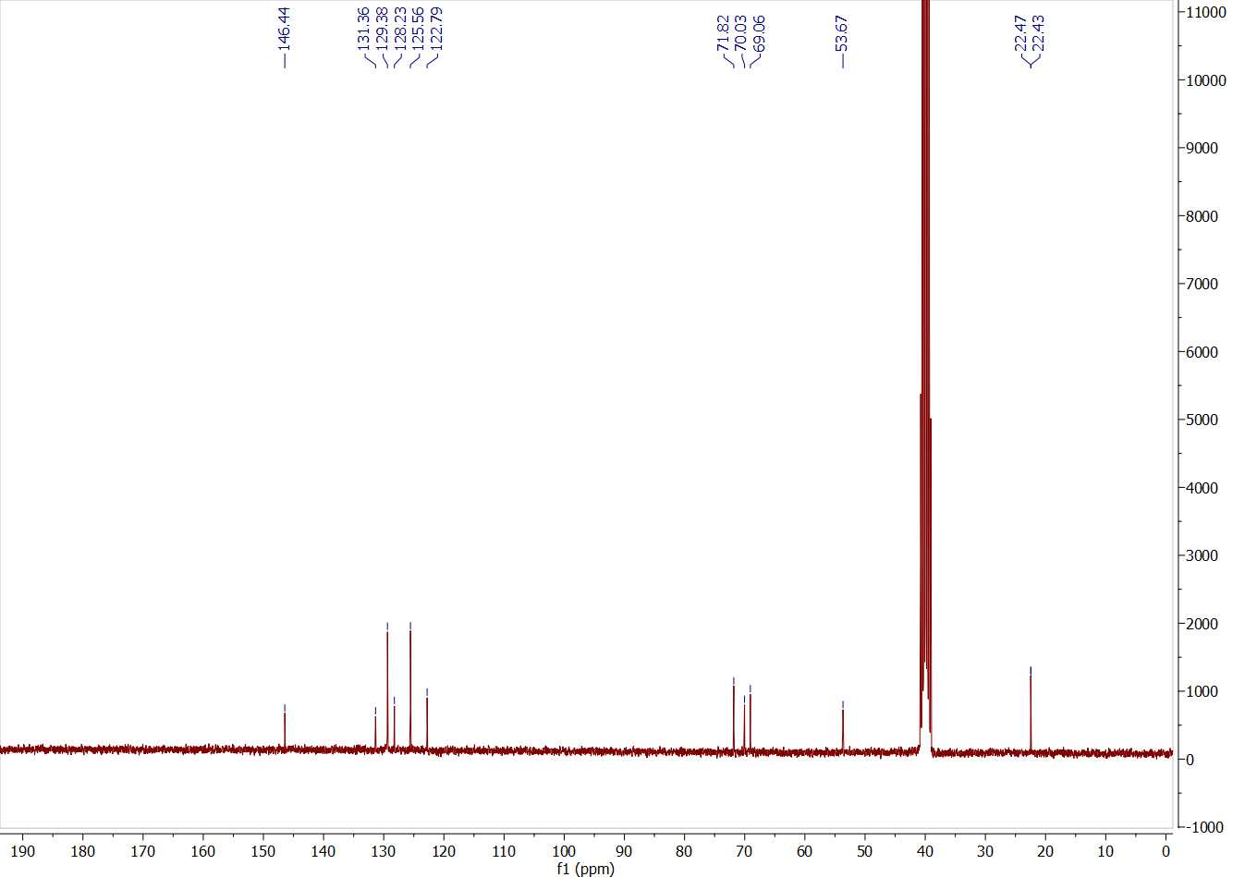
38: FT-IR spectrum of 1-butoxy-3-(4-phenyl-1H-1,2,3-triazol-1-yl)propan-2-ol.
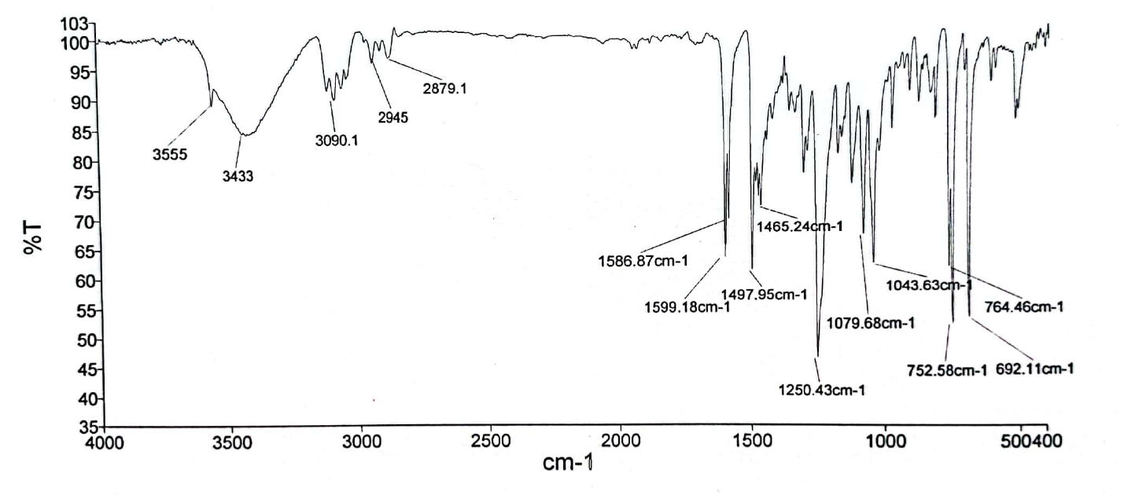

39: ¹H NMR spectrum of 1-butoxy-3-(4-phenyl-1H-1,2,3-triazol-1-yl)propan-2-ol.
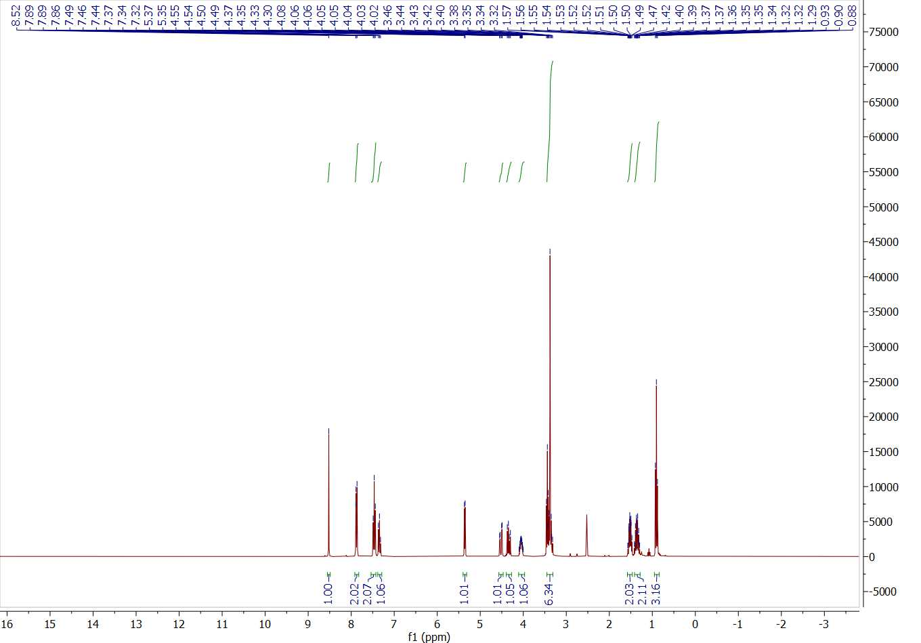
40: ¹³C NMR spectrum of 1-butoxy-3-(4-phenyl-1H-1,2,3-triazol-1-yl)propan-2-ol.
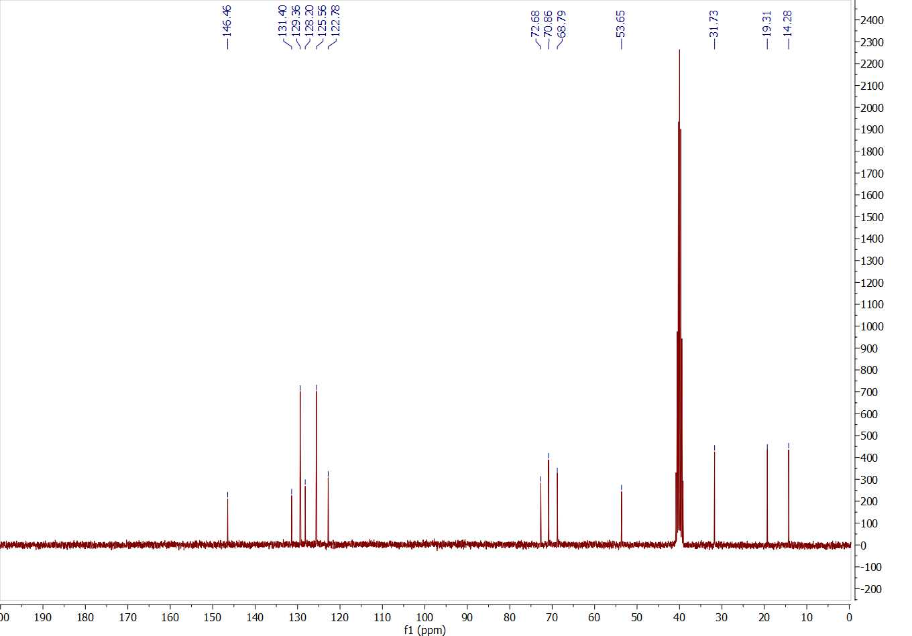
41: FT-IR spectrum of 1-phenyl-2-(4-phenyl-1H-1,2,3-triazol-1-yl)ethan-1-one.
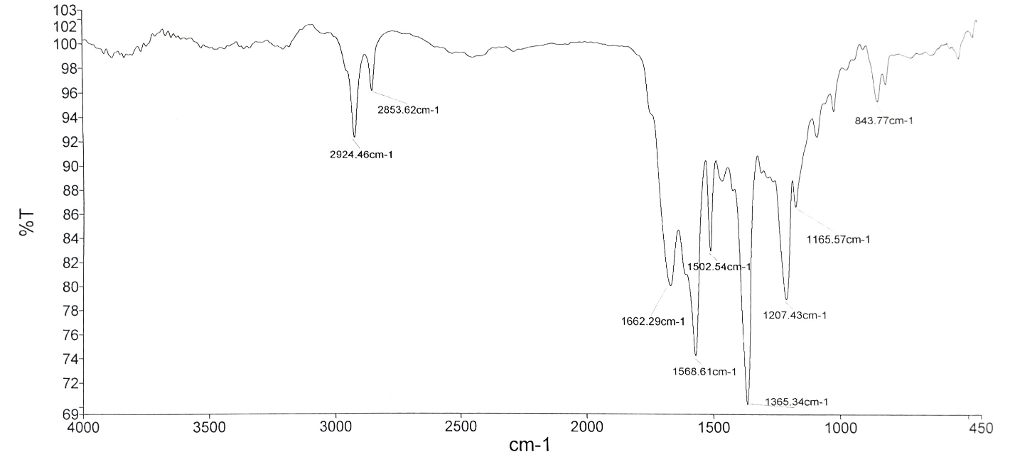
42: FT-IR spectrum of recovered catalyst.
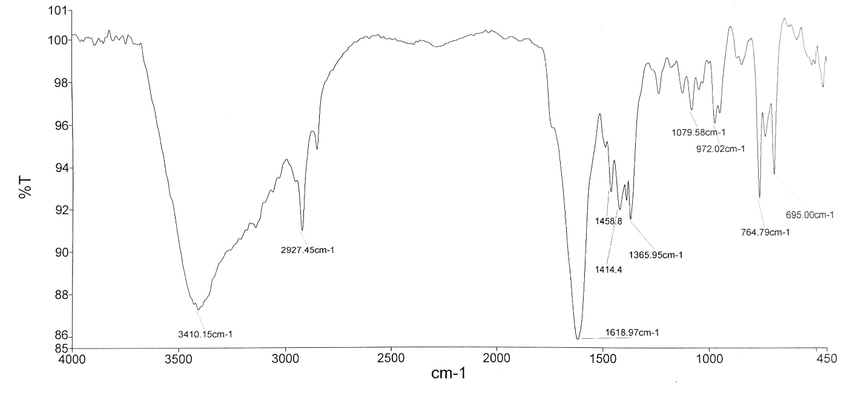
Spectral data
4,4',4''-((1,3,5-Triazine-2,4,6-triyl)tris(oxy))tribenzaldehyde (TFPC)
M.p.= 162-164 °C, FT‐IR (KBr, ν, cm⁻¹): 3068, 2834, 2739, 1704, 1566, 1372, 1211. ¹H NMR (301 MHz, DMSO-d6) δ_{ppm} 10.01 (s, 3H), 7.99 (d, J = 8.6 Hz, 6H, Aromatic), 7.51 (d, J = 8.6 Hz, 6H, Aromatic). ¹³C NMR (76 MHz, DMSO-d6) δ_{ppm} 192.4, 173.2, 156.1, 134.6, 131.6, 122.8.
1-Benzyl-4-phenyl-1H-1,2,3-triazole (1a)
M.p.= 124-127 °C, FT‐IR (KBr, ν, cm⁻¹): 3140, 1608, 1494, 1467, 1222, 1046. ¹H NMR (301 MHz, DMSO-d6) δ_{ppm} ¹H NMR (301 MHz, DMSO) δ 8.67 (s, 1H, Aromatic), 7.88 (d, J = 7.1 Hz, 2H, Aromatic), 7.48–7.31 (m, 8H, Aromatic), 5.68 (s, 2H, CH₂). ¹³C NMR (76 MHz, DMSO-d6) δ_{ppm} 147.2, 136.5, 131.2, 129.4, 129.3, 128.6, 128.4, 125.7, 122.1, 53.5.
4-Phenyl-1-tosyl-1H-1,2,3-triazole (1e)
M.p.= 99-101 °C, FT‐IR (KBr, ν, cm⁻¹): 3116, 3080, 1679, 1559, 1346, 1066, 862. ¹H NMR (301 MHz, DMSO-d6) δ_{ppm} 8.37 (s, 1H, Aromatic), 7.90-7.87 (m, 2H, Aromatic), 7.52-7.47 (m, 3H, Aromatic), 7.45 (s, 1H, Aromatic), 7.40-7.37 (m, 1H, Aromatic), 7.15 (d, J= 7.7 Hz, 2H, Aromatic), 2.31 (s, 3H, CH₃). ¹³C NMR (76 MHz, DMSO-d6) δ_{ppm} 145.9, 138.3, 130.7, 130.0, 129.7, 129.4, 128.8, 128.6, 126.0, 126.0, 21.3.
(1-Benzyl-1H-1,2,3-triazol-4-yl)methanol (1f)
M.p.= 106-109 °C, FT‐IR (KBr, ν, cm⁻¹): 3416, 2924, 1652, 1619, 1116, 1035, 694. ¹H NMR (301 MHz, DMSO-d6) δ_{ppm} 8.05 (s, 1H, Aromatic), 7.36 (m, 5H, Aromatic), 5.60 (s, 2H, CH2), 5.30 (s, 1H, OH), 4.55 (s, 2H, OH). ¹³C NMR (76 MHz, DMSO-d6) δ_{ppm} 148.8, 136.7, 129.2, 128.58, 128.4, 123.4, 55.5, 53.2.
1-(5-Methyl-1-(4-nitrophenyl)-1H-1,2,3-triazol-4-yl)ethan-1-one (1g)
M.p. = 139-141 °C, FT‐IR (KBr, ν, cm⁻¹): 3086, 1680, 1603, 1559, 1345, 855. ¹H NMR (301 MHz, DMSO-d6) δ_{ppm} 8.51 (d, J = 8.7 Hz, 2H, Aromatic), 8.01 (d, J= 8.7 Hz, 2H, Aromatic), 2.67 (s, 3H, CH₃), 2.61 (s, 3H, CH₃). ¹³C NMR (76 MHz, DMSO-d6) δ_{ppm} 193.8, 148.4, 143.6, 140.3, 138.7, 127.0, 125.6, 28.2, 10.3.
Ethyl 5-methyl-1-(4-nitrophenyl)-1H-1,2,3-triazole-4-carboxylate (1i)
M.p.= 122-124 °C, FT‐IR (KBr, ν, cm⁻¹): 3077, 2979, 1720, 1532, 1504, 1346, 1249. ¹H NMR (301 MHz, DMSO-d6) δ_{ppm} 8.51 (d, J= 8.7 Hz, 2H, Aromatic), 8.02–7.99 (d, J= 8.7 Hz, 2H, Aromatic), 4.40 (q, J= 7.1 Hz, 2H, CH₂), 2.62 (s, 3H, CH₃), 1.37 (t, J= 7.1 Hz, 3H, CH₃). ¹³C NMR (76 MHz, DMSO-d6) δ_{ppm} 161.4, 148.4, 140.4, 140.3, 136.7, 127.1, 125.6, 61.1, 14.7, 10.3.
1-(4-Phenyl-1H-1,2,3-triazol-1-yl)propan-2-ol (1k)
M.p. = 111-114 °C, FT‐IR (KBr, ν, cm⁻¹): 3429, 3263, 3144, 1609, 1464, 1231, 1139, 1089. ¹H NMR (301 MHz, DMSO-d6) δ_{ppm} 8.51 (s, 1H, Aromatic), 7.87 (dd, J = 8.3, 1.3 Hz, 2H, Aromatic), 7.49– 7.44 (m, 2H, Aromatic), 7.38–7.31 (m, 1H, Aromatic), 5.14 (d, J= 5.0 Hz, 1H, OH), 4.42-4.36 (m, 1H, CH), 4.31-4.24 (m, 1H, CH), 4.15-3.99 (m, 1H, CH), 1.12 (d, J = 6.2 Hz, 3H, CH₃). ¹³C NMR (76 MHz, DMSO-d6) δ_{ppm} 146.5, 131.4, 129.4, 128.2, 125.6, 122.6, 65.7, 57.2, 21.3.
2-(4-Phenyl-1H-1,2,3-triazol-1-yl)pentan-3-ol (1l)
M.p.= 102-104 °C, FT‐IR (KBr, ν, cm⁻¹): 3261, 3139, 2929, 1613, 1481, 1471, 1115, 766. ¹H NMR (301 MHz, DMSO-d6) δ_{ppm} 8.53 (s, 1H, Aromatic), 7.88 (dd, J = 8.3, 1.3 Hz, 2H, Aromatic), 7.47 (t, J = 7.6 Hz, 2H, Aromatic), 7.38-7.33 (m, 1H, Aromatic), 5.13 (d, J = 5.5 Hz, 1H, OH), 4.43 (dd, J = 13.8, 4.0 Hz, 1H, CH), 4.29 (dd, J = 13.7, 7.5 Hz, 1H, CH), 3.86-3.77 (m, 1H, CH), 1.56 -1.18 (m, 3H), 0.95 (t, J = 7.4 Hz, 3H, CH₃). ¹³C NMR (76 MHz, DMSO-d6) δ_{ppm} 146.4, 131.4, 129.4, 128.2, 125.6, 122.6, 70.8, 55.7, 27.7, 10.2.
1-Phenyl-2-(4-phenyl-1H-1,2,3-triazol-1-yl)ethan-1-ol (1m)
M.p.= 105-107 °C, FT‐IR (KBr, ν, cm⁻¹): 3408, 3090, 1484, 1459, 1075, 1050, 695. ¹H NMR (301 MHz, DMSO-d6) δ_{ppm} 8.88 (s, 1H, Aromatic), 7.1 (d, J = 9 Hz, 2H, Aromatic), 7.50–7.32 (m, 8H, Aromatic), 5.88 (dd, J = 9.2, 4.8 Hz, 1H), 5.46 (t, J = 5.4 Hz, 1H), 4.37 (ddd, J = 11.6, 9.3, 5.9 Hz, 1H, CH), 4.08 (dt, J = 11.6, 4.9 Hz, 1H, CH). ¹³C NMR (76 MHz, DMSO-d6) δ_{ppm} 146.7, 137.8, 131.3, 129.4, 129.2, 128.8, 128.3, 127.6, 125.6, 121.4, 66.9, 63.6.
1-Phenoxy-3-(4-phenyl-1H-1,2,3-triazol-1-yl)propan-2-ol (1n)
M.p.= 124-126 °C, FT‐IR (KBr, ν, cm⁻¹): 3257, 3139, 2929, 1485, 1466, 1440, 1126, 766. ¹H NMR (301 MHz, DMSO-d6) δ_{ppm} 8.58 (s, 1H, Aromatic), 7.89-7.86 (m, 2H, Aromatic), 7.47 (t, J= 7.5 Hz, 2H, Aromatic), 7.35-7.30 (m, 3H, Aromatic), 7.02-6.96 (m, 3H, Aromatic), 5.67 (d, J=5.5 Hz, 1H, OH), 4.71-4.64 (m, 1H, CH), 4.54-4.46 (m, 1H, CH), 4.35- 4.25 (m, 1H, CH), 3.99 (d, J = 5.4 Hz, 2H, CH₃). ¹³C NMR (76 MHz, DMSO-d6) δ_{ppm} 158.8, 146.5, 131.4, 130.0, 129.4, 128.3, 125.6, 122.9, 121.3, 115.0, 69.9, 68.3, 63.2, 53.3.
1-Isopropoxy-3-(4-phenyl-1H-1,2,3-triazol-1-yl)propan-2-ol (1o)
M.p.= 75-76 °C, FT‐IR (KBr, ν, cm⁻¹): 3258, 3139, 2930, 1609, 1464, 1441, 1126, 766. ¹H NMR (301 MHz, DMSO-d6) δ_{ppm} 8.52 (s, 1H, Aromatic), 7.87 (d, J = 6 Hz, 3, 2H, Aromatic), 7.47 (t, J = 7.5 Hz, 2H, Aromatic), 7.34 (dt, J= 6 Hz, 1.5, 1H, Aromatic), 5.33 (d, J = 5.5 Hz, 1H, OH), 4.52 (dd, J = 13.8, 3.7 Hz, 1H, CH), 4.33 (dd, J = 13.8, 7.9 Hz, 1H, CH), 4.05-3.96 (m, 1H, CH), 3.65-3.53 (sextet, J = 6 Hz, 1H, CH), 3.35-3.30 (m, 2H, CH), 1.13 (d, J = 7.4 Hz, 6H, CH₃). ¹³C NMR (76 MHz, DMSO-d6) δ_{ppm} 146.4, 131.4, 129.4, 128.2, 125.6, 122.8, 71.8, 70.0, 69.1, 53.7, 22.5, 22.44.
1-Butoxy-3-(4-phenyl-1H-1,2,3-triazol-1-yl)propan-2-ol (1p)
M.p.= 64-66 °C, FT‐IR (KBr, ν, cm-1): 3433, 3090, 1599, 1497, 1250, 1043. ¹H NMR (301 MHz, DMSO-d6) δ_{ppm} 8.52 (s, 1H, Aromatic), 7.89-7.86 (m, 2H, Aromatic), 7.46 (t, J = 7.5 Hz, 2H, Aromatic), 7.34 (t, J = 7.3 Hz, 1H, Aromatic), 5.36 (d, J = 5.5 Hz, 1H, OH), 4.52 (dd, J = 13.8, 3.7 Hz, 1H, CH), 4.34 (dd, J = 13.8, 7.8 Hz, 1H, CH), 4.10-4.0 (m, 1H, CH), 3.46–3.32 (m, 6H), 1.57–1.46 (m, 2H, CH₂), 1.42-1.29 (m, 2H, CH₂), 0.90 (t, J = 7.3 Hz, 3H, CH₃). ¹³C NMR (76 MHz, DMSO-d6) δ_{ppm} 146.5, 131.4, 129.4, 128.2, 125.6, 122.8, 72.7, 70.9, 68.8, 53.7, 31.7, 19.3, 14.3.

