Appendix. (Supporting information file)

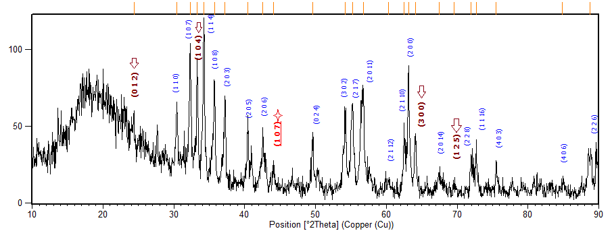

(b)

b

(a)

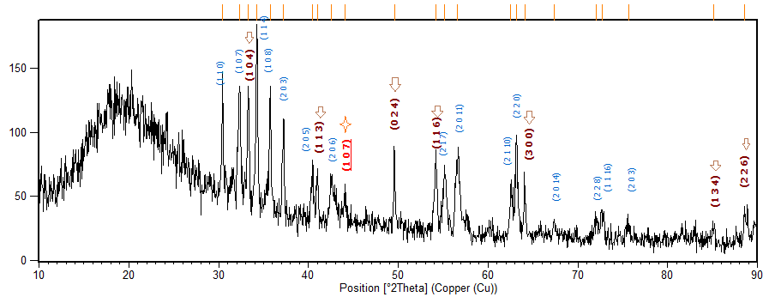

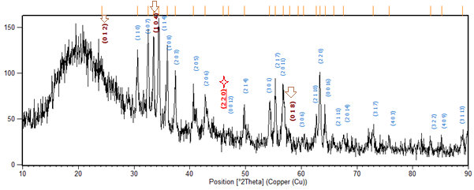

(c)

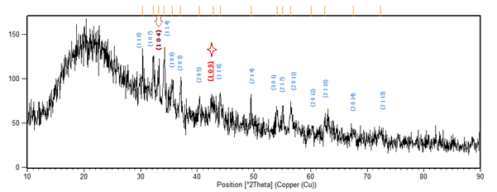

(d)

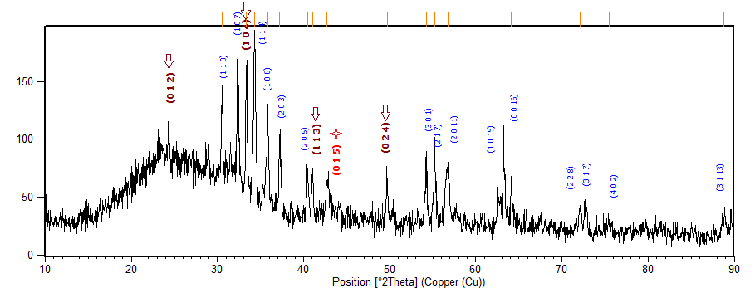

(e)

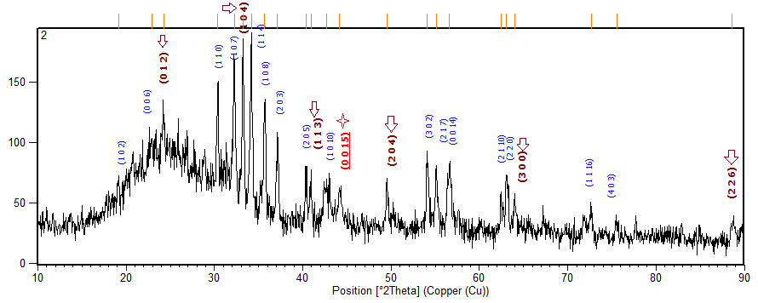

(f)

Fig. S1. XRD patterns of all samples including a) GO/2BF, b) 2GO/3BF, c) GO/BF, d) 3GO/2BF, e) 2GO/BF, f) 3GO/BF



Fig.S2. FTIR of GO nanosheets, barium ferrite (BF) nanoparticles and GO/BF aerogels with different percentages of BF nanoparticles