**Supplementary Files**

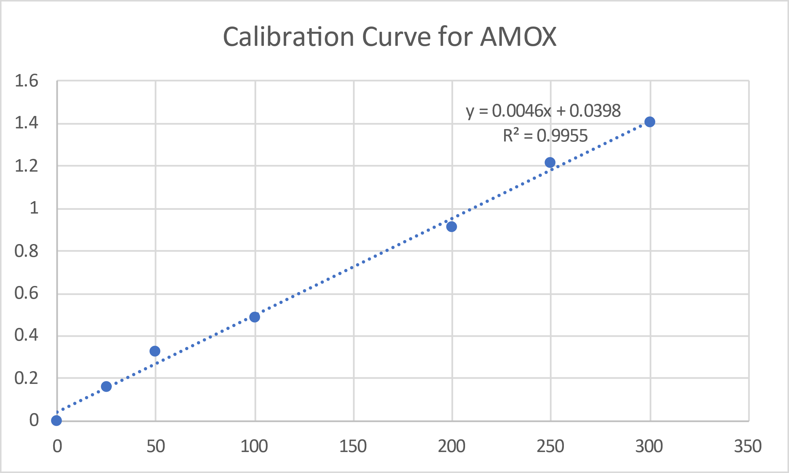

Supplementary material 1: Calibration curve for AMOX