Supplementary Material for Publication

Synthesis, physicochemical property, and antibacterial activity of novel nonionic 1-alkylaminoglycerol Gemini surfactants

Ruifeng Liaoa,b, Liangliang Shia,b, Yi Zhoua,b, Chenyue Jiaa,b, Jiangtao Fenga,b, Weinong Zhanga,b,c, Junbo Hea,b,c*

a Key Laboratory for Deep Processing of Major Grain and Oil, Ministry of Education, College of Food Science & Engineering, Wuhan Polytechnic University, Wuhan 430023, China

b Hubei Key Laboratory for Processing and Transformation of Agricultural Products, Wuhan Polytechnic University, Wuhan 430023, China

c Engineering Research Center of Lipid-based Fine Chemicals of Hubei Province, Wuhan 430023, China

Email addresses: [junb112he@whpu.edu.cn](mailto:junb112he@whpu.edu.cn) (J. He)

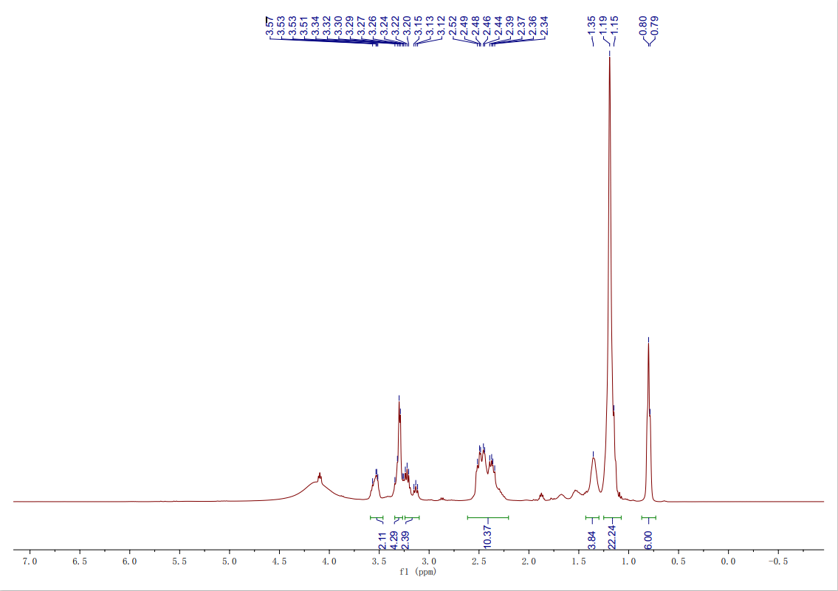

**Figure S1**. The 1H NMR spectra of Gemini surfactant **8-3-8**.

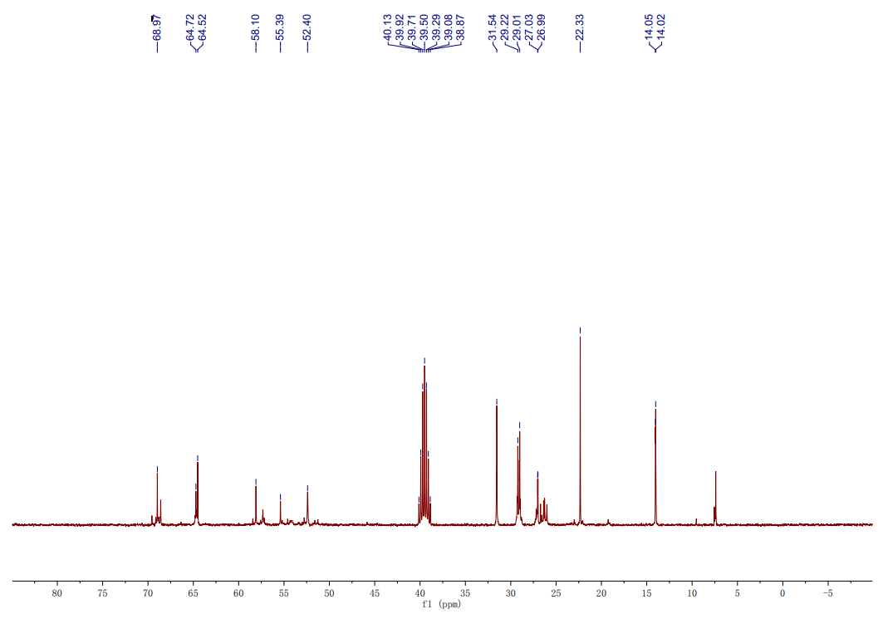

**Figure S2**. The 13C NMR spectra of Gemini surfactant **8-3-8**.

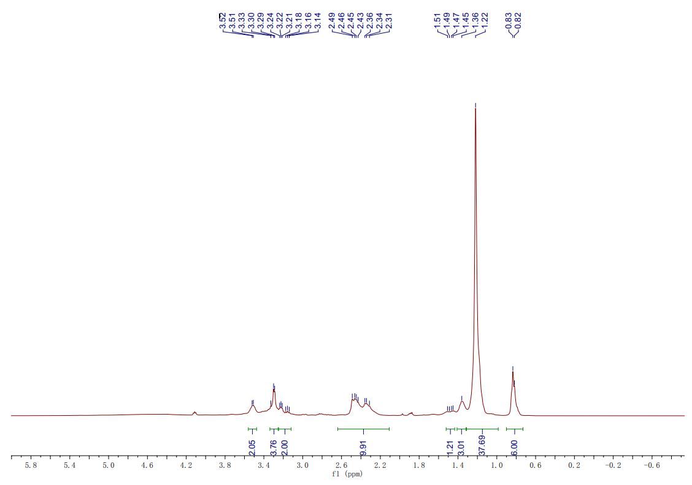

**Figure S3**. The 1H NMR spectra of Gemini surfactant **12-3-12**.

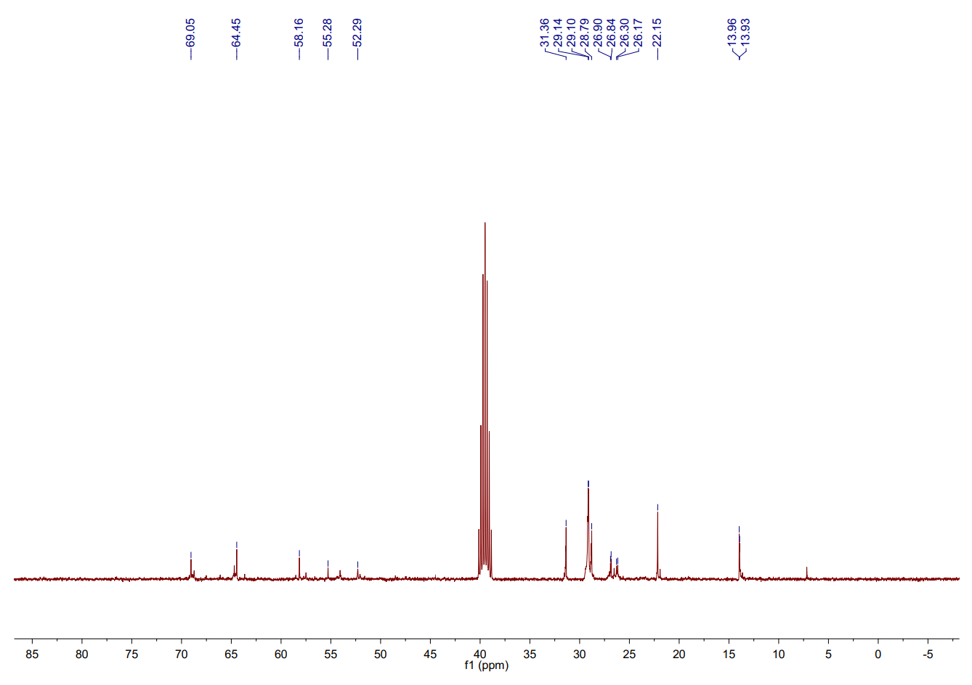

**Figure S4**. The 13C NMR spectra of Gemini surfactant **12-3-12**.

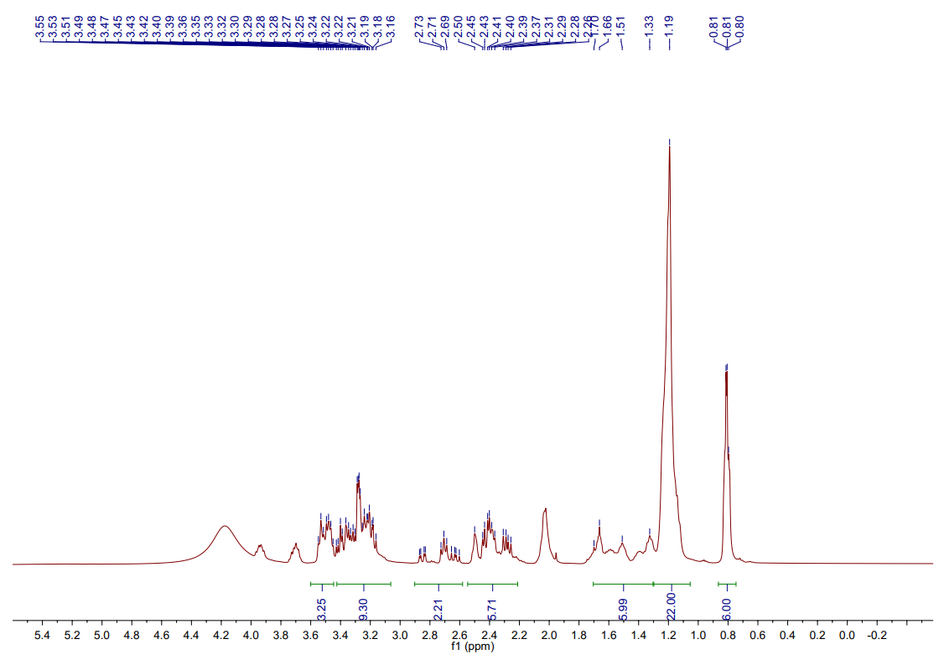

**Figure S5**. The 1H NMR spectra of Gemini surfactant **8-4-8**.

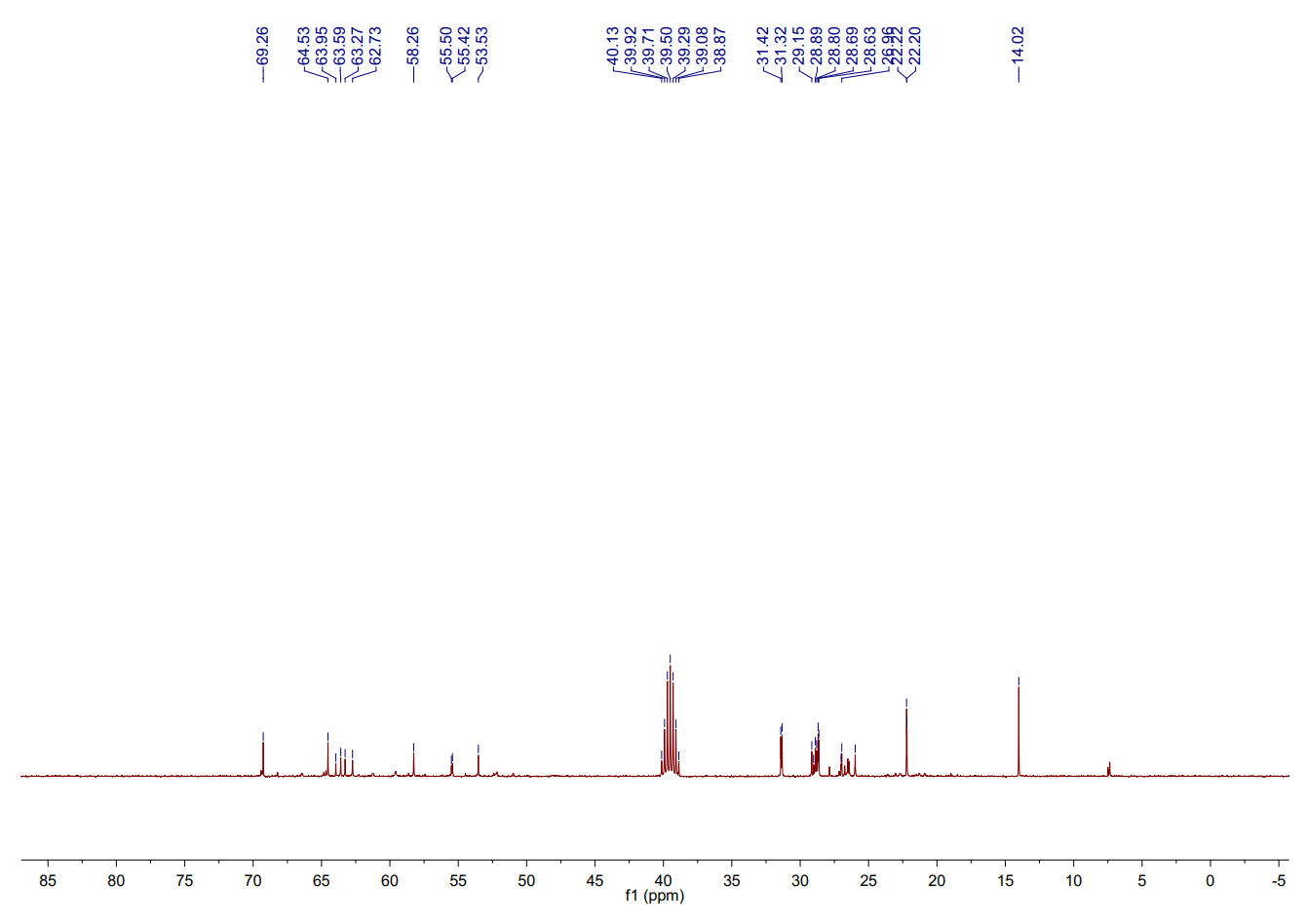

**Figure S6**. The 13C NMR spectra of Gemini surfactant **8-4-8**.

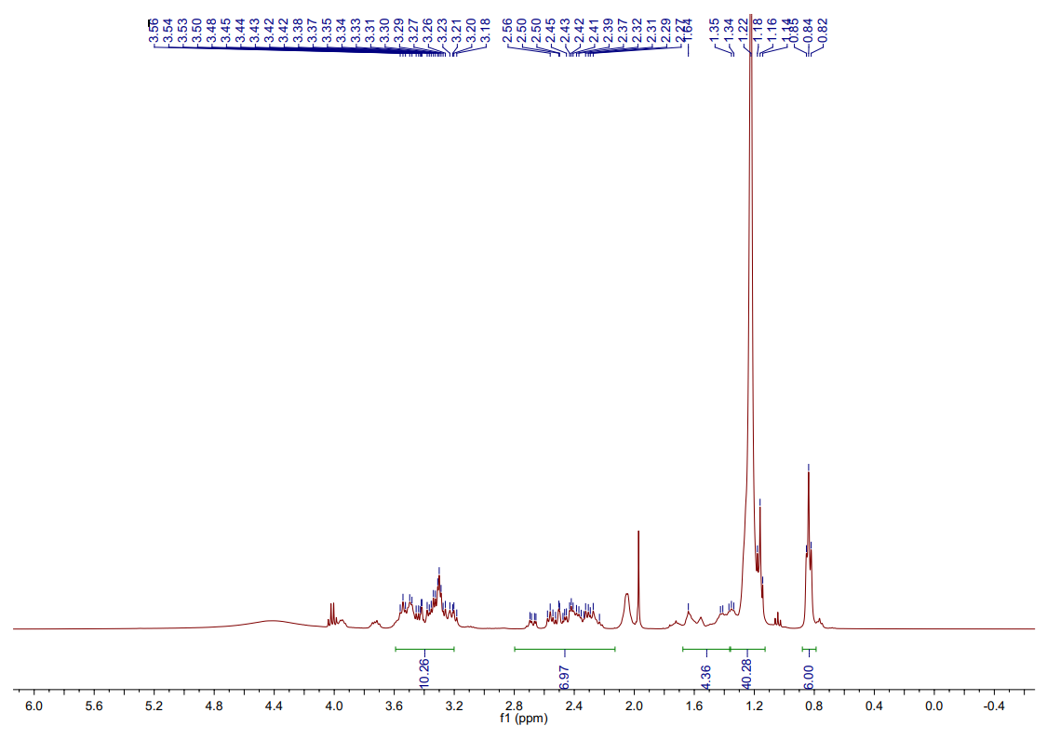

**Figure S7**. The 1H NMR spectra of Gemini surfactant **12-4-12**.

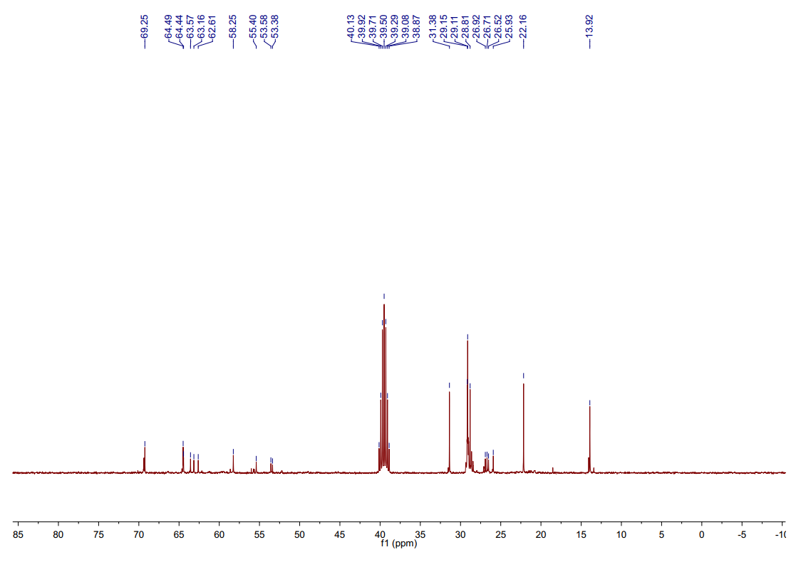

**Figure S8**. The 13C NMR spectra of Gemini surfactant **12-4-12**.

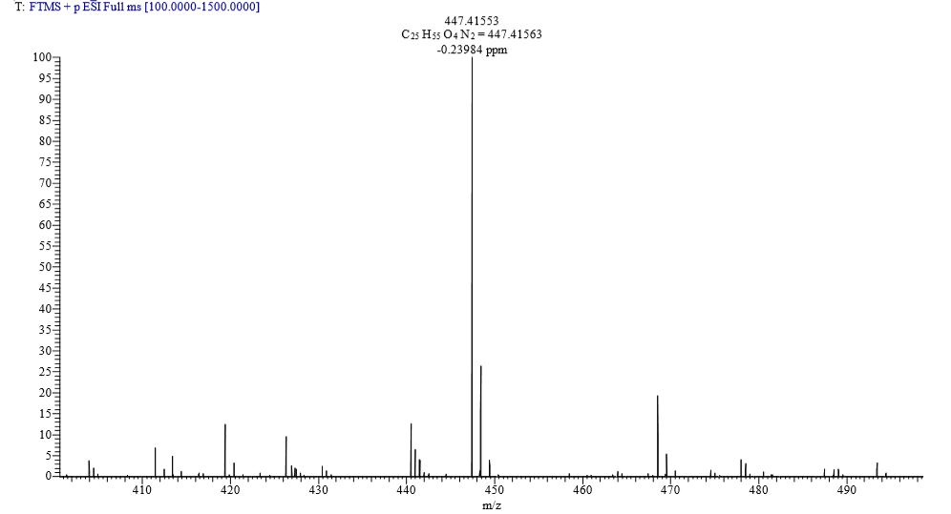

**Figure S9**. HRMS of Gemini surfactant **8-3-8**.

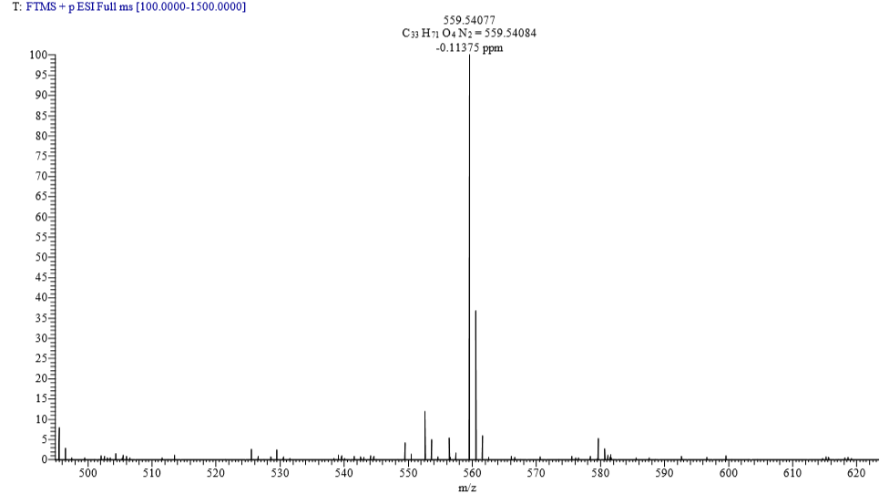

**Figure S10**. HRMS of Gemini surfactant **12-3-12**.

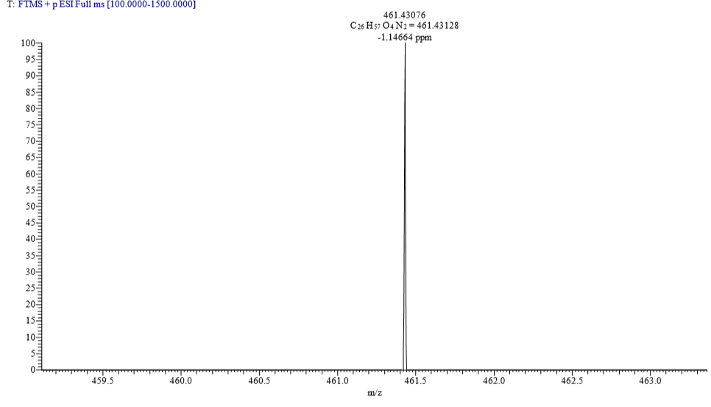

**Figure S11**. HRMS of Gemini surfactant **8-4-8**.

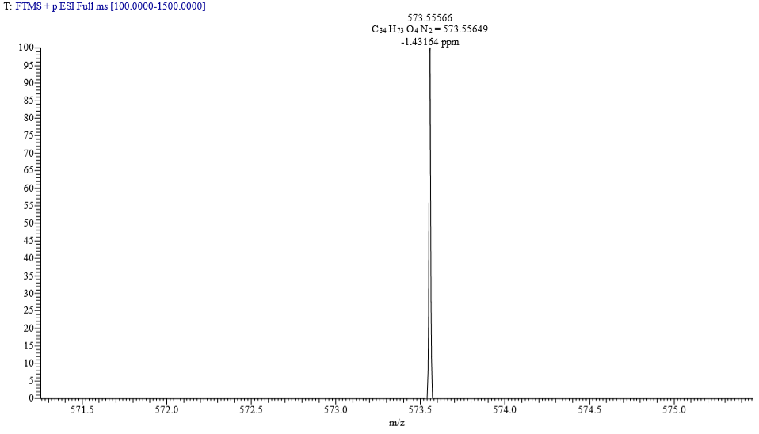

**Figure S12**. HRMS of Gemini surfactant **12-4-12**.

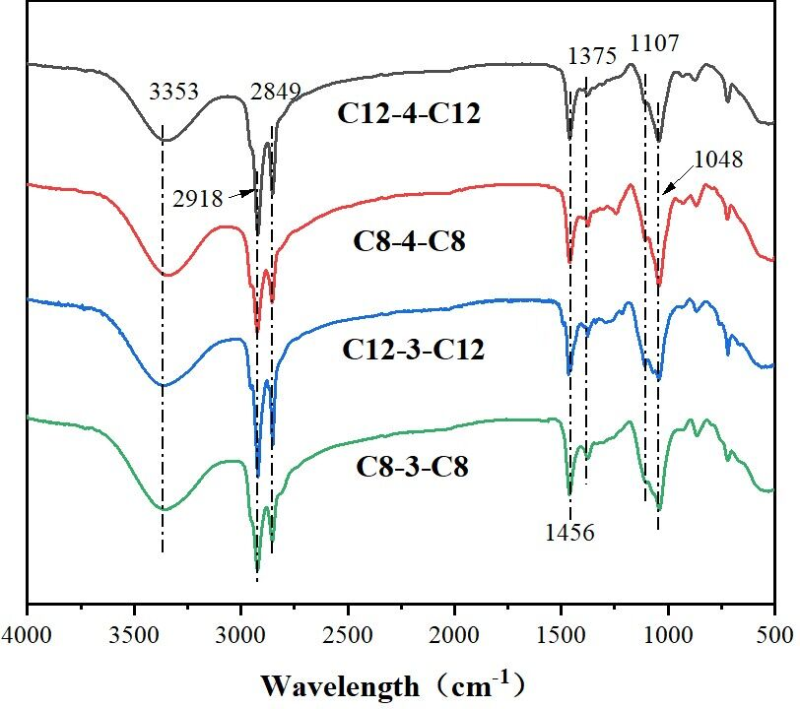

**Figure S13**. FTIR spectra of Gemini surfactant **8-3-8**, **12-3-12**, **8-4-8**, and **12-4-12**.