**Exploring the Potential Anti-Inflammatory Effect of Biosynthesized Gold Nanoparticles Using *Isodon excisus* Leaf Tissue in Human Keratinocytes**

**Sanjeevram Dhandapania, RongboWanga, Ki cheol Hwangb, Hoon Kimc,Yeon-Ju Kima\***

a Graduate School of Biotechnology, and College of Life Science, Kyung Hee University, Yongin-si, 17104, Gyeonggi-do, Republic of Korea

b Rafarophe Co, Venture Research Center, Cheongju, Republic of Korea

c Department of Food and Nutrition, Chung Ang University, Seodong-daero 4726, Daedeok-myeon, Anseong 17546, Republic of Korea

* Correspondence: Yeon-Ju Kim

Graduate School of Biotechnology, and College of Life Science, Kyung Hee University, Yongin-si, 17104, Gyeonggi-do, Republic of Korea

Tel.: +82-31-888-6180; +82-31-201-5634

Fax: +82-31-204-8116

Email: [yeonjukim@khu.ac.kr](mailto:yeonjukim@khu.ac.kr)

**A**



**B**

|  |  |  |  |  |  |
| --- | --- | --- | --- | --- | --- |
| **NO.** | **RT(min)** | **m/z([M+H]+)** | **Formula([M+H]+)** | **Δppm** | **Compound** |
| 1 | 6.48 | 611.1585 | C27 H31 O16 | -3.520 | Rutin |
| 2 | 6.69 | 465.1012 | C21 H21 O12 | -3.402 | Hyperoside |
| 3 | 7.92 | 361.0901 | C18 H17 O8 | -4.553 | Rosmarinic acid |

**Fig. S1**

The results of the UPLC-MS analysis of IE. (A) represents the photo-diode array chromatogram (PDA) and represents the base peak chromatogram (BPC). (B) The table provides the compound identification for the three major phytochemicals detected in IE.

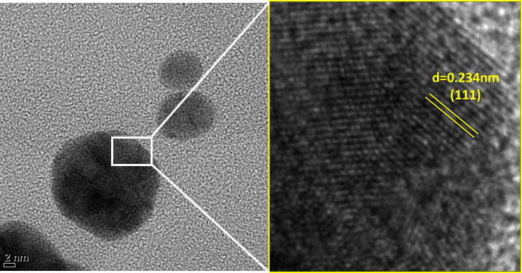

**Fig. S2** The TEM image shows the inter-planar distances (d) between parallel atomic planes of the IE-AuNPs

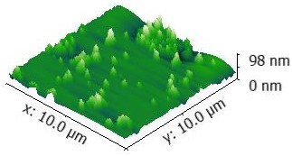

**Fig. S3** The AFM analysis confirms the size of the IE-AuNPs, providing additional evidence for their dimensions. The measured size values obtained from AFM analysis are presented in nanometers (nm).

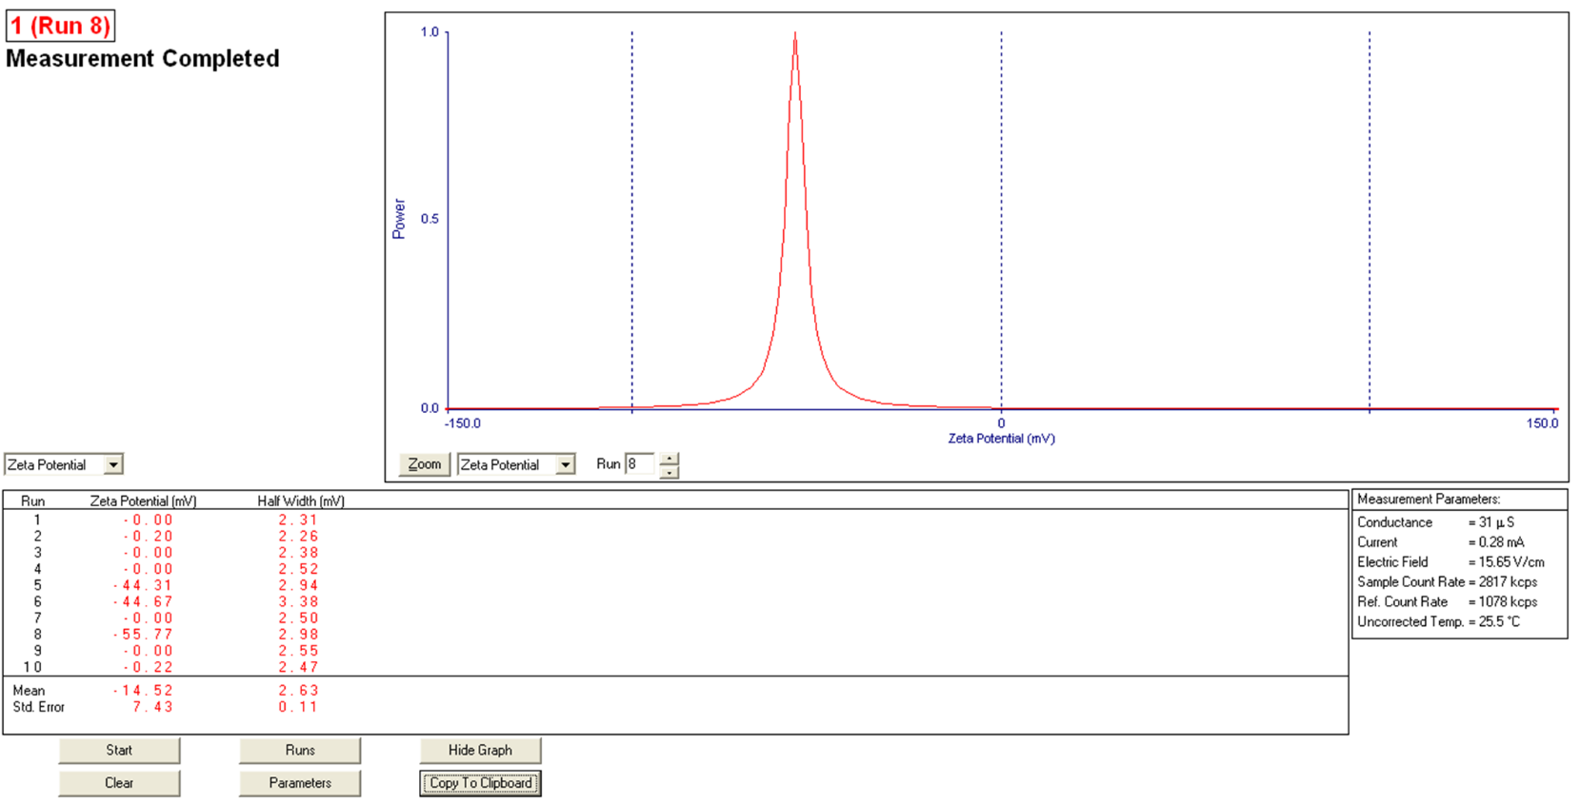**A**

**Zeta (mV): -55.77**

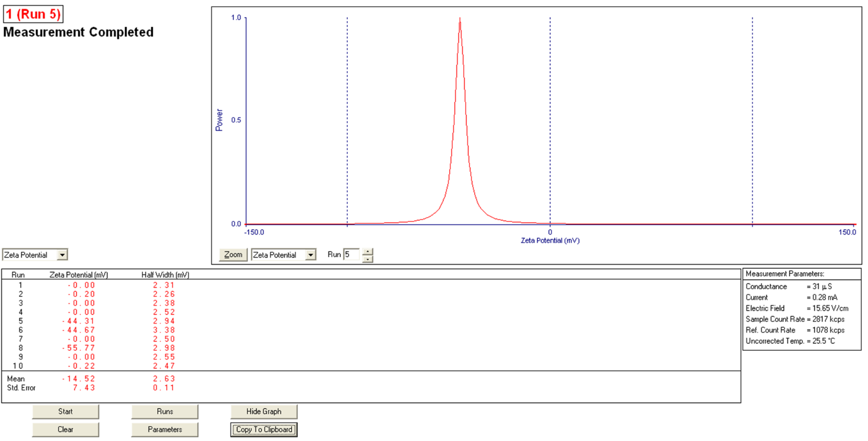**B**

**Zeta (mV): -44.67**

**Fig. S4** The Zeta potential confirms by indicating a highly stable dispersion with strong repulsion between the particles. Synthesized IE-AuNPs (A) Initially; (B) Six months later

**Fig. S5** Cell viability assay by treating IE-AuNPs, IE and PC

**Table S1**

List of techniques used in this study to characterize IE-AuNPs

|  |  |
| --- | --- |
| **Characterization techniques** | **Company** |
| X-ray diffraction (XRD) | Bruker, Karlsruhe, Germany |
| Fourier-transform infrared (FT-IR) | PerkinElmer Inc., Waltham, MA, USA |
| Selected area electron diffraction (SAED) | Tecnai G2 Spirit, FEI Company, USA |
| Energy-dispersive X-ray (EDX) spectroscopy | Tecnai G2 Spirit, FEI Company, USA |
| Transmission electron microscopy (TEM) | Tecnai G2 Spirit, FEI Company, USA |
| Dynamic light scattering (DLS) | Otsuka Electronics, Shiga, Japan |
| Atomic Force Microscope (AFM) | NanoSurf™ CoreAFM, Lausanne, Switzerland |
| Zeta Potential Analyzer | Brookhaven Corp. Holtsville, NY, USA |

**Table S2:**

The information of the ELISA kits used in the study

|  |  |
| --- | --- |
| **ELISA Kit** | **Company** |
| Human IL-6 Quantikine ELISA Kit #S6050 | R&D Systems Inc. (Minneapolis, MN, USA) |
| Human IL-8/CXCL8 Quantikine ELISA Kit # S8000C | R&D Systems Inc. (Minneapolis, MN, USA) |
| Human CCL17/TARC Quantikine ELISA Kit # SDN00 | R&D Systems Inc. (Minneapolis, MN, USA) |

**Table S3.**

List of primers used in this study

|  |  |  |
| --- | --- | --- |
| **Gene** | **Forward primer** | **Reverse primer** |
| **IL-6** | 5’-AGACAGCCACTCACCTCTTCAG-3’ | 5’-TTCTGCCAGTGCCTCTTTGCTG-3’ |
| **IL-8** | 5’-GAGAGTGATTGAGAGTGGACCAC-3’ | 5’-CACAACCCTCTGCACCCAGTTT-3’ |
| **CCL17/TARC** | 5’- TGTAAAACGACGGCCAGT-3’ | 5’- CAGGAAACAGCTATGACC-3’ |
| **CCL5/RANTES** | 5’- AGTGTGTGCCAACCCAGAGA-3’ | 5’- AGCAAGCAGAAACAGGCAAA -3’ |
| **CCL27/CTACK** | 5’- CTACAGCAGCATTCCTACTGC-3’ | 5’- ATGGAGCTTTCTCTCTTGGTG-3’ |
| **TIM23** | 5'-GTGGATCCACGCTATCTCGTTCAG-3’ | 5'-TTCAGAGTGACTGTTGGAGCAGGG-3' |
| **TOM20** | 5'-TTCTGACCAAGCTTCCGACCATTA-3’ | 5'-ACTGACCTAATGCTGAGATGGAAC-3' |
| **PARKIN** | 5’-TTCATCTACTGCAAAGGCCCCTGC-3’ | 5’-TCCCATTTGCAGCACGCATTCCTC-3’ |
| **PINK1** | 5’-TCCTCCAGCGAAGCCATCTTAAGC-3’ | 5’-TGCAGCACATTTGCAGCTAAGCGT-3’ |
| **MAP1LC3A** | 5’-ACATGAGCGAGTTGGTCAAGATCA-3 | 5’-GATGGATTCTGGCCCAGTCATATT-3’ |
| **MAP1LC3A** | 5’-ATAATTAGAAGGCGCTTACAGCTC-3' | 5’-TGGCAGGTTCTCTTCTCTAGATCT-3 |
| **Beclin1** | 5’-GCCAGGATGGTGTCTCTCGAAGAT-3' | 5’-GTGGAAGGTGGCATTGAGACATT-3’ |
| **SQSTM1** | 5’-ACCTGTCTGAGGGCTTCTCGCACA-3 | 5’-CTCTTCTCCTCTGTGCTGGAACTC-3’ |
| **GADPH** | 5’- GTCTTCACCACCATGGAGA-3’ | 5’- CGGCCATCACGCCACAGTTT-3’ |

**Table S4**.

The information of the antibodies used in the study

|  |  |
| --- | --- |
| **Antibody** | **Company** |
| PhosphoPlus® PI3K Antibody Duet | Cell signaling (Danvers, MA, USA) |
| PhosphoPlus® AKT Antibody Duet | Cell signaling (Danvers, MA, USA) |
| PhosphoPlus® p70SK6 Antibody Duet | Cell signaling (Danvers, MA, USA) |
| PhosphoPlus® Beclin 1 Antibody Duet | Cell signaling (Danvers, MA, USA) |
| PhosphoPlus® LC3 Antibody Duet | Cell signaling (Danvers, MA, USA) |
| PhosphoPlus® NF-κB p65/RelA Antibody Duet | Cell signaling (Danvers, MA, USA) |
| β-Actinh Mouse mAb | Cell signaling (Danvers, MA, USA) |
| Anti-mouse IgG, HRP-linked Antibody | Cell signaling (Danvers, MA, USA) |
| Anti-rabbit IgG, HRP-linked Antibody | Cell signaling (Danvers, MA, USA) |
| PhosphoPlus® p62/SQSTM1 Antibody | Proteintech (Chicago, IL, USA) |
| PhosphoPlus® PINK1 Antibody | Proteintech (Chicago, IL, USA) |
| PhosphoPlus® PARKIN Antibody | Proteintech (Chicago, IL, USA) |
| PhosphoPlus® TIM20 Antibody | Proteintech (Chicago, IL, USA) |
| PhosphoPlus® TOM23 Antibody | Proteintech (Chicago, IL, USA) |