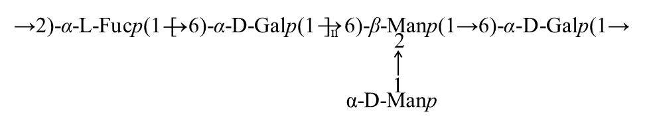

**Supplementary Fig. 1.** The predicted structure of PFSV-2.